# Team Project 1 Application Documentation

To use the program, there is a central menu navigation system based off of simple cin input. The UI should be very intuitive.

There are three central screens:

# The Main Menu

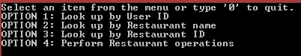

This menu should appear, after the databases are loaded (from folder ‘../RCdata/’)

# The User Menu

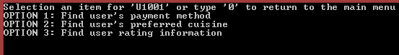

You can access the user menu following option 1 of the main menu and entering that you would like to continue working with the user

# The restaurant menu

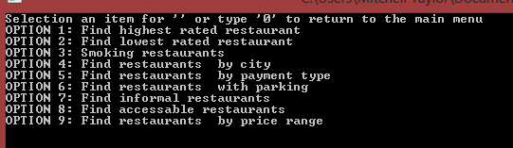

The restaurant menu can be accessed from option 4.

# Using database functionality

We used the an API we generated with Doxygen. This helped bring clarity to our projects organization. We used a lot of built in API features like record iterator, etc. We did not receive an actual API, so we only were able to use features that were evident to us.