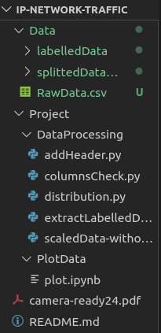
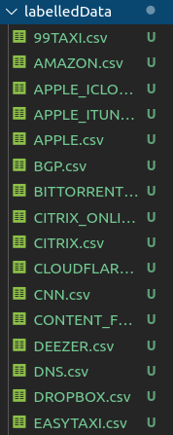
- File organization - labelledData (with header)

- You should run columnsCheck first to know what kind of data is collected.
- Then run extractLabelledData to have splittedDataWithLabels. It looks the same as labelledData organization but without header
- Next, run addHeader to add header to all csv file in data we’ve just ran => labelledData with header
- If you r curious about our dataset, run distribution.py to see the imbalance of our data
- ./PlotData/plot.ipynb is used to visualize data. In this session I try with RawData.csv. So, to find each data special feature, try with others splitted dataset.

