Practice1.rmd

Michael Banks

06/11/2021

summary(cars)

## speed dist   
## Min. : 4.0 Min. : 2.00   
## 1st Qu.:12.0 1st Qu.: 26.00   
## Median :15.0 Median : 36.00   
## Mean :15.4 Mean : 42.98   
## 3rd Qu.:19.0 3rd Qu.: 56.00   
## Max. :25.0 Max. :120.00

## Assignment 1 Plots

You can also embed plots, for example:

plot(pressure)

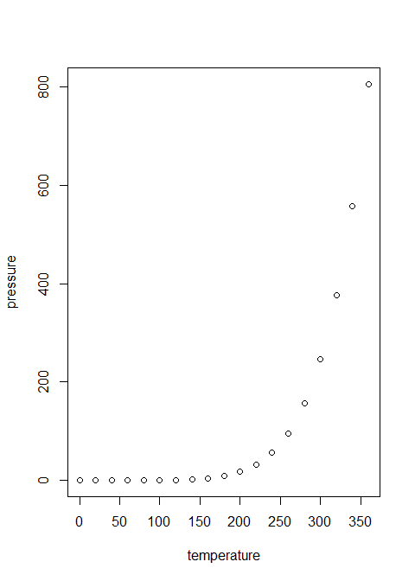

# write data from R into CSV

write.csv(cars,file = "Data/cars.csv")