MT Legal: Instagram launch kit
Ten posts, all 1080 x 1350 so they fill the feed: a six-slide launch carousel (00), then nine regular posts (03 is a three-slide carousel). Post the launch carousel first, then 01 through 09 in order; Instagram shows the newest at the top left, so the grid ends up looking like grid-preview.jpg. Two or three posts a week is plenty.

Profile
Name field: MT Legal | Nashville Attorney
Bio (under 150 characters):
Client-centered counsel for DeFi, digital assets & trial work.
Madison T. Biggs, Esq. · Nashville, TN
Attorney advertising. Not legal advice.

Link: https://midtennlegal.com
Profile photo: brand/mt-legal-mark.png (the MT mark with LEGAL)
Category: Lawyer & Law Firm
Contact buttons: Call (615-601-0633) and Email (Mtbiggs@midtennlegal.com)
Highlights to set up later: About, DeFi, Estate, Know Your Rights, FAQ

00 · Launch carousel: Introducing MT Legal
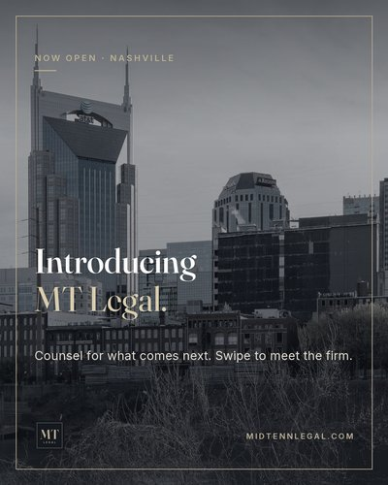  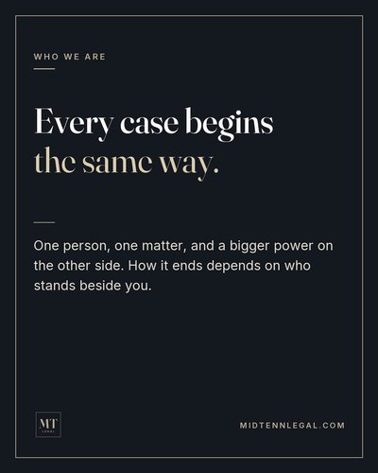    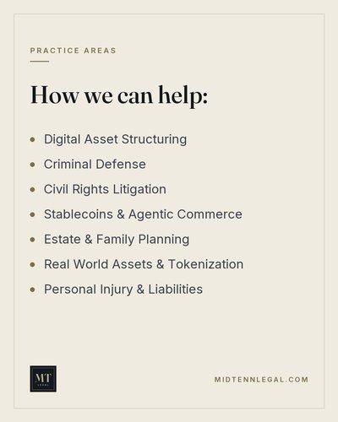  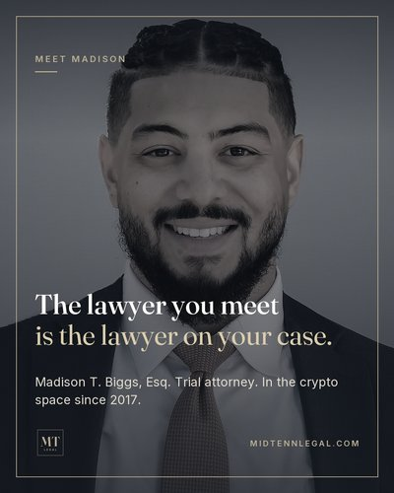   | FILE 00a-launch-cover.png, 00b-launch-who-we-are.png, 00c-launch-approach.png, 00d-launch-practice-areas.png, 00e-launch-meet-madison.png, 00f-launch-get-started.png  CAPTION  MT Legal is open in Nashville.  Every case begins the same way: one person, one matter, and a bigger power on the other side. How it ends depends on who stands beside you. I built this firm to be that person: someone who listens first, speaks plainly, and stays with you from the first call to the final appearance.  Dedicated support for DeFi and digital assets, alongside criminal defense, civil rights, estate and family planning, and personal injury. Swipe to see how we can help, then start with a brief call at no cost.  Link in bio, or scan the code on the last slide.  #NashvilleLawyer #MTLegal #MiddleTennessee #DeFi #DigitalAssets #CriminalDefense  Attorney advertising.  ALT TEXT  Cover: Nashville skyline in black and white with the words "Introducing MT Legal."  Slide 2: "Every case begins the same way. One person, one matter, and a bigger power on the other side."  Slide 3: "Client-centered, start to finish."  Slide 4: List of practice areas, from Digital Asset Structuring to Personal Injury & Liabilities.  Slide 5: Portrait of Madison T. Biggs, Esq., trial attorney, with the words "The lawyer you meet is the lawyer on your case."  Slide 6: "Start with a brief call, at no cost," with the website, phone number, and a QR code.

01 · Counsel for what comes next
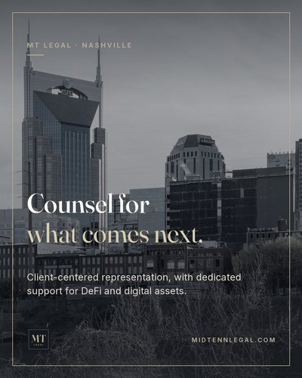 | FILE 01-counsel-for-what-comes-next.png  CAPTION  Every matter we take starts the same way: one person on one side, and a far bigger power on the other.  MT Legal is a client-centered Nashville firm with dedicated support for DeFi and digital assets, plus traditional practice from criminal defense to estate planning. Whether you face the state in court or the banks, exchanges, and gatekeepers that control money and property, you work directly with your attorney.  Start with a brief call at no cost. Link in bio.  #NashvilleLawyer #MiddleTennessee #DeFi #DigitalAssets #NashvilleTN  ALT TEXT  Nashville skyline in black and white with the words "Counsel for what comes next."

02 · Our principle
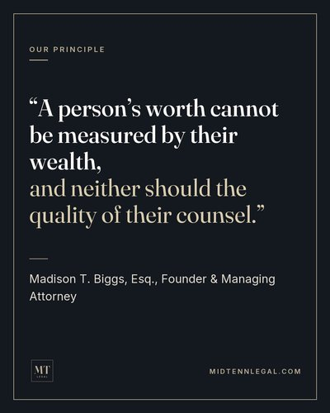 | FILE 02-worth-quote.png  CAPTION  This is the line the firm is built on.  Good counsel shouldn't depend on the size of your bank account or the size of the other side's legal team. Whether it's a courtroom in Davidson County or a fight with a platform over your own assets, you deserve someone in your corner who treats your matter like it matters.  #AccessToJustice #NashvilleLawyer #ClientFirst #MTLegal  ALT TEXT  Quote reading "A person's worth cannot be measured by their wealth, and neither should the quality of their counsel," attributed to Madison T. Biggs, Esq.

03 · Carousel: If you died tomorrow, could your family reach your crypto?
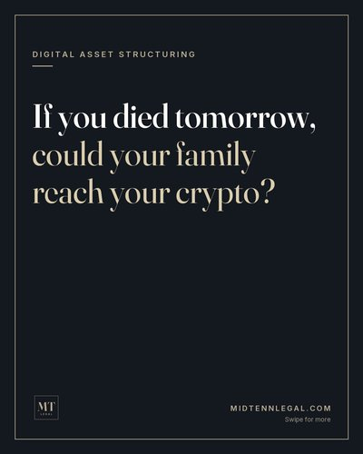  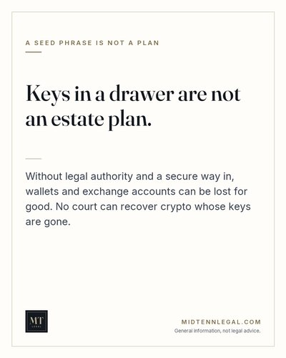  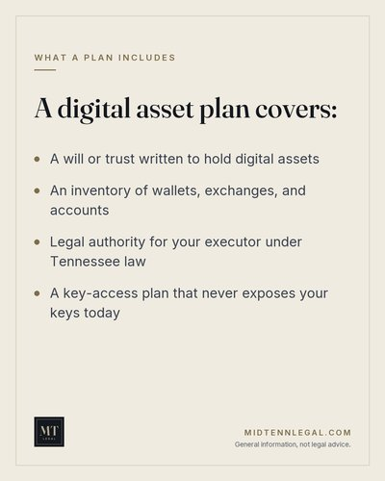 | FILE 03a-crypto-estate-cover.png, 03b-crypto-estate-keys.png, 03c-crypto-estate-checklist.png  CAPTION  I've been in the crypto space since 2017, and the most common way digital wealth disappears isn't a hack. It's a family that can't get in.  A seed phrase in a drawer is not an estate plan. Your executor needs legal authority to act, and a secure way to reach your wallets and accounts, without anyone holding your keys while you're alive.  Swipe for what a digital asset plan covers. Questions? Link in bio.  #CryptoEstatePlanning #DigitalAssets #Bitcoin #EstatePlanning #NashvilleTN  General information, not legal advice.  ALT TEXT  Cover: "If you died tomorrow, could your family reach your crypto?"  Slide 2: "Keys in a drawer are not an estate plan."  Slide 3: Checklist: a will or trust for digital assets, an inventory of wallets and accounts, legal authority for your executor, and a key-access plan.

04 · Pulled over in Tennessee?
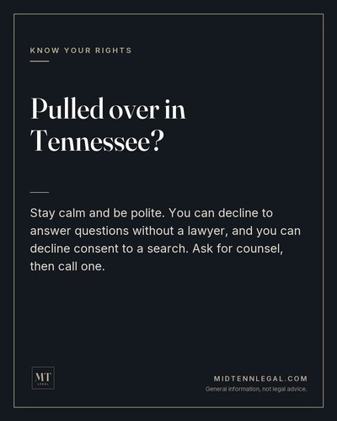 | FILE 04-pulled-over.png  CAPTION  Save this one.  At a traffic stop, stay calm and be polite. You can decline to answer questions without a lawyer, and you can decline consent to a search. Provide your license, registration, and proof of insurance when asked. Ask for counsel, then call one.  If you've already been charged, reach out before your first court date.  #KnowYourRights #NashvilleLawyer #CriminalDefense #DavidsonCounty #Tennessee  General information, not legal advice.  ALT TEXT  "Pulled over in Tennessee? Stay calm and be polite. You can decline to answer questions without a lawyer, and you can decline consent to a search."

05 · Stablecoins now have federal rules
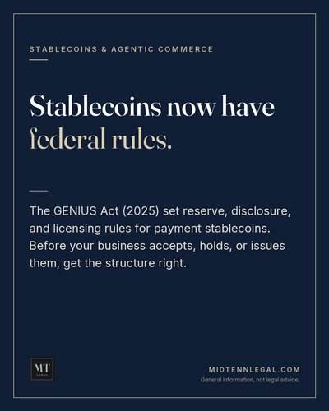 | FILE 05-stablecoins-genius-act.png  CAPTION  The GENIUS Act (2025) created the first federal framework for payment stablecoins: reserve, disclosure, and licensing rules for issuers.  For Nashville businesses that opens a real opportunity: settle payments in minutes, cut card and wire fees, and reach customers abroad. It also means the structure has to be right before you accept, hold, or issue them.  Building something with stablecoins or agentic commerce? Let's talk.  #Stablecoins #GENIUSAct #Fintech #AgenticCommerce #NashvilleBusiness  General information, not legal advice.  ALT TEXT  "Stablecoins now have federal rules," with a short summary of the GENIUS Act.

06 · One person. A bigger power.
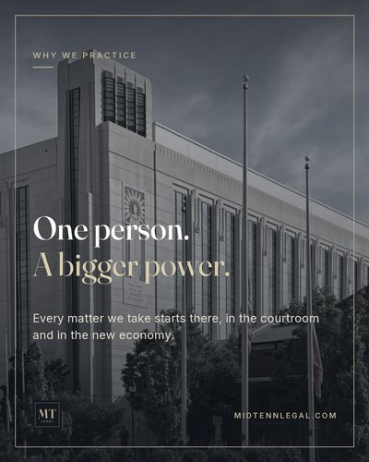 | FILE 06-one-person-bigger-power.png  CAPTION  I learned how the system works from the inside: two years as a deputy court clerk, an internship with the District Attorney's Office, and then the defense table.  That's still the job. One person on one side, a bigger power on the other, and someone making sure your side gets heard. Today that fight happens in courtrooms and in the new economy.  #TrialAttorney #NashvilleLawyer #CivilRights #ClientFirst #MiddleTennessee  ALT TEXT  Davidson County courthouse in black and white with the words "One person. A bigger power."

07 · Can you tokenize a Nashville duplex?
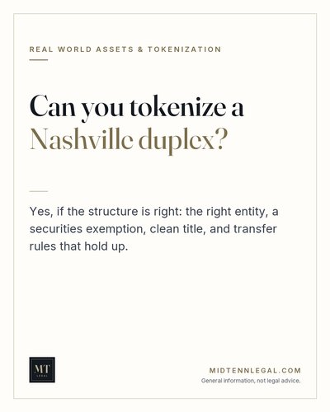 | FILE 07-tokenize-a-duplex.png  CAPTION  Short answer: yes, if the structure is right.  Tokenization can open a property to smaller investors and faster transfers. Done wrong, it's an unregistered securities offering. The legal work is what makes the token mean something: the right entity, a securities exemption, clean title, and transfer rules that hold up.  #Tokenization #RealWorldAssets #RWA #NashvilleRealEstate #Web3  General information, not legal advice.  ALT TEXT  "Can you tokenize a Nashville duplex? Yes, if the structure is right."

08 · Your rights have a deadline
 | FILE 08-one-year-deadline.png  CAPTION  Tennessee has one of the shortest filing deadlines in the country. Most civil rights and personal injury claims must be filed within one year.  Evidence fades, footage gets deleted, and insurers count on you waiting. If something happened to you, don't sit on it.  #PersonalInjury #CivilRights #Tennessee #NashvilleLawyer #KnowYourRights  General information, not legal advice.  ALT TEXT  "Your rights have a deadline. In Tennessee, most civil rights and personal injury claims must be filed within one year."

09 · Meet Madison
FILE 09-meet-madison.png
CAPTION
Hi, I'm Madison.
I've been in the crypto space since 2017 and in courtrooms across Middle Tennessee as a trial attorney. I started MT Legal so clients would always know who is handling their matter: me, from the first call to the last.
Belmont Law graduate. Adjunct professor of Business Law at Fisk University. Member of Nashville's Bitcoin community.
#MeetTheAttorney #NashvilleLawyer #Bitcoin #CryptoLawyer #MTLegal
ALT TEXT
Portrait of Madison T. Biggs, Esq. with the words "The lawyer you meet is the lawyer on your case."

Stories and Reels ideas
- "Ask Madison" sticker each week: answer one question on camera in under 60 seconds.
- Reel: "3 things to do the day you're arrested" (stay quiet, ask for a lawyer, write down what happened).
- Reel: "Where does your crypto go when you die?", filmed walking past the courthouse.
- Story poll: "Do your family members know how to access your crypto?" Yes / No.
- Behind the scenes: conferences, Bitcoin meetups, teaching at Fisk (with permission).

Before posting
- Keep "Attorney advertising" in the bio. Tennessee treats social posts about your services as advertising under RPC 7.1 to 7.3.
- No client stories, results, or reviews without written consent, and no "expert" or "specialist" wording (RPC 7.4).
- Don't answer specific legal questions in comments or DMs; invite people to book a call instead.

