1. Go to this website. <http://sqlitebrowser.org/>

(it should look like this)

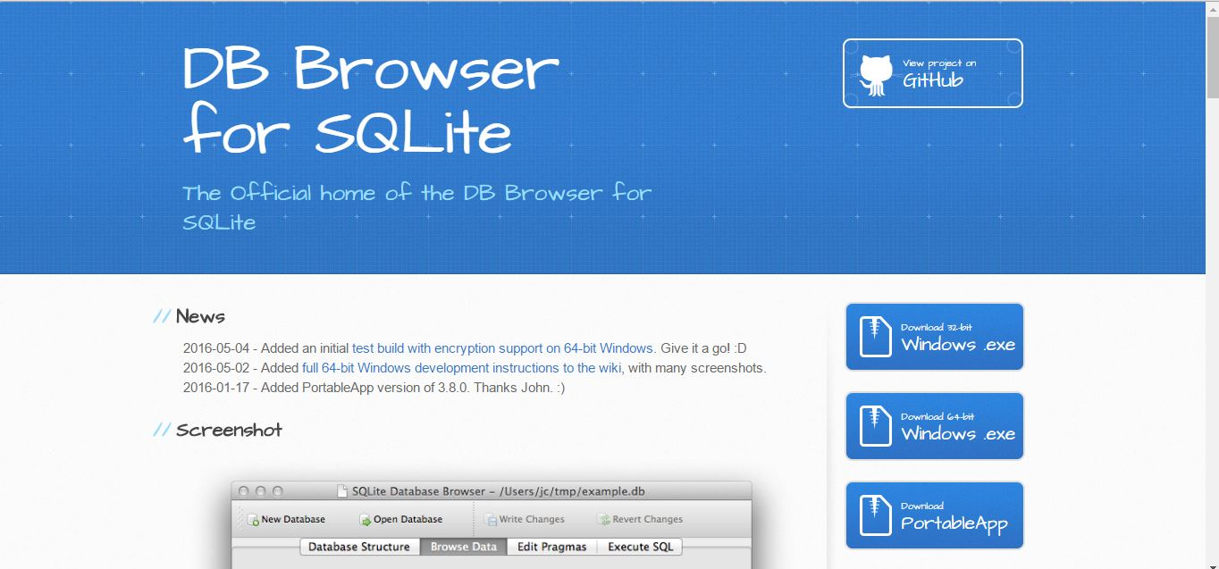

1. Then scroll down and click on the Download Icon that is right for your laptop, that will start the download for the program.
2. Double-click on the downloaded program, you should get a window that looks like this.

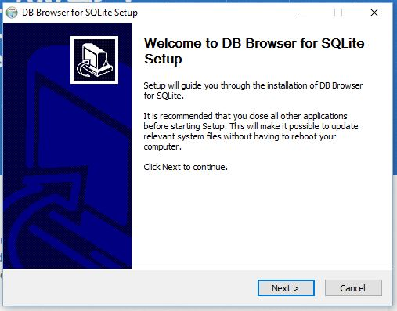

1. Click next, and then read and agree to the terms of use. Click next.
2. The next screen will give you the option of were to download it. The default for windows users is in the program file. This is where I keep programs, but you can change it if you want to. Click next.
3. The next screen will give you the option of creating a shortcut. I like having shortcuts, but feel free to click the “no shortcut” box. Click install.
4. It will take a few minutes to install, how fast this happens kind of depends on your computer.
5. If everything goes right you should see this screen. Click Finish.

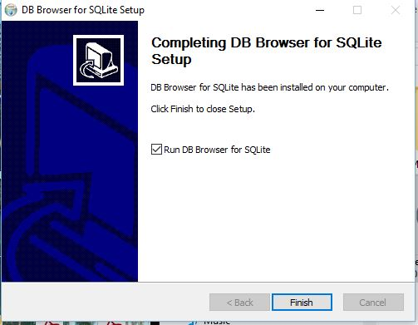

1. That’s it! You did it!
2. If anything went wrong, don’t worry. Just come a few minutes before class and we can sort it out there.