Python Install Instructions:

1. Determine what operating system you are using.
   1. For windows search “about your PC” in your settings look for the Edition (this is the OS) and system type (this will tell you if you are using a 32bit or 64bit processor)
   2. For mac users, click on the Apple icon in the top left corner of your screen. From there, you can click 'About this Mac'. You'll now see a window in the middle of your screen with information about the Mac you're using. You are looking for your version number and processor name. Use the chart below to determine if you have a 32 or 64 bit processor.

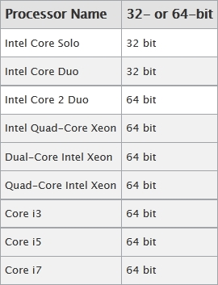

1. Next go to <https://www.python.org/downloads/release/python-353/>
   1. This is where you can download the python version 3.5.3 (there is a newer version python 3.6, but it is still in the testing stage)
   2. Scroll down the page until you see the section header **Files**
   3. Choose the file that is compatible with your computer
      1. For windows users I would recommend using either the Window x86-64 executable installer (for 64-bit processors), or the Windows x86 executable installer (for 32-bit processors)
      2. Mac users only have two options (64-bit or 32-bit)
2. After you download the proper version of python, install it like you would any other program
   1. Use the default installations, and make sure you check the box that adds python 3.5 to PATH (this might just be for windows users)
   2. The default installation should include IDLE, pip and documentation

That’s it. You did it!