Configuring DCOM for MTConnect

Configuring DCOM for MTConnect 1
Run dcomcnfg 2
Open DCOM config inside Component Services 4
Right Click My Computer and Select Properties 5
Set Siemens 840D OPC COM server Properties 6
Set Siemens OPC Server Authentication Level to None 7
Location 8
Security 9
Launch and Activation Permissions 10
Access Permissions 15

Run dcomcnfg

Either Start->Run dcomcnfg from the command line
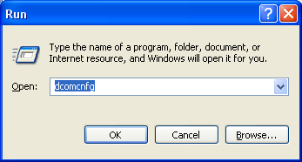
Or
Start Administration Tools->Cmponent Services

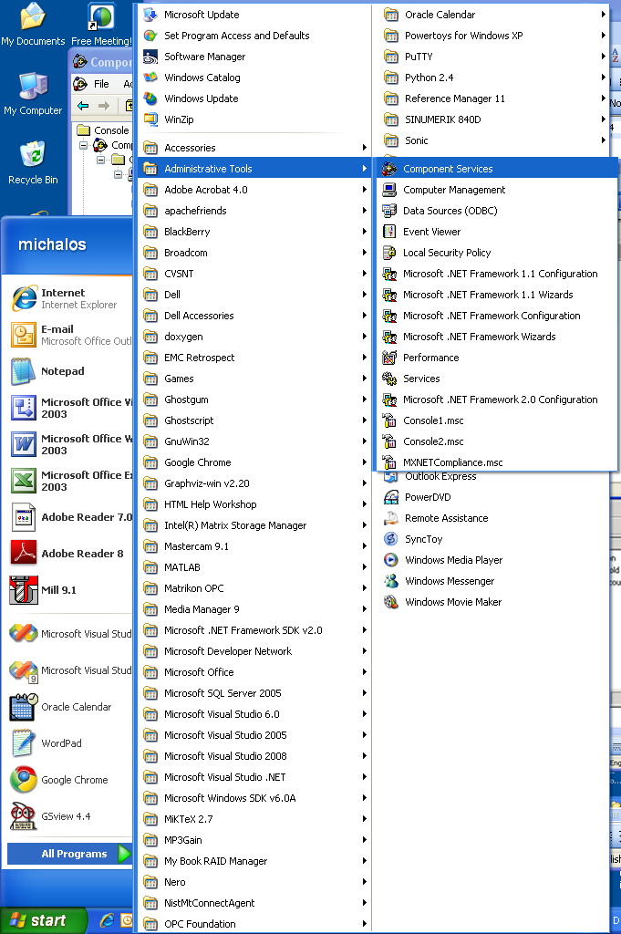

Open DCOM config inside Component Services

Click Component Services -> Computers -> My Computer
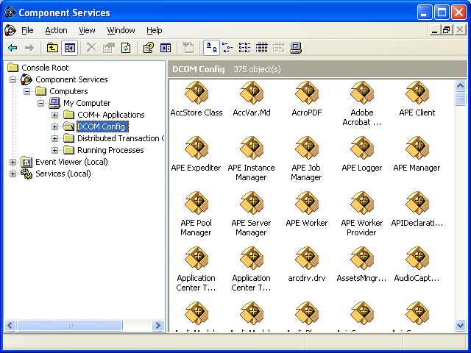
Note you may get a bunch of DCOM configuration warnings: IGNORE THEM.
Example:

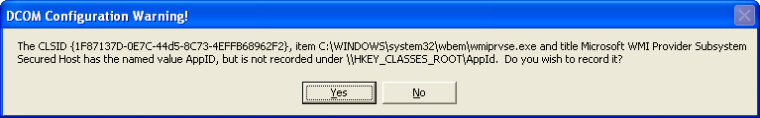

Right Click My Computer and Select Properties
Make sure Enable Distributed COM on this computer is checked.
SID: see that these two settings have been configured for DST 444.
Set Authentication to None
Set Impersonation to Impersonate.
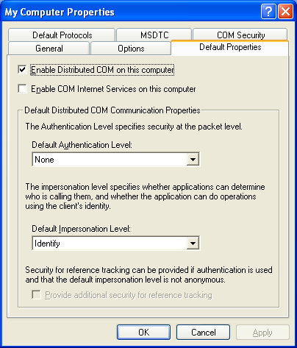

Set Siemens 840D OPC COM server Properties
Select DCOM Config, (use List view option) and then right click on OPC.SINUMERIK.MachineSwitch and select Properties.
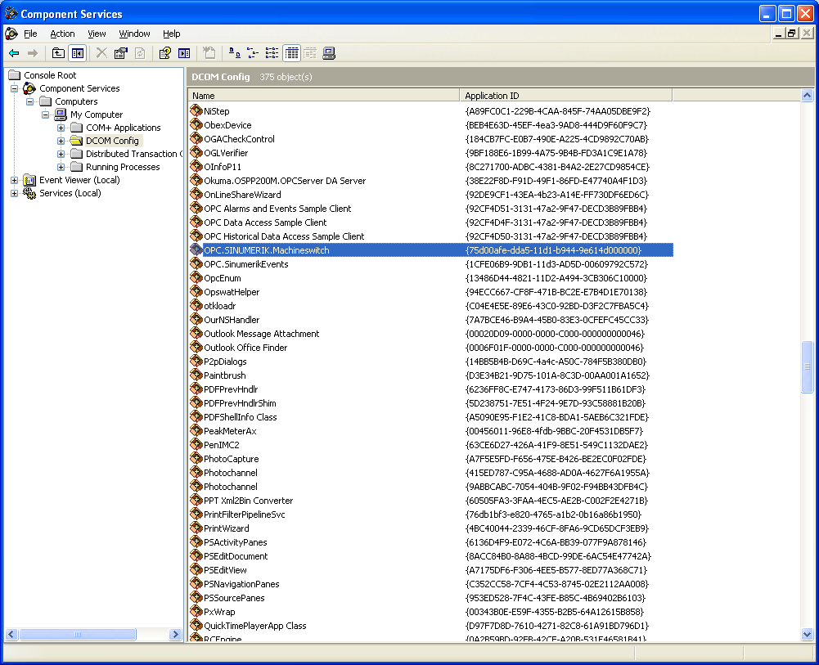

Set Siemens OPC Server Authentication Level to None

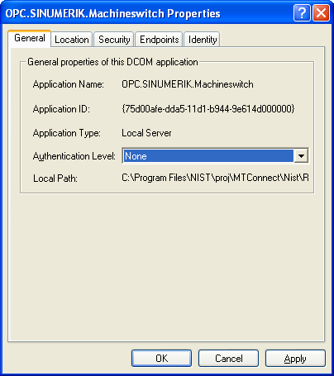

Location
Run the OPC server on this machine
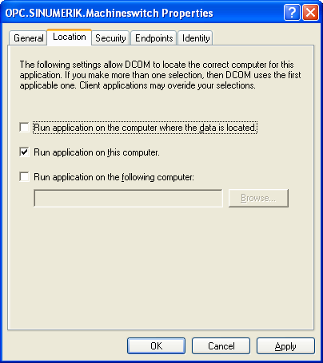

Security
Check customize all Launch, Activation, and Configuration Permissions
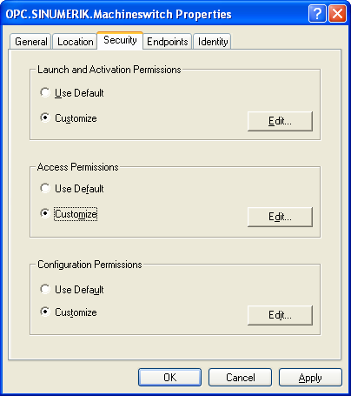

Launch and Activation Permissions
Make sure System has permissions for Remote Launch and Activation
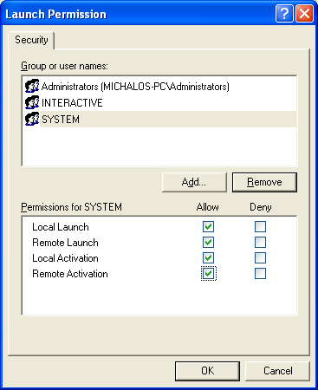

Add Network (not sure this is necessary). Select Add, Select users or Groups Dialog pops up
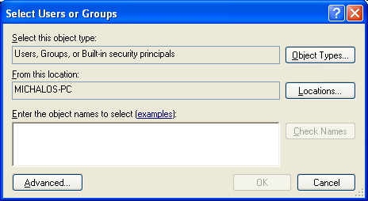

Select Advanced
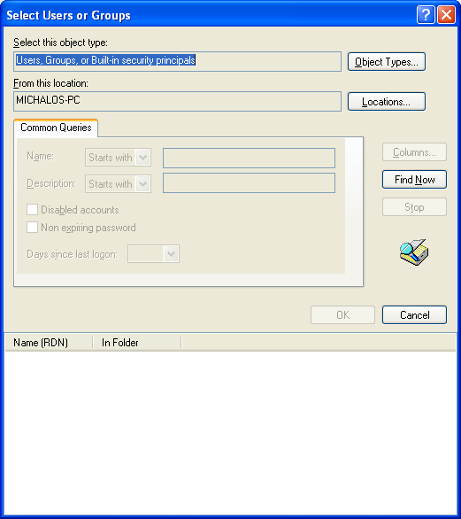

Click Find Now
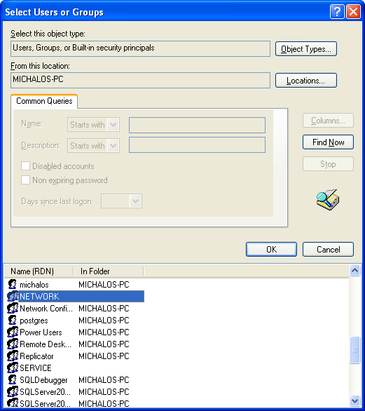
Select network and click OK
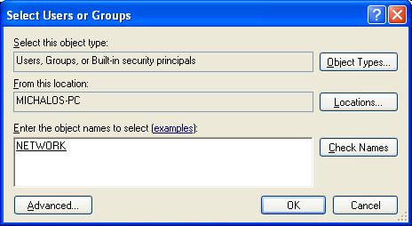
Select OK.
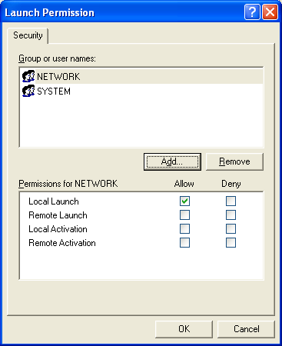

Allow Remote Lauch and Activation and Click OK
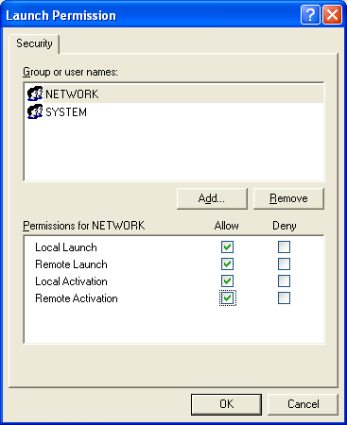

Access Permissions
Check customize all Launch, Activation, Access and Configuration Permissions
Make sure System has permissions Remote Launch and Activation

