TO : AH
CC : GM, CSS
FROM : MIS
DATE : 16th of FEBRUARY, 2019
SUBJECT : CI CODE APPROVAL FOR CREDIT APPLICATION

Good Morning,
We would like to inform you that CI CODE APPROVAL FOR CREDIT APPLICATION will be fully implemented on:

- February 20, 2019 for MC Division Area 3
• February 25 to March 9, 2019 for MC Division All Other Areas

Thus: CI (Credit Investigator) will now issue code approval using G Approval Code app from their android phone. This is applicable to branches in need to approve the credit application entry having CI as QM Result (ex: CI000000U). Branches will now seek CI’s assistance base on route.

Moreover: All other QM result will remain as is, wherein; Branches seek CSS assistance if needed.

Attached herewith is the PDF presentation for your references. Kindly disseminate to your respective branches. Upon branch’ receipt of this IOC, kindly read and follow the steps on “Approval Code Installation Guide.pdf” and “User Management Procedure.pdf” for advance app installation and user account creation prior to the implementation date on the area.
Any questions and clarifications feel free to contact us.
Thank you and please be guided accordingly.
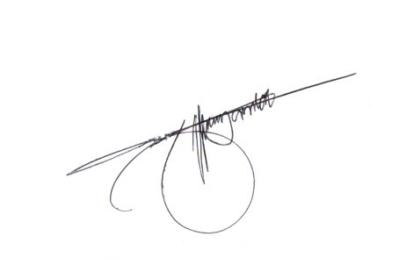
Sincerely Yours,

Jeffrey T. Yambao
Head, MIS

