Sign Up Removed
Tycoon Add and Edit Enabled
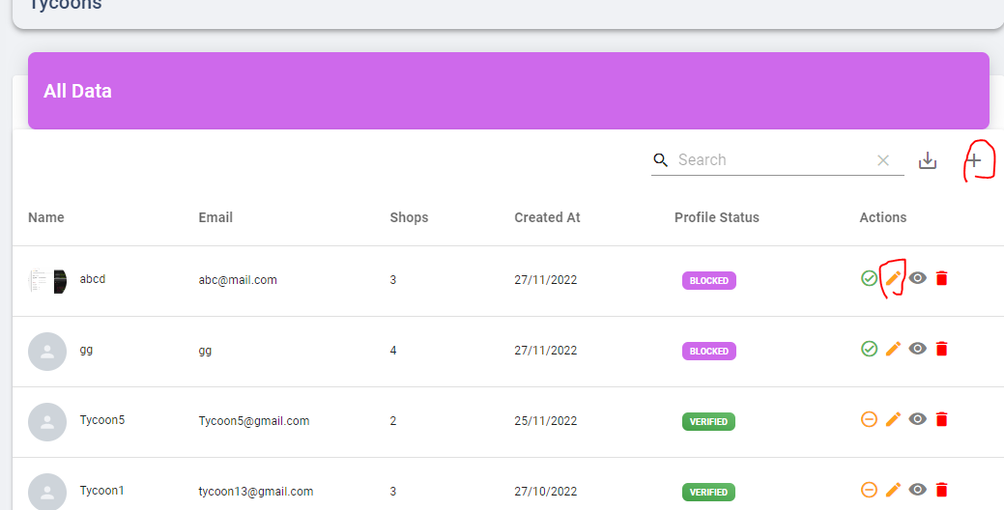
Subscription Add edit Dialog Resign
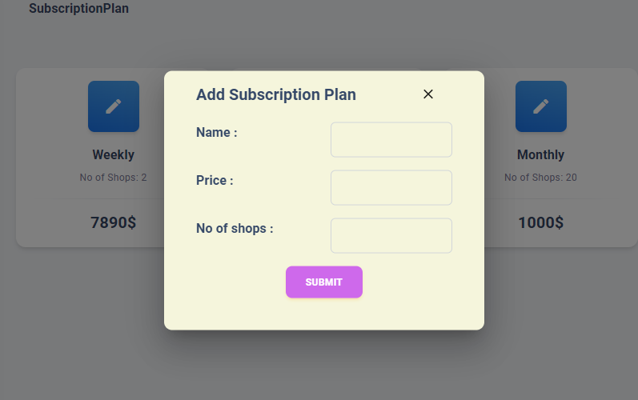
No of shops Only Number Input
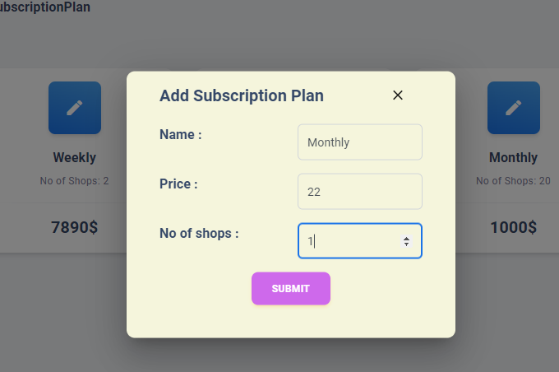
Not enter Empty Data
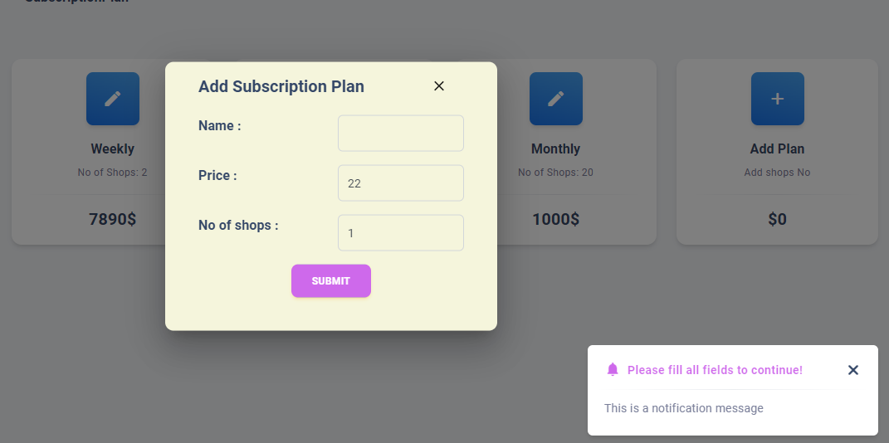
Delete Subscription Plan
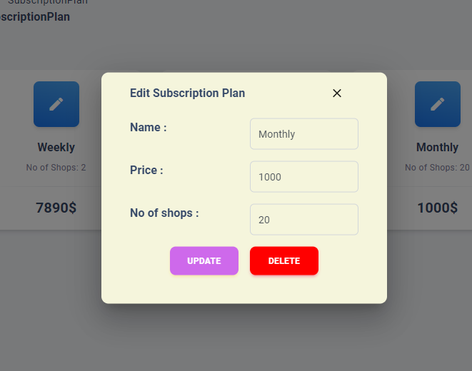

Splash on home Resolved

