Sign Up Removed

Tycoon Add and Edit Enabled

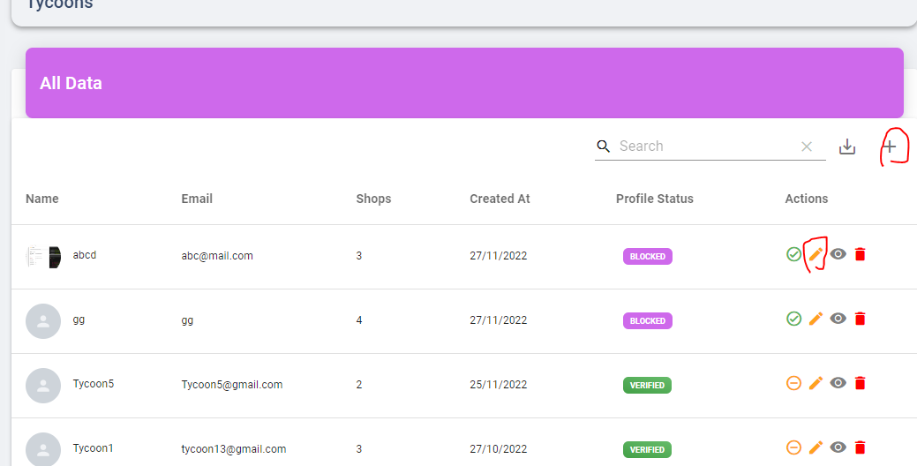

Subscription Add edit Dialog Resign

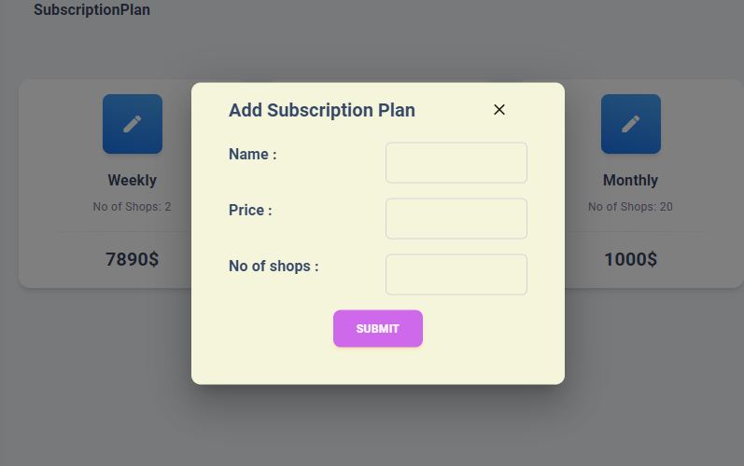

No of shops Only Number Input

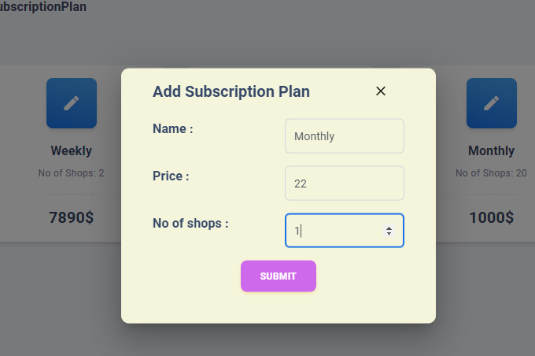

Not enter Empty Data

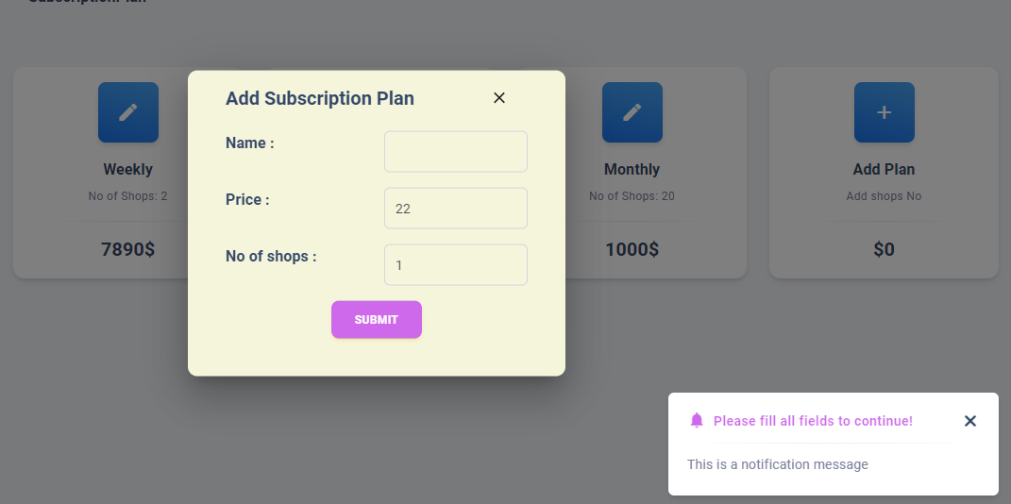

Delete Subscription Plan

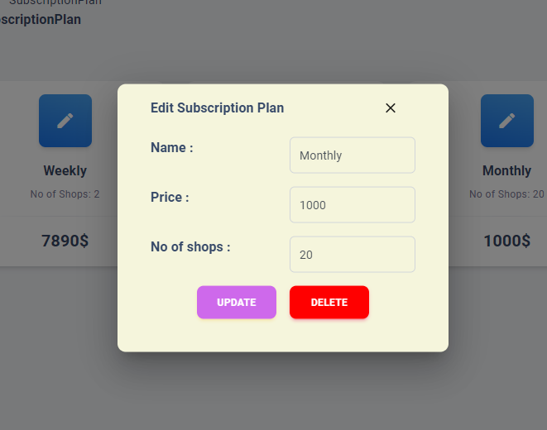

Splash on home Resolved