**GLOW**

**WOW**

PRODUCTS ON OFFER FROM WOW-GLOW:

Paula Katz – Owner Operator

0404.884.998

wowglowaustralia@gmail.com.au

____________________________________________________________

**Flashing Extendable Sword**

[](javascript:popupWindow('http://www.everythingglows.com.au/flashing-extendable-sword-pi-497.html?image=0'))

____________________________________________________________

**Lightup Shutter glasses**

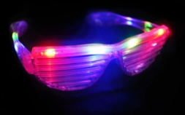

___________________________________________________________

___________________________________________________________

# 8" Glow Bracelets in mixed colours

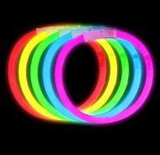

____________________________________________________________

# Flashing Bow Head Bobber

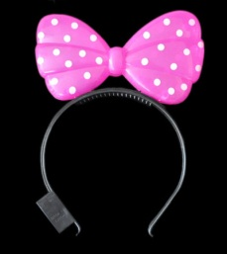

____________________________________________________________

**Ball shaped flashing necklaces – 4 Colours**

# http://www.soldsmart.com.au/files/FS0085X70/FS0085X7003.jpg

____________________________________________________________

____________________________________________________________

**LED Dreadlock Head Bopper -Rainbow**

# LED Dreadlock Head Bopper Rainbow

____________________________________________________________

# Fairy Wing Set – Wings, Tiara, Wand

# http://www.blueberryexpress.com.au/components/com_virtuemart/shop_image/product/Fairy_Wing_Set___509709ea7db10.jpg

____________________________________________________________

# Glow Fairy Floss Stick

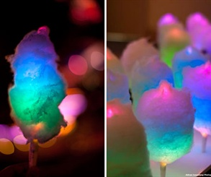

____________________________________________________________

**____________________________________________________________**

[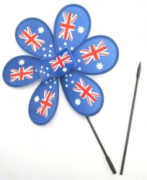](http://www.blueberryexpress.com.au/components/com_virtuemart/shop_image/product/Australia_Flag_W_50ca78727acba.jpg)**Australia Flag Windmill - 30cm diameter and 56cm stick**

**____________________________________________________________**

**Australia Flag Hat**

# http://thumbs4.ebaystatic.com/d/l225/m/m6sjtyTT0wbO2pk8HUbypfQ.jpg

____________________________________________________________

# http://www.blueberryexpress.com.au/components/com_virtuemart/shop_image/product/Aussie_Sombrero__50c918d65c363.jpgAussie Sombrero

____________________________________________________________

**LED Flashing Badge**



