Estimating total deaths of adult female green turtles at Raine Island

Tomo Eguchi

07/04/2020

## Introduction

Determining the number of deaths of green turtles at Raine Island is important in understanding the effects of these deaths on the population, as well as for investing in measures to decrease the deaths. In this document, I used data on observed deaths from periodical surveys of the island to estimate the total deaths for each nesting season.

## Methods

The dataset for this analysis contained the observed deaths of female green turtles at Raine Island from the 1995 to 2019 season. The dataset included presumed zeros at the beginning (October 15 - October 20) and end of each nesting season (April 1 - April 5). Observations were made only when a research team was present on the island. The number of trips per season varied over the years (Figure 1). Cause of deaths were grouped into either “heat-related” or “cliff-fall.”

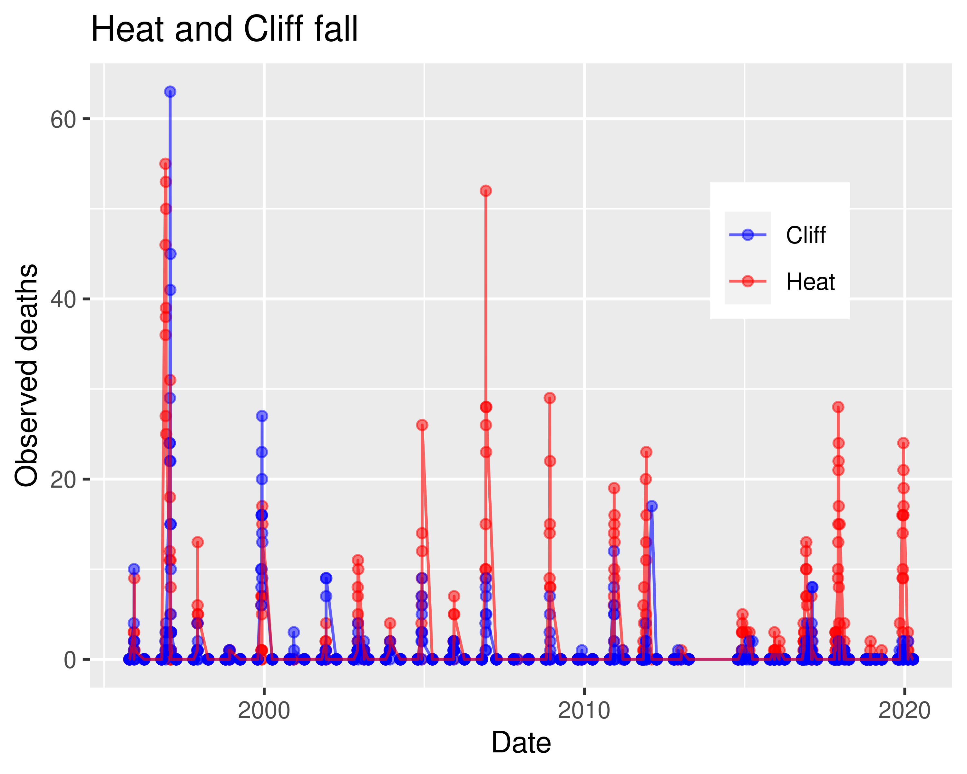

Figure 1. Observed deaths of green turtle females from heat-related and cliff-fall causes at Raine Island.

In order to estimate the number of unobserved deaths from the two causes (i.e., heat-related or cliff-fall), I fitted parametric functions to the data within each season using the state-space approach. The state space is modeled by modified versions of Richards function, whereas the observations are assumed to have either normal or Poisson distribution around the function. Modification of the Richards function represent varying assumptions of the underlying process. In total, 36 models were constructed. The base function has the following form (Girondot et al. 2007).

M1 = (1 + (2 * exp(K) - 1) * exp((1/S1) * (P - d))) ^ (-1/exp(K))

M2 = (1 + (2 * exp(K) - 1) * exp((1/S) * (P - d))) ^ (-1/exp(K))

N = min + (max - min) * (M1 * M2)

S1 = -S

d = the number of days from the beginning of nesting season

S > 0 defines the “fatness” of the function

K > 0 defines the “flatness” at the peak of the function

P defines where the peak is relative to the range of d min(d) < P < max(d).

min = 0.

max = the maximum number of deaths per day.

Model names were abbreviated to indicate which parameters were estimated and what distributions were used as the observation model. I also developed a series normal-observation models where observation variance changed over time (sigmaYt). Varying K by season resulted in non-convergence. Consequently, time dependent K models were not considered. No correlation was found between the numbers of heat-related and cliff-fall deaths. Consequently, these data were modeled separately.

Model parameters were estimated via the Bayesian approach using JAGS (v.4.3.0) with the jagsUI package (v.1.5.1, REF) in R (v.4.0.2; R Development Core Team). Convergence of Markov-chain Monte Carlo (MCMC) was determined using the Rhat statistic and visual inspection of trace plots (Gelman et al. YR). Models were compared using LOOIC (Vehtari et al. 2017) and Goodness-of-fit was determined using the Pareto-K statitsic (Vehtari et al. 2017). I first eliminated models that did not converge using the Rhat statistic, then used LOOIC and Pareto-K statistic to select the best model. Joint posterior distributions of estimated parameters from the best model, then, were used to estimate the unobserved number of deaths and their 95% credible intervals.

## Results

### Heat-related deaths

MCMC convergence did not reach for 19 models (Appendix). These models are not considered further. For those models with acceptable convergence (Rhat < 1.1). The best model was S_K_P_Pois, which included time-independent S (i.e., s1 = -S), K, time-independent P, and the Poisson distribution as the observation model (i.e., the mean and variance of observations are equal over time). The second best model also was a Poisson-observation model with time-dependent S parameter (Table 1). The Pareto-k statistics indicated 99.8% of data points were < 0.7, indicating an excellent fit of the model to the data (Appendix). The best (S_K_P_Pois) model was used to estimate the number of total heat-related deaths.

Table 1. LOOIC, their SE, and Rhat statistics for models fit to the heat-related deaths of green turtles at Raine Island and showed MCMC convergence for all parameters.

|  |  |  |  |
| --- | --- | --- | --- |
| Model | LOOIC | SE | Maximum Rhat |
| S_K_P_Pois | 1752.75 | 126.77 | 1.08 |
| St_K_P_Pois | 1755.03 | 126.00 | 1.03 |
| S_K1_K2_Pois | 2170.08 | 144.55 | 1.04 |
| S1_S2_K_Pois | 2191.80 | 146.20 | 1.00 |
| St_K1_K2_Pois | 2227.96 | 147.09 | 1.04 |
| S_K1_K2_P_sigmaYt_norm | 2407.89 | 68.43 | 1.02 |
| S1_S2_K_P_sigmaYt_norm | 2407.99 | 68.49 | 1.00 |
| S_K_P_sigmaYt_norm | 2411.38 | 69.24 | 1.02 |
| S1_S2_K1_K2_sigmaYt_norm | 2415.52 | 64.72 | 1.02 |
| S_K1_K2_sigmaYt_norm | 2417.52 | 64.87 | 1.05 |
| St_K1_K2_sigmaYt_norm | 2504.06 | 73.37 | 1.02 |
| St_K_sigmaYt_norm | 2610.51 | 74.78 | 1.00 |
| St_K1_K2_P_norm | 2971.86 | 116.41 | 1.03 |
| S1_S2_K1_K2_P_norm | 3044.03 | 101.24 | 1.08 |
| St_K_Pois | 3109.35 | 228.78 | 1.01 |
| S_K_norm | 3433.02 | 87.73 | 1.00 |
| St_K_norm | 3470.30 | 84.64 | 1.00 |

The mean peak of heat-related deaths occurred at 62.7 (SE = 0.7), which corresponded to the middle of June (95% CI ranged from 61.3 to 64.1). There was a significant variability in the height of the peak among seasons (Figure 2).

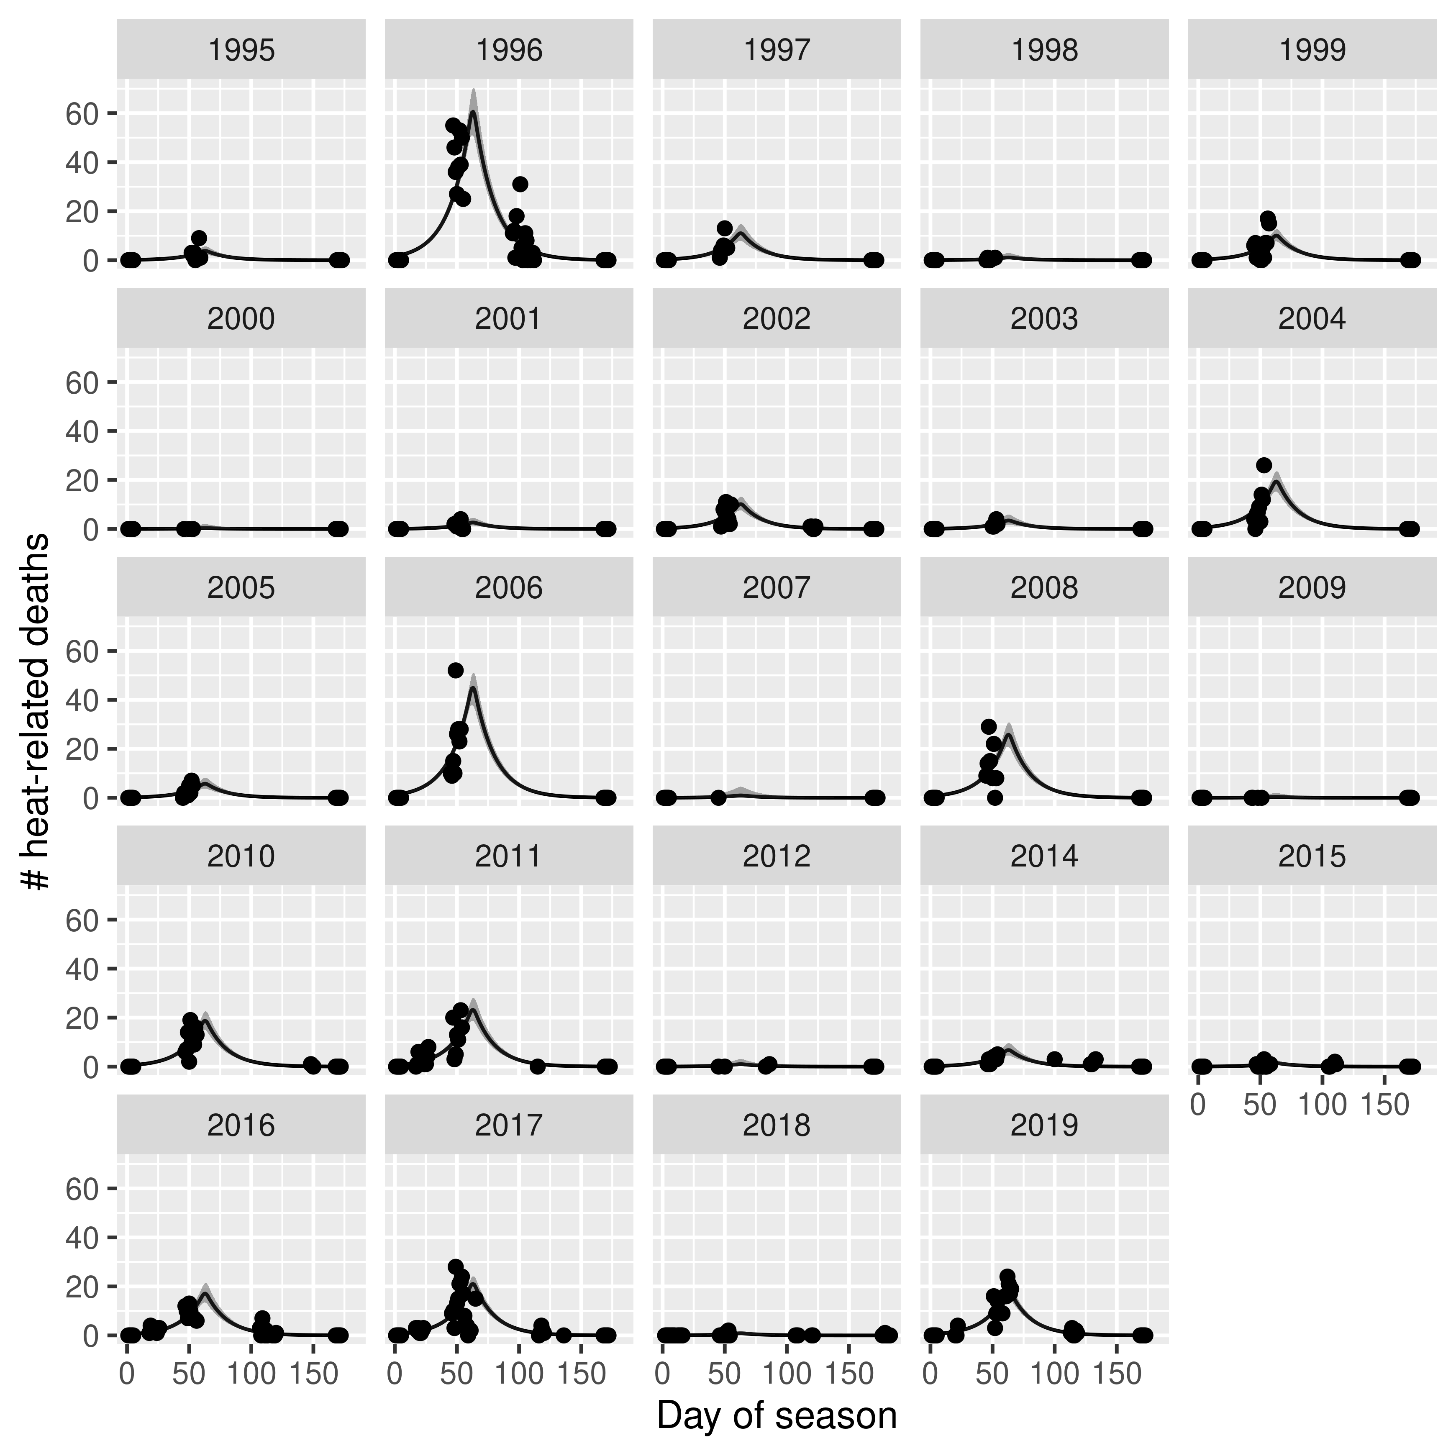

Figure 2. Season-specific fitted functions and their 95% CIs for heat-related deaths at Raine Island. Dots indicate the observed deaths.

To determine the total number of heat-related deaths, I added estimated deaths for each season. The total abundance weas computed using the estimated total abundance from mark-resight estimation. There appeared to be two relationships between the abundance and heat-related deaths, where one had a greater slope than the other (Figure 3).

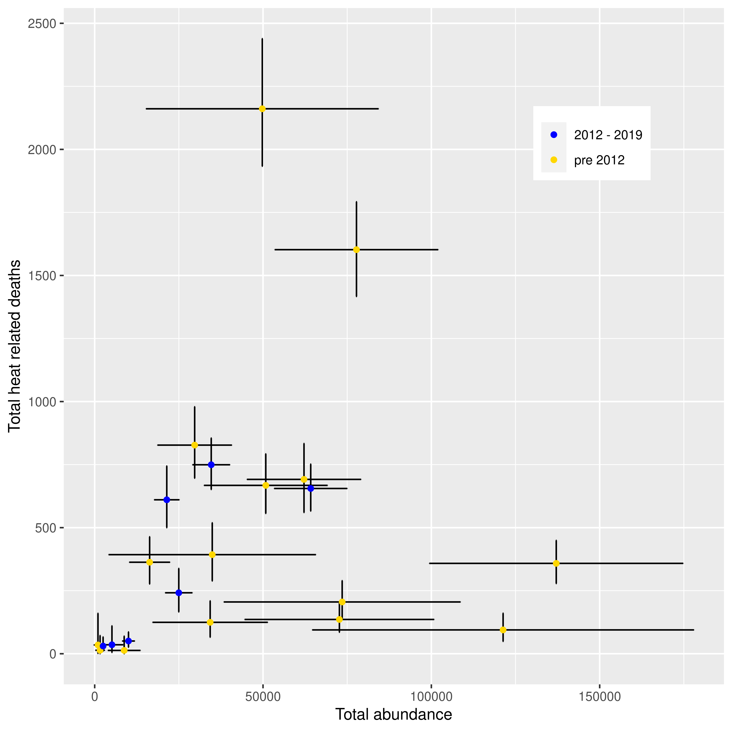

Figure 3. The relationship between estimated total abundance and heat-related deaths. Erro bars indicate approximate 95% CIs.

The median proportion of heat-related deaths relative to the total abundance ranged from 7.89\times 10^{-4} to 0.0436 (Figure 4). Their 95% CIs ranged from 0 to 0.457.

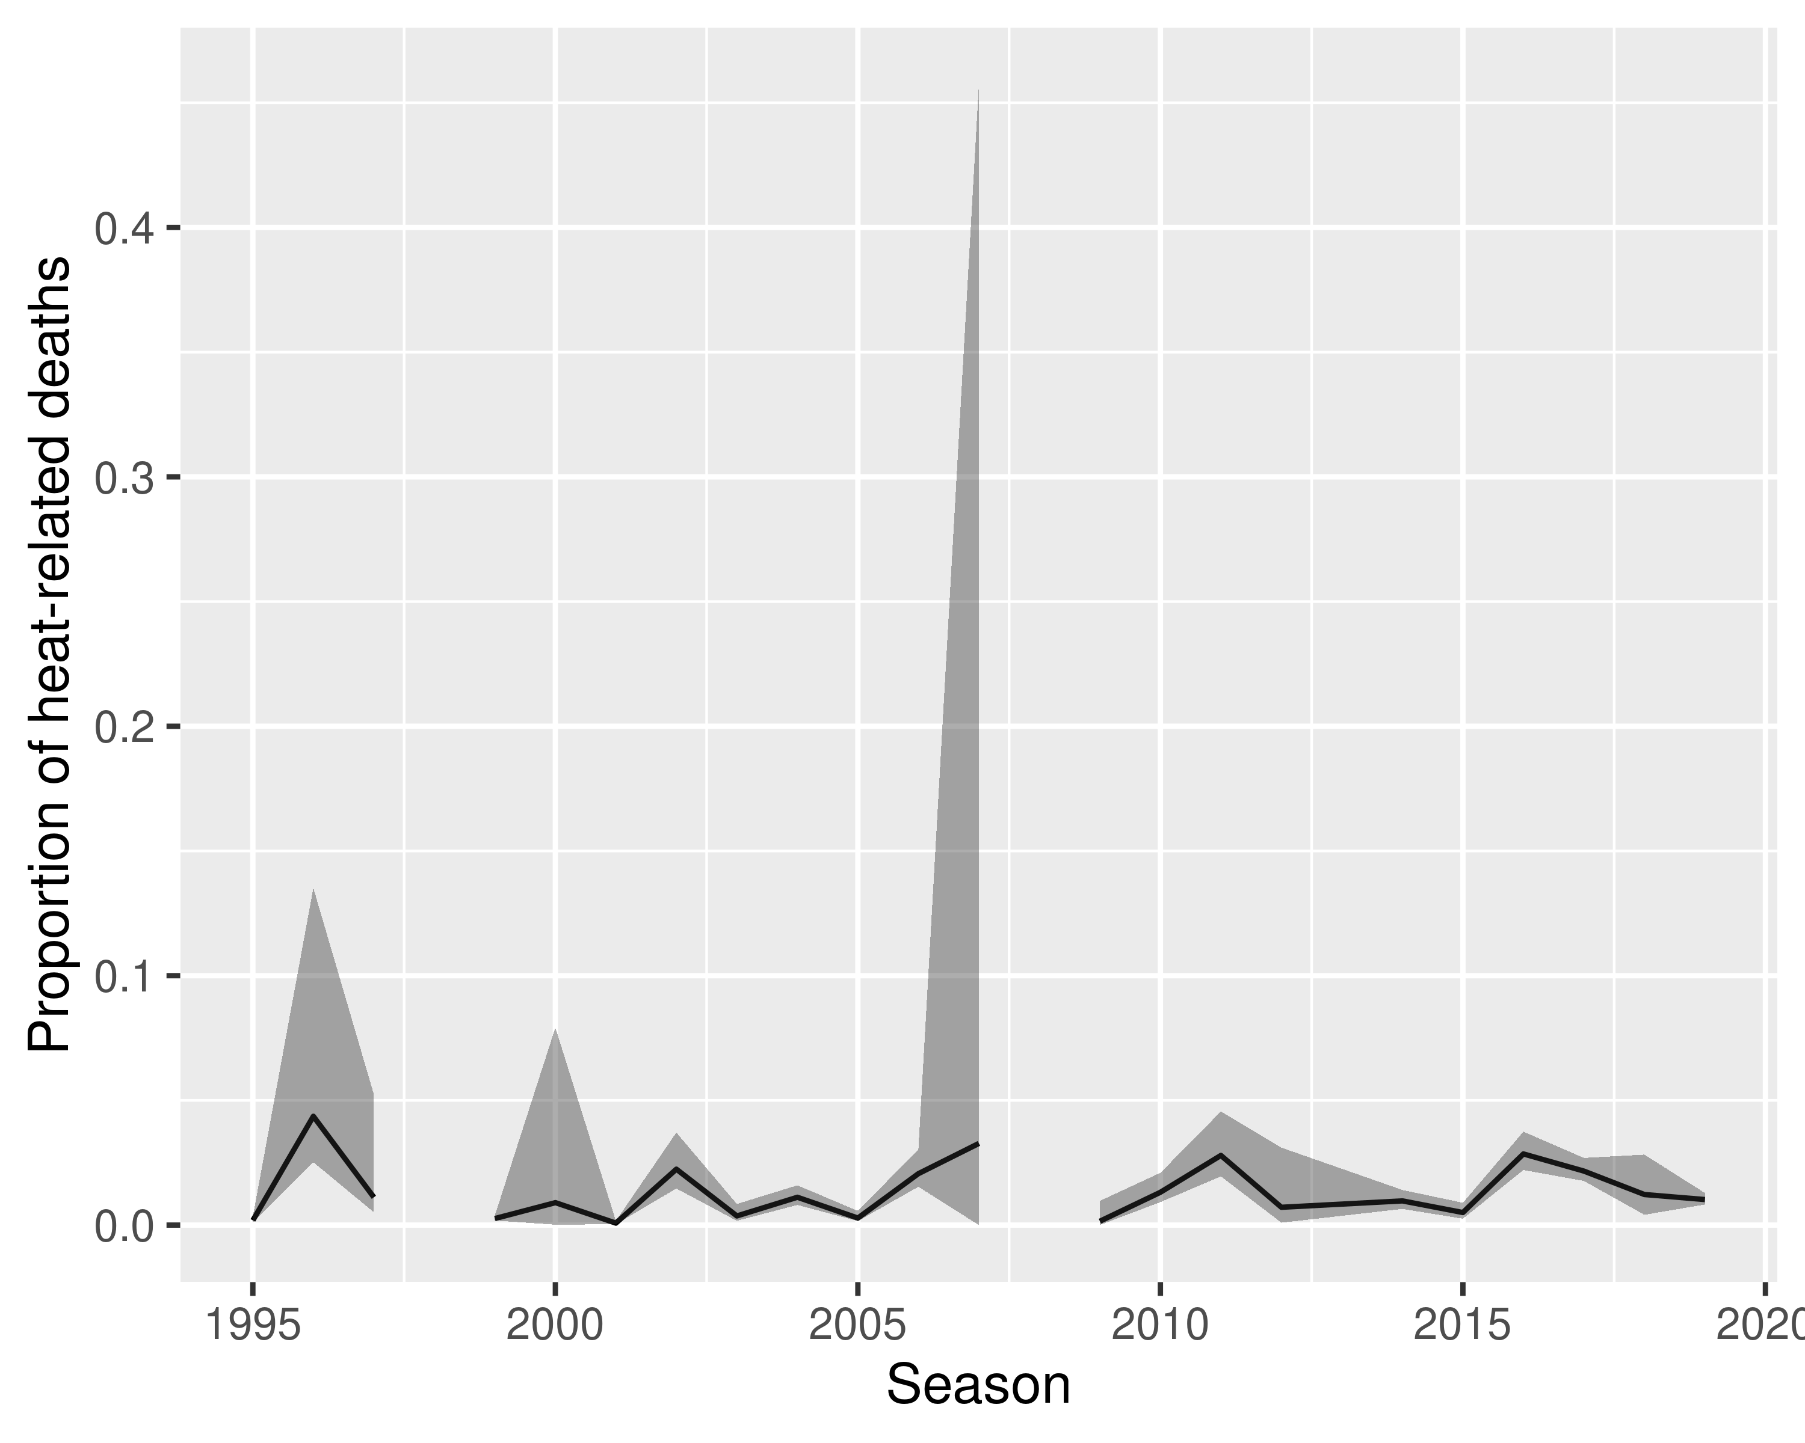

Figure 4. Changes in proportion of heat-related deaths over time. Gray band indicates approximate 95% CIs.

The total median heat-related deaths per season ranged from 14 (season = 2009) to 2162 (season = 1996) (Table 2)

Table 2. The estimated number of heat-related deaths of green turtles at Raine Island. N is the estimated number of deaths and P is the proportion of deaths relative to the total abundance

|  |  |  |  |  |  |  |
| --- | --- | --- | --- | --- | --- | --- |
| Season | N (2.5%) | N (50%) | N (97.5%) | P (2.5%) | P (50%) | P (97.5%) |
| 1995 | 85.4 | 135.9 | 202.1 | 0.00 | 0.00 | 0.00 |
| 1996 | 1933.4 | 2161.0 | 2438.9 | 0.03 | 0.04 | 0.14 |
| 1997 | 288.7 | 392.9 | 519.1 | 0.01 | 0.01 | 0.05 |
| 1998 | 9.2 | 39.4 | 103.7 | NA | NA | NA |
| 1999 | 278.6 | 358.3 | 449.3 | 0.00 | 0.00 | 0.00 |
| 2000 | 0.5 | 13.8 | 71.9 | 0.00 | 0.01 | 0.08 |
| 2001 | 49.2 | 94.5 | 160.5 | 0.00 | 0.00 | 0.00 |
| 2002 | 276.7 | 362.9 | 463.7 | 0.01 | 0.02 | 0.04 |
| 2003 | 65.6 | 124.6 | 209.5 | 0.00 | 0.00 | 0.01 |
| 2004 | 560.3 | 691.4 | 833.5 | 0.01 | 0.01 | 0.02 |
| 2005 | 138.1 | 205.3 | 289.6 | 0.00 | 0.00 | 0.01 |
| 2006 | 1416.9 | 1602.3 | 1792.2 | 0.02 | 0.02 | 0.03 |
| 2007 | 1.3 | 34.8 | 160.1 | 0.00 | 0.03 | 0.46 |
| 2008 | 770.6 | 918.9 | 1083.6 | NA | NA | NA |
| 2009 | 0.5 | 13.1 | 69.5 | 0.00 | 0.00 | 0.01 |
| 2010 | 556.5 | 667.6 | 792.3 | 0.01 | 0.01 | 0.02 |
| 2011 | 696.3 | 827.3 | 979.2 | 0.02 | 0.03 | 0.05 |
| 2012 | 5.3 | 35.6 | 110.4 | 0.00 | 0.01 | 0.03 |
| 2014 | 166.0 | 241.7 | 338.1 | 0.01 | 0.01 | 0.01 |
| 2015 | 26.1 | 50.4 | 86.3 | 0.00 | 0.01 | 0.01 |
| 2016 | 500.1 | 610.5 | 744.2 | 0.02 | 0.03 | 0.04 |
| 2017 | 651.5 | 749.4 | 855.1 | 0.02 | 0.02 | 0.03 |
| 2018 | 10.6 | 30.5 | 66.3 | 0.00 | 0.01 | 0.03 |
| 2019 | 566.0 | 655.3 | 751.7 | 0.01 | 0.01 | 0.01 |

### Cliff-fall deaths

MCMC convergence did not reach for 23 models (Appendix). These models are not considered further. For those models with acceptable convergence (Rhat < 1.1). The best model was St_K_sigmaYt_norm, which included time-dependent S, K, time-dependent observation variance (sigmaYt) and the normal distribution as the observation model. The second best model also was a Normal-observation model with time-dependent S and sigmaY parameters (Table 3). The Pareto-k statistic indicated that 99% of data points were < 0.7, indicating an excellent fit of the model. The best (St_K_sigmaYt_norm) model was used to estimate the number of total heat-related deaths.

Table 3. LOOIC, their SE, and Rhat statistics for models that were fitted to the cliff-fall deaths of green turtles at Raine Island and showed MCMC convergence for all parameters.

|  |  |  |  |
| --- | --- | --- | --- |
| Model | LOOIC | SE | Maximum Rhat |
| St_K_sigmaYt_norm | 1948.96 | 77.23 | 1.00 |
| St_K_P_sigmaYt_norm | 1949.68 | 76.19 | 1.00 |
| St_K1_K2_sigmaYt_norm | 1949.94 | 76.60 | 1.00 |
| S1_S2_K1_K2_P_sigmaYt_norm | 2056.42 | 87.73 | 1.05 |
| S_K_sigmaYt_norm | 2086.31 | 84.48 | 1.01 |
| S_K1_K2_sigmaYt_norm | 2087.41 | 84.00 | 1.01 |
| S1_S2_K_sigmaYt_norm | 2088.88 | 84.47 | 1.01 |
| St_K1_K2_P_norm | 2369.19 | 151.06 | 1.01 |
| St_K1_K2_norm | 2839.76 | 204.55 | 1.00 |
| St_K_norm | 2846.60 | 209.56 | 1.00 |
| S_K1_K2_norm | 2948.14 | 160.01 | 1.02 |
| S_K_norm | 2948.99 | 166.75 | 1.03 |
| S1_S2_K_norm | 2951.44 | 162.21 | 1.01 |

In the best model, the peak of the cliff-fall deaths was assumed to be the half-way in to the season. The second best model (St_K_P_sigmaYt_norm) included P as the estimated parameter and its mean was 88.2 and 95% CI from 84.3 to 92, indicating that it was not different from the half-way into the season (86.2).

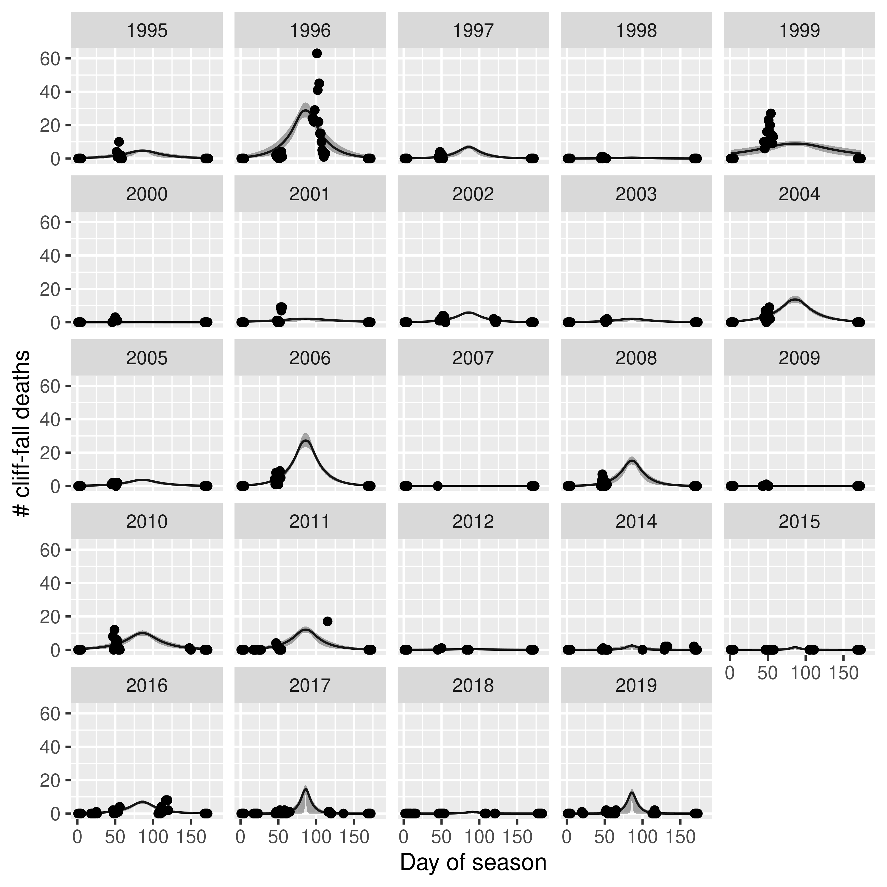

Figure 5. Fitted functions for cliff-fall deaths at Raine Island. Shaded areas indicate 95% CIs.

To determine the total number of cliff-fall deaths, I added estimated deaths for each season. The total abundance was computed using the estimated total abundance from mark-resight estimation. There appeared to be two relationships between the abundance and cliff-fall deaths, as they were found in the heat-reldated datehs, where one had a greater slope than the other (Figures 3 and 6).

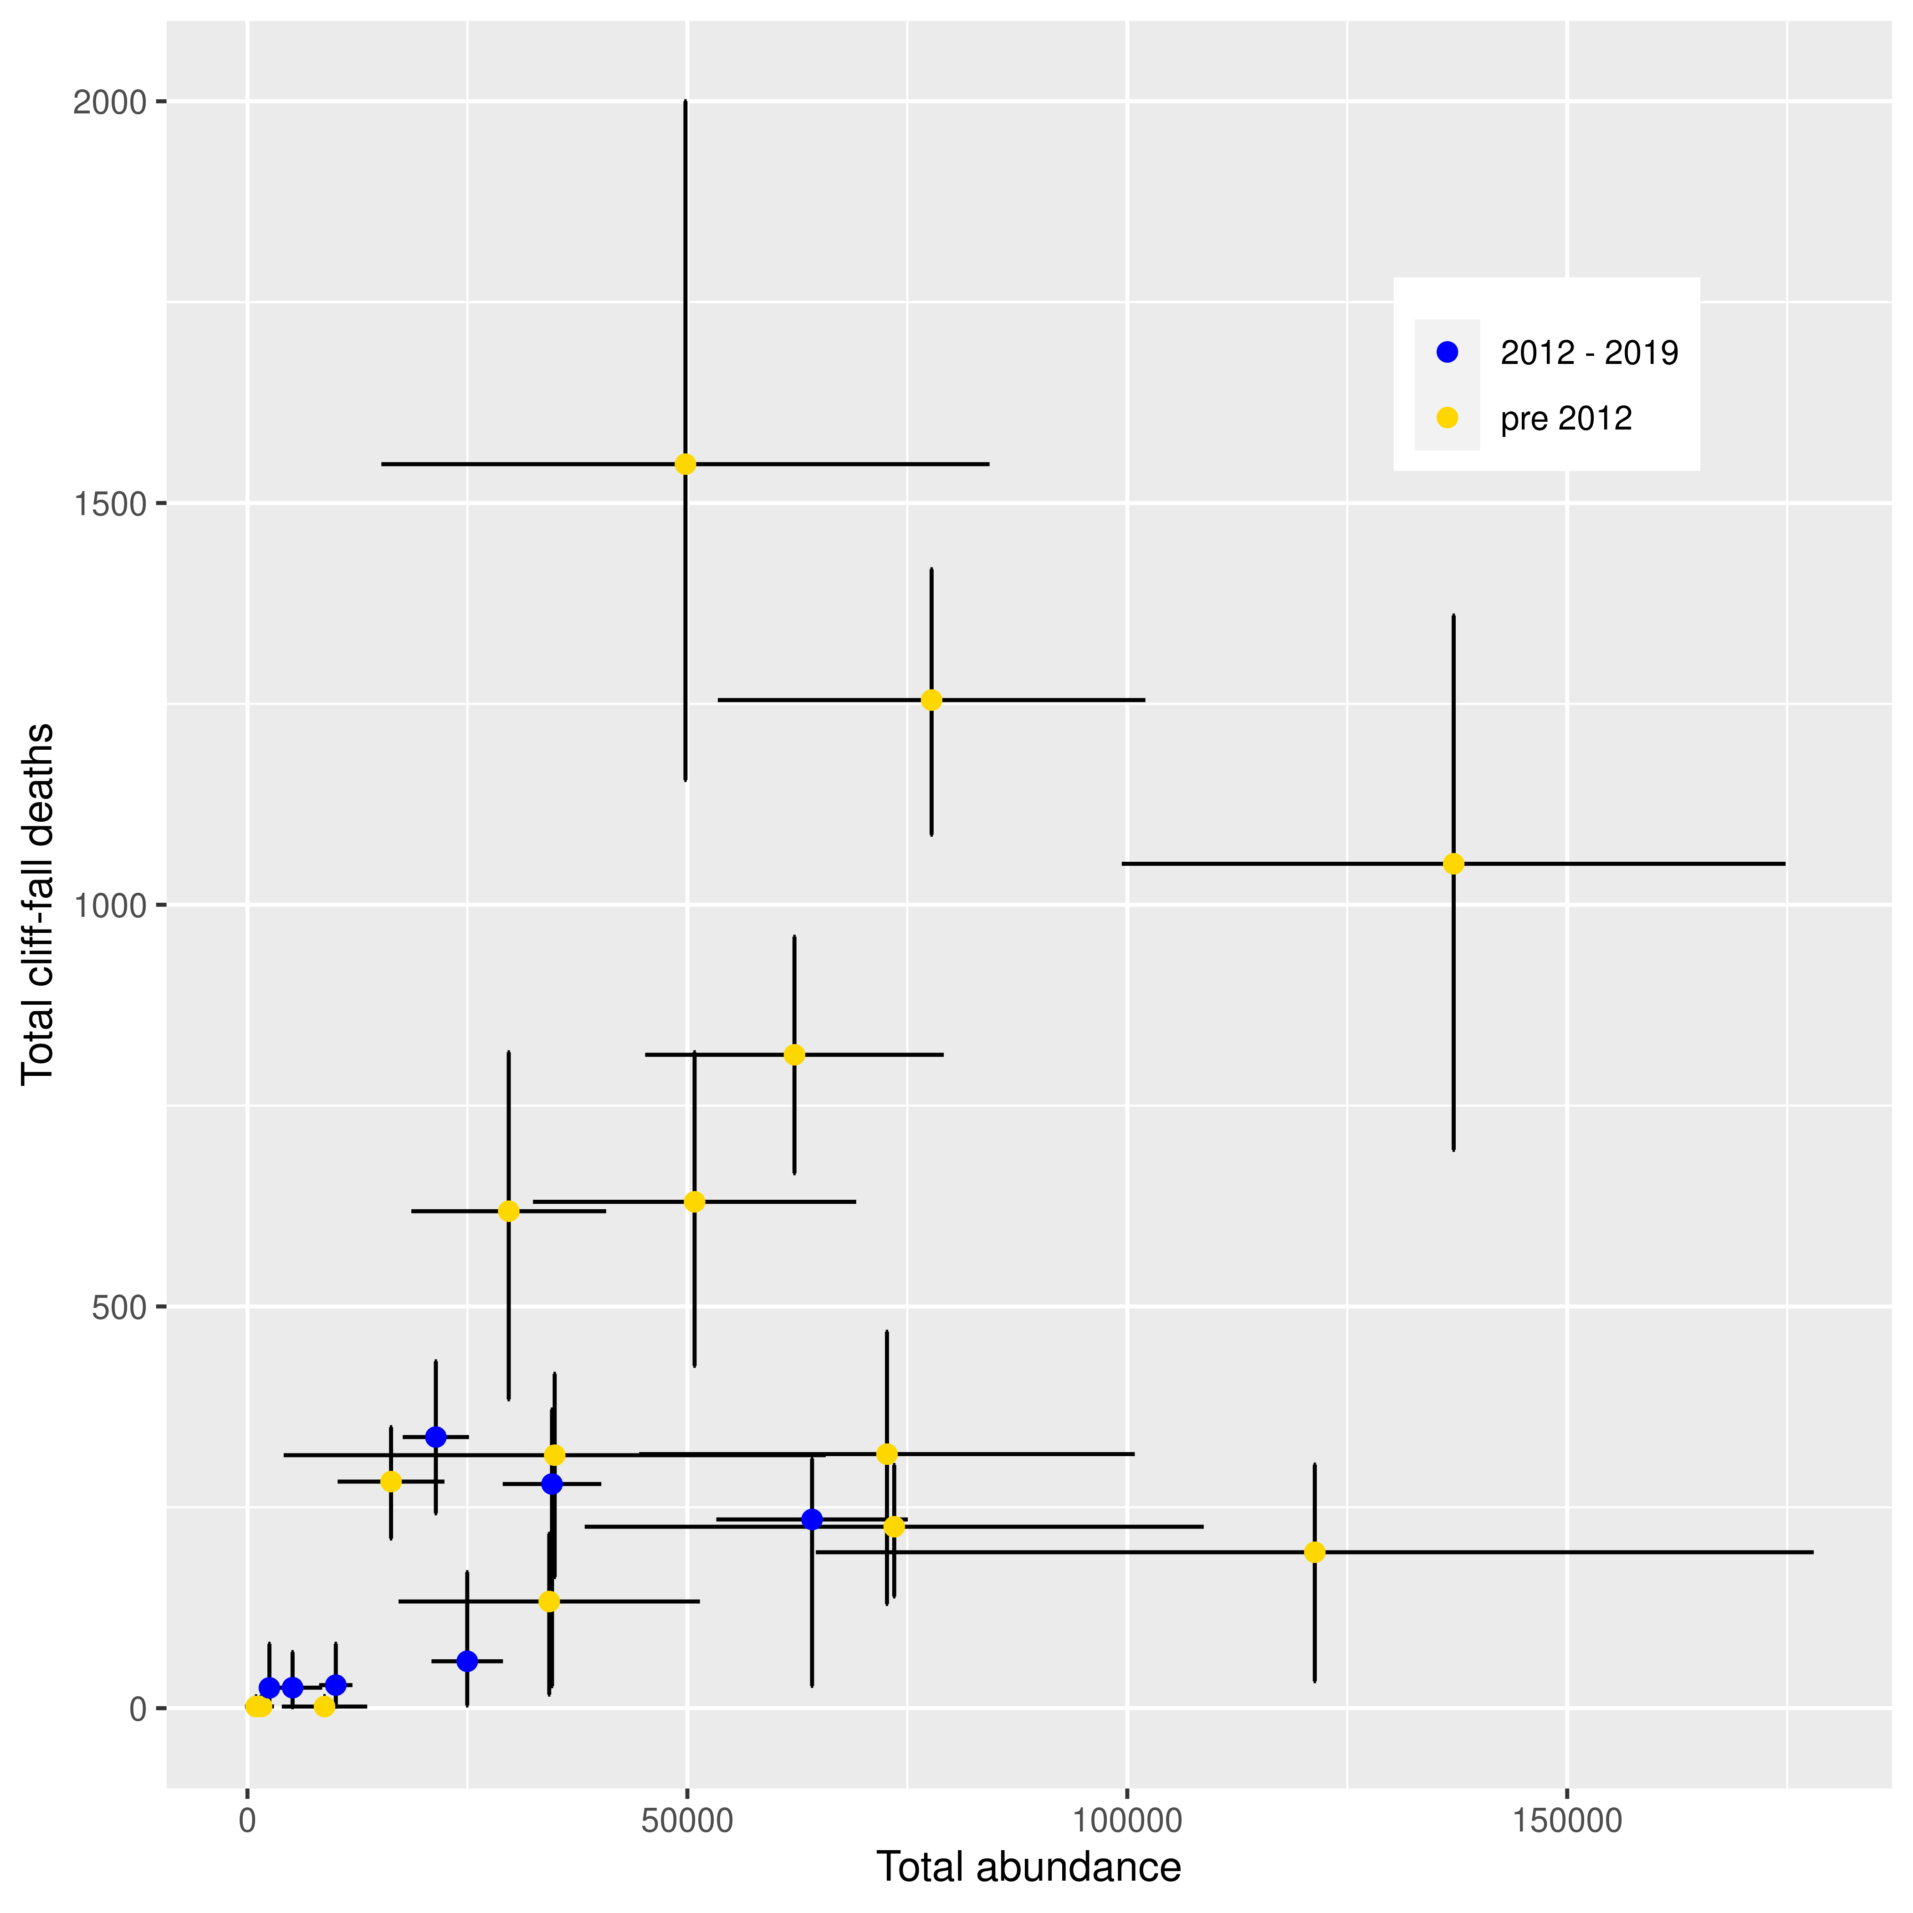

Figure 6. The relationship between estimated total abundance of female green turtles and total cliff-fall deaths. Eror bars indicate the 95% CIs.

The median proportion of cliff-fall deaths relative to the total abundance ranged from NA to 0.0312 (Figure 4). Their 95% CIs ranged from 0 to 0.0969.

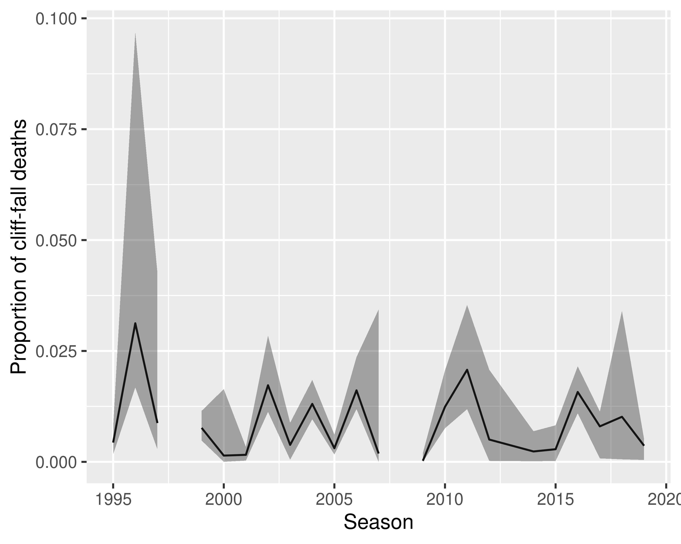

Figure 7. Changes in proportion of cliff-fall deaths over time. Gray band indicates approximate 95% CIs.

The total median cliff-fall deaths per season ranged from 3 (season = 2007) to 1549 (season = 1996) (Table 2)

Table 4. The estimated number of cliff-fall deaths of green turtles at Raine Island. N is the estimated number of deaths and P is the proportion of deaths relative to the total abundance

|  |  |  |  |  |  |  |
| --- | --- | --- | --- | --- | --- | --- |
| Season | N (2.5%) | N (50%) | N (97.5%) | P (2.5%) | P (50%) | P (97.5%) |
| 1995 | 129.7 | 316.2 | 468.5 | 0.00 | 0.00 | 0.01 |
| 1996 | 1155.2 | 1548.4 | 2000.2 | 0.02 | 0.03 | 0.10 |
| 1997 | 163.2 | 314.9 | 416.2 | 0.00 | 0.01 | 0.04 |
| 1998 | 1.3 | 27.6 | 70.3 | NA | NA | NA |
| 1999 | 694.9 | 1051.0 | 1360.0 | 0.00 | 0.01 | 0.01 |
| 2000 | 0.0 | 2.2 | 16.4 | 0.00 | 0.00 | 0.02 |
| 2001 | 33.5 | 194.1 | 303.2 | 0.00 | 0.00 | 0.00 |
| 2002 | 211.2 | 282.0 | 349.7 | 0.01 | 0.02 | 0.03 |
| 2003 | 16.9 | 132.8 | 217.2 | 0.00 | 0.00 | 0.01 |
| 2004 | 665.8 | 813.2 | 960.2 | 0.01 | 0.01 | 0.02 |
| 2005 | 139.1 | 225.8 | 302.7 | 0.00 | 0.00 | 0.01 |
| 2006 | 1087.1 | 1254.7 | 1417.6 | 0.01 | 0.02 | 0.02 |
| 2007 | 0.0 | 2.0 | 14.7 | 0.00 | 0.00 | 0.03 |
| 2008 | 394.8 | 624.0 | 786.2 | NA | NA | NA |
| 2009 | 0.0 | 2.0 | 15.0 | 0.00 | 0.00 | 0.00 |
| 2010 | 426.1 | 630.2 | 816.4 | 0.01 | 0.01 | 0.02 |
| 2011 | 384.4 | 618.5 | 816.4 | 0.01 | 0.02 | 0.04 |
| 2012 | 1.1 | 25.5 | 69.8 | 0.00 | 0.01 | 0.02 |
| 2014 | 3.3 | 58.4 | 169.3 | 0.00 | 0.00 | 0.01 |
| 2015 | 1.8 | 28.7 | 80.2 | 0.00 | 0.00 | 0.01 |
| 2016 | 242.5 | 337.4 | 431.7 | 0.01 | 0.02 | 0.02 |
| 2017 | 27.4 | 279.0 | 371.8 | 0.00 | 0.01 | 0.01 |
| 2018 | 1.4 | 25.3 | 80.2 | 0.00 | 0.01 | 0.03 |
| 2019 | 27.7 | 234.9 | 310.6 | 0.00 | 0.00 | 0.01 |

## Appendix

### MCMC evaluation of the best model for heat-related deaths

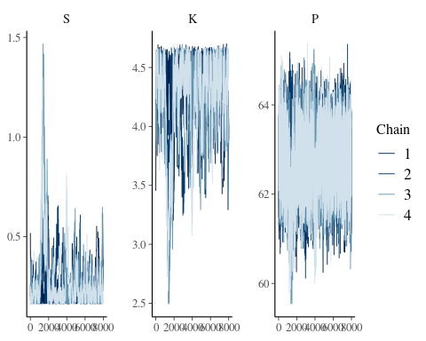

### MCMC density plots of all parameters of the best model for heat-related deaths

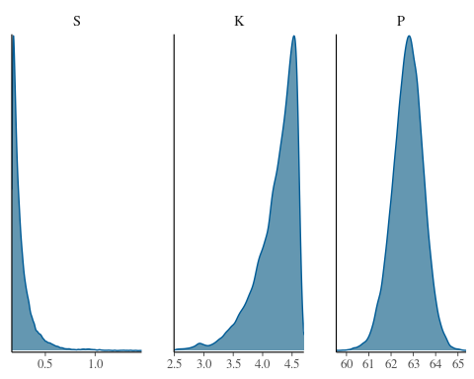

### Pareto-k statistics for the best heat-related deaths model

## Pareto k diagnostic values:  
## Count Pct. Min. n_eff  
## (-Inf, 0.5] (good) 519 98.5% 72   
## (0.5, 0.7] (ok) 7 1.3% 65   
## (0.7, 1] (bad) 1 0.2% 23   
## (1, Inf) (very bad) 0 0.0% <NA>

### LOOIC and Rhat statistics of all heat-related deaths models

Table A1. LOOIC, their SE, and maximum Rhat statistics for all models fit to the heat-related deaths of green turtles at Raine Island.

|  |  |  |  |
| --- | --- | --- | --- |
| Model | LOOIC | SE | max(Rhat) |
| St_K1_K2_P_Pois | 1719.68 | 123.61 | 1.18 |
| S1_S2_K_P_Pois | 1729.61 | 122.08 | 1.31 |
| S1_S2_K1_K2_Pois | 1739.60 | 123.04 | 1.13 |
| S_K1_K2_P_Pois | 1740.91 | 123.22 | 1.30 |
| S_K_P_Pois | 1752.75 | 126.77 | 1.08 |
| S1_S2_K1_K2_P_Pois | 1753.03 | 123.89 | 1.51 |
| St_K_P_Pois | 1755.03 | 126.00 | 1.03 |
| S_K1_K2_Pois | 2170.08 | 144.55 | 1.04 |
| S1_S2_K_Pois | 2191.80 | 146.20 | 1.00 |
| St_K1_K2_Pois | 2227.96 | 147.09 | 1.04 |
| St_K_P_sigmaYt_norm | 2394.16 | 73.82 | 1.29 |
| S_K1_K2_P_sigmaYt_norm | 2407.89 | 68.43 | 1.02 |
| S1_S2_K_P_sigmaYt_norm | 2407.99 | 68.49 | 1.00 |
| S1_S2_K1_K2_P_sigmaYt_norm | 2409.98 | 68.40 | 1.10 |
| S_K_P_sigmaYt_norm | 2411.38 | 69.24 | 1.02 |
| S1_S2_K1_K2_sigmaYt_norm | 2415.52 | 64.72 | 1.02 |
| St_K1_K2_P_sigmaYt_norm | 2416.83 | 76.58 | 1.16 |
| S_K1_K2_sigmaYt_norm | 2417.52 | 64.87 | 1.05 |
| S1_S2_K_sigmaYt_norm | 2431.47 | 65.63 | 1.29 |
| St_K1_K2_sigmaYt_norm | 2504.06 | 73.37 | 1.02 |
| S_K_sigmaYt_norm | 2556.92 | 72.90 | 1.11 |
| St_K_sigmaYt_norm | 2610.51 | 74.78 | 1.00 |
| St_K1_K2_P_norm | 2971.86 | 116.41 | 1.03 |
| St_K_P_norm | 2979.44 | 106.47 | 1.11 |
| S_K_Pois | 3001.63 | 228.26 | 1.14 |
| S1_S2_K1_K2_P_norm | 3044.03 | 101.24 | 1.08 |
| S_K_P_norm | 3059.75 | 113.37 | 2.63 |
| S1_S2_K1_K2_norm | 3090.43 | 108.69 | 2.06 |
| St_K_Pois | 3109.35 | 228.78 | 1.01 |
| S1_S2_K_P_norm | 3112.86 | 114.97 | 1.79 |
| S_K1_K2_P_norm | 3114.94 | 111.80 | 13.86 |
| S_K1_K2_norm | 3122.65 | 109.49 | 1.57 |
| S1_S2_K_norm | 3123.90 | 101.70 | 1.70 |
| St_K1_K2_norm | 3146.03 | 93.49 | 1.12 |
| S_K_norm | 3433.02 | 87.73 | 1.00 |
| St_K_norm | 3470.30 | 84.64 | 1.00 |

### MCMC evaluations of the best model for cliff-fall deaths

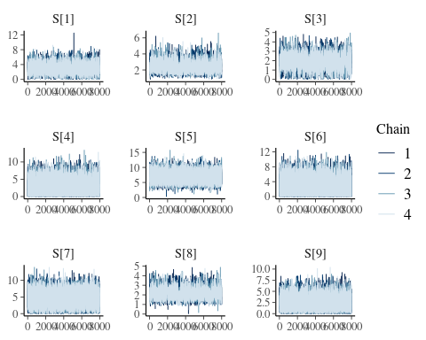

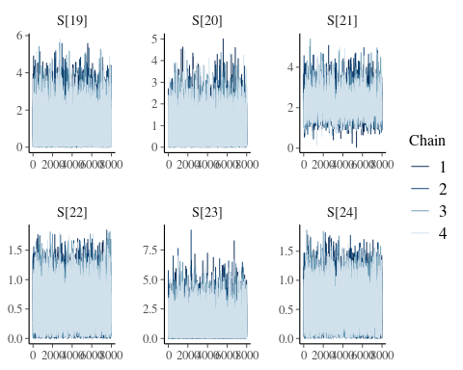

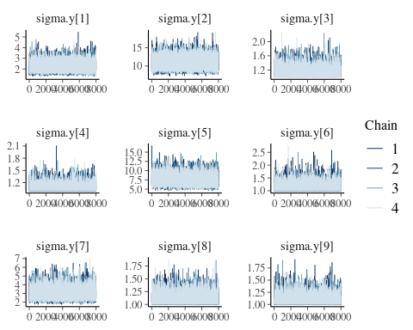

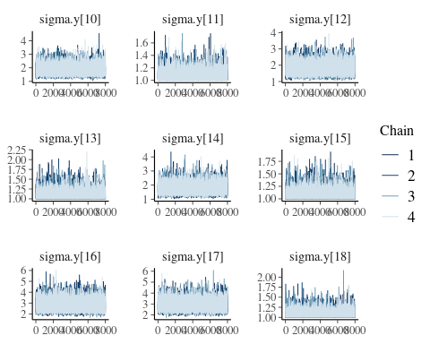

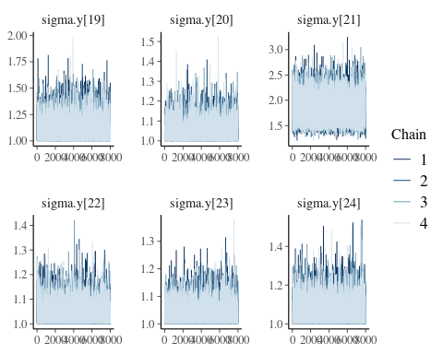

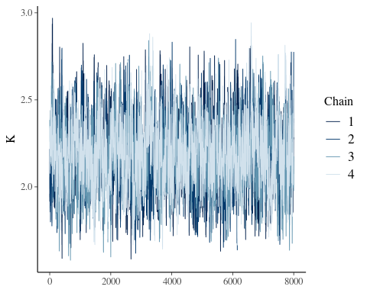

### MCMC trace plots of all parameters of the best model for heat-related deaths

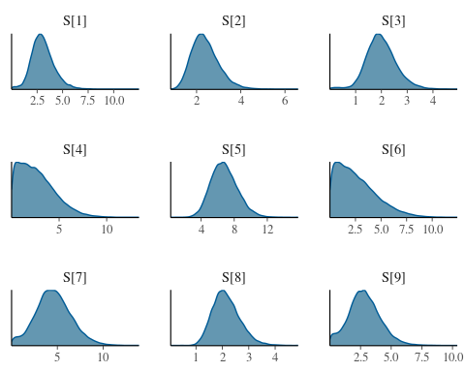

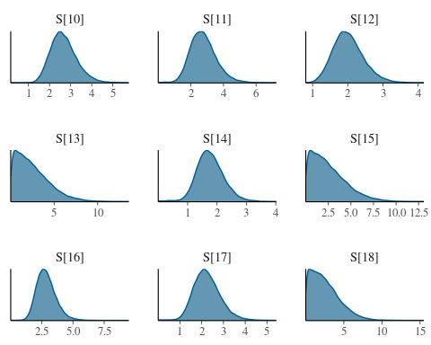

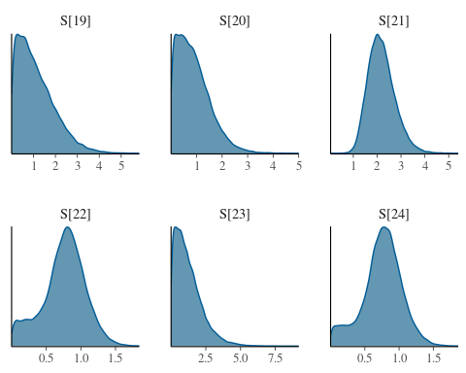

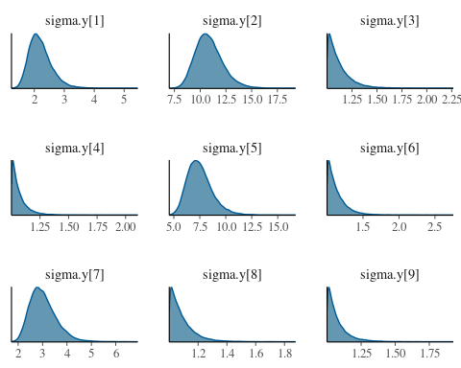

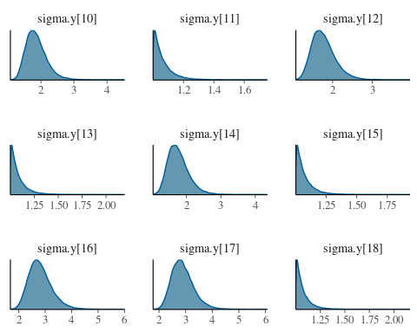

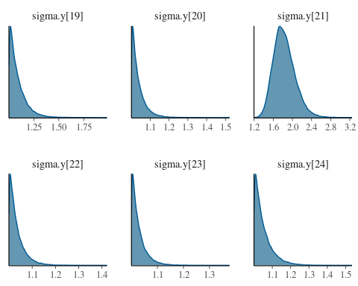

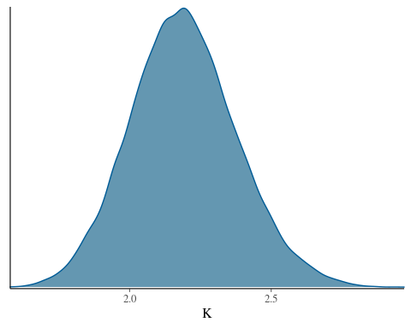

### Pareto-k statistics for the best cliff-fall deaths model

## Pareto k diagnostic values:  
## Count Pct. Min. n_eff  
## (-Inf, 0.5] (good) 514 97.5% 2079   
## (0.5, 0.7] (ok) 8 1.5% 667   
## (0.7, 1] (bad) 3 0.6% 60   
## (1, Inf) (very bad) 2 0.4% 2

Table A4 LOOIC, their SE, and maximum Rhat statistics for all models fit to cliff-fall deaths of green turtles at Raine Island.

|  |  |  |  |
| --- | --- | --- | --- |
| Model | LOOIC | SE | max(Rhat) |
| S_K1_K2_P_Pois | 1118.95 | 94.75 | 1.26 |
| S1_S2_K1_K2_P_Pois | 1123.05 | 96.17 | 1.28 |
| St_K1_K2_P_Pois | 1129.01 | 87.55 | 1.75 |
| S_K_P_Pois | 1146.86 | 104.95 | 1.20 |
| S1_S2_K_Pois | 1155.76 | 108.16 | 1.29 |
| S_K1_K2_Pois | 1159.67 | 106.65 | 1.29 |
| S1_S2_K1_K2_Pois | 1162.07 | 107.64 | 6.07 |
| S_K_Pois | 1178.32 | 111.10 | 1.49 |
| S1_S2_K_P_Pois | 1182.45 | 104.66 | 7.03 |
| St_K_P_Pois | 1295.84 | 121.05 | 2.72 |
| St_K1_K2_Pois | 1325.06 | 128.72 | 17.03 |
| St_K_Pois | 1330.44 | 131.83 | 17.01 |
| St_K1_K2_P_sigmaYt_norm | 1937.42 | 79.30 | 1.27 |
| St_K_sigmaYt_norm | 1948.96 | 77.23 | 1.00 |
| St_K_P_sigmaYt_norm | 1949.68 | 76.19 | 1.00 |
| St_K1_K2_sigmaYt_norm | 1949.94 | 76.60 | 1.00 |
| S_K1_K2_P_sigmaYt_norm | 2050.99 | 85.98 | 1.28 |
| S1_S2_K_P_sigmaYt_norm | 2055.14 | 87.62 | 1.17 |
| S1_S2_K1_K2_P_sigmaYt_norm | 2056.42 | 87.73 | 1.05 |
| S_K_sigmaYt_norm | 2086.31 | 84.48 | 1.01 |
| S_K1_K2_sigmaYt_norm | 2087.41 | 84.00 | 1.01 |
| S1_S2_K_sigmaYt_norm | 2088.88 | 84.47 | 1.01 |
| S1_S2_K1_K2_sigmaYt_norm | 2091.55 | 84.57 | 4.99 |
| S_K_P_sigmaYt_norm | 2104.96 | 85.01 | 10.02 |
| St_K1_K2_P_norm | 2369.19 | 151.06 | 1.01 |
| St_K_P_norm | 2627.22 | 156.04 | 11.99 |
| S_K1_K2_P_norm | 2787.34 | 130.06 | 1.21 |
| S_K_P_norm | 2806.41 | 116.86 | 1.29 |
| S1_S2_K1_K2_P_norm | 2808.55 | 142.67 | 1.17 |
| S1_S2_K_P_norm | 2812.10 | 144.26 | 1.15 |
| S1_S2_K1_K2_norm | 2838.99 | 125.59 | 1.13 |
| St_K1_K2_norm | 2839.76 | 204.55 | 1.00 |
| St_K_norm | 2846.60 | 209.56 | 1.00 |
| S_K1_K2_norm | 2948.14 | 160.01 | 1.02 |
| S_K_norm | 2948.99 | 166.75 | 1.03 |
| S1_S2_K_norm | 2951.44 | 162.21 | 1.01 |