**Supplementary Data**

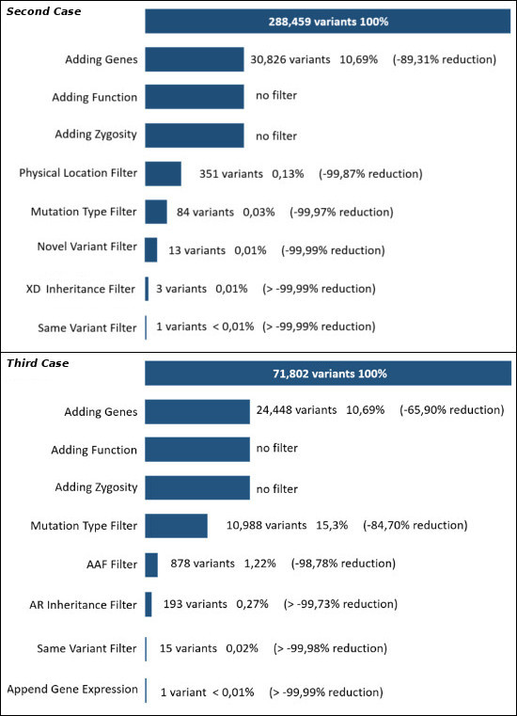*Figure S1: Annotation and filtering cascade of unique variants across all case VCF input files. Both case studies annotated variants against a hg19 gene map comprised of exons, introns, UTR, splice sites, and 500bp promoter regions. Variants that did not fall within any of these sites were deemed wholly-intergenic and discarded from the analysis. (Top) Second Case study makes use of prior genetic linkage data which highlighted a locus of interest on the X chromosome, and was used in conjunction with the X-linked Dominant Inheritance Filter to reveal 1 causative missense variant. (Bottom) Third Case study looked only for rare non-synonymous coding variants by applying the Mutation Type and AAF filters in conjunction with an Autosomal Recessive Inheritance Filter, which when combined with additional organ-specific gene expression data, resulted in one disease-causing variant.*

**Comparison to other Bioinformatic Tools**

*Variant Annotation:*

|  |  |  |  |  |  |  |  |  |  |  |
| --- | --- | --- | --- | --- | --- | --- | --- | --- | --- | --- |
| **Name** | **SNP** | **VCF** | **Multi-site** | **Gene-Context** | **Functional** | **VCF Filtering** | **CLI** | **GUI** | **End-User** | **Note** |
| ANNOVAR | all | both | newline | full | Y | Y | Y | N | Programmer |  |
| AnnTools | all | both | N | full | Y | N | Y | N | Programmer |  |
| NGS-SNP | SNV | both | - | gene | N | Y | Y | N | Programmer |  |
| SeattleSeq | SNV/Indel | in only | N | full | Y | N | N | Cloud-only | BioInf |  |
| F-SNP | SNV | in only | N | full | Y | N | N | Cloud-only | BioInf | Set of detached databases |
| UCSC Variant Annotator | all | in only | newline | full | Y | N | Y | Cloud-only | BioInf |  |
| OVAS (Annot) | all | both | Y | full | Calculated | Y | Y | Web local | BioInf |  |

**Pipeline Module Overview**