- Results

In this section we examine the output of seven linkage projects; five small straightforward of which three are non-problematic, and two with larger more complex pedigrees. Due to the focus of the Nephrology group at the Royal Free Hospital, all linkage projects follow rare disease models, with a primary aim in determining a single disease locus indicative of a causative variant.

Haplotypes will also be compared using HaploPainter and HaploHTML5.

Linkage Projects

The small pedigrees underwent two types of runs: single-core and multi-core. Due to the speed at which both types operate on small pedigrees, each type performed 10 trials each. The larger pedigrees were for the most part single-core due to resource limitations, but parallelizations were undertaken where possible.

We will examine the pipeline by looking at the four main visual components of each analysis: the pedigree, the GRR relationship charts, the Mendelian error plots, and finally the linkage plots. Run times will be displayed at the end of the section.

Small Pedigrees

Here we look at a variety of pedigrees, each with an increasingly larger bit-size within the 19-bit limit that defines the threshold for large “big data” pedigrees. Small pedigrees are run through the pipeline without any runtime modifications required, resulting in a complete set of plots from all linkage programs.

3-Bit Autosomal Recessive

Figure 1 shows a very simple pedigree; depicting one affected male (2053) amongst unaffected male (2052) and female (2054) siblings from two parents (2056 and 2055). All individuals are genotyped; the parents and the affected offspring being the main targets of informative meiosis, and the siblings acting as controls.

The GRR relationship chart shows normal bunching of sib-pairs (red), two close clusters of parent-offspring relations (yellow), and one single unrelated connection (cyan) between the two parents. For small non-consanguineous pedigrees, parents typically exhibit separate clusters of relation to their offspring since allele inheritance is never perfectly even and some offspring will share more alleles with one parent than another.

In larger (usually inbred) pedigrees, these two parental clusters either bunch together due to the parents being more related, or the gap between two outlying parent clusters are filled with other more-related parental clusters to form one large group that is still distinct from other sib-pair and half-sib groups.

The number of markers used for this analysis was 35,155 of which only 9 exhibited Mendelian errors and were filtered out from subsequent analysis. This constitutes 0.025% of the number of markers and is of no cause for concern, allowing the rest of the analysis to progress.

Due to the low bit-size, the estimated lod score for the pedigree gave a maximum score of 0.2499 (Allegro and Genehunter), which is reflected in the genome-wide plot. Unfortunately most regions of the genome reached this score (approx >~ 80%) likely due to there not being enough lack of homology between the affected and unaffected siblings. The score is also far below the minimum LOD score for informative linkage (LOD > 2) meaning that the analysis was likely not very useful in identifying or excluding regions of interest for a causative disease locus.

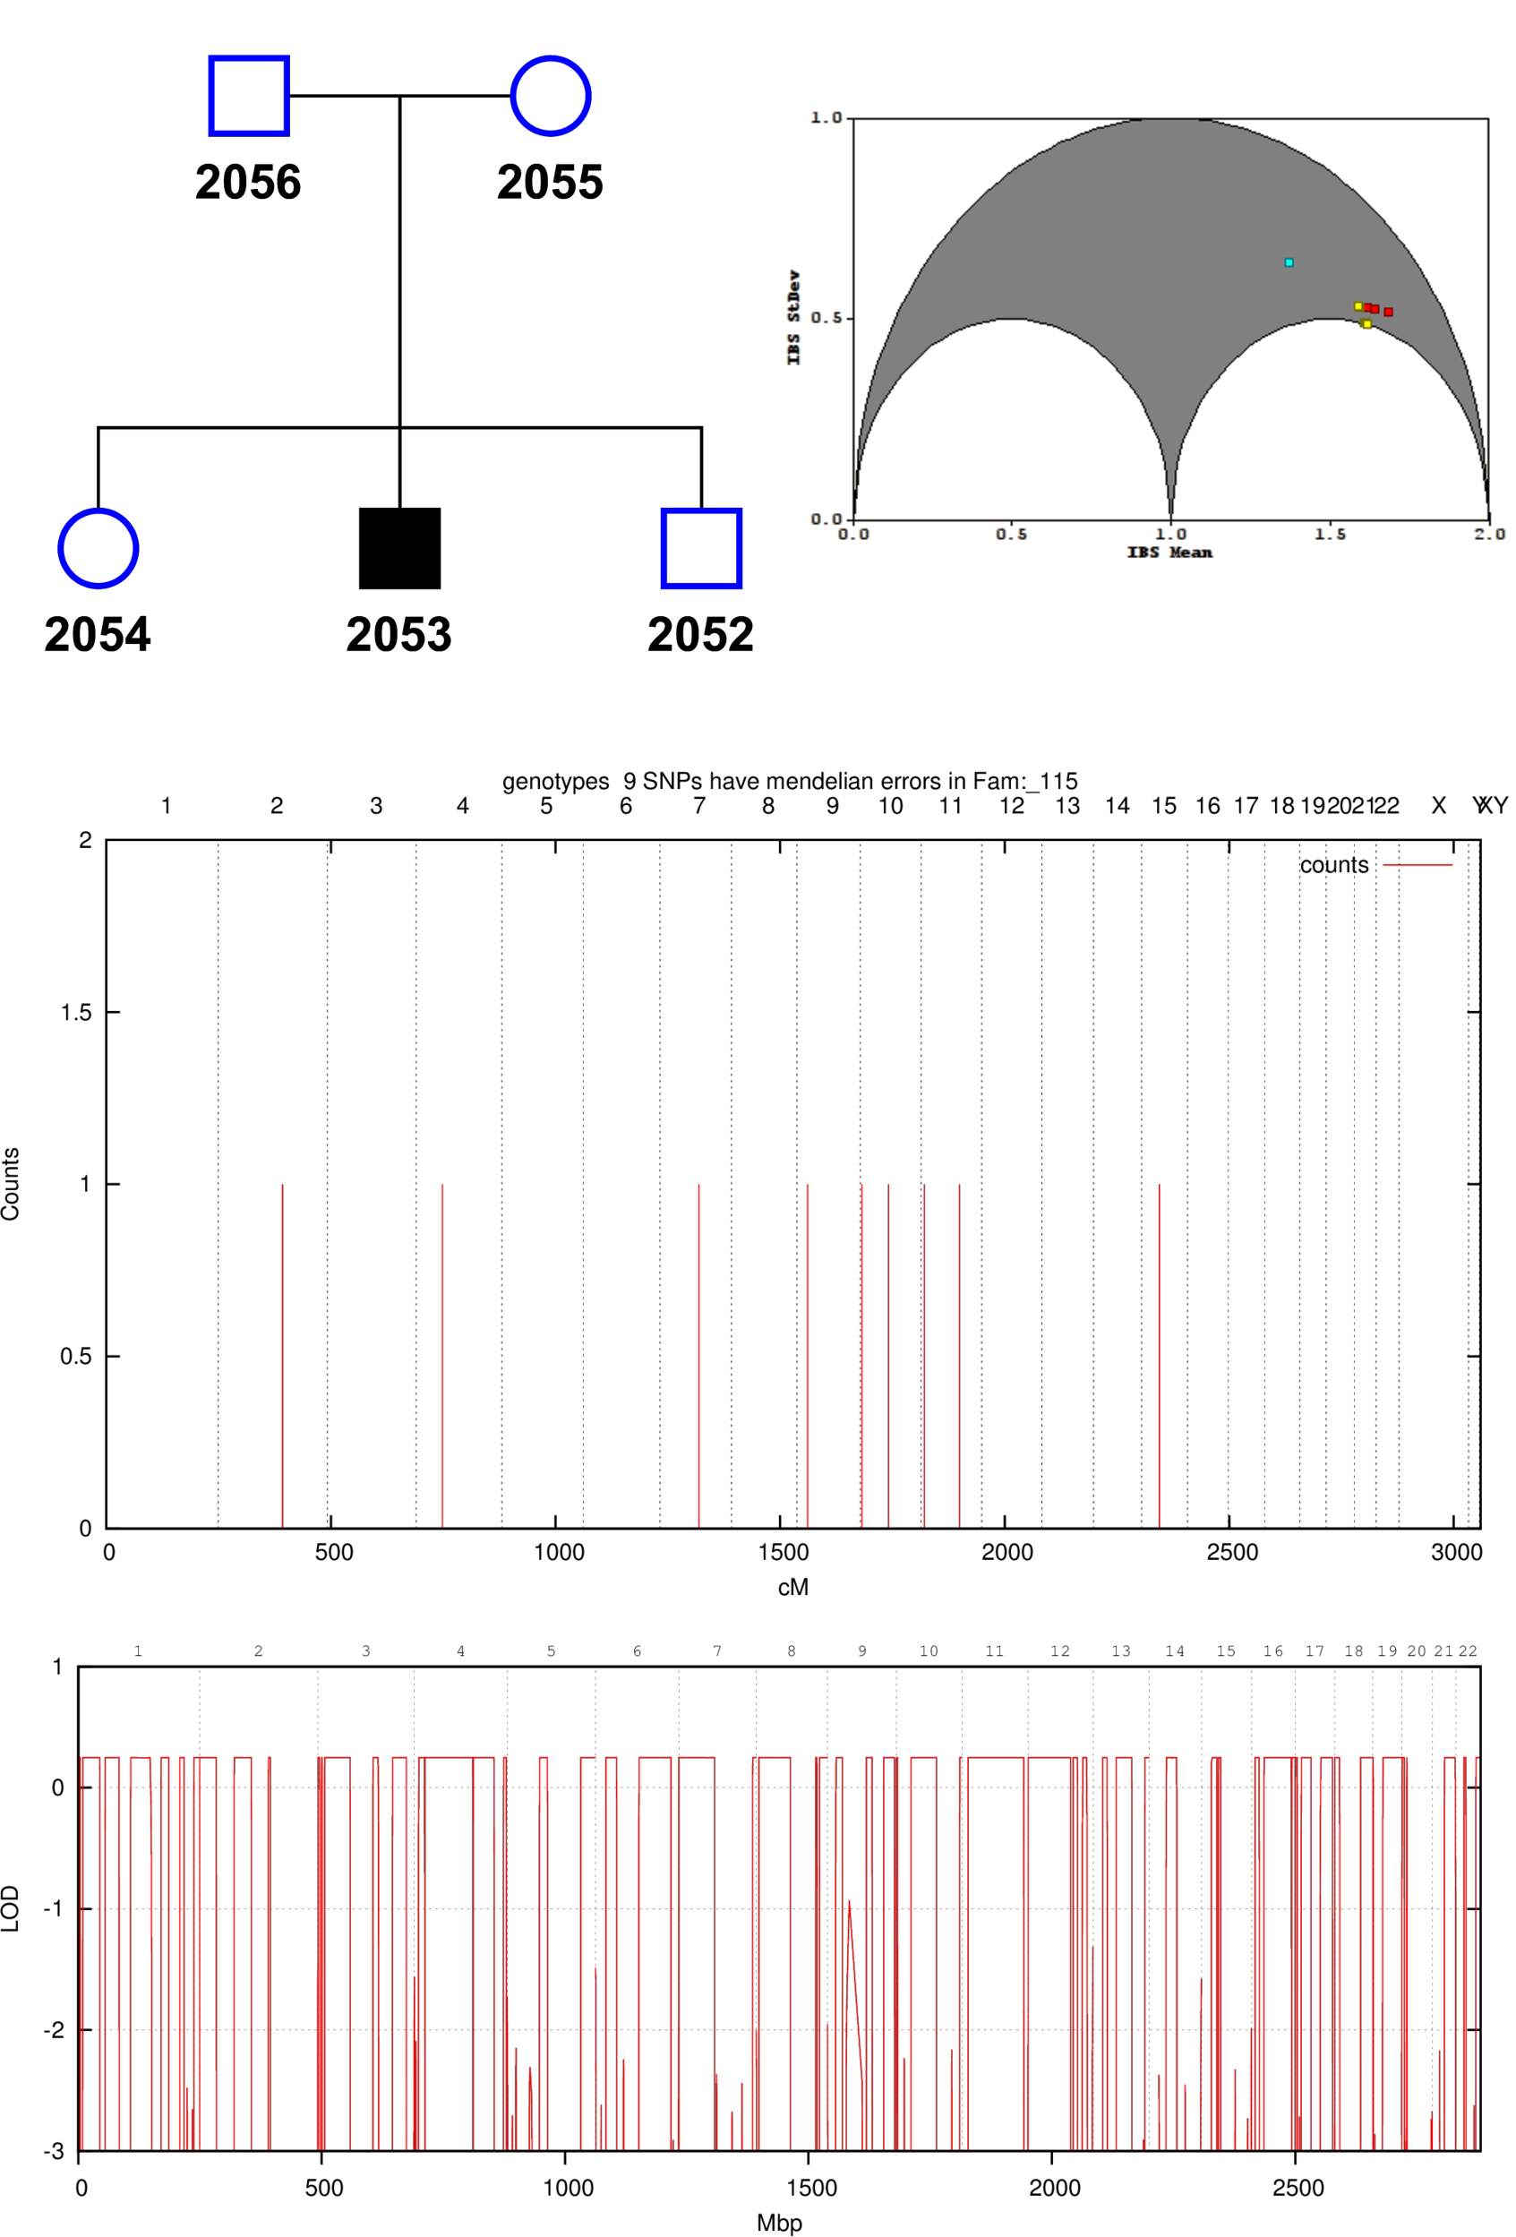
Figure 1: 3-bit Autosomal Recessive Pedigree. (Top) Family Tree and GRR, (Middle) Mendelian errors, (Bottom) Genomewide linkage plot.

5-Bit Autosomal Recessive

This pedigree is very similar to the 3-bit pedigree above, but the bit-size increases by 2-bits for each non-founder added, and here we have one extra affected offspring. The GRR relationship diagram in Figure 2 also shows a similar pattern of groups as before, but this time there are more parental clusters which exhibit the faint beginnings of a larger parental cluster.

55 SNPs (of 41,479 markers) were identified having Mendelian errors, with a cluster of 6 towards the telomeric p-arm of chromosome 8. Removing these from the analysis also had negligible impact (0.133%).

The estimated LOD score was 0.8519 (Allegro and Genehunter) which was once again reached by the linkage with a smaller number of peaks to indicate locus of interest. Though a single causative peak could not be determined, wide regions of exclusion defined chromosomes 2, 3, 6, and 7, as well much narrower peaks genome-wide.

We can also see a few distinct types of peaks: the nicely squared “flat” plateau peaks, the “rounded” bullet-like peaks, and the sharp “shard” peaks. Flat peaks tend to be of more worth to the analysis because they indicate that there are at minimum three markers exhibiting the same LOD score to constitute a left-wall, a right-wall and a point in-between.

Rounded peaks show discord or a lack of resolution within the linkage region. The small peak at chromosome 7 (LOD=-0.1) shows that at maximum there there are three markers constituting the peak with the left and right walls in rough agreement LOD-score wise, but that a single marker in-between them is significantly higher, forcing the plotting program (GNUplot) to smooth the peak into a rounded shape. These types of peaks are extremely common in low-marker analyses (< 5000 SNPs) and are rare in high-marker analyses ( > 50,000 SNPs). Shards convey the same level of information, with the further disadvantage of only being constituted by two markers, both with unequal LOD scores.

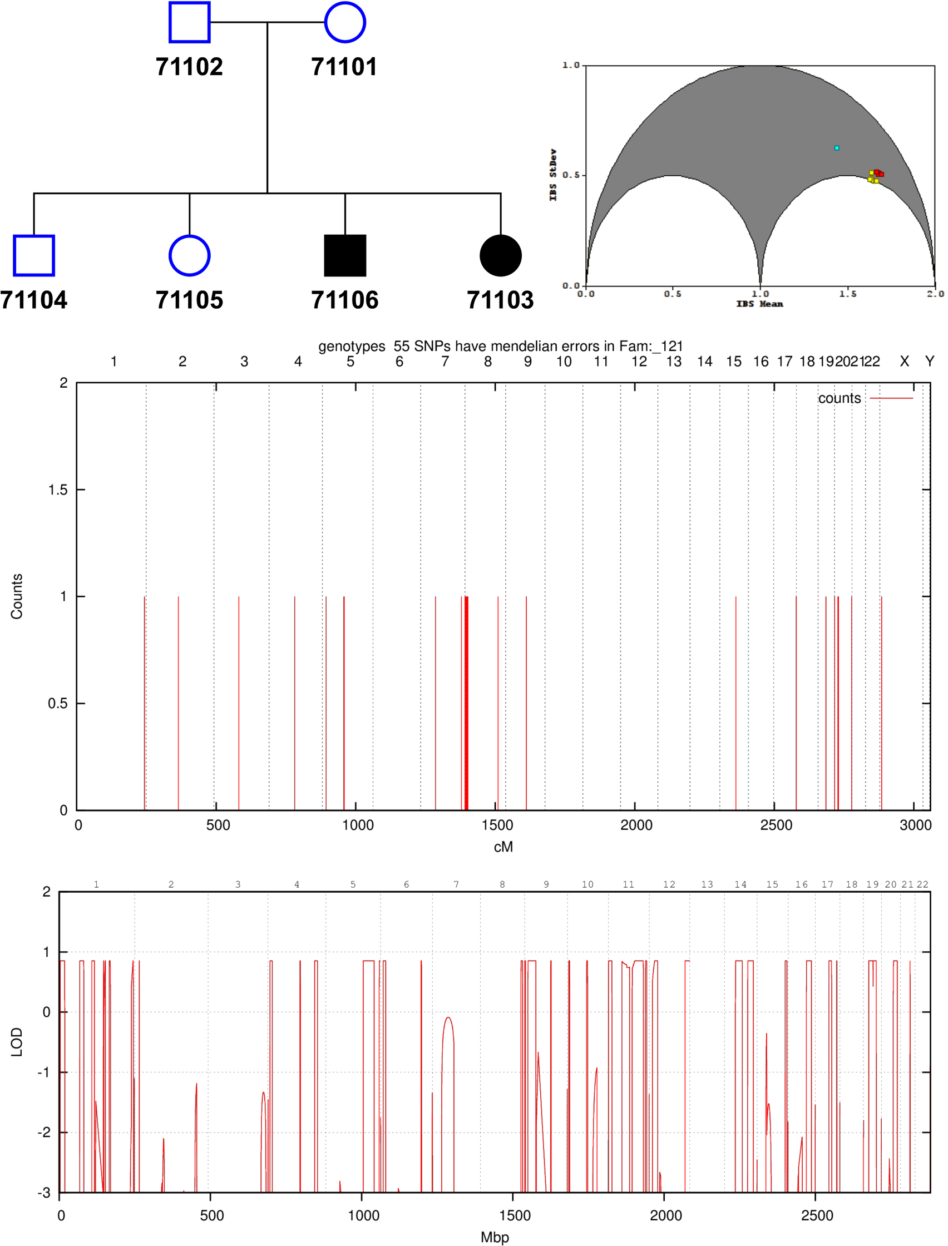
Figure 2: 5-bit Autosomal Recessive Pedigree (119)

7-bit and 9-bit Autosomal Dominant

In this analysis we see examples of excessive Mendelian errors, as well as the trial-and-error process of trying to determine the ‘true’ model of a given data set through successive run iterations.

Figure 3 shows ten pedigree variants from the same initial base.

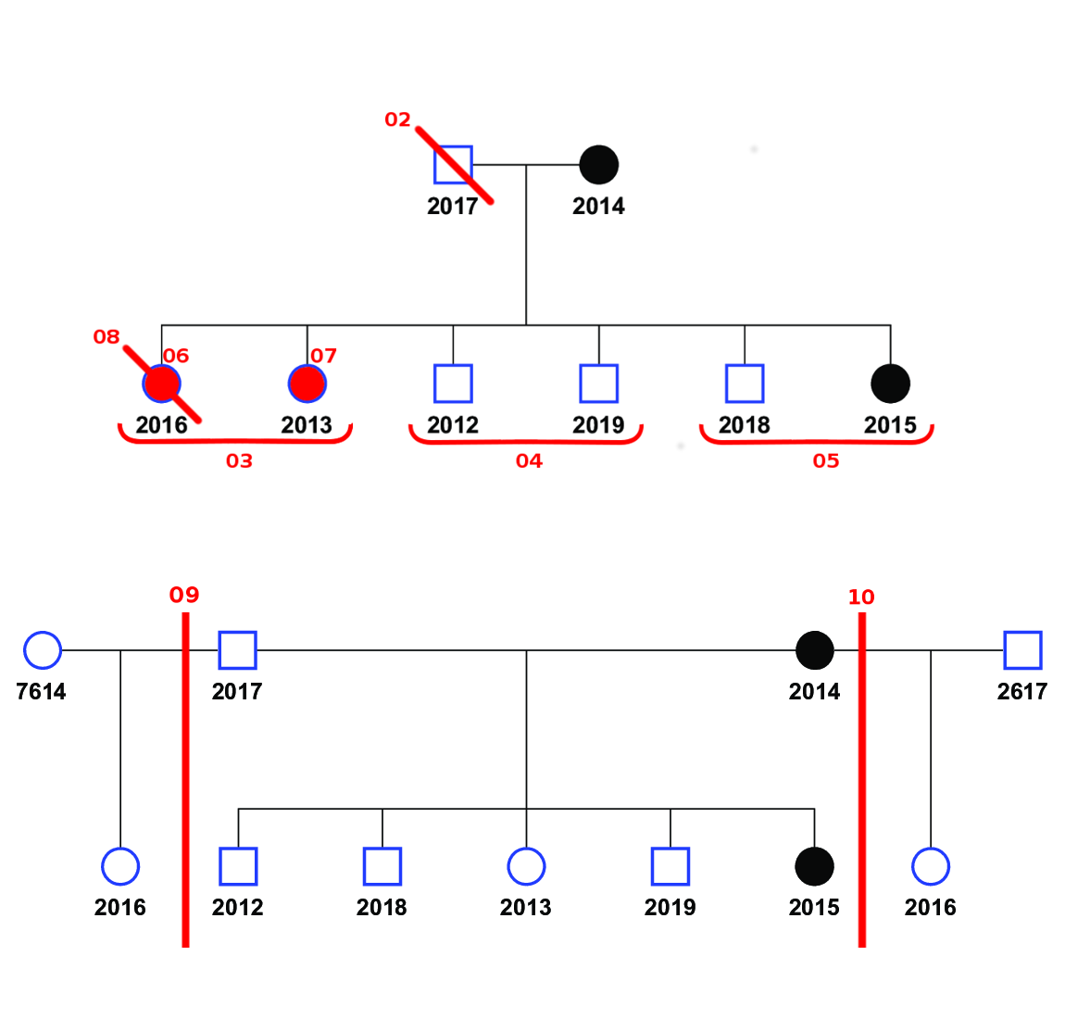
Figure 3: Autosomal Dominant Pedigree split into 10 scenarios. The base scenario (Top) exists without any red-line modifications. Individuals with a diagonal red line crossing through them denote a scenario (numbered in red) where that individual was removed from the pedigree. Individuals filled in red denote analyses where only that individual was considered in relation to their parents with all other offspring omitted. Red underlined groups denote parent-sibling analyses where siblings are grouped and evaluated separately. The bottom pedigree is the same as the top base scenario, but with alternate mother and father for individual 2016 making it half-sib with other offspring.

5 bit ped: 119 complete

7-bit ped: 117_FSGS (interesting) + complete

15-bit ped: 120 compete

18-bit ped: 111 complete and chr7

21 to 25-bit ped: 109 5K (interesting)
– explain where the pedigree changes

29-bit ped: complete

GRR step
Bitsize | #Genotypes | Chip | 1 | 2 | 3 | 4 | Mean
3 | 710,542 | HumanOmniExpress-24v1 | 122 | 122 | 122 | 122 | 122
5 | 301,233 | HumanCytoSNP-12v2 | 122 | 122 | 122 | 122 | 122
7 | 716,504 | HumanOmniExpress-24v1 | 123 | 122 | 122 | 122 | 122
15 | 298,564 | HumanCytoSNP-12v1 | 122 | 122 | 122 | 122 | 122
18 | 300,691 | HumanCytoSNP-12v2 | 122 | 122 | 122 | 122 | 122
21 | 1,102,510 | HumanOmniExpress-24v1 | 130 | 132 | 130 | 131 | 131

 |  | Single-Core |  |  |  | Multi-Core |  |  |  | Average
Proj. | Bit | 1 | 2 | 3 | 4 | 1 | 2 | 3 | 4 | Single | Multi
ATR | 3 | 825 | 814 | 827 | 836 | 202 | 195 | 195 | 201 | 825.5 | 198.3
DEN | 5 | 841 | 837 | 845 | 840 | 210 | 202 | 208 | 209 | 840.8 | 207.3
MCD | 7 | 852 | 844 | 852 | 865 | 206 | 203 | 198 | 205 | 853.3 | 203.0
FDD | 15 | 878 | 884 | 866 | 853 | 278 | 157 | 245 | 152 | 870.3 | 208.0
GRD | 18 | 914 | 973 | 1003 | 1026 | 321 | 230 | 285 | 228 | 979.0 | 266.0
ADA* | 21 | 18571 | 17768 | 18920 | 17963 | 8312 | 9217 | 9732 | 8903 | 18305.5 | 9041.0
CFA* | 25 | 181436 | 185163 | - | - | - | - | - | - | 183299.5 | -
DET* | 29 | 561552 | - | - | - | - | - | - | - | 561552.0

