4.

**Function 1: is_weighted**

**Code:**

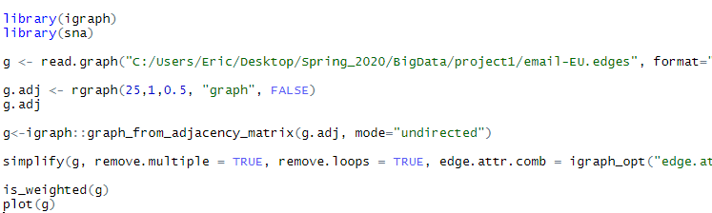

**Result:**

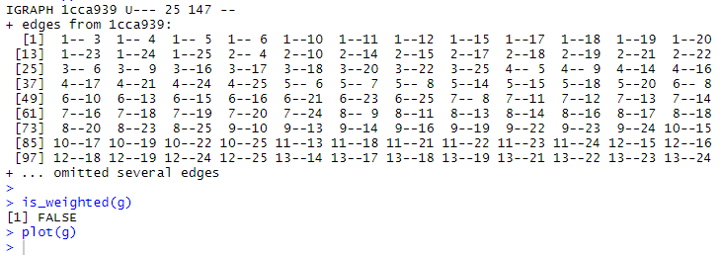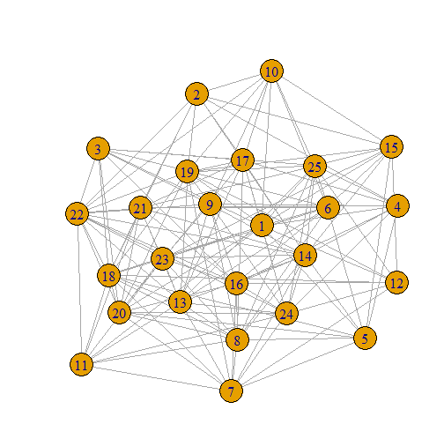

**Function 2: Vertex_connectivity**

**Code:**

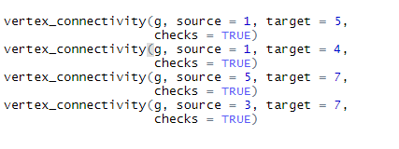

**Result:**

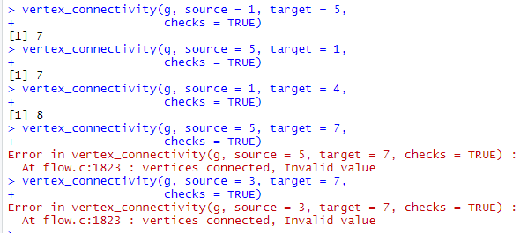

**Function 3: diameter**

**Code:**



**Result:**



**Function 4: isomorphic**

**Code:**



**Result:**



**Function 5: as_adj_list**

**Code:**



**Results:**

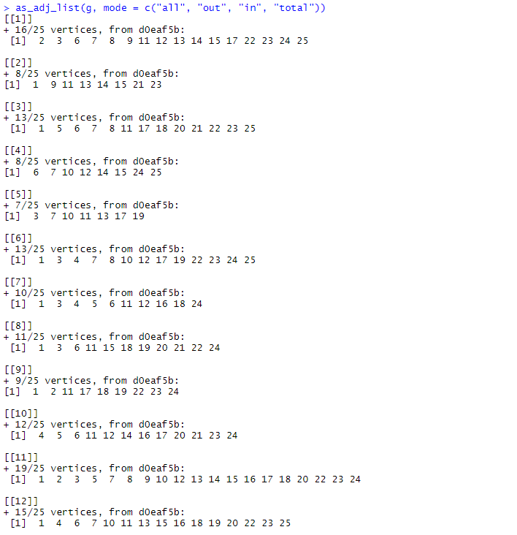

**Function 6: which_multiple**

**Code:**



**Result:**

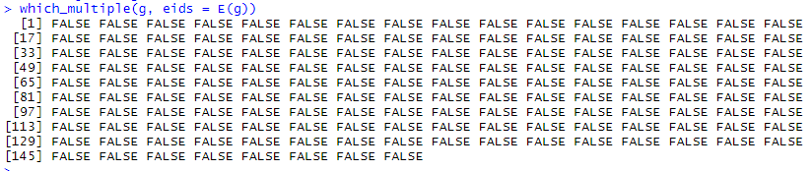

**Function 7: knn -> Average nearest neighbor degree**

**Code:**



**Result:**

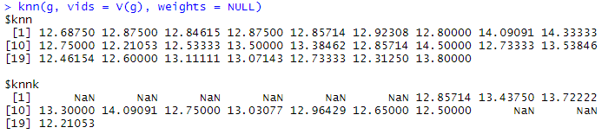

**Function 8:**

**Code:**



**Result:**

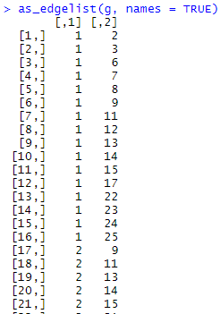**etc...**

**#5**

**Largest path:**





**Largest clique:**

**Ego:**



**Result:**

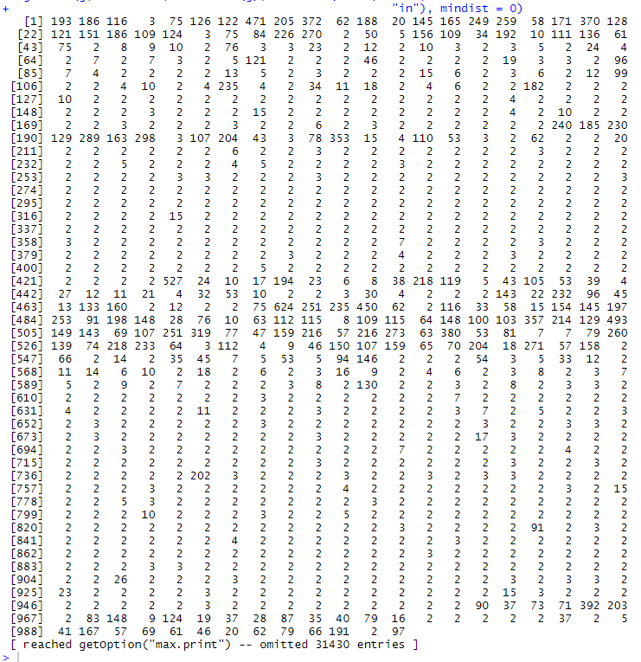

**Testing this**