Unit 5 Project

Step 1: Define Your Audience and Tone

* Who will visit your site?
  + Salt + Spoon is a **food blog** I’m creating to **document and share original and adapted recipes**. It will be for any **food lover** **(visual appetite)** who comes across it but mostly for friends, family, and myself.
* Who are your competitors in similar industries?
  + I would say any other personal blogs
* What can make you and/or your product stand out against your competitors?
  + I think a **clean, crisp design** but with a little **hint of spice** plus great images would help me stand out. I’m also hoping to **hand illustrate** some recipes.
* How would you speak to your clientele if you were communicating in person?
  + **My blog is all about experimenting** and taking advantage of what you already have to create something new. Most important is that it’s simple, **easy to understand, and inspires people to have fun.**
* How could you translate that style and tone digitally?
  + I’d have **great images** that stand out against a clean, simple design because a picture says a thousand words. I’d also want the site to have some elements of fun from **pops of color and punchy writing.**
* What colors represent your restaurant/business?
  + white or neutral background for images to stand out against. Accents colors that are warm and cool. **I think greys plus pops of orange-coral and blues would work well.**
* What images illustrate your message?
  + Still thinking about a logo of some kind. I’d say something

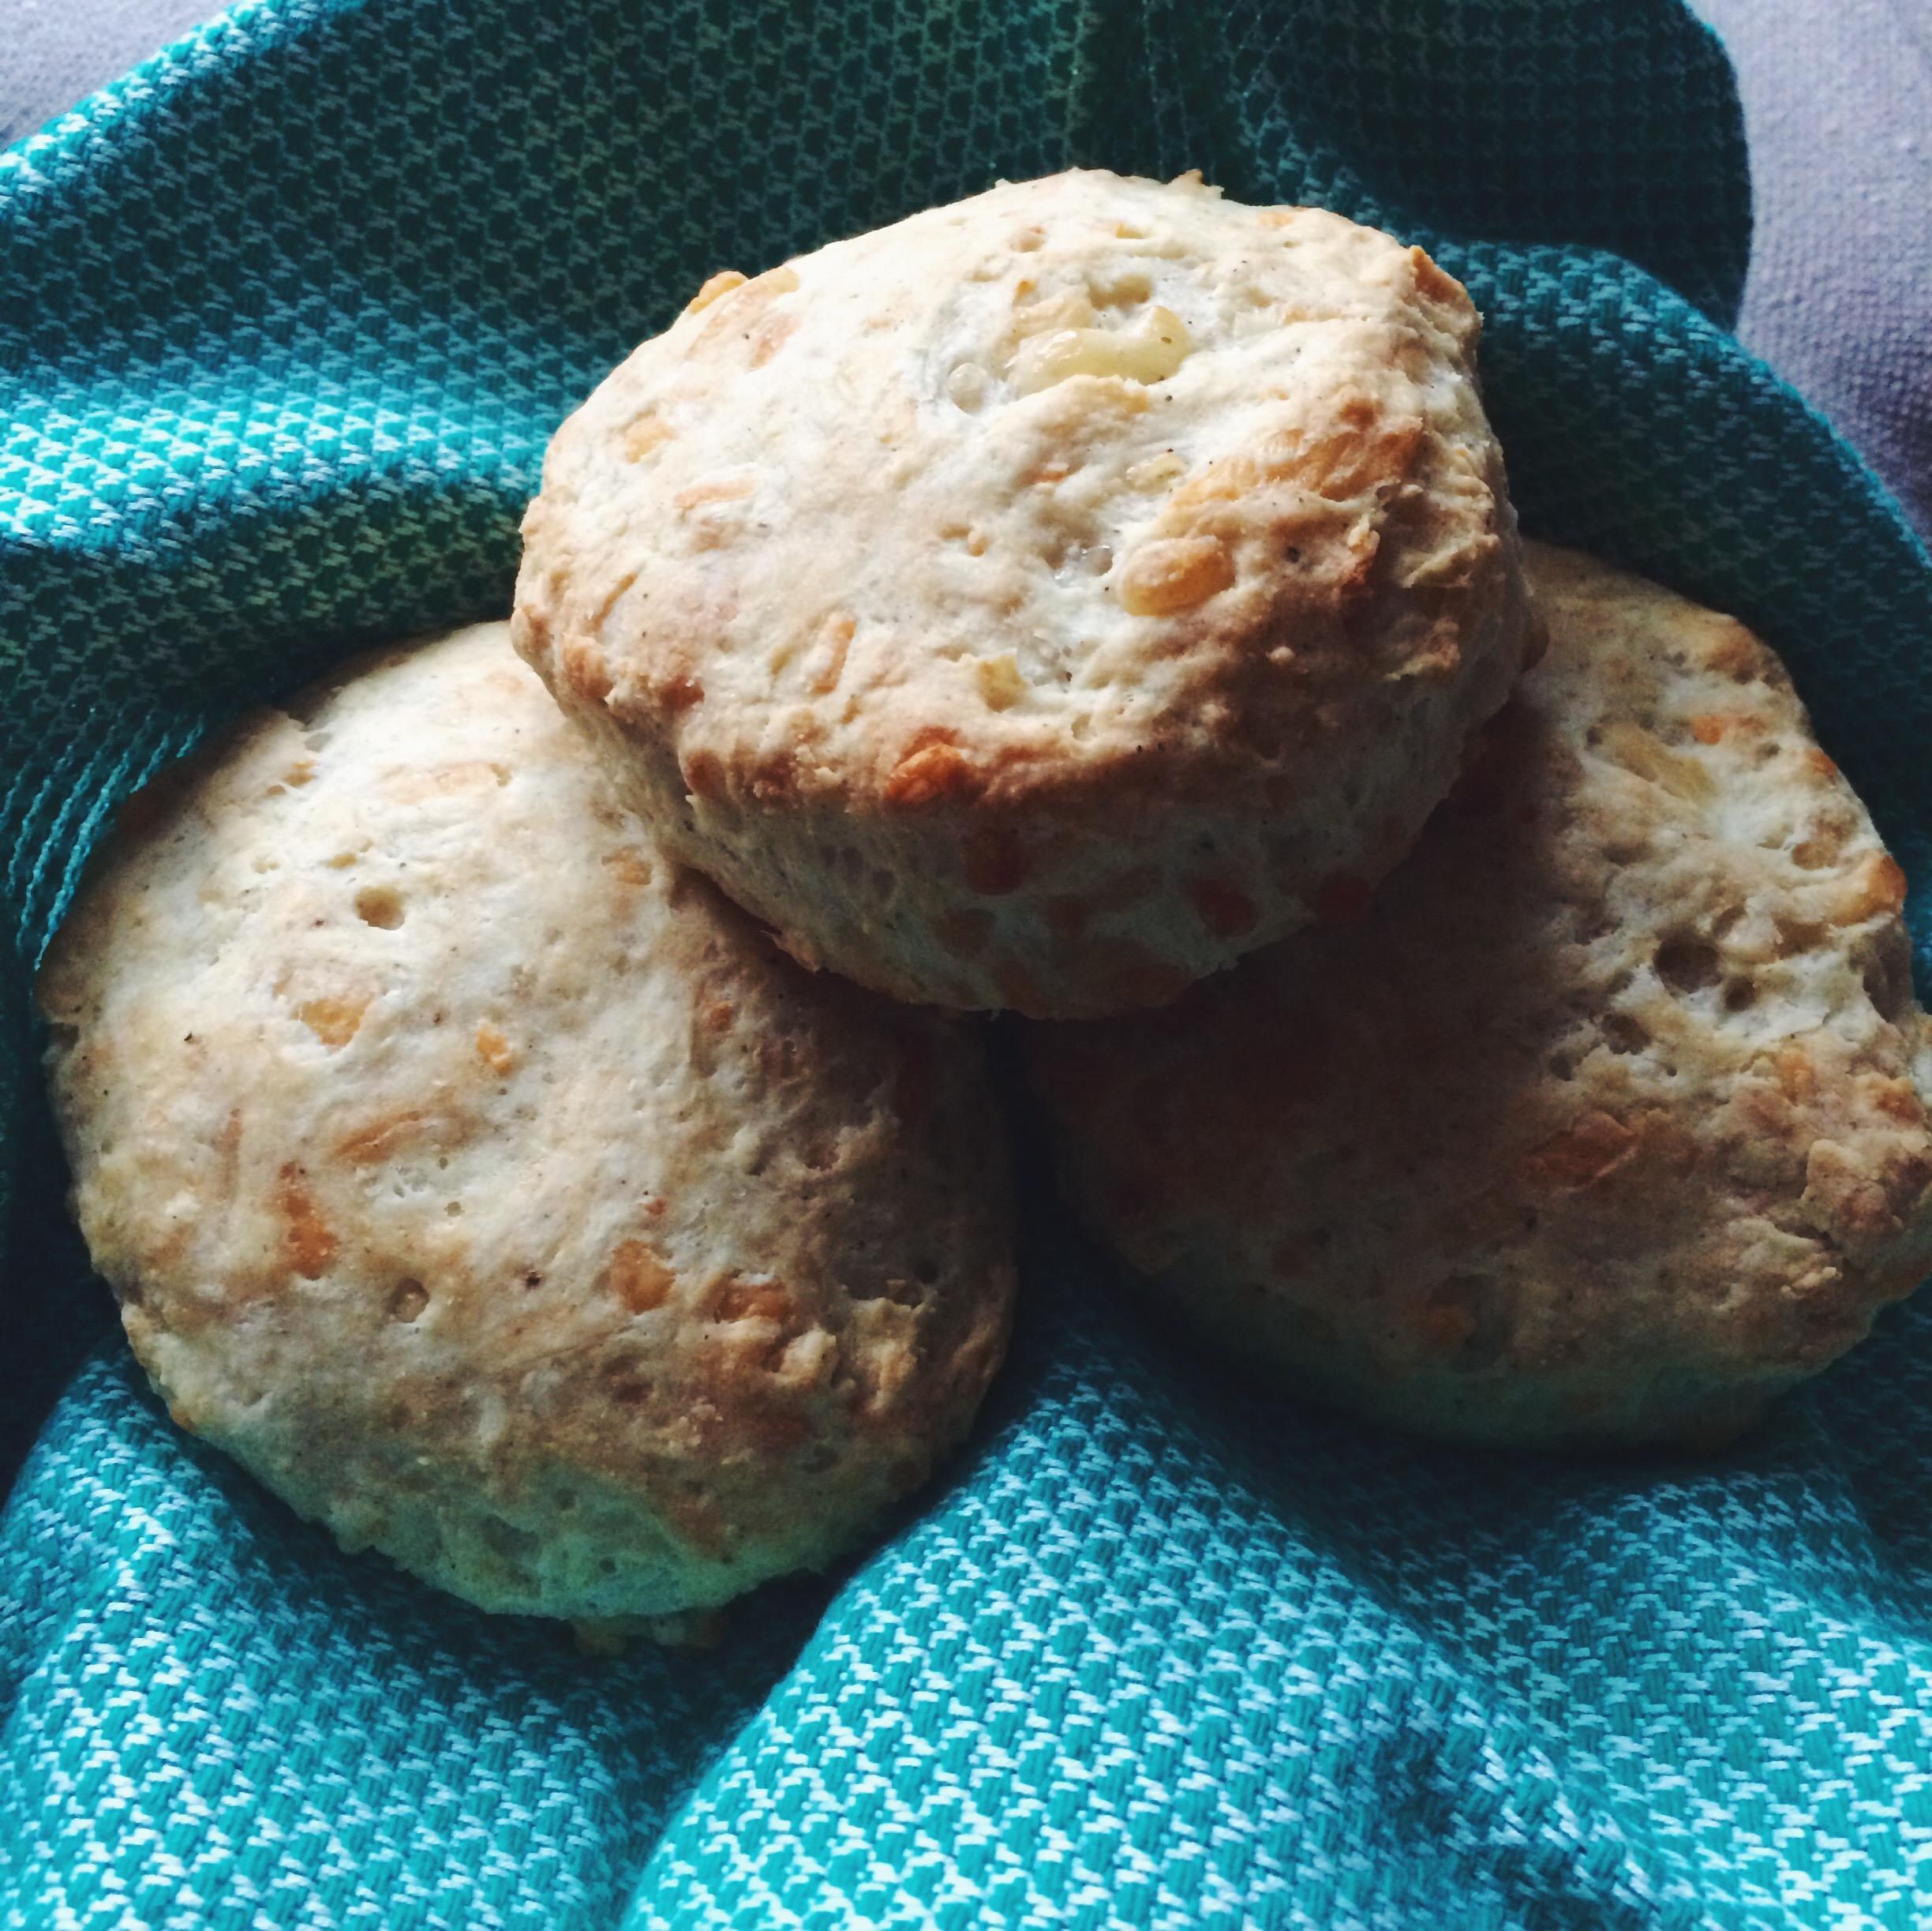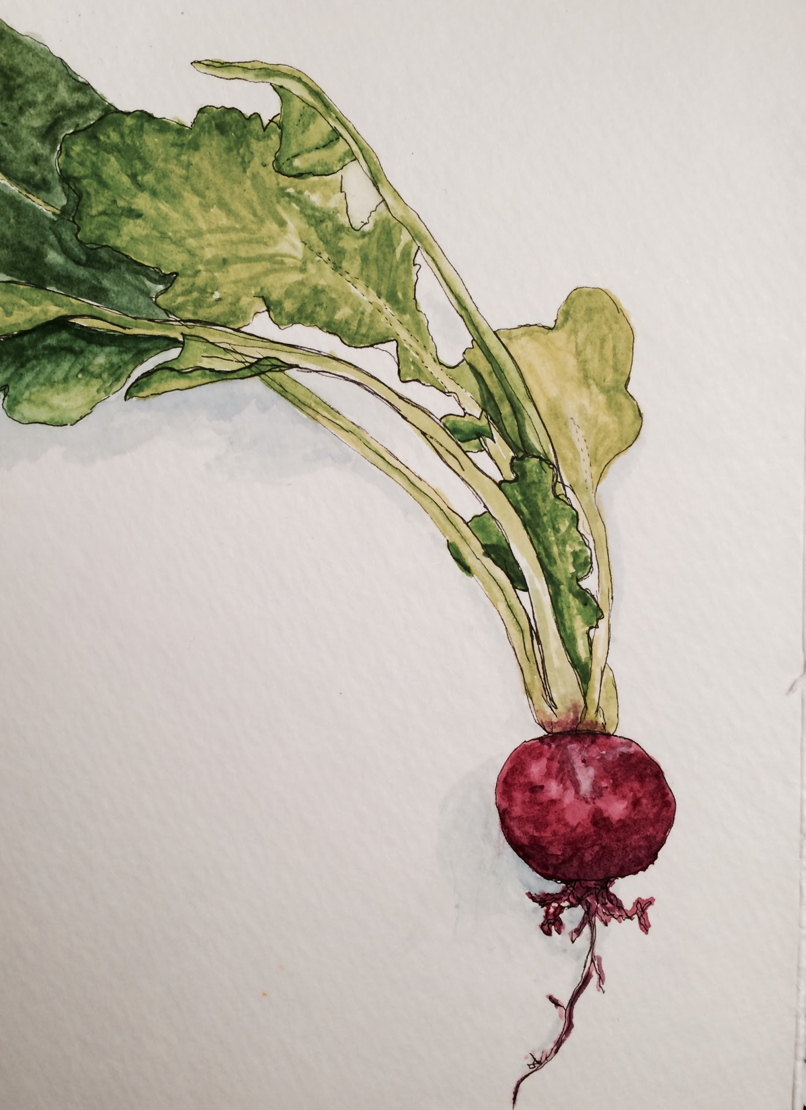

Step 2: Identify Content

* Imagine your site has two pages, a homepage and one other page of your choice (about, contact, gallery, etc.). Would the design remain constant across both pages? How so? How would the design differ?
  + **I’d like a navigation, search bar, links to social media, about me, and the header to be on every page throughout the site.**
* Make sure to clearly describe the name, look, and purpose of each page. What should each page contain? Will there be text content? Or just images?
  + **Homepage**
    - **overview of the blog that showcases some recipes and highlights what there is to offer. Easy navigation and clean flow.** 
      * **navigation/menu**
      * **header with logo**
      * **social media space**
      * **images**
      * **intro content related to most recent posts with “read more” section**
  + **About Me**
    - **home base for contact info and general about me section. Simple.** 
      * **navigation/menu**
      * **header with logo**
      * **image**
      * **intro content**
      * **social media space**
      * **contact information**