**Unit 5 Step 1**

**Client: Dude and Chick - Stationery Sweetness - Letterpress Greeting Cards**

**Designer:** Mary Reagan Harvey

**Date:** 6/26/15

**Step 1: Define Your Audience/Tone**

In steps 1 and 2 of this project, you'll be playing the role of the client. Once you've completed these two steps, you'll email the documents you create to your partner.

Pretend you've decided to outsource the design and construction of the website you’ve been working on in the first four units. Your partner will be playing the role of the designer to whom you’ve outsourced this work. In order for your partner to understand your goals, create a document telling them a little more about your site.

Use these questions to outline your thoughts:

* Who will visit your site? Stationery people, Card people, Gift Shop Owners (wholesale), Letterpress shop entrepreneurs, Hipsters into letterpress, competitors, Illustrators, 30-40 something women who can’t see their friends on the coasts like they use to and want to send them a note on their birthday or because of an event. Grown up kids that want to get their parents a funny quality card but not give them a gift. Crafters. Those who appreciate quality, locally made gifts from the Midwest.
* Who are your competitors in similar industries? Egg Press (portland, OR), Benchpressed (Etsy shop from Minneapolis, MN), Snow and Graham (Chicago), Paper Source (also the main buyer of his cards), Hammerpress Letterpress and Design Studio, Smudge Ink Stationery and Gifts, Blackbird Letterpress (etsy shop), Hello Lucky, Elum
* What can make you and/or your product stand out against your competitors? Craftmanship, Quirky impactful designs and illustrations, St. Paul native
* How would you speak to your clientele if you were communicating in person? I own my own letterpress and design company, specializing in greeting cards, I use to do custom work for weddings, baby announcements, business cards. How could you translate that style and tone digitally? Classy, retro, tongue and cheek
* What colors represent your restaurant/business? Process blue, magenta, black
* What images illustrate your message?

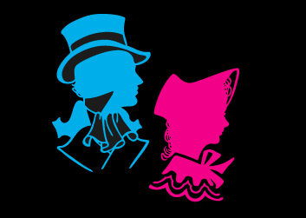

Other image (older not currently in use)

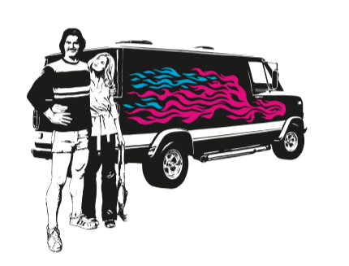

If you'd like to see a sample, follow this [document](https://docs.google.com/document/d/1OfIuvDPY0mN24j-xC5j4KZ7dsPzMqkCIhIvjdMQnDnY/edit?usp=sharing) as a guide.