Melchior Thambipillai 27.10.2017
Stylianos Agapiou

Blockchain-based Sybil attack resistance protocol

Introduction

Sybil attacks resistance protocols are becoming more and more important as decentralized systems such as cryptocurrencies grow. From what we know fully preventing Sybil attacks in a decentralized way is an impossible task since IP addresses do not map to individuals. However there are 2 main approaches to minimize the risk of Sybil attacks : Either making it hard for an individual to control a lot of peers, or detecting anomalous activity patterns of Sybil attacks in the decentralized system in order to eject malicious nodes. This project focuses on the first approach and rely on the hardness of some computation. Indeed, if joining a peer-to-peer network requires a lot of computation like solving a cryptopuzzle, joining a lot of peers becomes very expensive, so expensive that an attacker will renounce to even try.

Goals and functionalities

As a first part of the project, a goal will be that joining peers have to show a PoW(proof-of-work) in order to be accepted. We decided to implement some protocol to create a cryptopuzzle and ask for its solution to the peer who wants to join. The solution should be a time-limited valid token that proves eligibility to be part of the network.

More concretely, each joined peer should store the IDs of the accepted nodes. A new peer N that doesn’t already have an ID makes a join request to some already joined peer P. P sends to N an available ID and timestamp, as well as a cryptopuzzle. This cryptopuzzle should not depend solely on P, because if P and N are both malicious and cooperate, solving a cryptopuzzle created by P is trivial.
Then N solves the cryptopuzzle, the solution will be its proof-of-work, and sends back the solution to P who verifies it. All peers should then be aware that N is now part of the network.
The timestamp will be included in the solution of the cryptopuzzle, this way all peers have each ID with the creation timestamp. Based on some expiration delay, these IDs will become obsolete and the peers will have to show another PoW.

Once we have that ID based on a proof-of-work, the next goal is to ensure that communication inside the system is based on the possession and validity of such a token. Each token should correspond to a single user, another user shouldn’t be able to usurpate another user’s token. This will be the second part of the project.

More concretely, each time a peer A wants to communicate with a peer B (either to send a rumor, a private message, etc), B should verify that A is part of the accepted peers that have showed proof-of-work that have not expired yet. It should not be possible for a malicious peer M to communicate as A, so B should have a way to verify some kind of signature of A. Another requirement is that a malicious peer M that has showed PoW should not be able to use its ID to communicate from different locations at the same time. So peers should be aware of which peers are active at the moment in order to refuse communication from an active peer from another location.

Related work
As mentionned earlier there can be multiple approaches to detect or prevent Sybil attacks such as trusted certifications or social graphs patterns but here we focus on the different ways to create some expensive kind of cost to join the system which limitates the risk of Sybil attacks.

There are many approaches to create incentives to discourage adversaries to perform Sybil attacks. For example the Dash cryptocurrency requires to pay 13’000 dollars to acquire a master node. Another approach is to use CAPTCHAs which are presumably hard to compute for a program but not for a human, but solving a lot of them would be very time-consuming even for humans especially if the system requires recurring solutions.

The paper « Limiting Sybil Attacks in Structured Peer-to-Peer Networks » (http://nsrc.cse.psu.edu/tech_report/NAS-TR-0017-2005.pdf) describes a way to make a joining peer compute crypto-challenges without relying on a single peer or all the peers to create the puzzle (the first case would be insecure if that peer is malicious and the second case is practically infeasible since the probablity that all peers are active is very low). The nodes are organized in a tree hierarchical topology. In order to join, a peer must find a leaf node and ask him for a crypto-challenge. Once solved this gives the joining peer a token granting him the right to ask for another crypto-challenge to the parent node. This continues until the peer has solves the challenge of the root node, at which point the peer is allowed inside the network. This has the nice property to distribute the load and trust among different peers but it requires a hierarchy and most importantly a single root node that must be trusted. This is not a desirable property as here we are trying to build completely decentralized systems.

Another approach is described in « Computational Puzzles as Sybil Defenses » (https://nymity.ch/sybilhunting/pdf/Borisov2006a.pdf). Chord is used as an example topology to define peers’ neighbors. The idea is to broadcast challenges to all other peers and such challenges must be a contribution of all the peers. They use concatenation of peers ids to compute puzzles and ensure from the non-invertibility property of hash functions that a challenge cannot be computed without having the challenges from other peers. Peers regularly ping each other to know which peers are active and must participate in the puzzle computation protocol. Each peer can verifiy that a new challenge includes its own challenge. This time the solution is a fully decentralized system without any root node. It ensures that a challenge is computed by all active nodes. However the nodes down at that moment are not part of the computation. Another limitation is that the communication protocol with all its pings and broadcasts is quite expensive in terms of bandwidth.

Probably the most related work is Bitcoin since it uses the blockchain technology that we are going to use in this project and describe in the next section.

Background

Our design and implementation for the first part of the project will make use of the blockchain technology. Blockchain is a continuously growing distributed list of records grouped in entities called ‘blocks’ that are linked by hashing. Basically each block contains some data relevant for the application using the blockchain plus 2 other fields : a nonce and a hash. In a peer-to-peer system, every peer has a local copy of the whole blockchain. New data can be added only in a block that must itself be added to the blockchain by referencing the previous block.
More precisely, the hash field inside a block is the hash of the previous block in the chain, this allows to verify that a block is the successor of another block. The blockchain has to require that the hash of each block matches some pattern in order to be valid (conventionally a number of leading zero bits in the hash).
This is where the nonce field is used : to validate a block containing some data and the hash of the previous block, one must ensure that the hash of the block matches the required pattern by trying different values of nonces. From the non-invertibility property of hash functions, brute-force with different values of nonces is the only way to find a correct hash. This gives a proof-of-work for any peer wanting to add a block to the chain.

The second part of the project will make use of asymmetric cryptography and hash functions for digital signatures. This is used for authentication of communications. If A sends a message to B, B wants to make sure that the sender is indeed A. One way to do it is for A to ‘sign’ the message.
Concretely A has a public-private key pair, hash the message it wants to send and ‘decrypt’ it with its private key, this will be the signature that is sent along with the message. At reception B ‘encrypt’ the signature with A’s public key. If the result is equal to the hash of the message then the signature is verified. This can be done using different asymmetric cryptosystems such as RSA or El-Gamal.
In the case of RSA for example, the message m is hashed to H(m) and ‘decrypted’ with the secret exponent ‘d’ and public parameter ‘N’ to sig = (H(m)^d) mod N. The receiver verifies the signature with the public exponent ‘e’ by checking if (sig^e) mod N = H(m).

Design and Architecture

First part : blockchain-based joining
Implementation will be done by Melchior Thambipillai.

Each peer should somehow store a list of peers that have showed PoW, the list should be unique and not alterable. As stated earlier it is required for the cryptopuzzle to be made by all peers and not just one peer who may be malicious. But in a decentralized system we cannot expect to have all peers active at the same time to compute a cryptopuzzle together. For all these reasons, blockchain seemed the way to go : there will be one block per joined peer, a joining peer will have to add a new block to the blockchain. each block will have at least 4 fields : the ID of the peer, the block creation timestamp, the nonce and the hash of the previous block.

All peers will have a local copy of the blockchain. From the hash-based linking of blocks, this storage of nodes is indeed unique and not changeable as required. Moreover, each block depends on a peer and on the previous block, so we ensure that the cryptopuzzle cannot be forged by a single peer, it will depend on the last block and by transitivity on all the blocks. Since all peers have a whole copy of the blockchain, this requires only a single peer to be active at the time of a joining request.
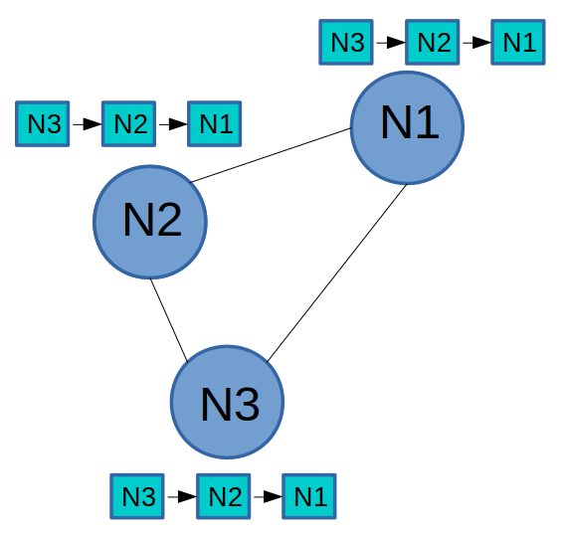
Blockchain replicated in the network

This design is not sufficient : a malicious peer can eavesdrop communication and be aware of the IDs of already joined peers. When a peer A leaves the network, a malicious peer M can usurpate A’s ID to communicate. If M manages to perform a man-in-the-middle attack, he can use A’s ID even when A is active by dropping its packets.
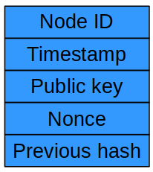
Block fields
We need authentication to prevent this. So we need to add another field in each block : the peer’s public key. This will allow each peer to verify that a peer claiming an ID is in posession of the corresponding private key and so is indeed the correct peer. This can be done with digital signatures either with a challenge-response protocol or with HMACs, we will explore this in the second part.

Here is a workflow of the joining protocol :

1) A sends a rumor or private message m to B along with some conventional way of saying that this is a joining request (more details about that in part2).
2) B sees that A’s ID is not part of the blockchain, so it sends to A an ID, a timestamp and the hash of the last block.
3) A generates a public-private key pair.
4) A mines a new block with the fields : ID|timestamp|pub key|nonce|prev hash
5) A sends the block to B.
6) B verifies it, if it is valid B adds the block to its local blockchain and broadcasts the new block using gossiping.
7) B treats m normally now that A is allowed to be part of the network.

(At some later stage, in step 2) B will see that A is in the blockchain but the timestamp has expired. In this case the workflow is the same and we proceed with the same steps, which means A has to mine a new block again. This increases difficulty for an attacker to control a lot of peers : to have N peers in permanence the adversary has to mine N blocks every dt time units, where dt is the expiration delay.

We have to consider the case of bootstrapping a network : assume A and B are not joined in any network and want to communicate. A can make a join request to B as in step 1), then B will not proceed to step 2) since there is no blockchain yet. So B create its own block, the first of the blockchain (the genesis block, with any value as previous hash) and then it can proceed with step 2.

Note that this does not handle merging of different peer-to-peer networks. One peer can join any network or create its own and wait for other peers to join, but a set of peers joined together cannot merge their blockchain with the one in another peer-to-peer network.
Second part : peer-to-peer authentication
Implementation will be done by Stylianos Agapiou.

Evaluation Plan

We will create different p2p topologies and measure the joining time for a normal peer as well as the joining time for a set of Sybil peers in order to compare them. The normal joining time should be reasonable and the Sybil joining time should be very expensive. We will try different values for our parameters (the expiration delay and the difficulty of each cryptopuzzle) and compare the results.

We also have to check that coordinating multiple malicious peers will not affect the validity of the protocol. For example if a malicious peer wants to join through another malicious peer.

It is important to also make sure that bootstrapping of networks is done correctly (when no nodes are joined).

