

**SUMP PUMP MONITOR PROOF OF CONCEPT REPORT**

**Revision History**

|  |  |  |  |
| --- | --- | --- | --- |
| **Rev** | **Author** | **Change Description** | **Date** |
| 0.1 | Michael Skiba | Initial draft | 2018-05-24 |

## 1 Objective

The Sump Pump Monitor needs to monitor the water level in the sump pit of a home.

## 2 Design

A two conductor wire can act as a capacitor. When the wire is submerged the capacitance changes. Using a hex inverter to create a clock circuit, a variable frequency can be generated that varies with how submerged the wire is.

### 2.1 Circuit

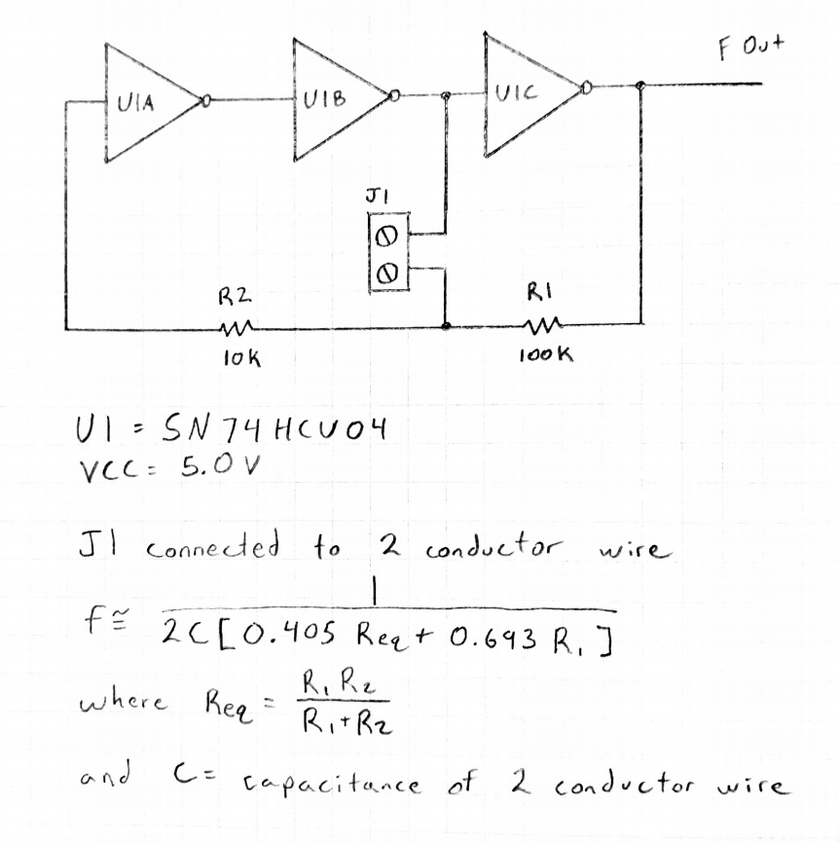

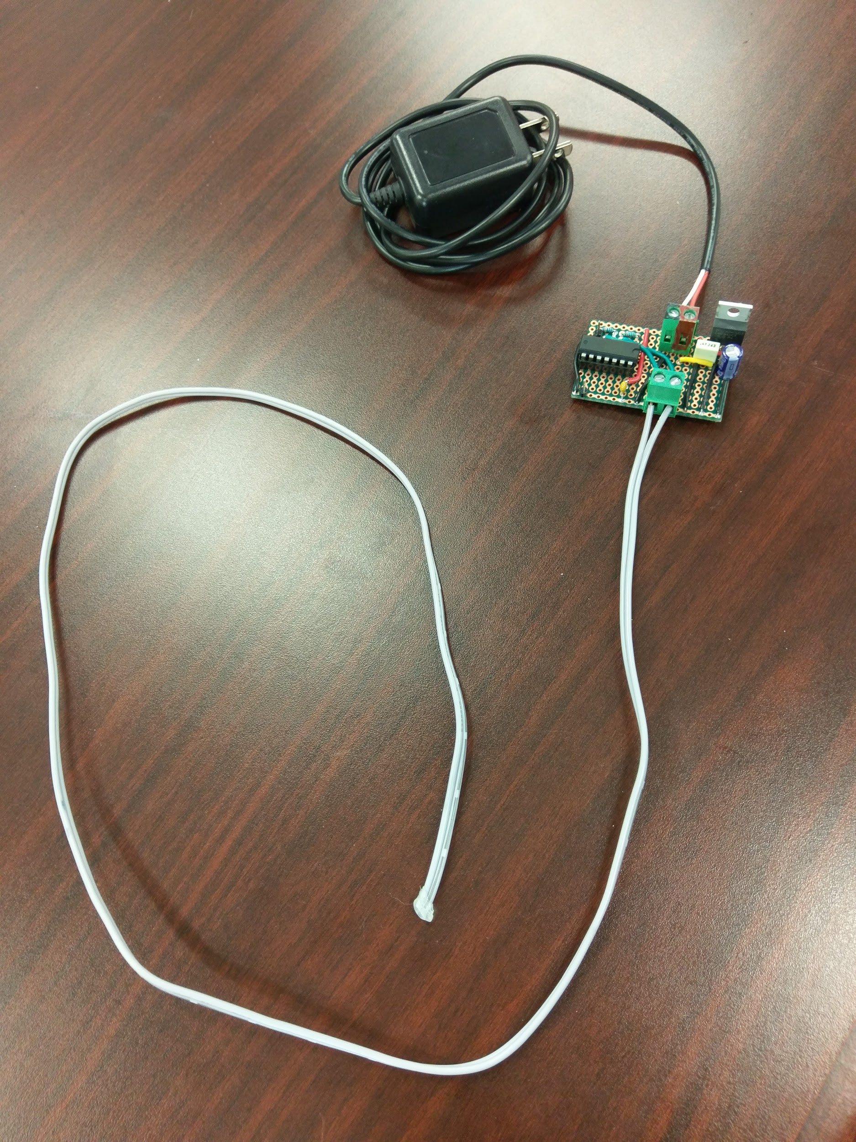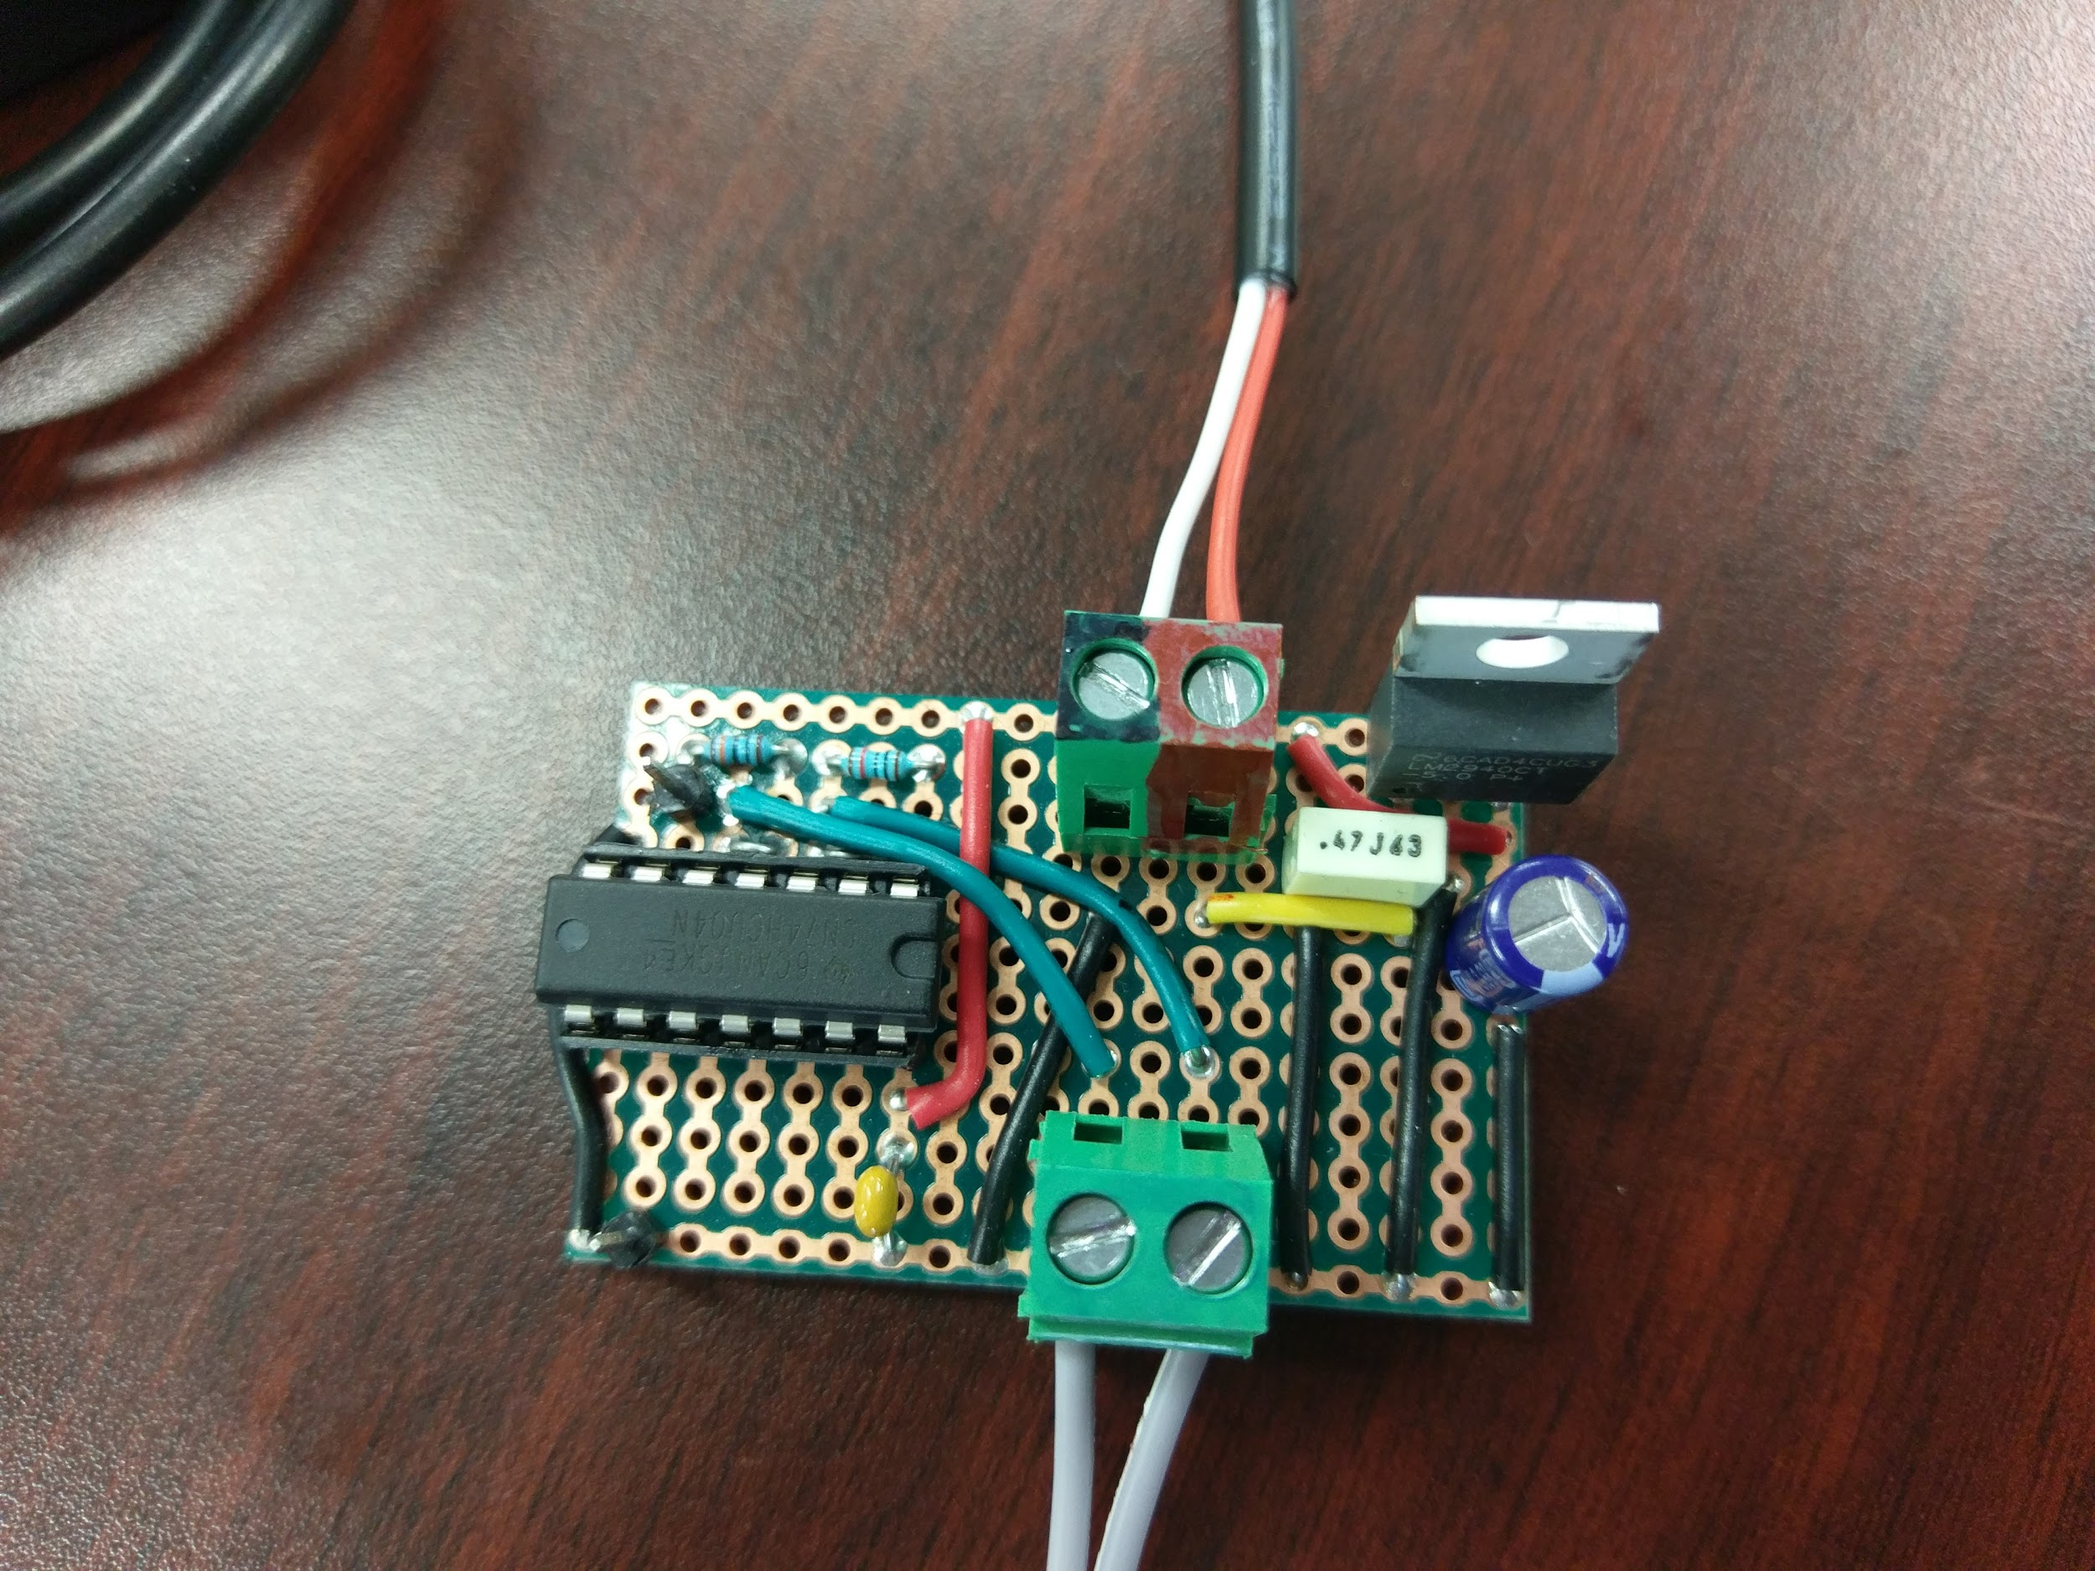

## 3 Results

The prototype was able to produce a variable frequency that corresponded to the amount the cable was submerged.