

**SUMP PUMP MONITOR PRODUCT REQUIREMENTS DOCUMENT**

**Revision History**

|  |  |  |  |
| --- | --- | --- | --- |
| **Rev** | **Author** | **Change Description** | **Date** |
| 0.1 | Michael Skiba | Initial draft | 2018-01-18 |
| 0.2 | Michael Skiba | Added cable information | 2018-01-19 |
| 1.0 | Michael Skiba | Initial release | 2018-01-19 |
| 1.1 | Michael Skiba | Added firmware upgrades to functional requirements | 2018-01-19 |
| 1.2 | Michael Skiba | Fixed cable requirements | 2018-01-19 |
| 1.3 | Shristi Sahu | Added Leak Detector pairing and notifications | 2018-01-19 |
| 1.4 | Michael Skiba | Update Base Specifications, added Battery Specifications | 2018-01-24 |
| 1.5 | Shristi Sahu | Add BT/WiFi name and app requirements | 2018-01-24 |
| 1.6 | Shristi Sahu | Added outline | 2018-01-25 |

1. Overview
   1. Key Features
   2. Notifications
2. Specifications
   1. Environmental Specifications
   2. Performance Specifications
   3. Hardware Specifications
      1. Base Specifications
      2. Probe Specifications
   4. Mechanical Specifications
      1. Material
      2. Tooling
      3. Fit and Finish
   5. Battery Specifications
      1. General Specifications
      2. Electrical Characteristics
      3. Performance Specifications
      4. Environmental Specifications
      5. Safety Characteristics
3. Functional Requirements
   1. LEDs
   2. Speaker
      1. Beep
      2. Speaker Grill
   3. Button
   4. Cable
   5. Power
   6. Guardian App and Leak Detector Pairing
      1. WiFi/BT Name
      2. Guardian App
   7. Notifications
      1. Conditions
      2. Notification Priority
   8. Standalone Operation
   9. Firmware Upgrades

### 1 Overview

The Guardian Sump Pump Monitor is a system that monitors the water level in a sump and the current of the pump to detect abnormal conditions. The Sump Pump Monitor system consists of the Base and the Probe cable.

#### 1.1 Key Features

* Plug in Base and Probe cable
* AC powered
* Battery backup, rechargeable (for monitor, not for powering pump)
* WiFi, BT, and Guardian RF
* Audio indicator and in-app notifications
* Wall plate screw
* Standalone operation or pairing with Guardian App
* Leak Detector pairing

#### 1.2 Notifications

The Sump Pump Monitor will be able to alert the user via audio and in-app notifications of the following conditions:

* Sump overflow
* Water above normal level
* Pump running too long/float stuck up
* High current use by pump/pump failure imminent
* Pump blockage
* Power failure
* Leak detected

### 2 Specifications

This section describes the requirements and scope of the Sump Pump Monitor

#### 2.1 Environmental Specifications

|  |  |
| --- | --- |
| **Feature** | **Description** |
| Operating Temperature Range | 0°C to 70°C |
| Operating Humidity Range | 5% to 90% RH Non Condensing |
| Storage Temperature Range | -40°C to 75°C - capable of operation after a 20 minute transition from storage to operating temperature |
| Storage Humidity Range | 0% to 95% RH - capable of operation after a 20 minute transition from storage to operating humidity |
| Vibration | All axes, amplitude: 2mm, frequency: 1Hz - 20,000Hz |
| Mechanical Shock (Drop) | 1m |

#### 2.2 Performance Specifications

|  |  |
| --- | --- |
| **Feature** | **Description** |
| Battery Life | >6 Hours |
| Range | >1000 ft (Guardian RF)  >150 ft indoors (2.4GHz) |
| Life Expectancy | 10 years |
| Reliability | 1st year 99%  5 years 95% |

#### 

#### 

#### 

#### 2.3 Hardware Specifications

##### 2.3.1 Base Specifications

|  |  |
| --- | --- |
| **Item** | **Description and specifications** |
| RF module | SX1276IMLTRT, IC RF TXRX 802.15.4 28VQFN |
| MCU | ESP-WROOM-32, generic Wi-Fi + Bluetooth MCU |
| Battery Management IC |  |
| Battery | SP603450, 3.7 V, 1100mAh, 4.07Wh battery module - Same as Ring Extender |
| Bluetooth | ESP-WROOM-32, generic Wi-Fi + Bluetooth MCU |
| Wifi | ESP-WROOM-32, generic Wi-Fi + Bluetooth MCU |
| Cable Connector | 3.5mm TRRS jack - female |
| Input voltage | 110V-240V 0.8A, 50 - 60Hz (if not available,could be set as 110V-120V.60Hz) |
| Guardian RF distance | 1000 ft |
| Guardian RF Receive sensitivity |  |
| WiFi Receive sensitivity |  |
| BT Receive sensitivity |  |
| Guardian RF Transmit power |  |
| WiFi Transmit power |  |
| BT Transmit power |  |
| Operation current |  |
| Maximum current |  |
| 3x LEDs | White - Same as Guardian |
| RS485 | Header mounted on PCB, for test mode |
| Speaker | > 80 dB |
| Calibration | Calibration during normal operation |
| OTA | Support remote upgrade FW |
| Maximum power of pump | 2200W/20A |

##### 2.3.2 Probe Specifications

The Sump Pump Level Sensor Cable is a multi-conductor cable

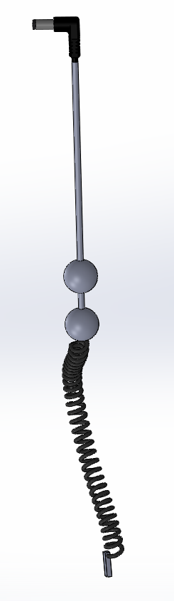

Cable Sections and Requirements:

|  |  |  |
| --- | --- | --- |
| **Label** | **Part** | **Requirements** |
| A | 90⁰ jack | * 90 degrees, TRRS plug - male |
| B | Straight Cable | * 4 conductor cable, style TBD * Possibly shielded * 4.6 meters * Does not need to be waterproof * AWG 28 |
| C | Stay | * Shape TBD * 100-200 grams * Securely molded to wire or mechanically fastened |
| D | Straight Cable | * 4 conductor flat straight cable * 8cm * Does not need to be waterproof * AWG 28 |
| E | Overflow Sensor | * Shape TBD * Two of the wires in the 4-conductor wire will terminate here at exposed contacts for detecting water * Must withstand 5+ years at >90% humidity |
| F | Coiled Cable | * 2 conductor coiled cable * Must be 1.2 meters when fully extended * Waterproof, must withstand 5+ years fully submerged * Insulation must not absorb water, maintain dielectric constant * Water must not stick wire to surface (hydrophobic) * AWG 28 |
| G | Plumb | * Approximately 50 - 100 grams, heavy enough to fully extend the coiled section when held vertically * Securely molded to end of wire or mechanically fastened * Waterproof * Heavy metal core * Size/Shape TBD |

Cross section of Coiled Cable:



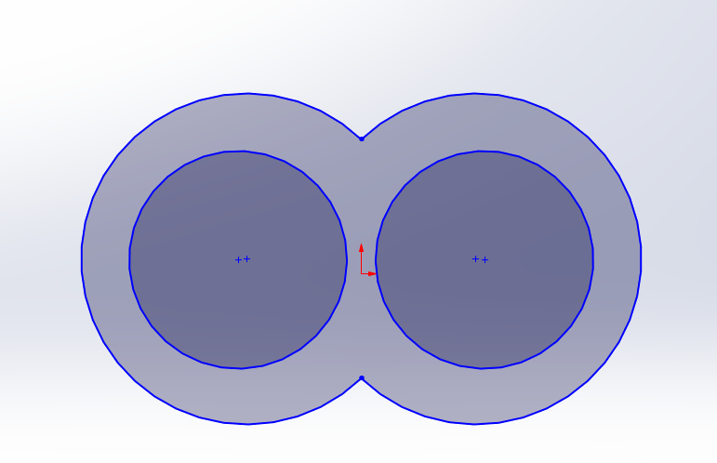

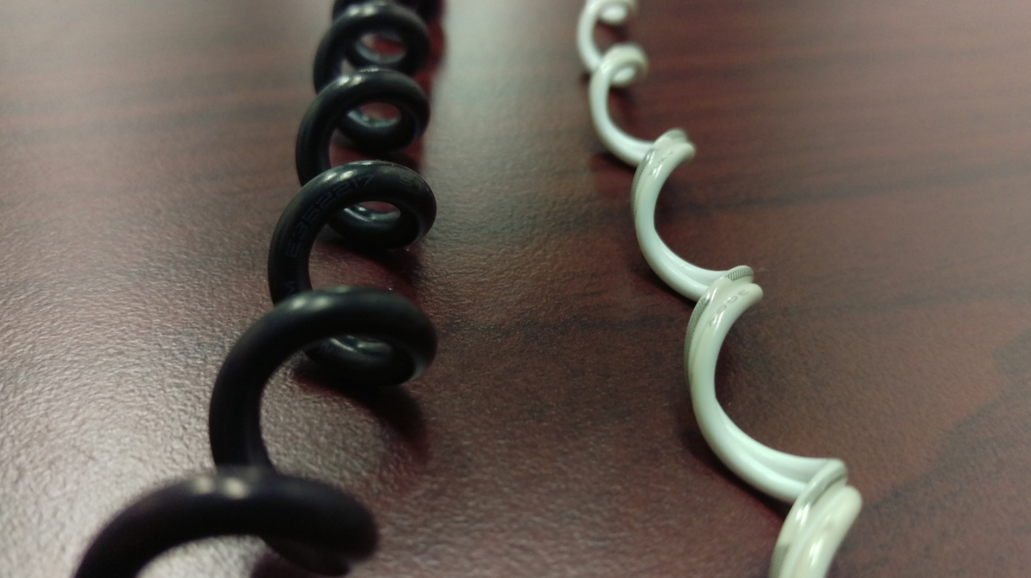

White Cable has the cross section that we require

#### 2.4 Mechanical Specifications

The 3D CAD shall be modeled on nominal dimensions and shall be the primary source of dimensional information.   
  
All devices shall ship with batteries installed and connected. Devices will be in sleep/shipping mode until plugged in.

##### 2.4.1 Material

|  |  |
| --- | --- |
| **Item** | **Description and specifications** |
| Type | Plastic |
| Resin | Blue:3005U;  Gray:CoolGray6U |
| Finish | Same as Guardian |

##### 2.4.2 Tooling

Tooling shall be good for over 300,000 injections.

##### 2.4.3 Fit and Finish

* Flash allowance shall not to exceed 0.13 mm (0.005in). Flash applies to parting lines, ejector pins, ejector blades and ejection sleeves
* Parting line mismatch shall not exceed 0.13 mm (0.005 in)
* Gate & Ejector pin scar/vestige shall be sub-flush unless otherwise specified
* Cosmetic surfaces shall be free of nicks, scratches, or tooling marks
* The finish and color shall be similar to the Guardian. Non-visible surfaces may not be textured
* Guardian logo, power, WiFi, and Guardian RF icons will be glossy, similar to Guardian

#### 

#### 

#### 

#### 

#### 

#### 2.5 Battery Specifications

##### 2.5.1 General Specifications

|  |  |
| --- | --- |
| **Item** | **Specifications** |
| Model No. | Li-polymer Rechargeable battery  1100mAh 3.7V 4.07Wh 603450  L/N: 1512 1ICP7/35/51 |
| Sizes: | H (Max): 53.4 mm  W (Max): 35 mm  T (Max): 6.5 mm (Initial Dimension)  7.0 mm (After cycling 300 times)    H: height W: width T: thickness |
| CONNECTOR WIRE | ACES 50233-003 UL3302 AWG28# |

##### 2.5.2 Electrical Characteristics

|  |  |  |  |
| --- | --- | --- | --- |
| **Item** | **Specification** | | |
| Minimum capacity | 1100 mAh @ 0.2C Discharge | | |
| Battery impedance | ≤ 220 mΩ | | |
| Cell impedance | ≤ 70 mΩ | | |
| Shipment voltage | ≥ 3.7V | | |
| Weight | Approximately 24g | | |
| Nominal voltage | 3.7 V | | |
| Fully charge voltage(FC) | 4.2 V Defined in this DOC: FC = 4.2 V | | |
| Fully discharge voltage(FD) | 3.3 V Defined in this DOC: FD = 3.3 V | | |
| Standard charge current | 0.5 C | | |
| Standard charging method | 0.5C CC (constant current) charge to FC, then CV(constant voltage FC) charge till charge current decline to ≤0.01C | | |
| Charging time | Approximately 5 hours (Standard charging) | | |
| Standard discharge current | 0.2C | | |
| Max. charge current (0℃～15℃) | 0.2C | | |
| Max. charge current (15℃～25℃) | 0.5C | | |
| Max. charge current (25℃～45℃) | 1C | | |
| Max. discharge current (-10℃～15℃) | 0.2C | | |
| Max. discharge current (15℃～60℃) | 2.73C(3A) Duration: 0.1s | | |
| Charge cut-off voltage | 4.25 V | | |
| Discharge cut-off Voltage | 3.25 V | | |
| Storage temperature (-20℃~60℃) | ≤1 month | The duration when percentage of recoverable capacity is no  less than 80% of the initial capacities. | |
| Storage temperature (-20℃~45℃) | ≤3 month |
| Storage temperature (-20℃~28℃) | ≤1 year |
| Recoverable capacity | Constant current 0.5C charge to FC, then constant voltage FC charge to current declines to 0.01C, rest for 10min..constant current 0.5C discharge to FD..rest for 10min.Repeat above steps 3 times, recording the maximum capacity | | |
| Storage humidity | ≤75% RH | | |
| Appearance | Without distortion, leakage, smoke, or flames | | |
| Standard testing condition | Temperature: 23 ± 5℃  Humidity: ≤75%RH  Atmospheric pressure: 86-106 Kpa | | |
| Safety Charge Limitation | Temperature Range | Maximum Charging Current | Maximum Charging Voltage |
| -15℃~0℃ | 0.1C | 4.1V |
| 0℃~10℃ | 0.5C | 4.2V |
| 10℃~45℃ | 1C | 4.2V |
| 45℃~60℃ | 1C | 4.2V |
| Safety Discharge Limitation | Temperature Range | Maximum Discharging Current | Minimum Discharging  Voltage |
| -20℃~-10℃ | 0.1C | 3.3V |
| -10℃~0℃ | 0.2C | 3.3V |
| 0℃~15℃ | 0.2C | 3.3V |
| 15℃~45℃ | 1C | 3.3V |
| 45℃~60℃ | 1C | 3.3V |

##### 2.5.3 Performance Specifications

|  |  |  |
| --- | --- | --- |
| **Item** | **Test Methods and Condition** | **Criteria** |
| 0.2C Capacity | At standard testing condition, after standard charging, rest battery for 10min, then discharging at 0.2C to voltage FD, recording the discharging time. | ≥300min |
| 1C Capacity | At standard testing condition, after standard charging, rest battery for 10min, then discharging at 1C to voltage FD, recording the discharging Capacity | ≥54min |
| Cycle Life | Constant current 0.5C charge to 8.40V, then constant voltage charge to current declines to 0.01C, rest 10min ， constant current 0.5C discharge to 8.40V， rest 10min. Repeat above steps till continuously discharging capacity Higher than 80% of the Initial Capacities of the Cells | ≥ 300 times, thickness swelling  ≤ 8% |
| Charging and Discharging at low temperature (0~10℃) | At 0~10℃, constant current 0.5C charge to FC, then constant voltage charge to current declines to 0.05C, rest 10 min, constant current 0.5C discharge to FD, rest 10min. Repeat above steps no more than 50 times. Using the Cell on this condition, the attenuation of the capacity accelerates. | No safety issue |
| Charging at low temperature (-15~0℃) | At -15~0℃, constant current 0.1C charge to 4.1V, then constant voltage charge to current declines to 0.05C. Charging at this condition no more than 50 times. Using the Cell on this condition, the attenuation of the capacity accelerates. | No safety issue |
| Self-Discharge | At 23±2℃, Humidity≤75%RH, Atmospheric pressure 86-106 Kpa, After standard charging, no outer loading circuit, rest the pack one month. Then use 0.2 C discharge to FD, recorded discharge time | ≥ 276min |

##### 2.5.4 Environmental Specifications

|  |  |  |
| --- | --- | --- |
| **Item** | **Test Methods and Condition** | **Criteria** |
| Discharge at high temperature | At standard testing condition, after standard charging, rest the Cells 4h at 60±2℃, then discharging at 1C to voltage FD, recording the discharging time. | ≥54min |
| Discharge at low temperature | At standard testing condition, after standard charging, rest the Cells 16h at -20±2℃, then discharging at 0.2C to voltage FD, recording the discharging time. | ≥210min |

##### 2.5.5 Safety Characteristics

|  |  |  |
| --- | --- | --- |
| **Item** | **Test Methods and Condition** | **Criteria** |
| Overcharge testing (NO PCM) | At standard testing condition, charging cells with constant current 3C to voltage 4.6V, then with constant voltage 4.6V till current decline to 0. Stop test till cells temperature 10 ℃ lower than max temperature. | No smoke or fire |
| Over discharge testing (NO PCM) | At standard testing condition, the cells will be discharge to cut-off voltage, then connect with external load of 30 ohm for 24 hours. | No fire, no smoke, no leaks |

### 3 Functional Requirements

The Sump Pump Monitor measures water level and pump current to detect abnormal conditions.

#### 3.1 LEDs

The three LEDs on the front of the Sump Pump Monitor will behave the same as the Guardian.

#### 3.2 Speaker

When an alarm condition is detected the Speaker will beep like the Guardian, but after 5 beeps the speaker will play an audio warning describing the condition detected like “Overflow Detected” or “Power Failure”. After the audio warning, the sequence of 5 beeps and audio warning will repeat until the alarm is cancelled. The audio warning must be clear and of high quality, preferably a female voice with a Southern accent.

##### 3.2.1 Beep

The beep will be a 2.6 kHz tone, at least 80 dB, with the same duration and period as the Guardian.

##### 3.2.2 Speaker Grill

The plastic case will need a grill for the speaker to maximize the volume.

#### 3.3 Button

The button on the front of the Sump Pump Monitor is used for cancelling alarms. Additionally the button can be held for 15 seconds to clear the WiFi settings and 10 more seconds to perform a factory reset.

#### 3.4 Cable

The cable will connect to the Sump Pump Monitor via 3.5mm TRRS (4 conductor) jack under the battery cover.

#### 3.5 Power

* When plugged in, the unit shall run on AC AND charge the battery
* When plugged in, the unit shall run on AC with a failed battery
* When plugged in, if power is lost, the unit shall operate on battery power

#### 3.6 Guardian App and Leak Detector Pairing

The Sump Pump Monitor can be connected with the Guardian App and communicate over WiFi. After connecting with the Guardian App the Sump Pump Monitor can pair with Leak Detectors.

##### 3.6.1 WiFi/BT Name

The device must broadcast a unique BT/WiFi name ‘GuardianSPM - XXXX’ where the device PIN replaces XXXX.

##### 3.6.2 Guardian App

When paired with the Guardian App the level of information/data the user can access is TBD

#### 3.7 Notifications

The user will be notified of abnormal conditions via audio and in-app notifications (if paired to app).

##### 3.7.1 Conditions

* Sump overflow
  + The sump overflow condition is triggered when the overflow sensor on the Probe cable comes in contact with water. The audio notification will be “Overflow detected”
* High water level/pump float stuck down
  + The high water level condition is triggered when the Probe sense wire detects the sump water level is much higher than normal. The audio notification will be “High water level”
* Pump running too long/float stuck up
  + The pump running too long/float stuck up condition is triggered when the pump has been running for longer than usual and the pump current drops, indicating a dry sump. The audio notification will be “I’m getting tired”
* High current use by pump/pump failure imminent
  + This condition is triggered when the pump is running and the measured current is much higher than normal. The audio notification will be “Pump overworked”
* Pump blockage
  + This condition is triggered when the pump is triggered at the normal high water level by the float but the water level is decreasing slower than normal and the pump is drawing more current than normal. The audio notification will be “Pump blockage”
* Power failure
  + The power failure condition is triggered when the unit loses AC power. The Monitor must be able to function for 6 hours without power. The audio notification will be “Power failure”
* Leak Detected
  + The leak detected condition is triggered when a paired Leak detector encounters water. The audio notification will be “Leak Detected”

##### 3.7.2 Notification Priority

If multiple conditions are detected the device will play each audio notification sequentially. For example:

If there is a power failure and an overflow there will be 5 beeps then “power failure” then 5 beeps then “overflow detected” then the sequence repeats.

#### 3.8 Standalone Operation

Because there is no calibration required when the user pairs the Sump Pump Monitor to their Guardian App after physical installation, the Monitor should be able to function the same way if the user chooses not to connect it to their WiFi. In this case, the only notifications the user will receive will be audio. Note that the option to pair Leak Detectors will be unavailable in standalone mode.

#### 3.9 Firmware Upgrades

The Sump Pump Monitor will be capable of OTA firmware updates. In case an OTW firmware update is required during development and testing the device will be designed in such a way that the firmware can be updated without risk of electrocution.