# Quick-Start Guide to WSJT-X Version 1.1

Upgrading to *WSJT-X* Version 1.1 increases your maximum displayed bandwidth from 1000 to to 5000 Hz and brings you the JT65A mode as well as JT9. If your receiver provides an SSB filter with at least 4 kHz bandwidth, set your HF dial frequency to one of the standard JT65 frequencies — for example, 14.076 MHz for 20 meters. The full range of frequencies occupied by JT65 and JT9 signals will then be displayed on the waterfall, and you can make QSOs on both modes using the usual double mouse-click procedure and no other switching. If you’re an experienced user of *WSJT-X*, this brief guide should help you get started with version 1.1.

# Installation and Initial Checkout using Sample Files

1. Install the Windows package in the usual way. The default installation directory is presently configured as C:\WSJTX2, so you can keep your v1.0 installation intact in its directory C:\WSJTX. If desired, you may copy your configuration file wsjtx.ini into the new installation directory. Version 1.1 works well in Linux and OS X, as well as windows: see last page for some details.
2. Start *WSJT-X* from the new location and enter any missing configuration parameters.
3. Select **JT9+JT65** on the **Mode** menu.
4. Use the mouse to drag the left and right edges of the Wide Graph to extend it to nearly the full screen width. Increase **Bins/Pixel** until the waterfall’s frequency scale extends to at least 4000 Hz. Then use the mouse to decrease the Wide Graph’s width until the 4000 Hz tick mark is just visible at the right edge.
5. Set the **Slope** control to 1.1 (more on this parameter below).
6. Note that instead of the parameters **f Min** and **f Max** used previously, v1.1 has a single parameter **JT65 3000 JT9**. The number in the middle is an audio frequency in Hz that sets the expected dividing line between JT65 and JT9 signals. A reasonable value is something like 2700 Hz.
7. So your results will be identical to those on the next page, toggle the button **Tx JT9** so that it reads **Tx JT65**, and set the Tx and Rx frequencies to 1714 Hz.
8. Click on **File | Open**, navigate to the …\save\Samples directory under your installation directory, and open the sample file 130610_2343.wav. The waterfall and main window should look like the screen shots on the next page. The sample file contains 17 decodable signals — nine in JT65 mode (flagged with the character # in the decoded text windows), and eight in JT9 mode (flagged with @). Since the Tx mode was set to **Tx JT65**, signals in that mode were decoded first. If you had selected **Tx JT9**, JT9 signals would be decoded first.
9. You should confirm that mouse-click behavior is similar to that described in the Basic Operating Tutorial of the v1.0 [WSJT-X User’s Guide](http://www.physics.princeton.edu/pulsar/K1JT/WSJT-X_Users_Guide.pdf). Most commands behave nearly identically in v1.1, with the program determining the mode (JT9 or JT65) of each signal. For example, double-click on the waterfall near 813 Hz: a signal originating from W7VP will be decoded, and the line

2343 -11 0.3 813 # KK4DSD W7VP -16

should appear in the QSO Frequency text box. Double-click on the waterfall at 3196 Hz and the program will decode a JT9 message from IZ0MIT:

2343 -7 0.3 3196 @ WB8QPG IZ0MIT -11

Notice that when a signal is decoded in this way the Tx mode automatically switches to that of the decoded signal, and Rx and Tx frequency markers on the waterfall scale resize themselves accordingly.

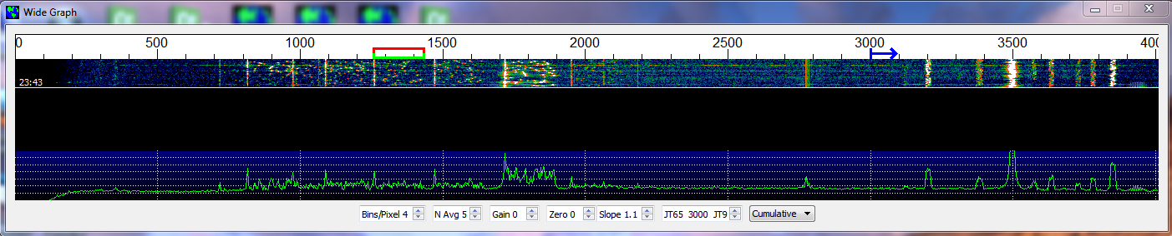

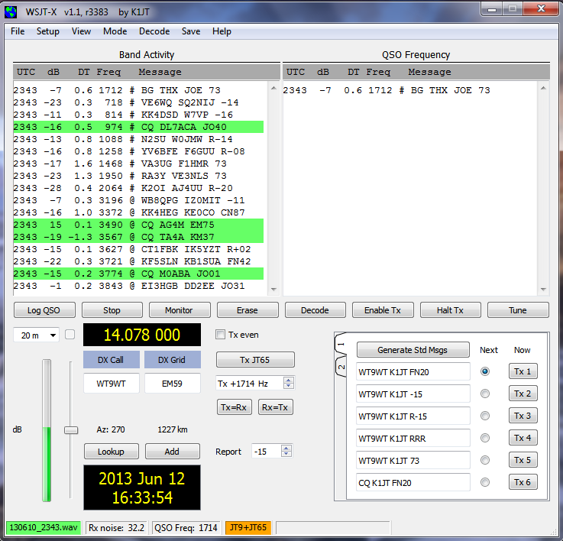

1. Scroll back in the Band Activity window and double-click on the message CQ DL7ACA JO40. The program will set Tx mode to JT65 and Tx and Rx frequencies to that of DL7ACA, 974 Hz. If you had checked **Double-click on call sets Tx Enable** on the **Setup** menu, the program would prepare itself to start a QSO with DL7ACA.
2. Double-click on the decoded JT65 message CQ TA4A KM37. The program will set Tx mode to JT9 and both frequencies to 3567 Hz. You’re now configured properly for a JT9 QSO with TA4A.
3. Open the other file in the Samples directory, …\save\Samples\130418_1742.wav. You may have seen this file before — it’s part of the *WSJT-X* v1.0 installation package. The waterfall display reveals that these data were recorded with a much narrower Rx bandwidth (the **Low Cut** and **High Cut** settings on my TS-2000 were 200 Hz and 2600 Hz, respectively). You will necessarily have data similar to this if you have no Rx filter wider than about 2.7 kHz. For best viewing of such data reduce the width of the Wide Graph so that only the active part of the spectrum shows. The signals in this file are all JT9 signals; to decode them you’ll need to move the **JT65 | JT9** delimiter down to, say 1000 Hz. This setup is very similar to what you have used with *WSJT-X* v1.0.
4. Now is a good time to experiment with the **Zero** and **Slope** parameters. **Zero** sets the baseline level for waterfall colors, while **Slope** provides a way to correct for non-flat spectral response in your radio. For the receiver setup of this file good values are around –8 and +0.2, respectively. If the **Cumulative** spectral baseline (green curve) slopes downward toward higher frequencies, increase the **Slope** setting. Re-open the wave file after each change, to see the new results. Here’s the resulting waterfall display with parameters set properly for my radio with 200-2600 Hz filter settings:

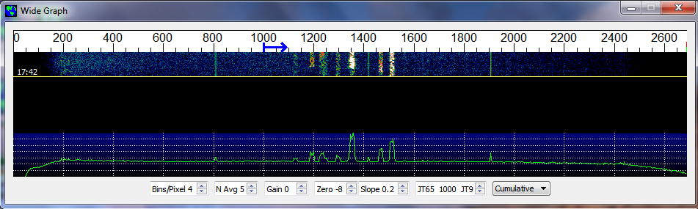

# Basic On-the Air Operation

1. To take advantage of the wideband, dual-mode capability of *WSJT-X* v1.1, set your Rx bandwidth to at least 4 kHz (USB mode, of course). On the TS-2000 I set **Low Cut** to 200 and **High Cut** to 5000 Hz. Note that the fixed Tx filters in most SSB transceivers will not pass audio frequencies higher than about 2700 Hz; *WSJT-X* v1.1 takes care of this by using **Split** mode. The Tx dial frequency (VFO B) is offset in 1000 Hz steps, with the generated audio frequency adjusted to fall in the range 1000 – 2000 Hz. With CAT enabled and your transceiver set to **Split** mode, frequency control will be handled automatically.
2. If you have only a standard SSB filter on the Rx side you won’t be able to use more than about 2.7 kHz bandwidth. You can still have all of the JT9 and part of the JT65 sub-band available, however. On 20m, say, set dial frequency (VFO A) to 14.0774 and the **JT9 | JT65** dividing line at 1600 Hz. JT9 signals in their conventional sub-band will then appear at 1600 – 2600 Hz, while JT65 signals are below 1000 Hz.
3. **This is important:** *JT-Alert* version 2.2.4, by VK3AMA, does not yet know about the dual-mode capability of *WSJT-X*. Do not use JT-Alert with *WSJT-X* v1.1 until Laurie has a chance to update his program.
4. Otherwise, operation of *WSJT-X* v1.1 is similar to v1.0. PSK Reporter should work normally. Note that without *JT-Alert* your signal reports won’t appear on HamSpots.
5. You’re now ready to go! With *WSJT-X* v1.1 you can make JT65 and JT9 QSOs, alternating between the two modes as you wish, using nothing but mouse clicks.

# Differences Between JT65 and JT9

JT65 has been widely used for EME on the VHF/UHF bands since 2003. More recently it has also become popular on the HF bands. It’s a mature mode with well-optimized decoders. The two modes use essentially the same message structure and QSO procedures, but internally they use widely different coding, synchronization, and modulation schemes. JT9 is about 2 dB more sensitive than JT65 and uses less than 1/10 the bandwidth.

Both modes compress user messages into 72 bits and add strong forward error correction (FEC). Received messages are almost always decoded exactly as transmitted, or there will be no decode at all. The Reed-Solomon code used in JT65 has rate r = 12/63 = 0.19, which implies a redundancy ratio 1/r = 5.25. Each transmission uses 63 six-bit symbols, 378 bits in all, to convey 72 bits of user information. In addition to the information-carrying symbols, JT65 devotes half of its transmitted energy to a synchronization tone keyed in a pseudo-random pattern known to the receiving software. The JT65A tone spacing is 2.69 Hz, and the total bandwidth 177.6 Hz.

In contrast, JT9 uses a long-constraint (K=32) convolutional code with nominal rate r=1/2 and a zero tail. As a result there are (72+31) × 2 = 206 information-carrying bits in a transmission. These bits are transmitted using 69 three-bit symbols, and a further 16 symbols carry synchronizing information. The JT9-1 tone spacing is 1.736 Hz, and total bandwidth 15.6 Hz.

It will be interesting to see how these two very different schemes compare in practice, on the various amateur MF and HF bands and under different propagation conditions. Please share your experiences with others!

# Linux and OS X

*WSJT-X* v1.1 works well under Linux and OS X, but at present on these systems you’ll need to compile the program yourself or obtain it from someone who has done so. You will also need a copy of kvasd, the executable program implementing the Koetter-Vardy algebraic soft-decision Solomon decoder. And to a greater extent than with Windows, you’ll need to know your way around your system from a program-development point of view.

# Summary

*WSJT-X* v1.1 should be an excellent tool for making detailed comparisons of the JT65 and JT9 protocols. Evidence to date shows that on-the-air performance is comparable, with a slight edge to JT9 at the lowest decodable signal levels. Note that the waterfall screen shot on page 2 (a full-size version of whick is available at <http://physics.princeton.edu/pulsar/K1JT/wsjtx_1.1c.png> ) shows how nine JT65 signals already fill most of that mode’s conventional 2 kHz sub-band, even with some of overlapping. In comparison, the eight JT9 signals have no overlap and leave plenty of room for several dozen signals, even in a 1 kHz sub-band. Arguably JT9 makes much better use of available spectrum and has few if any disadvantages. I invite you to make your own side-by-side comparisons of JT65 and JT9.

Finally: *WSJT-X* v1.1 r3389 is alpha-level software. It has been tested at my station under Windows 7 and Ubuntu Linux, and by G4KLA under OS X, but not yet with many other setups.

Please report any problems with its use! An open release of v1.1 is likely within a few weeks.

*Joe Taylor, K1JT — June 24, 2013*