**WSPR-X User’s Guide**

Joe Taylor, K1JT

Revision date: January 9, 2013

# Overview

WSPR-X is an experimental version of WSPR that implements a slow mode using 15-minute rather than 2-minute T/R sequences. The program is in an early stage of development: it does not support I/Q audio for use with direct conversion equipment, and it does not do "band hopping". This early release is primarily intended to facilitate experimentation with the slow “WSPR-15” mode on the MF and LF bands. For background information and a full description of the WSPR protocol, see the [WSPR 3.0 User’s Guide](http://physics.princeton.edu/pulsar/K1JT/WSPR_3.0_User.pdf). This brief document should help you get started with WSPR-X. It assumes that you are familiar with previous versions of WSPR.

# Basic Operating Instructions

1. On initial program startup WSPR-X should look something like the following screen shot:

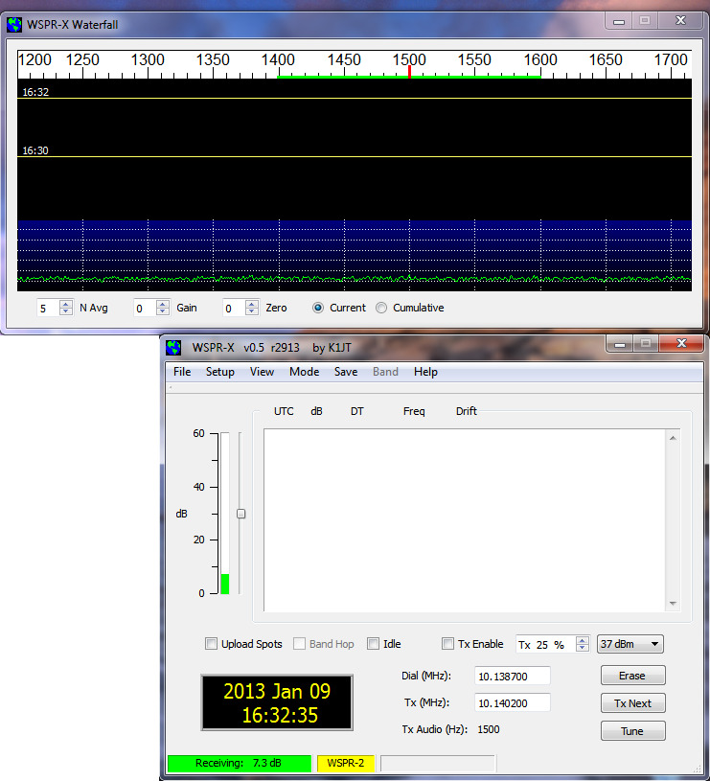

1. Hit **F2** to activate the **Setup | Options** screen. Enter your callsign and grid locator, the COM port to be used for PTT control, and select the desired devices for Audio In and Audio Out.

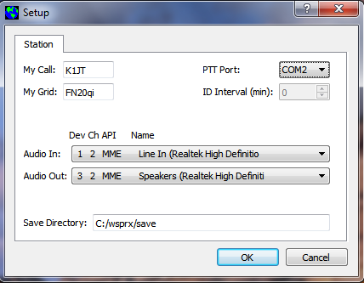

1. Your SSB transceiver’s dial frequency should be entered in the **Dial (MHz)** entry field on the main screen. The 200-Hz WSPR-2 sub-band lies 1400 to 1600 Hz above the dial frequency; this range is indicated by a green bar on the scale at top of the waterfall window. If you will be transmitting, double-click on this scale to select your Tx frequency, which will then propagate to the **Tx (MHz)** entry field and the **Tx Audio (Hz)** label, and select your Tx power from the **dBm** spinner control

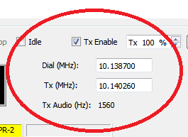

1. The program enters receiving mode automatically on startup. If you wish also to transmit, check **Tx Enable** and set the desired percentage of Tx sequences, e.g., 25%. Checking **Upload Spots** will cause the details of your decoded WSPR transmissions to be uploaded to [WSPRnet.org](http://www.WSPRnet.org).