**Usability Study on YouTube’s My Channel Page**

**By**

**Mounish Thatikonda**

**Introduction:**

Youtube is a video sharing website where a millions of videos are uploaded by users every year, in this website users can upload, view, share, rate, like, unlike, comment on the videos, usage of this website is growing rapidly year after year, Youtube uses adobe flash player to play the videos recently it upgraded to its own player called Youtube html5 player. Usually the videos are uploaded by individual users or by corporate companies. The videos include entertainment, educational, video blogging, etc. kind of videos, now a days few series are also releasing on Youtube instead of televisions. And even most of the television channels telecast on Youtube real-time. Some of the corporate companies make some content available for us only after we pay certain amount, and come of them rent movies on Youtube. Youtube has become a powerful tool to search the video contents, it will working as powerful as google search engine but only for videos.

**History:**

Youtube was founded by Chad Hurley, Steve Chen, jawed Karim, those three guys where the employees of PayPal. When they have thought about the website they just have prototype then, and bought the domain www.youtube.com in early 2005s and later on with the support of Sequoia Capital Company they started developing into a working model and got succeeded, until late 2006 it was a popular and only good website for sharing videos. In October 2006 google Inc. acquired this website for a $1.6 billion amount, later on google has introduced some revolutionary changes to Youtube and at this point it was the best and popular video sharing website in the whole world.

**My Channel:**

It is a page in Youtube.com where the user get to upload the video and manage and organize the video stuff. The guest user of Youtube will not be having access to that page, however user has to sign up first or if user have a google account it is possible to login with that. After logging in user can see a dashboard on the left side of the home page where my channel link is located as per present user interface. And on the top of my channel home page its gives users option to keep their display picture and also cover photo for that channel, and later coming down we can see the list of videos uploaded by us, those list will be sorted by date, we also can sort them as we want or we also can classify them into parts where some of the videos comes under one category and some other in other category, so this is about the home page.

While coming to the analytics, we will be provided with various number of analytics of our videos which helps us in improvement and development. Those analytics includes graphs and graphical illustrations of our video’s characteristics among the people who use watched our videos. And all these options like analytics, live stream, dashboard and subscriptions comes under creator studio which is the major tool for frequent video uploaders. It helps really well for the users who has YouTube as their carrier.

**Objectives of the study:**

As this website Youtube is meant for videos, uploading videos will be the important part, and later analyzing editing and sharing them. So ultimately my channel page is very important in the Youtube. But we are frequently hearing from many Youtube users that they are facing any difficulties in uploading videos, they are encountering some bugs while uploading, and also problems with playback after the was uploaded, and finally need some more in depth analysis on the uploaded videos. So for these reasons now this study is concentrated on these questions. For this study, I have done ***site visit*** and also conducted ***online survey***, and I have also people to perform a simple task regarding this section during the site visit.

**Participants:**

Participants here are divided into two categories, one is who I interviewed in site visit and another one who I took survey online. So totally twenty three people participated in this study from them 13 took the online survey and 10 of them participated in the interview. As Youtube is a video sharing website people who use them should feel ease to navigate through out the website and find everything that relates to uploading a video easy. To make sure weather the required qualities are accessible easily I asked few questions and also asked the participants to do a tasks that is to upload a small video provided by me and delete it later publishing it. Before conducting the interview participants where pre assessed to make sure that all the participants have Youtube accounts. Interview was held in an Engineering college’s library, at first I asked few random people in the whole college about the interview if they were interested and allotted a time frame for each of them who accepted and interview location was given. That place resembles to be an apt environment for conducting interviews. Students from different courses and different years participated in it, they were very excited about the interview as they feel that using Youtube has some real troubles. And while coming to the online survey, it is designed in google forms and that particular link has been shared with 15 of my present classmates and college mates from Frostburg state 2 of them didn’t responded for my request so finally the survey was done with 13 people.

**Data Collection:**

Planning is very important in site visits, to make the site visit success a script of the interview questions where prepared after planning the site visit keeping in mind all the aspects of the website which is going to be studied. The script includes the following data including instructions which the interviewer has to follow and the questions he has to ask and also the general greetings. The script for this study is given clearly below.

*Name ______________________*

*Place: ______________________*

*Date: ______________________*

*Time: _____________________*

***Script****: Well wishing, thank you for accepting to give me this interview, it will take around 10 to 15 minutes, I will ask you few questions first and later I will ask you to perform few small tasks in Youtube website, I will be observing you and I will record the audio in my mobile phone throughout the whole process,**Is that ok with you*

*If yes turn on the recorder*

*If not continue.*

*Questions:*

*Except the first one all he questions comes with 3 options which are beginner, intermediate, expert.*

*Which field are you currently studying in?*

*What do you think your level of experience with the computer?*

*What do you think your level of expertise with Youtube?*

*What do you think you level of experience with my channel page?*

***Task:***

***S****o as of now we completed questions section so let’s begin with task section, please logon to this computer and open a browser and login to Youtube with your account details and open my channel page.*

***Wait for the user to complete all the tasks***

*Now can you please upload the small video provided by me in a flash drive to Youtube and delete it after you published. And during this process you cannot ask me or anybody else for help and feel free to comment whenever you want in this process, are you ready?*

*If yes*

***Start the stopwatch and wait for the user to complete the task and note down the time****.*

*As you completed the task, I would like to ask few questions about the task.*

*Record all answers for the questions.*

*What do you think is frustrating in the task that I asked you perform?*

*What changes do you think will improve this process?*

*What do you think about this my channel page?*

*Any other comments that you like to say?*

*Finally state any insight in the given task?*

And while coming to online survey questions are organized in reasonable manner using google forms and shared with the people who has an Youtube account, the format of the questions are as follows

1. *Full name*

*___________________*

1. *Age*

*___________________*

1. *Gender*

*___________________*

1. *Occupation*

*___________________*

1. *How long have you been using Youtube?*

*(Number of years)*

1. *Since how many years you are owning a channel?*

*(Number of years)*

1. *How do you rate the video uploading procedure?*

*(Rate: bad, good, excellent)*

1. *How to you rate the privacy?*

*(Rate: bad, good, excellent)*

1. *How often did you use creator studio features?*

*(Never, once in a while, often)*

1. *What lags did you find in using MyChannel page?*

*______________________*

1. *What changes do you recommend for this page?*

______________________

1. Any other comments?

And the responses and the statistics for these questions are given in the appendix A, so by analyzing these responses we have to conclude the apt model.

**Analysis:**

With the reference of ‘user and task analysis for interface design’ chapter 11 about the methods of analyzing data, it is decided to going with two methods which are ‘**User matrix’** and ‘**task flowchart’**  , task flowchart is used to illustrate the flow of the task given to the user during the site visit, this one helps us finding any difficulties that we faced in the middle of the process of the task for each and every member at real time when ever error is occurred. And the user matrix is used to table up the contents we find in site visits and analyze those listings side by side and organize the collected data.

**Task flowchart:**

It is used to examine the flow process of every user individually , and also to get updates about the process whenever needed, as the task is given to the participants they had difficulty in whole process mainly during the uploading process , that’s why this chart refers users to leave a comment about the possibilities , and after uploading sometimes it won’t play , it will get lost , for that reason it asked to leave a comment if there is any problem with playback, the chart given below is the flow chart for the task given.

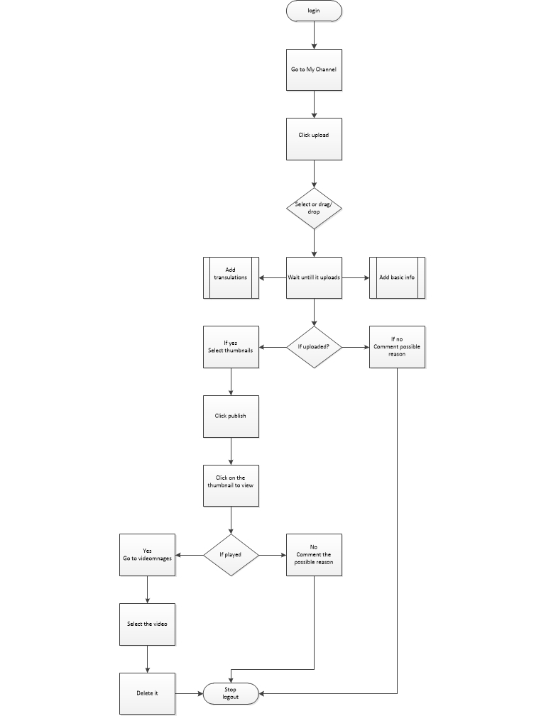

**User matrix:**

User matrix is built to help organize the data that we collected from site visit, this helps us to get a better idea of the enormous data that make sense to us. The table presented below shows the results of the questions asked in the site visit, this table helps getting the bad qualities that affect user for doing his job. This data was used to complete further study.

|  |  |  |  |  |  |  |  |  |
| --- | --- | --- | --- | --- | --- | --- | --- | --- |
| USER MATRIX | | | | | | | | |
| Basic  observations | Time and date | Current field of study | Experience with computer | Experience with Youtube | Experience with my channel page | Time taken to complete the task(excluding time for uploading) in sec | Felt any difficulty  Completing the task |
| P1 | 7/25  10.11 | Electronics | Intermediate | Intermediate | Beginner | 125 | yes |
| P2 | 7/25  10.30 | Electronics | Intermediate | Intermediate | Beginner | 114 | yes |
| P3 | 7/25  10.50 | Civil engineering | excellent | excellent | intermediate | 80 | no |
| P4 | 7/25  11.10 | Aeronautical | Excellent | Intermediate | Intermediate | 88 | No |
| P5 | 7/26  14.45 | Electrical | Intermediate | Beginner | Beginner | 139 | yes |
| P6 | 7/26  15.02 | Electrical | Excellent | Beginner | Beginner | 120 | no |
| P7 | 7/26  15.16 | Computer science | Excellent | Excellent | Excellent | 63 | No |
| P8 | 7/26  15.37 | Computer science | Excellent | Excellent | Excellent | 71 | No |
| P9 | 7/26  16.03 | Bio tech | Beginner | Beginner | Beginner | 192 | Yes |
| P0 | 7/26  16.24 | Bio tech | Intermediate | Intermediate | beginner | 132 | yes |

**Analysis of findings:**

So for the Youtube/mychannel page regarding uploading the video the first problem facing by many users is video formats. when they try to use the format that is not supported by the Youtube they say it as ‘annoying’ ‘frustrating’, so for that they have to convert the video in some other application and bring it back here to upload, the second thing is internal bugs during upload that stop or hangs the process, for this user have to redo it all over again, its ok if it is a small video what if it is a big one and stopped in the final stages f upload process. Third one is playback, due to cache errors videos won’t play properly even though it is uploaded.

**Conclusion:**

**A**s a conclusion, it will be so much accessible for the users if the video formats that are accepted by the Youtube is increased to the level that there are no other formats for videos. And next thing is traffic, videos fail to upload during peak hours due to high traffic, to solve this problem Youtube could increase server count to give users better experience. The last one is video playback , videos won’t play at all , so for this users have to clear their cache and cookies for their browser, this is annoying there could be a link at least that says ‘ click here to play your video (clear your cache and cookies)’ and clears whichever is required after asking for permissions. These are all the suggestions based up on the user suggestions that are taken from the site visit and online survey.

**Appendix A**

Online survey – source: forms.google.com

**Usability study on Youtube my channel page**

Pie diagrams that shows the majority of the user behavior in this survey

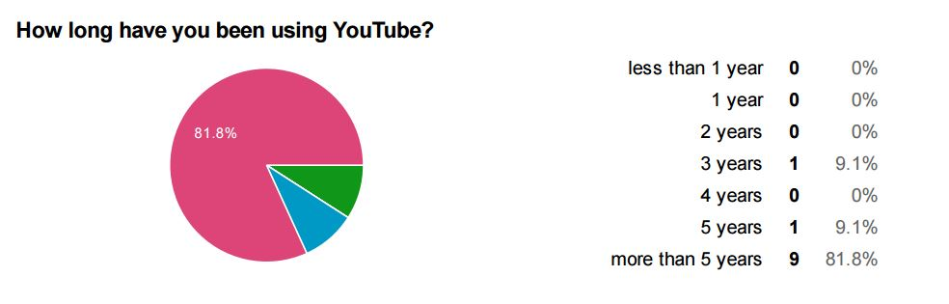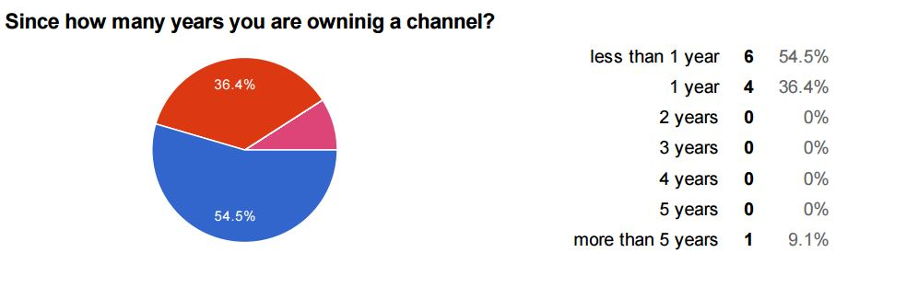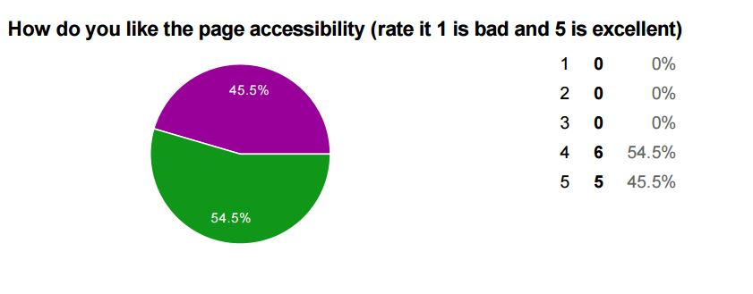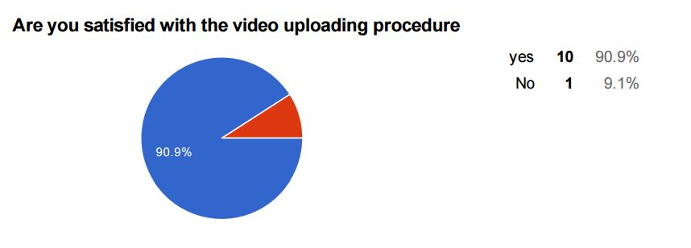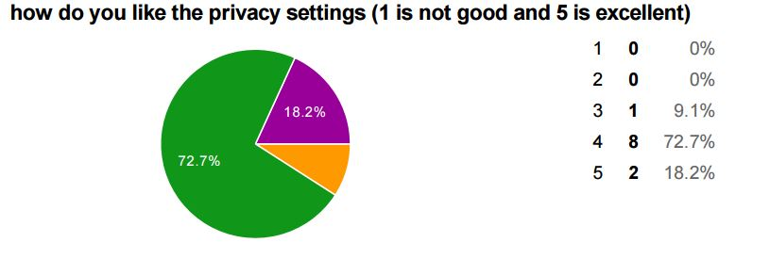

**References:**

1) Hackos, J. T., & Redish, J. (1998). User and task analysis for interface design. New York: Wiley.

2) Norman, D. A. (2002). The design of everyday things (1st Basic paperback. ed.). New York: Basic Books.

3) www.youtube.com