**Q1.**

**CODE:**

package Q_01;  
import javax.swing.*;  
  
public class framewindow {  
 public static void main(String[] args) {  
  
 JFrame myWindow;  
 myWindow=new JFrame();  
 myWindow.setSize(800,600);  
 myWindow.setTitle("Welcome to Java");  
 myWindow.setVisible(true);  
  
 }  
}

**OUTPUT :**

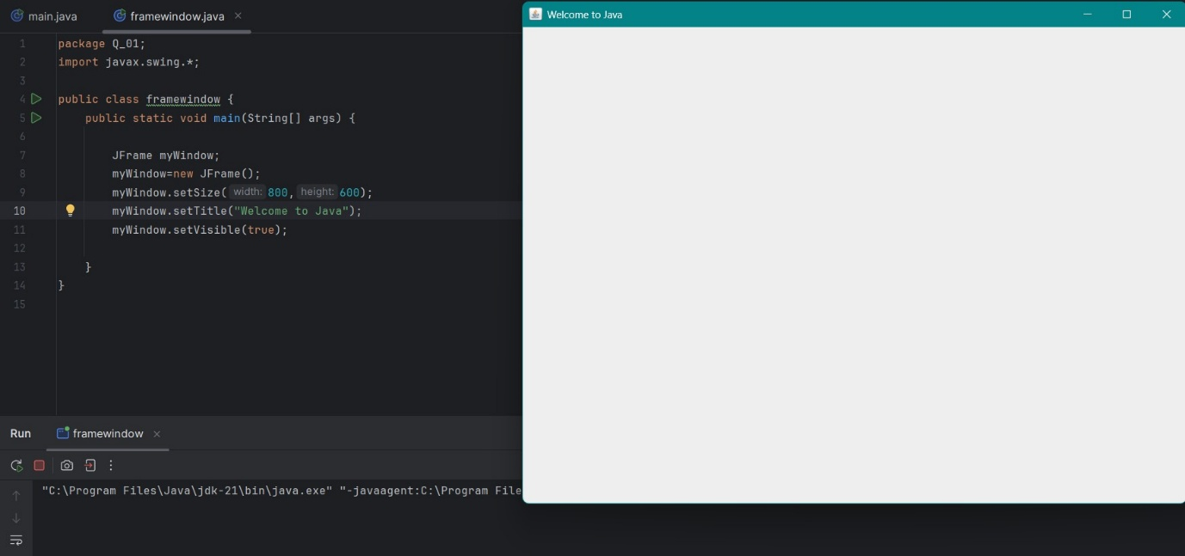

**Q2.**

**CODE :**

package Q_02;  
import javax.swing.*;  
import java.util.Scanner;  
  
  
public class username {  
 public static void main(String[] args){  
 Scanner scanner=new Scanner(System.*in*);  
  
 System.*out*.println("Enter your first name:");  
 String firstName=scanner.nextLine();  
  
 System.*out*.println("Enter your last name:");  
 String lastName=scanner.nextLine();  
  
 String fullName=firstName+" "+lastName;  
  
 JFrame username;  
 username=new JFrame();  
 username.setSize(600,400);  
 username.setTitle(fullName);  
 username.setVisible(true);  
  
 }  
}

**OUTPUT :**

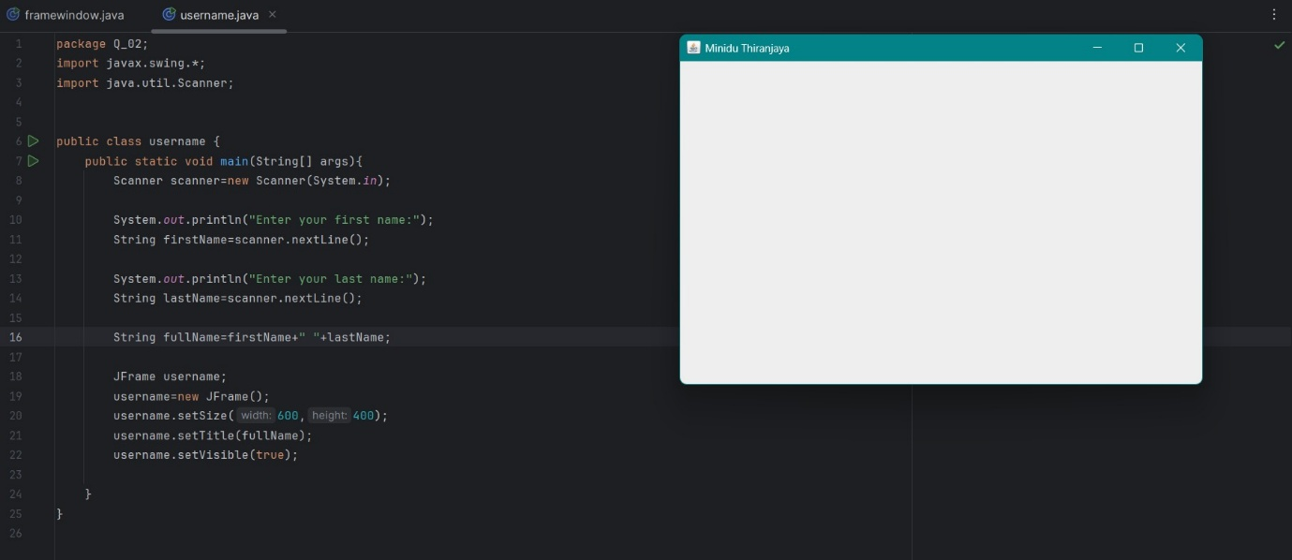

**Q3.**

**CODE:**

package Q_03;  
import javax.swing.*;  
import java.util.Scanner;  
  
public class f_name {  
 public static void main(String[] args) {  
 Scanner scanner = new Scanner(System.*in*);  
  
 System.*out*.println("Enter your first name:");  
 String firstName = scanner.nextLine();  
  
 System.*out*.println("Enter your middle name:");  
 String middileName = scanner.nextLine();  
  
 System.*out*.println("Enter your last name:");  
 String lastName = scanner.nextLine();  
  
 String fullName = firstName + " " + middileName.charAt(0) + "."+" " + lastName;  
  
 JFrame f_name;  
 f_name = new JFrame();  
 f_name.setSize(400, 400);  
 f_name.setTitle(fullName);  
 f_name.setVisible(true);  
  
 }  
}

**OUTPUT :**

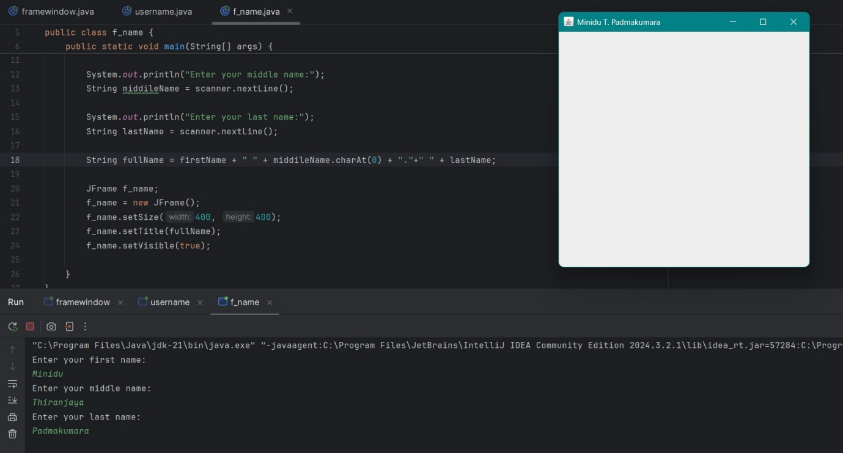

**Q04**.

**CODE:**

package Q_04;  
import java.time.LocalDate;  
import java.time.format.DateTimeFormatter;  
  
public class date_01 {  
 public static void main(String[] args) {  
   
 LocalDate today = LocalDate.*now*();  
  
 DateTimeFormatter format = DateTimeFormatter.*ofPattern*("dd MMM yyyy");  
 String date = today.format(format);  
  
 System.*out*.println("Today's date: "+ date);  
 }  
  
 }

**OUTPUT :**

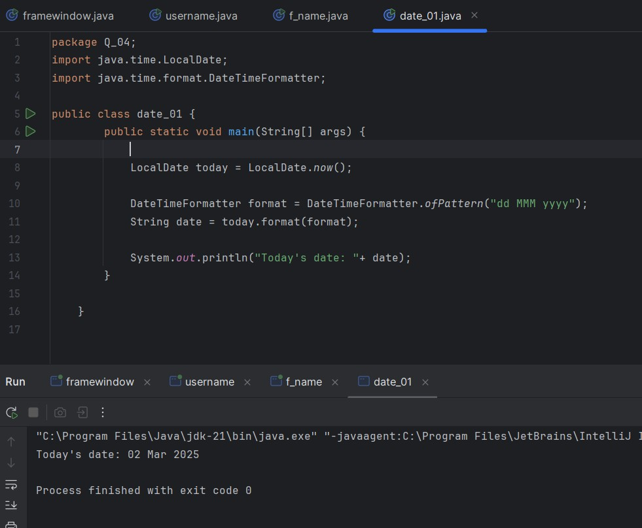

**Q5.**

**CODE :**

package Q_05;  
import java.time.LocalDate;  
import java.time.format.DateTimeFormatter;  
  
public class date_02 {  
 public static void main(String[] args) {  
  
 LocalDate today = LocalDate.*now*();  
  
 DateTimeFormatter format = DateTimeFormatter.*ofPattern*("EEEE, MMMM d, yyyy");  
 String date = today.format(format);  
  
 System.*out*.println("Today's date: " + date);  
 }  
}

**OUTPUT :**

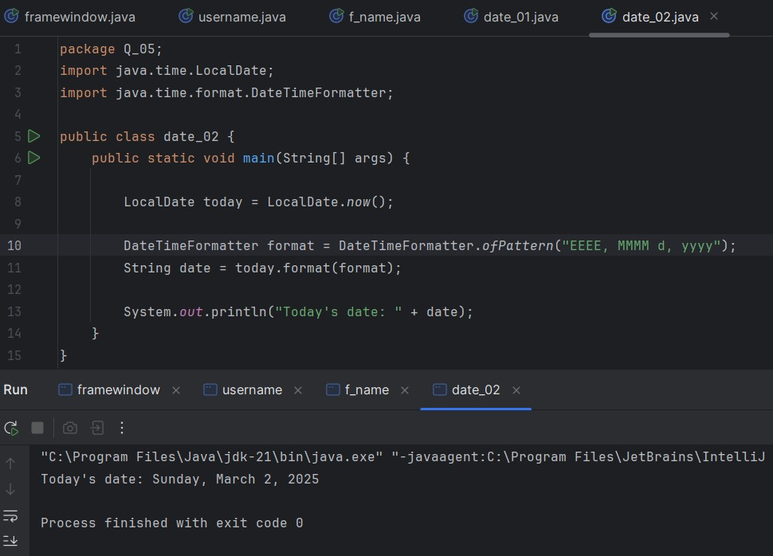

**Q6.**

**CODE :**

package Q_06;  
import javax.swing.JFrame;  
import java.util.Scanner;  
  
public class customFrame {  
 public static void main(String[] args) {  
 Scanner scanner = new Scanner(System.*in*);  
  
 System.*out*.print("Enter frame width: ");  
 int width = scanner.nextInt();  
  
 System.*out*.print("Enter frame height: ");  
 int height = scanner.nextInt();  
  
 scanner.nextLine();  
  
 System.*out*.print("Enter frame title: ");  
 String title = scanner.nextLine();  
  
 JFrame customFrame;  
 customFrame = new JFrame();  
 customFrame.setSize(width, height);  
 customFrame.setTitle(title);  
 customFrame.setVisible(true);  
  
 scanner.close();  
 }  
}

**OUTPUT:**

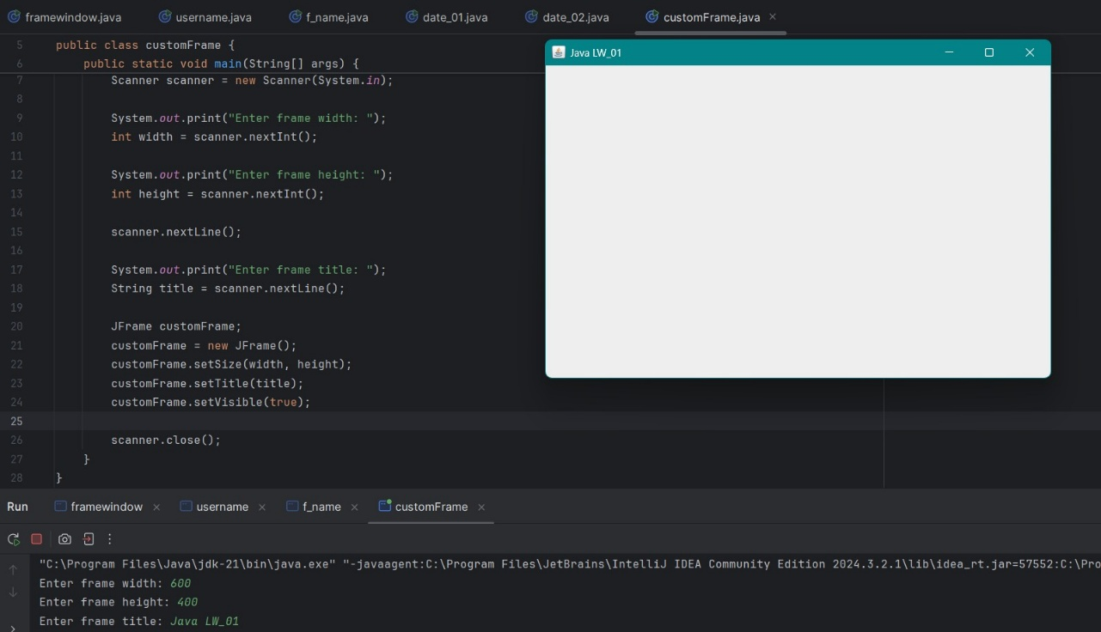

**Q7.**

**CODE :**

package Q_07;  
import javax.swing.*;  
import java.time.LocalTime;  
import java.time.format.DateTimeFormatter;  
  
  
  
public class time {  
 public static void main(String[] args) {  
  
 LocalTime currentTime = LocalTime.*now*();  
 DateTimeFormatter formatter = DateTimeFormatter.*ofPattern*("hh:mm:ss a");  
 String C_time = currentTime.format(formatter);  
  
 JFrame Time;  
 Time = new JFrame();  
 Time.setSize(600, 400);  
 Time.setTitle(C_time);  
 Time.setVisible(true);  
 }  
  
}

**OUTPUT :**

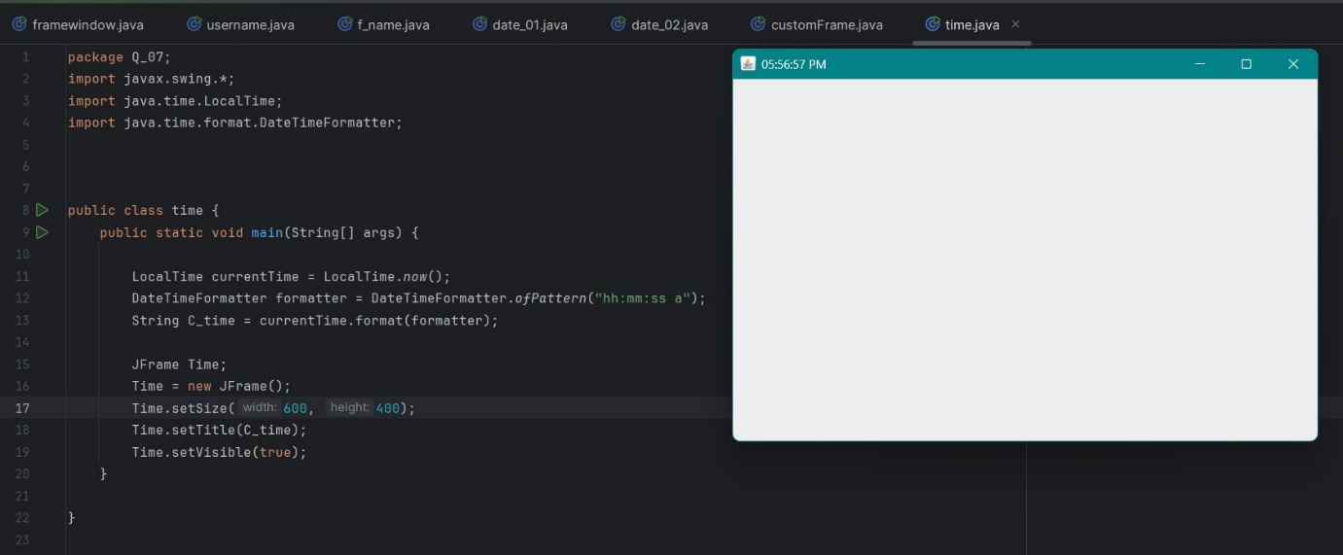

**Q8.**

**CODE :**

package Q_08;  
import java.util.Scanner;  
  
public class exclamationMark {  
 public static void main(String[] args) {  
 Scanner scanner = new Scanner(System.*in*);  
  
 System.*out*.print("Enter a value with a single exclamation mark: ");  
 String input = scanner.nextLine();  
  
 int exclamationIndex = input.indexOf('!');  
  
 if (exclamationIndex != -1) {  
 String before = input.substring(0, exclamationIndex).trim();  
 String after = input.substring(exclamationIndex + 1).trim();  
  
 System.*out*.println(before);  
 System.*out*.println(after);  
 } else {  
 System.*out*.println("No exclamation mark found in the string.");  
 }  
  
 scanner.close();  
 }  
  
}

**OUTPUT :**

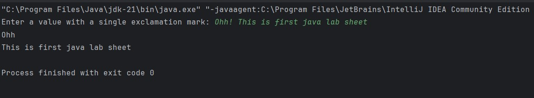

**Q9.**

**CODE :**

package Q_09;  
import java.util.*;  
  
public class character {  
 public static void main(String[] args) {  
 Scanner scanner = new Scanner(System.*in*);  
 System.*out*.println("Enter the Text : ");  
 String text = scanner.nextLine();  
 int length = text.length();  
  
 System.*out*.println(length);  
 System.*out*.println(text.charAt(0));  
 System.*out*.println(text.charAt(length-1));  
  
 }  
  
}

**OUTPUT :**

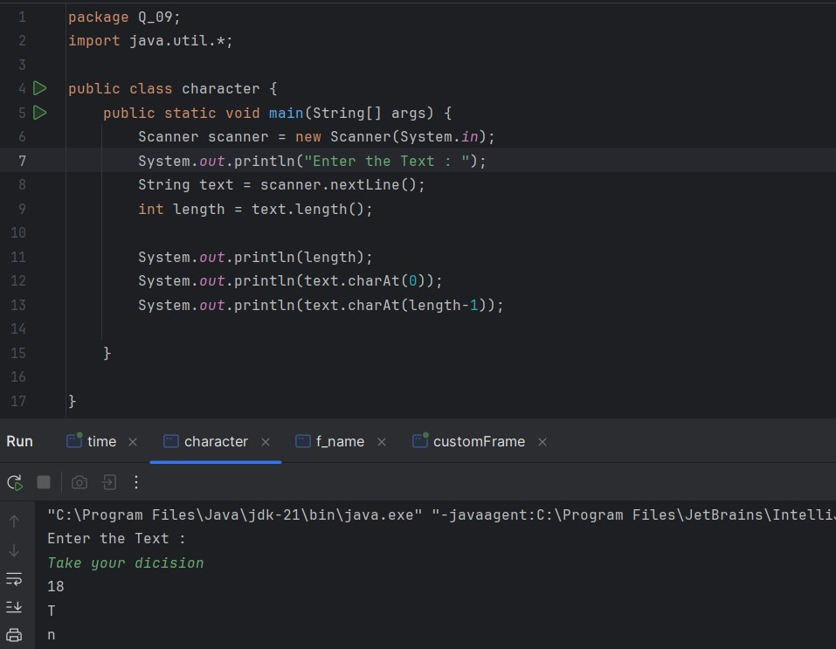

**Q10.**

**CODE :**

package Q_10;  
import java.util.Scanner;  
  
public class middleCharacter {  
 public static void main(String[] args) {  
 Scanner scanner = new Scanner(System.*in*);  
  
 System.*out*.print("Enter the odd lenght word: ");  
 String word = scanner.nextLine();  
  
 if (word.length() % 2 == 1) {  
 int middleIndex = word.length() / 2;  
 System.*out*.println("Middle character: " + word.charAt(middleIndex));  
 }  
 else {  
 System.*out*.println("Error: The word must have an odd number of characters.");  
 }  
  
 }  
}

**OUTPUT :**

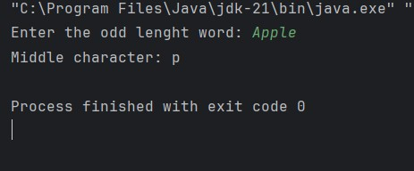

**Q11.**

**CODE :**

package Q_11;  
import java.util.Scanner;  
  
public class name {  
 public static void main(String[] args) {  
 Scanner scanner = new Scanner(System.*in*);  
  
 System.*out*.println("Enter your first name: ");  
 String firstName = scanner.nextLine();  
  
 System.*out*.println("Enter your middle name: ");  
 String middileName = scanner.nextLine();  
  
 System.*out*.println("Enter your last name: ");  
 String lastName = scanner.nextLine();  
  
 String fullName = lastName + "," + " " + firstName + " "+ middileName.charAt(0) + ".";  
 System.*out*.println(fullName);  
 }  
}

**OUTPUT :**

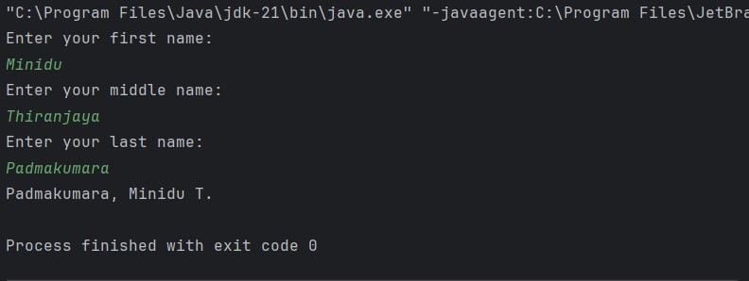

**Q12.**

**CODE :**

package Q_12;  
import javax.swing.*;  
  
public class myFirstframe {  
 public static void main(String[] args) {  
  
 JFrame myWindow;  
 myWindow=new JFrame();  
 myWindow.setSize(400, 200);  
 myWindow.setLocation( 50, 100 );  
 myWindow.setTitle("My first Frame");  
 myWindow.setVisible(true);  
 }  
}

**OUTPUT :**

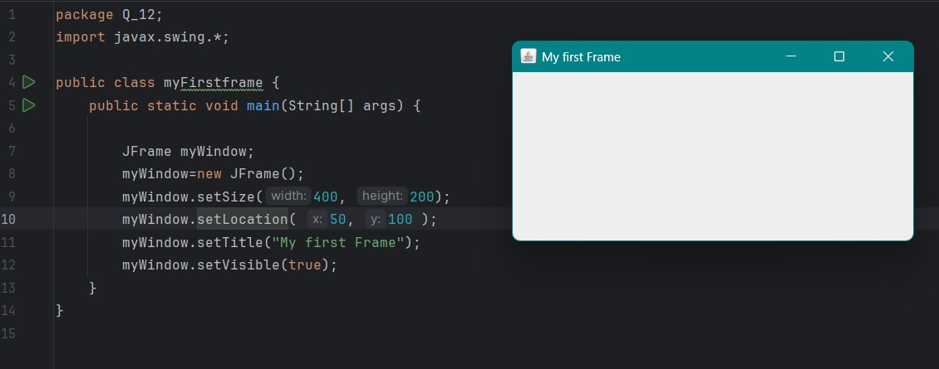

**Q13.**

**CODE :**

import javax.swing.*;  
class SampleWindow {  
 public static void main(String[] args) {  
 JFrame myWindow;  
 myWindow = new JFrame();  
 myWindow.setSize(500, 250);  
 myWindow.setTitle("UOK");  
 myWindow.setVisible(true);  
 try {Thread.*sleep*(500);} catch(Exception e) { }  
 myWindow.setVisible(false);  
 try {Thread.*sleep*(500);} catch(Exception e) { }  
 myWindow.setVisible(true);  
 }  
}

**OUTPUT :**

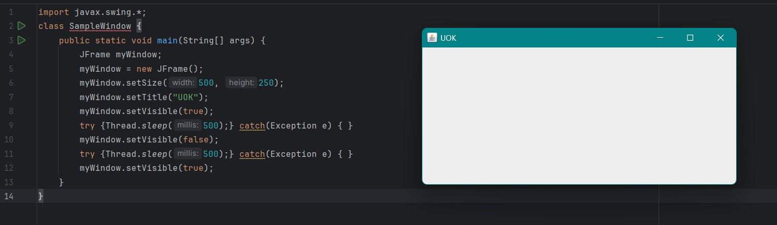

The program creates a simple Swing window (JFrame**)** with the title "UOK", sized 500x250 pixels. It does the following:

1. **Displays the window** (setVisible(true)).
2. **Waits for 0.5 seconds** (Thread.sleep(500)).
3. **Hides the window** (setVisible(false)).
4. **Waits for another 0.5 seconds** (Thread.sleep(500)).
5. **Shows the window again** (setVisible(true)).