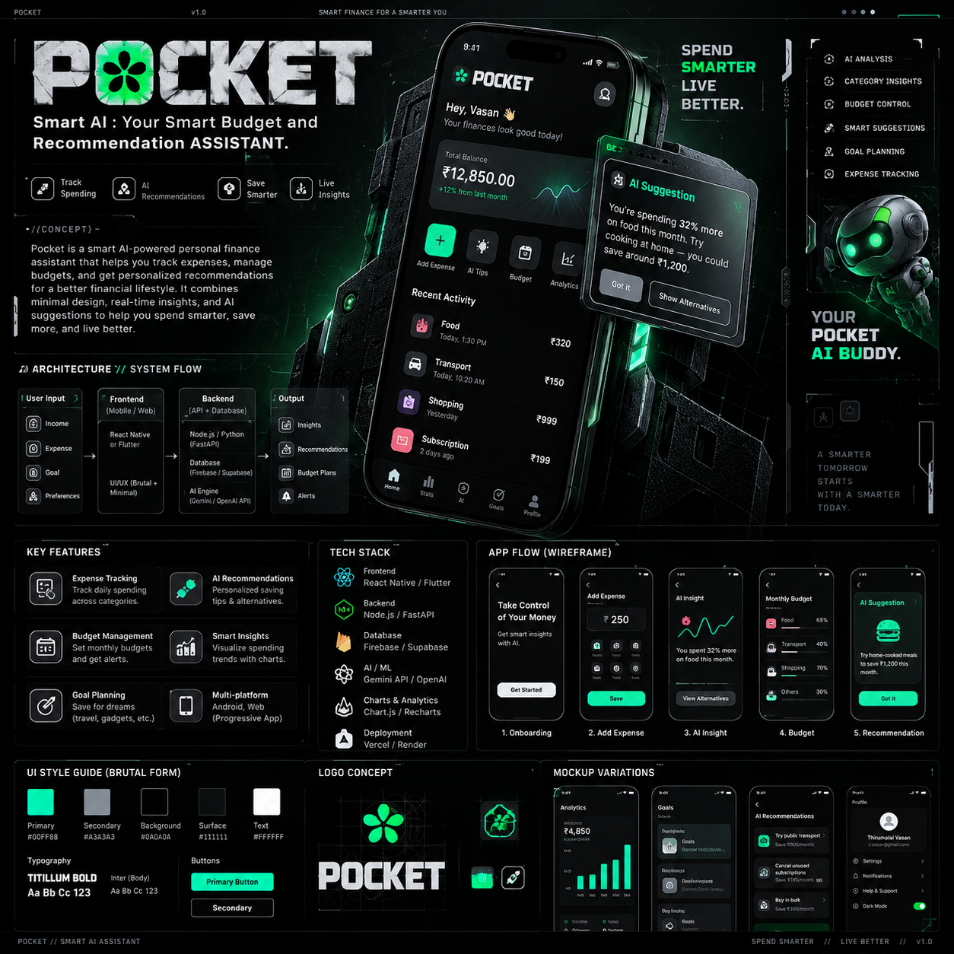
POCKET.AI
Smart Budget & Recommendation Assistant
PROJECT REPORT | TEAM MEMBERS
THIRUMALAI VASAN
SASHINDHARA
VISHAL
TIKNESH
MOHAMED FARZULA
POCKET.AI — PROJECT REPORT
Smart Budget & Recommendation Assistant
1. Project Overview
POCKET.AI is an AI-powered personal finance and budgeting web application designed to help users understand their spending, manage monthly budgets, track savings goals, and receive personalized financial recommendations. The project combines a modern fintech dashboard with an intelligent assistant to make everyday money management simpler, clearer, and more actionable.
2. Problem Statement
Students and everyday users often find it difficult to track daily expenses, control discretionary spending, and plan savings consistently. Financial information can be scattered across notes, banking applications, and manual calculations. POCKET.AI addresses this problem by bringing transaction tracking, budget monitoring, analytics, savings goals, and AI-based insights into one easy-to-use platform.
3. Objectives
- Record and organize income and expenses.
- Create and monitor monthly category-based budgets.
- Visualize spending patterns with financial analytics.
- Create and track savings goals.
- Generate personalized AI financial insights.
- Provide practical recommendations for improving spending and saving habits.
4. Key Features
Feature | Description
Dashboard | Shows balance, income, expenses, savings rate, recent transactions, budget status, and AI insights.
Transaction Management | Add, search, review, and remove income or expense records.
Budget Management | Tracks category-wise spending against monthly limits.
Analytics | Visualizes cash-flow trends and expense distribution.
Savings Goals | Tracks targets, current savings, progress, and remaining amounts.
POCKET AI | Provides spending summaries, saving suggestions, budget recommendations, and goal insights.
Responsive UI | Designed for desktop, tablet, and mobile screens.
5. Technology Stack
- Frontend: Next.js with TypeScript
- UI: Responsive custom CSS with Cyber-Brutalist Premium FinTech design
- Charts: Recharts
- Icons: Lucide React
- Database / production upgrade: Supabase PostgreSQL
- Authentication / production upgrade: Supabase Auth with Google OAuth
- AI Layer: AI-powered financial insight and recommendation interface
6. System Structure
POCKET.AI
├── Authentication → Google OAuth / User Session
├── Dashboard → Balance / Income / Expenses / AI Insights
├── Transactions → Add / Search / Delete
├── Budgets → Category-wise Tracking
├── Analytics → Cash-flow / Expense Distribution
├── Savings Goals → Progress Tracking
└── POCKET AI → Spending Analysis / Budget Recommendations / Saving Suggestions
7. User Workflow
- Open POCKET.AI and enter the application.
- View the financial dashboard.
- Record income and expenses through the transaction interface.
- Review calculated balance, expenses, and budget usage.
- Use analytics to understand spending trends.
- Create savings goals and monitor progress.
- Use POCKET AI for personalized financial recommendations.
8. Design Concept
The interface follows a Cyber-Brutalist and Premium FinTech visual language. The dark background reduces visual noise, while the neon mint accent emphasizes important financial metrics, actions, and AI elements. Modular cards, thin borders, technical grid patterns, high-contrast typography, and responsive layouts create a modern AI-finance experience.
9. Security & Privacy
The production architecture is designed around authenticated ownership of financial records. Google OAuth should be handled through Supabase Auth, so POCKET.AI does not collect or store a user's Google password. Supabase Row Level Security can restrict database records so users can access only their own financial data.
10. Expected Benefits
- Makes personal budgeting easier for students and everyday users.
- Provides a single place for expenses, budgets, analytics, and goals.
- Turns raw spending records into understandable visual insights.
- Encourages better saving habits through goals and recommendations.
- Provides a foundation for future AI-powered personal finance features.
11. Conclusion
POCKET.AI demonstrates how modern web technologies and artificial intelligence can be combined to create a practical personal finance assistant. The project focuses on usability, financial visibility, responsive design, and intelligent recommendations. Its modular architecture provides a foundation for future integration with secure authentication, cloud databases, and advanced AI services.
— END OF PROJECT REPORT —

