GUIDE

Please make sure you put in multiple-choice, one_ word, long_question ( **NOT** selected multiple,word,long)

OPEN THE TABLE FIRST

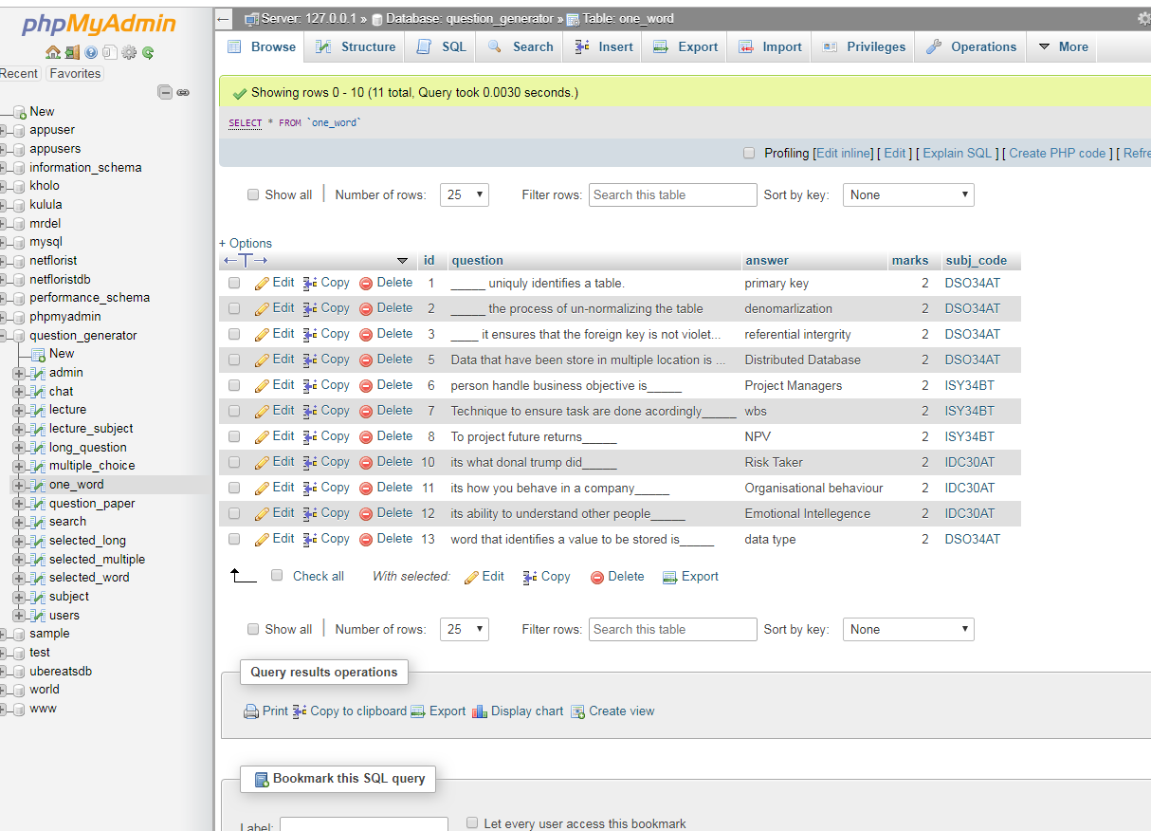

Click insert

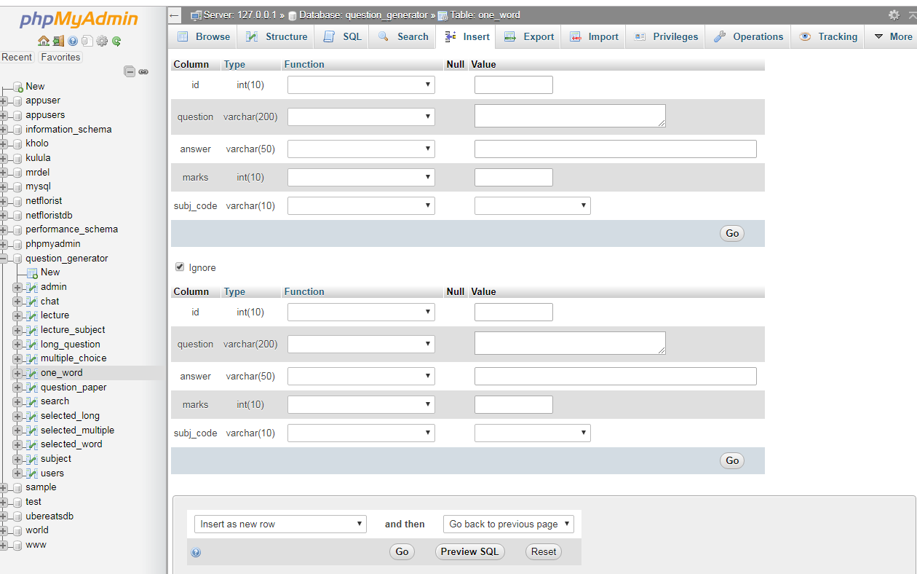

Enter values don’t enter **id** its autogenerated

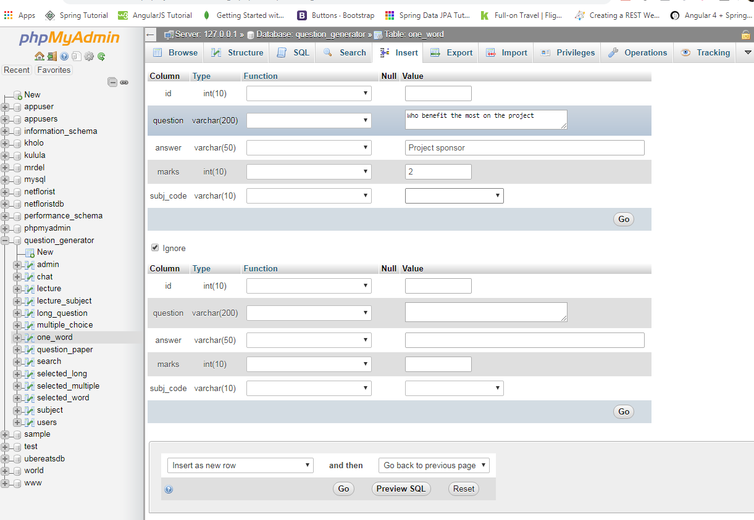

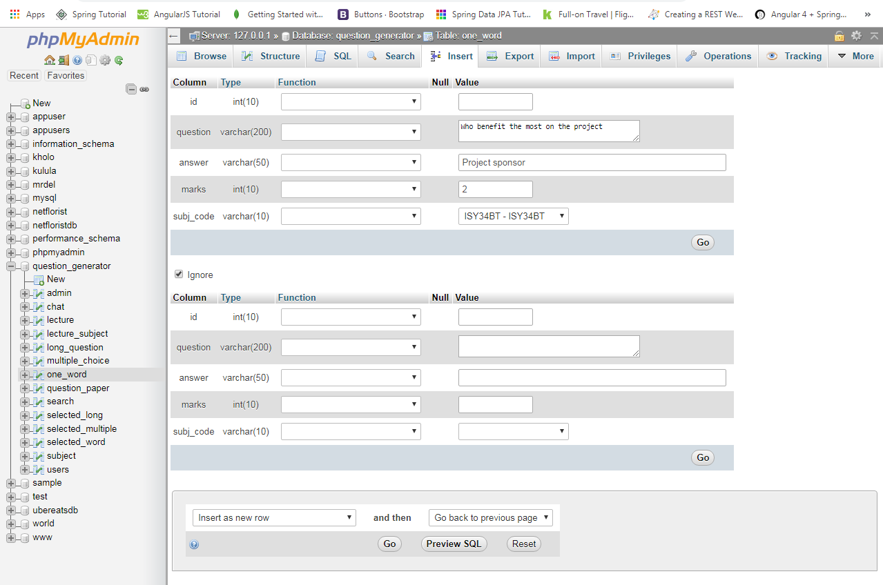

At the end click go or after the insert if you inserting one

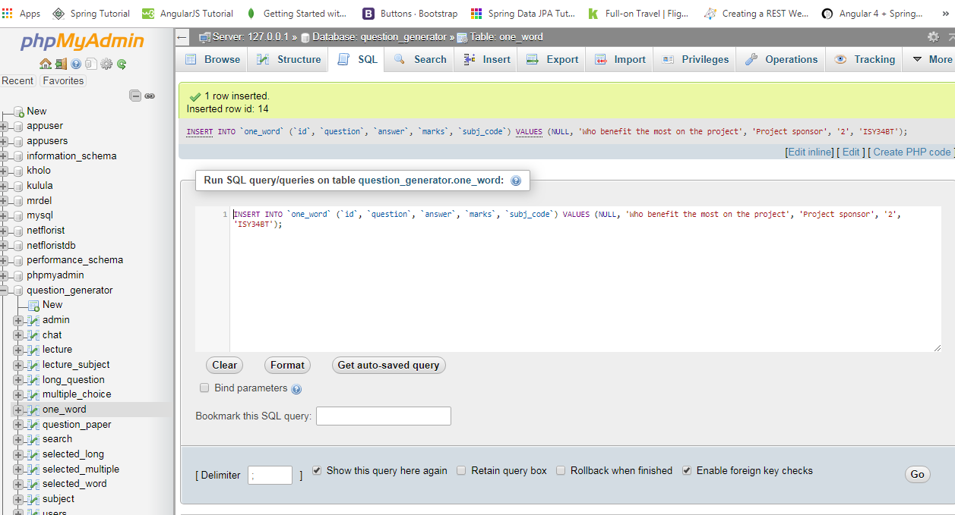

**IF YOU DON’T UNDERSTAND IT USE YOU TUBE**