Election Proposal (Training Set & Basic Descriptive)

Aliya Alimujiang and Minh Nguyen

10/18/2020

Based on this it looks like Biden gets more retweets and favorites.

training <- read.csv("../../Election and Tweets/10172020training.csv")

boxplot(training$retweets ~ training$candidate)

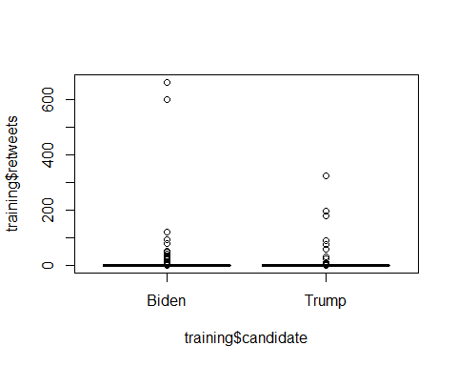

boxplot(training$favorites ~ training$candidate)

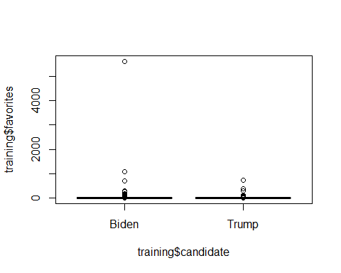

boxplot(training$length ~ training$candidate)

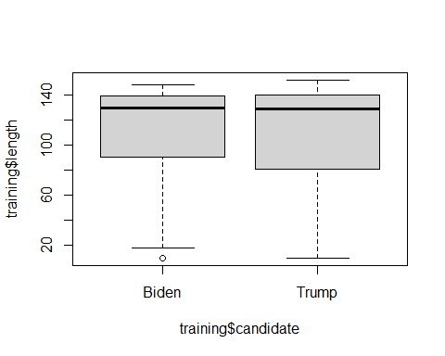

training %>%  
 filter(candidate == "Trump") -> df.trump  
  
mean(df.trump$retweets)

## [1] 1.573171

mean(df.trump$favorites)

## [1] 4.171951

training %>%  
 filter(candidate == "Biden") -> df.biden  
  
mean(df.biden$retweets)

## [1] 24.95658

mean(df.biden$favorites)

## [1] 13.21456