***Road Alignment Report 1***

List of Acronyms

BCC – Beginning of the Circular Curve.

BCC-PI – Direction of the straight from BCC to PI.

BTC – Beginning of the Transition Curve.

BTC-PI – Direction of the straight from BTC to PI.

C – Crown Point

Ch_BCC – Chainage or SKD of the BCC

ECC – End of the Circular Curve.

ETC – End of the Transition Curve.

g1 - Gradient of the first straight of a vertical curve expressed as a percentage.

g2 - Gradient of the Second straight of a vertical curve expressed as a percentage.

I – The intersection angle of the two straights at the PI from BCC and to ECC or from BTC and to ETC.

PI – Point of Intersection of the two straights of a transition curve or horizontal curve.

PI-ECC – Direction of the straight from the PI to the ECC.

PI-ETC – Direction of the straight from PI to ETC.

R – Radius of the horizontal curve.

SKD – Staking Kilometer Distance.

Xpi – X coordinate of the PI.

Yip – Y coordinate of the PI.

1. Introduction

This document briefly explains how to use the road setting out package of the proposed products. Click this link and https//:+#+ and read the click the button that correspond to headings in (2) to (5)

2. Horizontal Curve Control Points.

If you open the compute Horizontal Curve control points button, a screen with input cells will appear (refer to Figure1 below). Insert numbers in the input fields and click the compute traverse button. The results will appear in your computer screen. The output will contain the coordinates for the Beginning of BCC, C, and ECC.

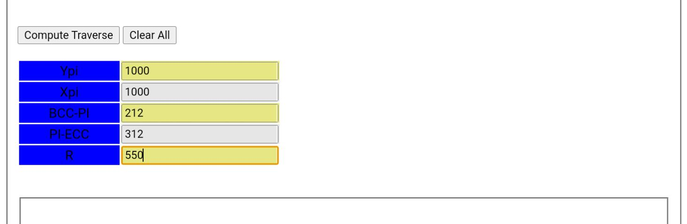*Figure1: Input cells for the computation of Horizontal Curve Control Points.*

3. Horizontal Curve Setting Out.

Going back to the link and click Horizontal Curve Setting Out button and see a screen as in Figure2. Insert the values in the input fields and click “Compute Setting Out Data” button. The design allows the peg_interval to be always 20. The radius of the Circular Curve can be scaled from the plan, the value of I can be calculated using (1). The values for directions BCC-PI and PI-ECC can be scaled from the plan. If I is negative, that would mean the horizontal curve is left handed, and if I is positive, then it is a right handed curve.

This design does not compute setting out data for left handed curves as it will give an error of the horizontal curve is left handed. However, the code can be updated to be able to calculate left handed curves if the users shows interest in these product. The user is also expected to calculate the value of the SKD of the BCC manually, shall the users show interest in this product, the field for BCC SKD input will be changed to take the SKD of the PI. The SKD input should be multiples of 20. The SKD input refers to the first SKD beyond the BCC. For example if the SKD of the BCC is 1234, then the value of the SKD input should be 1240, if 2368 then the SKD input field will be 2380.

$$I = BCC-PI – PI-ECC ……………….…………………………………………………………(1)$$

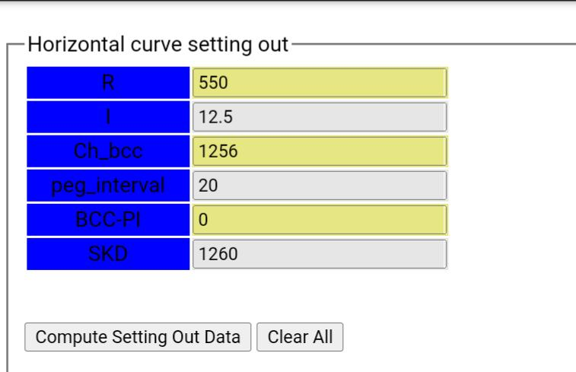*Figure 2: Input Fields for computing a horizontal curve setting out data.*

4. Control Points of the Transition curve

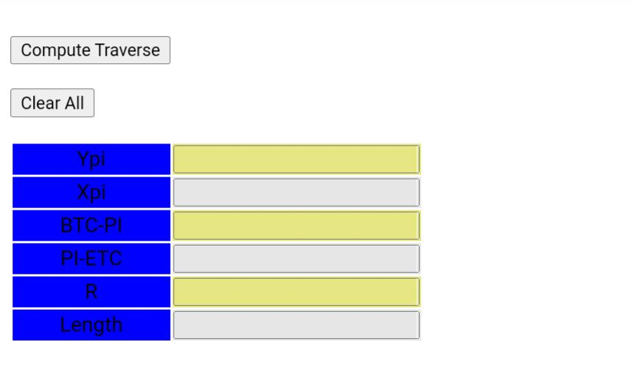Pressing the button “Transition Curve Control Points “ will result in a screen like the one in Figure 3. L Is the Length of the PI. At the end of a transition curve, the radius of the transition curve is normally equal to the radius of the horizontal curve joining the transition curve, thus R is the radius I just briefly discussed. After inserting all the values in the fields in Figure 3, press “Compute Traverse “ butt to get the coordinates of the BTC, BCC, ECC, and ETC. These values can be used to set a total station on.

*Figure 3: Input Fields for computing transition curve control points.*

5. Transition Curve Setting Out.

The setting out of a transition curve will be from BTC to BCC at this point. If the users show interest in the product, the programme will be extended to determine the setting out coordinates from the BTC all the way to ETC.

Figure 4 show the input fields for computing a transition curve setting out data. The procedure for computing transition curve staking data might be confusing. To ease the confusion, start by clicking the “Compute Staking by Distance “ button. See the message printed on the screen. Insert all values for the input fields except the “skd” field, now click the “Compute Staking By Distance “ button and see the output. The output is the SKD of the BTC, first analyse the output and increase it to the next multiple of 20. That is if the output is for BTC SKD is 756 then insert 760 in the “skd” input field, if the output is 23 then the next multiple of 20 is 40. Since the values of distance between BTC and the first SKD after BTC changes all the time, this is the best way at the moment of getting the value for the “skd” input field.

The computed result will assume that the arcs of the transition curve is the interval of 20. For now, this computation is limited to a 100 units length of a curve.

6. Vertical Curve Setting Out

Vertical Curve is another curve that can be staked using this package. Vertical Curves are divided into Symmetrical curves, and unsymmetrical curve. Only symmetric curves are supported by this product, and again if the users show interest in these products, the unsymmetrical curve setting out will be able to be performed. See Figure 5 for Vertical Curve input Fields. Most of the input fields in Figure 5 are straight forward and are also there in the list of acronyms. Now suppose that the SKD of the BVC is know, then the input in the “skd” input field will be the first multiple of 20 after the BVC. After inserting all the input fields click the “Compute Heights “ button.

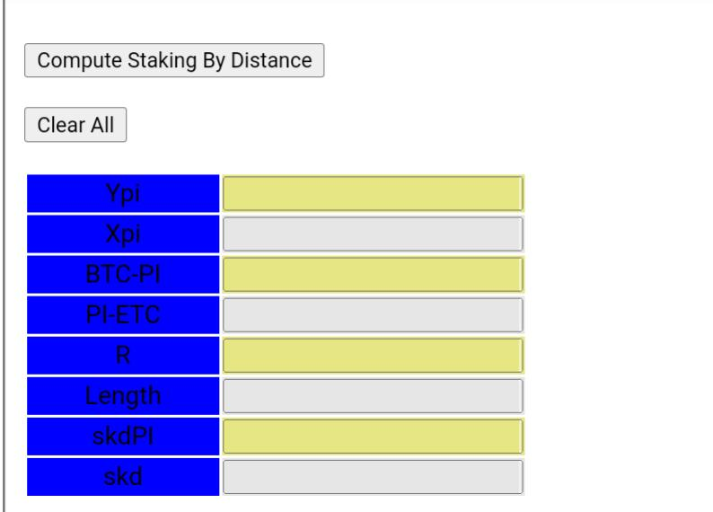

*Figure 4: Transition Curve Setting Out input Fields.*

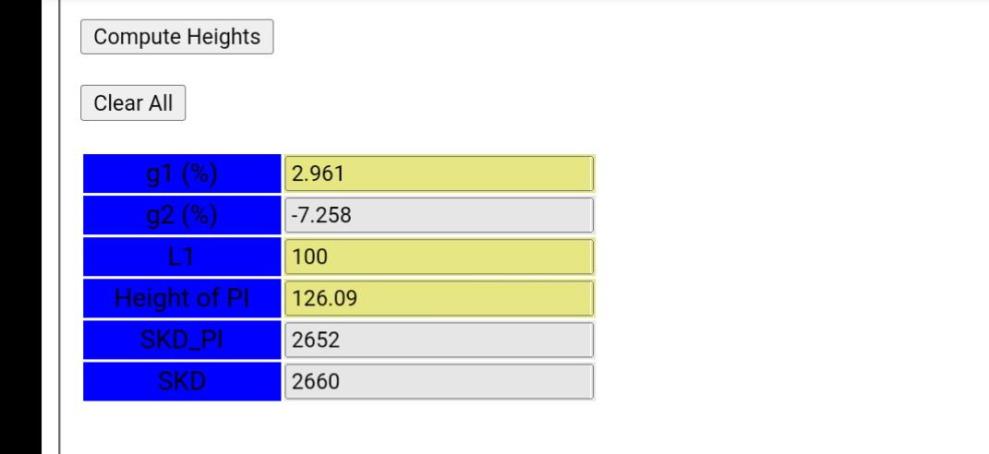

*Figure5: Vertical Curve input Fields*

7. Conclusion

Shall one have queries about the product, they are free to call me or WhatsApp me on:

+27 76 134 4617.