Likelihood 2013, Homework #1
Due Wednesday, February 6.

You may work with others but the work you turn in must be your own. Make an earnest effort to solve problems on your own.

1). The binoculars of four ornithologists (Betty, Mabel, Matilda, and Pete Hosner) get mixed up in a bag when running away from a charging rhino. After they escape, binoculars are passed out at random upon hearing a Blue-throated Barbet. Find the probability that
a). Betty gets her own binoculars
b). Mabel and Matilda get their own binoculars
c). Pete, Mabel and Matilda each get their own binoculars before they are all trampled or gored because they were only paying attention to birds.

2). Consider a bi-variate probability distribution P[x,y]. The sample space is all positive integers for x and y. The distribution function:
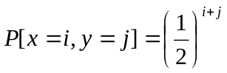for all i and j in the sample space.
a). Show that 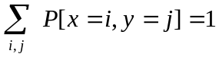 where the sum is taken over all {i,j} in the sample space.

b). Find the probability that x+y ≤ 3.

3). The joint pdf (probability density function) is f(x,y) = 6(1 - x - y). The sample space is the unit square: 0 < y < 1 and 0 < x < 1. Find the conditional p.d.f.'s f(x│y) and f(y│x).

4). Your sample is n measurements from a Poisson distribution: 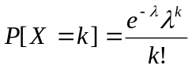. The data are n independent values {X₁, X₂, X₃… X_{n}}. Solve analytically (using calculus) for the maximum likelihood estimator for λ.

