Likelihood 2016, Homework #1
Due Wednesday, February 3.

You may work with others but the work you turn in must be your own.

1). Your sample is n independent measurements from a Poisson distribution: 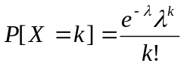.
a) If the data are the values {X₁, X₂, X₃… X_{n}}, solve analytically (using calculus) for the maximum likelihood estimator for λ.
b) If the data are the values reported in PoissonCounts.xls, calculate the MLE for λ and plot the log-likelihood function from λ = 0.1 to λ = 5.

2). Analyze the data contained in the “simple_birds” tab of “Jack.xls.” Each bird will have a series of events (where s/he flies to a location with a mysterious place name like “MTS” or “GREAT BEYOND”). First calculate the wait time between successive events for each bird. If a bird has five events, it will have four time intervals.

a) If the wait-times are independent (within and among birds) and governed by a common exponential distribution with parameter β, obtain the MLE for β.
b) Compare the observed distribution of wait-times (pooling across birds) to the distribution predicted by your model. What do you conclude?

3. Consider a bi-variate probability distribution P[x,y]. The sample space is all positive integers for x and y. The distribution function: 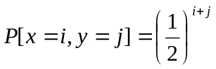for all i and j in the sample space. Find the probability that x+y ≤ 3.

