Likelihood 2019, Homework #1
Due Wednesday, February 6.

You may work with others but the work you turn in must be your own.

1). Your sample is n independent measurements from a Poisson distribution: 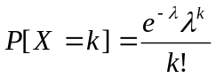.
a) If the data are the values {X₁, X₂, X₃… X_{n}}, write out the equations for the likelihood and the log-likelihood.

b) Solve analytically (using calculus) for the maximum likelihood estimator for λ.

c) If the data are the values reported in PoissonCounts.xls, calculate the MLE for λ and plot the log-likelihood function from λ = 0.1 to λ = 5.

2). Consider a bi-variate probability distribution P[x,y]. The sample space is all positive integers for x and y. The distribution function: 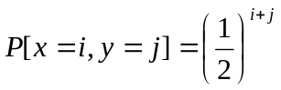for all i and j in the sample space. Find the probability that x+y ≤ 3.

