InstallScout
User guide · version 1.8.46
From Windows installer to Intune: analyze the file, edit the silent command, package .intunewin and upload the Win32 app. Silent switches are one step — the destination is the package in Intune.

1. What InstallScout is
InstallScout is a Windows program for EXE, MSI, COM and MSIX. It does not run the installer. It analyzes the file, lets you edit the silent command, builds a local .intunewin (PSADT v4) and uploads the Win32 app to Intune with install, uninstall, detection and app logo.
Example | Engine | Typical result
Git-2.51.0-64-bit.exe | Inno Setup | Local and online agree on /VERYSILENT … · System
jre-8u491-windows-x64.exe | InstallShield | Local /s /v"/qn" · Java 8 /S · System
AcroRdrDC….exe | Self Extractor | /sAll … · online Acrobat Reader · System
SlackSetup.exe | Squirrel | Per-user · User

Start: double-click InstallScoutPortable.exe or run Start.bat. The UI defaults to English.

2. Start and window
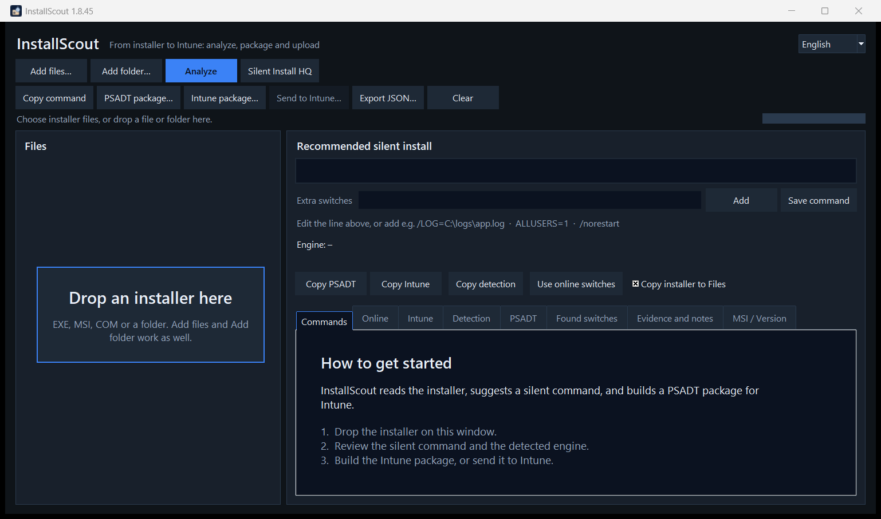
Figure 1. InstallScout 1.8.46 — Drop an installer here, a short introduction, and buttons on two rows.
Drop an installer on the window, or use Add files / Add folder. The empty start shows Drop an installer here in the file list and a short introduction on the Commands tab. Left: files, engine and confidence. Right: editable silent command, Extra switches, and the tabs Commands, Online, Intune, Detection, PSADT, Found switches, Evidence and notes, and MSI / Version. The buttons sit on two rows. Status and progress sit on their own row under the buttons.
Button | Action
Analyze | Read the file locally
Analyze | Local read, then WinGet + Chocolatey
Silent Install HQ | Name search in the browser — the file is not uploaded
Add / Save command | Extra switches, or save the edited line
Intune package… | Local .intunewin — required before upload
Upload to Intune… | Logo, sign-in, Win32 app and optional supersedence

3. Workflow
The process ends with upload. The silent command is a middle step.
- Add the file and click Analyze.
- Edit the green command, or add extra switches, then click Save command / Add.
- Read the Online tab when it fills in. A confident local engine is kept on conflict. On none, use Silent Install HQ.
- Open Intune and check Install context (System/User).
- Build an Intune package (local .intunewin). Test with Invoke-AppDeployToolkit.exe.
- Upload to Intune — the dialog shows the whole form. One Edge profile is shown; open the field to pick another. Sign in, optionally choose supersedence, and upload.

4. Local switch check
Local analysis looks inside the binary and builds the command from that engine’s known silent flags. Inner setup is unpacked locally without running the installer when the wrapper itself has no reliable silent line.
- Engine + confidence — 75 %+ is typically usable.
- Recommended silent install — the command PSADT and Intune use.
- Found switches and evidence — why the engine was chosen.
Situation | Unpack
7-Zip/WinRAR SFX, IExpress, WiX Burn, InstallShield, Advanced Installer, Self Extractor | ZIP, embedded MSI, CAB
Unknown engine or low confidence | Same cheap unpack
Inno, NSIS, Squirrel, DDPM, Wacom, Chrome, Python | Not unpacked
Self Extractor with /sAll, --silent or /silent | Outer command kept
Self Extractor without outer silent flags | Inner setup (often MSI) used

Example: Git (Inno Setup)
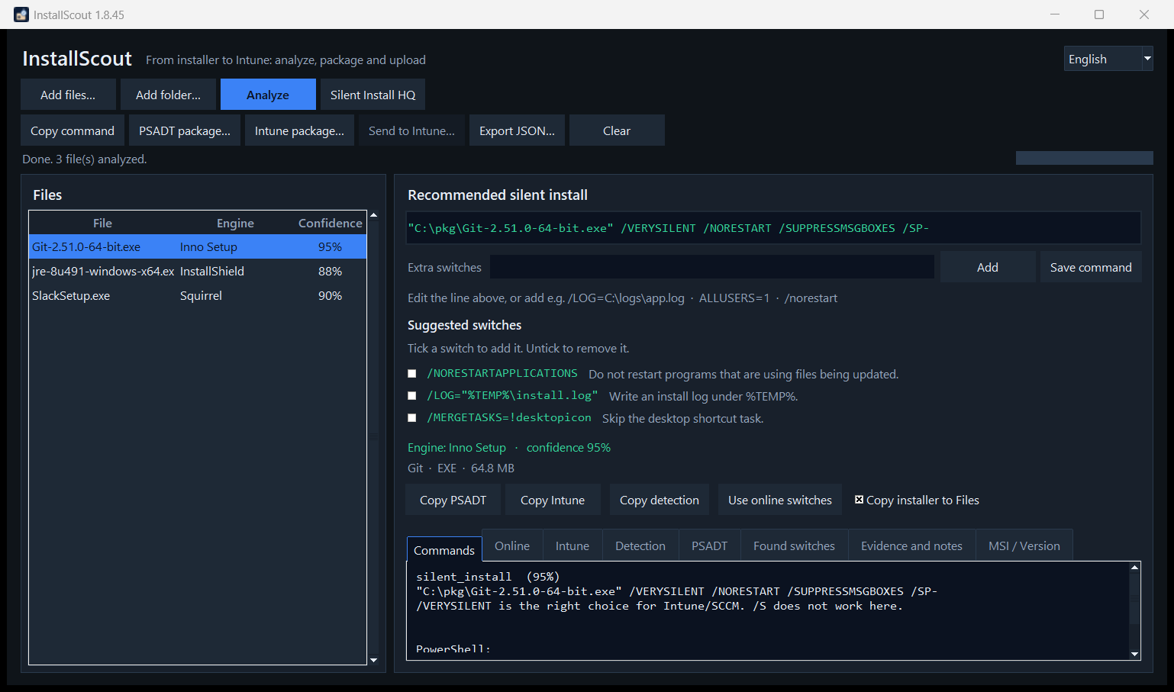
Figure 2. Git analyzed as Inno Setup with VERYSILENT.
Engine: Inno Setup · confidence 95 %
"C:\pkg\Git-2.51.0-64-bit.exe" /VERYSILENT /NORESTART /SUPPRESSMSGBOXES /SP-
Inno does not use /S.

Example: Java 8 (InstallShield)
jre-8u491-windows-x64.exe /s /v"/qn"
/s is InstallShield; /v"/qn" is passed to the embedded MSI.
In the PSADT package, an InstallShield line that contains quotes is started through cmd /d /s /c, so /v"/qn" is preserved. The package elevates itself when it is not already running as administrator.

Example: vendor Self Extractor
FileDescription Self Extractor is a vendor wrapper (Adobe, Lenovo and others), not a product. If /sAll or /rps is in the file, the line is /sAll /rs /rps /msi /quiet. Otherwise the inner setup is unpacked. Online and Intune use the product name or file stem (AcroRdrDC), not the wrapper label.
Engine | Silent
MSI / WiX | msiexec /i file.msi /qn
NSIS | /S (capital S)
Advanced Installer | /exenoui /qn
WiX Burn | /quiet
7-Zip SFX / Wacom | /s
Self Extractor | /sAll … or --silent / /silent
DDPM | /Silent

5. Manual switches
The green line is editable. Under it are Extra switches, Add and Save command.
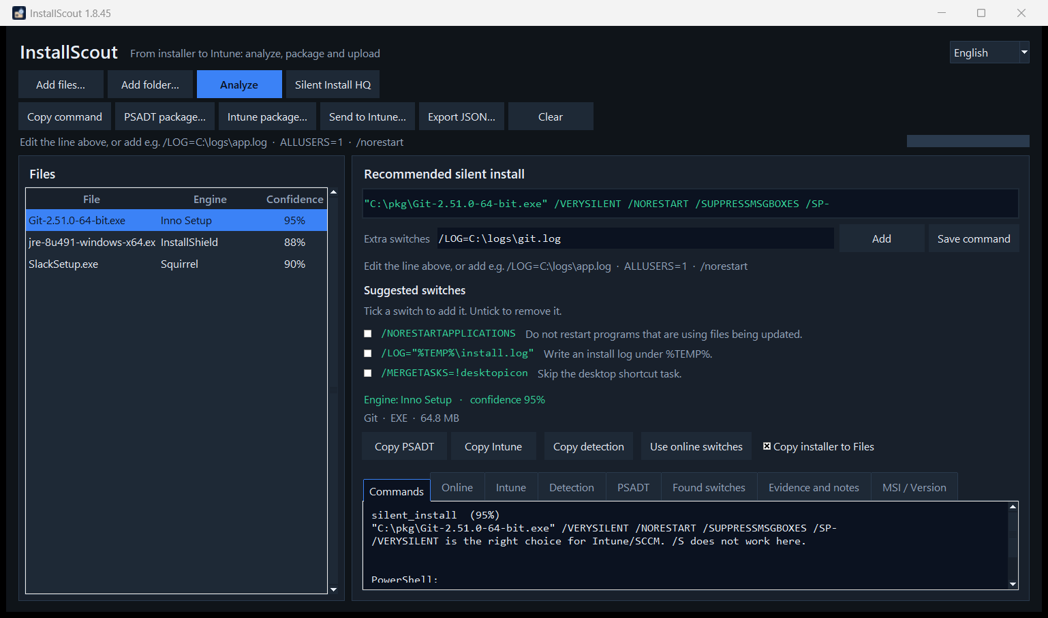
Figure 3. Extra switches, Add and Save command.
- Edit the whole command and click Save command (or press Enter).
- Put extra flags in Extra switches, e.g. /LOG=C:\logs\app.log, ALLUSERS=1 or /norestart, then click Add.
- Suggested switches appear with a short description. Tick one to include it. /install and /norestart are not added automatically. Inno keeps /NORESTART.
- Changes are also saved when you package, copy or check online.
- If the command changes, build the Intune package again before upload.
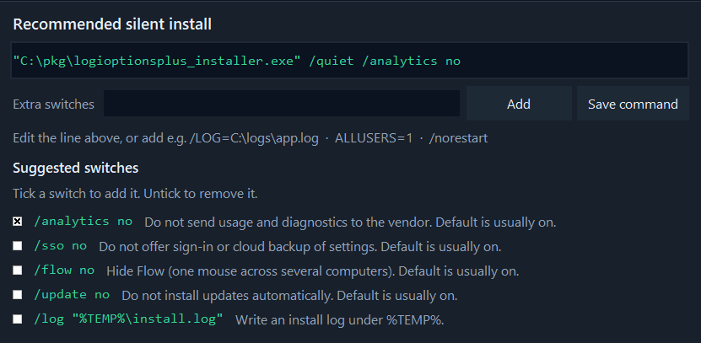
Figure 4. Suggested switches. Tick a box to add the switch. Here /analytics no is selected.

6. Online switch check
Analyze looks the product up in WinGet and Chocolatey afterwards. A confident local engine is kept when the catalog disagrees. A weak local guess is replaced when the catalog matches. Silent Install HQ (silentinstallhq.com) opens a name search — the file is not uploaded. Only the product name and vendor are sent. Wrapper labels such as Adobe Self Extractor are not searched. Compact file names are expanded: AcroRdrDC → Acrobat Reader, GoogleChromeStandalone… → Google Chrome, npp.8.6 → Notepad++. Java Platform SE 8 U491 is listed as Java 8.
Result | Meaning
match | Same installer family
partial | Some flags overlap
conflict | Different family — test in a VM
none | No hits
error | Network or source failure

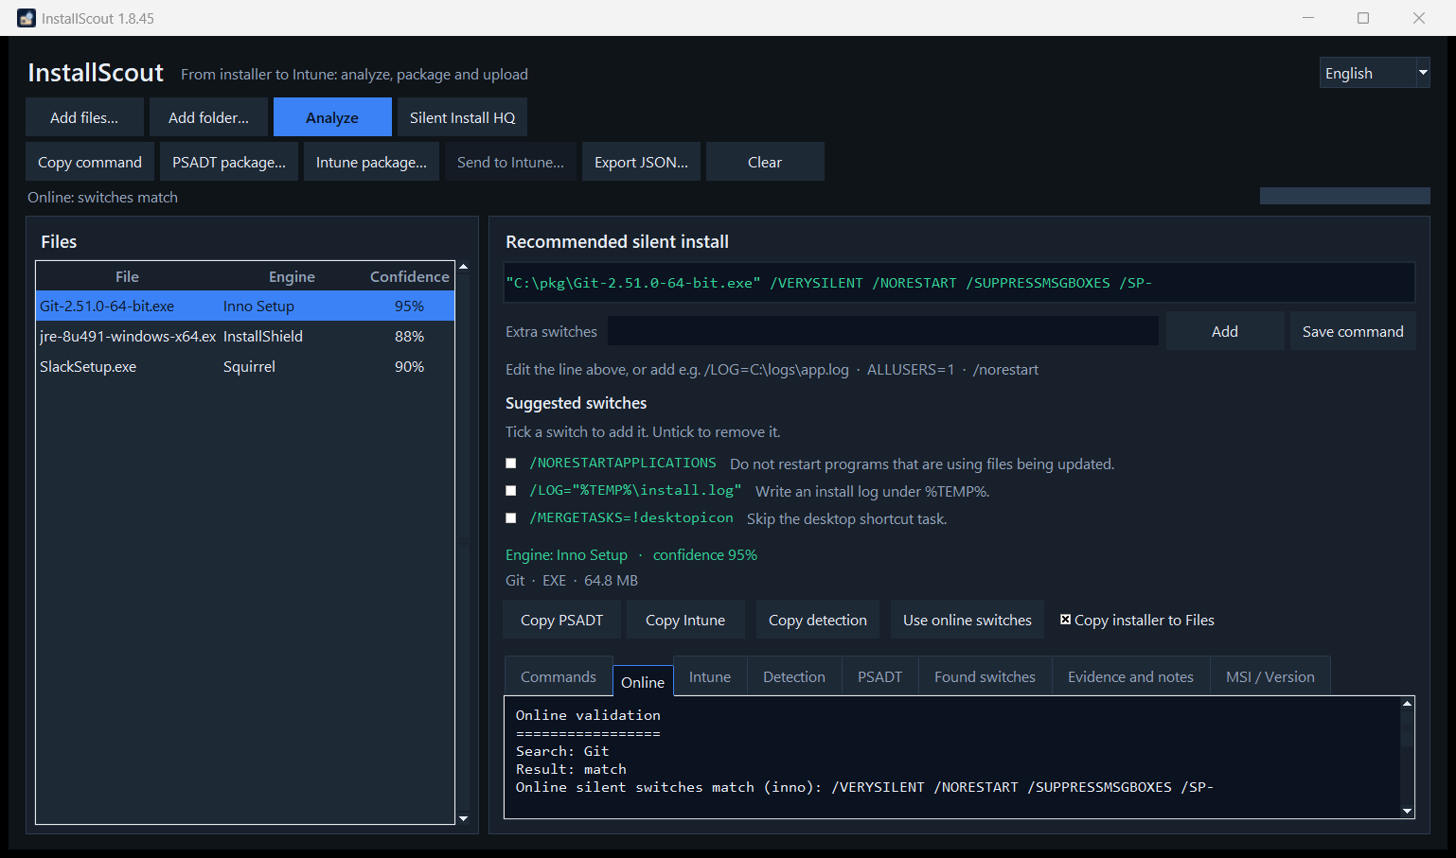
Figure 5. Online match for Git.
Java: online finds /S, locally it is InstallShield /s /v"/qn". Keep local switches when they match the engine in the file. Use online switches if the local engine is uncertain.

7. User vs system context
Intune Win32 must run as system or user. InstallScout infers context and shows it on the Intune tab and in Upload to Intune. You can override it at upload.
- Squirrel, ALLUSERS=0 / InstallAllUsers=0, or AppData in the arguments → User.
- ALLUSERS=1, MSI, InstallShield, Advanced Installer, WiX, Wacom, MSIX → System.
- Inno, NSIS and 7-Zip SFX with no per-user marker → System.
- A path under %LOCALAPPDATA%\Temp does not count — only the arguments after the file path.
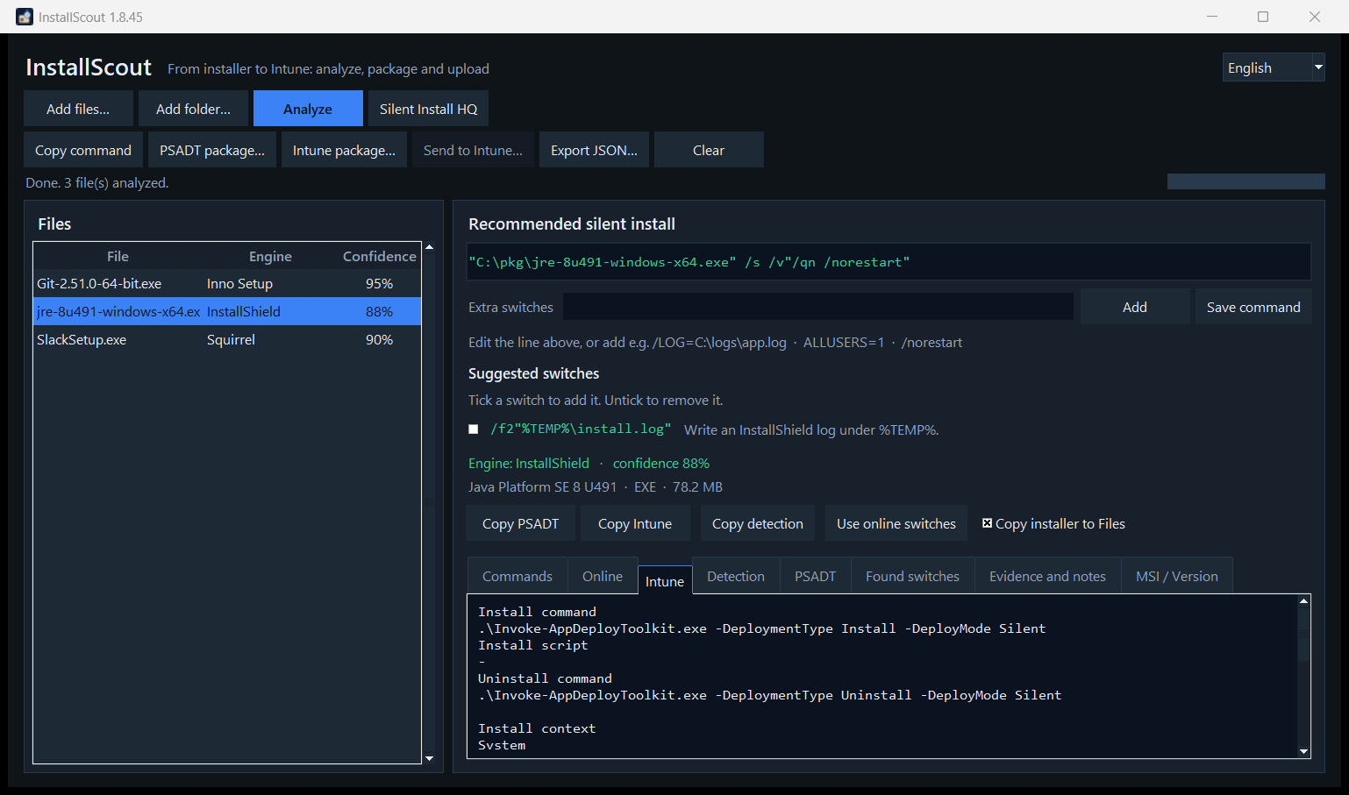
Figure 6. InstallShield/Java with Install context System.
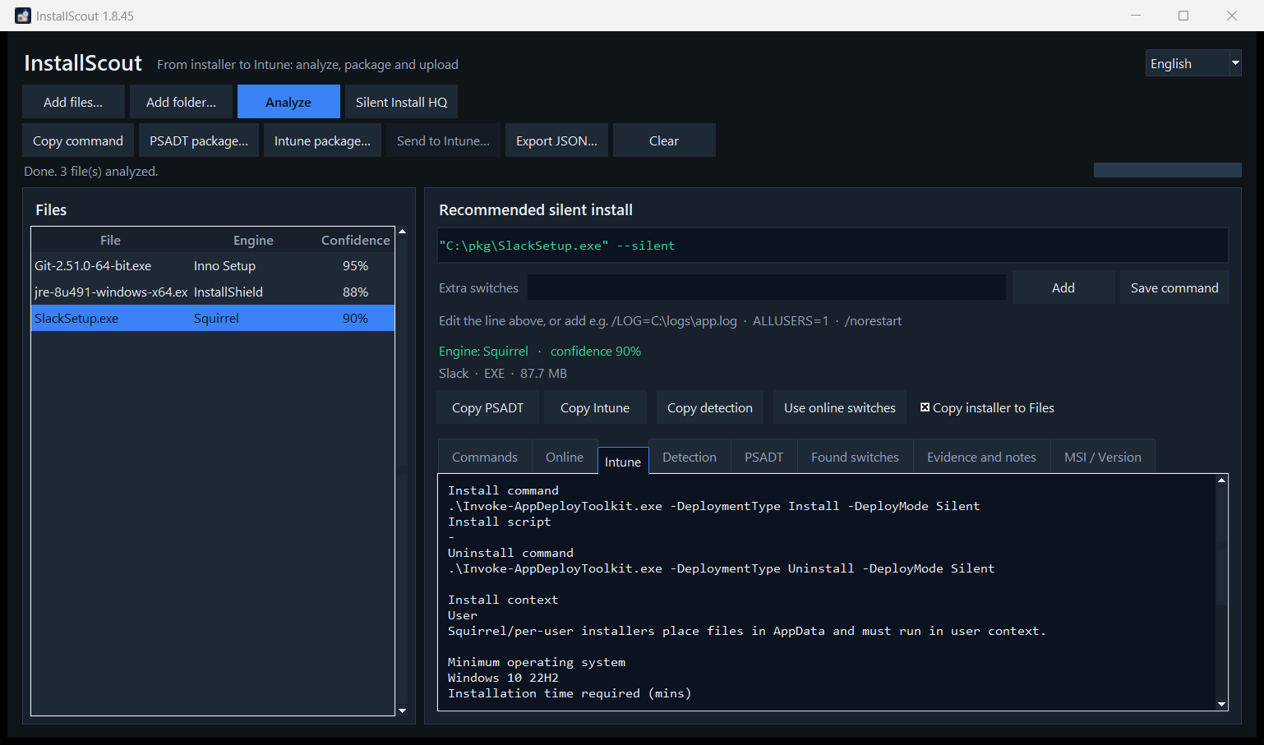
Figure 7. Squirrel/Slack with Install context User.
Context | Typical target | Detection
System | C:\Program Files, HKLM Uninstall | Machine ARP / MSI ProductCode
User | %LOCALAPPDATA%, HKCU Uninstall | The user’s Uninstall key

8. Upload to Intune
Two steps: first a local .intunewin, then Upload to Intune. The program uploads the package you already saved.
Analyze → optional extra switches → Intune package… → Upload to Intune… (logo + Graph)
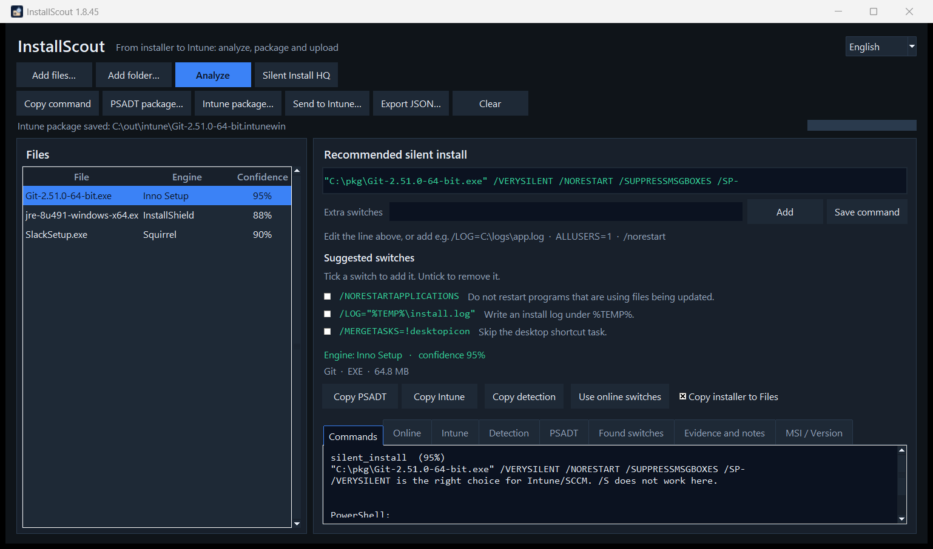
Figure 8. Upload to Intune is active when a local .intunewin exists.
Test the source before upload:
.\Invoke-AppDeployToolkit.exe -DeploymentType Install -DeployMode Silent

App logo
On Upload to Intune the icon is extracted from the EXE (and logo.png / icon.ico next to the file, if present). Override with Choose file…, Paste (Ctrl+V) or Remove. MSI often only has a default icon.
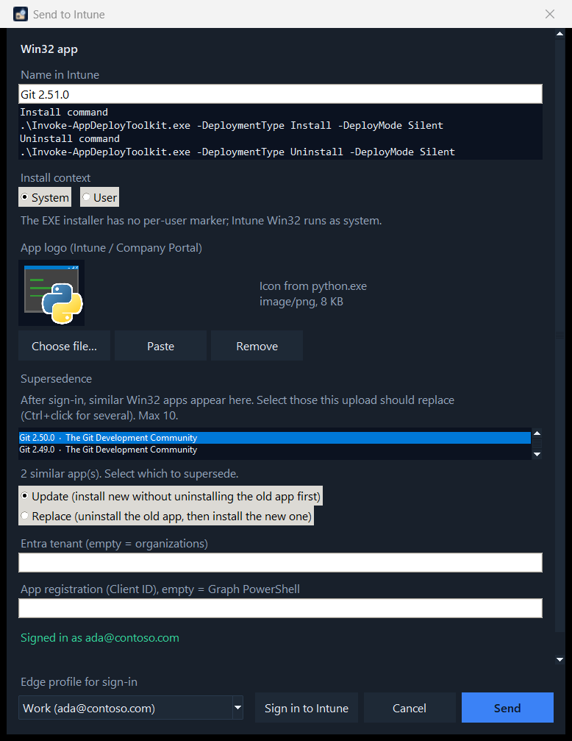
Figure 9. App logo in Upload to Intune: preview, Choose file, Paste, Remove.
- Check install, uninstall and detection.
- Confirm Install context (System/User).
- Check the app logo. Override with a file or paste if the automatic icon is wrong.
- Tenant and Client ID can stay empty (organizations + Microsoft Graph PowerShell). InstallScout does not create an Entra app.
- The field shows one Edge profile. Open it to pick another, then click Sign in to Intune (PKCE, localhost). Sign-in is bound to the tenant and Client ID and is stored with Windows DPAPI.
- After sign-in: optionally select supersedence (Update or Replace) among similar Win32 apps. Nothing is selected automatically.
- Upload — creates the app, uploads .intunewin, sets detection, logo and optional supersedence.

Supersedence
The new Win32 app can replace older versions in the tenant (the same feature as in the Intune portal). Wait until the status is Signed in as …, not only that the Edge profile opened. The search uses the product name, not the entire Win32 catalogue. Nothing is selected automatically.
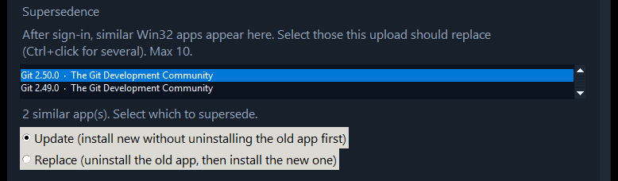
Figure 10. Supersedence in Upload to Intune: Git 2.50.0 selected, Update is the default.
- Ctrl+click to select (at most 10 — Intune’s limit).
- Update (default): install the new app without uninstalling the old one first.
- Replace: uninstall the old app, then install the new one.
- Relationships are written only after the new app is created (Graph updateRelationships).
- If supersedence fails, the new app still remains. You can set the relationship in the portal afterwards.
- CLI: --supersede update|replace matches on product name. Repeat --supersede-id with a known app ID.

Detection
Intune treats the app as installed when Detection.ps1 writes a line to STDOUT and exits 0. Empty output means not installed. The same rules apply to every vendor.
- Product code (MSI, or a GUID in the uninstall command) is tried first, and the version must be the same or newer.
- An EXE without a product code is matched on display name, publisher and version. Logi Options+ Installer matches Logi Options+.
- A trailing Installer, Setup or Bootstrapper word may be absent. A leftover generic word such as Advanced is not used.
- Legal suffixes are ignored: Logitech, Inc. matches Logitech, and Microsoft Corporation matches Microsoft.
- Version is compared numerically. 2.7.961922 and a newer version count; 2.6 does not. 2.8.1 is only an example.
- MSIX is matched on the package name. Both the machine and the user uninstall keys are read.
Intune field | Value
App type | Win32 (win32LobApp)
Install / uninstall | .\Invoke-AppDeployToolkit.exe -DeploymentType … -DeployMode Silent
Detection | PowerShell script, 64-bit
runAsAccount | system or user
Minimum OS | Windows 10 22H2
Max runtime / restart | 60 min / No specific action
Logo | largeIcon (PNG/JPEG from EXE, file or clipboard)
Supersedence | Optional: Update or Replace against up to 10 older Win32 apps

- Entra user with DeviceManagementApps.ReadWrite.All.
- Default Client ID: Microsoft Graph PowerShell (14d82eec-204b-4c2f-b7e8-296a70dab67e).
- Conditional Access can block. IT can set a custom Client ID with redirect http://localhost.

9. Command line
.\InstallScoutPortable.exe --cli "C:\installers\Git-64-bit.exe"
.\InstallScoutPortable.exe --cli .\setup.exe --online
.\InstallScoutPortable.exe --cli .\setup.exe --sihq
.\InstallScoutPortable.exe --cli .\setup.exe --switches "/LOG=C:\logs\app.log"
.\InstallScoutPortable.exe --cli .\setup.exe --intune C:\out\intune
.\InstallScoutPortable.exe --cli .\setup.exe --intune C:\out\intune --publish-intune --icon .\logo.png
.\InstallScoutPortable.exe --cli .\setup.exe --intune C:\out\intune --publish-intune --supersede update
.\InstallScoutPortable.exe --cli .\setup.exe --intune C:\out\intune --publish-intune --supersede replace --supersede-id <app-guid>

10. Supported engines
MSI, Inno Setup, NSIS, InstallShield, WiX Burn, Advanced Installer, InstallAware, BitRock, Squirrel, Wise, install4j, Qt Installer, 7-Zip SFX, Wacom, WinRAR SFX, IExpress, Self Extractor, DDPM, MSIX/AppX, ClickOnce. Wrappers and unknown EXEs are unpacked locally first so an inner MSI can replace Unknown 15 %.

11. Limits
- The program does not install anything. Unpack never runs the installer. Test in a VM.
- Online catalogs may use a different name or a newer build. Wrapper VersionInfo (Self Extractor) is not a catalog product.
- Context and EXE logo are qualified guesses. Override them in Upload to Intune.
- MSI often has no usable icon — use Choose file or Paste.
- Upload to Intune is inactive until a local .intunewin exists.
- The supersedence list appears only after sign-in has finished (Signed in as …).
- If supersedence fails, the new Win32 app still remains in Intune.
- Installer binaries are not sent during the online check.

