Bayesian Checks

library(zoib)  
library(tidyverse)  
library(GGally)  
library(ggpubr)  
library(kableExtra)  
library(mice)  
library(parallel)  
  
theme_set(theme_pubr(legend = "bottom"))

# read imputed data

nnns_imputed<- readRDS("../Haojia_work/nnns_imputed.rds")  
  
dat <- lapply(1:20, function(i) complete(nnns_imputed, i))

# Use ZOIB package

## ZOIB Model

$$f\left(y_{i}|η_{i}\right)=\left\{\begin{matrix}p_{i}, & y_{i}=0 \\ \left(1−p_{i}\right)q_{i}, & y_{i}=1 \\ \left(1−p_{i}\right)\left(1−q_{i}\right)Beta\left(α_{i_{1}},α_{i_{2}}\right) & y_{i}∈\left(0,1\right)\end{matrix}\right.$$

$$\begin{matrix}logit\left(μ^{\left(0,1\right)}=\frac{α_{1}}{α_{1}+α_{2}}\right)=x_{1}β_{1}+I_{1}\left(z_{1,i}γ_{1,i}\right) \\ log\left(v_{i}=α_{1}+α_{2}\right)=x_{2}β_{2}+I_{2}\left(z_{2,i}γ_{2,i}\right) \\ logit\left(p_{i}\right)=x_{3}β_{3}+I_{1}\left(z_{3,i}γ_{3,i}\right) \\ logit\left(q_{i}\right)=x_{4}β_{4}+I_{1}\left(z_{4,i}γ_{4,i}\right)\end{matrix}$$

## Fit ZOIB model

set.seed(11282023)  
  
tictoc::tic()  
  
# Define a function for model fitting  
fit_model <- function(d) {  
 zoib(  
 Percent_of_feeds_taken_by_mouth_at_discharge ~  
 Pre_Op_NNNS_attention_score +  
 Length_of_intubation_days +  
 Cardiac_Anatomy +  
 Age_at_Surgery_days +  
 Female #x1 design matrix  
 | 1 | #x2 design matrix  
 Pre_Op_NNNS_attention_score +  
 Length_of_intubation_days +  
 Cardiac_Anatomy +  
 Age_at_Surgery_days +  
 Female | #X3 design matrix  
 Pre_Op_NNNS_attention_score +  
 Length_of_intubation_days +  
 Cardiac_Anatomy +  
 Age_at_Surgery_days +  
 Female, #x4 design matrix  
 data = d,  
 n.response = 1,  
 zero.inflation = TRUE,  
 one.inflation = TRUE,  
 link.mu = "logit",  
 link.x0 = "logit",  
 link.x1 = "logit",  
 random = 0,  
 n.chain = 4,  
 n.iter = 3000,  
 n.thin = 2,  
 n.burn = 200,  
 seeds = c(11, 29, 20, 23)  
 )  
}  
model_results <- lapply(dat, fit_model)  
# Save results  
saveRDS(model_results, "pre_op_models.rds")  
  
tictoc::toc()

set.seed(11282023)  
  
tictoc::tic()  
  
# Define a function for model fitting  
fit_model <- function(d) {  
 zoib(  
 Percent_of_feeds_taken_by_mouth_at_discharge ~  
 Post_Op_NNNS_attention_score +  
 Length_of_intubation_days +  
 Cardiac_Anatomy +  
 Age_at_Surgery_days +  
 Female #x1 design matrix  
 | 1 | #x2 design matrix  
 Post_Op_NNNS_attention_score +  
 Length_of_intubation_days +  
 Cardiac_Anatomy +  
 Age_at_Surgery_days +  
 Female | #X3 design matrix  
 Post_Op_NNNS_attention_score +  
 Length_of_intubation_days +  
 Cardiac_Anatomy +  
 Age_at_Surgery_days +  
 Female, #x4 design matrix  
 data = d,  
 n.response = 1,  
 zero.inflation = TRUE,  
 one.inflation = TRUE,  
 link.mu = "logit",  
 link.x0 = "logit",  
 link.x1 = "logit",  
 random = 0,  
 n.chain = 4,  
 n.iter = 3000,  
 n.thin = 2,  
 n.burn = 200,  
 seeds = c(11, 29, 20, 23)  
 )  
}  
  
# Parallelize model fitting  
model_results <- lapply(dat, fit_model)  
  
# Save results  
saveRDS(model_results, "post_op_models.rds")  
  
tictoc::toc()

## Interpreting output:

b: vector of estimates from Eqn 1; that is, g(mu) = xb*b +z*gamma

d: vector of estimates from Eqn 2; that is, log(eta) = xd*d+z*gamma

b0: vector of estimates from Eqn 3; that is, g(p0) = x0*b0 +z*gamma

b1: vector of estimates from Eqn ;4 that is, g(p1) = x1*b1+z*gamma

# Pool chains

post_op_models =readRDS(file="post_op_models.rds")  
pre_op_models =readRDS(file="pre_op_models.rds")  
  
post_op_coeff = list()  
pre_op_coeff = list()  
for(i in 1:length(post_op_models)){  
 pre_op_coeff[[i]] = pre_op_models[[i]]$coeff  
 post_op_coeff[[i]] = post_op_models[[i]]$coeff  
}  
  
pooled_pre_op = runjags::combine.mcmc(mcmc.objects = pre_op_coeff, collapse.chains = FALSE)  
pooled_post_op = runjags::combine.mcmc(mcmc.objects = post_op_coeff, collapse.chains = FALSE)  
  
saveRDS(pooled_pre_op, "pooled_pre_op.rds")  
saveRDS(pooled_post_op, "pooled_post_op.rds")

pooled_pre_op = readRDS("pooled_pre_op.rds")  
pooled_post_op = readRDS("pooled_post_op.rds")

## Check convergence

### Traceplots

#### Pre-op

pooled_pre_op |> traceplot()

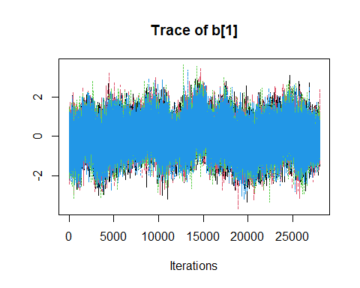

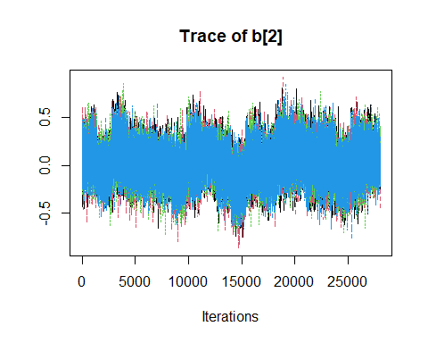

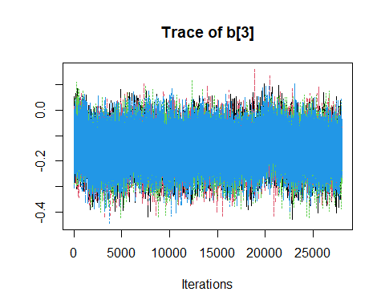

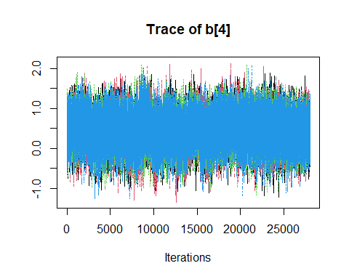

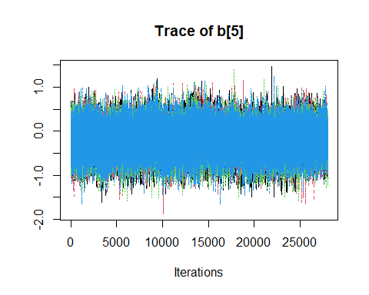

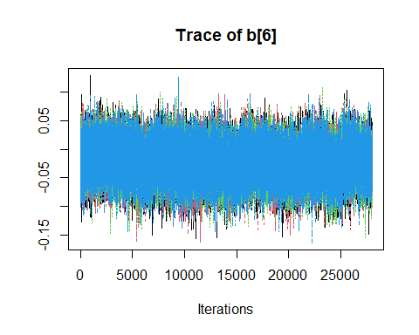

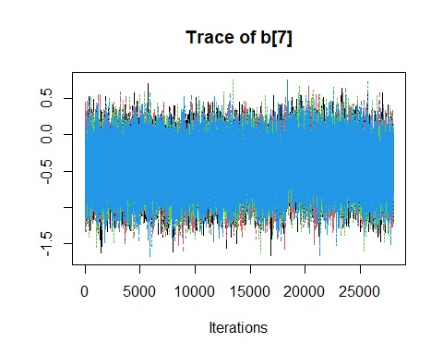

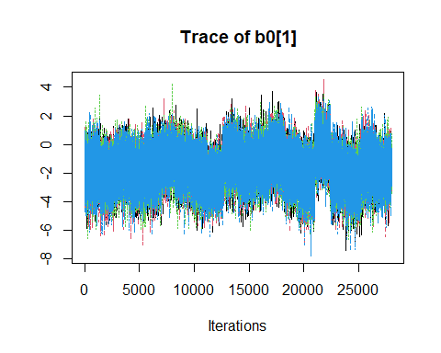

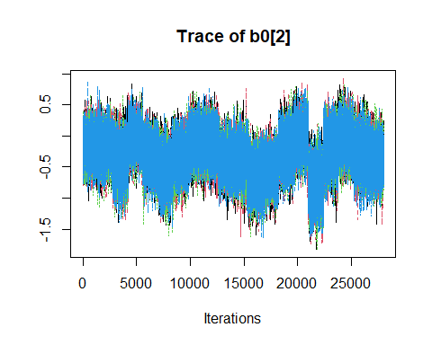

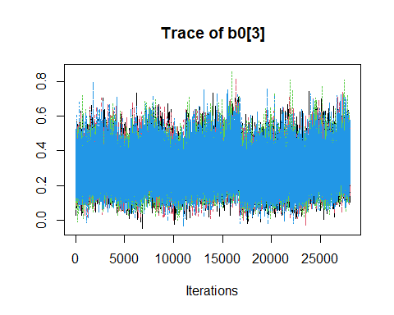

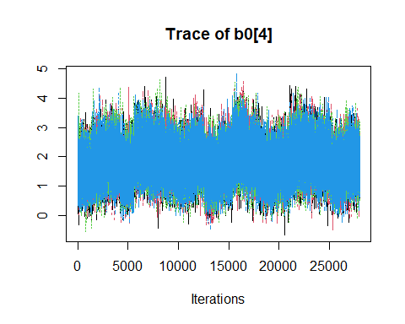

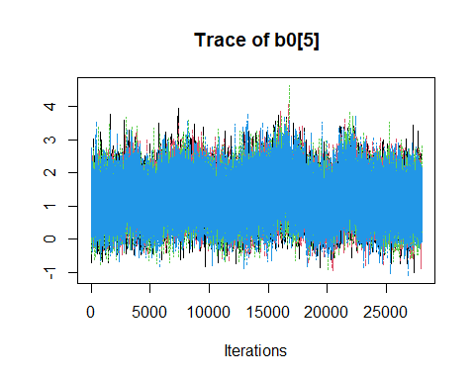

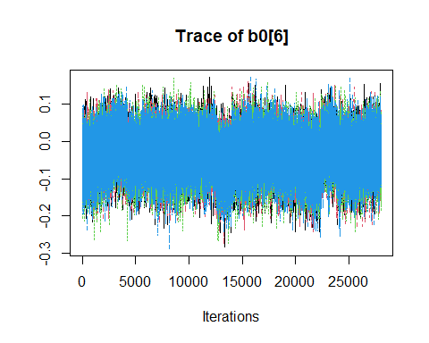

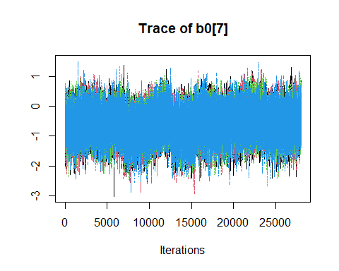

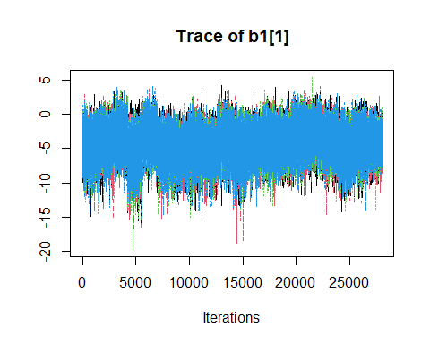

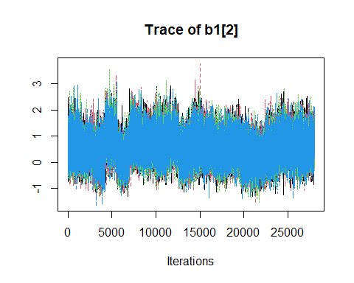

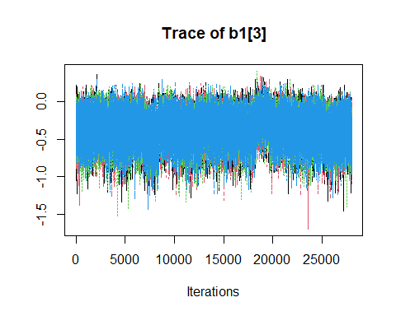

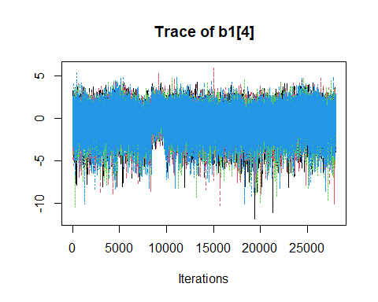

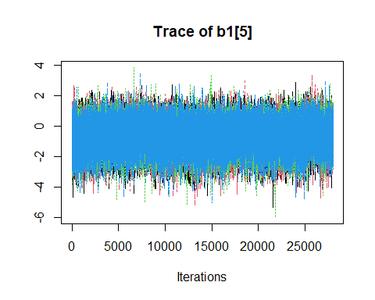

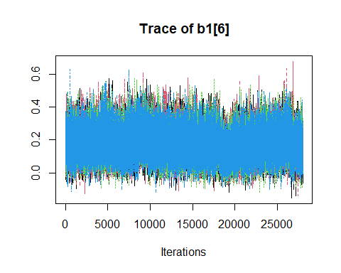

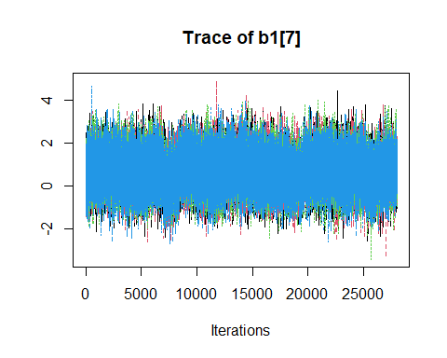

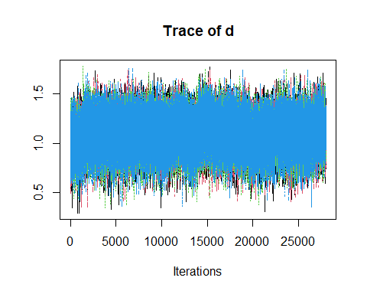

#### Post-op

pooled_post_op |> traceplot()

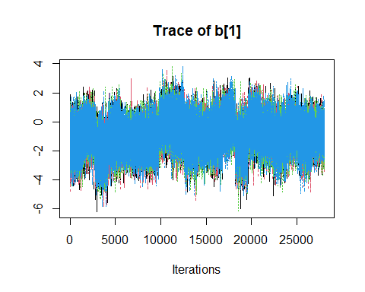

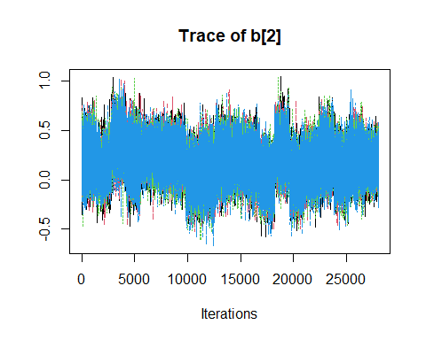

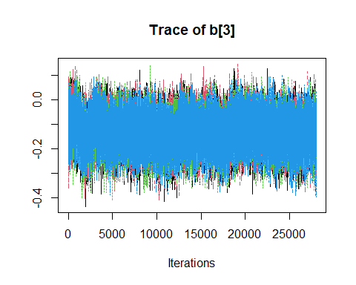

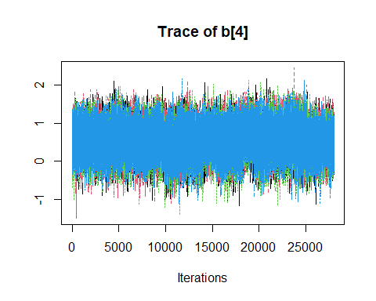

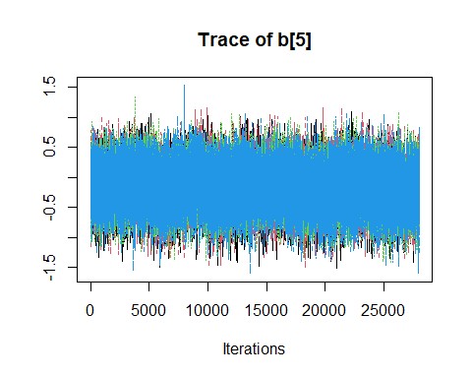

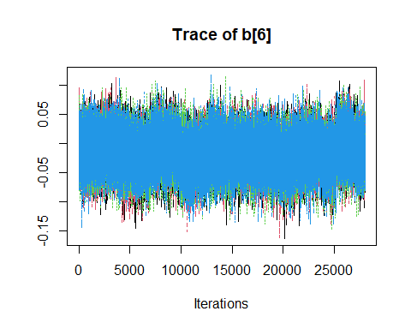

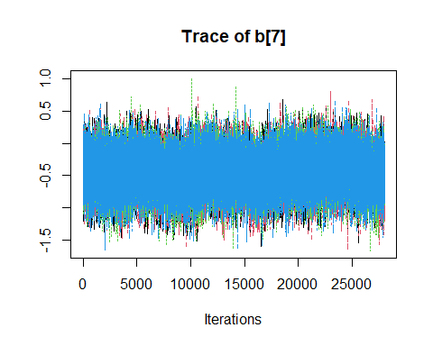

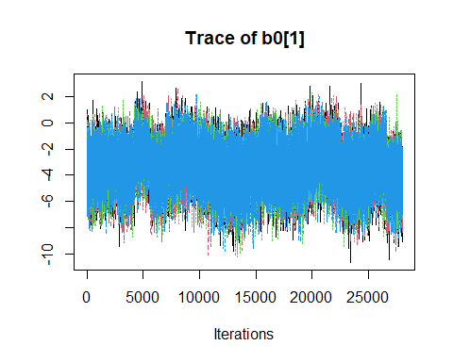

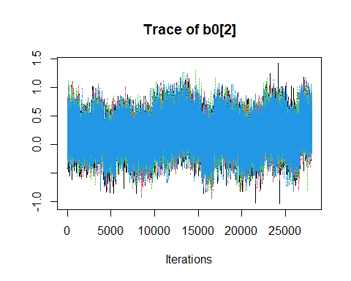

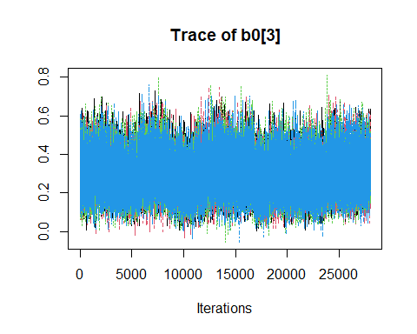

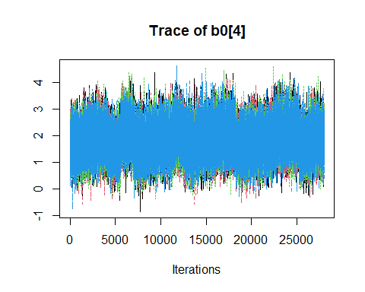

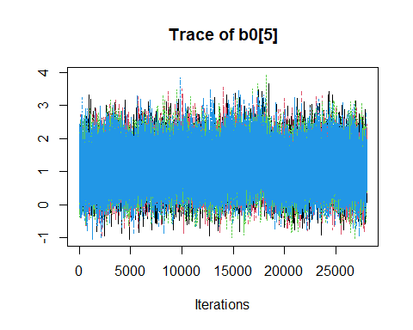

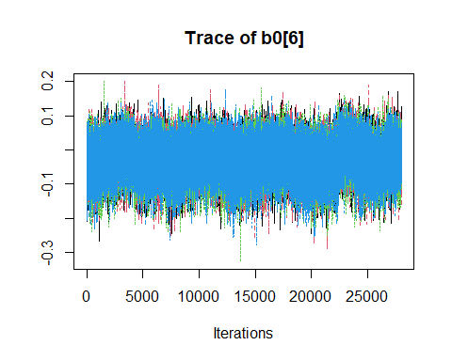

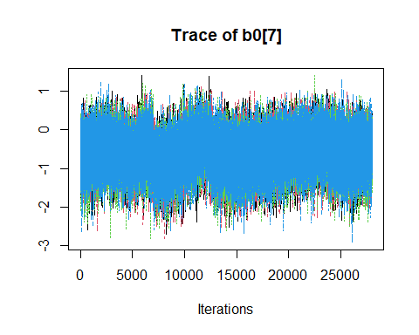

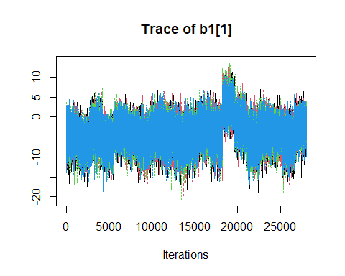

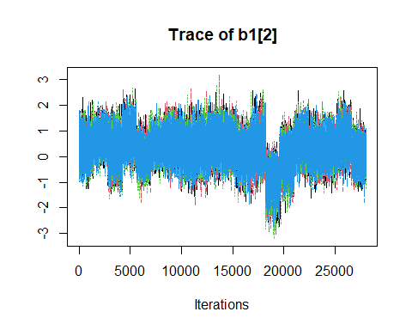

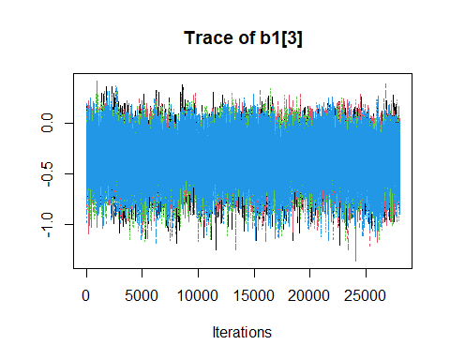

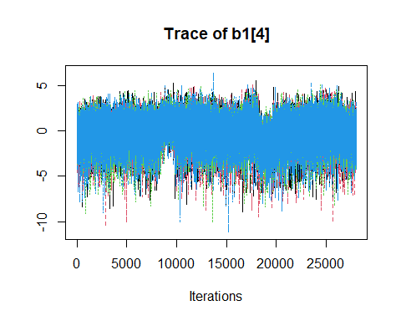

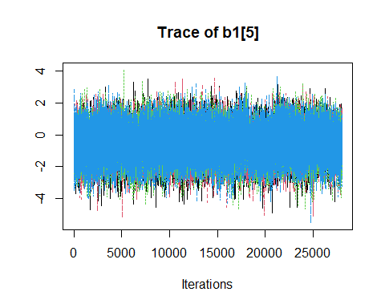

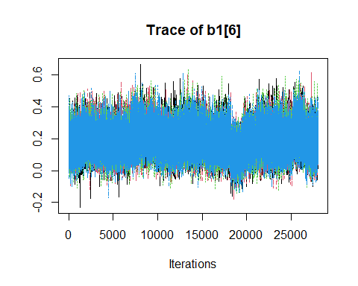

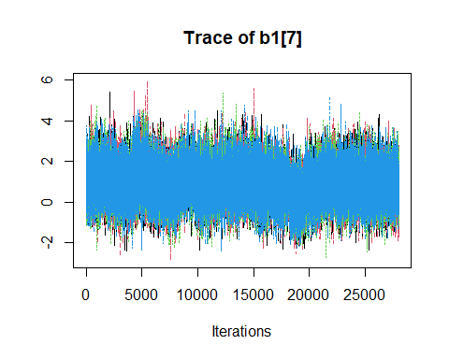

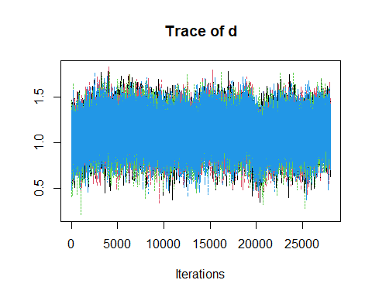

### Autocorrelation plots

#### Pre-op

pooled_pre_op |> autocorr.plot()

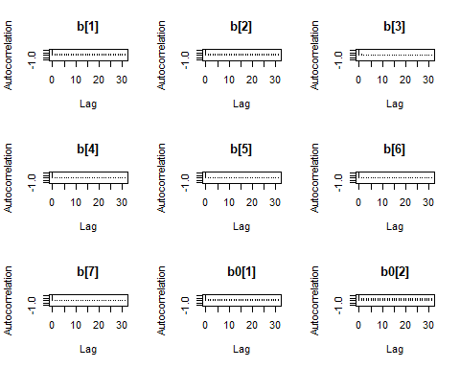

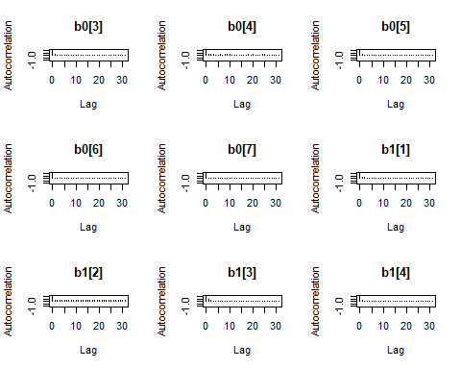

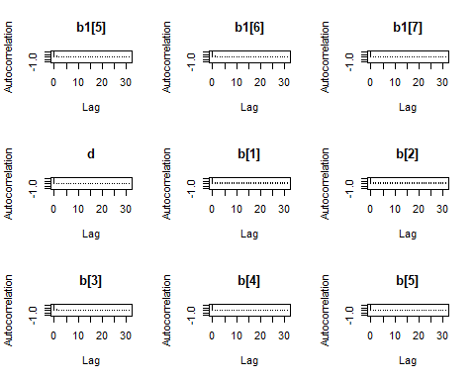

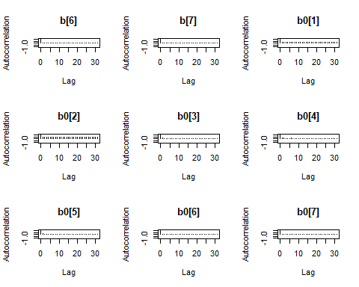

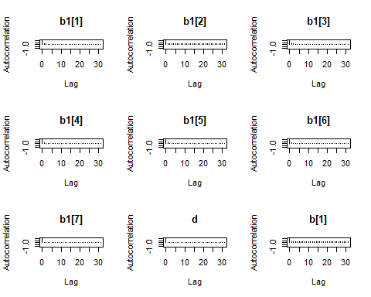

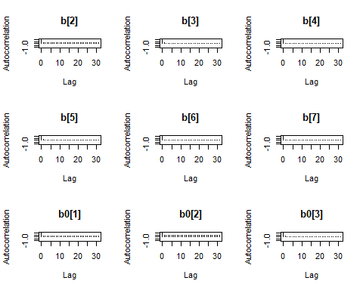

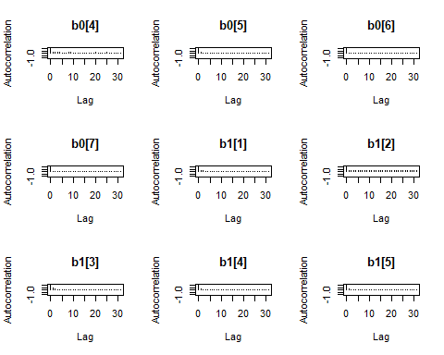

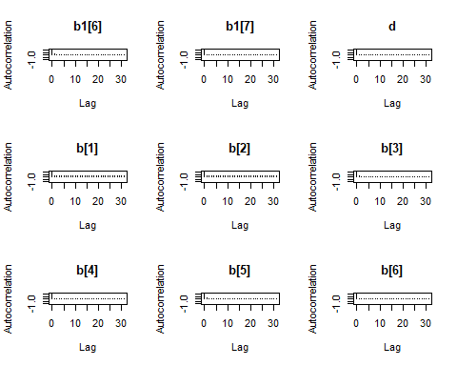

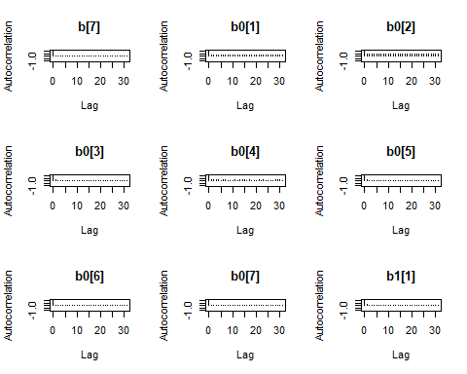

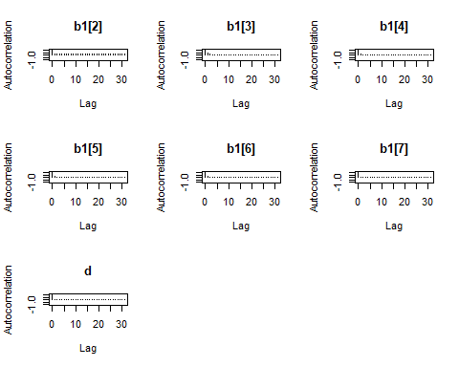

#### Post-op

pooled_post_op |> autocorr.plot()

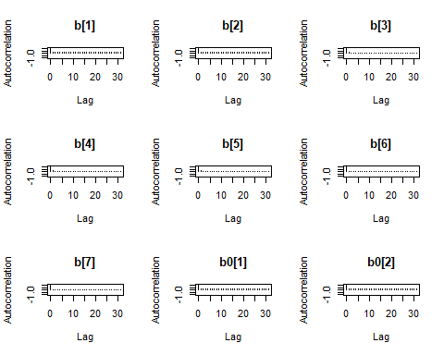

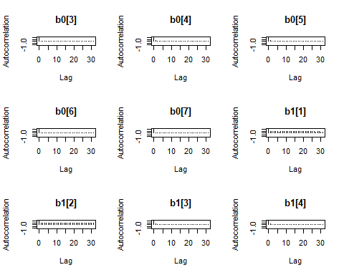

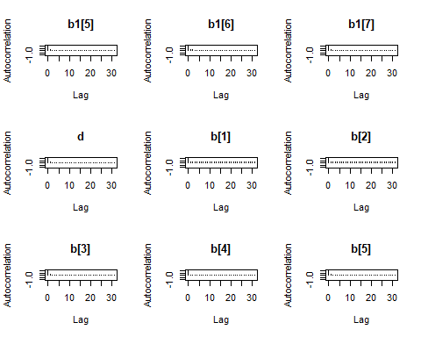

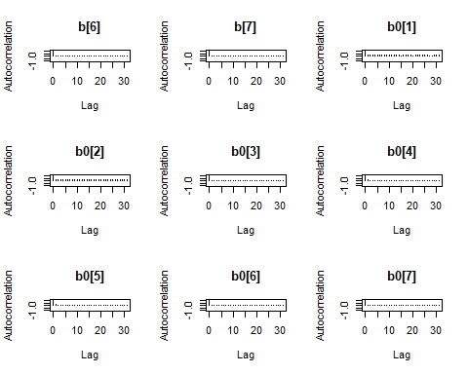

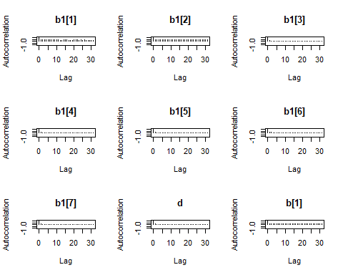

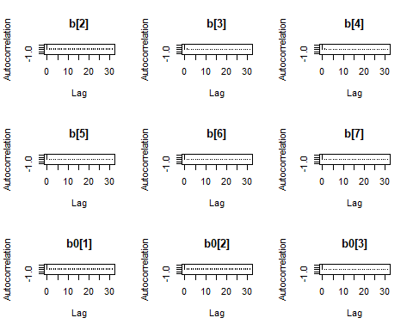

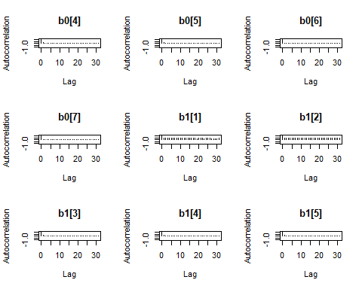

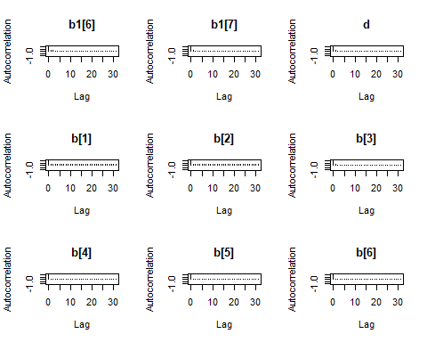

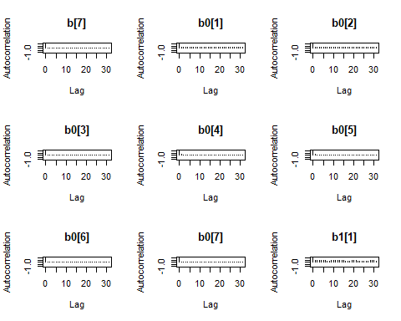

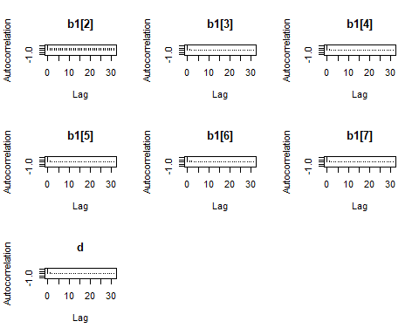

# Summary table

summary_pooled_pre_op = pooled_pre_op |> summary()  
summary_pooled_post_op = pooled_post_op |> summary()  
  
rnames = c("Baseline","Attention Score","Length of Intubation (d)",  
 "Single Ventricle w/ Arch Obstruction","Two Ventricles w/ Arch Obstruction",  
 "Age", "Female")  
  
pre_mean = summary_pooled_pre_op$statistics[,"Mean"]  
pre_lb = summary_pooled_pre_op$quantiles[,"2.5%"]   
pre_ub = summary_pooled_pre_op$quantiles[,"97.5%"]  
  
  
  
post_mean = summary_pooled_post_op$statistics[,"Mean"]  
post_lb = summary_pooled_post_op$quantiles[,"2.5%"]   
post_ub = summary_pooled_post_op$quantiles[,"97.5%"]   
  
  
pre_b_df= cbind("Mean"= pre_mean[1:7] |> exp() |> round(2),  
 "2.5%"= pre_lb[1:7] |> exp() |> round(2),  
 "97.5%" = pre_ub[1:7] |> exp() |> round(2))  
  
pre_b0_df= cbind("Mean"= pre_mean[8:14] |> exp() |> round(2),  
 "2.5%"= pre_lb[8:14] |> exp() |> round(2),  
 "97.5%" = pre_ub[8:14] |> exp() |> round(2))  
pre_b1_df= cbind("Mean"= pre_mean[15:21] |> exp() |> round(2),  
 "2.5%"= pre_lb[15:21] |> exp() |> round(2),  
 "97.5%" = pre_ub[15:21] |> exp() |> round(2))  
  
pre_df = cbind(pre_b_df,pre_b0_df,pre_b1_df)  
rownames(pre_df) = rnames  
  
  
  
post_b_df= cbind("Mean"= post_mean[1:7] |> exp() |> round(2),  
 "2.5%"= post_lb[1:7] |> exp() |> round(2),  
 "97.5%" = post_ub[1:7] |> exp() |> round(2))  
  
post_b0_df= cbind("Mean"= post_mean[8:14] |> exp() |> round(2),  
 "2.5%"= post_lb[8:14] |> exp() |> round(2),  
 "97.5%" = post_ub[8:14] |> exp() |> round(2))  
post_b1_df= cbind("Mean "= post_mean[15:21] |> exp() |> round(2),  
 "2.5%"= post_lb[15:21] |> exp() |> round(2),  
 "97.5%" = post_ub[15:21] |> exp() |> round(2))  
  
post_df = cbind(post_b_df,post_b0_df,post_b1_df)  
rownames(post_df) = rnames  
  
  
pre_kable = pre_df |>  
 kable(caption = "Odds Ratio of Percent Oral Feed Model Results (Pre-Operation)") |>  
 add_header_above(header = c("Predictor" = 1,  
 "Odds of Oral Feed \n when oral feed between 0 and 1" = 3,  
 "Odds of 0% Oral Feed" = 3,  
 "Odds of 100% Oral Feed" =3)) |>  
 add_footnote(paste("Posterior variance is estimated to be ", pre_mean[22] |> exp() |> round(2),  
 " (",pre_lb[22] |> exp() |> round(2),",", pre_ub[22]|> exp()|> round(2),")"))  
  
post_kable = post_df |>  
 kable(caption = "Odds Ratio of Percent Oral Feed Model Results (Post-Operation)") |>  
 add_header_above(header = c("Predictor" = 1,  
 "Odds of Oral Feed \n when oral feed between 0 and 1" = 3,  
 "Odds of 0% Oral Feed" = 3,  
 "Odds of 100% Oral Feed" =3)) |>  
 add_footnote(paste("Posterior variance is estimated to be ", post_mean[22] |> exp() |> round(2),  
 " (",post_lb[22] |> exp() |> round(2),",", post_ub[22]|> exp()|> round(2),")"))

## Pre-operation

pre_kable

Odds Ratio of Percent Oral Feed Model Results (Pre-Operation)

| Predictor | Odds of Oral Feed when oral feed between 0 and 1 | | | Odds of 0% Oral Feed | | | Odds of 100% Oral Feed | | |
| --- | --- | --- | --- | --- | --- | --- | --- | --- | --- |
|  | Mean | 2.5% | 97.5% | Mean | 2.5% | 97.5% | Mean | 2.5% | 97.5% |
| Baseline | 0.96 | 0.21 | 4.47 | 0.20 | 0.02 | 2.32 | 0.02 | 0.00 | 1.11 |
| Attention Score | 1.02 | 0.71 | 1.47 | 0.74 | 0.37 | 1.35 | 1.74 | 0.63 | 5.34 |
| Length of Intubation (d) | 0.86 | 0.76 | 0.98 | 1.35 | 1.13 | 1.67 | 0.69 | 0.45 | 0.99 |
| Single Ventricle w/ Arch Obstruction | 1.57 | 0.71 | 3.36 | 6.19 | 1.90 | 22.14 | 0.76 | 0.03 | 10.62 |
| Two Ventricles w/ Arch Obstruction | 0.81 | 0.42 | 1.59 | 3.43 | 1.11 | 11.58 | 0.52 | 0.08 | 3.05 |
| Age | 0.98 | 0.92 | 1.04 | 0.97 | 0.87 | 1.07 | 1.19 | 1.02 | 1.43 |
| Female | 0.65 | 0.37 | 1.13 | 0.56 | 0.21 | 1.44 | 1.94 | 0.40 | 9.96 |
| a Posterior variance is estimated to be 3 ( 2.08 , 4.22 ) |  |  |  |  |  |  |  |  |  |

## Post-operation

post_kable

Odds Ratio of Percent Oral Feed Model Results (Post-Operation)

| Predictor | Odds of Oral Feed when oral feed between 0 and 1 | | | Odds of 0% Oral Feed | | | Odds of 100% Oral Feed | | |
| --- | --- | --- | --- | --- | --- | --- | --- | --- | --- |
|  | Mean | 2.5% | 97.5% | Mean | 2.5% | 97.5% | Mean | 2.5% | 97.5% |
| Baseline | 0.39 | 0.04 | 3.29 | 0.03 | 0.00 | 0.67 | 0.02 | 0.00 | 37.09 |
| Attention Score | 1.20 | 0.82 | 1.75 | 1.19 | 0.71 | 2.01 | 1.33 | 0.34 | 4.09 |
| Length of Intubation (d) | 0.88 | 0.77 | 1.00 | 1.34 | 1.12 | 1.65 | 0.72 | 0.47 | 1.03 |
| Single Ventricle w/ Arch Obstruction | 1.72 | 0.77 | 3.71 | 6.20 | 1.94 | 21.52 | 0.84 | 0.02 | 13.07 |
| Two Ventricles w/ Arch Obstruction | 0.85 | 0.44 | 1.64 | 3.16 | 1.06 | 9.91 | 0.63 | 0.09 | 3.92 |
| Age | 0.98 | 0.92 | 1.05 | 0.97 | 0.87 | 1.07 | 1.21 | 1.02 | 1.45 |
| Female | 0.64 | 0.36 | 1.11 | 0.54 | 0.20 | 1.40 | 2.47 | 0.46 | 14.76 |
| a Posterior variance is estimated to be 3.07 ( 2.13 , 4.34 ) |  |  |  |  |  |  |  |  |  |