|  |  |
| --- | --- |
| KSU_logo.jpg | **King Saud University**  **College of Computer and Information Sciences**  **Department of Computer Science** |

**CSC 220: Computer Organization**

**Labwork-8**

**Experiment:** Design the bus system to connect four 4-bit registers

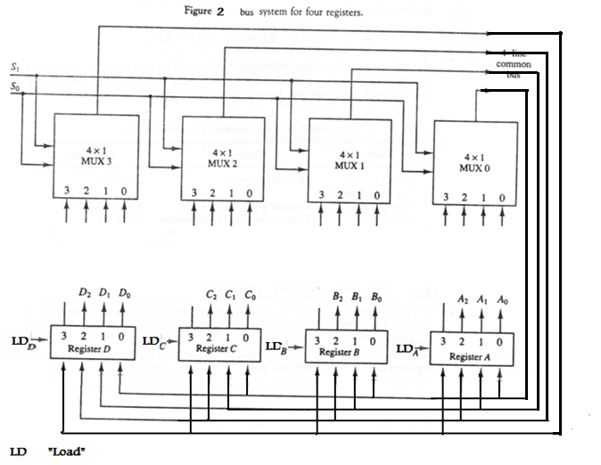

*D*3  *C*3  *B*3  *A*3

*D*3

*C*3

*B*3

*A*3

*D*2  *C*2  *B*2  *A*2

*D*1  *C*1  *B*1  *A*1

*D*0  *C*0  *B*0  *A*0