A visual guide to the Rugby World Cup Japan 2019



Intro

Rankings and methodology were first explained at the following link:

<https://sites.northwestern.edu/msia/2019/01/25/introducing-a-new-rating-system-for-world-rugby-union-based-on-the-elo-rating-system-the-elor-elo-rugby/>. Those rankings are used to get game probabilities and through a Monte-Carlo simulation, odds of winning the tournament. Those odds will change after each game, but this is how things stand at the beginning of the tournament. All the numbers are at the end of the post.

Figure 1: ELO Rankings at the entry to the tournament

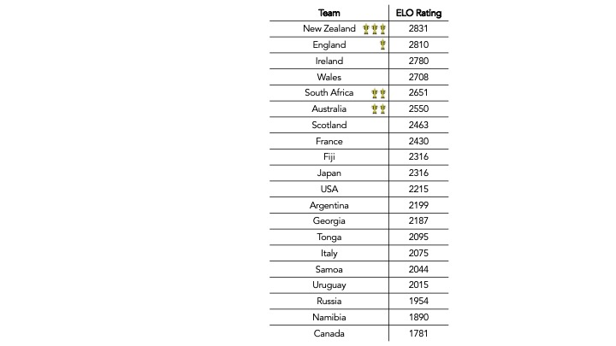

Figure 2: Group A matchups win probabilities

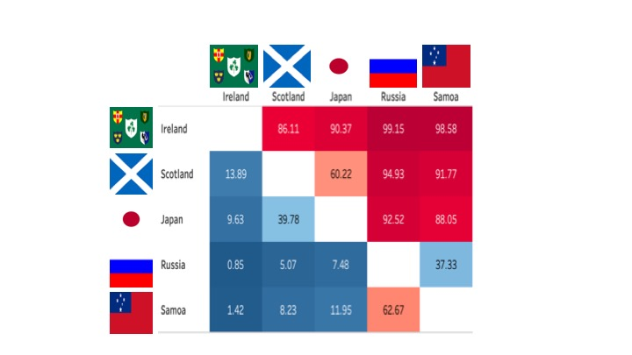

Figure 3: Group A chances of finishing first, second and overall qualifying chances.

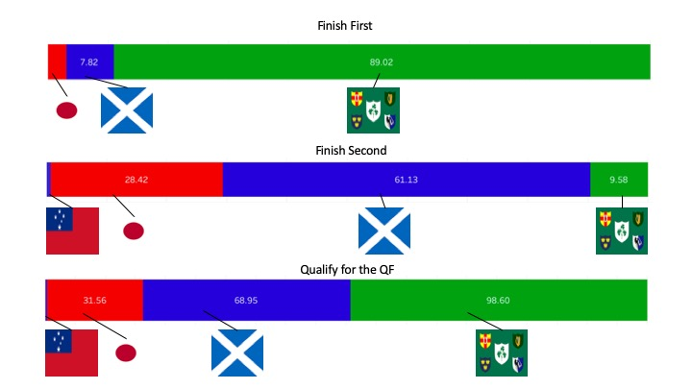

Figure 4: Group B matchups win probabilities

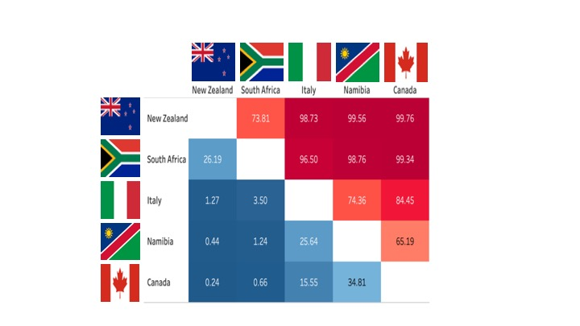

Figure 5: Group B chances of finishing first, second and overall qualifying chances.

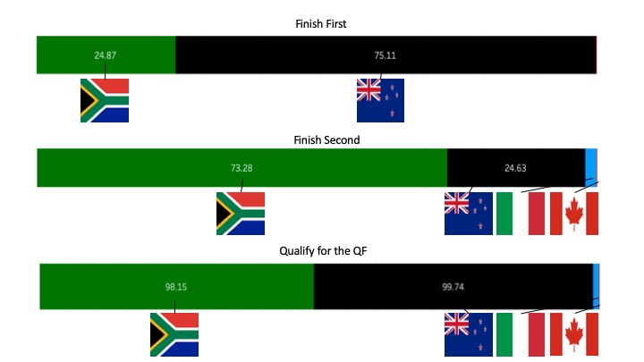

Figure 6: Group C matchups win probabilities

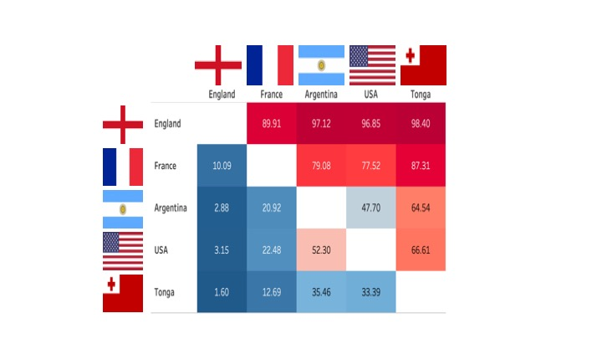

Figure 7: Group C chances of finishing first, second and overall qualifying chances.

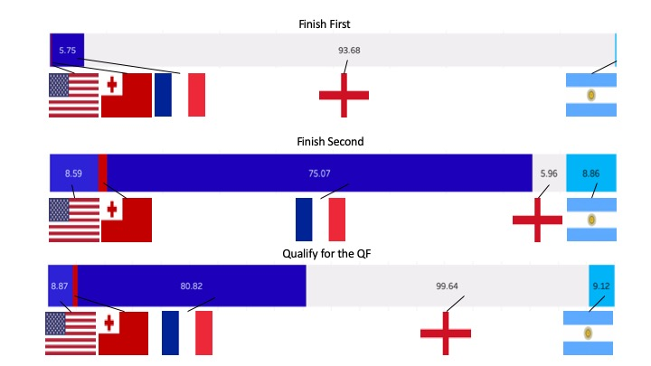

Figure 8: Group D matchups win probabilities

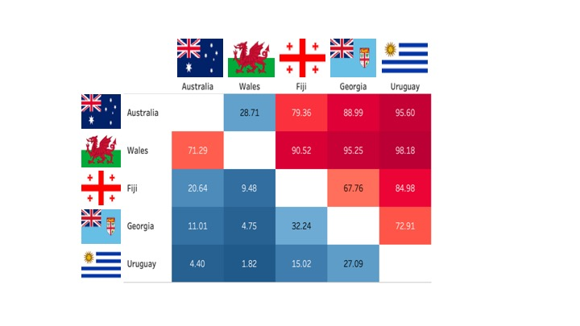

Figure 9: Group D chances of finishing first, second and overall qualifying chances.

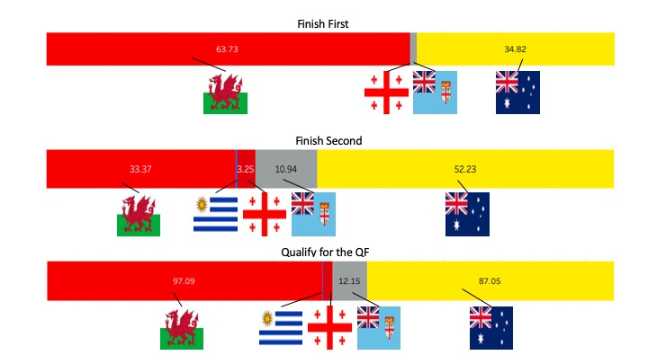

Figure 10: Knock-out round chances

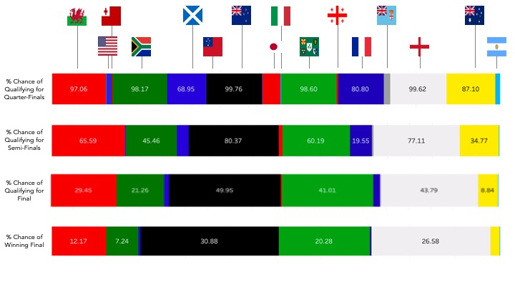

Figure 11: Most likely knock-out matchups and chances of advancing at each stage

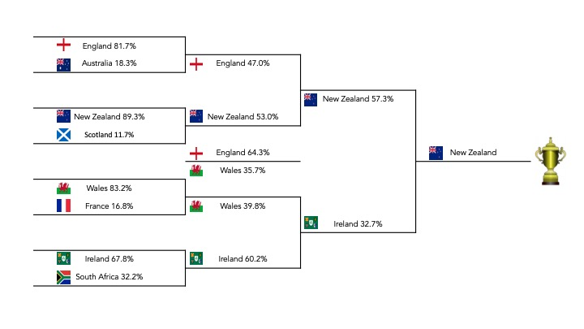

Figure 12: Tournament summary in probabilities

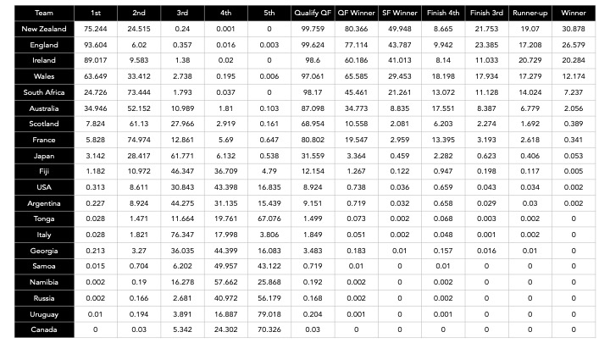

Conclusion

This is how things stand at the beginning of the tournament. The odds will change with time and I will update each and every day on this blog with game odds and margin predictions. Those will be linked on this page. I will reassess the knockout-rounds when the quarterfinalists are set as well. Now let the games begin.