DCCO

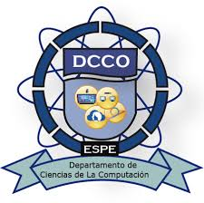

Second Semester

JOSEPH BENJAMIN MEDINA SANCHEZ

ARELYS MAHOLY OTAVALO VILLARREAL

MATHEWS SAID PASTOR HERNANDEZ

MARYURI SALOME QUIÑA MOLINA

OOP -

Professor: Edison Lascano

Problem

We need a system that manages a company’s inventory, purchase records, sales returns, suppliers, and customers, to maintain a brief management of small businesses and this facilitates decision-making. To understand what the program should do, it is necessary to first understand some basic concepts about products, purchase and sales transactions, and related records.

Overview

In the field of inventory management, companies need to keep a detailed record of all product movements: when they are sold, when they are sold, when they are returned, and at what price. Additionally, the system will maintain a complete record of customers allowing tracking of their purchases and interaction history. An efficient inventory system helps reduce losses, optimize costs, and improve customer service through comprehensive management of products, suppliers and customers.