查詢觀看次數最高的10部影片
SELECT "影片標題", "觀看次數"
FROM videos
WHERE "觀看次數" IS NOT NULL
ORDER BY CAST(REPLACE("觀看次數", ',', '') AS INTEGER) DESC
LIMIT 10;
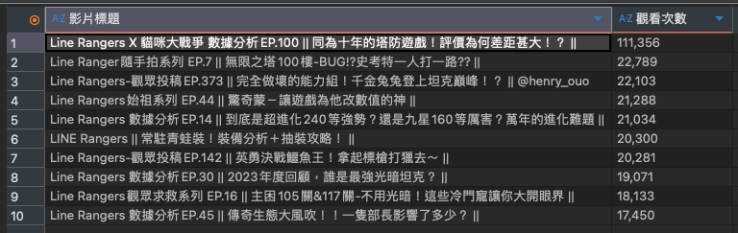
查詢按讚數最高的 10 部影片
SELECT "影片標題", "按讚數"
FROM videos
WHERE "按讚數" IS NOT NULL
ORDER BY CAST(REPLACE("按讚數", ',', '') AS INTEGER) DESC
LIMIT 10;
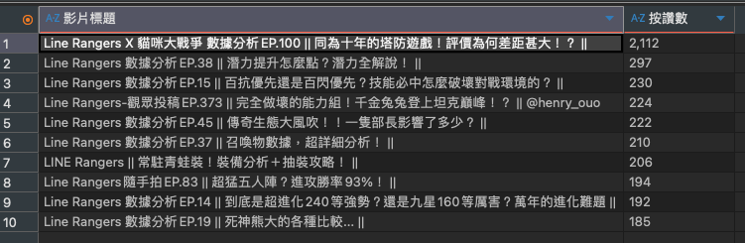
在眾多影片中，觀眾普遍喜歡「數據分析」系列

查詢留言數最高的 10 部影片
SELECT "影片標題", "留言數"
FROM videos
WHERE "留言數" IS NOT NULL
ORDER BY "留言數" DESC
LIMIT 10;
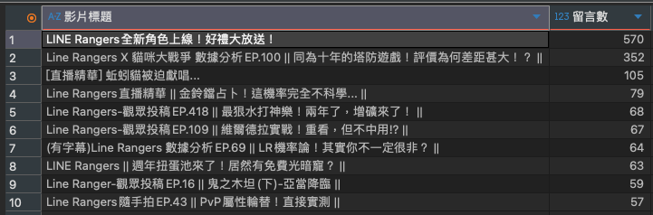
查詢觀看時數最高的 10 部影片
SELECT "影片標題", "留言數"
FROM videos
WHERE "留言數" IS NOT NULL
ORDER BY "留言數" DESC
LIMIT 10;
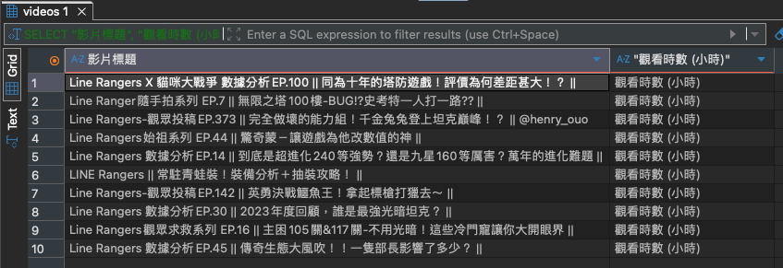

查詢曝光次數最高的 10 部影片
SELECT "影片標題", "曝光次數"
FROM videos
WHERE "曝光次數" IS NOT NULL
ORDER BY CAST(REPLACE("曝光次數", ',', '') AS INTEGER) DESC
LIMIT 10;
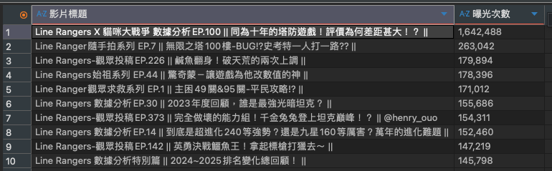
查詢曝光點閱率最高的 10 部影片
SELECT "影片標題", "曝光點
閱率(%)"
FROM videos
WHERE "曝光點
閱率(%)" IS NOT NULL
ORDER BY CAST(REPLACE("曝光點
閱率(%)", '%', '') AS REAL) DESC
LIMIT 10;
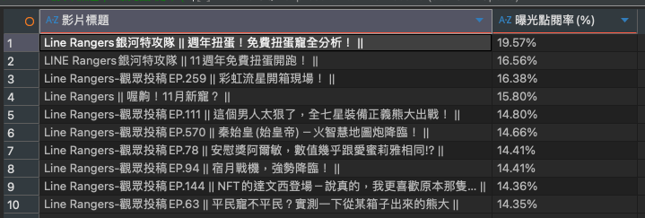

查詢預估收益最高的 10 部影片
SELECT "影片標題", "預估收益
(USD)"
FROM videos
WHERE "預估收益
(USD)" IS NOT NULL
ORDER BY CAST(REPLACE(REPLACE("預估收益
(USD)", '$', ''), ',', '') AS REAL) DESC
LIMIT 10;
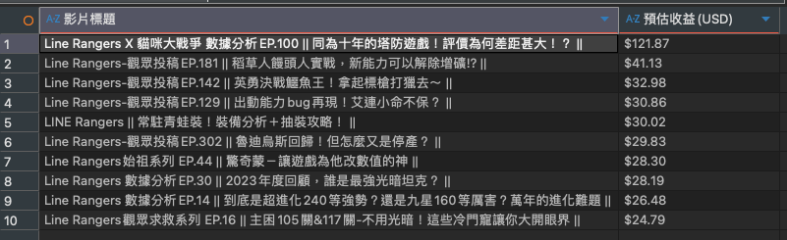
查詢 2024 年之後發布、觀看次數最高的 10 部影片
SELECT "影片標題", "發布日期", "觀看次數"
FROM videos
WHERE "發布日期" >= '2024-01-01'
ORDER BY CAST(REPLACE("觀看次數", ',', '') AS INTEGER) DESC
LIMIT 10;
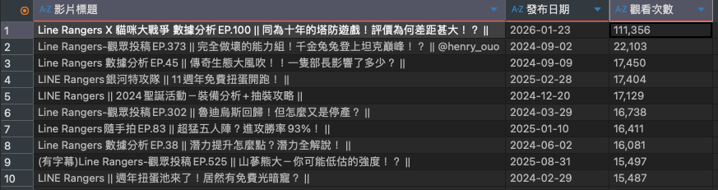

查詢觀看次數超過 20000 的影片，並依觀看次數排序取前 10 筆
SELECT "影片標題", "觀看次數"
FROM videos
WHERE CAST(REPLACE("觀看次數", ',', '') AS INTEGER) > 20000
ORDER BY CAST(REPLACE("觀看次數", ',', '') AS INTEGER) DESC
LIMIT 10;
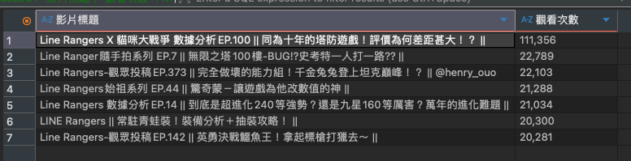
資料數不足，因此只有七筆資料（其餘影片觀看次數都少於兩萬）
查詢按讚數超過 200 的影片，並依按讚數排序取前 10 筆
SELECT "影片標題", "按讚數"
FROM videos
WHERE CAST(REPLACE("按讚數", ',', '') AS INTEGER) > 200
ORDER BY CAST(REPLACE("按讚數", ',', '') AS INTEGER) DESC
LIMIT 10;
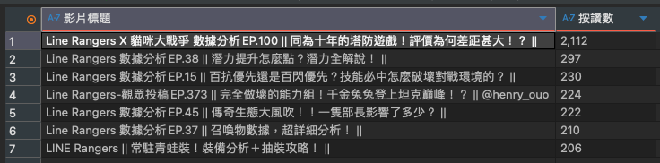
資料數不足，因此只有七筆資料（其餘影片按讚數都少於200）

