As per jira MDB-3399, new firm setup screen developed in Regulatory Reporting application for setting up the Firm name and Firm ID for a particular application (Dashboard application). A new table is required to store the firm setup information.

**Table Name: RegulatoryReporting_Firm**

|  |  |  |
| --- | --- | --- |
| Column Name | Data Type | Description |
| RegulatoryReporting_Firm_Id | Int | Primary Key Identity Column |
| CUST_ID | CHAR(12) | Customer ID; reference to CUST table |
| Project_Id | Small Int | Reference to RegulatoryReporting_Lookup table; User pick from dropdown |
| Firm_Id | varchar(20) | Customer Firm Id user input |
| Firm_Name | varchar(200) | Customer Firm Name via user |

Unique constraint on Project_Id, CUST_ID, Firm_Id

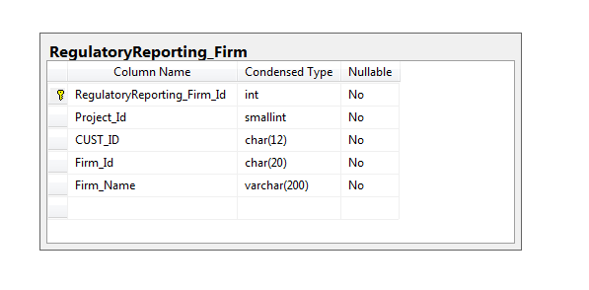

Screenshot from confluence for Firm Setup Screen.

