**Database Configuration for IMSPlatform**

**Objective:**

IMS has multiple applications with different URL’s, login screens and site minders. Here is the list of applications

1. Manager Dashboard SEI Application (HTML 5)
2. KYC
3. Regulatory Reporting (FormPF, CPOPR, AIFMD etc.)

Goal is build an application to single sign-on to access all three applications. Near future more IMS applications like ECR will be added.

This is how the menu system works for *all* the applications sitting under the IMS Platform not just MDB 3. Don't think of it as a way to define URLs, it is how we define what the menu is, what text is displayed, who has permissions for it, what action gets taken when it is selected and where the user gets sent when a menu item is selected (i.e. if a new browser window is opened or if it is handled within the existing frame).

For menu items that work within an application (like clicking on Dashboard while in MDB 3) a Controller and Action is defined. For External menu items a full URL is defined. Each menu item is also associated with an application menu item as well as a parent menu item. The Parent is used to define drop down menus.

There is also a separate Table defined for the Application menu. This includes a partial or full URL and whether the application gets opened in a new window or the current browser. This also has permissions associated with each application menu item.

Once the data tables are created we can add a service to use then and create an interface to manage the menu items.

**Database Diagram:**

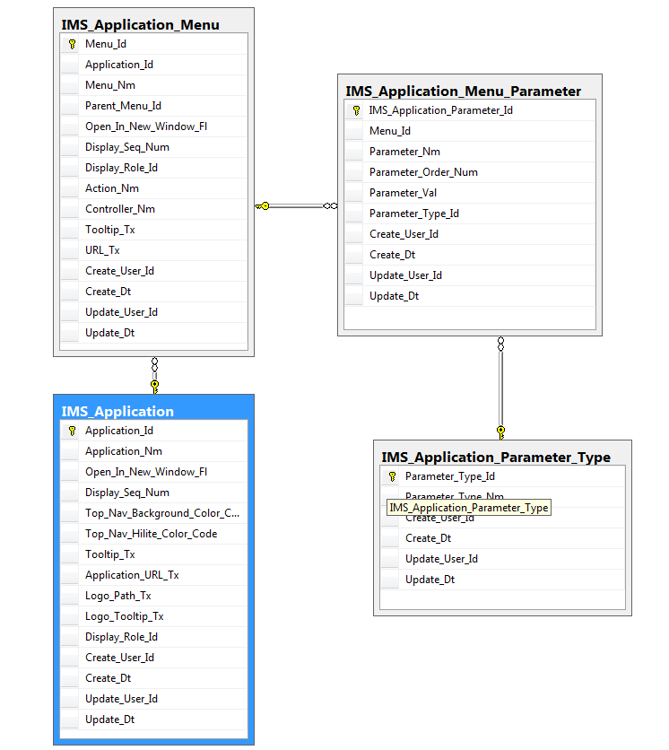

**Reference Document and Samples files**

**Path:** **\\seipvcsv1\m_GoldCode\Build\Netik\CodeReview\2014.3.1_MDB_ReviewSet4\**