For demonstration purpose, I am using SQL Server 2008 R2 and the instance name is INTEL.

**Moving the msdb database**  
At present, my msdb database resides under the following path D:\Program Files\Microsoft SQL Server\MSSQL10_50.MSSQLSERVER\MSSQL\DATA and I want to move it’s mdf and ldf file to the paths named E:\Microsoft SQL Server\MSQL\Data and E:\Microsoft SQL Server\MSQL\Log respectively.

Connect to the SQL Server Management Studio, open a new query window and select the msdb database, please refer the screen capture below:

[[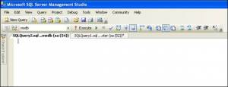](http://satnamdba.files.wordpress.com/2011/07/pic1.jpg)](http://satnamdba.files.wordpress.com/2011/07/pic1.jpg)

Execute the below T-SQL query against the msdb database to get the logical file name of the data and log files of the tempdb database.

select * from sysfiles

Please refer the screen capture below:

[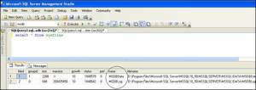](http://satnamdba.files.wordpress.com/2011/08/pic3.jpg)

As seen from the screen capture above, the logical name of the data file of the msdb database is msdbdata whereas the logical name of the log file of the msdb database is msdblog.

Execute the below set of T-SQL statements against the msdb database.

ALTER DATABASE msdb  
MODIFY FILE ( NAME =’msdbdata’,  
FILENAME = ‘E:\Microsoft SQL Server\MSQL\Data\msdbdata.mdf’)

ALTER DATABASE msdb  
MODIFY FILE ( NAME =’msdblog’,  
FILENAME = ‘E:\Microsoft SQL Server\MSQL\Log\msdblog.ldf’)

In the first query, msdbdata is the logical name of the data file of msdb database and E:\Microsoft SQL Server\MSQL\Data is the new path to hold its data file whereas msdblog is the logical name of the log file of msdb database and E:\Microsoft SQL Server\MSQL\log is the new path to hold its log file.

Please refer the screen capture below:

[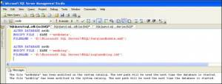](http://satnamdba.files.wordpress.com/2011/08/pic4.jpg)

Stop the SQL Server Services. This can be done using the command prompt, please refer the screen capture below.

On the command prompt, type the following command

NET STOP MSSQLSERVER

[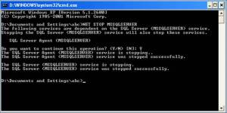](http://satnamdba.files.wordpress.com/2011/08/pic5.jpg)

After executing the command, the SQL Server Services is stopped.

Move the data and the log file of the msdb database present under the original path D:\Program Files\Microsoft SQL Server\MSSQL10_50.MSSQLSERVER\MSSQL\DATA to its new path  
E:\Microsoft SQL Server\MSQL\Data and E:\Microsoft SQL Server\MSQL\Log respectively.

Start the SQL Server Services.

On the command prompt, type the following command  
NET START MSSQLSERVER

[http://satnamdba.files.wordpress.com/2011/07/pic6.jpg?w=300&h=27](http://satnamdba.files.wordpress.com/2011/07/pic6.jpg)

Once done, check whether the msdb data and log files are present at the newly allocated location. To do that, execute the below query against the msdb database.

select * from sysfiles

Please refer the screen capture below.

[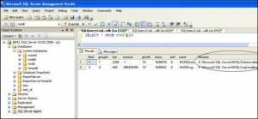](http://satnamdba.files.wordpress.com/2011/07/pic7.jpg)

From the above screen capture, we can conclude that we have successfully moved the msdb database to the newly allocated location successfully.

**Moving the model database**

At present, model database is present under the following path D:\Program Files\Microsoft SQL Server\MSSQL10_50.MSSQLSERVER\MSSQL\Data and I want to move its mdf and ldf file to the paths named E:\Microsoft SQL Server\MSQL\Data and E:\Microsoft SQL Server\MSQL\Log respectively.  
Connect to the SQL Server Management Studio, open a new query window and select the model database, please refer the screen capture below:

Execute the below T-SQL query against the model database to get the logical file name of the data and log files of the model database.

select * from sysfiles

Please refer the screen capture below:

[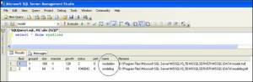](http://satnamdba.files.wordpress.com/2011/07/pic9.jpg)

As seen from the screen capture above, the logical name of the data file of the model database is modeldev whereas the logical name of the log file of the model database is modellog.  
Execute the below set of T-SQL statements against the model database.

ALTER DATABASE model  
MODIFY FILE ( NAME =’modeldev’,  
FILENAME = ‘E:\Microsoft SQL Server\MSQL\Data\modeldev.mdf’)

ALTER DATABASE model  
MODIFY FILE ( NAME =’modellog’,  
FILENAME = ‘E:\Microsoft SQL Server\MSQL\Log\modellog.ldf’)

In the first query, modeldev is the logical name of the data file of model database and E:\Microsoft SQL Server\MSQL\Data is the new path to hold its data file whereas modellog is the logical name of the log file of model database and E:\Microsoft SQL Server\MSQL\log is the new path to hold its log file.

Please refer the screen capture below:

[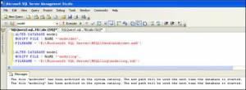](http://satnamdba.files.wordpress.com/2011/07/pic10.jpg)

Stop the SQL Server Services. This can be done using the command prompt, please refer the screen capture below.

On the command prompt, type the following command

NET STOP MSSQLSERVER

[](http://satnamdba.files.wordpress.com/2011/07/pic11.jpg)

After executing the command, the SQL Server Services is stopped.

Move the data and the log file of the model database present under the original path D:\Program Files\Microsoft SQL Server\MSSQL10_50.MSSQLSERVER\MSSQL\DATA to its new path  
E:\Microsoft SQL Server\MSQL\Data and E:\Microsoft SQL Server\MSQL\Log respectively.

Start the SQL Server Services.

On the command prompt, type the following command

NET START MSSQLSERVER

[http://satnamdba.files.wordpress.com/2011/07/pic12.jpg?w=300&h=27](http://satnamdba.files.wordpress.com/2011/07/pic12.jpg)

Once done, check whether the model data and log files are present at the newly allocated location. To do that, execute the below query against the model database.

select * from sysfiles

Please refer the screen capture below.

[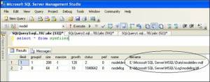](http://satnamdba.files.wordpress.com/2011/07/pic132.jpg)

From the above screen capture, we can conclude that we have successfully moved the model database to the newly allocated location successfully.

**Moving the distribution database**

At present, distribution database is present under the following path D:\Program Files\Microsoft SQL Server\MSSQL10_50.MSSQLSERVER\MSSQL\Data and I want to move its mdf and ldf file to the paths named E:\Microsoft SQL Server\MSQL\Data and E:\Microsoft SQL Server\MSQL\Log respectively.

Connect to the SQL Server Management Studio, open a new query window and select the distribution database, please refer the screen capture below:

[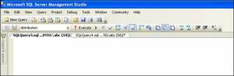](http://satnamdba.files.wordpress.com/2011/07/pic141.jpg)

Execute the below T-SQL query against the distribution database to get the logical file name of the data and log files of the distribution database.

select * from sysfiles

Please refer the screen capture below:

[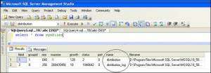](http://satnamdba.files.wordpress.com/2011/07/pic15.jpg)

As seen from the screen capture above, the logical name of the data file of the distribution database is distribution whereas the logical name of the log file of the distribution database is distribution_log.

Execute the below set of T-SQL statements against the distribution database.

ALTER DATABASE distribution  
MODIFY FILE ( NAME =’distribution’,  
FILENAME = ‘E:\Microsoft SQL Server\MSQL\Data\distribution.mdf’)

ALTER DATABASE distribution  
MODIFY FILE ( NAME =’distribution_log’,  
FILENAME = ‘E:\Microsoft SQL Server\MSQL\Log\distribution_log.ldf’)

In the first query, distribution is the logical name of the data file of distribution database and E:\Microsoft SQL Server\MSQL\Data is the new path to hold its data file whereas distribution_log is the logical name of the log file of distribution database and E:\Microsoft SQL Server\MSQL\log is the new path to hold its log file.

Please refer the screen capture below:

[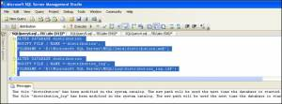](http://satnamdba.files.wordpress.com/2011/07/pic16.jpg)

Stop the SQL Server Services. This can be done using the command prompt, please refer the screen capture below.

On the command prompt, type the following command  
NET STOP MSSQLSERVER

[](http://satnamdba.files.wordpress.com/2011/07/pic17.jpg)

After executing the command, the SQL Server Services is stopped.

Move the data and the log file of the distribution database present under the original path D:\Program Files\Microsoft SQL Server\MSSQL10_50.MSSQLSERVER\MSSQL\DATA to its new path  
E:\Microsoft SQL Server\MSQL\Data and E:\Microsoft SQL Server\MSQL\Log respectively.

Start the SQL Server Services.

On the command prompt, type the following command  
NET START MSSQLSERVER

[http://satnamdba.files.wordpress.com/2011/07/pic18.jpg?w=300&h=27](http://satnamdba.files.wordpress.com/2011/07/pic18.jpg)

Once done, check whether the model data and log files are present at the newly allocated location. To do that, execute the below query against the distribution database.

select * from sysfiles

Please refer the screen capture below.

[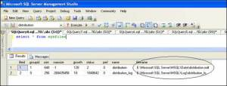](http://satnamdba.files.wordpress.com/2011/07/pic19.jpg)

<http://satnamdba.wordpress.com/2011/08/28/moving-system-database-to-a-different-location-in-sql-server-2008-r2-%E2%80%93-part-2/>