**This document contains**

* Moving system databases in SQL Server 2008
* How to repair a SQL Server 2008 Suspect database
* Restore Master Database

Moving system databases in SQL Server 2008

I am going to move all the system and user databases from C:\Program Files\Microsoft SQL Server\MSSQL10.MSSQLSERVER\MSSQL\DATA folder to C:\Program Files\System databases location.  
  
Select name, physical_name from sys.master_files  
  
The below screenshot shows the path of the database files before movement.  
  
  
[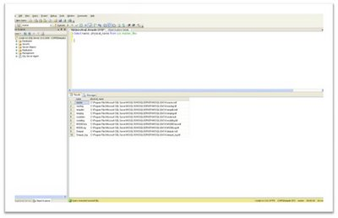](http://4.bp.blogspot.com/_Fos6ItVjxwM/SQ6aOSfixZI/AAAAAAAAAwk/NHXvb0G95TE/s1600-h/1.bmp)  
  
**Moving Tempdb database:**  
  
We need to use the Alter database command to move tempdb database files from one location to another as shown in the below screenshot.  
  
*Use master*  
*go*  
*Alter database tempdb modify file (name=tempdev,filename='C:\Program Files\System databases\tempdb.mdf')*  
*go*  
*Alter database tempdb modify file (name=templog,filename='C:\Program Files\System databases\tempdb.ldf')*  
*go*  
  
Once we execute the above command the o/p will be something like,  
[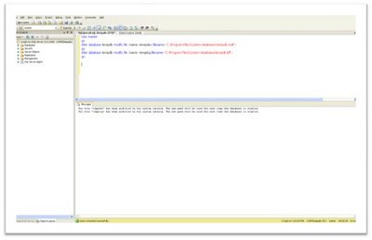](http://1.bp.blogspot.com/_Fos6ItVjxwM/SQ6aO48l3bI/AAAAAAAAAws/jbTq0PGuUDE/s1600-h/2.bmp)  
The file "tempdev" has been modified in the system catalog. The new path will be used the next time the database is started.  
The file "templog" has been modified in the system catalog. The new path will be used the next time the database is started.  
  
The next time the Sql Service is restarted the tempdb database files will be created in the new location.  
  
  
**Moving master database:**  
  
We need to change the path to point to the new location where master database files will be located in the SQL Server startup parameters (in SQL Server configuration manager). Right click on SQL Server and go to properties – advanced tab.  
  
Original path in Startup parameters will be similar to the one shown below,  
  
*-d C:\Program Files\Microsoft SQL Server\MSSQL10.MSSQLSERVER\MSSQL\DATA\master.mdf;-eC:\Program Files\Microsoft SQL Server\MSSQL10.MSSQLSERVER\MSSQL\Log\ERRORLOG;-lC:\Program Files\Microsoft SQL Server\MSSQL10.MSSQLSERVER\MSSQL\DATA \mastlog.ldf*  
[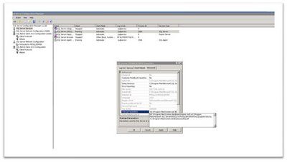](http://1.bp.blogspot.com/_Fos6ItVjxwM/SQ6aPKtIAqI/AAAAAAAAAw0/SzU5NQAJXS0/s1600-h/3.bmp)  
New path in Startup parameters which we have to enter will be similar to the one shown below since I am going to change the location of the master database to C:\Program Files\System databases folder the command will be like something,  
  
*-dC:\Program Files\System databases\master.mdf;-eC:\Program Files\Microsoft SQL Server\MSSQL10.MSSQLSERVER\MSSQL\Log\ERRORLOG;-lC:\Program Files\System databases\mastlog.ldf*  
  
If you wish to change the location of the error log to a new location please specify that as well next to –e in the above command.  
  
-d implies that it’s the location data file of master database.  
-l implies that it’s the location log file of master database.  
-e implies that it’s the location the SQL Server error log file.  
  
After changing the new path in startup parameter, SQL Server will prompt for a service restart so that the changes will take effect. You can either use the SQL Server configuration manager to accomplish this or use NET START MSSSQLSERVER command from command prompt to start SQL Server.  
[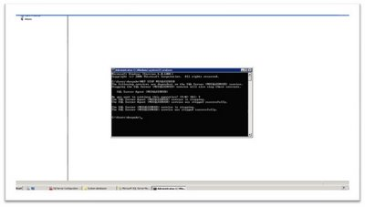](http://4.bp.blogspot.com/_Fos6ItVjxwM/SQ6aPgeBhTI/AAAAAAAAAw8/PGEBfTbXU0Y/s1600-h/4.bmp)  
Net Start Mssqlserver – to start SQL Server this is a default instance  
Net Stop Mssqlserver – to stop SQL Server this is a default instance  
Net Start Mssql$instancename – to start SQL Server this is a named instance  
Net Stop Mssql$instancename – to stop SQL Server this is a named instance  
  
**Moving Msdb and Model database:**  
  
We need to make use of Alter database to move the database to new location similar to the movement of tempdb database. After running the below query in the screenshot we need to stop Sql Service and copy the database files to new location and then restart Sql service. The same procedure is applicable for both Msdb and Model database.  
  
For msdb use the below command,  
  
*Use master*  
*go*  
*Alter database msdb modify file (name=msdbdata,filename='C:\Program Files\System databases\msdbdata.mdf')*  
*go*  
*Alter database msdb modify file (name=msdblog,filename='C:\Program Files\System databases\msdblog.ldf')*  
*go*  
[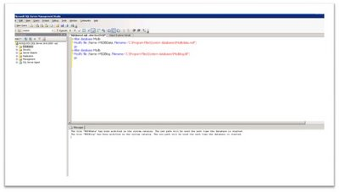](http://3.bp.blogspot.com/_Fos6ItVjxwM/SQ6aPoDMGiI/AAAAAAAAAxE/mM8nKdLZQQg/s1600-h/5.bmp)  
For model db use the command similar to  
  
*Use master*  
*go*  
*Alter database model modify file (name=modeldev,filename='C:\Program Files\System databases\model.mdf')*  
*go*  
*Alter database model modify file (name=modellog,filename='C:\Program Files\System databases\modellog.ldf')*  
*go*  
[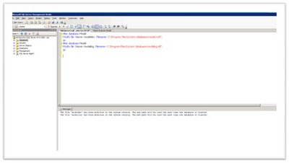](http://3.bp.blogspot.com/_Fos6ItVjxwM/SQ6caUHB5cI/AAAAAAAAAxM/QRlv0dj3U5M/s1600-h/6.bmp)  
  
**Moving user databases:**  
  
We can make use the same alter database statements, stop sql services and then copy the database files to new location and restart Sql Server.  
  
[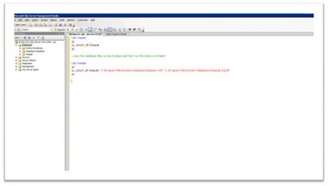](http://2.bp.blogspot.com/_Fos6ItVjxwM/SQ6cakT7QgI/AAAAAAAAAxc/SvPwFqXcfj4/s1600-h/8.bmp)  
  
(or) We can also make use of sp_detach_db to detach the database, then copy the database files to new location and attach it using sp_attach_db procedure as shown below.  
  
  
*Use master*  
*go*  
*sp_detach_db Deepak*  
*go*  
  
*Use master*  
*go*  
*sp_attach_db Deepak 'C:\Program Files\System databases\Deepak.mdf', 'C:\Program Files\System databases\Deepak_log.mdf'*  
*go*  
  
  
[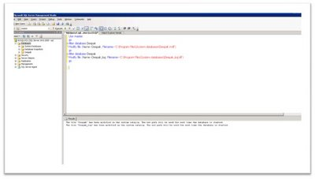](http://4.bp.blogspot.com/_Fos6ItVjxwM/SQ6caQ1SinI/AAAAAAAAAxU/kbZW3PLsFog/s1600-h/7.bmp)  
Finally we can check the path of all the database we have moved using the below command,  
  
Select name, physical_name from sys.master_files  
  
[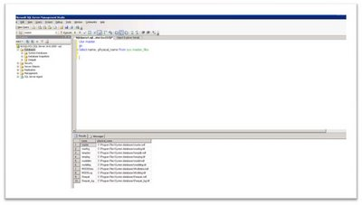](http://4.bp.blogspot.com/_Fos6ItVjxwM/SQ6carZlXZI/AAAAAAAAAxk/5uonpRl90N0/s1600-h/9.bmp)

<http://deepakrangarajan.blogspot.com/2008/11/moving-system-databases-in-sql-server.html>

**How to repair a SQL Server 2008 Suspect database**

Sometimes when you connect to your database server, you may find it in **suspect mode**. Your database server won’t allow you to perform any operation on that database until the database is repaired.

A database can go in suspect mode for many reasons like improper shutdown of the database server, corruption of the database files etc.

To get the exact reason of a database going into suspect mode can be found using the following query,

DBCC CHECKDB (‘YourDBname’) WITH NO_INFOMSGS, ALL_ERRORMSGS

Output of the above query will give the errors in the database.To repair the database, run the following queries in Query Analyzer,

EXEC sp_resetstatus ‘yourDBname’;

ALTER DATABASE yourDBname SET EMERGENCY

DBCC checkdb(‘yourDBname’)

ALTER DATABASE yourDBname SET SINGLE_USER WITH ROLLBACK IMMEDIATE

DBCC CheckDB (‘yourDBname’, REPAIR_ALLOW_DATA_LOSS)

ALTER DATABASE yourDBname SET MULTI_USER

References : <http://blog.van-huizen.com/2009/10/how-to-repair-sql-server-2008-suspect.html>

<http://gargmanoj.wordpress.com/2008/07/17/how-to-repair-a-sql-server-2005-suspect-database/>

**Restore Master Database**

here are certain situation when user wants to start SQL Server Engine in***“single user”*** mode from the start up.

To start SQL Server in single user mode is very simple procedure as displayed below.

Go to SQL Server Configuration Manager and click on  SQL Server 2005 Services. Click on desired SQL Server instance and right click go to properties. On the Advance table enter param ‘**-m;**‘ before existing params in Startup Parameters box.

Make sure that you entered semi-comma after -m. Once that is completed, restart SQL Server services to take this in effect. Once this is done, now you will be only able to connect SQL Server using sqlcmd.

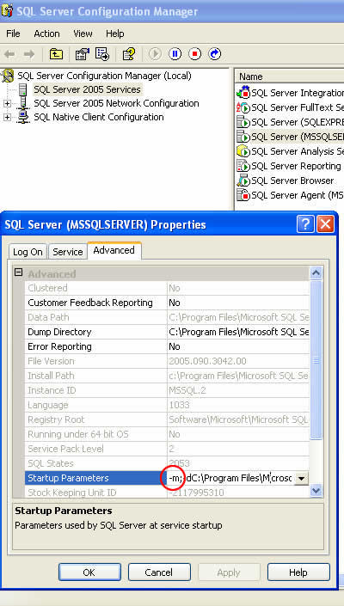

Make sure to remove newly added params after required work is completed to restart it in multi user mode.

Once SQL Server instance is running in single user mode, immediately connect it using sqlcmd and run following command to restore the master database.

RESTORE DATABASE master FROM DISK = 'C:\BackupLocation\master.back' WITHREPLACE;  
GO

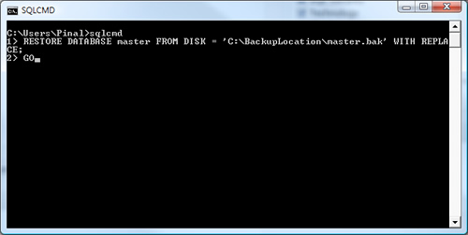

I have tested it couple of times and it has worked fine for me. If you encounter any error please leave a comment and I will do my best to solve it.

<http://blog.sqlauthority.com/2009/02/14/sql-server-restore-master-database-an-easy-solution/>