TempDB Monitor

2012-02-16

Greetings everyone, at Raj’s request I have spent some time today building a process that monitors tempdb usage on TEDWANADB01. As currently implemented the process checks every 10 minutes to see if any files in tempdb is over 80% utilized, and if so it writes detailed information into the SQL Server event log.

The processes is implemented as SQL Agent job TempDB Monitor. The body of the job is in the attached script. The script itself can serve as an example of how to collect some pretty detailed information about what’s happening in tempdb. And after Abu and the rest of the team has a chance to study this we may want to implement the script as a stored procedure.

Here is some sample output:

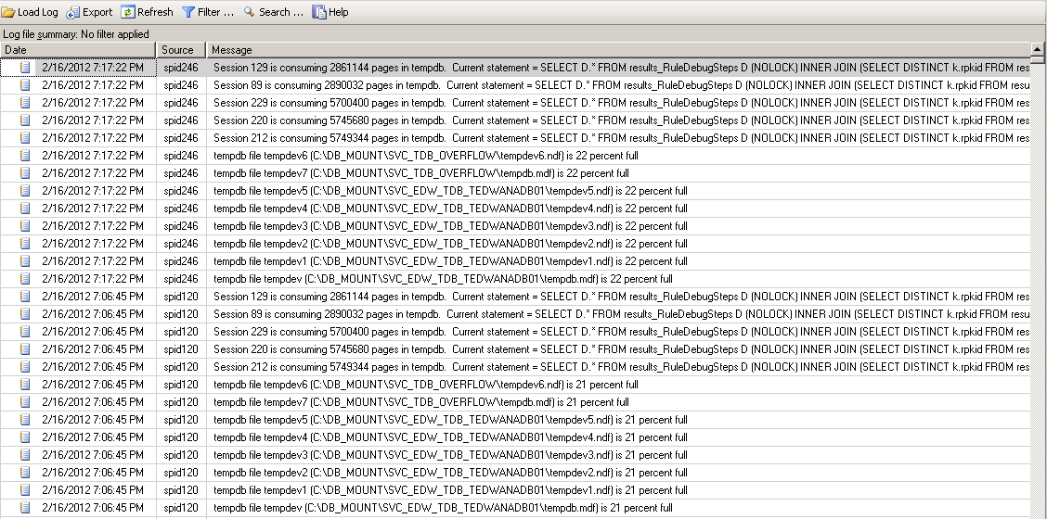

When this output was created I had set the @pctusedThreshold to 0…I wanted to force some output. The threshold is now set at 80, so this information will only be collected when at least 1 of the files in tempdb becomes 80% full.

As implemented this process doesn’t sent out any email alerts. And the messages that are raised by the process are severity 10, meaning just informational. It looks to me like we have notive SQL Server Alerts set up on the box, and it looks like the alert for Insufficient Resources is enabled, so if we want to get this information out in an email message to the team we just need to modify this to raise an error of severity level 17.

Abu, please give all of this and let me know what you think. Also let me know if you’d like me to implement this process on TEDWAPPDB02 as well.

Take care, talk to you soon,

A