Contents

1. Move the Master Database in SQL Server 2008 R2

Let’s presume our master database is in completely the wrong location: 

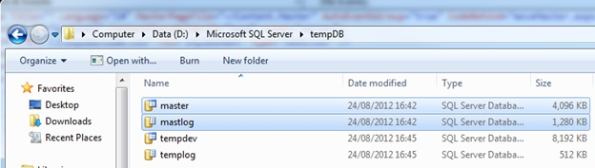

In fact you can see… it’s actually in the tempDB folder with my tempDB files. Clearly we don’t want it there, so let’s move it.  
  
Note: You can also see the location of your master database files by looking in the GUI or using T-SQL. This technique is documented as part of this article: [*How to move tempDB in SQL Server 2008 R2.*](http://www.theboreddba.com/Categories/system%20databases/movetempDB.aspx)  
  
Go to your SQL Server and Stop the Service: 

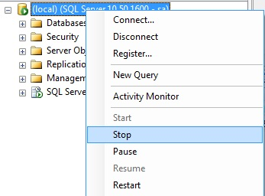

Once stopped, locate your files and move them (cut and paste works just fine) from your old location to your new location: 

Once stopped, locate your files and move them (cut and paste works just fine) from your old location to your new location: 

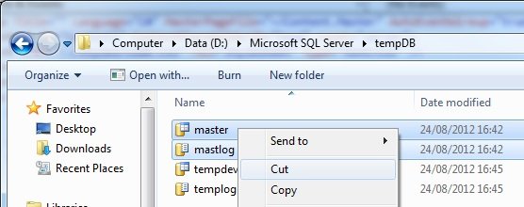

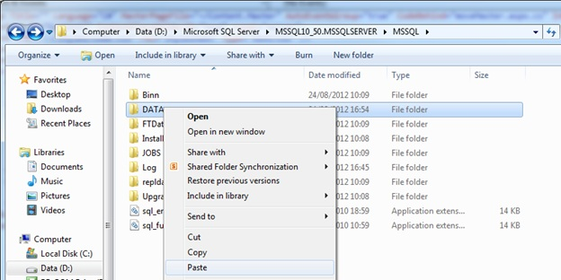

Next, open SQL Server Configuration Manager and click on SQL Server Services on the left hand side: 

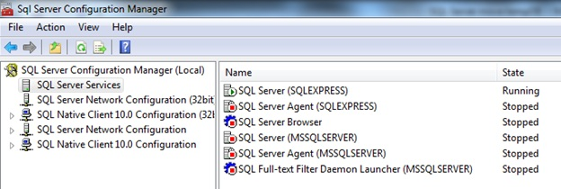

In here, locate the main SQL Server Service, right click, and select Properties: 

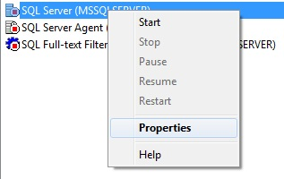

Click on Advanced: 

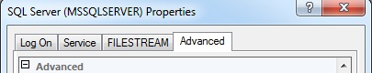

And you should be able to see “Startup Parameters”: 

http://www.theboreddba.com/images/Databases/moveMaster/startupParams.jpg

Clicking the drop down arrow will let you see a nice text box which will tell you exactly where SQL is looking for your master database: 

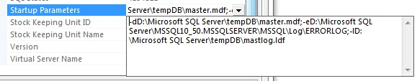

In this case you can see that the drives are:

-dD:\Microsoft SQL Server\tempDB\master.mdf  
-lD:\Microsoft SQL Server\tempDB\mastlog.ldf

You simply want to change these to the new location. In my case these are:

-dD:\Microsoft SQL Server\MSSQL10_50.MSSQLSERVER\MSSQL\DATA\master.mdf  
-lD:\Microsoft SQL Server\MSSQL10_50.MSSQLSERVER\MSSQL\DATA\mastlog.ldf



That’s it.  
  
Click “Apply” and you’ll get a little notification box: 

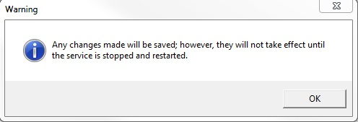

Click OK and then simply start the SQL Service: 

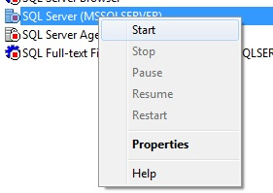

Your files are now exactly where you wanted them: 

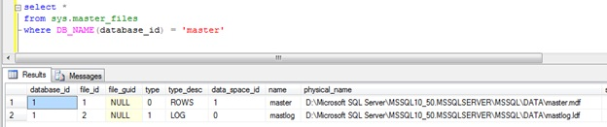

1. Move The tempDB Database
2. Let’s presume for a moment that my tempDB is in completely the wrong location and I need it moved…
3. 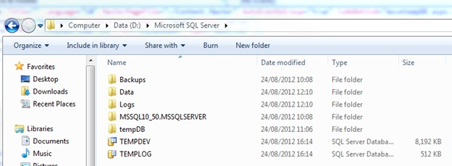
4. As you can see, it’s clearly not where it belongs, so I’m going to move it from here and into the tempDB folder.  
     
   Firstly, you may not actually know for certain where your tempDB is hiding. There are a couple of ways you can find this out, you can use the GUI by right clicking tempDB and selecting Properties:
5. 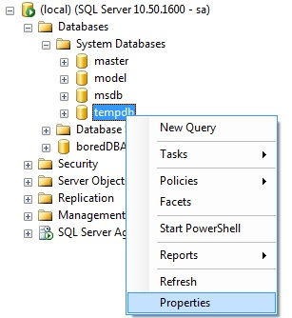
6. Then click on the Files tab on the left:
7. 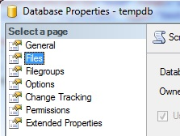
8. Next, scroll across until you see the Path shown:
9. 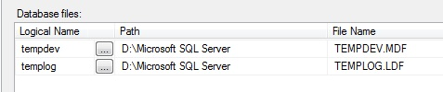
10. The two other ways are both faster and involve a little T-SQL. You can use either of the following:
11. 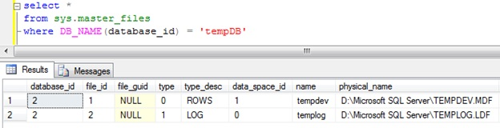
12. or
13. 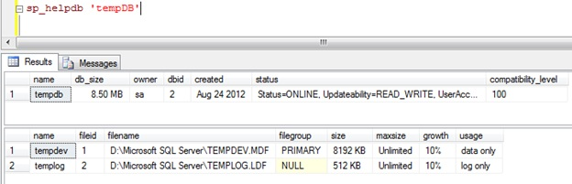
14. All of these should lead you to the current location of your tempDB files.  
      
    Knowing the location is not actually essential for this process, but it’s always good to know.  
      
    To actually move the location of tempDB (in my case to “D:\Microsoft SQL Server\tempDB\”) you simply need to run the following:
15. 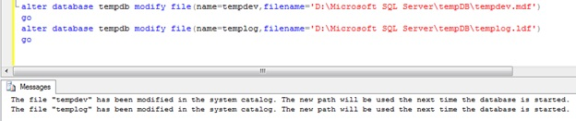
16. You can see the confirmation message specifies that this will take effect the next time you restart SQL Server. This is because at restart SQL will drop and re-create tempDB and therefore it will do so at this new location.  
      
    Quick service restart and there we have it…
17. 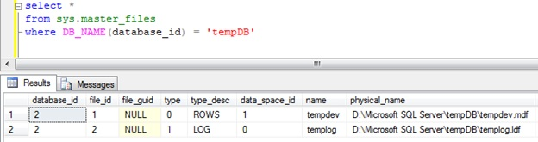

Model and MSDB Databases in SQL Server 2008 R2

To move the Model and MSDB databases in SQL Server 2008 R2 follows the same pattern as with tempDB. However, the reason I have put this in a seperate article is that I will also cover the steps involved in moving these databases under SQL Server 2005 (though not in great detail).  
  
Firstly we find the current location of the Model and MSDB files: 

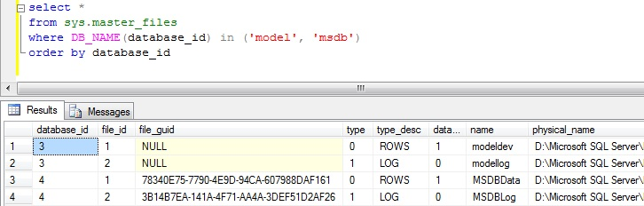

In SQL Server 2008 R2 all you need to do is run the following: 

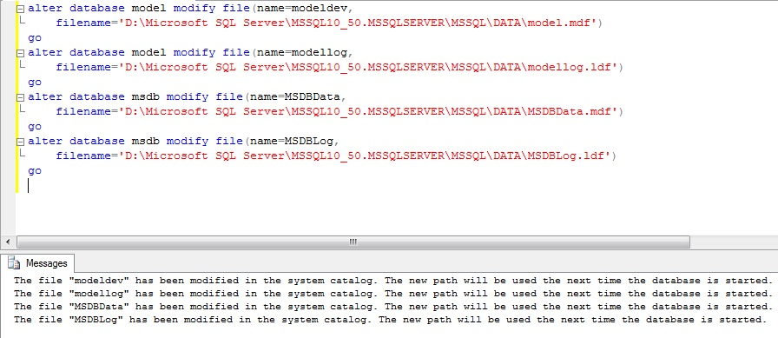

Then you need to stop the SQL Server: 



Move the physical files on your operating system, and then start you SQL Server once more: 

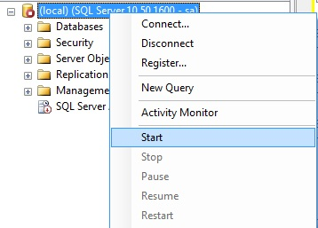

That's it.  
  
This is FAR simpler than the method for SQL Server 2005. For this method we need a completely different approach.  
  
As above we check for the current location of the files. Once found we then have to open SQL Server Configuration Manager and click on SQL Server Services on the left hand side: 



In here, locate the main SQL Server Service, right click, and select Properties: 



Click on Advanced: 



And you should be able to see “Startup Parameters”: 

http://www.theboreddba.com/images/Databases/moveMaster/startupParams.jpg

Clicking the drop down arrow will let you see a nice text box which will tell you exactly what parameters are being used for startup: 



You need to add **;-c-m-T3608** to the end of this: 

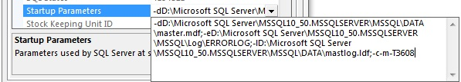

Then start the service and SQL Server will start in single user mode. 

http://www.theboreddba.com/images/Databases/moveMSDB/startServiceConfigManager.jpg

Connect to SQL Server using Management Studio...  
  
If you see the following error... 

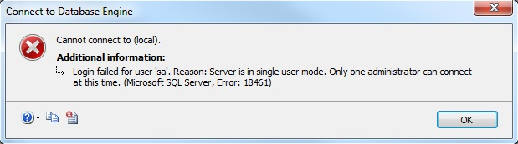

It is because you already have a connection in Object Explorer. Therefore Disconnect this... 

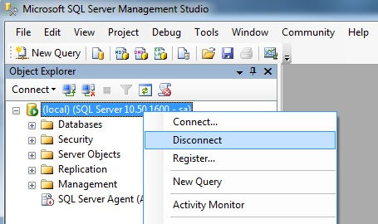

You will now be able to open a solitary Query window... 

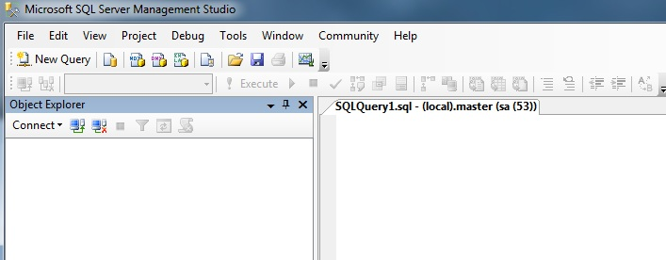

Once you have done this you will be able to detach the msdb and model databases...

sp_detach_db 'msdb'   
go   
sp_detach_db 'model'   
go

Now move your files in the file system to the location you want them and then re-attach the databases:

sp_attach_db 'model',   
    'D:\Microsoft SQL Server\MSSQL10_50.MSSQLSERVER\MSSQL\DATA\model.mdf',   
    'D:\Microsoft SQL Server\MSSQL10_50.MSSQLSERVER\MSSQL\DATA\modellog.ldf',   
go   
sp_attach_db 'msdb'   
    'D:\Microsoft SQL Server\MSSQL10_50.MSSQLSERVER\MSSQL\DATA\MSDBData.mdf',   
    'D:\Microsoft SQL Server\MSSQL10_50.MSSQLSERVER\MSSQL\DATA\MSDBLog.ldf',   
go

NOTE: If you move both model and msdb together then you HAVE to complete this in the correct order otherwise you will get errors. You must detach MSDB first, then model, and then you must attach model before MSDB.  
  
Remove the parameters from the startup line and start SQL Server. The databases are now being used from their new locations.