Mikayla Timm

project 4

11/15/15

COP4534

Description of Data Structures

For this project, I used an Adjacency List inspired structure for storing the bins and items. There is an AdjacencyList pointer that holds the number of bins in the list and a pointer to the first Bin. Each Bin in the list stores data about the Bin including the number of Items in the Bin, the maximum size taken from bins.txt, the space remaining after subtracting the values of all the items in the bin from the max size, a pointer to the first Item in the bin, and a pointer to the next Bin in the list. Each Bin has Items in it. Each Item has a value taken from binItems.txt as well as a pointer to the next Item. The last Bin in the list points to a NULL bin pointer, and the last item in each bin points to a NULL item pointer.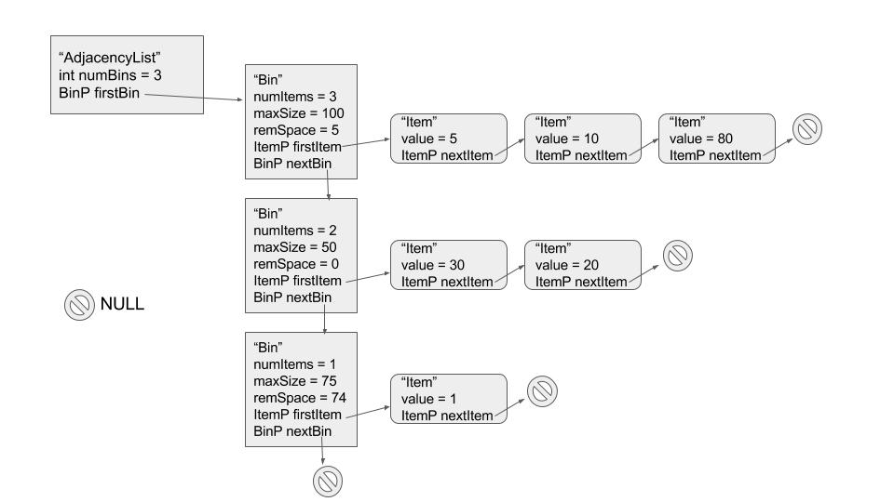

I chose these structures because it made it easy to conceptualize how to pack everything. The list stores all the bins that have been “packed”. The bins store items that fit in the bins, just like in real life. For each of the algorithms you have to be able to know how much space is left in the bin to know if the item will fit or not. Keeping everything organized in this fashion makes it easy to traverse the list and each bin. Keeping track of the number of bins in the AdjacencyList structure also makes it easy to print out all the results at the end.