Max Tjen

PQHS 414

Assignment 3

1. Two types of steps, DATA and PROC
2. For all of the incorrect variable names except ‘2000MeaslesCount’ and ‘AGE-In-2000’, they are incorrect because they include a blank/space character. For ‘2000MeaslesCount’, it is incorrect because it begins with a number. For ‘AGE-In-2000’, it is incorrect because it includes a special character that isn’t the underscore.
3. 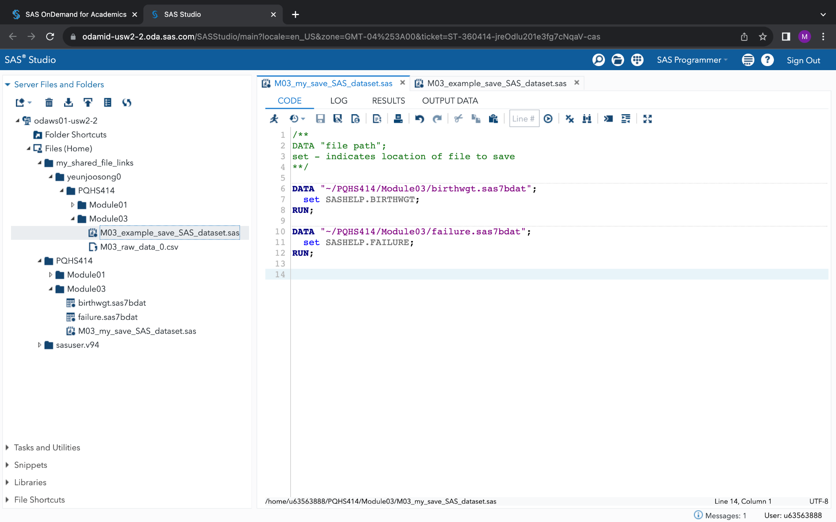  
     
     
     
     
     
     
     
     
     
   1. 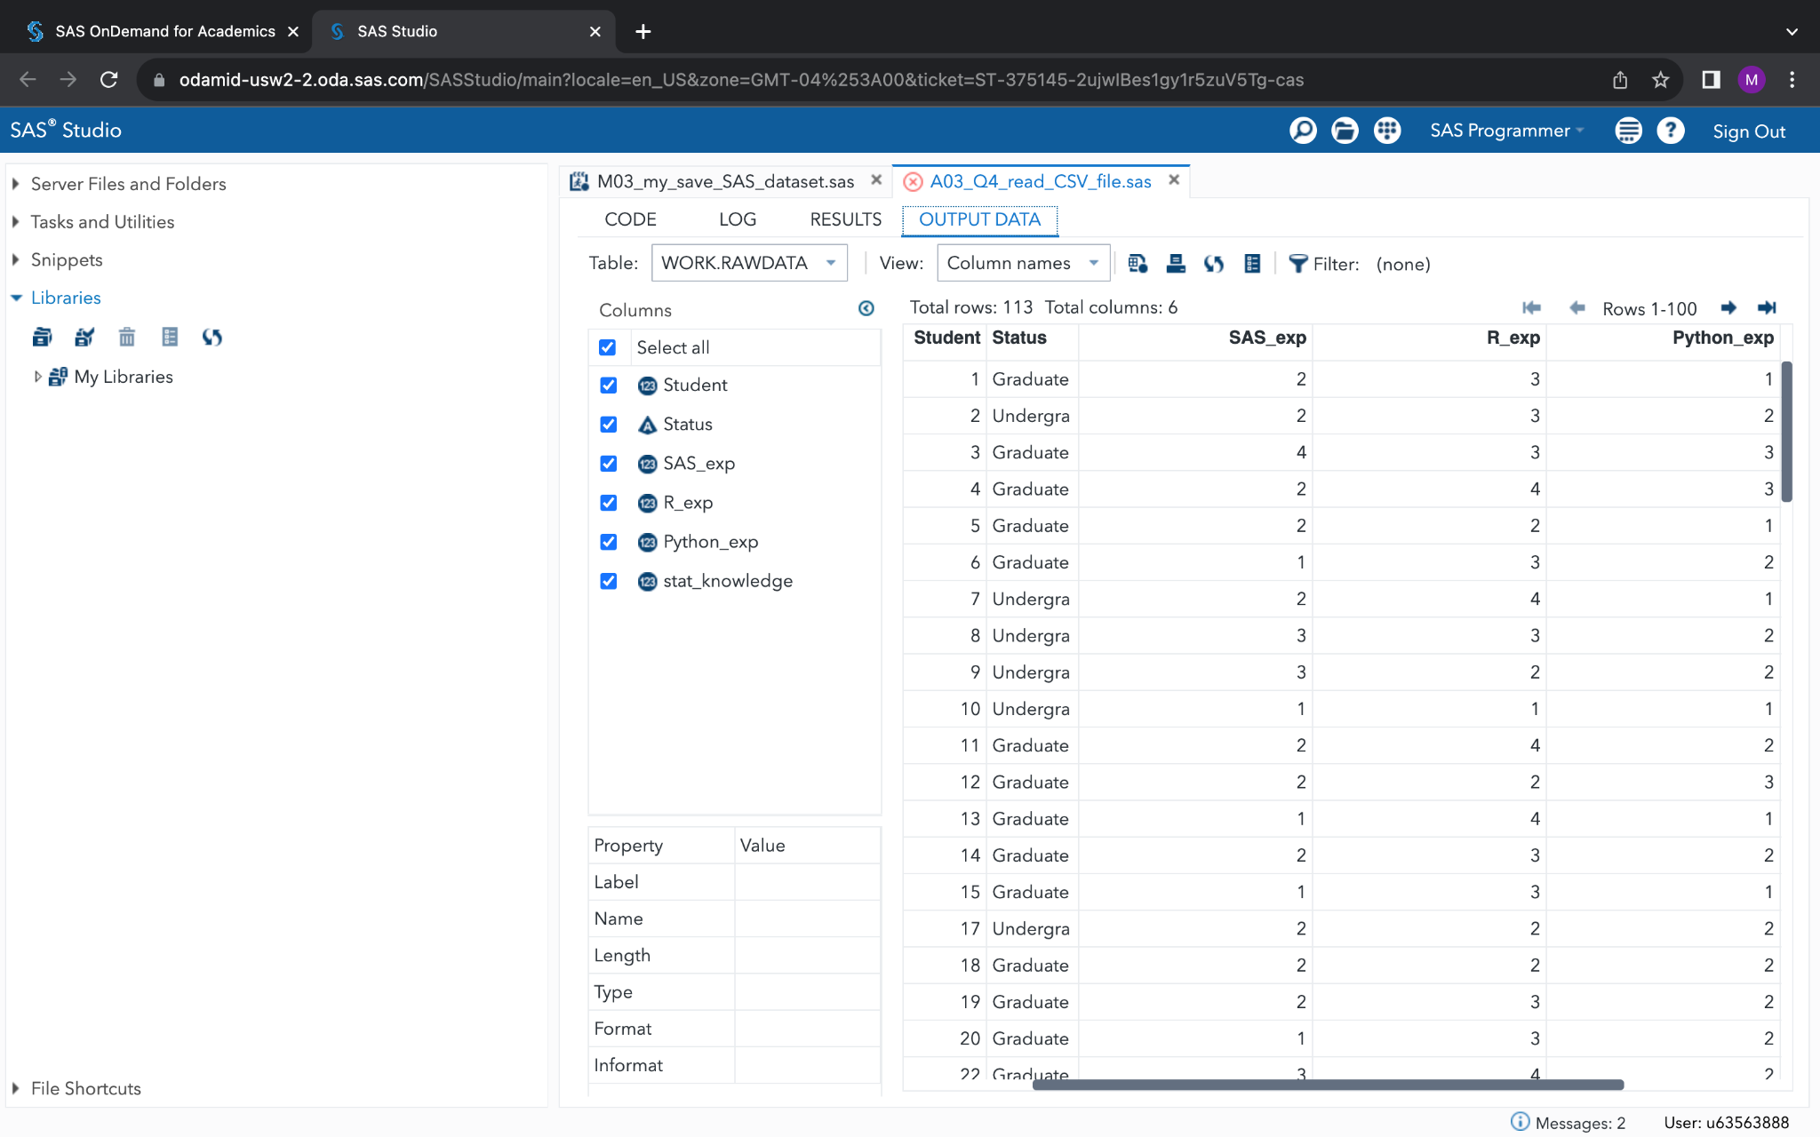
   2. PROC IMPORT

6) You can right click on the CSV file within the SAS studio navigation pane and then click

‘Import Data’, which will then generate some code to view the file (similar to using

snippets).