Max Tjen

PQHS 414

Assignment 6

1. A SAS expression is a conditional statement that is used within IF statements to see if a condition is met
2. WHERE statement subset datasets while IF statements can also subside datasets but overall, they are used as a condition check to execute a statement if the condition is met  
   1. Logical ⇒ AND, OR
   2. Arithmetic ⇒ multiplication, division, addition …
   3. Comparison ⇒ <, >, <=, >= …
3. SAS arithmetic operators are executed in order by the SAS group priorities, which is essentially the same as the typical order of operations. This order is: exponentiation ⇒ multiplication, division ⇒ addition, subtraction  
   1. 3 storms: Allen, Jacinthe, Wilf/Danitza
   2. 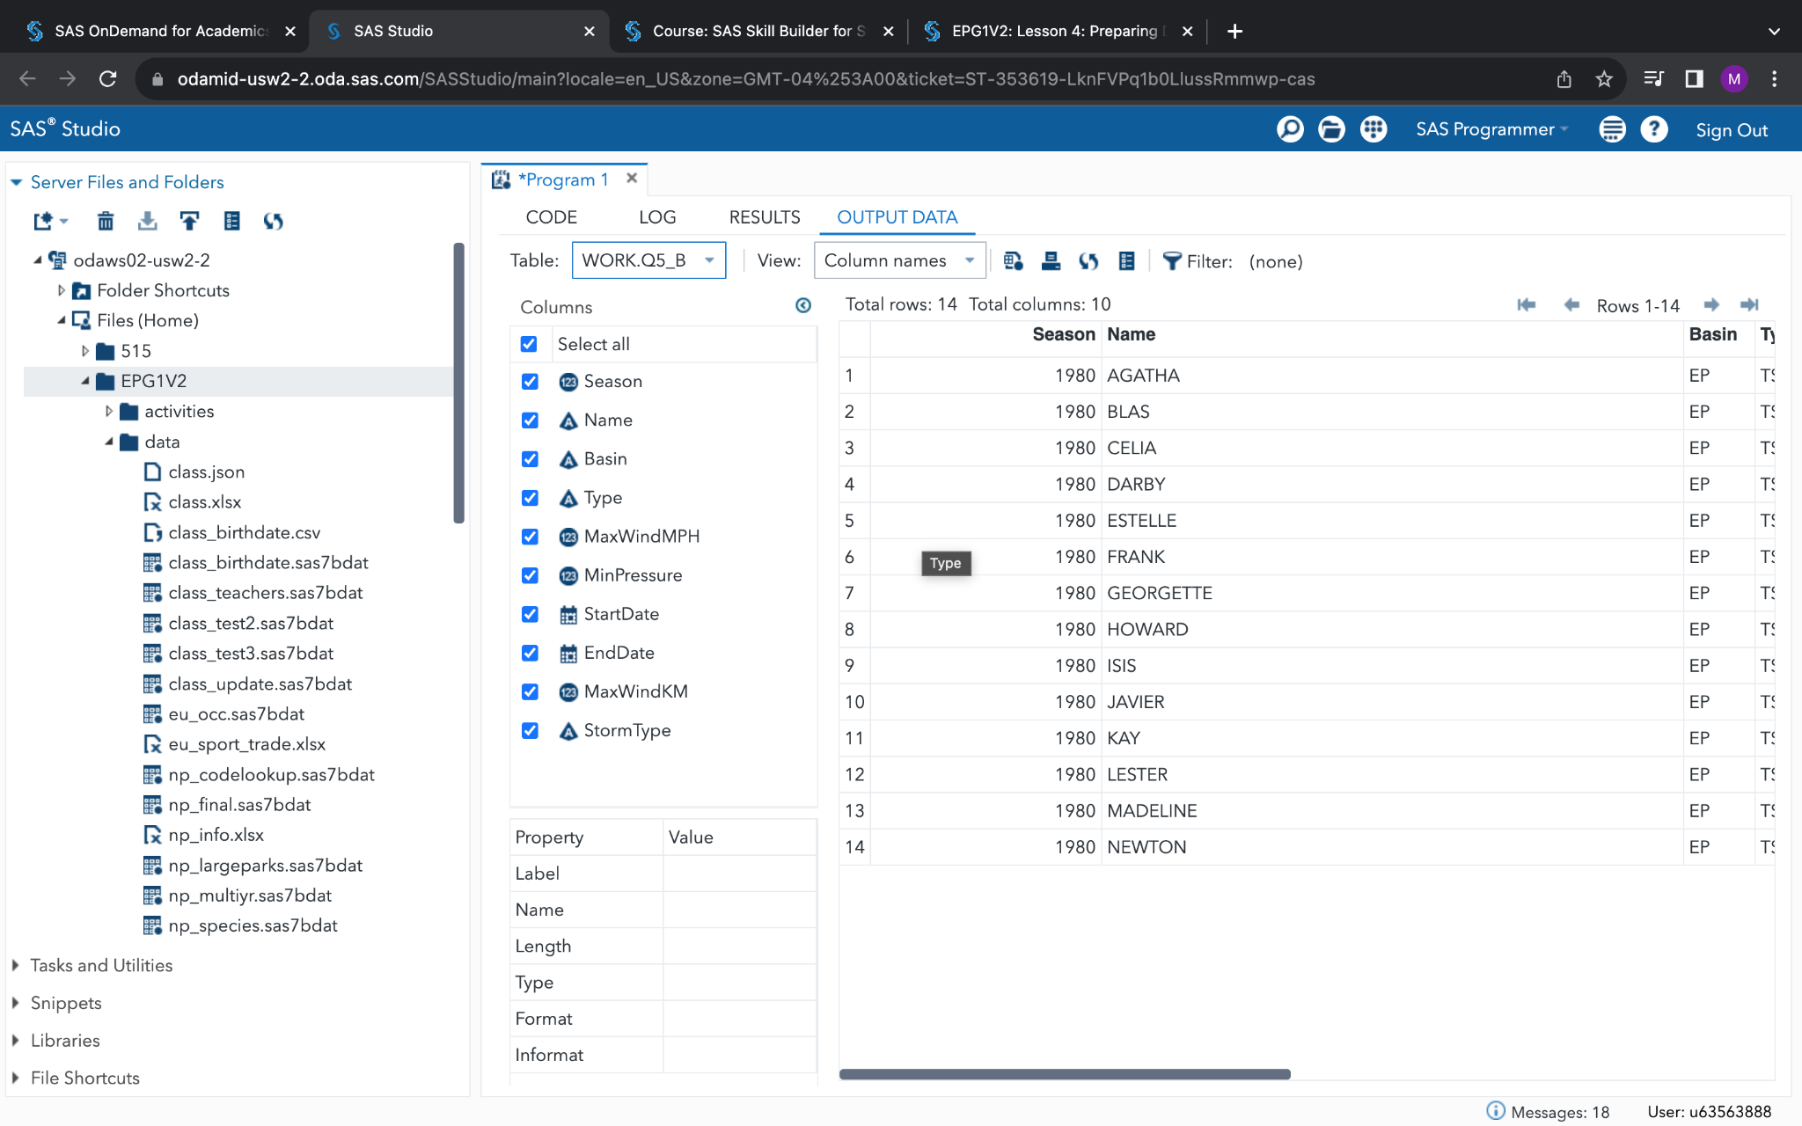
   3. 0 storms
   4. Norma
   5. Hurricane Katrina
   6. Hurricane Allen
   7. Hurricane Gloria
   8. 3 tables: Atlantic (488 rows), Indian (672 rows), Pacific (1,958 rows)
   9. Atlantic ⇒ 1983, Indian ⇒ 1987, Pacific ⇒ 2010
4. 8 parks are classified as preserves
5. In SAS file
6. In SAS file
7. 