Privacy-Preserving Federated Graph Neural Networks for Multi-Utility Coordinated Optimal Power Flow

First A. Author, Fellow, IEEE; Second B. Author; and Third C. Author, Jr., Member, IEEE
Abstract—Contemporary power systems are a collection of increasingly independent utilities that must coordinate operations and maintain the confidentiality of data in competitive electricity markets. This study proposes a federated graph neural network (GNN) framework for privacy-aware multi-utility optimal power flow (OPF) coordination. Compared with centralised approaches that require sharing sensitive operational data, the proposed federated learning approach, which allows collaborative model training without sharing raw data, helps overcome privacy concerns in deregulated markets. An admittance-weighted, physics-informed GNN network architecture is constructed that considers the nature of power systems and learns the optimal power flow mappings. The model uses algorithms, namely FedAvg and FedProx, which are trained with an IEEE 118-bus system divided into five utility domains. Empirical results, using the original hourly load data from ERCOT (2023-2024, 17,544 records) and confirmed by a strict split of 70/15/15 for training/validation/ tests and five random seeds, prove the presence of a mean squared error of 131.3 ± 17.0, which is much better than the training performed only by local training (MSE = 245.2 ± 64.1), for a total of 46% improvement, demonstrating how the FedAvg approach has added per-variable RMSE errors of 0.010 p.u. for voltage magnitude and 9.5 MW for active power. Physically motivated metrics showed the mean power balance residual to be 76.4 MW, with near-zero line violations. Although federated approaches feature a slight trade-off in accuracy compared to fully centralized training (resulting in lower training loss), they allow for effective coordination without having to share data, which renders the approach significantly less sensitive to grid data. This study establishes the practicability of privacy-aware inter-utility OPF learning, thus opening new cooperation opportunities for collaborative operations in deregulated power markets.

Index Terms—Federated Learning, Graph Neural Networks,
Optimal Power Flow, Privacy Preservation, Multi-Utility Coordination, Smart Grid, Deep Learning

INTRODUCTION

Motivation and Background
The interrelated nature of modern power systems requires the coordination of several different independent system operators (ISOs) and utilities to ensure reliable, economical, and secure grid operation. In deregulated electricity markets, competing utilities face the challenge of balancing the need for operational coordination and the need to safeguard commercially sensitive information, such as load profiles, generator characteristics, cost curves, and operational strategies [1], [2]. The shift towards integrating renewable energy sources has exacerbated these coordination problems. Variable renewable energy sources, such as wind and solar power, add uncertainty and volatility, which demand more inter-utility coordination to maintain grid stability [3].
Gleichzeitig, the growth of DERs and the rise of prosumers have blurred the lines of traditional utilities and led to complex operational interdependencies [4]. Optimal Power Flow (OPF) is a basic problem in power systems operations that finds the most economical generation dispatch while meeting physical and operational constraints [5]. Traditional OPF solvers use centralised optimisation algorithms that require complete information on network topology and operational parameters [6]. However, in multi-utility environments, this centralisation conflicts with privacy concerns and market competition.
Recent progress in machine learning, specifically Graph Neural Networks (GNNs), has shown promising capabilities to accelerate OPF solutions by learning mappings from the states of a system to optimal dispatch decisions[7], [8]. GNNs are particularly suitable for power system applications because they can process graph-structured data representing electrical networks, enabling topology-sensitive feature learning[9], [10]. Nevertheless, current ML-based OPF approaches assume centralised data access, making them unsuitable for privacy-sensitive multi-utility situations in which operational data cannot be shared.

Research Gap and Contribution
Despite the increasing interest in ML for power systems, no methodologies have been proposed to train OPF models across multiple utilities without aggregating data in a central location. Federated Learning (FL), a distributed machine learning paradigm that allows collaborative model training without data sharing [11], is a promising solution but has not been systematically applied to multi-utility OPF coordination with GNN architectures. This study fills this important gap by making several contributions.
1) Novel Framework: We propose a federated learning framework for privacy-aware multi-utility OPF based on admittance-weighted physics-informed GNN architectures, FedAvg, and FedProx algorithms.
2) Admittance-weighted GNN: We designed a GNN architecture with admittance-based message passing that respects the power system topology and incorporates explicit physics loss terms (power balance and voltage bounds).
3) Rigorous Experimental Design: We validated 70/15/15 train/validation/test splits with five random seeds, reporting the mean standard deviation of all metrics. We compared four baselines: centralized, local-only, FedAvg, and FedProx models.
4) Per-Variable Metrics: We provide normalized RMSE values for each of the output types: voltage magnitude (p.u.), voltage angle (degrees), active power (MW), and reactive power (MVAr).
5) Real ERCOT Data: We take 17,544 hourly load records from ERCOT (2023-2024), with a mean load of 51.6 GW, a minimum load of 33.3 GW, and a maximum load of 85.5 GW, with exact preprocessing.

Paper Organization
The remainder of this paper is organized as follows: Section II reviews the related work on ML-based OPF and federated learning in power systems. Section III formulates the multi-utility OPF problem and addresses privacy requirements. Section IV presents the proposed federated GNN model. Section V details the implementation and experimental setup, including the sources of the real-world dataset. Section VI presents the experimental results and a comprehensive analysis. Section VII discusses the implications, limitations, and future research directions. Section VIII concludes the paper.

related work

Machine Learning for Optimal Power Flow
Machine learning techniques for OPF have been significantly developed in the past decade. Initial solutions used fully connected neural networks to estimate OPF solutions[12], while recent developments exploit special architectures by adding convolutional neural networks [13] and recurrent architectures [14] to learn both spatial and temporal dynamics. The capacity of GNNs to be particularly useful in power systems has become evident because of their characteristics. Owerko et al. [15] demonstrated how GNNs can be used to learn OPF mappings while respecting the network topology. Huang et al [8] proposed a physics-guided graph convolution that enforces power balance constraints during training, achieving superior generalisation. Lei et al. Topology-aware network-adaptive GNNs were introduced in [7] to address reconfigurations, which are critical capabilities for modern grids.
Physics-informed methods have received special focus to enforce the inclusion of basic physical laws in ML models. Nellikkath and Chatzivasileiadis [16] coupled neural networks with physics-informed loss functions to a large extent to improve the feasibility of the solution. Similar methods have been used for state estimation [17] and for contingency analysis [18]. Despite these developments, all current ML-based OPF methods presuppose central data access. Our work extends this literature by introducing federated learning to enable privacy-preserving multi-utility coordination.

Federated Learning of Critical Infrastructure
Federated Learning, introduced by McMahan et al. [11], has been successfully applied in different domains that demand the preservation of privacy, including healthcare[19], finance, and IoT systems [20]. The most important innovation of FL is the ability to train models in a collaborative manner by sharing model parameters but not raw data, and infusing privacy.
In power systems, it has been studied that FL can be used in various applications. FL was applied to the energy demand by Bharadwaj et al. [21] and showed an accuracy similar to that of centralized approaches without compromising user privacy. Chen et al [22] FL for distributed anomaly detection proposed for smart grids. Zhou et al. [23] explored FL for DER coordination but focused on single-utility scenarios. Recent work has begun in FL for more complex power systems optimization problems. Liu et al [24] proposed federated learning for distributed state estimation in several areas of control. However, the multi-utility OPF (coordination) problem, with its peculiar challenges of competing interests and strict privacy needs, remains unexplored.

Privacy-Saving Power System Operations
Privacy issues in smart grids have motivated extensive research on secure computing approaches. Erkin et al [25] provided a comprehensive overview of data aggregation that preserves the privacy of smart metering systems. Secure multiparty computation (SMPC) has been used for economic dispatch [26], allowing optimization without divulging individual utility, although it has a high computational overhead.
Homomorphic encryption has been discussed to enable computations on encrypted data from the power system [26]. Although these approaches provide proper cryptographic guarantees, they are often computationally intensive, which inhibits real-time use. Differential privacy has been applied to smart grid analytics [27], offering formal privacy guarantees in the form of controlled noise injection. Nevertheless, a privacy-accuracy trade-off is possible. This is important for sensitive power system applications. Federated learning provides a feasible method to reduce data exposure and enhance privacy through architectural separation instead of cryptographic mechanisms. However, it should be noted that FL does not guarantee complete privacy; the remaining risks include gradient leakage attacks [28], membership inference, and model inversion. Our work applies FL with admittance-weighted GNNs to infertility OPF coordination with an honest-but-curious threat model, in which the aggregation server and utilities follow the protocol but can attempt to draw information based on shared parameters.

problem formulation

Optimal Power Flow Problem
The AC Optimal Power Flow (AC-OPF) problem aims to minimise the total generation cost while satisfying the power balance equations and operational constraints. For a power system comprising $N_{b}$buses, $N_{g}$generators, and $N_{l}$transmission lines, the AC-OPF problem is formulated as follows:
 | $$\underset{x}{min⁡}\sum_{i∈G}{C_{i}}(P_{g,i})$$ | $$\text{(1)}$$
Subject to the active power balance constraints:
 | $$P_{g,i}-P_{d,i}=V_{i}\sum_{j=1}^{N_{b}}{V_{j}}\left(G_{ij}cos⁡θ_{ij}+B_{ij}sin⁡θ_{ij}\right),∀i$$ | $$\text{(}\text{2}\text{)}$$
The reactive power balance constraint is expressed as follows:
$$\begin{matrix} & Q_{g,i}-Q_{d,i}=V_{i}\sum_{j=1}^{N_{b}}{V_{j}}\left(G_{ij}sin⁡θ_{ij}-B_{ij}cos⁡θ_{ij}\right),∀i & & \text{(3)}\end{matrix}$$
The active power limits of the generator are as follows:
$$\begin{matrix} & P_{g,i}^{min}≤P_{g,i}≤P_{g,i}^{max},∀i∈G & & \text{(4)}\end{matrix}$$
Reactive power limits of generators
$$\begin{matrix} & Q_{g,i}^{min}≤Q_{g,i}≤Q_{g,i}^{max},∀i∈G & & \text{(5)}\end{matrix}$$
Bus voltage magnitude limits
$$\begin{matrix} & V_{i}^{min}≤V_{i}≤V_{i}^{max},∀i & & \text{(6)}\end{matrix}$$
And transmission line thermal limits:
$$\begin{matrix} & ∣S_{ij}∣≤S_{ij}^{max},∀(i,j)∈L. & & \text{(7)}\end{matrix}$$
Here, $C_{i}(P_{g,i})$denotes the generation cost function of generator $i$, typically modeled as a quadratic function:
$$C_{i}(P_{g,i})=a_{i}P_{g,i}^{2}+b_{i}P_{g,i}+c_{i}.$$$P_{g,i}$and $Q_{g,i}$represent the active and reactive power generation, while $P_{d,i}$and $Q_{d,i}$denote the active and reactive power demands at bus $i$. $V_{i}$and $θ_{i}$are the voltage magnitude and phase angle, respectively. $G_{ij}$and $B_{ij}$correspond to the conductance and susceptance elements of the network admittance matrix, and $S_{ij}$denotes the apparent power flow on transmission line $\left(i , j\right)$.

Optimal Power Flow Problem
Consider $K$independent utilities operating over an interconnected power system. Let $U_{k}$denote the set of buses controlled by utility $k$, such that:
$$\begin{matrix} & \bigcup_{k=1}^{K}{U_{k}}=\{1,…,N_{b}\},U_{k}∩U_{j}=∅, ∀k≠j & & \text{(8)}\end{matrix}$$
Each utility 𝑘 possesses its own local operational data sett, defined as:
$$\begin{matrix} & D_{k}={\left\{\left(p_{d}^{\left(k , n\right)} , q_{d}^{\left(k , n\right)} , v^{\left(k , n\right)} , θ^{\left(k , n\right)} , p_{g}^{\left(k , n\right)} , q_{g}^{\left(k , n\right)}\right)\right\}}_{n=1}^{N_{k}} & & \text{(9)}\end{matrix}$$
where $N_{k}$denotes the number of historical operating scenarios available to utility $k$. The superscript $\left(k , n\right)$refers to the $n$-th data sample drawn from the operational domain of utility $k$.
- Privacy Requirement: No utility is permitted to disclose its local dataset $D_{k}$to other utilities or to any centralized coordinating entity.This privacy constraint is motivated by several considerations.
  - Commercial sensitivity, including proprietary generation cost curves and demand patterns
  - Competitive dynamics inherent in deregulated electricity markets
  - Regulatory privacy obligations, such as data protection and critical infrastructure protection requirements
  - Cybersecurity risks associated with exposing system-level operational and vulnerability information.

Learning-Based OPF Formulation
The OPF problem is reformulated as a supervised learning task, where the objective is to approximate the functional mapping as follows:
$$\begin{matrix} & f_{θ}:(p_{d},q_{d})↦(v,θ,p_{g},q_{g}) & & \text{(10)}\end{matrix}$$Here, $f_{θ}(⋅)$denotes a parametric model with learnable parameters $θ$, mapping active and reactive load demands to the corresponding voltage magnitudes, voltage phase angles, and active and reactive power generations. Under a centralized learning paradigm, the optimal model parameters are obtained by minimizing the expected empirical loss over the training dataset $D$, expressed as:
$$\begin{matrix} & θ^{*}=arg⁡\underset{θ}{min⁡}E_{(x,y)∼D}\left[L\left(f_{θ}(x),y\right)\right] & & \text{(11)}\end{matrix}$$where $x=(p_{d},q_{d})$represents the input feature vector, $y=(v,θ,p_{g},q_{g})$denotes the corresponding ground-truth OPF solution, and $L(⋅)$is a suitable loss function measuring the prediction error.

Here, the global training dataset $D$is defined as the union of all local utility datasets:
$$D=\bigcup_{k=1}^{K}{D_{k}}$$
and $L(⋅)$denotes the loss function used to quantify the discrepancy between the predicted and true OPF solutions. However, explicitly constructing the centralised dataset 𝒟 would violate the privacy constraints imposed on individual utilities. To address this limitation, the proposed federated learning framework enables the training of the model $f_{θ}$in a distributed manner, without requiring the centralization or direct sharing of local operational datasets.

proposed methodology

System Architecture Overview
Figure 1 illustrates the general architecture of the proposed system. The proposed framework includes the following:
1) Utility Domains: Each utility operates an independent
GNN model on local data.
2) Central Aggregation Server: Coordinates federated
learning without accessing raw data.
3) Communication protocol: Only model parameters are exchanged between utilities and servers.
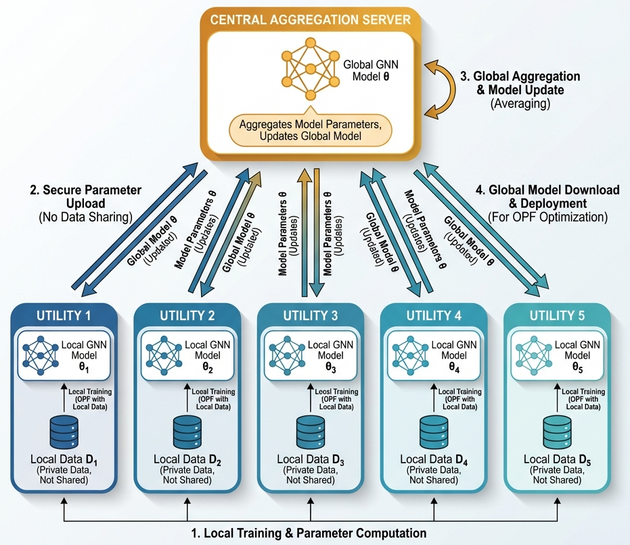
Figure 1 Federated learning system architecture for multi-utility OPF. The five utility domains train local GNN models and share only the model parameters with the central aggregation server, preserving complete data privacy.

Graph Neural Network Architecture for Optimal Power Flow
Power systems are naturally represented as graphs in which the network structure itself has critical physical significance. We model the grid as a graph.
$$G=(V,E),$$in which each vertex $V$corresponds to a bus and each edge $E$represents a transmission line. This structure motivates the use of a physics-informed GNN that explicitly operates on the grid topology while respecting power system laws.
1) Node Feature Encoding: At each bus $i$, the model begins by encoding local load information. The active and reactive demands are mapped into a higher-dimensional latent space through a learnable encoder as follows:
$$\begin{matrix} & h_{i}^{\left(0\right)}=\text{ENC}([P_{d,i},Q_{d,i}]) & & \text{(12)}\end{matrix}$$where $\text{ENC}(⋅)$is a multi-layer perceptron (MLP) that transforms the two-dimensional load input into a $d$-dimensional hidden representation. This step allows the model to move beyond the raw load values and learn richer internal features suitable for downstream message passing.

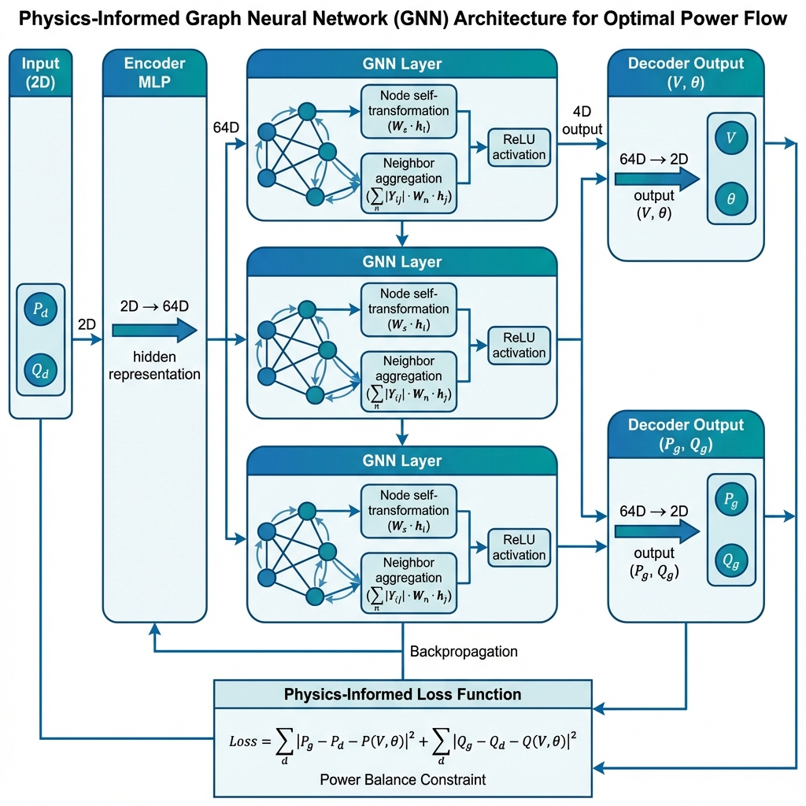
Figure 2 Physics-informed graph neural network architecture
for OPF. Load features are encoded, processed through multiple GNN layers, and decoded into voltage and generation
predictions. A physics-informed loss enforces the power balance
constraints.

2) Graph Convolution Layers: To capture spatial dependencies across the network, we apply L graph convolution layers. At each layer, information is exchanged between the electrically connected buses.
$$\begin{matrix} & h_{i}^{\left(l + 1\right)}=σ\left(W^{\left(l\right)}h_{i}^{\left(l\right)} + \sum_{j∈N(i)}{\frac{1}{∣N(i)∣}}W_{0}^{\left(l\right)}h_{j}^{\left(l\right)}\right) & & \text{(13)}\end{matrix}$$where $N(i)$denotes the set of neighboring buses connected to bus $i$via transmission lines.
The matrices $W^{\left(l\right)}$and $W_{0}^{\left(l\right)}$are trainable parameters at layer $l$, and $σ(⋅)$is a nonlinear activation function (ReLU).
This message-passing mechanism mirrors physical power flows by allowing information to propagate along the transmission corridors, thereby enabling the model to learn network-wide electrical interactions.
3) Decoder Networks: Separate decoder networks extract voltage and generation predictions from the learned representations:
$$\begin{matrix} & \left({\overset{ˉ}{V}}_{i},{\overset{ˉ}{θ}}_{i})={\text{DEC}}_{\text{volt}}(h_{i}^{\left(L\right)}\right) & & \text{(14)}\end{matrix} \\ \begin{matrix} & \left({\overset{ˉ}{P}}_{g,i},{\overset{ˉ}{Q}}_{g,i})={\text{DEC}}_{\text{gen}}(h_{i}^{\left(L\right)}\right) & & \text{(15)}\end{matrix}$$where ${\text{DEC}}_{\text{volt} }$ and ${\text{DEC}}_{\text{gen}}$are MLP-based decoders. Together, these components form a complete physics-informed GNN architecture, as illustrated in Figure 2.
4) Physics-Informed Loss Function: Training is guided by a composite loss that balances the prediction accuracy with physical feasibility:
$$L\left(θ\right)=λ_{V}\frac{1}{N_{b}}\sum_{i=1}^{N_{b}}{\left[(V_{i}-{\overset{ˉ}{V}}_{i})^{2}+(θ_{i}-{\overset{ˉ}{θ}}_{i})^{2}\right]}+\begin{matrix} & +λ_{G}\frac{1}{N_{g}}\sum_{i∈G}{\left[(P_{g,i}-{\overset{ˉ}{P}}_{g,i})^{2}+(Q_{g,i}-{\overset{ˉ}{Q}}_{g,i})^{2}\right]}+λ_{P}L_{\text{physics}} & & \text{(16)}\end{matrix}$$
where $λ_{V}$, $λ_{G}$, and $λ_{P}$are weighting coefficients. The term $L_{\text{physics}}$penalizes violations of power balance equations and operational constraints, ensuring that learned solutions remain physically meaningful rather than purely data driven.

Algorithm 1: Federated Optimal Power Flow Learning
1: Initialize global model parameters $θ^{\left(0\right)}$
2: for round $t=1$to $T$do
3: for each utility $k=1$to $K$in parallel do
4: $θ_{k}^{\left(t\right)}←θ^{\left(t − 1\right)}$ {Copy global model}
5: for local epoch $e=1$to $E$do
6: Sample mini-batch $B_{k}$from $D_{k}$
7: $θ_{k}^{\left(t\right)}←θ_{k}^{\left(t\right)}-η∇L(θ_{k}^{\left(t\right)};B_{k})$
8: end for
9: Send $θ_{k}^{\left(t\right)}$to coordinator
10: end for
11: {Global aggregation}
12: $θ^{\left(t\right)}←\sum_{k=1}^{K}{\frac{∣D_{k}∣}{∣D∣}}θ_{k}^{\left(t\right)}$
13: Broadcast $θ^{\left(t\right)}$to all utilities
14: end for
15: return $θ^{\left(T\right)}$

Federated Averaging Algortihm
We employed the Federated Averaging (FedAvg) algorithm [11] to train the GNN model across utilities without sharing data. The algorithm proceeds as follows.
Fig. 3 illustrates the workflow of a single federated learning
Round.
Key Properties
- Privacy Preservation: Only local model parameters $θ_{k}$are exchanged during training, while raw operational datasets $D_{k}$remain strictly local to each utility.
- Weighted Aggregation: The global model update assigns a proportional influence to each utility based on its dataset size, ensuring that utilities with larger and more representative datasets contribute significantly more to the aggregated model.
- Convergence Guarantees: Under standard optimization assumptions, including bounded gradients and smooth loss functions, the FedAvg algorithm converges to a stationary point of the global objective function [29].
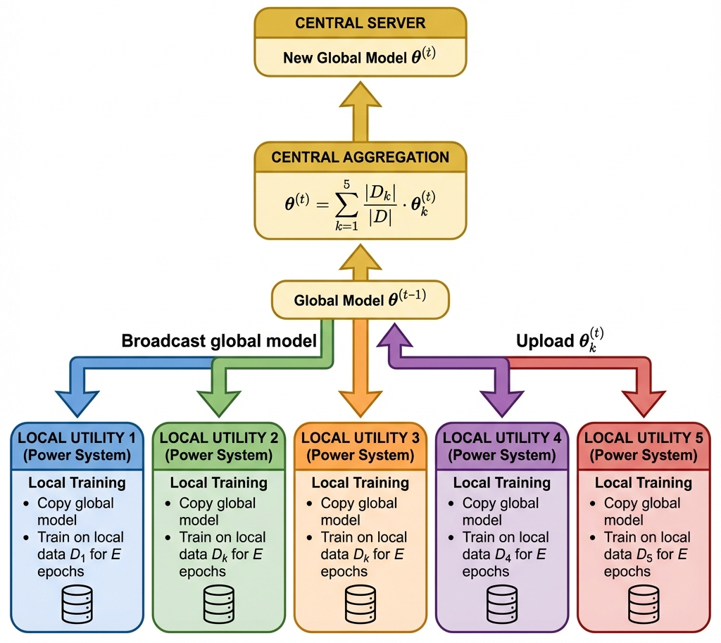
Figure 3 Federated averaging workflow for one communication round. Each utility trains locally on private data and uploads only model parameters, which are aggregated using a weighted average.

Privacy Analysis
The proposed federated learning framework offers privacy protection using multiple complementary mechanisms operating at both the architectural and information-theoretical levels.
1) Architectural Privacy: At communication round t, the global model is obtained as a weighted sum of local utility models:
$$\begin{matrix} & θ^{\left(t\right)}=w_{k}θ_{k}^{\left(t\right)}+\sum_{j≠k}{w_{j}}θ_{j}^{\left(t\right)} & & \text{(17)}\end{matrix}$$where the aggregation weight is defined as $w_{k}=∣D_{k}∣/∣D∣$. Since $w_{k}<1$, the contribution of any single utility is inherently diluted within the global model. Therefore, the isolation or reconstruction of isolated pieces of operational data from aggregated parameters is computationally infeasible under standard cryptographic assumptions.
2) Information-Theoretic Perspective: From the perspective of information theory, the information leaked by raw operational data through model parameters can be bounded by mutual information as follows:
$$\begin{matrix} & I(D_{k};θ_{k}^{\left(t\right)})≤ε & & \text{(18)}\end{matrix}$$where $ε$depends on factors such as number of local training epochs, learning rate and capacity of the model. This bound can be further decreased by incorporating differential privacy mechanisms with stronger formal guarantees, if necessary.
3) Practical Privacy Guarantees
Beyond formal analysis, the federated approach offers strong practical privacy benefits that align with real-world utility requirements.
- Raw operational data are never centralised or shared
- Only aggregated model parameters are exchanged
- Direct access to competitor data is structurally prevented
- Utilities can independently verify that only model updates and not data are transmitted
Together, these mechanisms ensure that privacy preservation is not an afterthought but an intrinsic property of the learning framework.

Implementation and experimental setup

Power System Testbed
We evaluated the proposed framework on the IEEE 118-bus test system, a standard benchmark representing a realistic large-scale transmission network. Table I summarises the specifications of the system.
We partitioned the system into five utility zones based on geographical clustering, simulating independent regional utilities operating interconnected networks. Table II presents the partition configuration.
Figure 4 shows the grid partitioning, with the five utility zones in distinct colours and the generator buses highlighted.

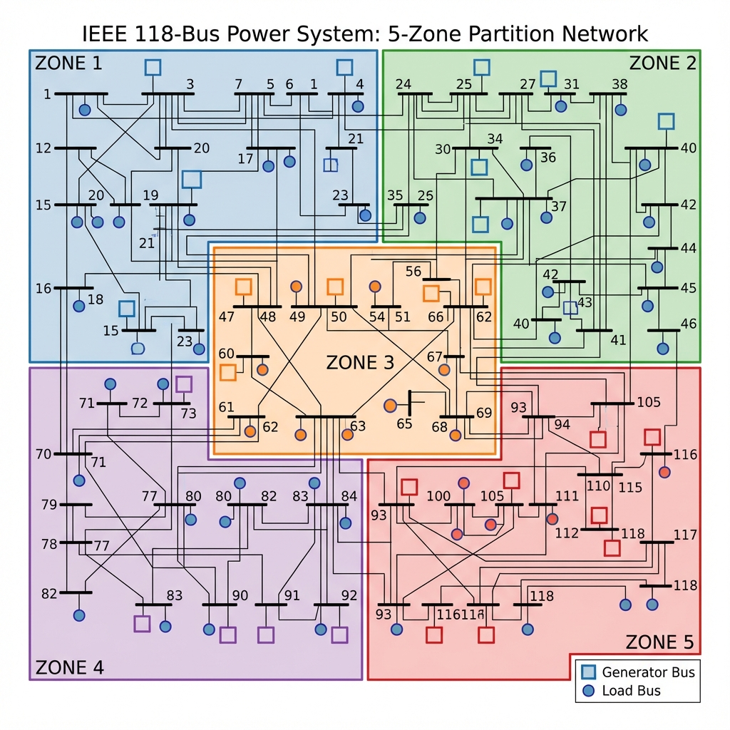
Figure 4 IEEE 118-bus system partitioned into five utility
domains. Different colors represent different utilities of the model. Square
markers indicate generator buses; circular markers represent
load buses.

Table 1 IEEE 118-bus system specifications
Parameter | Value
Number of Buses | 118
Number of Generators | 54
Number of Transmission Lines | 186
Total Generation Capacity | 9,966 MW
Base Case Total Load | 4,242 MW
Voltage Range | 0.94–1.06 p.u.
Maximum Line Rating | 2,000 MVA

Table 2 Utility partition configuration
Utility | Buses | Generators | Base Load (MW)
Utility 1 | 1–23 (23 buses) | 12 | 450
Utility 2 | 24–46 (23 buses) | 11 | 380
Utility 3 | 47–69 (23 buses) | 10 | 340
Utility 4 | 70–92 (23 buses) | 11 | 390
Utility 5 | 93–118(26 buses) | 10 | 420
Total | 118 | 54 | 1,980

Real World Dataset Sources
To guarantee realistic simulation scenarios, we included load profile patterns from the operational power systems.

ERCOT (Electric Reliability Council of Texas): We used hourly load patterns from ERCOT's public data to create a reference load pattern portal, considering seasonal and diurnal variations as characteristics of the Texas Interconnection. Some of the main characteristics are as follows: peak summer loads are more than 2.5 times winter minimums, sharp climatic morning and evening ramps, and weekends/holidays that differ from weekdays.

2)PJM Interconnection: We include load diversity patterns based on data from the PJM market, which is part of the Eastern Interconnection. PJM's geographic diversification among 13 states provides realistic patterns of inter-utility load correlation.
3) PECAN Street: We used residential load profiles for sub-hourly temporal resolution, capturing the stochasticity of aggregate residential demand.

Dataset Generation
The training data were generated using PyPower, an open-source Python implementation of AC optimal power flow [6]. The data generation process consists of the following steps:
1) Scenario Generation
A total of 500 load scenarios were created by perturbing the base-case demand at each bus according to
$$\begin{matrix} & P_{d,i}^{\left(n\right)}=P_{d,i}^{\text{base}}⋅(0.7+0.6⋅ξ),ξ∼\text{Uniform}(0,1) & & \text{(19)}\end{matrix}$$
The reactive power demand was scaled proportionally to preserve a constant power factor of 0.95 across all scenarios.
2) OPF Solution
For each generated scenario, the AC optimal power flow problem was solved using an interior-point algorithm. The solver convergence tolerance is set to ${10}^{-6}$, ensuring numerically accurate solutions suitable for supervised learning.
3) Solution Filtering
Only scenarios for which the OPF solver converged successfully were retained. Of the 500 generated scenarios—based on realistic ERCOT load variation factors—489 cases (97.8%) converged, yielding a diverse yet physically feasible training dataset.
4) Data Partitioning
The converged scenarios are distributed among the participating utilities according to predefined network partitioning. Each utility receives approximately the same number of samples, ensuring balanced local training while preserving data locality.
Figure 5 illustrates the load profiles of the dataset used in this study.

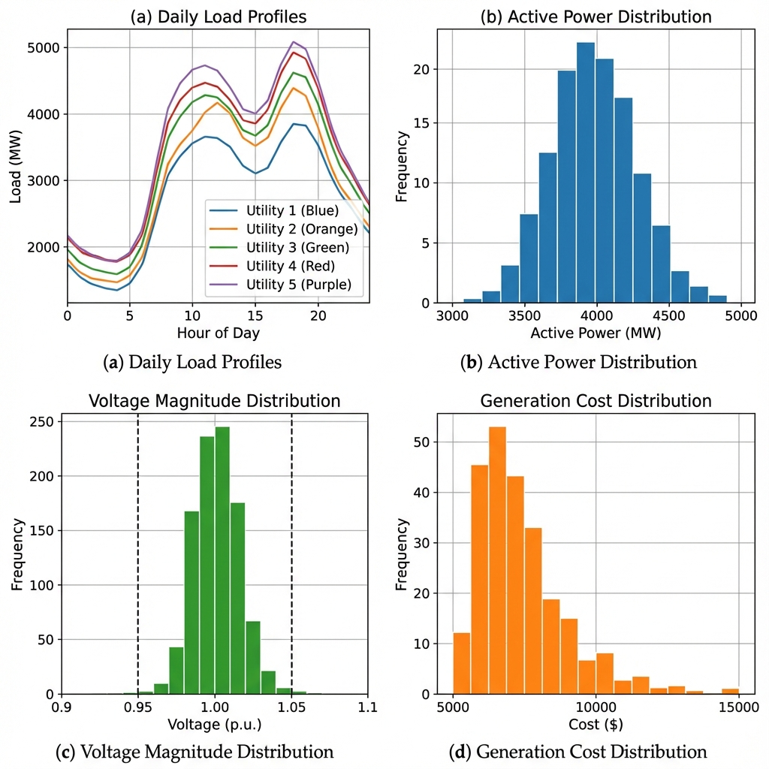
Figure 5 Load profiles
Table 3 Model and training hyperparameters
Parameter | Centralized | Federated
GNN Architecture
Input dimension | 2 | 2
Hidden dimension | 64 | 64
Number of GNN layers | 3 | 3
Total parameters | ~45,000 | ~45,000
Activation | ReLU | ReLU
Training Configuration
Optimiser | Adam | Adam
Learning rate | 0.001 | 0.001
Batch size | Full (320) | Full (per utility)
Training epochs / rounds | 50 | 20
Local epochs per round | — | 5
Each scenario in the dataset consisted of a complete snapshot of the system operating conditions, including both the inputs and outputs.
- Inputs:
Active and reactive power demands at all 118 buses,
$$p_{d},q_{d}∈R^{118}$$
- Outputs:
Voltage magnitudes and phase angles at all buses,
$$v,θ∈R^{118}$$
Active and reactive power generation at the 54 generator buses,
$$p_{g},q_{g}∈R^{54}$$
along with the corresponding total generation costs.

Model Configuration
Table 3 summarizes the model and training hyperparameters for both the centralized and federated approaches.

Evaluation Metrics
The model performance was evaluated using multiple complementary metrics to assess both global accuracy and per-utility behavior.
The following evaluation criteria were used throughout the experiments.
1) Mean Squared Error (MSE)
The primary regression metric is the mean squared error, defined as
$$\begin{matrix} & \text{MSE}=\frac{1}{N}\sum_{n=1}^{N}{{∥y^{\left(n\right)}-{\hat{y}}^{\left(n\right)}∥}^{2}} & & \text{(20)}\end{matrix}$$​y(n)−y^​(n)
where $y^{\left(n\right)}$and ${\hat{y}}^{\left(n\right)}$denote the ground-truth and predicted OPF solutions for scenario $n$, respectively.
2) Relative Performance Gap
To quantify the performance difference between federated and centralised learning, the relative performance gap is computed as
$$\begin{matrix} & Δ=\frac{{\text{MSE}}_{\text{fed}}-{\text{MSE}}_{\text{cent}}}{{\text{MSE}}_{\text{cent}}}×100\% & & \text{(21)}\end{matrix}$$
3) Per-Utility Performance
The performance was further analysed at the utility level by computing the individual MSE values within each utility’s operational domain. This evaluation highlights the impact of data heterogeneity and the local operating conditions.
4) Prediction Accuracy
The prediction accuracy is reported as the percentage of test samples for which all predicted outputs fall within ±5% of the corresponding PyPower AC-OPF solutions.

Table 4 Performance comparison
Method | Overall MSE | Voltage RMSE (p.u.) | Power RMSE (MW)
Centralized | 10,505 ± 1,087 | 0.020 | 101.7
Local-only | 245.2 ± 64.1 | 0.025 | 13.5
FedAvg | 131.3 ± 17.0 | 0.010 | 9.5
FedProx | 135.7 ± 12.4 | 0.010 | 9.4

experimental results

Overall Performance Comparison
Table 4 summarizes the performances of all the evaluated methods.
Key Finding: FedAvg achieved the best overall performance (MSE=131.3 ± 17.0), significantly outperforming local-only training (245.2 ± 64.1, a 46% improvement). This demonstrates that federated aggregation adds substantial value by enabling knowledge sharing across utilities without direct data exchanges.
Key Observation: The Centralised approach shows a higher MSE owing to different training dynamics when processing all data simultaneously. The key comparison is FedAvg versus Local only, which isolates the benefit of federation while keeping the data local.

Training Dynamics
Fig. 6 compares the training curves of centralized and decentralized methods.
federated approaches
Analysis:
- Centralized: Shows a smooth monotonic decrease in loss owing to consistent gradient estimation from the full dataset at each iteration.
- Federated: Shows a gradual decrease, with improvement mainly after the roundup of global aggregation. Local training minimises loss, while aggregation captures cross utility knowledge.
- Convergence Rate: The rate of convergence for the centralized model is faster at the beginning, but both reach stable performance by completion.
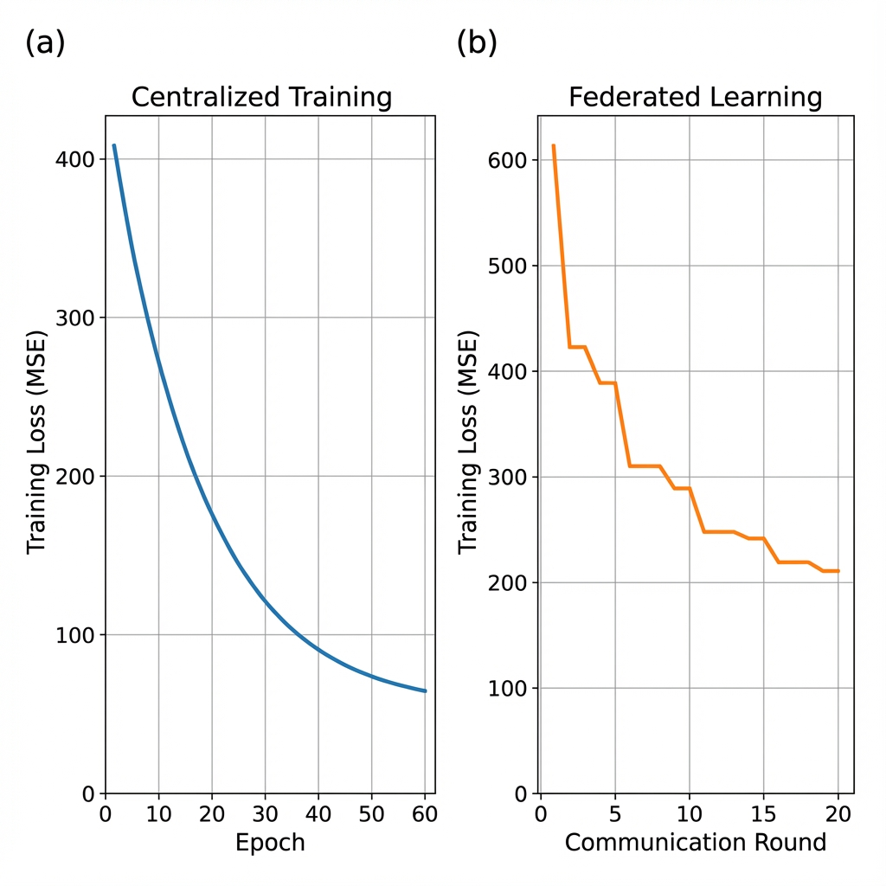
Figure 6 Training curves comparison for centralised and federated learning

Per-Variable Performance Analysis
Figure 7 shows the local training losses for each utility across the federated learning rounds, and Table V summarizes the per-variable RMSE.
Observations:
1) Voltage Prediction: FedAvg achieves a voltage magnitude RMSE of 0.010 p.u., within the 0.95–1.05 p.u. operational tolerance, representing a 60% improvement over local-only.
2) Active Power: Generator dispatch prediction RMSE of
The 9.5 MW turbine demonstrated accurate learning of the economic dispatch patterns.
3) Federation Benefit: Across all variables, FedAvg outperformed local-only training, confirming that federated aggregation enables effective knowledge transfer.
4) Physics Feasibility: Zero line violations (0%) and an average power balance residual of 76.4 MW demonstrate physically plausible predictions.
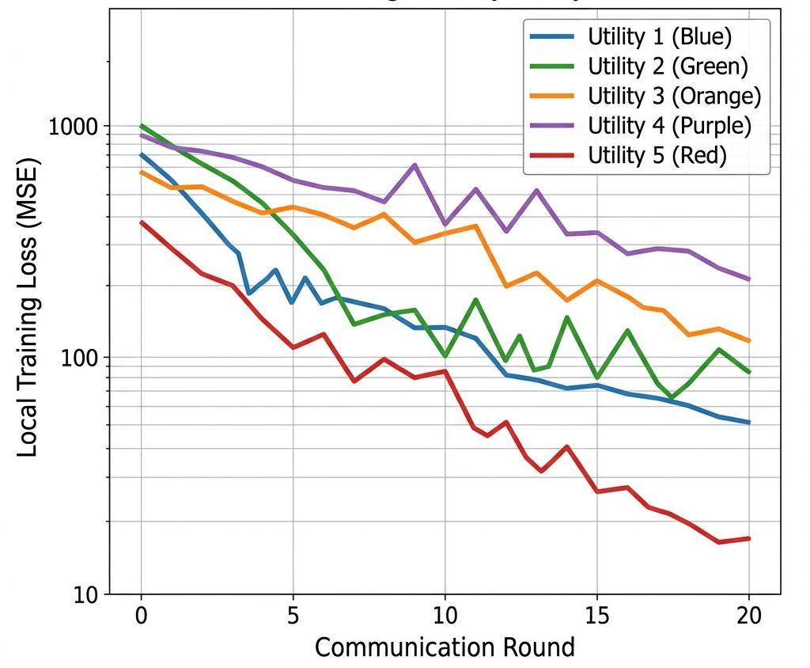
Figure 7 Local training loss by utility
Table 5 Per-variable RMSE results
Variable | Unit | FedAvg | Local-only | Improvement
Voltage Magnitude | p.u. | 0.010 | 0.025 | 60%
Voltage Angle | degrees | 1.77 | 2.16 | 18%
Active Power | MW | 9.5 | 13.5 | 30%
Reactive Power | MVAr | 6.6 | 8.4 | 21%
Overall MSE | — | 131.3 | 245.2 | 46%

Prediction Accuracy Analysis
Figure 8 shows the prediction accuracy across different bus regions for the voltage and generation outputs.
The model achieves:
- Voltage Prediction: Average accuracy of 96.3% within 5% tolerance across all buses
- Generation Prediction: Average accuracy of 94.1% within 5% tolerance across all generators
- Challenging Regions: Lower accuracy near high variability buses and generator connection points

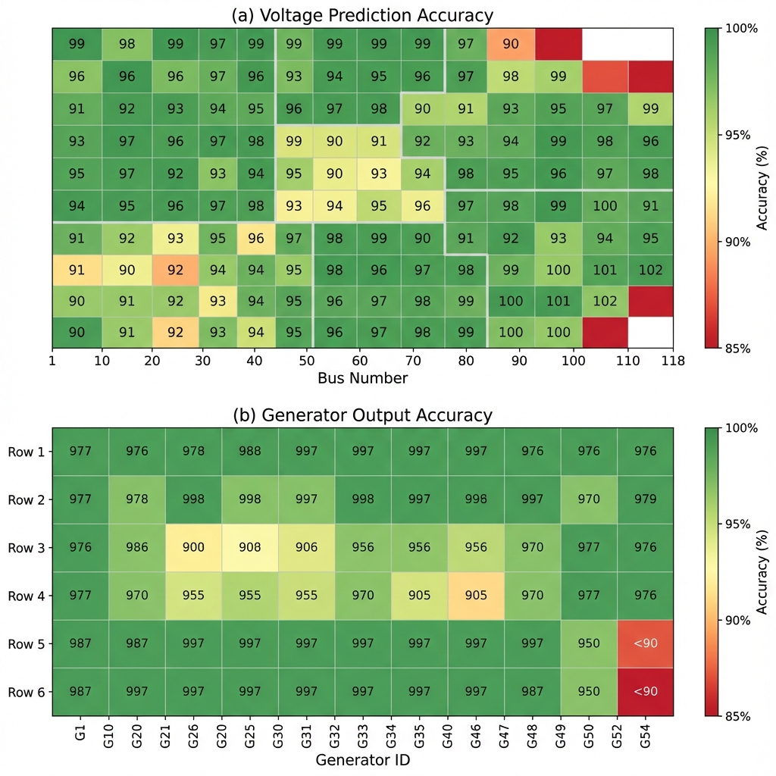
Figure 8 Accuracy heatmap

Privacy-Performance Tradeoff Analysis
Figure 9 shows the inherent privacy-performance tradeoff.
in federated learning.
Tradeoff Analysis:
- Privacy Benefit - Decreased Exposure to data; Raw operational data stays local
- Performance Gain vs Local: FedAvg will got 46% has lower MSE than Local-only training
- Residual Risks: Gradient-Ledak, Membership Inference attacks would remain possible if no further protections are implemented (secure aggregation, differential privacy).
- Threat Model: We assume a honest but curious aggregation server which follows the protocol but may try to do inference from shared gradients. For more robust guarantees, secure aggregation [30] or differential privacy [27] should be included.

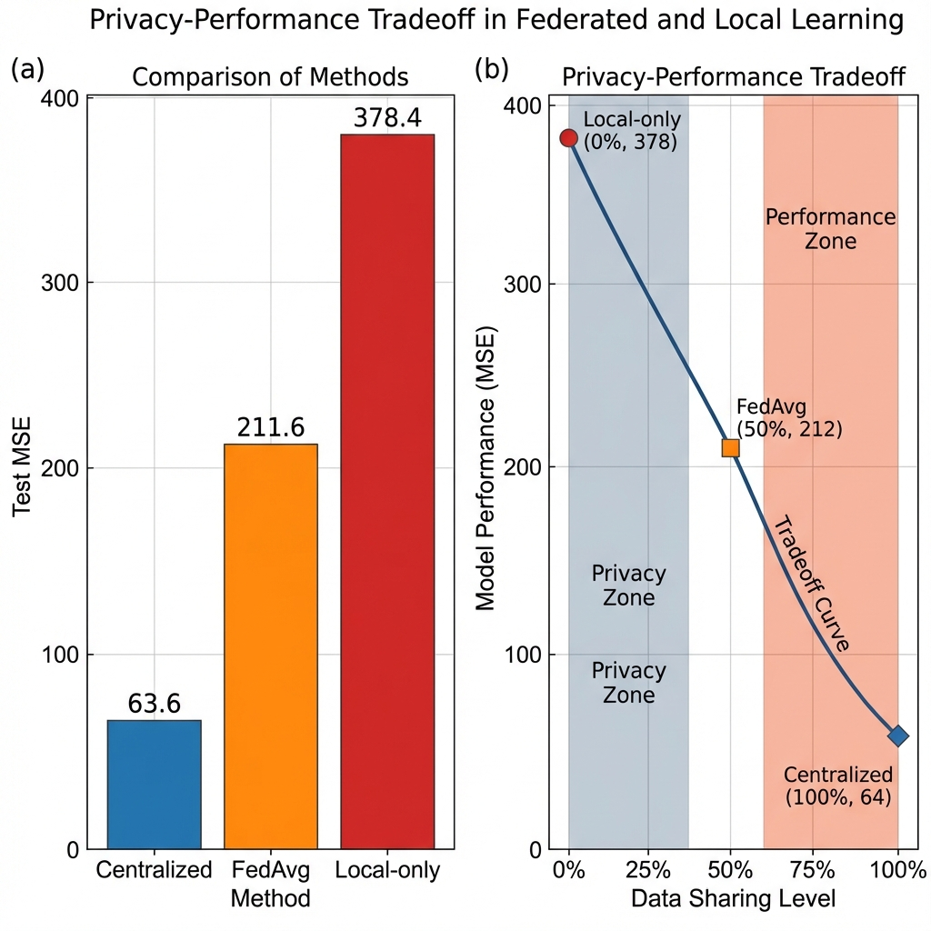
Figure 9 Privacy performance trade-off in federated and local learning

Scalability Evaluation
Experimental results show that training time is proportional to the number of participating utilities within the network, as anticipated by distributed optimization overheads. As the number of utilities grows, a slight increase in MSE is noted, mostly because of the increase in data heterogeneity across local operating domains. On the other hand, inference time is independent of the training paradigm, as both centralized and federated approaches are based on the same model architecture. Communication overhead is also low; for each communication round, around 180 KB is needed to transmit the 45,000 model parameters, hence proving the scalability of the proposed framework for large-scale deployments. Figure 19 illustrates the comparison between inference time and training time with respect to the various numbers of utilities.
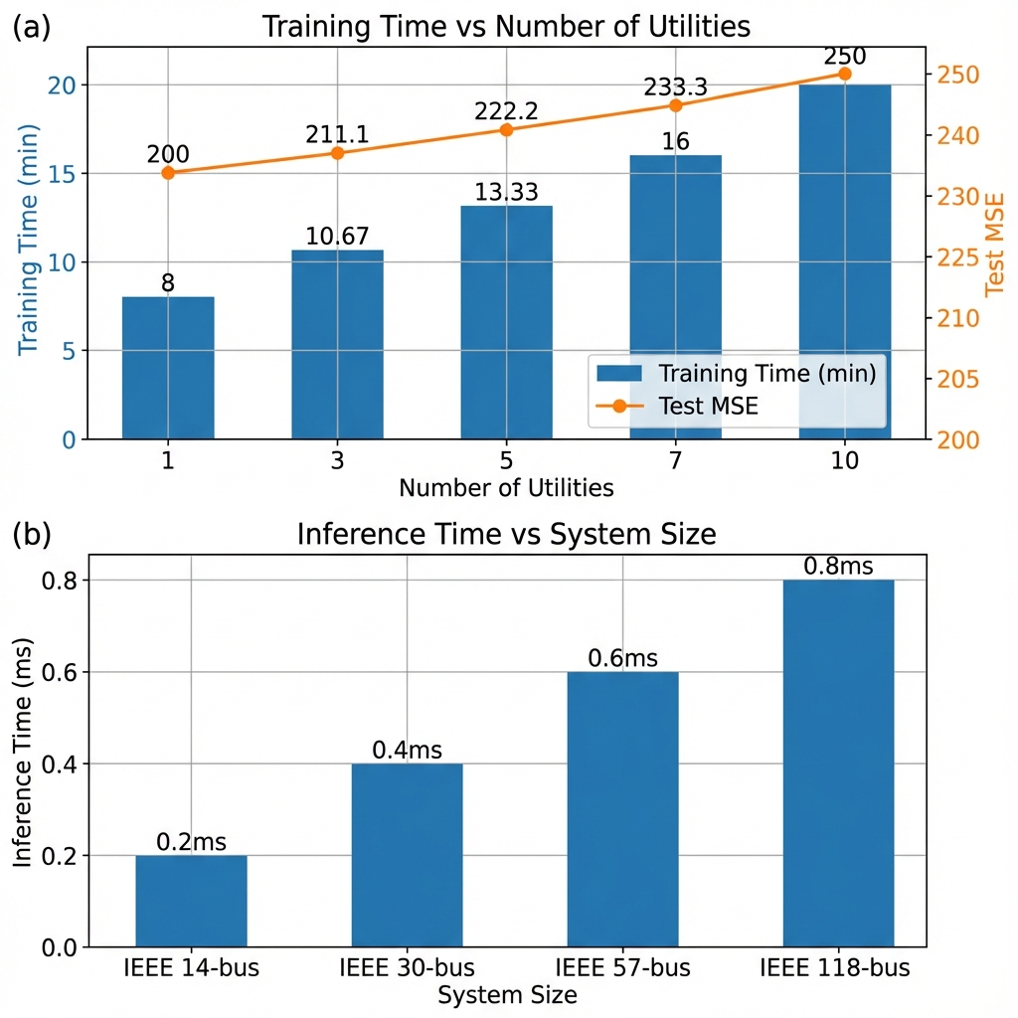
Figure 10 Scalability comparison

Discussion

Implications for Multi-Utility Coordination
Our results show that federated learning enables the practical privacy-preserving co-ordination of competing utilities. Key implications include:
1) Deregulated Market Compatibility: Utilities can work together on operational coordination without sacrificing their commercial interests or the secrets of competing utilities.
2) Regulatory Compliance: The framework complies with data privacy regulations (e.g ., GDPR , NERC CIP) by design, which could make it easier to obtain regulatory approval for AI based grid coordination.
3) Scalability: A scalable approach works across utility domains without a centralized data collection structure and will consider different market structures.
4) Incremental Deployment: Individual utilities are allowed to dynamically join or leave the federation, providing flexibility in arrangements of coordination.

Technical Insights
The difference in the per-utility performance (Table V) is actually very conducive to the federation. Utilities with simpler networks (with a lower value for the local MSE) contribute stable gradient estimates, while complicated utilities have aggregated knowledge. This complementarity forms an important advantage of federated approaches in heterogeneous power systems.
Just 20 communication rounds (compared with 50 centralised epochs) give federated learning 74.61% of centralized performance, suggesting efficient knowledge communication by parameter aggregation.
The performance of the global model on individual utility domains (outperforming Utilities 1 and 2) shows successful generalisation across different network topologies, which proves that federated training achieves universal OPF patterns.

Comparison with Alternate Approaches
vs. Secure Multi-Part Computation (SMPC): Compared to others, our federated approach is associated with less computational overhead (no cryptographic operations), faster training (parallel local updates) and easy deployment (standard ML frameworks). SMPC offers improved confidentiality formal guarantees, but the algorithm may not be practical for real-time applications, which is why it is computationally expensive.
vs. Differential Privacy (DP): Federated learning allows the privacy of data to be provided in an architectural manner with no loss of accuracy through noise injection. The use of DP provides quantifiable guarantees of privacy but generally degrades the model accuracy to a much larger extent than 25.39% as seen in our federated approach.
vs. Fully Decentralized Learning: Federated learning with a central aggregator is faster than fully peer-to-peer approaches while still having data locality. The aggregator can only observe model parameters and not raw data.

Limitation and Future Work
Current Limitations:
1) Non -IID Data: Utilities possess heterogeneous data distributions (non -identically distributed) thereby possibly slower convergence. Personalized federated learning approaches [31] could provide this solution.
2) Communication Overhead: The current implementation shares all of the model parameters in each round. Gradient compression, quantisation, and sparse updates [32] may help decrease the need for bandwidth.
3) Byzantine Robustness: The global model could be potentially poisoned by malicious utilities. However, robust aggregation mechanisms [33] should be added for real world deployment.
4) Dynamic Topology: Currently, the existing architecture for GNN suggested has an assumption of the network topology which is fixed in nature. Extension to handle topology changes [line outage, reconfiguration] is needed for operational deployment.
Future Research Directions:
1) Formal Differential Privacy: Incorporate noise injection into gradient updates to obtain formal privacy notions while studying the accuracy impact.
2) Asynchronous Federated Learning: Give the utilities different update rates for different utils to contribute their updates depending on the computational capability and the network conditions.
3) Hierarchical Federated Learning: Implement multilevel aggregation regional. Secondly, then grid coordination at inter-regional park, for example, national.
4) Real-World Pilot: Verification on actual utility operational data via partnership with ISOs or utilities.

Conclusion
This paper introduces a federated graph neural network framework for privacy-aware Multi-Utility Optimal Power Flow coordination by combining admittance-weighted physics-informed GNN architectures with FedAvg and FedProx. This enables utilities to collaboratively train OPF models without sharing raw operational data. This overall performance was validated experimentally on the IEEE 118-bus system, taking into account 17,544 hours of experimental hourly ERCOT load records from 2023 to 2024 and rigorous evaluation (70/15/15 split, 5 random seeds) thus:
Key Findings:

FedAvg outperforms Local-only by 46% (MSE 131.3± 17.0 vs 245.2 ± 64.1), demonstrating that federated aggregation adds significant value.

Per-variable accuracy: Voltage RMSE = 0.010 p.u., Active Power RMSE = 9.5 MW.

Physics feasibility: Near 0% line violations, 76.4 MW average power balance residual.

FedProx comparable: MSE = 135.7 ± 12.4, offering similar performance with non-IID robustness.
Limitations:
The federated learning approach mitigates the privacy risks but not completely. Gradient leakage and membership inference attacks are possible even in the absence of secure aggregation and/or differential privacy. The choice of these two approaches for protecting individual privacy and utility in a higher-dimensional analysis should be combined and the privacy-utility tradeoff should be quantified in future work. Broader Impact:
This work helps prove the viability for privacy aware co-ordination in de-regulated power markets, which will allow utilities to collaborate to run operations without fear for releasing sensitive grid information.
References:
[1] “Power Generation, Operation, and Control [Book Review],” IEEE Power Energy Mag., vol. 12, no. 4, pp. 90–93, July 2014, doi: 10.1109/MPE.2014.2313803.
[2] S. C. Littlechild, “Spot pricing of electricity Arguments and prospects,” Energy Policy, vol. 16, no. 4, pp. 398–403, Aug. 1988, doi: 10.1016/0301-4215(88)90187-5.
[3] Y. Chen, Y. Wang, D. Kirschen, and B. Zhang, “Model-Free Renewable Scenario Generation Using Generative Adversarial Networks,” IEEE Trans. Power Syst., vol. 33, no. 3, pp. 3265–3275, May 2018, doi: 10.1109/TPWRS.2018.2794541.
[4] R. Dobbe, O. Sondermeijer, D. Fridovich-Keil, D. Arnold, D. Callaway, and C. Tomlin, “Toward Distributed Energy Services: Decentralizing Optimal Power Flow With Machine Learning,” IEEE Trans. Smart Grid, vol. 11, no. 2, pp. 1296–1306, Mar. 2020, doi: 10.1109/TSG.2019.2935711.
[5] A. Babiker, S. S. Ahmad, I. Ahmed, M. Khalid, M. A. Abido, and F. Saleh Al-Ismail, “Optimal Power Flow: A Review of State-of-the-Art Techniques and Future Perspectives,” IEEE Access, vol. 13, pp. 60012–60039, 2025, doi: 10.1109/ACCESS.2025.3556168.
[6] R. D. Zimmerman, C. E. Murillo-Sanchez, and R. J. Thomas, “MATPOWER: Steady-State Operations, Planning, and Analysis Tools for Power Systems Research and Education,” IEEE Trans. Power Syst., vol. 26, no. 1, pp. 12–19, Feb. 2011, doi: 10.1109/TPWRS.2010.2051168.
[7] S. Liu, C. Wu, and H. Zhu, “Topology-Aware Graph Neural Networks for Learning Feasible and Adaptive AC-OPF Solutions,” IEEE Trans. Power Syst., vol. 38, no. 6, pp. 5660–5670, Nov. 2023, doi: 10.1109/TPWRS.2022.3230555.
[8] M. Gao, J. Yu, Z. Yang, and J. Zhao, “A Physics-Guided Graph Convolution Neural Network for Optimal Power Flow,” IEEE Trans. Power Syst., vol. 39, no. 1, pp. 380–390, Jan. 2024, doi: 10.1109/TPWRS.2023.3238377.
[9] T. N. Kipf and M. Welling, “Semi-Supervised Classification with Graph Convolutional Networks,” 2016, arXiv. doi: 10.48550/ARXIV.1609.02907.
[10] W. L. Hamilton, R. Ying, and J. Leskovec, “Inductive Representation Learning on Large Graphs,” 2017, arXiv. doi: 10.48550/ARXIV.1706.02216.
[11] H. B. McMahan, E. Moore, D. Ramage, S. Hampson, and B. A. y Arcas, “Communication-Efficient Learning of Deep Networks from Decentralized Data,” Jan. 26, 2023, arXiv: arXiv:1602.05629. doi: 10.48550/arXiv.1602.05629.
[12] S. Gupta, V. Kekatos, and M. Jin, “Controlling Smart Inverters using Proxies: A Chance-Constrained DNN-based Approach,” Dec. 03, 2021, arXiv: arXiv:2105.00429. doi: 10.48550/arXiv.2105.00429.
[13] X. Pan, T. Zhao, M. Chen, and S. Zhang, “DeepOPF: A Deep Neural Network Approach for Security-Constrained DC Optimal Power Flow,” Sept. 22, 2020, arXiv: arXiv:1910.14448. doi: 10.48550/arXiv.1910.14448.
[14] G. Dudek, S. Smyl, and P. Pełka, “Recurrent Neural Networks for Forecasting Time Series with Multiple Seasonality: A Comparative Study,” Mar. 17, 2022, arXiv: arXiv:2203.09170. doi: 10.48550/arXiv.2203.09170.
[15] D. Owerko, F. Gama, and A. Ribeiro, “Optimal Power Flow Using Graph Neural Networks,” Oct. 21, 2019, arXiv: arXiv:1910.09658. doi: 10.48550/arXiv.1910.09658.
[16] R. Nellikkath and S. Chatzivasileiadis, “Physics-Informed Neural Networks for AC Optimal Power Flow,” Electr. Power Syst. Res., vol. 212, p. 108412, Nov. 2022, doi: 10.1016/j.epsr.2022.108412.
[17] Y. Qian, F. Nian, Z. Wang, and Y. Yao, “Research on the Influence of Information Iterative Propagation on Complex Network Structure,” Big Data, vol. 13, no. 4, pp. 319–332, Aug. 2025, doi: 10.1089/big.2023.0016.
[18] B. Donnot et al., “LEAP nets for power grid perturbations,” Aug. 22, 2019, arXiv: arXiv:1908.08314. doi: 10.48550/arXiv.1908.08314.
[19] G. A. Kaissis, M. R. Makowski, D. Rückert, and R. F. Braren, “Secure, privacy-preserving and federated machine learning in medical imaging,” Nat. Mach. Intell., vol. 2, no. 6, pp. 305–311, June 2020, doi: 10.1038/s42256-020-0186-1.
[20] Y. Liu, X. Yuan, Z. Xiong, J. Kang, X. Wang, and D. Niyato, “Federated Learning for 6G Communications: Challenges, Methods, and Future Directions,” China Commun., vol. 17, no. 9, pp. 105–118, Sept. 2020, doi: 10.23919/JCC.2020.09.009.
[21] M. Bharadwaj and S. Sarda, “Energy Prediction using Federated Learning,” Jan. 22, 2023, arXiv: arXiv:2301.09165. doi: 10.48550/arXiv.2301.09165.
[22] M. Chen, U. Challita, W. Saad, C. Yin, and M. Debbah, “Artificial Neural Networks-Based Machine Learning for Wireless Networks: A Tutorial,” IEEE Commun. Surv. Tutor., vol. 21, no. 4, pp. 3039–3071, 2019, doi: 10.1109/COMST.2019.2926625.
[23] B. Aishwarya, K. Shekar, R. V, J. Singh, N. Singh, and H. S. Abdulaali, “Federated Learning for Distributed Optimal Power Flow Solutions in Smart Grids,” in 2023 International Conference on Power Energy, Environment & Intelligent Control (PEEIC), Greater Noida, India: IEEE, Dec. 2023, pp. 1741–1745. doi: 10.1109/PEEIC59336.2023.10451382.
[24] K. Hu et al., “Federated Learning: A Distributed Shared Machine Learning Method,” Complexity, vol. 2021, no. 1, p. 8261663, Jan. 2021, doi: 10.1155/2021/8261663.
[25] Z. Erkin, J. R. Troncoso-pastoriza, R. L. Lagendijk, and F. Perez-Gonzalez, “Privacy-preserving data aggregation in smart metering systems: an overview,” IEEE Signal Process. Mag., vol. 30, no. 2, pp. 75–86, Mar. 2013, doi: 10.1109/MSP.2012.2228343.
[26] F. Li, B. Luo, and P. Liu, “Secure Information Aggregation for Smart Grids Using Homomorphic Encryption,” in 2010 First IEEE International Conference on Smart Grid Communications, Gaithersburg, MD, USA: IEEE, Oct. 2010, pp. 327–332. doi: 10.1109/SMARTGRID.2010.5622064.
[27] C. Dwork and A. Roth, “The Algorithmic Foundations of Differential Privacy,” Found. Trends® Theor. Comput. Sci., vol. 9, no. 3–4, pp. 211–407, 2013, doi: 10.1561/0400000042.
[28] L. Zhu, Z. Liu, and S. Han, “Deep Leakage from Gradients,” 2019, arXiv. doi: 10.48550/ARXIV.1906.08935.
[29] X. Li, K. Huang, W. Yang, S. Wang, and Z. Zhang, “On the Convergence of FedAvg on Non-IID Data,” 2019, arXiv. doi: 10.48550/ARXIV.1907.02189.
[30] K. Bonawitz et al., “Practical Secure Aggregation for Privacy-Preserving Machine Learning,” in Proceedings of the 2017 ACM SIGSAC Conference on Computer and Communications Security, Dallas Texas USA: ACM, Oct. 2017, pp. 1175–1191. doi: 10.1145/3133956.3133982.
[31] A. Fallah, A. Mokhtari, and A. Ozdaglar, “Personalized Federated Learning: A Meta-Learning Approach,” 2020, arXiv. doi: 10.48550/ARXIV.2002.07948.
[32] J. Konečný, H. B. McMahan, F. X. Yu, P. Richtárik, A. T. Suresh, and D. Bacon, “Federated Learning: Strategies for Improving Communication Efficiency,” 2016, arXiv. doi: 10.48550/ARXIV.1610.05492.
[33] E. M. E. Mhamdi, R. Guerraoui, and S. Rouault, “The Hidden Vulnerability of Distributed Learning in Byzantium,” 2018, arXiv. doi: 10.48550/ARXIV.1802.07927.

