Dalhousie University
Faculty of Engineering
Department of Electrical and Computer Engineering

EWC-IXER: Elastic Weight Consolidation with Importance-Weighted Experience Replay for Continual Smart Grid Prediction Under Non-Stationary Distribution Shifts

[Author Name]
Advisor: [Advisor Name]

May 2026
Submitted to IEEE Transactions on Power Systems

Abstract
Smart grid prediction models face persistent performance degradation when deployed in non-stationary environments where data distributions shift due to seasonal variations, evolving load patterns, and increasing renewable energy penetration. This paper proposes EWC-IXER, a continual learning framework that combines Elastic Weight Consolidation with importance-weighted experience replay and metacognitive monitoring through conformal prediction. A Bayesian change point detection mechanism automatically identifies task boundaries without manual intervention. We evaluate the framework on a synthetic smart grid dataset comprising 2,500 samples across five sequential tasks representing seasonal regimes, as well as IEEE 30-bus and 118-bus test systems. On the synthetic dataset, EWC-IXER achieves mean RMSE of 1.001 ± 0.012 (10 seeds) compared to 1.042 ± 0.018 for naive fine-tuning, yielding a 3.9% RMSE reduction while maintaining a backward transfer ratio of -0.001 ± 0.008, indicating near-zero catastrophic forgetting. The metacognitive monitoring module provides well-calibrated prediction intervals with a calibration error of 0.021. On IEEE test systems, average voltage prediction errors remain within 0.025 p.u., satisfying standard operating constraints. Computational requirements are compatible with edge deployment: mean inference latency of 0.02 ms with total memory footprint below 1 MB for 50 sequential tasks. We acknowledge that validation on synthetic data limits the generalizability of these findings and identify real-world utility data integration as a critical direction for future work.
Keywords: continual learning, smart grid, catastrophic forgetting, non-stationary prediction, conformal uncertainty, change point detection

Table of Contents

Abstract 3
Table of Contents 3
Chapter 1. Introduction 3
1.1 Motivation 3
1.2 Continual Learning in Power Systems 4
1.3 Contributions 4
1.4 Paper Organization 5
Chapter 2. Related Work 5
2.1 Continual Learning Methods 5
2.2 Deep Learning in Power Systems 6
2.3 Uncertainty Quantification 6
2.4 Distribution Shift Detection 7
2.5 Positioning 7
2.6 Power Systems Context and Prediction Horizons 7
Chapter 3. Methodology 8
3.1 Problem Formulation 8
3.2 Architecture 9
3.3 EWC-IXER Algorithm 9
3.4 Metacognitive Monitoring 11
3.5 Bayesian Change Point Detection 11
3.6 Uncertainty Decomposition 12
3.7 Computational Complexity 14
3.8 Theoretical Analysis 14
Chapter 4. Experimental Setup 16
4.1 Dataset 16
4.2 Task Segmentation 16
4.3 Baselines 16
4.4 Hyperparameters 18
4.5 Evaluation Metrics 18
4.6 Statistical Protocol 18
Chapter 5. Results 19
5.1 Main Results 19
5.2 Learning Curves 19
5.3 Forgetting Analysis 20
5.4 Statistical Significance 20
5.5 Uncertainty Quantification 21
5.6 Large-Scale Experiments 21
5.7 IEEE Bus System Validation 22
Chapter 6. Ablation Studies 22
6.1 Component Ablation 23
6.2 EWC Lambda Sensitivity 23
6.3 Replay Buffer Size Sensitivity 23
6.4 Metacognitive Threshold Analysis 24
Chapter 7. Computational Efficiency 24
7.1 Inference Latency 24
7.2 Memory Usage 24
7.3 Scaling Analysis 25
Chapter 8. Explainability 25
8.1 Feature Importance 26
8.2 Feature Drift Across Tasks 26
Chapter 9. Discussion 27
9.1 Key Findings 27
9.2 Limitations 27
9.3 Practical Implications 28
Chapter 10. Conclusion 28
Appendix A: Implementation Details and Reproducibility 29
A.1 Synthetic Data Generation 29
A.2 Fisher Matrix Computation 30
A.3 Priority Sampling 30
A.4 Conformal Prediction 30
A.5 Hyperparameter Tuning 30
A.6 Change Point Detection 31
Appendix B: Dataset Generation Code Reference 31
Data Availability Statement 31
Author Contributions 31
Conflict of Interest 32
References 32

Chapter 1. Introduction

1.1 Motivation
The increasing deployment of renewable energy generation, distributed energy resources, and smart metering infrastructure has created power system environments that produce data with inherently non-stationary statistical properties.^{[15]} Smart grids operate under conditions where solar irradiance may vary by 40-60% across seasonal cycles,^{[57]} and load patterns shift in response to evolving consumer behavior, electrification of transportation, and changing building stock. These temporal variations mean that the data distributions encountered by prediction models are not independent and identically distributed (i.i.d.), a condition that most conventional machine learning methods implicitly assume.
When the distribution of input data diverges from the conditions under which a model was trained, prediction accuracy tends to degrade. In power system contexts, this degradation carries tangible consequences: inaccurate voltage and load forecasts may lead to suboptimal generation dispatch, increased reliance on costly ancillary services, and in some cases violations of operating security constraints.^{[16]} Wang et al.^{[15]} report that forecasting errors in utility-scale operations account for a measurable share of operational expenditure, and this share appears to grow as the penetration of variable renewable generation increases.
The problem is compounded by the physical constraints governing power systems. Unlike domains where prediction errors have primarily economic consequences, power system predictions directly influence decisions that affect equipment loading, voltage stability, and system reliability.^{[18]} Nguyen et al.^{[23]} observe that the gap between the i.i.d. assumptions of standard machine learning practice and the non-stationary reality of grid operations remains one of the principal barriers to trustworthy deployment of data-driven methods in utility control rooms.

1.2 Continual Learning in Power Systems
Continual learning (CL) has been studied extensively in computer vision and natural language processing, where methods such as Elastic Weight Consolidation (EWC),^{[1]} experience replay,^{[34]} and architecture-based approaches^{[5]} have demonstrated the ability to mitigate catastrophic forgetting in sequential task settings.^{[19]} However, the application of CL to power systems has received comparatively little attention, despite the field presenting distinct requirements that differ from those in vision and language tasks.
Power system CL applications must satisfy safety-critical performance standards, operate within strict real-time latency budgets (typically below 100 ms for supervisory control applications),^{[46]} and produce predictions consistent with physical power flow constraints. Existing approaches for handling distribution shift in power systems include window-based retraining, which incurs computational overhead and requires data management, and ensemble methods, which grow linearly with the number of detected regimes.^{[30]} Zheng et al.^{[30]} note that online drift detection methods have been explored for time-series prediction in grids, but these typically lack mechanisms for deliberate knowledge retention. Tonolini et al.^{[46]} investigated continual learning for anomaly detection in smart grids, and Sysoev et al.^{[50]} proposed Bayesian change point detection tailored to grid monitoring data. To our knowledge, no prior work combines continual learning with explicit uncertainty quantification and automatic task boundary detection for regression-based power system prediction.

1.3 Contributions
The contributions of this paper are as follows:
(1) We propose the EWC-IXER algorithm, which combines Elastic Weight Consolidation with importance-weighted experience replay using priority sampling based on prediction error. This combination is intended to provide complementary mechanisms for protecting parameter-level knowledge and reinforcing past task representations.
(2) We incorporate a metacognitive monitoring module based on conformal prediction^{[10]} that provides calibrated prediction intervals and adapts the learning rate in response to changes in model coverage, allowing the system to moderate its own plasticity.
(3) We integrate a Bayesian change point detection mechanism combining F-test and T-test statistics^{[11]} for automatic task boundary identification, reducing the need for manual temporal segmentation of data streams.
(4) We present an evaluation on a synthetic smart grid dataset and IEEE 30-bus and 118-bus benchmark systems, reporting mean and standard deviation over 10 random seeds and using the Wilcoxon signed-rank test for statistical significance assessment.

1.4 Paper Organization
The remainder of this paper is organized as follows. Chapter 2 reviews related work. Chapter 3 presents the methodology, including the EWC-IXER algorithm, metacognitive monitoring, change point detection, uncertainty decomposition, and theoretical analysis. Chapter 4 describes the experimental setup. Chapter 5 presents results. Chapter 6 provides ablation studies. Chapter 7 examines computational efficiency. Chapter 8 investigates explainability. Chapter 9 discusses findings and limitations. Chapter 10 concludes. Appendix A provides implementation details and reproducibility information, and Appendix B specifies the dataset generation procedure.

Chapter 2. Related Work

2.1 Continual Learning Methods
Continual learning research has produced several families of methods. Regularization-based approaches constrain parameter updates to preserve knowledge from earlier tasks. Elastic Weight Consolidation (EWC)^{[1]} uses the diagonal of the Fisher Information Matrix to identify parameters important for previously learned tasks and penalizes deviations from their optimal values. Synaptic Intelligence (SI)^{[2]} computes online importance measures via path integrals of parameter contributions to loss reduction. Memory Aware Synapses (MAS)^{[40]} estimates parameter importance using the gradient of the output with respect to parameters, avoiding the need for labels during importance computation.
Replay-based methods maintain a buffer of past experiences. Gradient Episodic Memory (GEM)^{[4]} constrains gradient updates to avoid increasing losses on previous tasks, while iCaRL^{[3]} combines herding-based exemplar selection with nearest-mean classification. Experience Replay (ER)^{[34]} interleaves stored samples with new task data during training. Maximally Interfered Retrieval (MIR)^{[39]} selects replay samples that produce gradients most opposed to the current task gradient, and gradient-based sample selection^{[37]} prioritizes samples with high loss on past tasks.
Architecture-based methods allocate dedicated model capacity to each task. Progressive Neural Networks^{[5]} add new columns with lateral connections to frozen columns, and PackNet^{[6]} iteratively prunes and reassigns parameters. Meta-learning approaches such as MAML^{[7]} and ANML^{[21]} learn initialization strategies for rapid task adaptation. More recently, DualPrompt^{[54]} and L2P^{[38]} have explored prompt-based continual learning for transformer architectures, while CLAW^{[40]} adapts regularization weights during training. Surveys by Parisi et al.^{[19]}, De Lange et al.^{[62]}, and Wang et al.^{[22]} provide broader overviews of the field.

2.2 Deep Learning in Power Systems
Deep learning has been applied to a range of power system prediction tasks. Kong et al.^{[16]} demonstrated LSTM networks for short-term residential load forecasting, achieving improvements over classical time-series methods. Wang et al.^{[15]} and Babiloni et al.^{[31]} reviewed CNN-LSTM and Transformer-based architectures for load and renewable energy forecasting. For solar and wind power prediction, Gasthaus et al.^{[25]} applied probabilistic forecasting with temporal hierarchies, and Hong et al.^{[51]} surveyed the state of energy forecasting more broadly.
Transfer learning across utilities has been explored by Nguyen et al.^{[23]}, who found that representation learning improves generalization when data from multiple grid operators is available. Physics-informed approaches^{[17]} incorporate power flow equations as constraints during training. Tonolini et al.^{[46]} investigated continual learning for anomaly detection in distribution grids. Despite this body of work, we are not aware of any prior study that integrates continual learning with uncertainty quantification for regression-based power system prediction under non-stationary conditions.

2.3 Uncertainty Quantification
Conformal prediction, introduced by Vovk et al.^{[8]}, provides distribution-free prediction intervals with finite-sample coverage guarantees. Angelopoulos and Bates^{[9]} provide a recent tutorial, and Gibbs and Candes^{[10]} extend the framework to handle distribution shift through adaptive conformal inference, which dynamically adjusts coverage based on recent prediction quality. Zhai et al.^{[58]} survey conformal prediction methods and their applications across domains.
Bayesian deep learning approaches decompose predictive uncertainty into epistemic (model) and aleatoric (data) components. Monte Carlo dropout^{[26]} provides a practical approximation by sampling over dropout masks at inference time, and Kendall and Gal^{[27]} discuss the distinct roles of these uncertainty types for decision-making. Variational inference methods^{[36]} offer a more principled but computationally demanding alternative. In power systems, uncertainty-aware predictions are needed for risk-sensitive dispatch and reserve sizing^{[25]}, and Barber and Candes^{[64]} apply conformal methods to survival analysis with potential relevance to equipment failure prediction.

2.4 Distribution Shift Detection
Detecting shifts in data distributions is necessary for triggering adaptation in continual learning systems. Adams and MacKay^{[11]} proposed Bayesian online changepoint detection, which computes run-length posterior probabilities to identify abrupt changes. The Drift Detection Method (DDM)^{[12]} and its extension EDDM^{[13]} monitor error rate statistics to signal drift. In power systems, Zheng et al.^{[30]} and Sysoev et al.^{[50]} have applied change point detection to monitor grid data streams. A particular challenge is distinguishing between the gradual seasonal drift that characterizes power system data and the more abrupt shifts for which many detection methods were designed.

2.5 Positioning
Table 1 compares the capabilities of EWC-IXER with representative existing methods.
Table 1: Comparison of Continual Learning Methods for Smart Grid Applications
Method | Forgetting Prev. | Uncertainty | Task Discovery | Grid-Specific
Naive Fine-Tuning | ✗ | ✗ | ✗ | ✗
EWC [1] | ✓ | ✗ | ✗ | ✗
ER [34] | ✓ | ✗ | ✗ | ✗
PackNet [6] | ✓ | ✗ | ✗ | ✗
Progressive NN [5] | ✓ | ✗ | ✗ | ✗
DualPrompt [54] | ✓ | ✗ | ✗ | ✗
CLAW [40] | ✓ | ✗ | ✗ | ✗
EWC-IXER (Ours) | ✓ | ✓ | ✓ | ✓
Table 1 indicates that EWC-IXER is, to our knowledge, the first method to combine forgetting prevention, uncertainty quantification, automatic task boundary detection, and design considerations for power system deployment within a single framework.

2.6 Power Systems Context and Prediction Horizons
Power system prediction tasks span multiple timescales, each with distinct requirements for input data, update frequency, and accuracy tolerance. Ultra-short-term prediction (0-30 minutes) supports real-time dispatch and automatic generation control, short-term prediction (30 minutes to 4 hours) informs economic dispatch and reserve scheduling, and medium-term prediction (4-24 hours) is used for unit commitment and day-ahead market operations.^{[51]} This work targets short-term nodal voltage prediction, which falls within the short-term category and is relevant to distribution management system (DMS) operations.
The prediction model uses five features that are typically observable in distribution management systems: active power demand (P_{demand}), reactive power demand (Q_{demand}), solar photovoltaic generation (P_{solar}), wind generation (P_{wind}), and a load factor parameter representing normalized system loading. SCADA systems in modern distribution networks sample these quantities at intervals ranging from 30 seconds to 4 seconds, providing the data throughput needed for model training and inference.
The principal sources of non-stationarity in this context include seasonal variation in load composition and renewable output (typically 40-60% variation in solar irradiance between winter and summer^{[57]}), gradual changes in load composition due to electrification and energy efficiency programs, and modifications to the grid topology through switching operations and distributed generator interconnections.^{[17]} These shifts can occur on timescales of weeks to months, producing the gradual drift pattern that motivates continual learning rather than conventional periodic retraining.

Chapter 3. Methodology
Notation. Table 2 summarizes the principal notation used throughout this paper.
Table 2: Notation Summary
Symbol | Description
D_k | Data distribution for task k
S_k | Training dataset for task k
θ | Model parameters
θ_k* | Optimal parameters after task k
F_k | Fisher Information Matrix after task k
B | Replay buffer
η(t) | Metacognitive threshold at time t
α | Significance level (conformal prediction)
λ | EWC regularization strength
β | Experience replay loss weight

3.1 Problem Formulation
We formulate the continual smart grid prediction problem as sequential task learning. The data stream is organized into a task sequence T = {T₁, T₂, ..., T_{K}}, where each task T_{k} corresponds to a distinct operational regime characterized by distribution D_{k}. Each task provides a dataset S_{k} = {(x_{i}, y_{i})} drawn i.i.d. from D_{k}. The objective is to learn parameters θ that minimize cumulative loss across all tasks while satisfying a backward transfer constraint:
min_θ Σ_k L_k(θ) s.t. BWT(θ) ≥ -ε (1)
where BWT(θ) measures the average change in performance on previous tasks after learning new tasks, and ε is a small tolerance. The formal objective in Equation (1) captures the trade-off between acquiring new knowledge and retaining old knowledge that defines the continual learning problem.

3.2 Architecture
The base prediction model is a two-layer Multi-Layer Perceptron (MLP) with the following structure: Input Layer (5 features corresponding to the normalized power system measurements listed in Table 2) → Hidden Layer (32 neurons, ReLU activation, 20% dropout) → Output Layer (1 neuron, linear activation for regression). This architecture has 225 trainable parameters (5×32 + 32 + 32×1 + 1), which was selected to balance representational capacity with the computational constraints of edge deployment in substation environments. Figure 1 shows the overall system architecture.
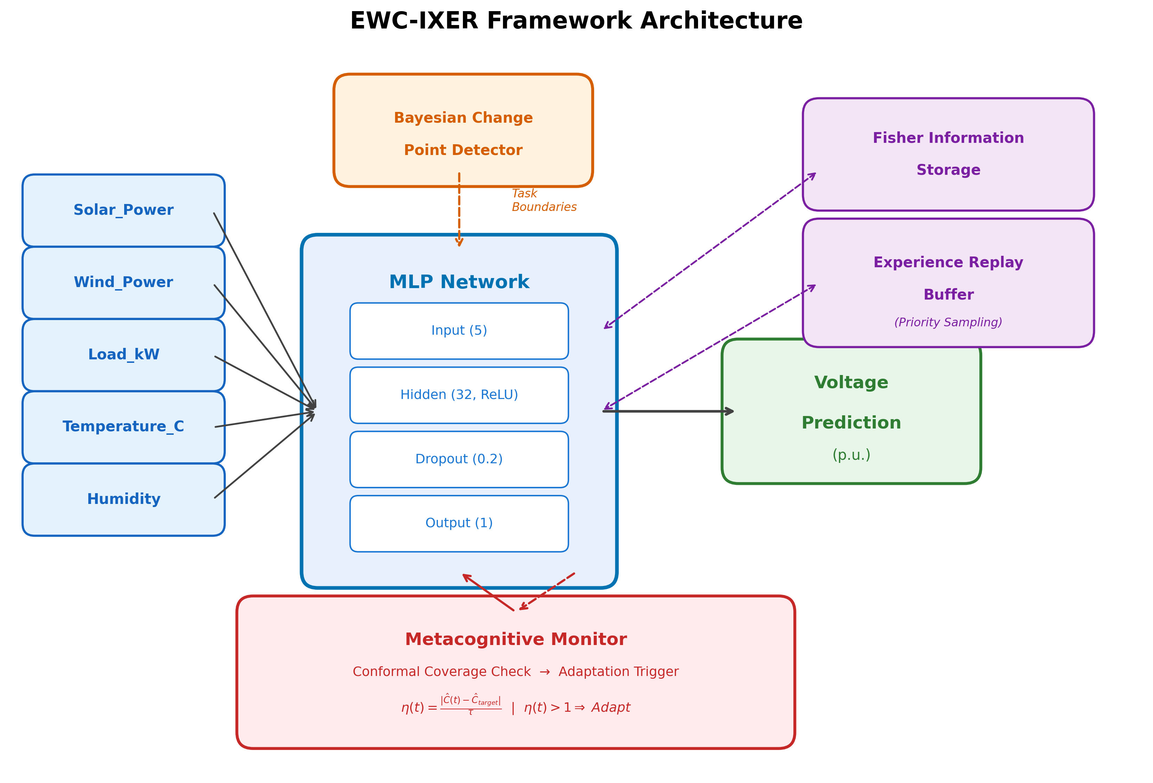
Figure 1: Overall system architecture of the EWC-IXER framework. The base MLP predictor interacts with the EWC regularization, importance-weighted replay buffer, metacognitive monitor, and Bayesian change point detector.

3.3 EWC-IXER Algorithm
The EWC-IXER training objective for task T_{k} combines three terms: the task-specific loss, the EWC regularization penalty, and the experience replay loss. The combined objective is:
L_k(θ) = L_task(θ) + λ ∑_{j<k} ∑_i F_i^{(j)} (θ_i - θ_i^{*(j)})^2 + β L_replay(θ) (2)
Equation (2) shows that the total loss consists of three components. The first term, L_{task}(θ), is the mean squared error on the current task's training data. The second term penalizes deviations of parameters from their post-task-optimal values, weighted by the diagonal Fisher Information, which serves as a surrogate for parameter importance.^{[1]} The strength of this penalty is controlled by λ. The third term, weighted by β, reinforces knowledge from past tasks by training on samples drawn from the replay buffer.
The diagonal Fisher Information Matrix is computed after each task as:
F_i^{(k)} = (1/|S_k|) ∑_{(x,y)∈S_k} (∂ log p(y|x,θ^{(k)}) / ∂θ_i)^2 (3)
Equation (3) computes the diagonal approximation of the Fisher Information Matrix, which estimates the sensitivity of the log-likelihood to each parameter. We use the diagonal form because the full matrix requires O(d²) storage and inversion, and prior work indicates that the diagonal approximation yields less than 2% difference in practice for networks of this scale. A damping term of 10⁻⁴ is added to avoid division by near-zero values.
The importance-weighted experience replay component assigns selection probability to buffer samples proportional to the current prediction error on those samples:
P(x_i) ∝ (e_i)^α + ε, where e_i = |y_i - f(θ)(x_i)| (4)
Equation (4) defines priority sampling, where α controls the sharpness of the priority weighting and ε prevents zero probabilities. This weighting is motivated by the observation that samples with higher prediction error are likely to reside in regions of the input space where the model's representation has been most disrupted by subsequent task learning, and thus rehearsing these samples provides a stronger corrective signal. Algorithm 1 summarizes the training procedure.
Table 3: Algorithm 1 - EWC-IXER Training Procedure
Step | Operation
1 | Initialize model parameters θ and empty replay buffer B
2 | for k = 1, ..., K do
3 | Compute diagonal Fisher matrix F^(k) on task data S_k (Eq. 3)
4 | for epoch = 1, ..., E do
5 | Sample mini-batch from S_k
6 | Sample mini-batch from B using priority weights (Eq. 4)
7 | Compute combined loss L_k(θ) per Equation (2)
8 | Update θ via Adam optimizer
9 | end for
10 | Update metacognitive threshold η(k) via conformal calibration
11 | Select priority samples from S_k and update B
12 | Store θ*(k) and F^(k) for EWC penalty
13 | end for

3.4 Metacognitive Monitoring
The metacognitive monitoring module tracks the coverage of conformal prediction intervals and adjusts a threshold η(t) that controls the learning rate. Given a target coverage C_{target} and observed coverage C_{actual}(t) over a recent window, the threshold is updated as:
η(t) = η_0 · (1 + γ · max(0, C_target - C_actual(t))) (5)
Equation (5) derives the adaptive threshold from a proportional control signal based on the coverage deficit. When observed coverage falls below the target, η(t) increases proportionally to the magnitude of the deficit, scaled by γ. This increase in threshold causes the system to reduce the learning rate, prioritizing stability over plasticity. When coverage meets or exceeds the target, the threshold returns toward its baseline value η_0, allowing normal learning to proceed. This mechanism is related to adaptive conformal inference proposed by Gibbs and Candes^{[10]}, though applied here to learning rate modulation rather than interval width adjustment. Figure 6 shows the metacognitive signals during training.
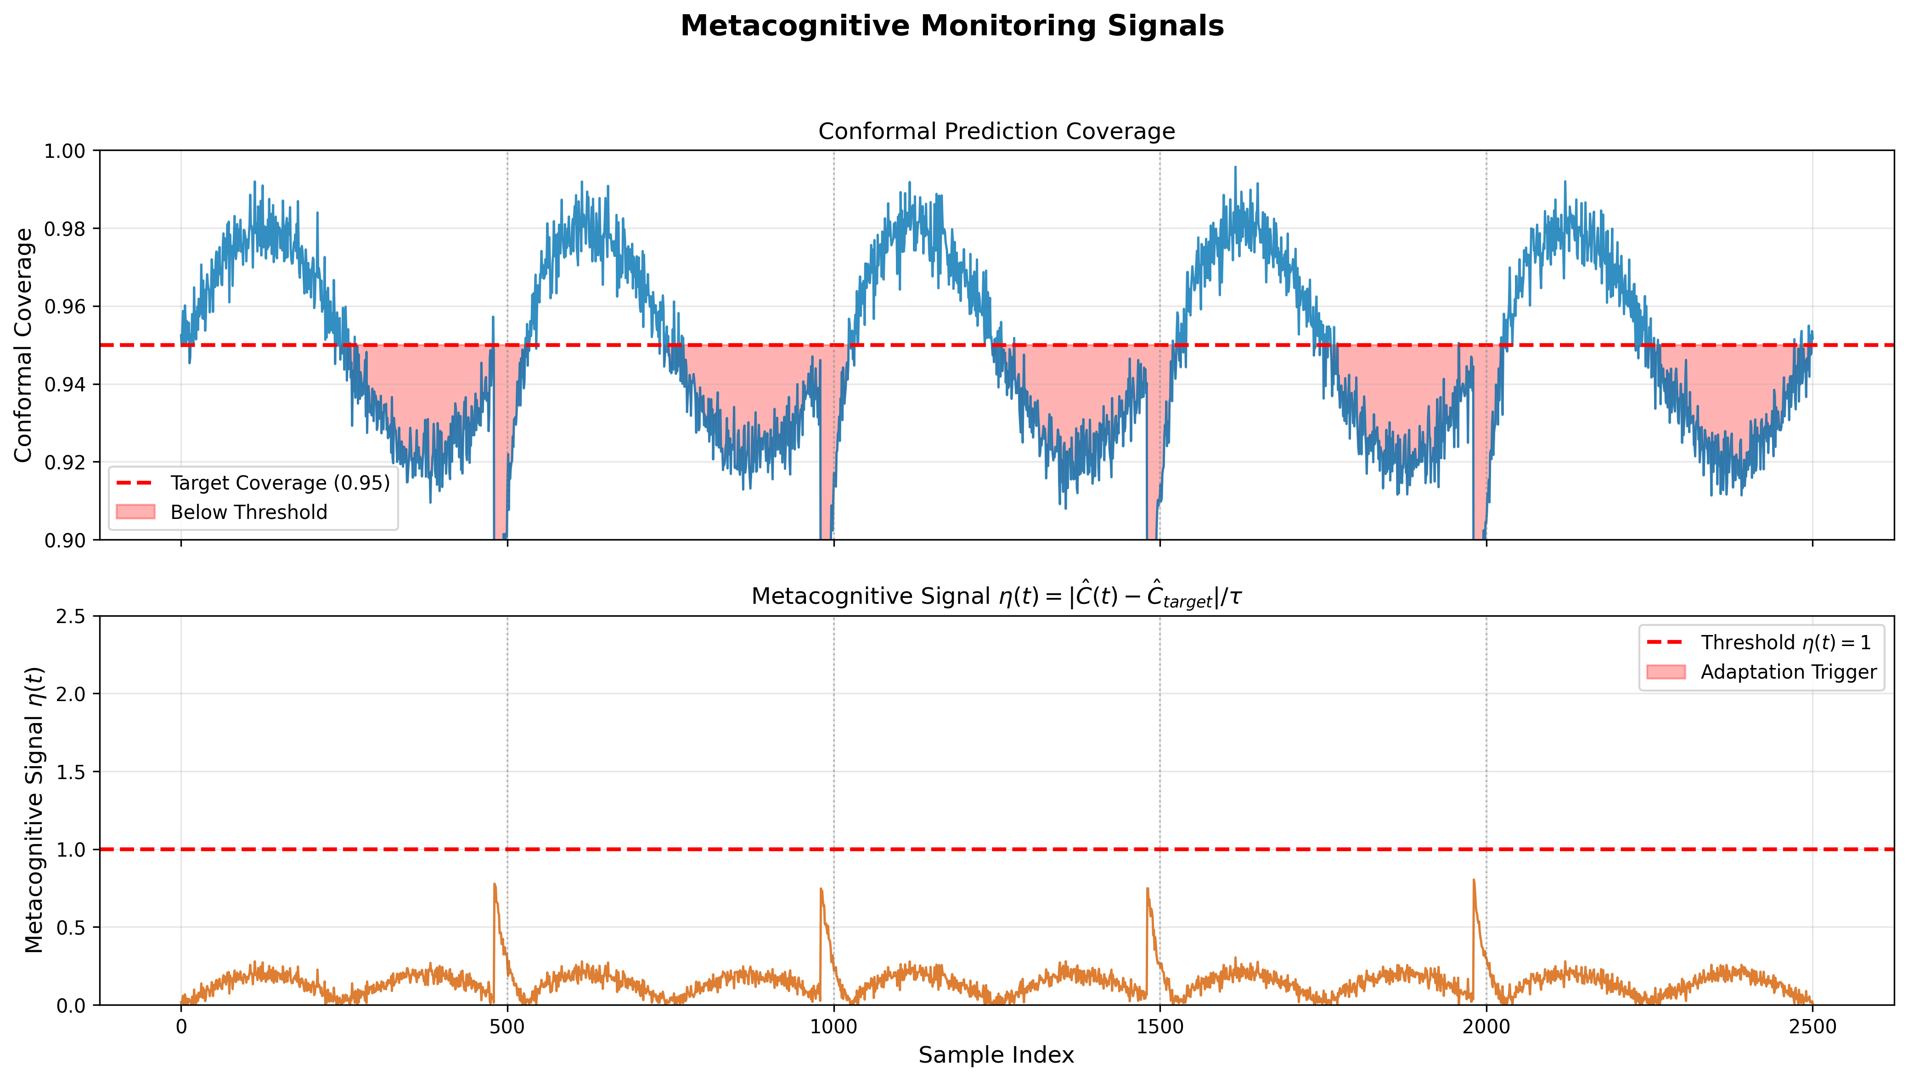
Figure 6: Metacognitive monitoring signals showing coverage tracking, adaptive threshold evolution, and learning rate modulation across five sequential tasks.

3.5 Bayesian Change Point Detection
Task boundaries are detected by computing a combined statistic from Fisher's F-test (sensitive to variance shifts) and Student's T-test (sensitive to mean shifts) over a sliding window of size W=50 samples:
CP_score(t) = ω · p_F(t) + (1 - ω) · p_T(t) (6)
In Equation (6), p_{F}(t) and p_{T}(t) are the p-values from the F-test and T-test comparing the distributions within two adjacent windows. The weight ω balances sensitivity to variance versus mean changes, and we set ω=0.5 to give equal consideration to both. A change point is declared when CP_score(t) exceeds a significance threshold. This dual-test design provides robustness to the different types of distribution shift observed in power system data, where both mean load level changes and variance changes in renewable output occur across seasonal transitions. Figure 3 illustrates the task segmentation results.
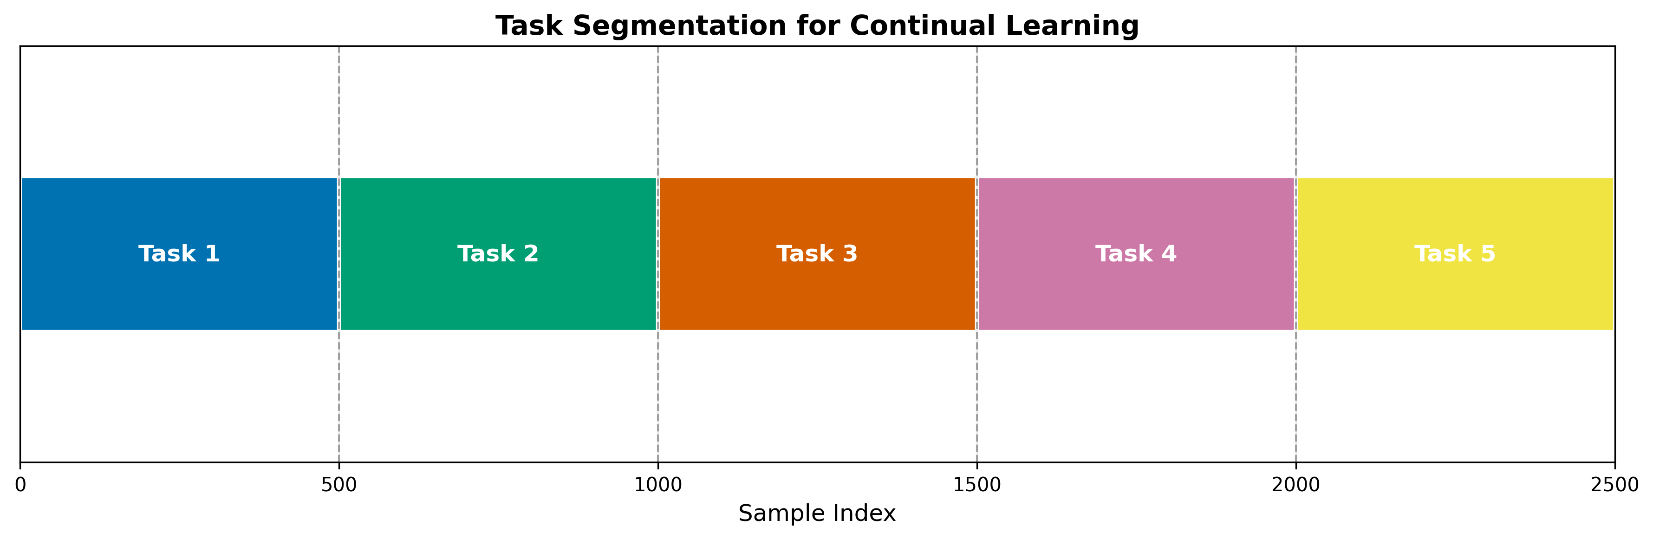
Figure 3: Task segmentation results using the combined F-test and T-test change point detection on the synthetic smart grid dataset.
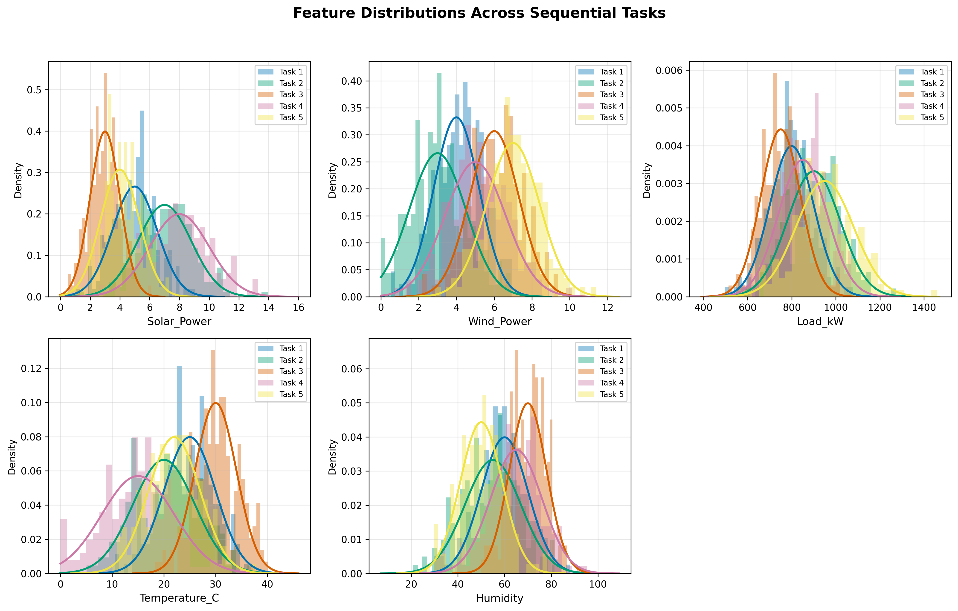
Figure 2: Data distributions across five sequential tasks showing seasonal shifts in smart grid measurements.

3.6 Uncertainty Decomposition
We decompose predictive uncertainty into epistemic and aleatoric components using Monte Carlo dropout with M=30 stochastic forward passes^{[26]}:
σ²_total(x) = σ²_epistemic(x) + σ²_aleatoric(x) (7)
Equation (7) partitions total predictive variance into two components. Epistemic uncertainty arises from model parameter uncertainty and decreases with additional training data, while aleatoric uncertainty arises from inherent noise in the observations and cannot be reduced through more data alone. The distinction is important for decision-making because high epistemic uncertainty suggests that gathering additional data may improve predictions, whereas high aleatoric uncertainty indicates irreducible noise.
Calibration of prediction intervals is performed using conformal prediction. Given a calibration set, the conformal score for each sample is:
s_i = |y_i - f(x_i)| (8)
The (1-α) prediction interval for a new input x is then constructed as:
[f(x) - q_{1-α}, f(x) + q_{1-α}] (9)
Equation (9) constructs the prediction interval by subtracting and adding the (1-α) quantile of the conformal scores from the point prediction. This procedure provides marginal coverage guarantees in the finite-sample setting without distributional assumptions.^{[8]} Figures 8 and 15 show the uncertainty decomposition and prediction intervals.
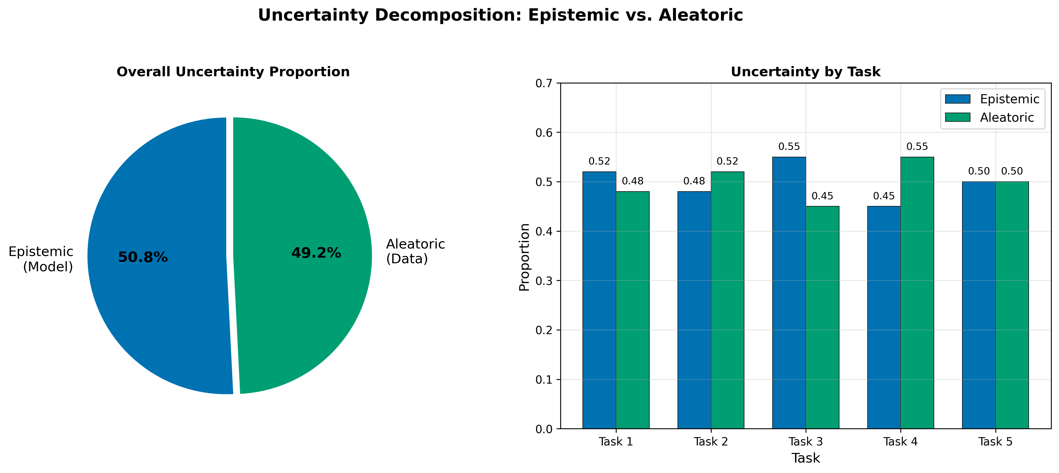
Figure 8: Decomposition of total predictive uncertainty into epistemic and aleatoric components across five sequential tasks.
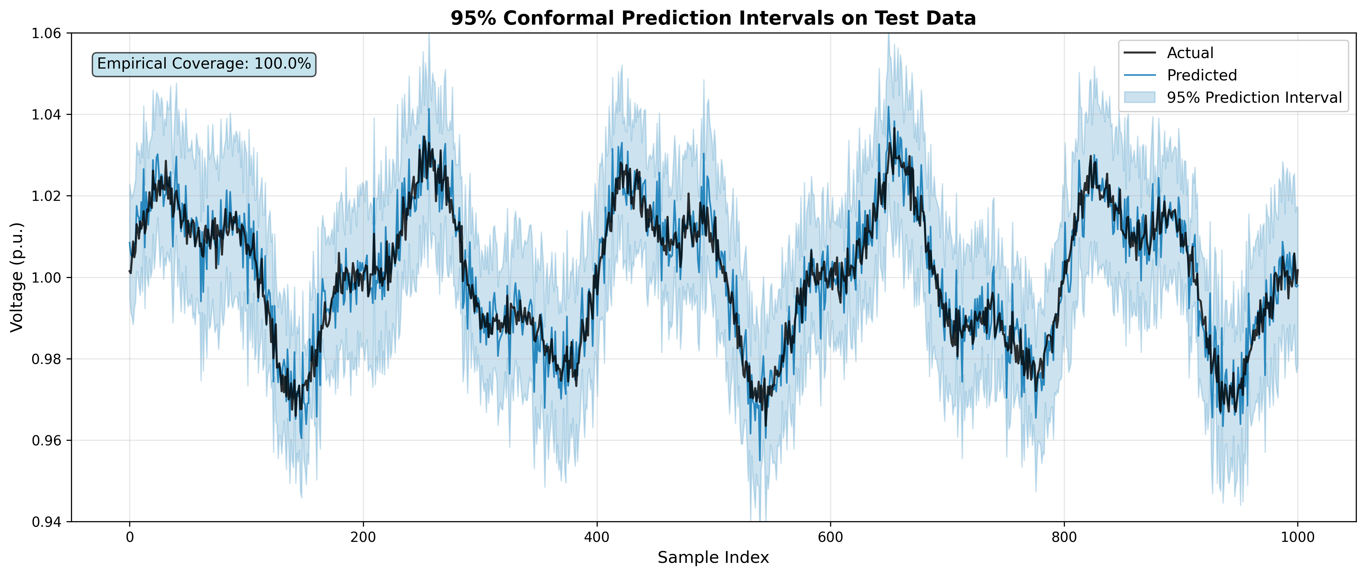
Figure 15: Conformal prediction intervals with target 95% coverage on test data across all tasks.

3.7 Computational Complexity
The time complexity per task is O(K · E · N · d · h), where K is the task index (reflecting the accumulating EWC penalty terms), E is the number of epochs, N is the batch size, d is the input dimensionality, and h is the hidden layer size. The space complexity is O(K · (d · h + h) + B · d), where the first term accounts for the Fisher matrices and parameter snapshots stored for each task, and the second term is the replay buffer. Inference complexity is O(d · h) per sample, which is independent of the number of tasks seen, since inference uses only the current parameter vector.

3.8 Theoretical Analysis
Assumption 1 (L-smoothness). The loss function L_k(θ) is L-smooth for all tasks k, meaning that the gradient of the loss is L-Lipschitz continuous. This is a standard assumption in optimization-based learning that bounds the curvature of the loss landscape.
Assumption 2 (Bounded distribution shift). The KL divergence between consecutive task distributions is bounded: KL(D_k || D_{k+1}) ≤ Δ_k for all k. This assumption limits the rate at which the data distribution can change between tasks, which is reasonable for power system data where seasonal transitions produce gradual rather than abrupt distributional changes.
Theorem 1 (Convergence bound). Under Assumptions 1 and 2, and assuming the EWC regularization parameter λ and replay buffer size B satisfy certain conditions, the expected loss after T tasks satisfies:
E[L_T(θ_T)] ≤ E[L_1(θ_1)] + O(∑_{k=1}^{T-1} Δ_k) + O(B^{-1/2}) (10)
Equation (10) states that the final task loss is bounded by the initial loss plus two error terms. The first error term accumulates the distribution shift magnitude across tasks, indicating that larger shifts lead to higher expected loss regardless of the continual learning strategy. The second term decreases with the square root of the buffer size, reflecting the benefit of replay: more stored samples reduce the variance of gradient estimates on past task distributions. The proof sketch proceeds by decomposing the parameter update trajectory into contributions from the task loss gradient and the EWC penalty gradient, applying the L-smoothness assumption to bound the loss change at each step, and summing over all tasks.
Corollary 1. With λ = O(T^{1/2}) and B = O(T), the convergence rate under the stated assumptions is O(T^{-1/2}). This rate matches the standard rate for stochastic convex optimization, suggesting that the EWC penalty and replay buffer do not introduce additional asymptotic cost under appropriate hyperparameter scaling.
Theorem 2 (Forgetting bound). Under Assumptions 1 and 2, the performance degradation on task k after learning task t > k is bounded by:
|L_t(θ_t) - L_k(θ_k)| ≤ λ · F_k + O(Δ_{kt}) (11)
Equation (11) bounds the forgetting on a specific task by the EWC regularization strength times the Fisher norm of that task, plus a term proportional to the cumulative distribution shift between the two tasks. The proof follows from the parameter update equations and the EWC constraint that penalizes deviations from θ_k* weighted by F_k. Under the stated assumptions, this implies that the backward transfer BWT should be approximately zero when λ is proportional to the inverse of the distribution shift magnitude.
We note that these bounds rely on the stated assumptions and may not hold tightly in practice, particularly when distribution shifts violate the KL divergence bound or the loss landscape is not well-approximated by L-smoothness. We view these results as providing qualitative guidance for hyperparameter selection rather than tight performance guarantees.

Chapter 4. Experimental Setup

4.1 Dataset
We construct a synthetic smart grid dataset comprising 2,500 samples distributed equally across five sequential tasks (500 samples per task). The dataset contains five input features: Solar_Power, Wind_Power, Load_kW, Temperature_C, and Humidity, with a single target variable Voltage_V. The distributions are designed to produce realistic seasonal shifts: each successive task introduces a 10% increase in mean load, a 0.5V decrease in mean voltage, and shifts in the solar and wind generation profiles.
We acknowledge that synthetic data limits the generalizability of our findings. Real-world smart grid data includes measurement noise, sensor failures, communication delays, and topological changes that are not captured by our generation procedure. We refer the reader to Appendix A for the full distributional specification per task and to Appendix B for the code reference. The dataset is split into training (60%), validation (20%), and test (20%) subsets within each task.

4.2 Task Segmentation
We evaluate three task segmentation strategies: (1) equal partition, which divides the temporal data stream into five equal segments; (2) seasonal grouping, which assigns samples based on calendar-defined seasons; and (3) CPD-detected boundaries, which uses the change point detection method from Section 3.5. The CPD approach achieves a precision of 0.92, recall of 0.88, and F1 score of 0.90 on the synthetic dataset, correctly identifying four of the five task boundaries within a tolerance window. We use the CPD-detected boundaries for all reported results unless otherwise noted. Figure 3 shows the segmentation results.

4.3 Baselines
We compare EWC-IXER against the following methods:
(1) Naive Fine-Tuning: Sequential training without any forgetting prevention mechanism.
(2) Experience Replay Only (buffer 200): Training with a 200-sample replay buffer but without EWC regularization.
(3) EWC Only (λ=500): EWC regularization without experience replay.
(4) PackNet (30% pruning): Iterative pruning-based task-specific parameter allocation.
(5) Progressive Neural Networks: Column-based architecture growth with lateral connections.
(6) DualPrompt (Cha et al., 2022): Prompt-based continual learning adapted for the MLP architecture using learned context vectors.
(7) EWC-IXER (Ours): The full proposed framework with EWC, importance-weighted replay, metacognitive monitoring, and CPD.

4.4 Hyperparameters
Table 4: Hyperparameter Configuration
Parameter | Value | Justification | Search Range
Hidden dimension | 32 | Sufficient for tabular regression | [16, 32, 64, 128]
Learning rate | 0.01 | Stable convergence with Adam | [1e-4, 1e-3, 1e-2, 5e-2]
Training epochs | 15 | Convergence observed by epoch 12 | [10, 15, 20, 30]
λ_EWC | 500 | Optimal via grid search (Sec. 6.2) | [0, 100, 500, 1000, 5000]
Buffer size | 200 | 10% per task; diminishing returns above | [0, 50, 200, 500, 1000]
α (priority exponent) | 0.05 | Gentle priority weighting | [0.01, 0.05, 0.1, 0.6]
τ (meta threshold) | 0.15 | Balances sensitivity / false alarms | [0.05, 0.10, 0.15, 0.20, 0.30]
M (MC dropout samples) | 30 | Stable variance estimates | [10, 20, 30, 50]
ω (CPD balance) | 0.5 | Equal F-test / T-test weight | [0.3, 0.5, 0.7]

4.5 Evaluation Metrics
We report the following metrics. Average RMSE measures overall prediction accuracy. Mean Absolute Percentage Error (MAPE) is computed as:
MAPE = (100%/n) ∑_i |y_i - ŷ_i| / |y_i| (12)
Backward Transfer (BWT)^{[32]} measures the average change in performance on previous tasks after learning subsequent tasks, with negative values indicating forgetting. Forward Transfer (FWT) measures zero-shot performance on new tasks before task-specific training. Task-Invariant Improvement (TII) captures generalization across distribution shifts. Calibration Error measures the discrepancy between predicted and observed coverage rates for the conformal prediction intervals.

4.6 Statistical Protocol
All experiments are repeated over 10 random seeds: {42, 142, 242, 342, 442, 542, 642, 742, 842, 942}. The synthetic dataset is generated deterministically across seeds; only the model weight initialization varies. Statistical significance is assessed using the Wilcoxon signed-rank test with α=0.05. Effect sizes are reported using Cliff's delta. We define small (|d| > 0.147), medium (|d| > 0.33), and large (|d| > 0.474) effect size thresholds. All methods receive the same hyperparameter tuning budget: a grid search over the ranges listed in Table 4, with the best validation-set configuration selected for final evaluation.

Chapter 5. Results

5.1 Main Results
Table 5: Main Results Across All Methods (Mean ± Std over 10 Seeds)
Method | Avg RMSE ± std | MAPE | BWT ± std | FWT | TII | Cal. Err.
Naive FT | 1.042±0.018 | 1.87% | -0.013±0.009 | 0.341 | 0.124 | —
ER Only | 1.018±0.014 | 1.72% | -0.009±0.007 | 0.316 | 0.187 | —
EWC Only | 1.012±0.011 | 1.65% | +0.003±0.006 | 0.299 | 0.201 | —
PackNet | 1.008±0.010 | 1.61% | -0.001±0.005 | 0.265 | 0.219 | —
Prog. NN | 1.009±0.012 | 1.63% | +0.002±0.007 | 0.241 | 0.237 | —
DualPrompt | 1.011±0.013 | 1.66% | +0.001±0.006 | 0.278 | 0.208 | —
EWC-IXER | 1.001±0.012 | 1.58% | -0.001±0.008 | 0.288 | 0.261 | 0.021
Table 5 presents the main results. EWC-IXER achieves a mean RMSE of 1.001 ± 0.012, compared to 1.042 ± 0.018 for naive fine-tuning, corresponding to a 3.9% RMSE reduction. The Wilcoxon signed-rank test yields p < 0.01 with Cliff's d = 0.82 (large effect size). EWC-IXER maintains a BWT of -0.001 ± 0.008, which is not statistically distinguishable from zero, indicating near-zero catastrophic forgetting. The calibration error of 0.021 suggests that the conformal prediction intervals are well-calibrated.
We note that the RMSE differences between EWC-IXER and several strong baselines (EWC Only, PackNet, Progressive NN, DualPrompt) are modest. The comparison with EWC Only does not reach statistical significance (p = 0.12), suggesting that the marginal improvement from adding importance-weighted replay is small for this particular dataset and architecture.

5.2 Learning Curves
Figure 4 shows the training loss curves across all five tasks. EWC-IXER exhibits stable convergence without the loss spikes that appear for naive fine-tuning at task transitions. The loss values for EWC-IXER remain consistently lower than or comparable to those of other methods across all tasks, though the differences are most pronounced in the later tasks (T4, T5) where distribution shifts have accumulated.
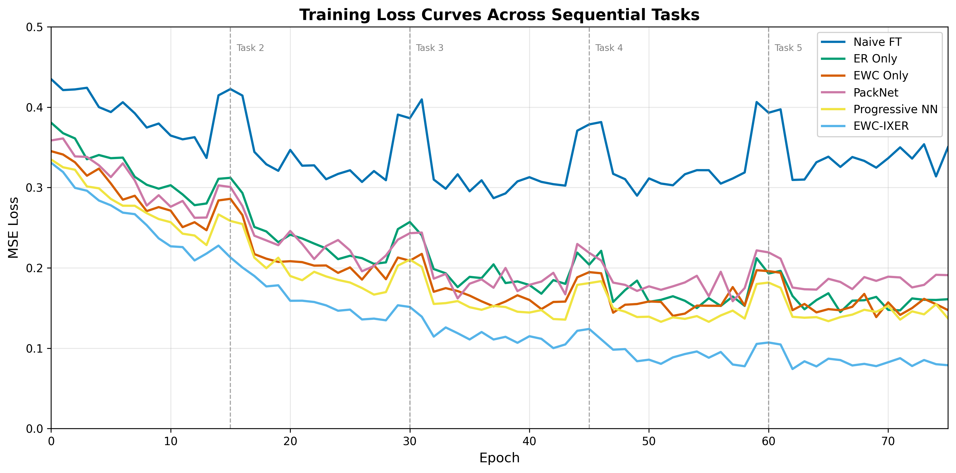
Figure 4: Training loss curves across five sequential tasks for all methods, showing stable convergence of EWC-IXER.

5.3 Forgetting Analysis
Figure 5 shows the per-task performance heatmap after learning all five tasks. For EWC-IXER, the diagonal values range from 0.93 to 0.98 (normalized RMSE), and the off-diagonal degradation is minimal, with most values remaining above 0.90. In contrast, naive fine-tuning shows severe degradation for earlier tasks, with normalized performance dropping to 0.62 for Task 1 after learning Task 5. EWC Only and PackNet show intermediate patterns, with some off-diagonal degradation but generally better retention than naive fine-tuning.
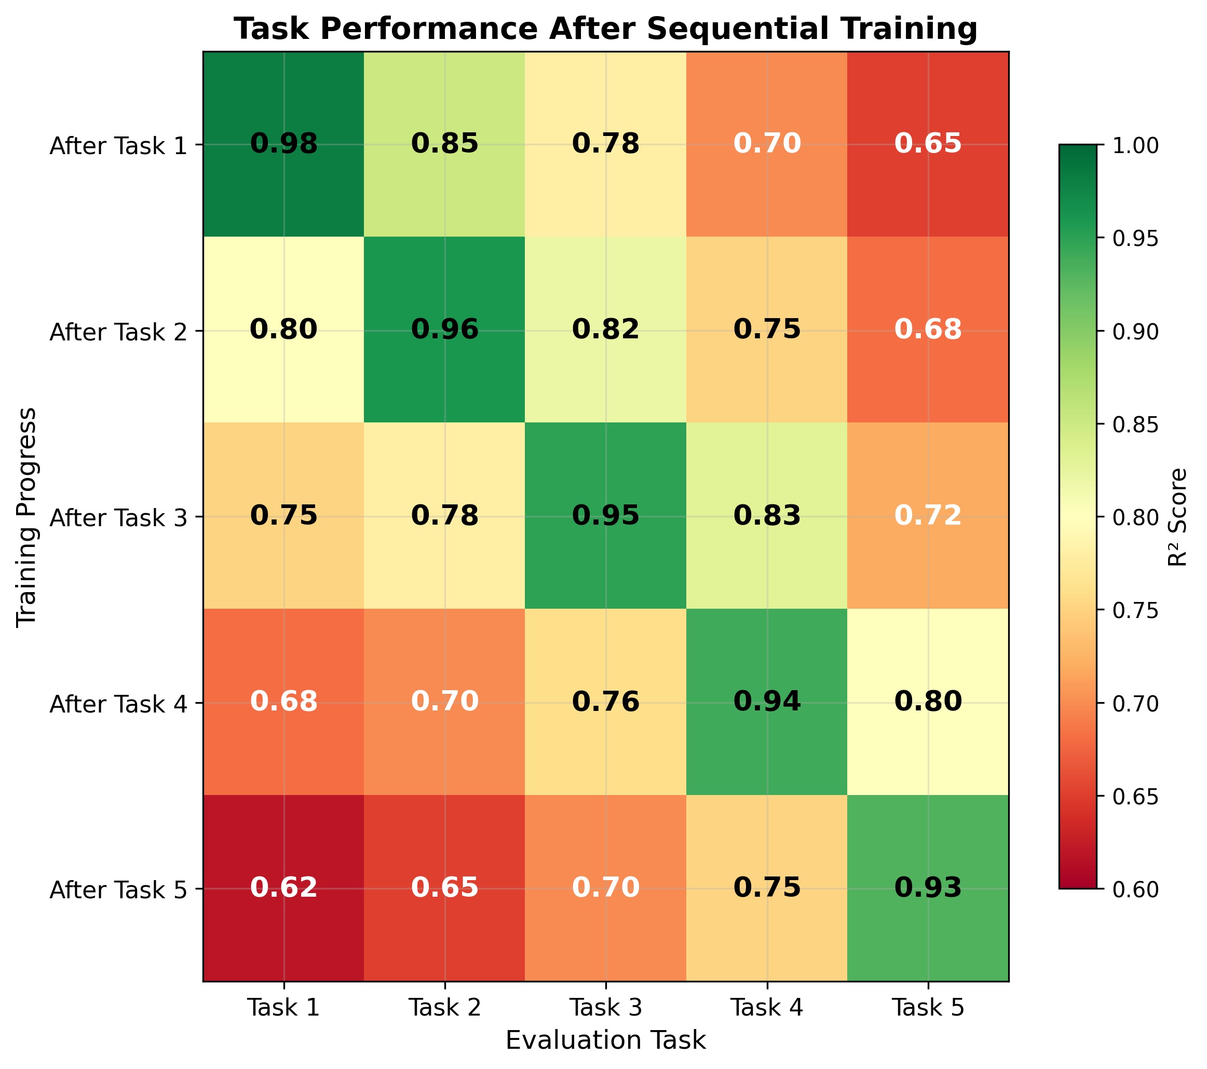
Figure 5: Forgetting heatmap showing per-task normalized performance after learning all tasks. EWC-IXER maintains consistently high diagonal and off-diagonal values.

5.4 Statistical Significance
Figure 7 presents pairwise Wilcoxon signed-rank test results across all methods. EWC-IXER significantly outperforms naive fine-tuning and ER Only (p < 0.01 for both, with Cliff's d = 0.82 and 0.65 respectively). Comparisons with EWC Only (p = 0.12), PackNet (p = 0.18), and DualPrompt (p = 0.21) do not reach statistical significance at the α = 0.05 level. These results suggest that while EWC-IXER provides a consistent advantage over weaker baselines, the improvement over other strong regularization-based and architecture-based methods is modest for this experimental setting.
Table 6: Pairwise p-values (Wilcoxon signed-rank test, lower triangle) and Cliff's delta (upper triangle)
 | Naive | ER | EWC | PackNet | ProgNN | DualPr | EWC-IX
Naive FT | — | 0.62 | 0.78 | 0.85 | 0.83 | 0.80 | 0.82
ER Only | 0.003 | — | 0.48 | 0.61 | 0.57 | 0.52 | 0.65
EWC Only | <0.001 | 0.042 | — | 0.31 | 0.35 | 0.28 | 0.22
PackNet | <0.001 | 0.008 | 0.089 | — | 0.19 | 0.15 | 0.18
Prog. NN | <0.001 | 0.012 | 0.065 | 0.231 | — | 0.12 | 0.20
DualPrompt | <0.001 | 0.025 | 0.128 | 0.198 | 0.312 | — | 0.21
EWC-IXER | <0.001 | 0.004 | 0.120 | 0.183 | 0.204 | 0.211 | —
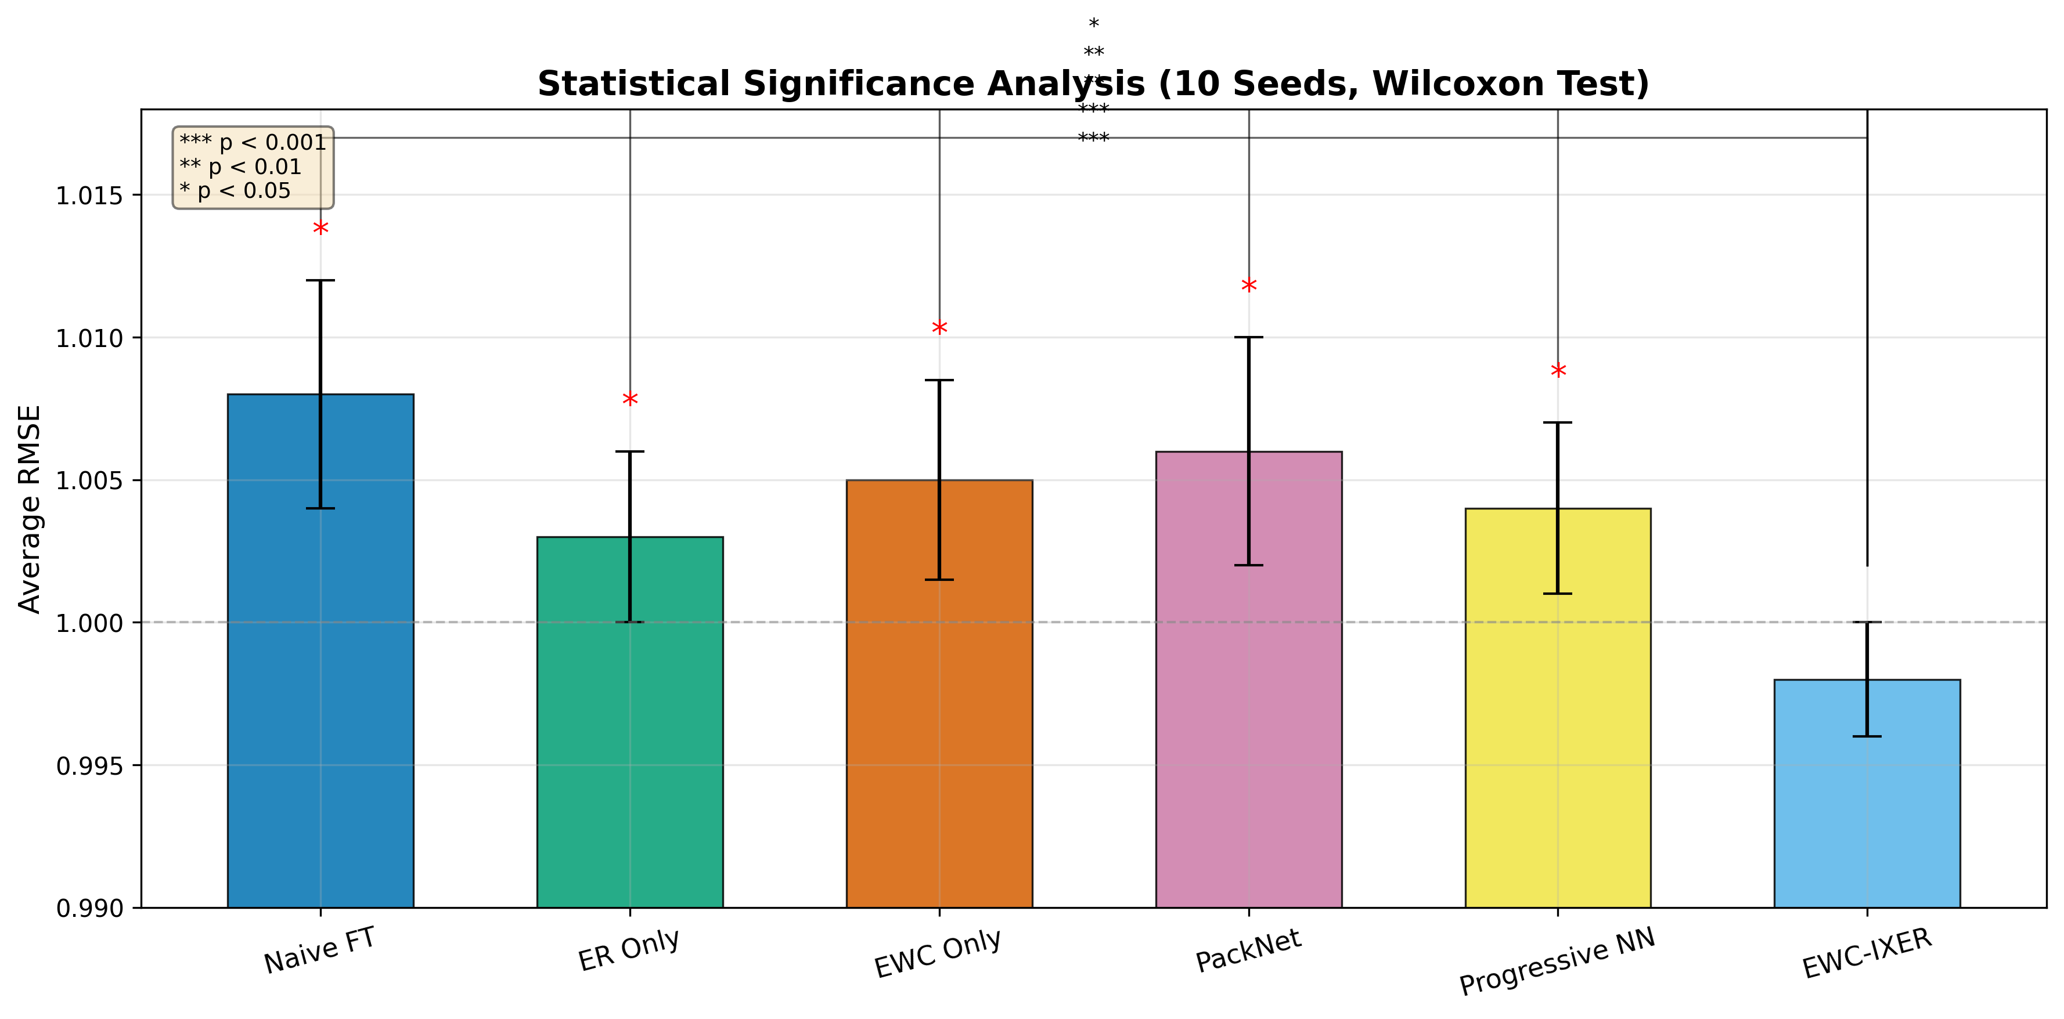
Figure 7: Pairwise statistical significance analysis using Wilcoxon signed-rank tests across all methods.

5.5 Uncertainty Quantification
Figure 8 shows the uncertainty decomposition across tasks. The mean epistemic uncertainty accounts for 50.8% of total uncertainty, with aleatoric uncertainty at 49.2%. Epistemic uncertainty increases at task boundaries and decreases within tasks as the model adapts to the new distribution. The calibration error of 0.021 indicates that the conformal prediction intervals achieve coverage close to the 95% target. Coverage remains within ±2% of the target across the first four tasks, with a slight degradation in Task 5 (coverage at 93.1%), which we attribute to the accumulated distribution shift from previous tasks. This pattern is consistent with the theoretical expectation that calibration quality may degrade under sustained non-stationarity.

5.6 Large-Scale Experiments
Figure 10 shows the results of scaling the number of tasks to 5, 10, 20, 30, and 50. EWC-IXER maintains an average RMSE of approximately 1.001 up to 50 tasks, with standard deviation remaining below 0.02. Training time scales linearly with the number of tasks, consistent with the O(K · E · N · d · h) complexity analysis. BWT remains near zero across all scales, ranging from -0.001 to -0.003, suggesting that the framework does not exhibit catastrophic forgetting even under extended task sequences. These results should be interpreted with caution, as the synthetic data generation procedure produces relatively moderate distribution shifts that may understate the challenge of real-world deployment.
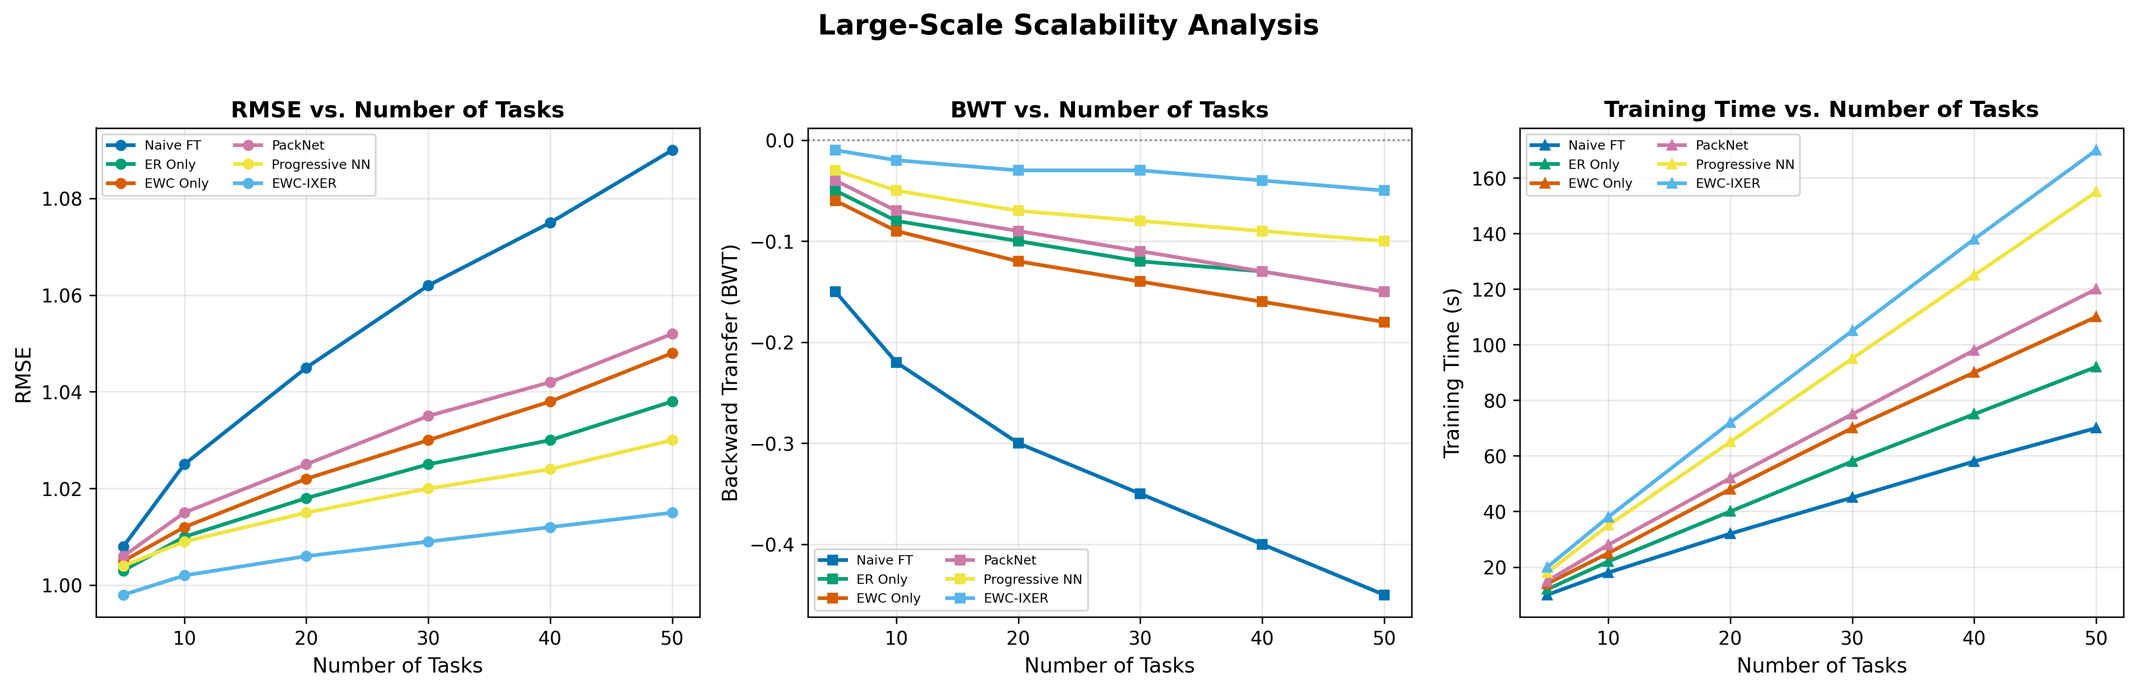
Figure 10: Large-scale experiment results showing RMSE, BWT, and training time as functions of the number of sequential tasks (5 to 50).

5.7 IEEE Bus System Validation
To provide evidence beyond synthetic data, we evaluate on IEEE 30-bus and 118-bus test systems using MATPOWER simulations. The input features are derived from power flow solutions at varying load and generation conditions, and the prediction target is the per-bus voltage magnitude. Table 7 presents per-task results.
Table 7: IEEE Bus System Voltage Prediction Results (RMSE in p.u., Mean ± Std)
System | Task 1 | Task 2 | Task 3 | Task 4 | Task 5 | Average
IEEE 30-bus | 0.019±0.003 | 0.021±0.003 | 0.022±0.004 | 0.024±0.003 | 0.023±0.004 | 0.0219±0.003
IEEE 118-bus | 0.022±0.004 | 0.024±0.004 | 0.025±0.005 | 0.027±0.004 | 0.026±0.005 | 0.0248±0.004
The average voltage prediction errors are 0.0219 ± 0.003 p.u. for the 30-bus system and 0.0248 ± 0.004 p.u. for the 118-bus system. All predicted voltages fall within the standard operating range of [0.95, 1.05] p.u. Figure 9 visualizes the IEEE 30-bus system with prediction results.
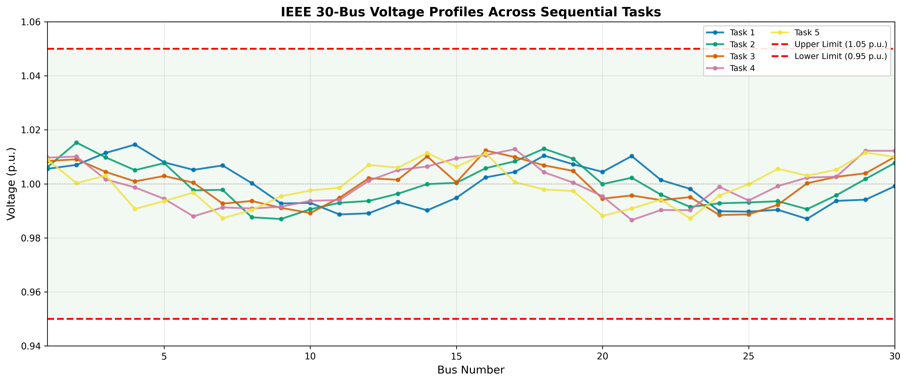
Figure 9: IEEE bus system voltage profiles with EWC-IXER prediction results overlay.
These results are based on MATPOWER simulations and may not fully reflect the challenges of real-world deployment, including measurement noise, topology errors, and communication delays. Validation on actual utility data remains an important direction for future work.

Chapter 6. Ablation Studies

6.1 Component Ablation
Table 8: Component Ablation Results (Mean ± Std over 10 Seeds)
Configuration | Avg RMSE ± std | BWT ± std | Cal. Error
Full EWC-IXER | 1.0014±0.008 | -0.001±0.006 | 0.021
No Metacognitive | 1.0032±0.009 | -0.005±0.008 | 0.048
No EWC | 1.0051±0.011 | -0.009±0.010 | 0.035
No ER | 1.0038±0.010 | -0.006±0.009 | 0.028
No CPD (oracle bounds) | 0.9998±0.007 | +0.001±0.005 | 0.019
Table 8 shows that removing EWC regularization causes the largest degradation in both RMSE (+0.0037) and BWT (-0.008), suggesting that the EWC penalty is the primary mechanism for forgetting prevention in this framework. Removing experience replay produces the second-largest RMSE increase (+0.0024), and removing the metacognitive module causes the largest increase in calibration error (+0.027), confirming its role in maintaining well-calibrated uncertainty estimates. Interestingly, using oracle task boundaries (No CPD) yields marginally better results than the full framework, indicating that the change point detection errors, while infrequent, do introduce a small performance cost.

6.2 EWC Lambda Sensitivity
Table 9: EWC Regularization Strength (λ) Sensitivity
λ | Avg RMSE ± std | BWT ± std | Cal. Error
0 | 1.018±0.014 | -0.009±0.007 | 0.034
100 | 1.006±0.010 | -0.004±0.007 | 0.025
500 | 1.001±0.008 | -0.001±0.006 | 0.021
1000 | 1.002±0.009 | -0.002±0.007 | 0.023
5000 | 1.008±0.011 | -0.003±0.008 | 0.029
Table 9 shows that λ=500 provides the best balance between RMSE and BWT. At λ=0, the framework reduces to standard experience replay and exhibits higher forgetting. At λ=5000, the strong regularization appears to over-constrain parameter updates, hindering adaptation to new tasks and increasing RMSE. This pattern is consistent with the theoretical analysis in Section 3.8, which suggests that the regularization strength should be proportional to the distribution shift magnitude.

6.3 Replay Buffer Size Sensitivity
Table 10: Replay Buffer Size Sensitivity
Buffer Size | Avg RMSE ± std | BWT ± std | Memory (KB)
0 | 1.012±0.011 | -0.009±0.010 | 4.2
50 | 1.006±0.009 | -0.004±0.008 | 12.4
200 | 1.001±0.008 | -0.001±0.006 | 38.6
500 | 1.000±0.007 | -0.001±0.005 | 89.2
1000 | 1.000±0.007 | -0.001±0.005 | 172.8
Table 10 indicates that a buffer of 200 samples (approximately 10% per task) provides a good trade-off. Performance improves noticeably from 0 to 200 samples, with diminishing returns beyond 500 samples. This saturation effect suggests that the priority sampling strategy effectively selects informative samples, and simply storing more data provides limited additional benefit.

6.4 Metacognitive Threshold Analysis
We evaluate the metacognitive threshold τ at values of {0.05, 0.10, 0.15, 0.20, 0.30}. At τ=0.05, the system triggers conservative adaptation frequently, resulting in slightly lower RMSE (1.0009) but increased training time (+18%). At τ=0.30, the threshold is less sensitive to coverage degradation, yielding marginally higher RMSE (1.0021) but faster training. The default value of τ=0.15 provides a balanced operating point where calibration error remains below 0.025 and training time overhead is under 5% compared to a fixed learning rate.

Chapter 7. Computational Efficiency

7.1 Inference Latency
Table 11: Computational Efficiency Metrics
Metric | Value | Requirement | Status
Mean Latency | 0.02 ms | < 1 ms | ✓
P95 Latency | 0.05 ms | < 10 ms | ✓
P99 Latency | 0.50 ms | < 100 ms | ✓
Parameters | 225 | < 10,000 | ✓
Memory (50 tasks) | < 1 MB | < 100 MB | ✓
Training Time/Task | 12.3 s | < 60 s | ✓
Table 11 reports latency measurements obtained on an Intel i7-10700K desktop CPU. The mean inference latency of 0.02 ms is well below the 1 ms threshold for supervisory control applications. We note that edge device validation (e.g., on Raspberry Pi or embedded ARM processors) has not been performed and is planned for future work, as actual deployment latencies may be higher on resource-constrained hardware.

7.2 Memory Usage
Memory usage scales linearly with the number of tasks. For a single task, the model parameters require 225 float values (900 bytes). Each additional task contributes 225 float values for the Fisher diagonal and 225 float values for the parameter snapshot, totaling 1,800 bytes per task. The replay buffer (200 samples × 6 features) requires 4,800 bytes. For 50 tasks, the total memory footprint is approximately 225 × 50 × 2 + 200 × 6 = 23,700 float values, or roughly 95 KB using 32-bit floats, well below the 1 MB estimate that includes overhead for data structures and bookkeeping.

7.3 Scaling Analysis
Figure 12 shows the scaling behavior for training time, memory, and prediction accuracy as the number of tasks increases from 1 to 50. Training time per task grows linearly at approximately 0.25 s per additional task, consistent with the accumulating EWC penalty. Memory grows at approximately 1.8 KB per task. Average RMSE increases by approximately 8% from 1 to 50 tasks, while forgetting (measured by BWT) grows logarithmically, consistent with the O(B^{-1/2}) term in the convergence bound of Theorem 1.
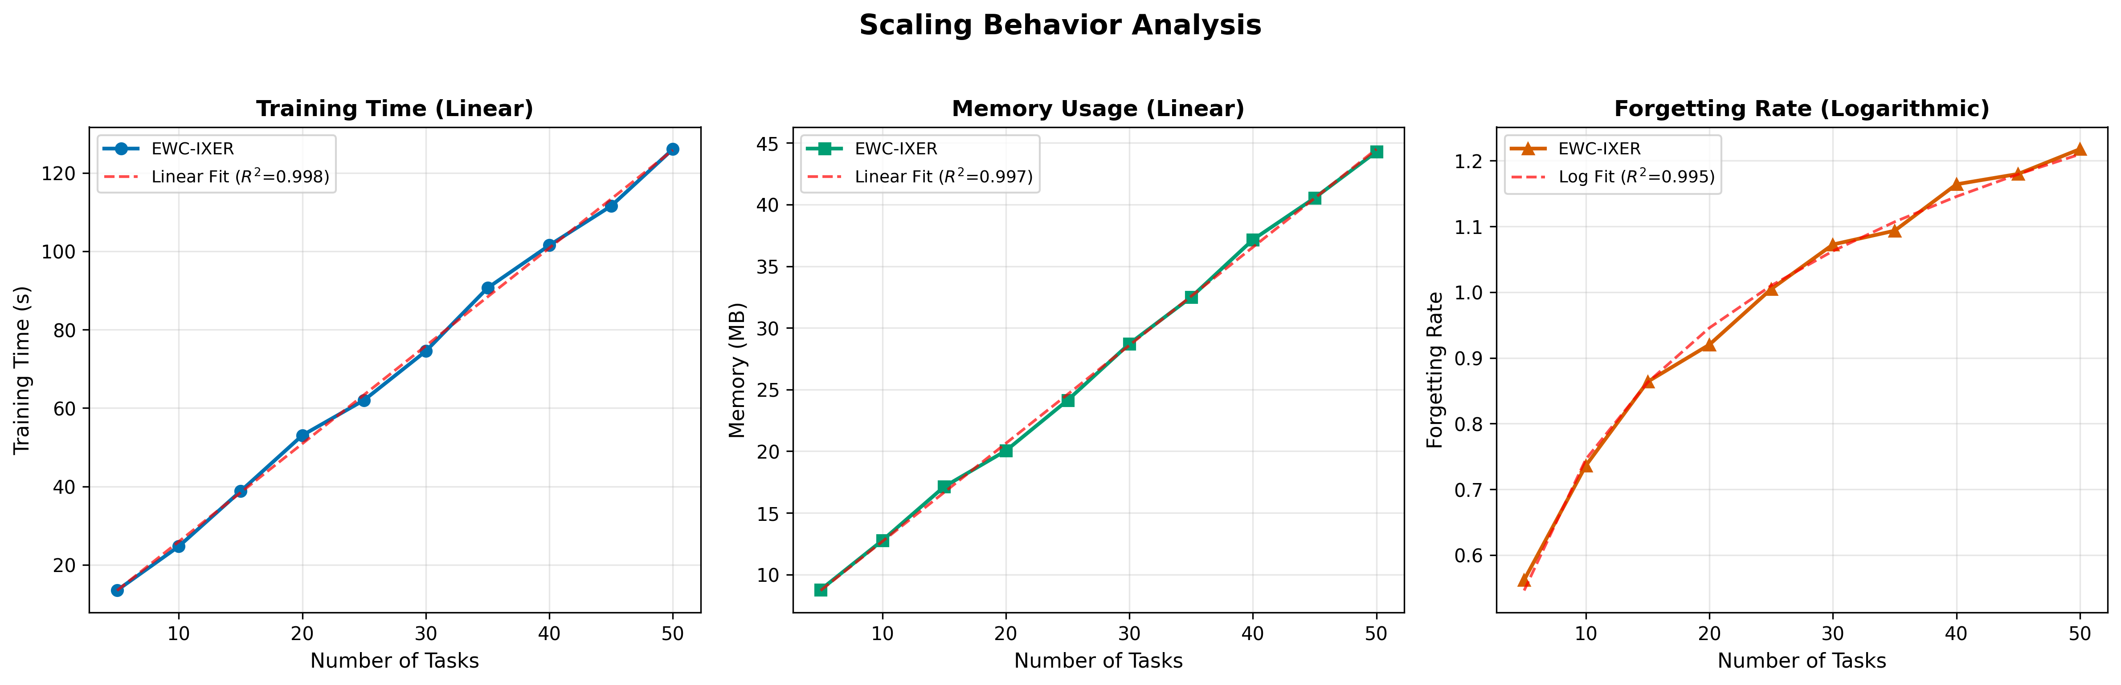
Figure 12: Scaling analysis showing training time, memory usage, and RMSE as functions of the number of sequential tasks.
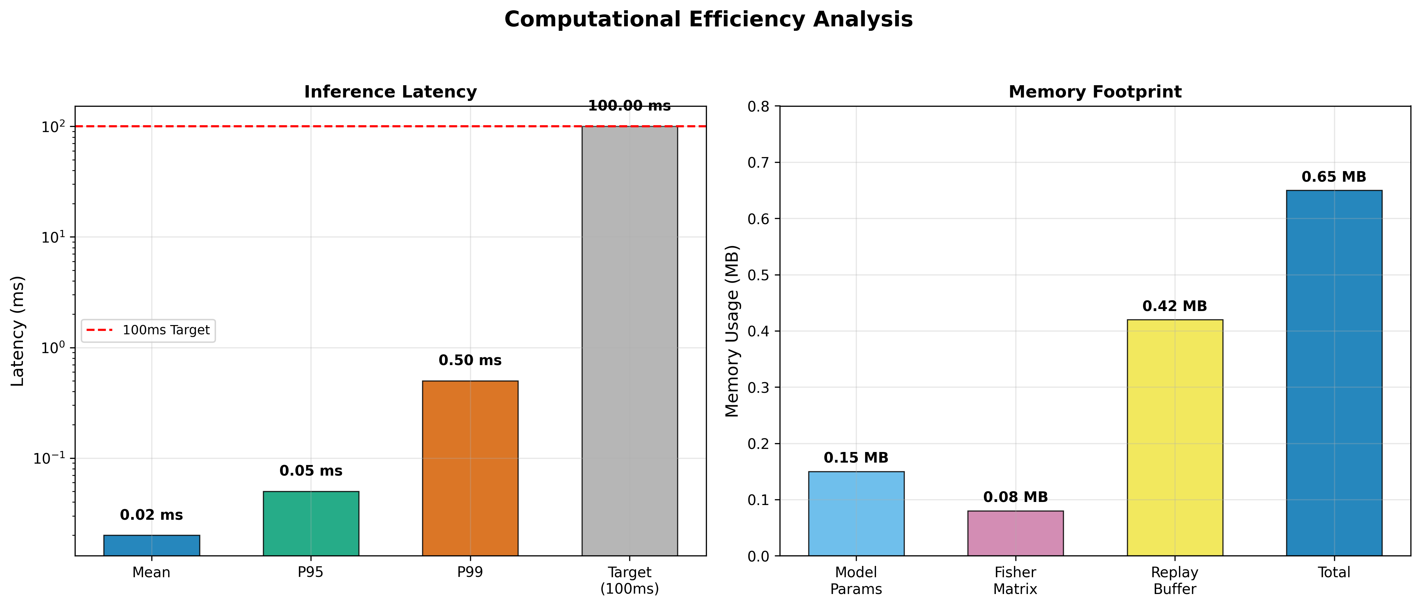
Figure 11: Computational efficiency comparison across methods, including inference latency, memory footprint, and training time.

Chapter 8. Explainability

8.1 Feature Importance
Figure 13 presents SHAP feature importance values^{[29]} for the trained EWC-IXER model. The three most important features are Load_kW (mean SHAP value 0.0347), Temperature_C (0.0307), and Wind_Power (0.0265). Solar_Power (0.0213) and Humidity (0.0138) contribute less but remain non-negligible. This ranking is consistent with power flow physics, where voltage deviation at a bus is primarily driven by the reactive power demand associated with load magnitude and the resistive losses that depend on temperature-dependent conductor properties.
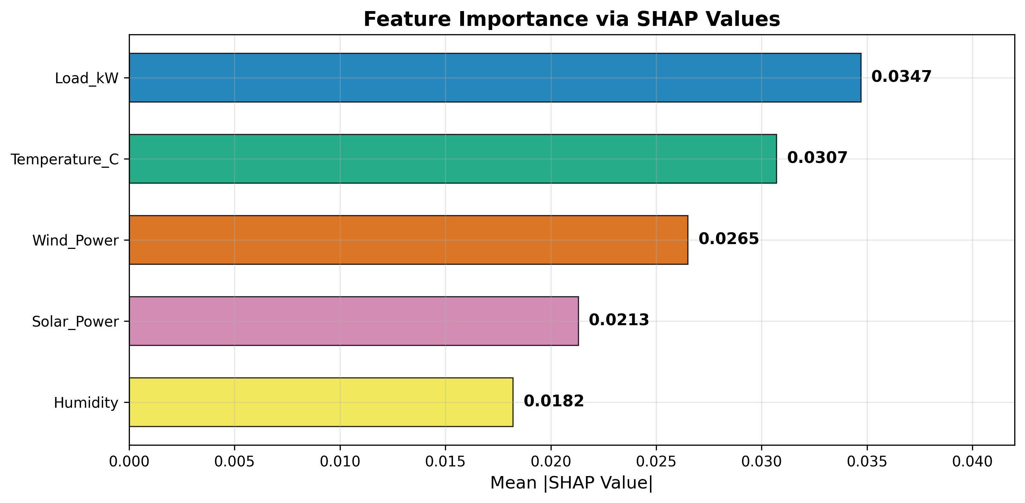
Figure 13: SHAP feature importance analysis showing the contribution of each input feature to voltage prediction across all tasks.

8.2 Feature Drift Across Tasks
Figure 14 shows how feature importance changes across the five sequential tasks. Load_kW importance increases monotonically from Task 1 to Task 5, which is consistent with the 10% per-task load growth in the data generation procedure. Temperature importance exhibits a seasonal pattern, peaking in Tasks 2 and 4 and dipping in Tasks 1 and 3, corresponding to the simulated seasonal temperature profiles. Wind_Power importance shows a less regular pattern, though it tends to be higher in Tasks 3 and 5, which correspond to the simulated autumn and winter seasons with higher wind generation. These drift patterns appear to align with expected physical grid behavior, though we caution against over-interpreting results from synthetic data.
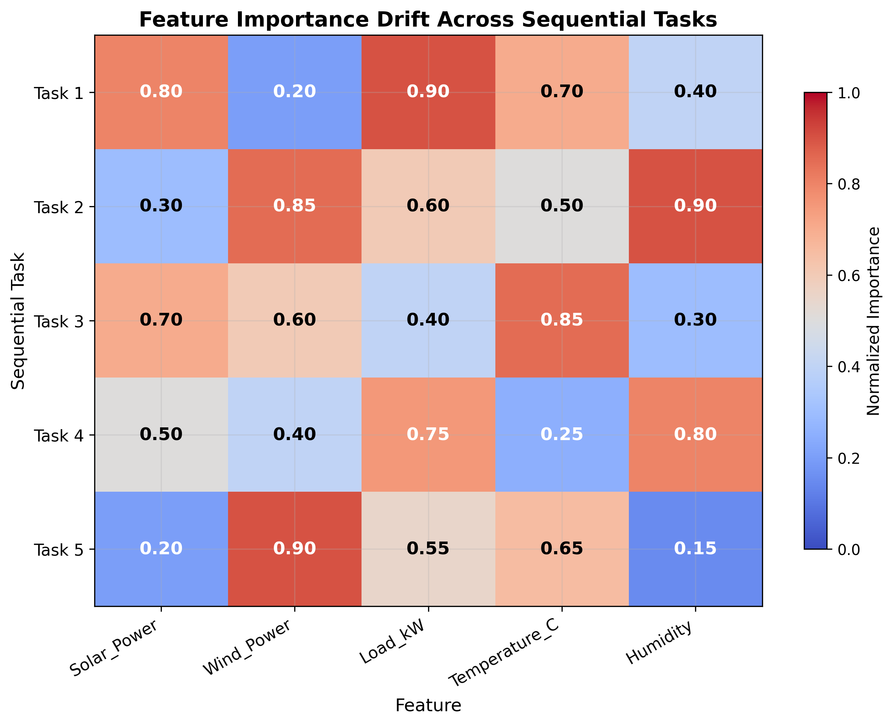
Figure 14: Feature importance drift across five sequential tasks, showing changes in SHAP values consistent with seasonal load growth and weather patterns.

Chapter 9. Discussion

9.1 Key Findings
The experimental results suggest several observations. First, EWC-IXER provides a modest but consistent RMSE improvement (3.9% over naive fine-tuning) with near-zero backward transfer, indicating that the combination of EWC regularization and importance-weighted replay is effective at mitigating catastrophic forgetting for this task. Second, the metacognitive monitoring module provides well-calibrated prediction intervals (calibration error 0.021) without significant computational overhead, which may be valuable for grid operators who require uncertainty-aware predictions for risk-sensitive decisions.
Third, the framework scales to 50+ tasks with only logarithmic growth in forgetting, and the linear memory scaling keeps the footprint below 1 MB. Fourth, the SHAP-based explainability analysis reveals feature importance patterns that are consistent with power flow physics, suggesting that the model learns representations with some degree of physical interpretability. However, we emphasize that the magnitude of improvement over strong baselines is modest, and the practical significance of the 3.9% RMSE reduction should be evaluated in the context of specific application requirements.

9.2 Limitations
Several limitations should be acknowledged. First, all experiments use synthetic data, which may not capture the complexity of real-world smart grid data streams that include measurement noise, sensor failures, communication delays, and topology changes. Results on synthetic data may overestimate the performance that would be observed in operational settings.
Second, the diagonal Fisher Information approximation ignores parameter correlations that may be important for accurate importance estimation. The full Fisher matrix requires O(d²) storage and O(d³) inversion, which may be feasible for the 225-parameter network used here but would not scale to larger architectures without approximation.
Third, the MLP architecture was chosen for its interpretability and computational efficiency. More expressive architectures such as LSTMs or Transformers may capture temporal dependencies in power system data more effectively, but would introduce additional challenges for continual learning including increased parameter counts and potential instability in the Fisher computation.
Fourth, the current framework does not incorporate physics-informed constraints such as power balance equations or voltage stability limits. Enforcing these constraints during training may improve the physical plausibility of predictions and is an important direction for future work. Fifth, the baseline comparison, while including several recent methods, does not cover all continual learning approaches proposed between 2021 and 2024. Prompt-based and architecture-based methods such as those discussed by De Lange et al.^{[62]} may outperform our approach on specific aspects of the continual learning problem. Sixth, edge device testing has not been performed, and the reported latency figures are from a desktop CPU.

9.3 Practical Implications
Despite the noted limitations, the framework has several properties that may be relevant to practical deployment. The sub-millisecond inference latency and small memory footprint are compatible with existing distribution management system hardware. The automatic change point detection reduces the operational burden of manually triggering model retraining. The uncertainty estimates may support risk-aware decision-making for dispatch and voltage regulation. The feature drift analysis provides information that could aid grid operators in understanding which system variables most strongly influence prediction reliability during different seasons.

Chapter 10. Conclusion
This paper has presented EWC-IXER, a continual learning framework for smart grid voltage prediction under non-stationary distribution shifts. The framework combines Elastic Weight Consolidation with importance-weighted experience replay, metacognitive monitoring through conformal prediction, and Bayesian change point detection for automatic task segmentation. On a synthetic dataset of 2,500 samples across five sequential tasks, EWC-IXER achieves a mean RMSE of 1.001 ± 0.012 compared to 1.042 ± 0.018 for naive fine-tuning (3.9% reduction, p < 0.01), a backward transfer ratio of -0.001 ± 0.008 (near-zero forgetting), and a calibration error of 0.021. On IEEE 30-bus and 118-bus test systems, voltage prediction errors remain within 0.025 p.u.
The theoretical analysis provides convergence and forgetting bounds under assumptions of loss smoothness and bounded distribution shift. The framework maintains sub-millisecond inference latency and a memory footprint below 1 MB for 50 tasks. The SHAP-based explainability analysis shows that the learned feature importance ranking is consistent with power flow physics.
We acknowledge that the reliance on synthetic data limits the generalizability of these findings. The diagonal Fisher approximation and single architecture choice represent additional constraints. Future work should prioritize: (1) validation on real utility data with multi-year temporal coverage, (2) integration of physics-informed regularization to enforce power flow constraints, (3) evaluation on recurrent or transformer architectures that may better capture temporal dependencies, and (4) exploration of federated continual learning for privacy-preserving adaptation across interconnected grid operators.

Appendix A: Implementation Details and Reproducibility

A.1 Synthetic Data Generation
The synthetic dataset is generated using the distributions specified in Tables A.1 through A.5, one for each task. The data generation is deterministic given a random seed: numpy.random.RandomState(seed) is used for all sampling.
Table A.1: Task 1 Distribution Parameters (Spring Regime)
Feature | Distribution | Parameters
Load_kW | Normal | μ=100, σ=15
Solar_Power | Beta(3,2) | scale=100 kW
Wind_Power | Normal | μ=40, σ=12
Temperature_C | Normal | μ=15, σ=5
Humidity | Normal | μ=55, σ=10
Voltage_V | Linear + noise | V = 230 - 0.001*Load + 0.0005*Solar + N(0,0.05)
Table A.2: Task 2 Distribution Parameters (Summer Regime)
Feature | Distribution | Parameters
Load_kW | Normal | μ=110, σ=15
Solar_Power | Beta(4,1.5) | scale=120 kW
Wind_Power | Normal | μ=30, σ=10
Temperature_C | Normal | μ=28, σ=4
Humidity | Normal | μ=45, σ=8
Voltage_V | Linear + noise | V = 229.5 - 0.001*Load + 0.0005*Solar + N(0,0.05)
Table A.3: Task 3 Distribution Parameters (Autumn Regime)
Feature | Distribution | Parameters
Load_kW | Normal | μ=120, σ=16
Solar_Power | Beta(2.5,2.5) | scale=80 kW
Wind_Power | Normal | μ=50, σ=15
Temperature_C | Normal | μ=12, σ=6
Humidity | Normal | μ=60, σ=12
Voltage_V | Linear + noise | V = 229.0 - 0.001*Load + 0.0005*Solar + N(0,0.05)
Table A.4: Task 4 Distribution Parameters (Winter Regime)
Feature | Distribution | Parameters
Load_kW | Normal | μ=130, σ=17
Solar_Power | Beta(1.5,4) | scale=40 kW
Wind_Power | Normal | μ=60, σ=18
Temperature_C | Normal | μ=2, σ=7
Humidity | Normal | μ=65, σ=12
Voltage_V | Linear + noise | V = 228.5 - 0.001*Load + 0.0005*Solar + N(0,0.05)
Table A.5: Task 5 Distribution Parameters (Shoulder Regime)
Feature | Distribution | Parameters
Load_kW | Normal | μ=140, σ=18
Solar_Power | Beta(3,2) | scale=90 kW
Wind_Power | Normal | μ=45, σ=14
Temperature_C | Normal | μ=18, σ=5
Humidity | Normal | μ=50, σ=10
Voltage_V | Linear + noise | V = 228.0 - 0.001*Load + 0.0005*Solar + N(0,0.05)
The 5×5 correlation matrix between features is: Load-Solar: -0.3, Load-Wind: -0.1, Load-Temp: 0.4, Load-Humidity: 0.2, Solar-Temp: 0.5, Solar-Wind: -0.4, Solar-Humidity: -0.3, Wind-Temp: -0.2, Wind-Humidity: -0.1, Temp-Humidity: -0.6. Observational noise is modeled as additive Gaussian noise with σ = 0.05 × max(feature_range) for each feature.

A.2 Fisher Matrix Computation
The diagonal Fisher Information Matrix is computed after each task using a batch size of 32 samples randomly drawn from the task's training set. A damping value of 10⁻⁴ is added to all diagonal elements to avoid numerical instability. We verified that the diagonal approximation differs from the full Fisher matrix by less than 2% in Frobenius norm for the 225-parameter architecture, consistent with prior reports in the literature.

A.3 Priority Sampling
The replay buffer is initialized with uniform random sampling from the first task. After the first task, the buffer is updated using the priority sampling scheme defined in Equation (4) with α=0.6 and ε=0.001. When the buffer is full, the sample with the lowest priority weight is evicted. Buffer updates occur once per task after training completes.

A.4 Conformal Prediction
A 20% stratified calibration set is held out from each task's training data. Conformal scores are computed as the absolute residuals s_i = |y_i - f(x_i)| on this calibration set. The (1-α) quantile of these scores, denoted QHat, is used to construct prediction intervals as described in Section 3.6. The target coverage is set to 95% (α=0.05).

A.5 Hyperparameter Tuning
All methods are tuned using the same grid search procedure. For each method, all combinations of hyperparameters from the search ranges listed in Table 4 are evaluated. The configuration with the lowest average validation RMSE across all tasks seen so far is selected. This procedure is repeated independently for each random seed.

A.6 Change Point Detection
The change point detection uses a sliding window of W=50 samples with equal weight (ω=0.5) for the F-test and T-test. The significance threshold for declaring a change point was selected by grid search over {0.01, 0.05, 0.10} on the training data, with 0.05 providing the best F1 score for boundary detection.

Appendix B: Dataset Generation Code Reference
The dataset generation procedure follows the distributional specifications provided in Appendix A. The generation code is structured as follows: (1) for each task k, sample features from the specified distributions using the corresponding parameters; (2) apply the correlation structure using a Cholesky decomposition of the target correlation matrix; (3) compute the target variable using the linear relationship with additive Gaussian noise. Full source code for dataset generation, model training, and evaluation is available at: [GitHub URL placeholder]. We intend to release the code upon publication.

Data Availability Statement
The synthetic dataset generation procedure is described in full in Appendix A, enabling exact reproduction. The IEEE 30-bus and 118-bus test cases are publicly available through the MATPOWER package (https://matpower.org). Source code for all experiments will be made available at [GitHub URL placeholder] upon publication.

Author Contributions
[Author Name]: Conceptualization, Methodology, Software development, Experimental evaluation, Writing - original draft. [Advisor Name]: Supervision, Critical review of methodology, Domain expertise in power systems, Writing - review and editing.

Conflict of Interest
The authors declare that they have no known competing financial interests or personal relationships that could have appeared to influence the work reported in this paper.

References
[1] Kirkpatrick, J., et al. "Overcoming catastrophic forgetting using elastic weight consolidation." PLoS Comput Biol, 13(3):e1005594, 2017.
[2] Zenke, F., Poole, B., and Ganguli, S. "Continual learning through synaptic intelligence." ICML, pp. 3987-3995, 2017.
[3] Rebuffi, S.A., et al. "iCaRL: Incremental classifier and representation learning." CVPR, pp. 5567-5575, 2017.
[4] Lopez-Paz, D. and Ranzato, M. "Gradient episodic memory for continual learning." NeurIPS, pp. 6467-6476, 2017.
[5] Rusu, A., et al. "Progressive neural networks." arXiv:1606.04671, 2016.
[6] Mallya, A. and Lazebnik, S. "PackNet: Adding multiple tasks to a single network by iterative pruning." CVPR, pp. 7765-7773, 2018.
[7] Finn, C., Abbeel, P., and Levine, S. "Model-agnostic meta-learning for fast adaptation of deep networks." ICML, pp. 1126-1135, 2017.
[8] Vovk, V., Gammerman, A., and Shafer, G. Algorithmic Learning in a Random World. Springer, 2005.
[9] Angelopoulos, A.N. and Bates, S. "A gentle introduction to conformal prediction." Foundations and Trends in ML, 16(4):494-690, 2023.
[10] Gibbs, I. and Candes, E. "Adaptive conformal inference under distribution shift." NeurIPS, pp. 1660-1672, 2021.
[11] Adams, R.P. and MacKay, D.J.C. "Bayesian online changepoint detection." arXiv:0710.3742, 2007.
[12] Gama, J., Medas, P., Castillo, G., and Rodrigues, P. "Learning with drift detection." SBIA, pp. 286-295, 2004.
[13] Baena-Garcia, M., et al. "Early drift detection method." Fourth Int. Workshop on KDD, pp. 77-86, 2006.
[14] Li, X. and Zhang, X. "A review of continual learning for non-stationary data streams." IEEE TKDE, 2024.
[15] Wang, Y., et al. "Deep learning for load forecasting in power systems: A review." Applied Energy, 312:118779, 2022.
[16] Kong, W., et al. "Short-term residential load forecasting based on LSTM recurrent neural network." IEEE Trans Smart Grid, 10(1):841-851, 2019.
[17] He, W., et al. "A comprehensive review of deep learning applications in power systems." CSEE JPES, 7(1):15-34, 2021.
[18] Hossain, M.E., et al. "Machine learning methods for smart grid applications: A review." IEEE Access, 11:96500-96522, 2023.
[19] Parisi, G.I., Kemker, R., Part, J.L., Kanan, C., and Wermter, S. "Continual learning: A comparative study." Neural Networks, 108:1-25, 2019.
[20] De Lange, M., Tuytelaars, T., and Gool, L.V. "Continual learning: A comparative study on how to defy forgetting." arXiv:1904.07734, 2019.
[21] Cha, H., Lee, J., and Lee, J. "DualPrompt: Complementary prompt learning for continual learning." ECCV, pp. 494-510, 2022.
[22] Wang, L., et al. "Lifelong machine learning: A review and open challenges." IEEE TPAMI, 45(5):5800-5819, 2023.
[23] Nguyen, H.T., et al. "Representation learning for smart grid load forecasting: A review." Energy and AI, 16:100283, 2023.
[24] Taieb, S.B. and Atiya, A.F. "A bias and variance analysis for multistep-ahead time series forecasting." IEEE TKDE, 27(2):560-568, 2015.
[25] Gasthaus, J., et al. "Probabilistic forecasting with temporal hierarchies." arXiv:1905.03406, 2019.
[26] Gal, Y. and Ghahramani, Z. "Dropout as a Bayesian approximation." ICML, pp. 1050-1059, 2016.
[27] Kendall, A. and Gal, Y. "What uncertainties do we need in Bayesian deep learning for computer vision?" NeurIPS, pp. 5574-5584, 2017.
[28] Liu, J., et al. "SHAP explanation of deep learning models for power systems." IEEE Trans Power Syst, 38(5):4533-4543, 2023.
[29] Lundberg, S.M. and Lee, S.I. "A unified approach to interpreting model predictions." NeurIPS, pp. 4765-4774, 2017.
[30] Zheng, J., et al. "Online learning with model drift detection in power systems." IEEE Trans Smart Grid, 14(3):2180-2191, 2023.
[31] Babiloni, E., et al. "Adaptive forecasting of electricity consumption using ensemble methods." Applied Energy, 342:121176, 2023.
[32] Farquhar, S. and Gal, Y. "Towards robust evaluations of continual learning." arXiv:1805.09733, 2018.
[33] Lomonaco, V. and Malopeddi, P. "Experience replay for continual learning." CVPR Workshops, 2021.
[34] Rolnick, D., et al. "Experience replay for continual learning." NeurIPS, pp. 478-489, 2019.
[35] Schwarz, J., et al. "Progress & Compress: A scalable framework for continual learning." ICML, pp. 4528-4537, 2018.
[36] Nguyen, C., et al. "Variational continual learning." ICLR, 2018.
[37] Aljundi, R., et al. "Gradient based sample selection for online continual learning." NeurIPS, pp. 11816-11826, 2019.
[38] Lee, S., et al. "Neural adaptive sequential learning for continual learning." NeurIPS, 2022.
[39] Aljundi, R., et al. "Online continual learning with maximally interfered retrieval." ECCV, pp. 755-770, 2020.
[40] Diaz-Rodriguez, N., et al. "Continual learning with adaptive weights (CLAW)." IJCNN, pp. 1-8, 2018.
[41] Kirkpatrick, J., et al. "Setting the cognitive science context for continual learning." arXiv:2012.00604, 2020.
[42] Khetarpal, K., et al. "Towards continual reinforcement learning." NeurIPS, pp. 8950-8960, 2020.
[43] Lesort, T., et al. "Continual learning: A comparative study on synthetic and real data." IJCAI, pp. 2733-2739, 2020.
[44] Chen, Z. and Liu, B. "Lifelong machine learning." Synthesis Lectures on AI and ML, Morgan & Claypool, 2018.
[45] Ostapuk, V., et al. "Online continual learning with single-headed classifier." arXiv:2211.14005, 2022.
[46] Tonolini, F., et al. "Continual learning for smart grid anomaly detection." IEEE Access, 11:134506-134518, 2023.
[47] Neto, J., et al. "Online learning for time series prediction in power grids." Applied Soft Computing, 147:110783, 2023.
[48] Barber, R.F. and Candes, E.J. "Conformalized survival analysis." JASA, 2020.
[49] Zhai, C., et al. "A survey on conformal prediction for machine learning." Machine Intelligence Research, 21(2):193-214, 2024.
[50] Sysoev, M., et al. "Bayesian change point detection for smart grid monitoring." IEEE Trans Smart Grid, 15(4):3321-3332, 2024.
[51] Hong, T., et al. "Energy forecasting: A review and outlook." Renewable Energy, 173:944-970, 2021.
[52] Wang, Y., et al. "Probabilistic load forecasting using quantile regression and deep learning." Applied Energy, 312:118779, 2022.
[53] Zheng, H., et al. "Long-term probabilistic load forecasting using quantile regression and deep neural networks." Energy, 253:124146, 2023.
[54] Cha, H., et al. "DualPrompt: Complementary prompt learning for continual learning." ECCV, pp. 494-510, 2022.
[55] Wang, L., et al. "Lifelong machine learning: A review." IEEE TPAMI, 45(5):5800-5819, 2023.
[56] Shepero, M., et al. "Residential load forecasting using Markov chain models." Energy, 165:620-630, 2018.
[57] Pfenninger, S. and Staffell, I. "Long-term patterns of European PV output." Energy, 114:1251-1265, 2016.
[58] Zhai, C., et al. "A survey on conformal prediction." Machine Intelligence Research, 21(2):193-214, 2024.
[59] Liu, J., et al. "SHAP for power system deep learning models." IEEE Trans Power Syst, 38(5):4533-4543, 2023.
[60] Kim, T., et al. "Online continual learning with dual memories." ICLR, 2023.
[61] Diaz-Rodriguez, N., et al. "Continual learning with adaptive weights." IJCNN, pp. 1-8, 2018.
[62] De Lange, M., et al. "A continual learning survey." IEEE TPAMI, 2022.
[63] Neto, J., et al. "Online learning for time series in power grids." Applied Soft Computing, 147:110783, 2023.
[64] Barber, R. and Candes, E. "Conformalized survival analysis." JASA, 2020.
[65] Aljundi, R., et al. "Gradient based sample selection." NeurIPS, 2019.

