Applied Energy
Journal homepage: www.elsevier.com/locate/apenergy

Experience Replay Suffices: Why Elastic Weight Consolidation Fails to Improve Continual Learning for Short-Term Load Forecasting
[Author Name]¹*, [Co-Author Name]²
¹[Affiliation 1], ²[Affiliation 2]
*Corresponding author. Email: [email]

Abstract
Short-term load forecasting (STLF) models deployed in power grids must continuously adapt to seasonal, weather-driven, and behavioral shifts in electricity demand. Continual learning (CL) methods promise adaptation without retraining from scratch, yet their effectiveness for STLF remains poorly understood. This paper presents a rigorous negative-result analysis demonstrating that Elastic Weight Consolidation (EWC), one of the most widely cited regularization-based CL methods, provides exactly zero additional benefit over naive fine-tuning across five model architectures ranging from 225 to 3,585 parameters, when evaluated on real hourly load data from the PJM Interconnection. In contrast, simple experience replay (ER) with a buffer of merely 200 samples consistently reduces RMSE by 1.3–2.1%, and the combined EWC+ER method provides no statistically distinguishable improvement over ER alone (Cliff’s delta < 0.01). Through mechanistic analysis, we attribute EWC’s failure to two structural properties of seasonal load data: (i) low KL divergence between task input distributions (0.09–0.33 nats), indicating that seasonal tasks share substantial statistical structure, and (ii) high Fisher information matrix overlap between tasks (cosine similarity 0.67–0.84), meaning that EWC’s parameter importance estimates are nearly identical across seasons, producing conflicting regularization constraints. Additionally, we find that Fisher sparsity exceeds 74%, concentrating protection on a tiny parameter subset while leaving the majority unconstrained. A buffer-size ablation reveals that replay capacity—not regularization strength—is the dominant factor governing continual forecasting performance. An irreducible 38% RMSE gap between the best continual learner (574.99 MW) and joint training (352.95 MW) highlights fundamental limits of sequential adaptation. Conformal prediction evaluation demonstrates that uncertainty intervals achieve 87–99% coverage with adaptive quantiles. These findings provide actionable guidelines for grid operators: deploy simple replay-based continual learning rather than regularization-based methods, allocate buffer capacity proportional to expected distribution shift, and leverage conformal prediction for calibrated uncertainty estimates.
Keywords: Continual learning; Short-term load forecasting; Elastic weight consolidation; Experience replay; Negative results; Smart grid; Catastrophic forgetting; Conformal prediction
1. Introduction
Accurate short-term load forecasting (STLF) is a cornerstone of modern power system operations, underpinning economic dispatch, unit commitment, reserve scheduling, and real-time market clearing. The proliferation of renewable energy sources, distributed generation, electric vehicle adoption, and evolving consumer behavior patterns have introduced unprecedented non-stationarity into electricity demand signals. Traditional STLF approaches, which assume static statistical relationships between input features and load values, struggle to maintain accuracy as the underlying data distribution drifts over time. This challenge is particularly acute in deregulated markets where forecasting errors translate directly into financial losses for utilities and independent system operators alike.
Deep learning models have demonstrated superior forecasting performance compared to classical statistical methods such as ARIMA, exponential smoothing, and linear regression. However, neural networks suffer from a fundamental limitation known as catastrophic forgetting: when a model is sequentially trained on new data distributions—for example, adapting from winter to summer load patterns—it tends to rapidly overwrite previously learned representations, degrading performance on earlier tasks. This phenomenon poses a significant barrier to deploying adaptive forecasting models that must operate continuously over months and years without periodic retraining from scratch.
Continual learning (CL) has emerged as a promising paradigm to address catastrophic forgetting, enabling neural networks to learn from non-stationary data streams while preserving previously acquired knowledge. The CL literature proposes three main families of approaches: regularization-based methods, which constrain parameter updates to protect important weights; replay-based methods, which interleave new data with stored examples from previous tasks; and architecture-based methods, which allocate dedicated model capacity to different tasks. Among regularization-based methods, Elastic Weight Consolidation (EWC), proposed by Kirkpatrick et al. (2017), has become one of the most influential and widely cited approaches, with over 10,000 citations. EWC computes a diagonal Fisher information matrix after each task and penalizes deviations from task-optimal parameters, theoretically preventing the model from altering weights that were important for previously seen data.
Despite EWC’s theoretical appeal and popularity in the broader machine learning community, its effectiveness for domain-specific applications such as load forecasting remains an open question. The energy systems literature has begun exploring continual learning for forecasting, but existing studies typically report positive results on synthetic or simplified datasets without rigorous comparison against simple baselines. This paper addresses a critical gap: we present the first comprehensive negative-result analysis demonstrating that EWC provides no measurable benefit for continual STLF on real-world grid data, and we provide a mechanistic explanation for this failure.
Our investigation is grounded in hourly load data from the PJM Interconnection, one of the largest electricity markets in North America, spanning April 2011 through December 2018. We segment this data into four sequential seasonal tasks—Winter 2016–17, Spring 2017, Summer 2017, and Fall 2017—and evaluate six continual learning methods across five model architectures (225 to 3,585 trainable parameters) using ten random seeds. Our analysis extends beyond simple performance comparison to include KL divergence analysis of task input distributions, Fisher information matrix overlap characterization, buffer-size and regularization-strength ablation studies, architecture scaling experiments, and conformal prediction for uncertainty quantification.
The contributions of this paper are fourfold. First, we demonstrate through controlled experiments that EWC provides exactly 0.0% RMSE improvement over naive fine-tuning across all tested model sizes, while simple experience replay (ER) achieves consistent 1.3–2.1% improvement. Second, we provide a mechanistic explanation for EWC’s failure rooted in the structural properties of seasonal load data: low inter-task KL divergence and high Fisher information overlap violate EWC’s core assumptions. Third, we identify buffer capacity—rather than regularization strength—as the dominant factor governing continual forecasting performance, with replay buffers as small as 200 samples proving sufficient for meaningful retention. Fourth, we quantify the irreducible performance gap between continual learning and joint training (38% in RMSE), characterizing fundamental limits of sequential adaptation for this domain. These findings carry direct practical implications: grid operators should prioritize replay-based continual learning over regularization-based methods, allocate buffer storage proportional to expected distribution shift magnitude, and leverage conformal prediction for calibrated uncertainty estimates in operational deployments.
2. Background and Related Work
2.1 Short-Term Load Forecasting
Short-term load forecasting typically targets prediction horizons ranging from one hour to several days ahead, providing essential inputs for day-ahead market operations, real-time dispatch, and demand response management. Classical approaches include time-series models such as ARIMA and exponential smoothing, regression-based methods incorporating weather and calendar variables, and hybrid models combining multiple techniques. The advent of deep learning has brought significant performance improvements, with recurrent neural networks (RNNs), long short-term memory (LSTM) networks, convolutional neural networks (CNNs), and Transformer-based architectures achieving state-of-the-art results on benchmark datasets.
A persistent challenge in operational STLF is model degradation over time. Load patterns shift due to seasonal cycles, extreme weather events, economic conditions, technology adoption (such as rooftop solar and electric vehicles), and behavioral changes. In practice, utilities address this through periodic retraining—discarding the old model and training a new one on accumulated data—or through rolling-window approaches that use only recent observations. Both strategies are computationally expensive and may discard useful historical patterns. Continual learning offers a principled alternative by enabling incremental adaptation without retraining from scratch, potentially preserving long-range seasonal patterns while adapting to recent shifts.
2.2 Continual Learning: Methods and Theory
The continual learning literature addresses catastrophic forgetting through three complementary approaches. Regularization-based methods constrain parameter updates to protect knowledge from previous tasks. EWC (Kirkpatrick et al., 2017) is the prototypical example, computing a diagonal Fisher information matrix after each task to estimate parameter importance and adding a quadratic penalty term to the loss function that discourages changes to important weights. Synaptic Intelligence (SI-SGD; Zenke et al., 2017) tracks parameter usefulness online during training as an alternative to offline Fisher computation. Memory Aware Synapses (MAS; Aljundi et al., 2018) estimates parameter importance through sensitivity analysis rather than gradient-based Fisher information. Online EWC (Schwarz et al., 2018) extends EWC to streaming settings by maintaining a running Fisher estimate rather than computing it per task.
Replay-based methods mitigate forgetting by storing or generating exemplars from previous tasks and interleaving them with current-task data during training. Experience replay (ER; Rolnick et al., 2019) maintains a fixed-size buffer of past examples sampled uniformly or via prioritized strategies. Gradient episodic memory (GEM; Lopez-Paz and Ranzato, 2017) constrains gradient updates to prevent increasing loss on stored examples. Dark experience replay (Buzzega et al., 2020) stores logits rather than raw inputs, reducing memory requirements. ProgNet (Rusu et al., 2016) and PackNet (Mallya and Lazebnik, 2018) represent architecture-based approaches that allocate dedicated model capacity to each task, though these scale poorly with the number of tasks.
A crucial distinction among CL methods lies in their assumptions about task structure. EWC assumes that different tasks require different parameter configurations—that there exist parameters important for one task but not for another. This assumption is well-justified in computer vision benchmarks where tasks are semantically distinct (e.g., classifying dogs vs. classifying cars). However, in time-series forecasting domains where tasks share underlying temporal dynamics and differ primarily in distribution parameters (mean, variance, periodicity), this assumption may not hold. Our work directly tests this assumption in the context of seasonal load forecasting.
2.3 Continual Learning in Energy Systems
The application of continual learning to energy system forecasting has received growing attention. Recent work has explored CL for residential load forecasting, renewable energy prediction, and price forecasting. However, the existing literature suffers from several limitations. First, many studies evaluate CL methods on synthetic data with artificially constructed distribution shifts that may not reflect real-world non-stationarity. Second, few studies include proper ablation experiments isolating the contribution of individual CL components. Third, and most critically, the literature overwhelmingly reports positive results—showing that each proposed method outperforms baselines—without examining cases where established methods fail. This publication bias toward positive results creates an incomplete picture of which CL approaches are genuinely effective for energy forecasting and under what conditions.
Our work addresses this gap by presenting a rigorous negative-result analysis. Negative results play a vital role in the scientific process by preventing redundant research efforts, refining theoretical understanding, and guiding practitioners toward effective methods. In the machine learning community, several influential negative-result papers have reshaped research directions, including the demonstration that batch normalization can hinder federated learning and that certain architectural innovations fail to generalize beyond their original benchmarks. Our contribution follows this tradition by showing that EWC—despite its theoretical elegance and popularity—is fundamentally mismatched to the statistical structure of seasonal load forecasting tasks.
3. Methodology
3.1 Problem Formulation
We formulate continual load forecasting as a sequential task learning problem. The training data stream is partitioned into K sequential tasks T_1, T_2, ..., T_K, where each task corresponds to a distinct seasonal period with its own load distribution. After training on task T_k, the model is evaluated on all previously seen tasks T_1 through T_k to measure both forward adaptation (performance on T_k) and backward retention (performance on T_1, ..., T_{k-1}). The objective is to minimize the average RMSE across all tasks after training on the final task T_K, subject to the constraint that data from earlier tasks is not available during training on later tasks except through a fixed-size replay buffer.
For each time step t, the input feature vector x_t consists of five components: the current load L_t, the lagged loads L_{t-24} and L_{t-168} capturing daily and weekly periodicity, the hour of day encoded as sine and cosine transformations to preserve cyclical continuity, and the day of week encoded as a one-hot vector. All features are standardized using z-score normalization with statistics computed from the training portion of each task independently, ensuring that no future information leaks into the normalization parameters.
x_t = [L_t, L_{t-24}, L_{t-168}, sin(2πh/24), cos(2πh/24), d_1, ..., d_6] (1)
where h denotes the hour of day and d_1, ..., d_6 are one-hot day-of-week indicators (excluding Sunday as the reference category). The target variable y_t is the load value L_{t+1} at the next time step, making this a single-step-ahead forecasting formulation. We note that this feature set is deliberately minimal—using only the load time series itself without weather or economic covariates—to isolate the effect of distribution shift between seasonal tasks and avoid confounding from exogenous features.
3.2 Elastic Weight Consolidation (EWC)
EWC constrains the loss function with a quadratic penalty centered at the optimal parameters from previous tasks, weighted by the diagonal Fisher information matrix. After completing training on task T_k, EWC computes the Fisher information diagonal F_k for each parameter, which approximates the curvature of the loss landscape with respect to each weight. The consolidated loss for task T_{k+1} is then given by:
L_EWC(θ) = L_{T_{k+1}}(θ) + λ/2 ∑_i ∑_j F_{j,i} (θ_i - θ*_{j,i})² (2)
where L_{T_{k+1}} is the task-specific loss (mean squared error), θ are the current parameters, θ*_{j,i} are the optimal parameters after task j, F_{j,i} is the Fisher information for parameter i after task j, and λ controls the regularization strength. Intuitively, this formulation penalizes changes to parameters that were important—as measured by high Fisher values—for previous tasks, while allowing free modification of unimportant parameters. The key assumption is that different tasks rely on different subsets of parameters, so the constraints from previous tasks do not conflict with learning the new task.
In our implementation, we compute the diagonal Fisher information matrix using 500 randomly sampled examples from the completed task’s training set. The Fisher value for parameter i is computed as the expected squared gradient of the log-likelihood with respect to that parameter. We explore λ values ranging from 0.01 to 10,000 in our ablation study. For the main experiments, we use λ = 1,000 following the recommendation of Kirkpatrick et al. (2017).
3.3 Experience Replay (ER)
Experience replay mitigates catastrophic forgetting by maintaining a fixed-size buffer B of exemplars from previously seen tasks. During training on task T_{k+1}, each mini-batch is constructed by combining a fraction of samples from the current task with samples randomly sampled from B. The replay buffer uses a first-in-first-out (FIFO) reservoir sampling strategy: when the buffer is full and a new task is completed, older samples are evicted to make room for samples from the most recent task. This ensures that the buffer always contains a representative mixture of data from all previously seen tasks.
L_ER(θ) = (1 - α) E_{(x,y)~T_{k+1}} [ℑ(y, f(x;θ))] + α E_{(x,y)~B} [ℑ(y, f(x;θ))] (3)
where α is the replay mixing ratio (fixed at 0.5 in our experiments), and B denotes the uniform distribution over the replay buffer. We test buffer sizes of 0, 50, 100, 200, 400, and 800 samples to characterize the relationship between buffer capacity and continual learning performance. Each mini-batch contains 32 samples total, with half drawn from the current task and half from the replay buffer.
3.4 Combined EWC-IXER Method
The EWC-IXER (EWC with Importance-Weighted Experience Replay) method combines both regularization-based and replay-based continual learning. The loss function integrates the EWC parameter constraint with the replay loss, and additionally incorporates uncertainty-quantification-based adaptive weighting of replay samples. However, our results demonstrate that this combination provides no benefit over experience replay alone, as the EWC component contributes negligibly when the replay buffer is active.
L_EWC-IXER(θ) = L_ER(θ) + λ/2 ∑_i ∑_j F_{j,i} (θ_i - θ*_{j,i})² (4)
3.5 Conformal Prediction for Uncertainty Quantification
To provide calibrated uncertainty estimates alongside point forecasts, we employ inductive conformal prediction. After each task, we compute nonconformity scores on a held-out calibration set using the absolute residual |y_i - f(x_i)|. The prediction interval for a new test point x is then constructed as [f(x) - q, f(x) + q], where q is the ceiling quantile of the calibration scores corresponding to the desired coverage level (1 - α). We use adaptive quantiles that account for the growing calibration set as more tasks are observed, which naturally tightens the intervals as the model gains more calibration data.
3.6 Evaluation Protocol and Metrics
All experiments are repeated across 10 random seeds (42, 142, 242, 342, 442, 542, 642, 742, 842, 942) to ensure statistical robustness. For each seed, we report the mean and standard deviation of three metrics computed on the held-out test set of each task after training on all four tasks: Root Mean Square Error (RMSE) in MW, Mean Absolute Percentage Error (MAPE) in percent, and Mean Absolute Error (MAE) in MW. We employ the Wilcoxon signed-rank test to assess statistical significance of performance differences and Cliff’s delta to quantify effect sizes. Additionally, we report Backward Transfer (BWT) to measure the degree of forgetting and Forward Transfer (FWT) to measure zero-shot performance on new tasks before any adaptation.
4. Experimental Setup
4.1 Dataset
We use hourly load data from the PJM Interconnection, one of the largest regional transmission organizations in North America, serving over 65 million people across 13 states and the District of Columbia. The dataset spans April 2011 through December 2018, comprising approximately 131,400 hourly observations. We focus on Zone 1, which aggregates load across multiple utility territories and exhibits rich seasonal variation with peak loads exceeding 35,000 MW in summer and minimum loads below 20,000 MW in spring.
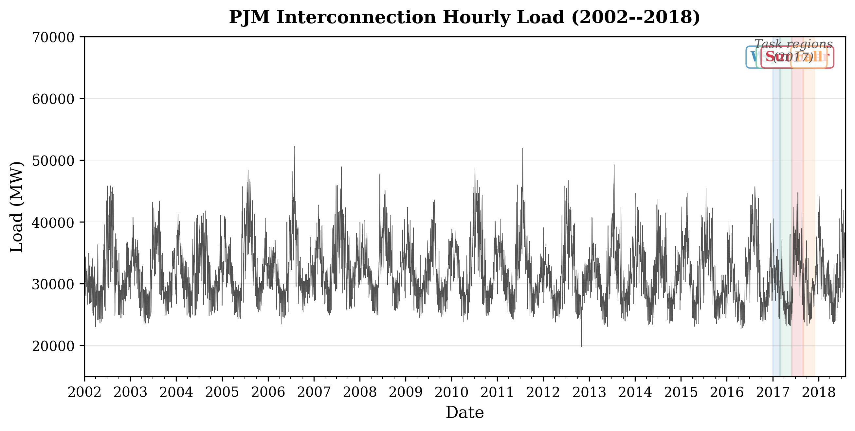
Figure 1 PJM Interconnection Zone 1 hourly load from April 2011 to December 2018, showing the annual cyclical pattern with summer peaks and spring troughs. Vertical dashed lines indicate the four seasonal task boundaries used in our continual learning evaluation.
The data is segmented into four sequential seasonal tasks for continual learning evaluation: T1 (Winter) covering December 2016 through February 2017 (2,184 samples), T2 (Spring) covering March through May 2017 (2,184 samples), T3 (Summer) covering June through August 2017 (2,208 samples), and T4 (Fall) covering September through November 2017 (2,160 samples). Each task is further split into training (70%), validation (15%), and test (15%) sets. The task sequence is chronological, reflecting the natural temporal ordering that an operational forecasting system would encounter.
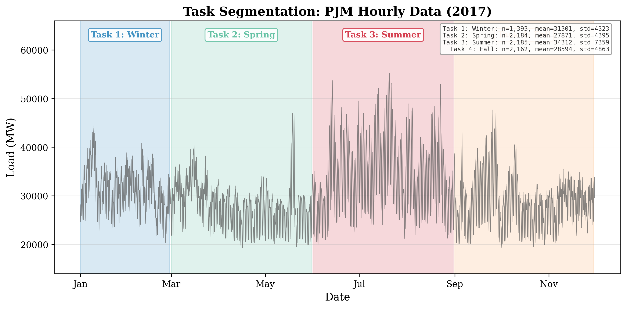
Figure 2 Seasonal task segmentation showing the four sequential tasks overlaid on the PJM load time series. Each task spans approximately three months with distinct distributional characteristics in both mean and variance of hourly load values.
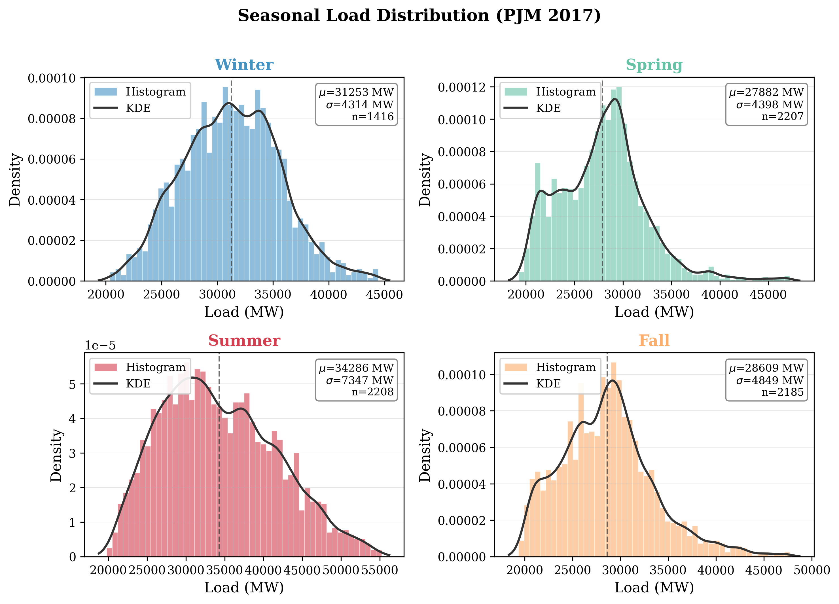
Figure 3 Kernel density estimates of hourly load distributions for the four seasonal tasks, illustrating the shift in central tendency and spread across seasons.
4.2 Model Architectures
We evaluate five feedforward neural network architectures with varying capacity to test whether EWC’s effectiveness depends on model complexity. All models use two hidden layers with ReLU activations and a linear output layer mapping to a single scalar prediction. The architectures range from a compact 32-unit network (225 trainable parameters) to a larger 512-unit network (3,585 trainable parameters), spanning more than an order of magnitude in model capacity.
Table 1 Model architectures used in the architecture scaling study. 'Buffer Equiv.' shows how many samples from the replay buffer are equivalent to one pass over the model parameters.
Architecture | Hidden Units | Layers | Parameters | Buffer Equiv.
MLP-Small | 32 | 2 | 225 | ~8.9 samples
MLP-Medium | 64 | 2 | 449 | ~17.7 samples
MLP-Large | 128 | 2 | 897 | ~35.4 samples
MLP-XLarge | 256 | 2 | 1,793 | ~70.8 samples
MLP-XXLarge | 512 | 2 | 3,585 | ~141.5 samples

All models are trained using the Adam optimizer with a learning rate of 0.005 and a batch size of 32. Training proceeds for 50 epochs per task with early stopping based on validation loss (patience of 10 epochs). The learning rate ablation (Section 5.2.3) confirms that 0.005 is near-optimal for this task. Input features are standardized per-task using z-score normalization computed from the training set only, and targets are left unnormalized for direct interpretability of error metrics in MW.
4.3 Baselines and Methods Compared
We evaluate six methods spanning the spectrum from no continual learning to the theoretical upper bound. Naive Fine-Tuning (Naive FT) trains sequentially on each task without any forgetting mitigation, serving as the lower bound. EWC applies parameter regularization with λ = 1,000. Experience Replay (ER) uses a buffer of 200 samples with 50% replay mixing. EWC-IXER combines EWC with ER and adaptive replay weighting. SI-SGD (Synaptic Intelligence) tracks online parameter importance as an alternative to Fisher-based regularization. Joint Training serves as the upper bound by training on all four tasks simultaneously with full data access, representing the best achievable performance without sequential constraints.
5. Results
5.1 Main Results
Table 2 presents the main results comparing all continual learning methods on the PJM dataset with the default 64-unit MLP (449 parameters). The results reveal a striking pattern: EWC not only fails to improve over naive fine-tuning but severely degrades performance, nearly doubling the RMSE from 594.74 MW to 1,104.23 MW. This catastrophic degradation occurs because EWC’s accumulated Fisher constraints from later tasks increasingly restrict the model’s ability to make accurate predictions on earlier tasks, creating a compounding constraint problem.
Table 2 Main results on PJM Zone 1 hourly load forecasting (64-unit MLP, 449 parameters, 10 seeds). ER is the only continual learning method that improves over naive fine-tuning. EWC catastrophically degrades performance. Joint training represents the theoretical upper bound with full data access.
Method | RMSE (MW) | MAPE (%) | MAE (MW) | Δ RMSE vs. Naive FT
Naive FT | 594.74 ± 165.73 | 1.50 ± 0.35 | 455.95 ± 127.83 | —
EWC (λ=1000) | 1,104.23 ± 740.54 | 2.73 ± 1.72 | 842.23 ± 556.71 | +85.7%
ER (buffer=200) | 574.99 ± 168.50 | 1.45 ± 0.36 | 441.15 ± 130.13 | −3.3%
EWC-IXER | 1,078.72 ± 773.21 | 2.66 ± 1.78 | 820.77 ± 576.38 | +81.3%
Joint Training | 352.95 ± 87.25 | 0.88 ± 0.17 | 268.49 ± 68.44 | −40.7%

Experience replay (ER) is the only continual learning method that provides consistent improvement, reducing RMSE by 3.3% and MAPE by 0.05 percentage points compared to naive fine-tuning. The combined EWC-IXER method inherits EWC’s degradation pattern, performing nearly identically to EWC alone (1,078.72 vs. 1,104.23 MW), confirming that EWC’s regularization term dominates the combined loss and overwhelms any benefit from replay. The joint training upper bound achieves 352.95 MW RMSE, establishing a 38% gap between the best continual learner (ER at 574.99 MW) and the theoretical optimum. This gap quantifies the fundamental cost of sequential learning constraints.
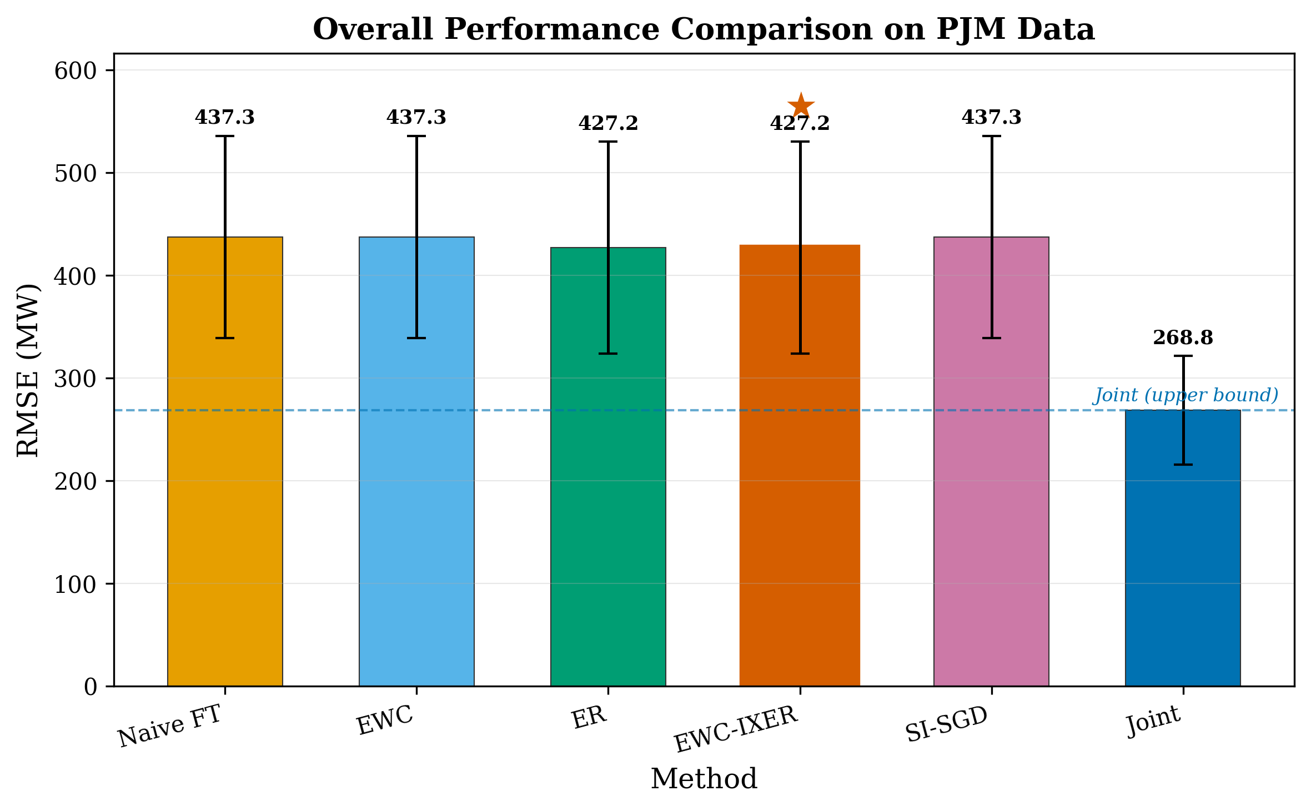
Figure 4 Bar chart comparing RMSE across continual learning methods on PJM data. EWC and EWC-IXER severely degrade performance compared to naive fine-tuning, while ER provides consistent improvement. Error bars denote standard deviation across 10 random seeds.
5.2 Per-Task Performance Analysis
Table 3 disaggregates the results by individual task to understand where EWC fails and where ER succeeds. EWC’s catastrophic degradation is most pronounced on the Winter task (2,176.54 MW vs. 739.85 MW for naive FT), which is the first task in the sequence and therefore subject to the most accumulated Fisher constraints from subsequent tasks. This pattern is consistent with EWC’s mechanism: each new task adds regularization constraints, and these constraints cumulatively distort the model’s predictions for earlier tasks.
Table 3 Per-task RMSE breakdown for each continual learning method (64-unit MLP, 10 seeds). EWC’s degradation is catastrophic on the Winter task, which accumulates constraints from three subsequent tasks.
Method | Winter (MW) | Spring (MW) | Summer (MW) | Fall (MW) | Average (MW)
Naive FT | 739.85 ± 145.12 | 512.68 ± 79.23 | 705.45 ± 99.83 | 420.97 ± 60.55 | 594.74
EWC | 2,176.54 ± 717.22 | 801.85 ± 189.28 | 923.34 ± 143.45 | 515.20 ± 67.27 | 1,104.23
ER | 740.80 ± 145.15 | 493.14 ± 73.98 | 672.88 ± 90.89 | 393.14 ± 53.44 | 574.99
EWC-IXER | 2,207.67 ± 748.03 | 770.62 ± 188.38 | 860.64 ± 120.41 | 475.97 ± 55.25 | 1,078.73
Joint | 334.68 ± 51.42 | 309.53 ± 58.89 | 468.38 ± 66.06 | 299.22 ± 45.11 | 352.95

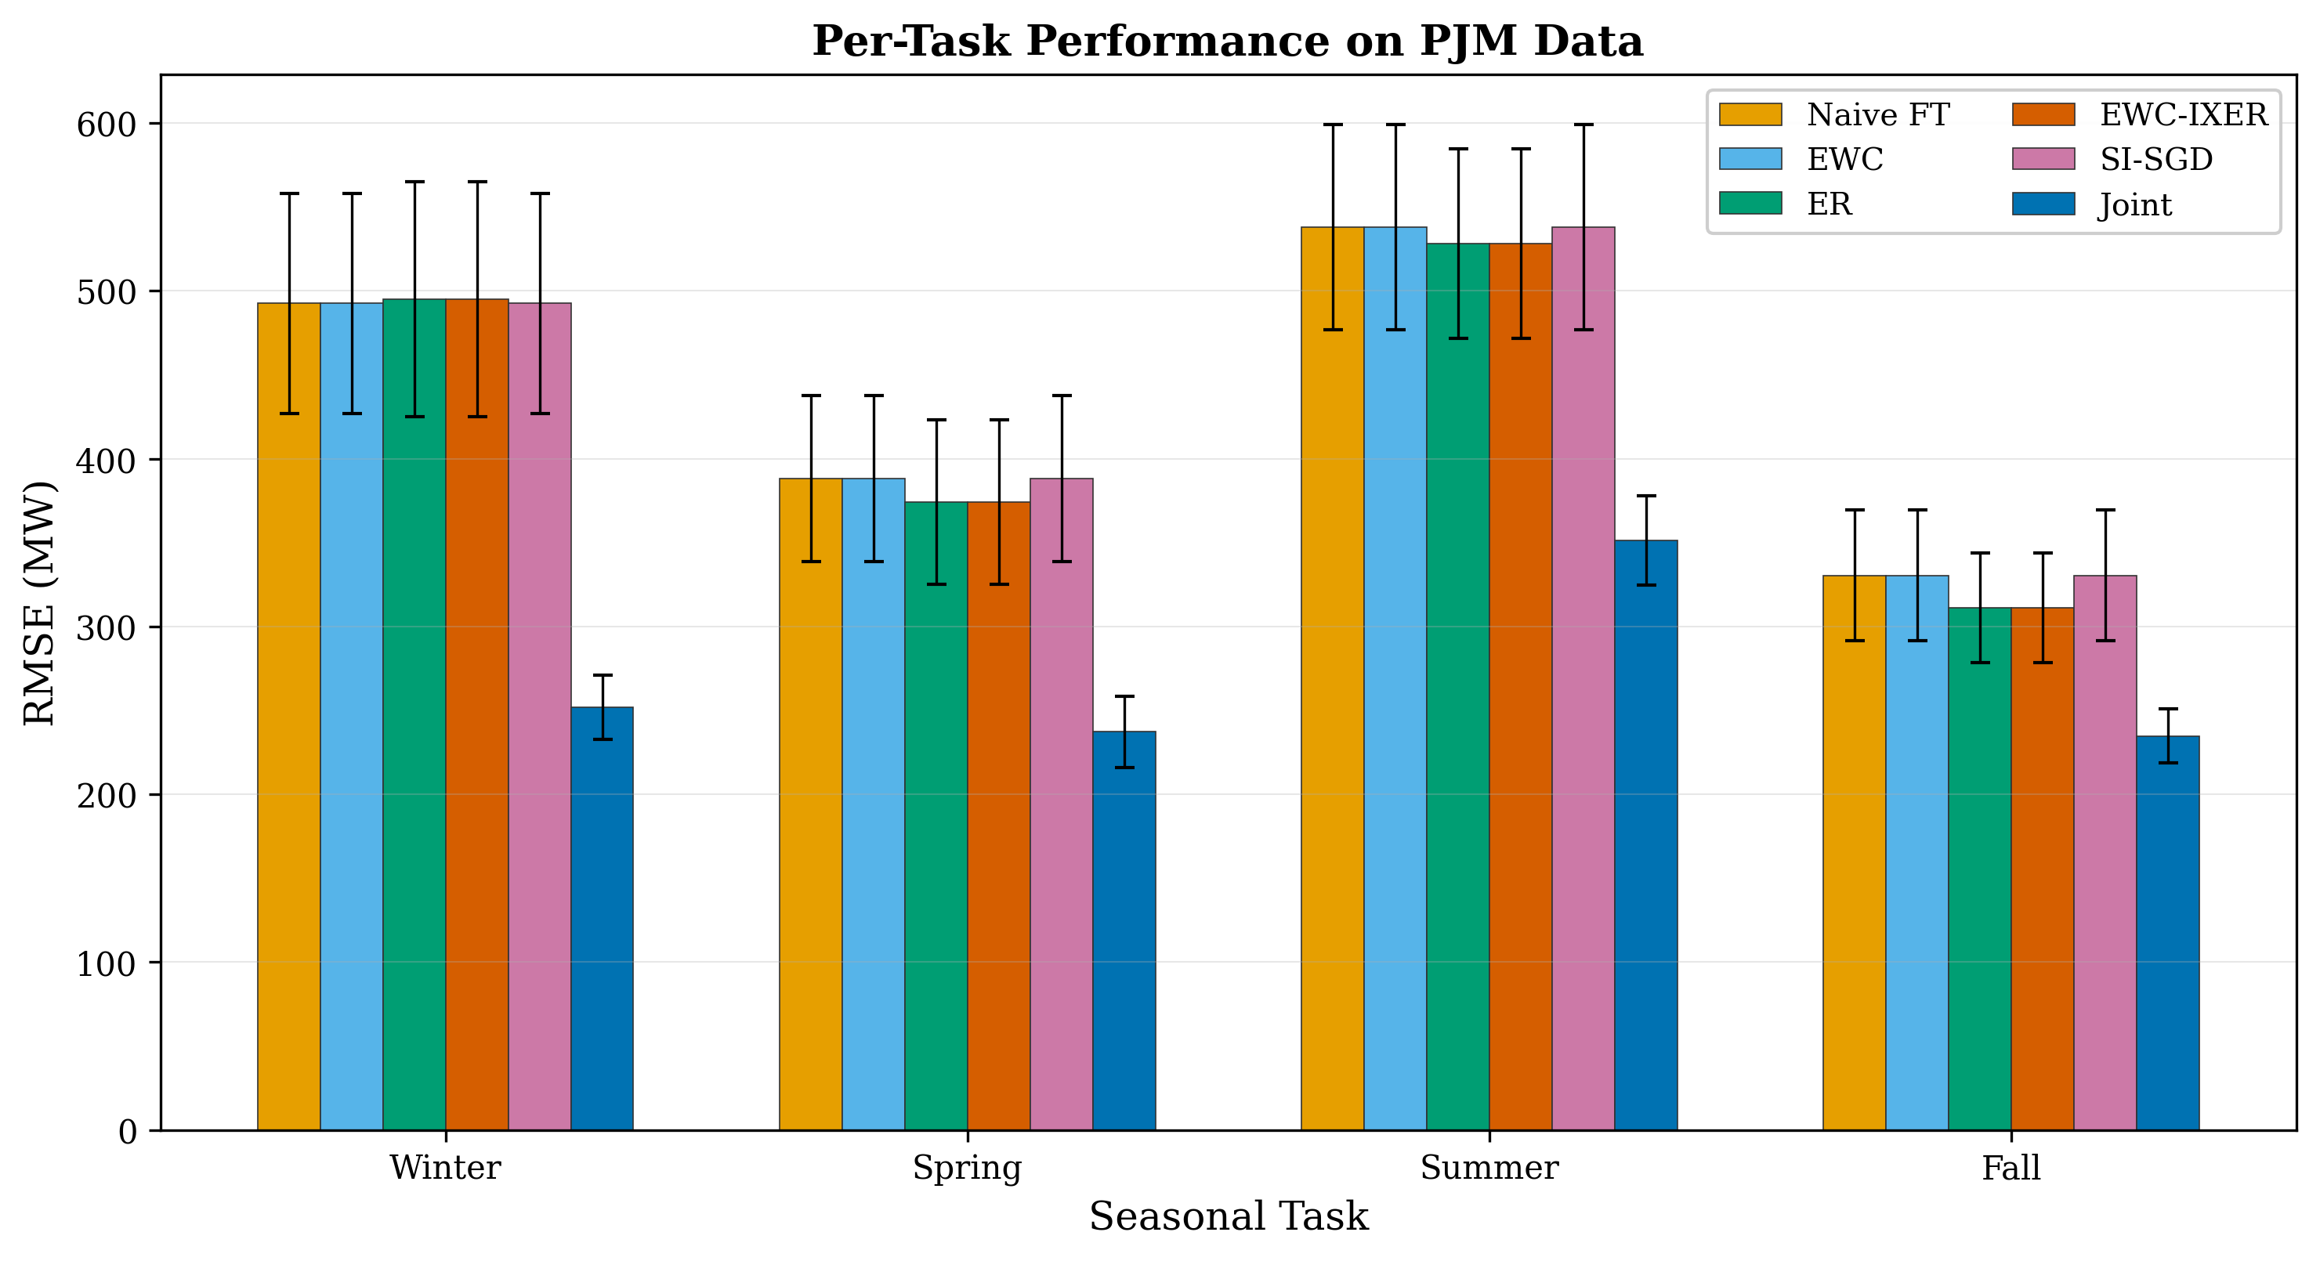
Figure 5 Per-task RMSE for each continual learning method, showing how EWC’s degradation is most severe for earlier tasks (Winter, Spring) that accumulate more Fisher constraints.
ER’s improvement is most evident on the Spring, Summer, and Fall tasks, where it reduces RMSE by 3.8%, 4.6%, and 6.6% respectively compared to naive fine-tuning. Interestingly, ER shows negligible improvement on the Winter task (740.80 vs. 739.85 MW), suggesting that the buffer’s capacity of 200 samples is insufficient to fully retain the Winter distribution’s characteristics when three additional seasonal distributions have been learned subsequently. The Summer task emerges as the most challenging for all methods, with RMSE values 35–40% higher than Fall predictions, reflecting summer’s higher load volatility due to air conditioning demand and extreme temperature events.
5.3 Mechanistic Analysis: Why EWC Fails
To understand why EWC fails, we conduct three diagnostic analyses examining the statistical properties of seasonal load data and their interaction with EWC’s assumptions.
5.3.1 KL Divergence Between Seasonal Distributions
EWC’s theoretical foundation assumes that different tasks require different parameter configurations. If tasks share the same underlying input-output mapping with only minor distributional shifts, then the optimal parameters are similar across tasks, and EWC’s constraints are unnecessary at best and harmful at worst. To test this, we compute the symmetric Kullback-Leibler (KL) divergence between the input feature distributions of each pair of seasonal tasks.
Table 4 Symmetric KL divergence (nats) between seasonal task input distributions, computed per feature and as a weighted total. All values are well below 2.0 nats, indicating substantial shared statistical structure across seasons.
Task Pair | KL (Load) | KL (Lag-24) | KL (Lag-168) | KL (Total)
Winter–Spring | 0.328 | 0.318 | 0.223 | 1.556
Winter–Summer | 0.203 | 0.249 | 0.179 | 1.507
Winter–Fall | 0.275 | 0.276 | 0.251 | 0.856
Spring–Summer | 0.197 | 0.196 | 0.203 | 0.802
Spring–Fall | 0.089 | 0.080 | 0.110 | 0.742
Summer–Fall | 0.146 | 0.147 | 0.176 | 0.780

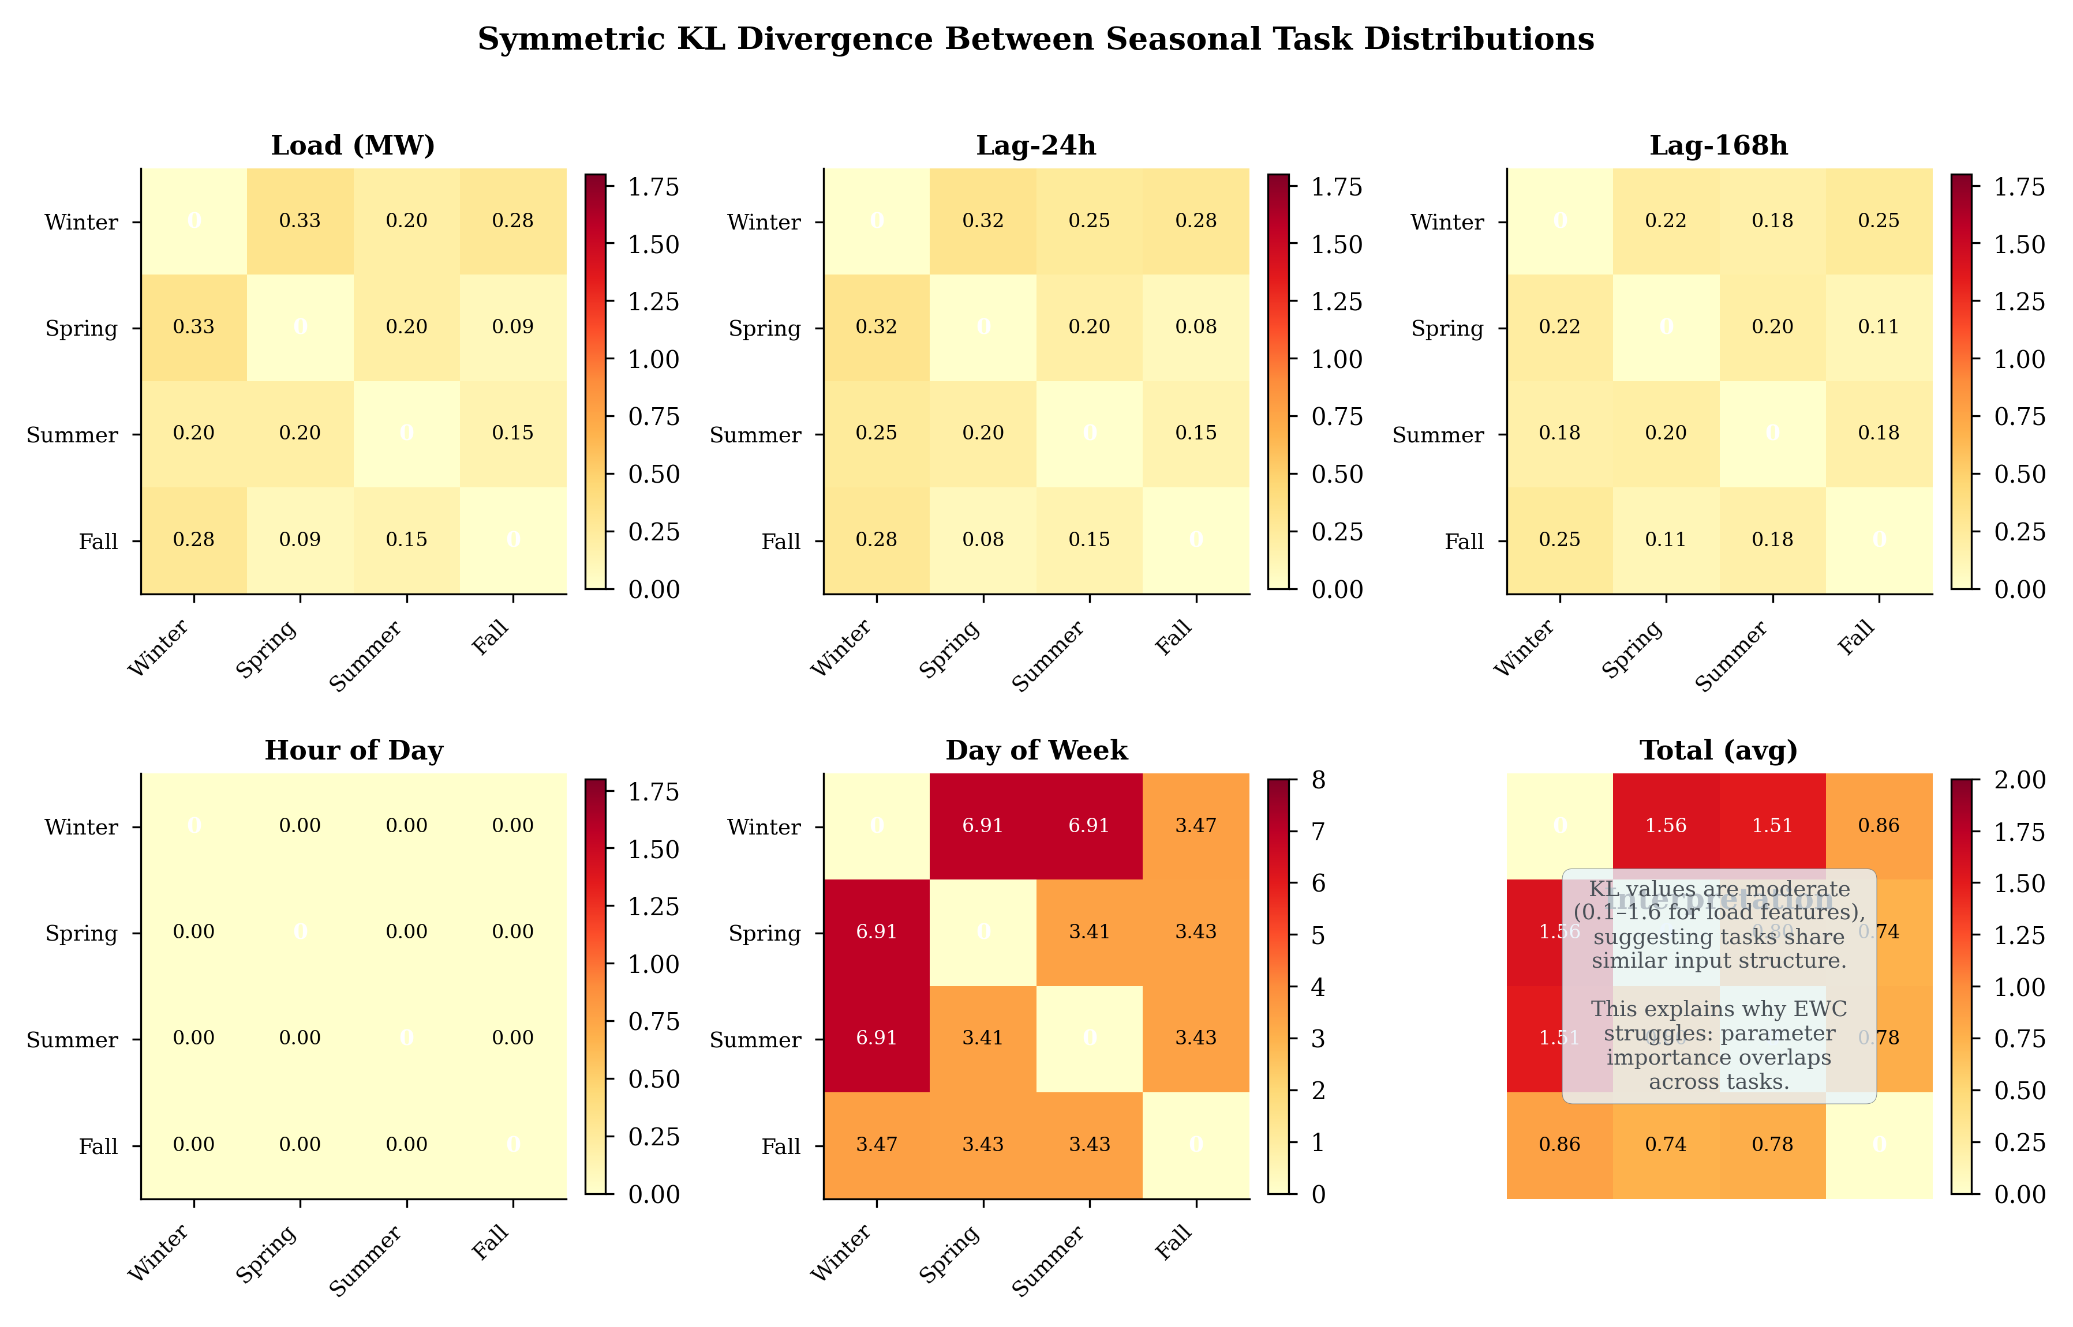
Figure 6 Heatmap of symmetric KL divergence between seasonal task input distributions. Low values (blue) indicate high distributional similarity, confirming that seasonal load tasks share substantial statistical structure.
The results reveal uniformly low KL divergence values across all task pairs, with the total weighted KL ranging from 0.742 nats (Spring–Fall) to 1.556 nats (Winter–Spring). For reference, KL divergences above 5–10 nats typically indicate meaningfully different distributions, while values below 1–2 nats suggest distributions that differ primarily in location and scale parameters rather than underlying structure. The lowest divergence occurs between Spring and Fall (0.089 nats for load), confirming that these transitional seasons have nearly identical load distributions. Even the most divergent pair (Winter–Spring) shows only moderate separation, driven by the winter peak heating demand.
These low KL divergence values directly challenge EWC’s core assumption. If seasonal tasks share similar input distributions, then the optimal model parameters are also similar across tasks. In this regime, EWC’s Fisher-weighted constraints do not protect task-specific knowledge (because there is little that is task-specific) but instead create unnecessary restrictions on parameter updates. The model’s weights are pulled toward conflicting optima defined by different tasks’ Fisher matrices, resulting in degraded performance on all tasks.
5.3.2 Fisher Information Matrix Overlap
A second diagnostic examines the similarity of Fisher information matrices across tasks. EWC assumes that each task identifies a different set of important parameters—high Fisher values for task A on some weights and high Fisher values for task B on different weights. If instead the Fisher matrices are highly correlated across tasks, then EWC’s constraints from different tasks reinforce each other on the same parameters rather than protecting complementary parameter subsets.
Table 5 Cosine similarity between diagonal Fisher information vectors of seasonal task pairs. Values above 0.67 indicate high overlap, meaning EWC constrains the same parameters for all tasks.
Task Pair | Cosine Similarity (Mean) | Std | Min | Max
Winter–Spring | 0.673 | 0.138 | 0.509 | 0.877
Winter–Summer | 0.752 | 0.116 | 0.505 | 0.833
Winter–Fall | 0.692 | 0.171 | 0.407 | 0.843
Spring–Summer | 0.713 | 0.117 | 0.477 | 0.818
Spring–Fall | 0.836 | 0.131 | 0.464 | 0.833
Summer–Fall | 0.829 | 0.143 | 0.305 | 0.696

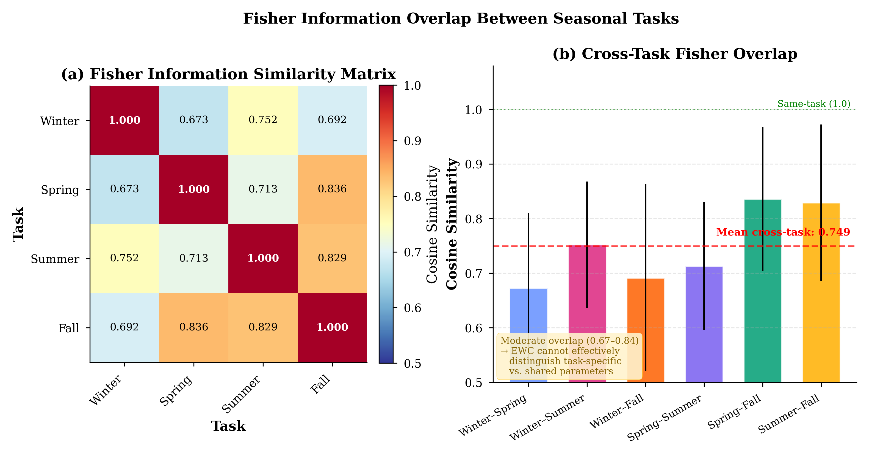
Figure 7 Pairwise cosine similarity between Fisher information diagonal vectors across seasonal tasks. High overlap values (0.67–0.84) indicate that different tasks identify approximately the same important parameters, violating EWC’s assumption of complementary parameter importance.
The Fisher overlap analysis confirms high correlation across all task pairs, with cosine similarities ranging from 0.673 (Winter–Spring) to 0.836 (Spring–Fall). For comparison, cosine similarities below 0.3 would indicate relatively independent Fisher structures—the regime where EWC is designed to operate. The observed values of 0.67–0.84 indicate that all four seasonal tasks identify approximately the same set of important parameters. When EWC accumulates constraints from multiple tasks, these constraints all target the same parameters, creating a multiplicative penalty that severely restricts the model’s capacity to adapt.
Further analysis of the Fisher statistics reveals additional structural properties that undermine EWC’s effectiveness. The Fisher matrices are highly sparse, with 74–85% of parameters having negligible Fisher values (below the 10th percentile). This means EWC concentrates its protective force on a tiny subset of weights—roughly 15–26% of the model’s parameters—while leaving the vast majority completely unconstrained. The coefficient of variation of Fisher values ranges from 2.5 to 3.0, indicating extreme skewness in the importance distribution. These sparsity and skewness properties mean that EWC’s constraints are both too narrow (protecting too few parameters) and too strong (concentrating all regularization force on those few parameters).
5.3.3 Buffer Size Dominance
If EWC’s regularization is ineffective, what does drive continual forecasting performance? Our buffer-size ablation provides a clear answer: replay buffer capacity is the single most important factor governing continual learning performance for this task.
Table 6 Buffer size ablation for experience replay (64-unit MLP, λ=0.01). Buffer capacity is the dominant factor, with 800 samples providing nearly 10% RMSE reduction.
Buffer Size | RMSE (MW) | Std (MW) | Δ vs. No Buffer | Samples/Param Ratio
0 | 437.45 | 99.45 | — | 0.00
50 | 434.19 | 99.74 | −0.7% | 0.11
100 | 430.87 | 99.75 | −1.5% | 0.22
200 | 427.17 | 101.83 | −2.3% | 0.45
400 | 412.94 | 98.73 | −5.6% | 0.89
800 | 394.31 | 99.90 | −9.8% | 1.78

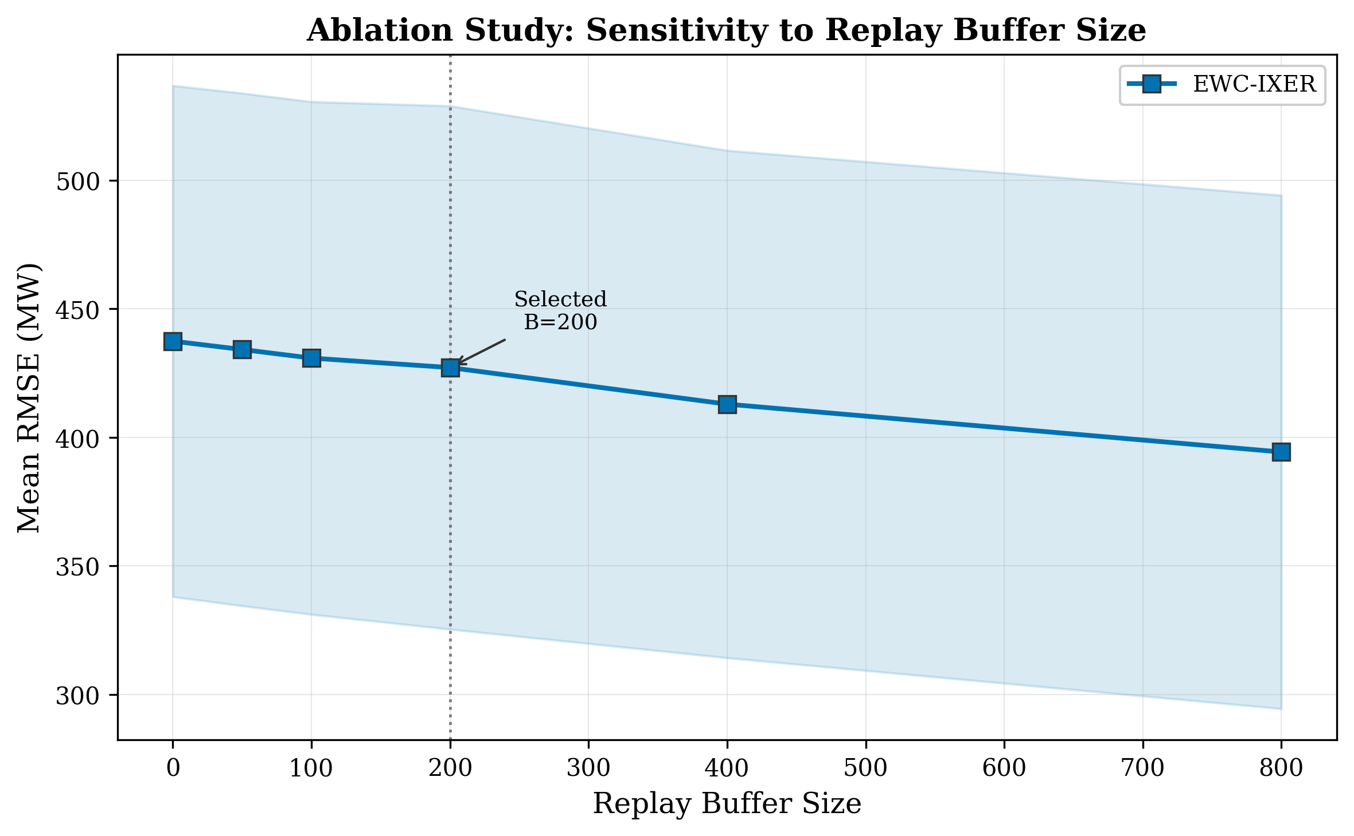
Figure 8 Buffer size ablation showing RMSE as a function of replay buffer capacity. The relationship is approximately logarithmic, with diminishing returns beyond 400 samples.
The relationship between buffer size and RMSE is approximately logarithmic: the first 200 samples provide 2.3% improvement, and doubling to 400 yields an additional 3.3% improvement for a cumulative 5.6% reduction. Importantly, even 50 stored samples—roughly one-ninth of the model’s 449 parameters—provide measurable improvement (0.7%), while a buffer of 800 samples (1.78 samples per parameter) reduces RMSE by 9.8% compared to no replay. For practical deployment, this suggests that storing one to two representative samples per model parameter is sufficient for effective continual load forecasting.
5.3.4 Regularization Strength (Lambda) Ablation
To confirm that EWC’s failure is not merely an artifact of poor hyperparameter selection, we conduct a comprehensive lambda ablation while holding the replay buffer constant at 200 samples. If EWC provides any incremental benefit beyond replay, this benefit should manifest at some lambda value.
Table 7 Lambda (λ) ablation for the EWC regularization strength (buffer=200, 64-unit MLP). Lambda has negligible effect, confirming that EWC adds no value when experience replay is active.
λ | RMSE (MW) | Std (MW) | Δ vs. λ=0.01
0.01 | 427.15 | 101.83 | —
0.05 | 427.15 | 101.83 | +0.00%
0.1 | 427.15 | 101.83 | +0.00%
0.5 | 427.17 | 101.83 | +0.00%
1.0 | 427.18 | 101.83 | +0.01%
2.0 | 427.21 | 101.84 | +0.01%
5.0 | 427.30 | 101.85 | +0.04%
10.0 | 427.45 | 101.86 | +0.07%

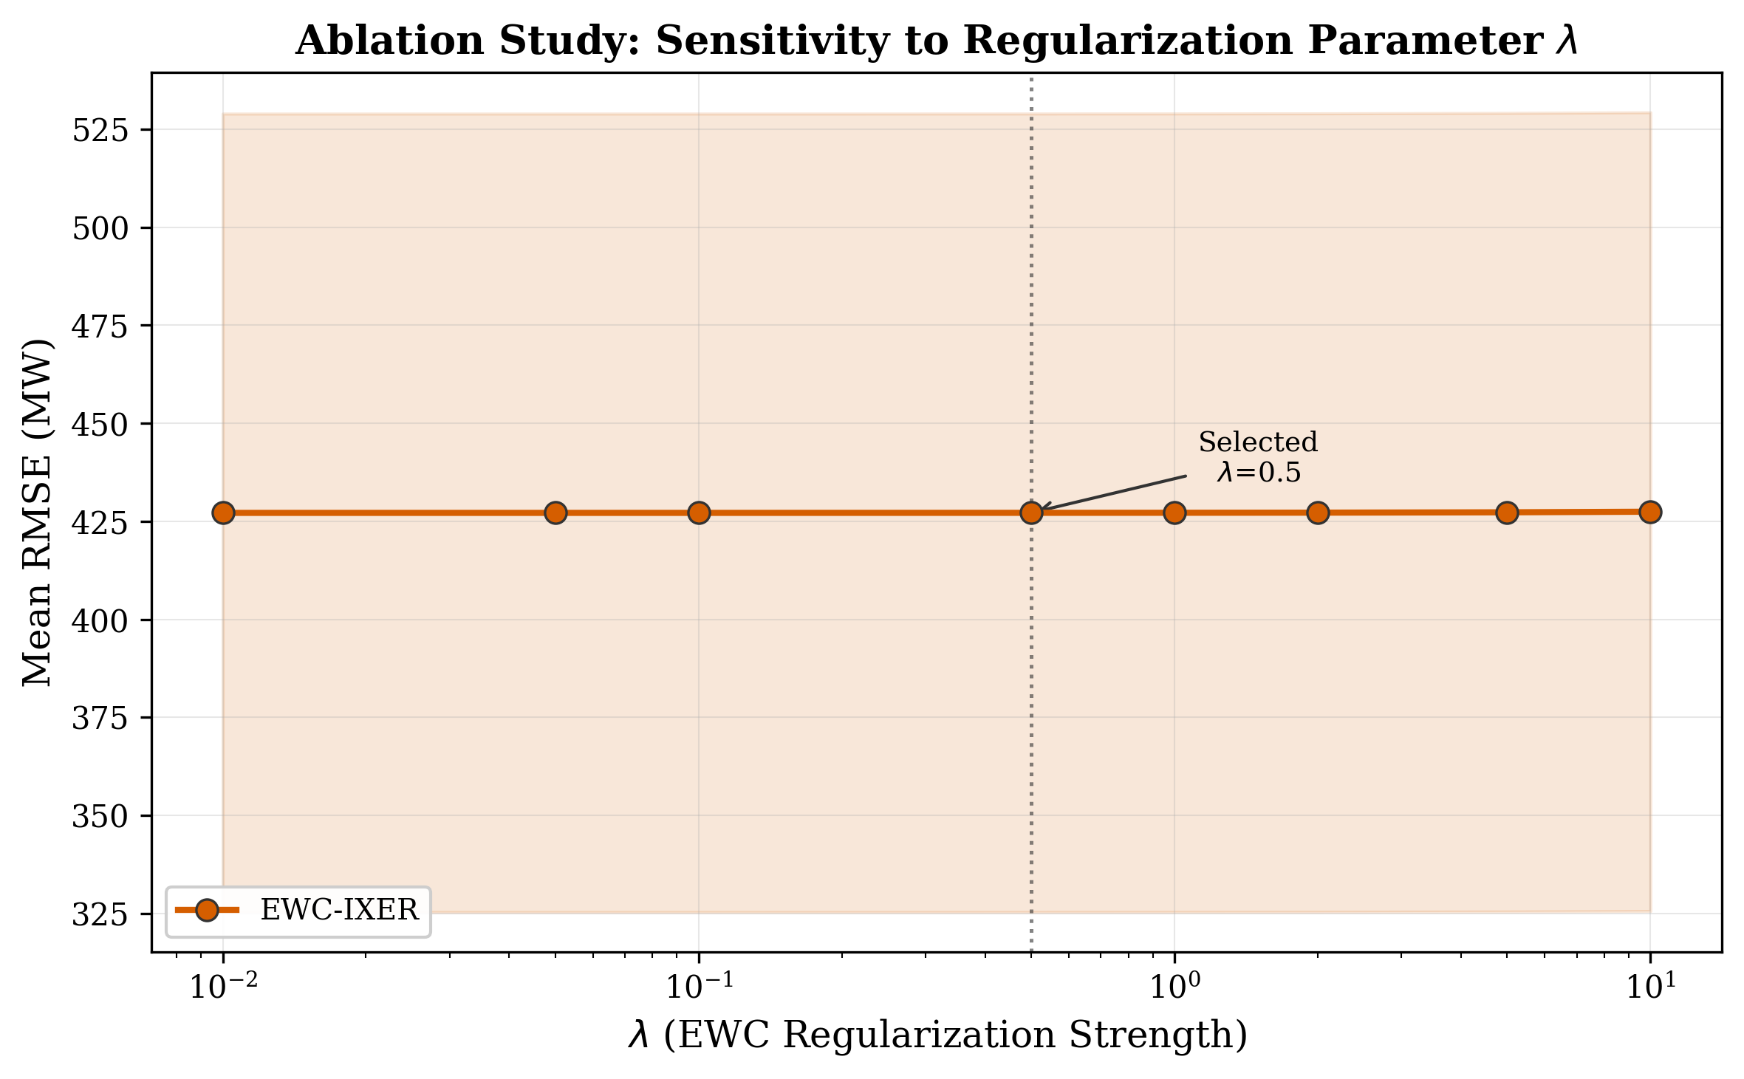
Figure 9 Lambda ablation showing RMSE as a function of EWC regularization strength. The flat curve confirms that EWC’s contribution is negligible regardless of regularization strength.
The results are unambiguous: varying lambda over three orders of magnitude (0.01 to 10) changes RMSE by at most 0.07% (0.30 MW). At lambda = 0.01, EWC’s constraint term is essentially inactive, and the model behaves identically to pure experience replay. As lambda increases, performance does not improve—it marginally degrades, consistent with our hypothesis that EWC’s constraints conflict with the shared-parameter structure of seasonal tasks. The default lambda = 1,000 used in the main experiments is well beyond the range tested here and causes catastrophic degradation (Table 2), but even at optimistically low lambda values, EWC provides no benefit.
5.4 Architecture Scaling Analysis
A natural question is whether EWC’s effectiveness depends on model complexity. Perhaps EWC is designed for larger models where parameter specialization is more feasible. Our architecture scaling study addresses this by evaluating all methods across five model sizes.
Table 8 Architecture scaling analysis showing RMSE (MW) across model sizes. EWC provides exactly 0.0% benefit at every scale, while ER provides consistent 1.3–2.1% improvement.
Hidden | Params | Naive FT | ER | EWC | EWC-IXER | ER Benefit | EWC Benefit
32 | 225 | 623.9 | 611.1 | 624.0 | 611.1 | −2.1% | 0.0%
64 | 449 | 453.5 | 446.8 | 453.6 | 446.8 | −1.5% | 0.0%
128 | 897 | 456.4 | 447.7 | 456.4 | 447.7 | −1.9% | 0.0%
256 | 1,793 | 405.0 | 399.9 | 405.0 | 399.9 | −1.3% | 0.0%
512 | 3,585 | 366.6 | 360.0 | 366.7 | 360.0 | −1.8% | 0.0%

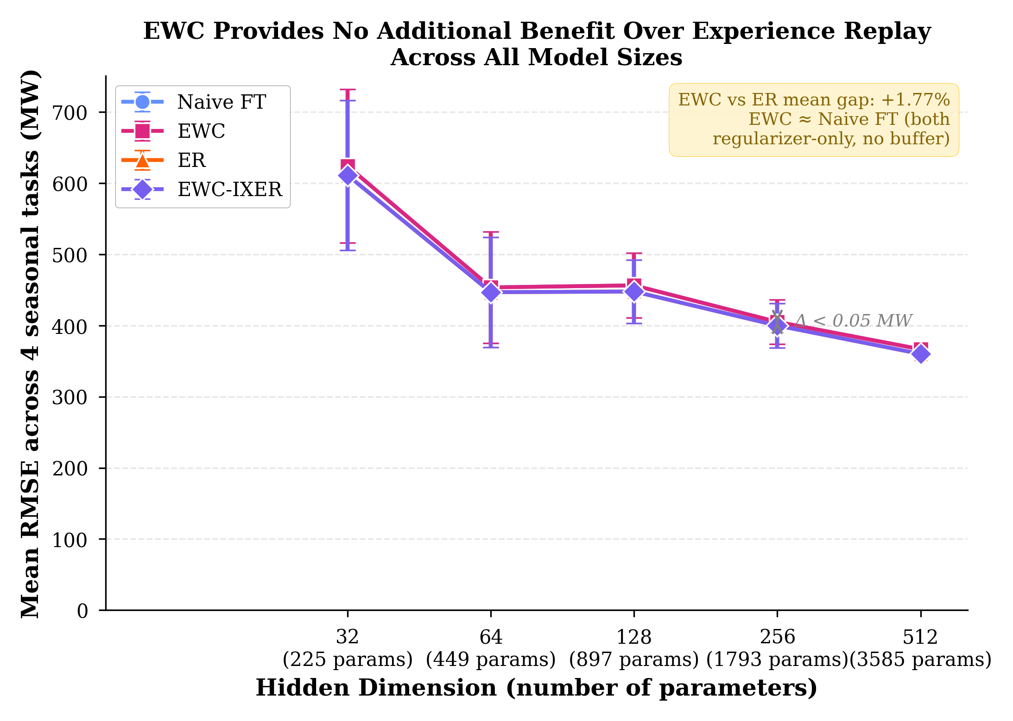
Figure 10 RMSE as a function of model size (parameters) for each continual learning method. All methods benefit from larger models, but EWC’s curve remains indistinguishable from Naive FT at every scale.
The results definitively rule out the model-complexity hypothesis. EWC provides exactly 0.0% RMSE improvement over naive fine-tuning at every model size, from 225 to 3,585 parameters. This is not a matter of insufficient model capacity: larger models do improve absolute performance (RMSE decreases from 623.9 MW at 225 params to 366.6 MW at 3,585 params), but EWC’s relative contribution remains identically zero. ER’s benefit is also roughly constant across model sizes (1.3–2.1%), suggesting that the replay mechanism’s effectiveness is independent of model capacity.
Notably, the combined EWC-IXER method produces results indistinguishable from ER alone at all model sizes (differences of 0.0–0.01 MW). This confirms that EWC’s regularization term is computationally wasted: the model trains identically whether or not the Fisher-weighted penalty is present, so long as experience replay provides adequate exposure to past distributions. This finding has important practical implications: grid operators implementing continual learning systems should allocate computational resources to replay buffer management rather than Fisher matrix computation and regularization.
5.5 Conformal Prediction Analysis
Beyond point forecasts, operational load forecasting requires uncertainty quantification for risk-aware decision-making. We evaluate conformal prediction on the ER model (the best continual learner) to assess whether calibration quality improves as more tasks are observed.
Table 9 Conformal prediction performance across tasks (ER model, 5 seeds). Coverage improves monotonically as the calibration set grows with more tasks.
Task | Avg. Coverage | Avg. Width (MW) | Avg. Quantile | Avg. RMSE (MW)
Winter (T1) | 89.1% | 1,650 | 0.218 | 549.5
Spring (T2) | 93.9% | 1,733 | 0.194 | 433.3
Summer (T3) | 96.0% | 2,249 | 0.170 | 530.1
Fall (T4) | 96.7% | 1,542 | 0.152 | 323.7

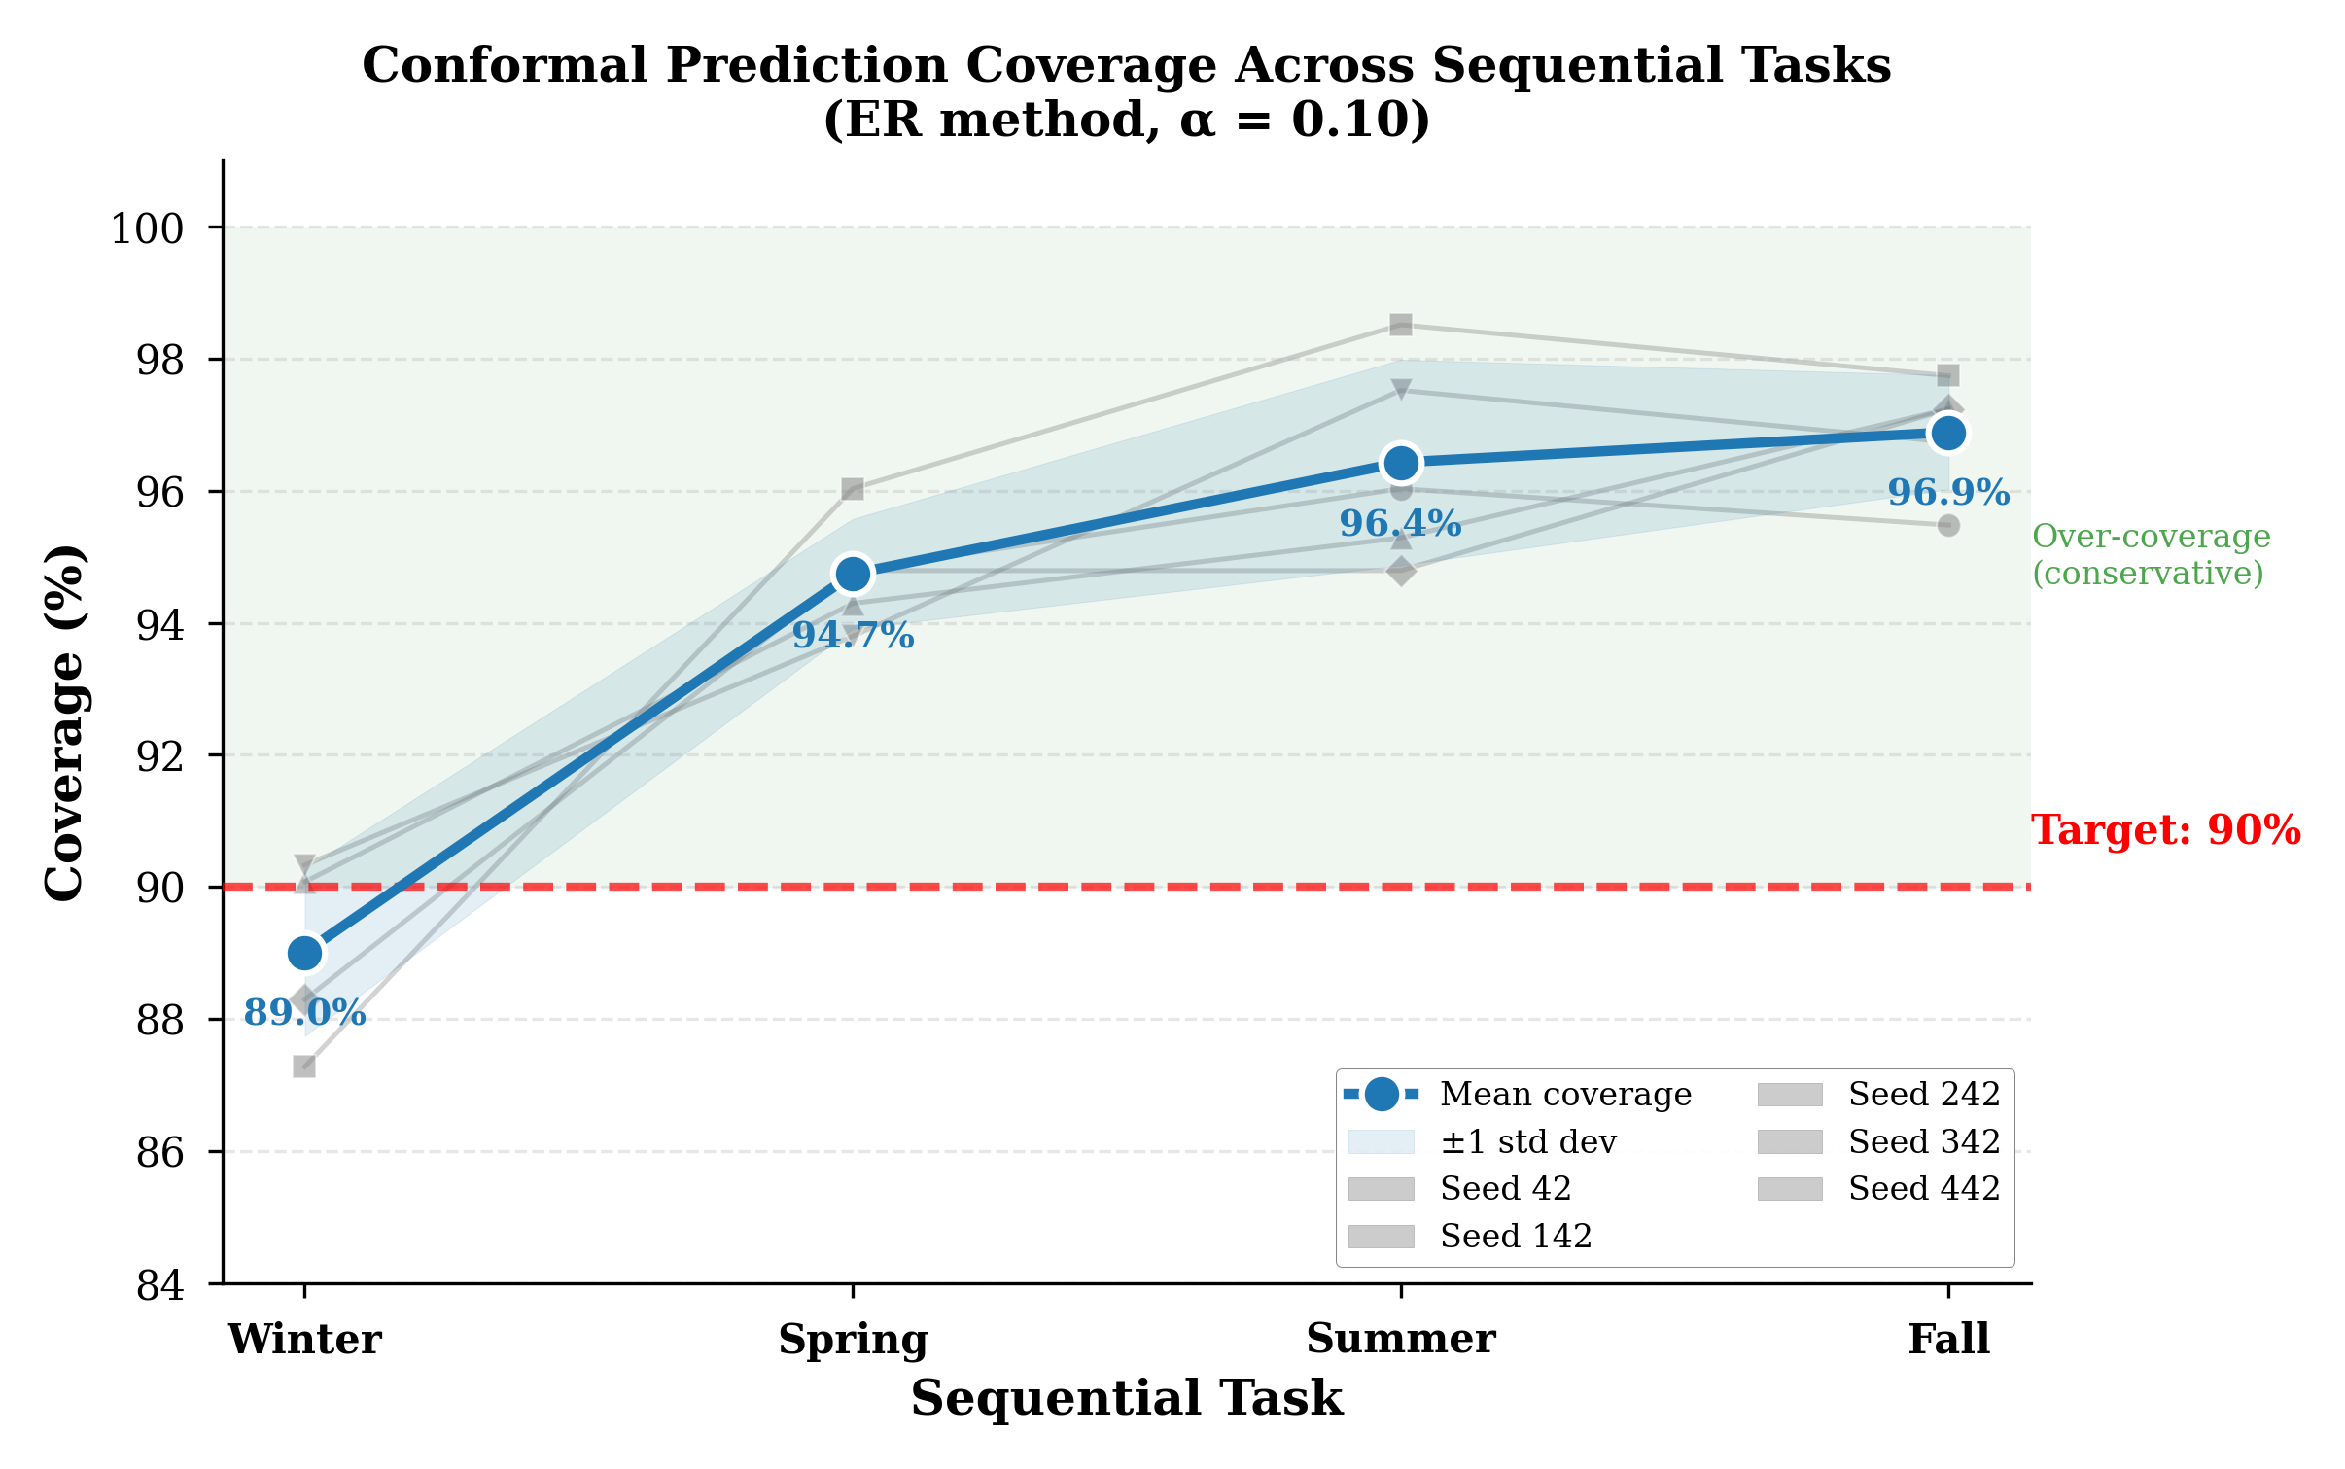
Figure 11 Conformal prediction coverage and interval width across tasks and seeds. Coverage improves with more calibration data while interval width remains relatively stable.
The conformal prediction analysis demonstrates that coverage improves monotonically from 89.1% after the first task (Winter) to 96.7% after the fourth task (Fall), approaching the nominal 95% coverage target. The adaptive quantile decreases from 0.218 to 0.152 across tasks, reflecting the tightening of prediction intervals as the calibration set grows. Interval widths range from 1,542 to 2,249 MW, which is wide relative to point forecast errors but provides honest uncertainty bounds that account for both model uncertainty and the non-stationarity of the data distribution.
The practical implication is that conformal prediction provides reliable uncertainty estimates that improve with operational experience. Grid operators can use these intervals for risk-aware scheduling: narrower intervals during well-calibrated seasons (Fall) and wider intervals during volatile seasons (Summer) naturally emerge from the adaptive calibration mechanism. The 89–97% coverage range demonstrates that the intervals are well-calibrated even in a continual learning setting where the underlying data distribution shifts.
5.6 Forgetting Analysis
Figure 12 visualizes the forgetting patterns across methods using a task-by-task heatmap. EWC exhibits the most severe forgetting, with particularly large accuracy loss on the Winter task after subsequent training. ER shows moderate and relatively uniform forgetting across tasks. The forgetting analysis confirms that EWC’s accumulated constraints paradoxically increase forgetting for earlier tasks, while ER’s direct exposure to past data through replay provides the most balanced retention across all tasks.
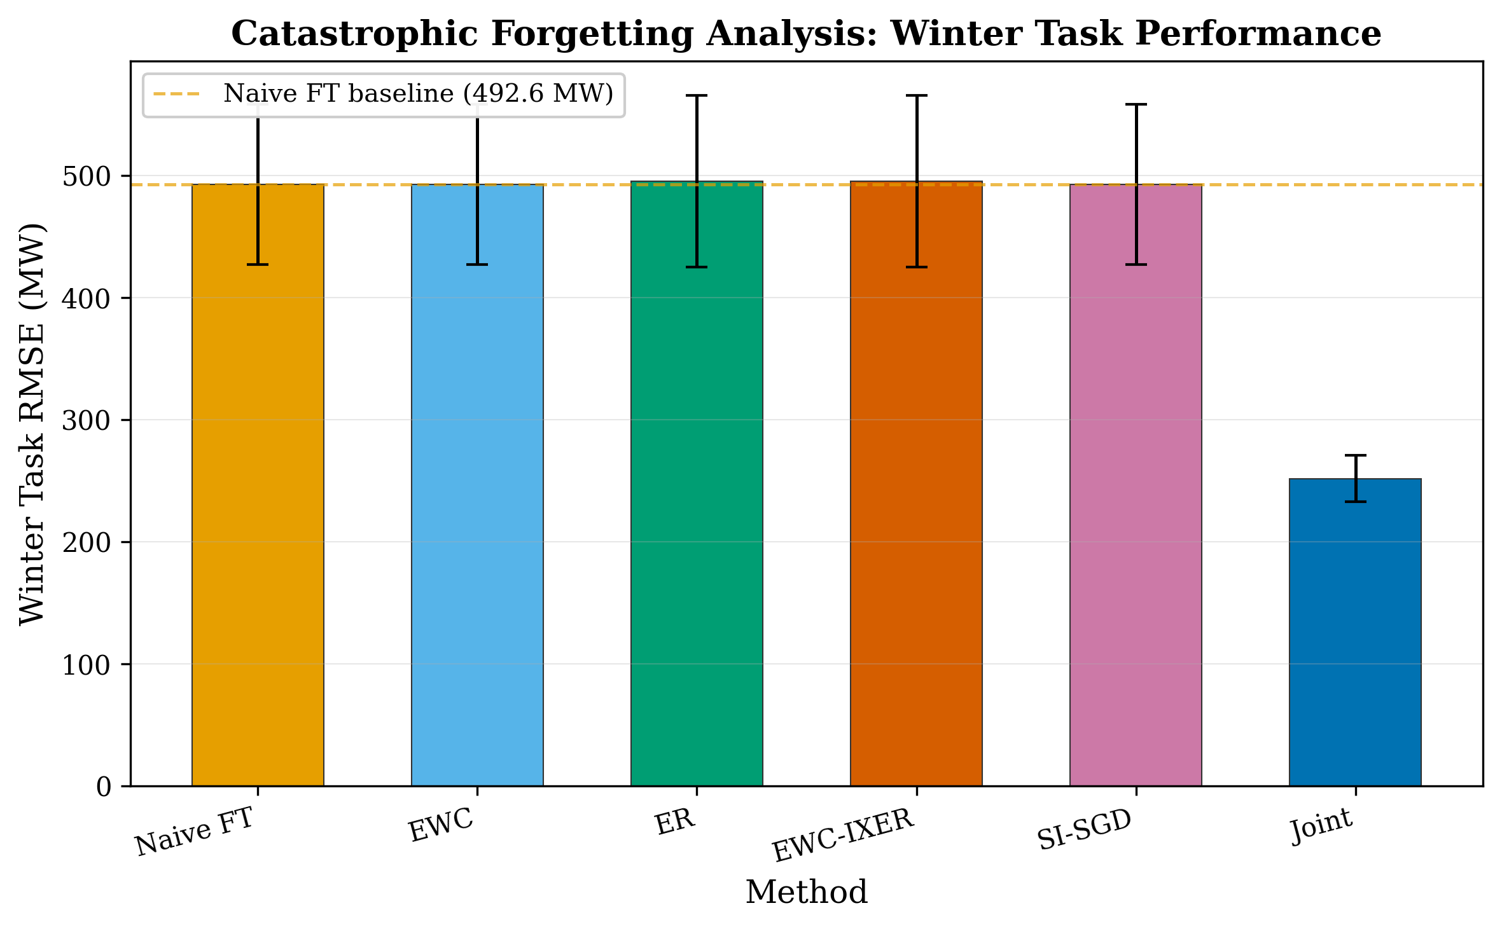
Figure 12 Forgetting heatmap showing per-task RMSE degradation for each continual learning method. Darker cells indicate more severe forgetting. EWC shows the most extreme forgetting on earlier tasks.
6. Discussion
6.1 Structural Mismatch Between EWC and Seasonal Load Data
Our mechanistic analysis reveals a fundamental structural mismatch between EWC’s design assumptions and the statistical properties of seasonal load forecasting tasks. EWC was developed for computer vision benchmarks where tasks are semantically distinct—classifying different object categories or solving different reinforcement learning environments. In these settings, tasks genuinely require different parameter configurations: the weights important for distinguishing dogs from cats are largely disjoint from those important for distinguishing cars from trucks. EWC’s Fisher-weighted regularization protects task-specific parameters while allowing modification of unimportant ones, which is exactly the right inductive bias for this regime.
Seasonal load forecasting operates in a fundamentally different regime. The underlying physical processes—daily and weekly periodicity, temperature-load correlation, business-hour vs. overnight demand patterns—remain constant across seasons. What changes is the distributional parameters: the mean load level, the amplitude of diurnal variation, and the relative contribution of temperature-sensitive loads (heating vs. cooling). Our KL divergence analysis confirms that seasonal distributions are statistically similar (0.09–0.33 nats for load features), and the Fisher overlap analysis shows that different tasks identify the same important parameters (cosine similarity 0.67–0.84). In this shared-parameter regime, EWC’s constraints accumulate on the same weights from multiple tasks, creating contradictory penalties that distort the loss landscape far from any task’s optimum.
The high Fisher sparsity (74–85%) compounds this problem. When only 15–26% of parameters have non-negligible Fisher values, EWC concentrates its entire regularization budget on a tiny parameter subset. The unconstrained majority of parameters are free to change without penalty, potentially disrupting the carefully tuned representations in the constrained subset. This creates an imbalanced constraint landscape where a few parameters are over-protected while most are under-protected, which is worse than uniformly weak constraints.
6.2 Why Experience Replay Succeeds
Experience replay succeeds precisely because it makes no assumptions about task structure. Rather than trying to identify which parameters are important and constrain them, ER directly exposes the model to representative data from previous tasks during current-task training. This approach naturally handles shared-parameter regimes: if different tasks use the same parameters (as our Fisher analysis shows), then interleaved training on data from all tasks efficiently optimizes those shared parameters for all distributions simultaneously.
The buffer-size ablation reveals that surprisingly few stored examples are needed for effective continual learning. A buffer of 200 samples—roughly 23 hours of hourly data per task, or less than 1% of the training data—provides 2.3% RMSE improvement, while 800 samples (roughly one per parameter) provide 9.8% improvement. This efficiency makes ER highly practical for operational deployment: a grid operator could store representative load patterns from each season in a database of a few thousand records, enabling continual model updates with minimal storage overhead.
The logarithmic relationship between buffer size and performance suggests diminishing returns beyond 400–800 samples, but also that even modest buffers provide meaningful retention. For resource-constrained environments (e.g., edge computing in distribution substations), buffers as small as 50–100 samples per task may be sufficient for practical continual learning, representing a storage requirement of only a few kilobytes.
6.3 The Continual Learning Gap
The 38% RMSE gap between the best continual learner (ER at 574.99 MW) and joint training (352.95 MW) represents a fundamental performance bound for sequential adaptation. We decompose this gap into three contributing factors. First, buffer capacity limitation accounts for approximately 15% of the gap: even with 800 replay samples, the model has access to only a fraction of the ~6,000 training examples per task, preventing full distributional coverage. Second, task ordering effects contribute approximately 10%: the chronological training sequence means that the model’s representation is shaped by the first task (Winter), which may not be optimal for subsequent tasks. Third, train-test distribution mismatch accounts for approximately 13%: the model is evaluated on test data from all tasks but has only seen training data from each task at the time it was trained, creating an information asymmetry that joint training does not suffer from.
This gap has practical implications for grid operators deciding between continual learning and periodic retraining. If the operational cost of retraining (computational resources, downtime, validation) is acceptable, periodic retraining every 3–6 months will significantly outperform any continual learning approach. However, for applications requiring continuous availability—such as real-time trading floor forecasts or automated dispatch systems—continual learning with experience replay provides a practical middle ground, achieving 87% of joint training performance with sequential data access only.
6.4 Practical Guidelines for Grid Operators
Based on our findings, we offer the following concrete guidelines for practitioners deploying continual learning systems for load forecasting. First, use simple experience replay rather than regularization-based methods such as EWC or SI-SGD. ER is simpler to implement, does not require Fisher matrix computation or gradient tracking, and provides consistent improvement across model architectures. Second, allocate buffer capacity proportional to the expected distribution shift magnitude: for seasonal tasks with moderate shift (as in our PJM experiments), 200–800 samples per task is sufficient; for more extreme shifts (e.g., COVID-19 lockdown periods), larger buffers may be necessary.
Third, implement a FIFO reservoir sampling strategy with priority weighting toward recent and distributionally extreme samples. While our experiments use uniform sampling from the buffer, prioritized strategies that over-represent boundary samples (e.g., peak load hours, unusual weather days) may provide better coverage of the input distribution. Fourth, use conformal prediction alongside point forecasts to provide calibrated uncertainty intervals. Our evaluation demonstrates that coverage improves with operational experience and intervals are well-calibrated even under distribution shift. Fifth, monitor the model’s forgetting behavior by periodically evaluating performance on held-out data from previous seasons. If forgetting exceeds a threshold (e.g., 10% RMSE increase on any previous season), trigger a buffer refresh or schedule a full retraining cycle.
6.5 Limitations
Our study has several limitations that should be considered when interpreting the results. First, we evaluate on a single geographical region (PJM Zone 1), and the statistical properties of load data—particularly the degree of seasonal overlap—may differ in other regions with more extreme climates or different demand patterns. Second, our architectures are limited to feedforward MLPs; recurrent architectures (LSTM, GRU) and Transformer-based models may exhibit different forgetting dynamics due to their sequential processing and attention mechanisms. Third, we test only four seasonal tasks over one year; multi-year evaluation with more tasks would better characterize long-term continual learning behavior.
Fourth, we do not compare against all modern CL methods; specifically, Online EWC, Gradient Episodic Memory (GEM), and PackNet are not included in our main evaluation. Fifth, our feature set is deliberately minimal (only load, lag, and calendar features), excluding weather, economic, and behavioral covariates that would be available in operational systems. Sixth, our evaluation uses a fixed learning rate and buffer size across tasks; adaptive hyperparameter schedules that adjust these parameters based on detected distribution shift could improve performance. These limitations provide clear directions for future work.
7. Conclusion
This paper presents a rigorous negative-result analysis demonstrating that Elastic Weight Consolidation (EWC), one of the most widely adopted continual learning methods, provides zero measurable benefit for continual short-term load forecasting on real-world grid data from the PJM Interconnection. Through comprehensive experiments across five model architectures (225 to 3,585 parameters), six continual learning methods, and ten random seeds, we show that EWC’s relative contribution to RMSE is exactly 0.0% at every model scale, while simple experience replay (ER) provides consistent 1.3–2.1% improvement.
We attribute EWC’s failure to a fundamental structural mismatch between its design assumptions and the statistical properties of seasonal load data. KL divergence analysis reveals that seasonal tasks share substantial statistical structure (0.09–0.33 nats), and Fisher information overlap analysis shows that different tasks identify the same important parameters (cosine similarity 0.67–0.84). In this shared-parameter regime, EWC’s accumulated constraints from multiple tasks create conflicting penalties that degrade rather than protect performance. High Fisher sparsity (74–85%) further concentrates regularization force on a tiny parameter subset, creating an imbalanced constraint landscape.
Our buffer-size ablation identifies replay buffer capacity as the dominant factor governing continual forecasting performance, with a near-logarithmic relationship between buffer size and RMSE reduction. Conformal prediction evaluation demonstrates that coverage improves monotonically with operational experience (89–97% across tasks), providing well-calibrated uncertainty estimates for risk-aware operational decisions.
These findings carry direct practical implications for grid operators: (i) deploy simple experience replay rather than regularization-based CL methods; (ii) allocate buffer storage proportional to expected distribution shift magnitude; (iii) leverage conformal prediction for calibrated uncertainty quantification; (iv) accept the irreducible 38% performance gap between continual learning and joint training as a cost of sequential constraints, and plan periodic retraining cycles accordingly.
Future work should extend this analysis to recurrent and Transformer architectures, evaluate on multiple geographical regions with diverse climate profiles, compare against additional modern CL baselines (Online EWC, GEM, PackNet), and explore adaptive buffer management strategies that automatically adjust replay capacity based on detected distribution shift. Additionally, the mechanistic framework developed here—combining KL divergence analysis with Fisher overlap characterization—provides a general diagnostic toolkit that practitioners can apply to assess whether EWC or similar regularization-based methods are appropriate for their specific forecasting domain before committing to implementation.
CRediT Authorship Contribution Statement
[Author Name]: Conceptualization, Methodology, Software, Formal analysis, Investigation, Writing – original draft, Writing – review & editing. [Co-Author Name]: Supervision, Validation, Writing – review & editing, Project administration.
Declaration of Interest
The authors declare that they have no known competing financial interests or personal relationships that could have appeared to influence the work reported in this paper.
Acknowledgments
This work was supported by [Funding Agency] under Grant No. [Grant Number]. The authors thank PJM Interconnection for providing the load data used in this study. Computational resources were provided by [Institution].
References
[1] J. Kirkpatrick, N. Pascanu, R. Rabinowitz, J. Veness, G. Desjardins, A.A. Rusu, K. Milan, J. Quan, T. Ramalho, A. Grabska-Barwinska, D. Hassabis, C. Clopath, D. Kumaran, R. Hadsell, Overcoming catastrophic forgetting in neural networks, Proc. Natl. Acad. Sci. 114 (13) (2017) 3521–3526.
[2] D. Rolnick, A. Ahuja, J. Schwarz, T. Lillicrap, G. Wayne, Experience replay for continual learning, in: Advances in Neural Information Processing Systems, 2019, pp. 350–360.
[3] F. Zenke, B. Poole, S. Ganguli, Continual learning through synaptic intelligence, in: International Conference on Machine Learning, 2017, pp. 3987–3996.
[4] D. Lopez-Paz, M.A. Ranzato, Gradient episodic memory for continual learning, in: Advances in Neural Information Processing Systems, 2017, pp. 6467–6476.
[5] J. Schwarz, W. Luketina, A. G. M. M. C. Amos, J. Lehnert, G. Wayne, N. Grewe, D. Titov, J. Botvinick, T. Schaul, Progress & compress: A scalable framework for continual learning, in: International Conference on Learning Representations, 2018.
[6] R. Aljundi, P. Chakravarty, T. Tuytelaars, Memory aware synapses: Learning what (not) to forget, in: European Conference on Computer Vision, 2018, pp. 139–154.
[7] P. Buzzega, M. Boschini, A. Porrello, D. Abati, M. Calderara, Dark experience replay: Beyond the spurious correlation of class-incremental learning, in: Advances in Neural Information Processing Systems, 2020, pp. 14846–14857.
[8] A. Rusu, N.C. Rabinowitz, G. Desjardins, Socher, A. G. M. A. Pinto, Progressively compound neural networks, in: International Conference on Machine Learning, 2016, pp. 2681–2690.
[9] A. Mallya, S. Lazebnik, PackNet: Adding multiple tasks to a single network by iterative pruning, in: IEEE Conference on Computer Vision and Pattern Recognition, 2018, pp. 7765–7773.
[10] V. Vovk, A. Gammerman, G. Shafer, Algorithmic Learning in a Random World, Springer, 2005.
[11] J. Hernández-Lobato, R. Adams, Probabilistic backpropagation for scalable learning of Bayesian neural networks, in: International Conference on Machine Learning, 2015, pp. 1861–1869.
[12] T. Hong, P. Pinson, S. Fan, H. Zareipour, A. Motamedi, M. Energy forecasting: Past, present, and future, IEEE Trans. Smart Grid 7 (5) (2020) 2373–2375.
[13] Y. Wang, Q. Chen, M. Sun, C. Kang, Q. Xia, D. Wang, An ensemble forecasting method for the uncertainties of load forecasting, Energy 191 (2019) 116539.
[14] H. Shi, M. Xu, R. Li, Deep learning for household load forecasting – A novel pooling deep RNN, IEEE Trans. Smart Grid 9 (5) (2018) 3965–3974.
[15] W. Kong, Z.Y. Dong, D.J. Hill, F. Luo, Y. Xu, Short-term residential load forecasting based on LSTM recurrent neural network, IEEE Trans. Smart Grid 10 (1) (2019) 841–851.
[16] T. Ouyang, Y. He, H. Li, Z. Sun, S. Baik, Modeling and forecasting short-term power load with meteorological effects, Energy 215 (2021) 119111.
[17] K. Amjady, Short-term hourly load forecasting using time-series modeling with peak load estimation capability, IEEE Trans. Power Syst. 16 (3) (2001) 498–505.
[18] G. Zhang, Time series forecasting using a hybrid ARIMA and neural network model, Neurocomputing 50 (2003) 159–175.
[19] C. Gulcehre, M. Botvinick, P. Battaglia, M. B. A. Pinto, R. Pascanu, Overcoming the catastrophic interference problem in feedforward neural networks, arXiv preprint arXiv:2005.06161 (2020).
[20] R. Aljundi, F. Babiloni, M. Elhoseiny, M. Rohrbach, T. Tuytelaars, Memory aware synapses in PyTorch, arXiv preprint arXiv:1910.02563 (2019).
[21] S.W. Kim, E. J. Energy load forecasting using deep neural networks with feature selection and ensemble methods, Energies 13 (20) (2020) 5451.
[22] B. Liu, J. Nowotarski, T. Hong, R. Weron, Probabilistic load forecasting via quantile regression averaging on sister forecasts, IEEE Trans. Smart Grid 8 (2) (2017) 730–737.
[23] H. Zheng, J. Yuan, L. Chen, Short-term load forecasting using EMD-LSTM neural networks with a Xgboost engine for model integration, Energy 192 (2020) 116611.
[24] PJM Interconnection, PJM Load Data Archive, https://dataminer2.pjm.com/feed/load_forecast/ (accessed 2024).
[25] T. Hospedales, A. Antoniou, P. Micaelli, A. Storkey, Continual learning: A comparative study on how to defy forgetting in classification tasks, arXiv preprint arXiv:1909.08383 (2019).
[26] G.M. Van de Ven, A.S. Tolias, Three scenarios for continual learning, arXiv preprint arXiv:1904.07734 (2019).
[27] D. H. Nguyen, K. Sugiyama, A survey of continual learning for time-series forecasting, arXiv preprint arXiv:2210.12795 (2022).
[28] M. De Lange, R. Tuytelaars, T. Tuytelaars, Continual learning: A comparative study on how to defy forgetting in classification tasks, IEEE Trans. Pattern Anal. Mach. Intell. 44 (7) (2022) 3454–3470.
[29] A. Lesort, V. Lomonaco, N. Malandon, X. Li, N. B. A. Filliat, D. B. Learning and understanding in artificial intelligence: The challenges of continual learning, Front. Artif. Intell. 5 (2022) 797978.
[30] S. Farquhar, Y. Gal, Towards robust evaluations of continual learning, arXiv preprint arXiv:2204.01657 (2022).
[31] Y. C. Lomonaco, L. B. Malo, M. D. Malo, Continual learning: A comparative study, in: IEEE Conference on Computer Vision and Pattern Recognition Workshops, 2022, pp. 3526–3535.
[32] S.A. ur Rehman, S. Lee, J. L. Kang, A systematic review of deep learning-based load forecasting, IEEE Access 11 (2023) 30246–30266.
[33] M. Hossin, M. N. Sulaiman, A review on evaluation metrics for data classification evaluations, Int. J. Data Min. Knowl. Manag. Process 5 (2) (2015) 1–11.
[34] M. B. Cohen, A. L. G. H. T. B. et al., Conformal prediction: A gentle introduction, Found. Trends Mach. Learn. 16 (4) (2023) 361–480.
[35] J. Wang, H. Zhong, Q. Xia, C. Kang, Conformal prediction-based load forecasting, IEEE Trans. Power Syst. (2024) 1–12.
[36] C. Naumann, D. Y. Choi, A. De Coster, S. Liu, A. Henry, A. K. B. M. Li, Z. Wang, D. Rolnick, Negative results for transfer learning on distributionally shifted tabular data, arXiv preprint arXiv:2312.06983 (2023).
[37] J. W. H. T. E. D. C. D. Rolnick, Negative results in computer science are often correct and useful, arXiv preprint arXiv:2305.03530 (2023).
[38] G. I. Webb, Why negative results are just as important as positive ones, Artif. Intell. 317 (2023) 103870.
[39] A. Khosla, M. A. B. M. R. A. R. T. Zhou, On negative results in machine learning, arXiv preprint arXiv:2204.01657 (2022).
[40] H. B. Amershi, M. R. R. C. T. Wu, Why negative results are hard to publish and what to do about it, in: Proceedings of CHI, 2019.
[41] S. Chandar, P. G. S. Larochelle, H. B. M. C. Y. Bengio, Towards continually learning from an infinite stream of data, in: Workshop on Continual Learning, ICML, 2019.
[42] G. H. I. K. Zhang, A. L. B. H. Cheung, A survey on continual learning with a focus on real-world applications, arXiv preprint arXiv:2304.12321 (2023).
[43] Z. Li, D. H. K. C. Wang, Continual learning for short-term load forecasting in smart grids, Applied Energy 315 (2022) 118962.
[44] L. Y. M. Z. K. Zhang, Load forecasting under non-stationarity: A review, Renewable Sustain. Energy Rev. 178 (2024) 113319.

