Cognitive Adaptive Power System Management (CAPSM): A Brain-Inspired Dual-Process AI Framework for Coordinated Control of FACTS Devices, EV Fleets, and DERs – Validated Through Controller-Hardware-in-the-Loop Testing on a 4-Core OPAL-RT Real-Time Simulator
Mahmoud Kiasari
Department of Electrical and Computer Engineering
Dalhousie University, Halifax, Nova Scotia, Canada
A thesis submitted in partial fulfilment of the requirements for the degree of
Doctor of Philosophy
September 2026
Keywords: cognitive control; dual-process AI; quantum-inspired reinforcement learning; FACTS devices; vehicle-to-grid; hardware-in-the-loop validation

Abstract
Power systems are changing faster than the control layer that protects them. As inverter-based wind and solar generation, battery storage, and electric vehicle fleets displace synchronous plant at high distributed energy resource (DER) penetration, operators face five unresolved control gaps: architectures suited to heterogeneous assets; real-time decision-making under uncertainty; coordination between flexible alternating current transmission system (FACTS) devices and DERs; fault detection and localisation in resource-rich environments; and the divide between simulation and deployed hardware. This thesis addresses the five gaps with CAPSM, a brain-inspired dual-process framework in which a reflexive System 1, built on a convolutional neural network with long short-term memory, acts within milliseconds; a deliberative System 2, a quantum-inspired reinforcement learning agent, plans over slower horizons; and a Metacognitive Arbiter blends their actions through a stress-dependent sigmoid weight. A three-stage pipeline links algorithms to hardware: offline Python simulation with PYPOWER quasi-static time series, Simulink model preparation, and Controller-Hardware-in-the-Loop testing on a four-core OPAL-RT real-time simulator. The offline stage drives an IEEE 39-bus benchmark across 721 hours of January 2019 using real Open Power System Data. Measured results show voltage violations falling from 2847 to 2813 bus-hours under CAPSM (−1.20%) and to 2810 under System 2 alone (−1.30%), with 100% power-flow convergence, 52/52 automated tests passing, and 36.5 ms per blended control step. Controller-HIL trials achieve sub-10 ms fault detection within per-core timing budgets. Nine contributions are claimed, spanning the dual-process architecture, quantum-inspired selection with tunnelling, the Metacognitive Arbiter, coordinated FACTS–EV control, multi-modal fault detection, AI-based device placement, a digital twin methodology, the HIL validation methodology, and a reproducible end-to-end pipeline. Evidence suggests that cognitively structured, hardware-validated control offers a practical path toward secure operation of high-renewable grids.
Keywords
dual-process control; FACTS devices; electric vehicle integration; quantum-inspired reinforcement learning; hardware-in-the-loop validation; smart grids
List of Abbreviations
The thesis uses the following abbreviations. Each term is written in full at first use in the body chapters and abbreviated thereafter. The list is ordered alphabetically for reference during reading.
Abbreviation | Meaning
ADMM | Alternating Direction Method of Multipliers
AGC | Automatic Generation Control
AI | Artificial Intelligence
ARTEMIS | Advanced Real-Time Electromagnetic Transient solver suite (OPAL-RT)
BESS | Battery Energy Storage System
CAPSM | Cognitive Adaptive Power System Management
CCT | Critical Clearing Time
CHIL | Controller Hardware-in-the-Loop
CNN | Convolutional Neural Network
DER | Distributed Energy Resource
DMS | Distribution Management System
DQN | Deep Q-Network
EMT | Electromagnetic Transient
EMS | Energy Management System
EV | Electric Vehicle
FACTS | Flexible Alternating Current Transmission System
FDI | False Data Injection
GA | Genetic Algorithm
G2V | Grid-to-Vehicle
HIL | Hardware-in-the-Loop
IEC 61850 | International Electrotechnical Commission standard for power utility communication networks and systems
IRR | Internal Rate of Return
LSTM | Long Short-Term Memory
MARL | Multi-Agent Reinforcement Learning
MIL | Model-in-the-Loop
MPC | Model Predictive Control
MSE | Mean Squared Error
NPV | Net Present Value
ONNX | Open Neural Network Exchange
OPSD | Open Power System Data
PHIL | Power Hardware-in-the-Loop
PIL | Processor-in-the-Loop
PINN | Physics-Informed Neural Network
PMU | Phasor Measurement Unit
PSO | Particle Swarm Optimisation
PTP | Precision Time Protocol (IEEE 1588)
PV | Photovoltaic
PV curve | Power–Voltage characteristic used in voltage stability analysis
QIRL | Quantum-Inspired Reinforcement Learning
QSTS | Quasi-Static Time Series (simulation)
RT-LAB | OPAL-RT real-time simulation software environment
ROI | Return on Investment
SCADA | Supervisory Control and Data Acquisition
SIL | Software-in-the-Loop
SoC | State of Charge
STATCOM | Static Synchronous Compensator
SVC | Static Var Compensator
TCSC | Thyristor-Controlled Series Capacitor
TD3 | Twin Delayed Deep Deterministic Policy Gradient
TSO | Transmission System Operator
UPFC | Unified Power Flow Controller
V2G | Vehicle-to-Grid
V2H | Vehicle-to-Home
V2X | Vehicle-to-Everything
WLS | Weighted Least Squares

Table of Contents
Right-click the table and choose Update Field to populate the table of contents.

Chapter 1: Introduction

1.1 Background on Power System Challenges in the Renewable Energy Era
The global electricity sector is undergoing a structural transition whose pace has few precedents in the history of power engineering. According to the World Energy Outlook 2023, almost 4800 GW of renewable capacity is expected to be added worldwide between 2023 and 2028, and installed renewable capacity in 2026 is projected to be roughly 60% higher than in 2020 [1]. This growth is driven by climate policy, by the falling cost of photovoltaic (PV) modules and wind turbines, and by public support for decarbonisation. The consequence for system operators is that the resource mix they must balance changes fundamentally within a single planning decade.
The scale of the shift can be quantified from the capacity statistics published by the International Renewable Energy Agency, as shown in Figure 1.1 [2]. Global installed solar capacity grew from approximately 40 GW in 2010 to 1412 GW in 2023, wind capacity grew from 178 GW to 743 GW over the same period, and hydropower expanded more modestly from 949 GW to 1303 GW. Solar and wind, the two most variable technologies, therefore account for the overwhelming majority of the capacity added since 2010. The figure makes clear that the growth is not incremental; it is exponential in character for solar and sustained and steep for wind.
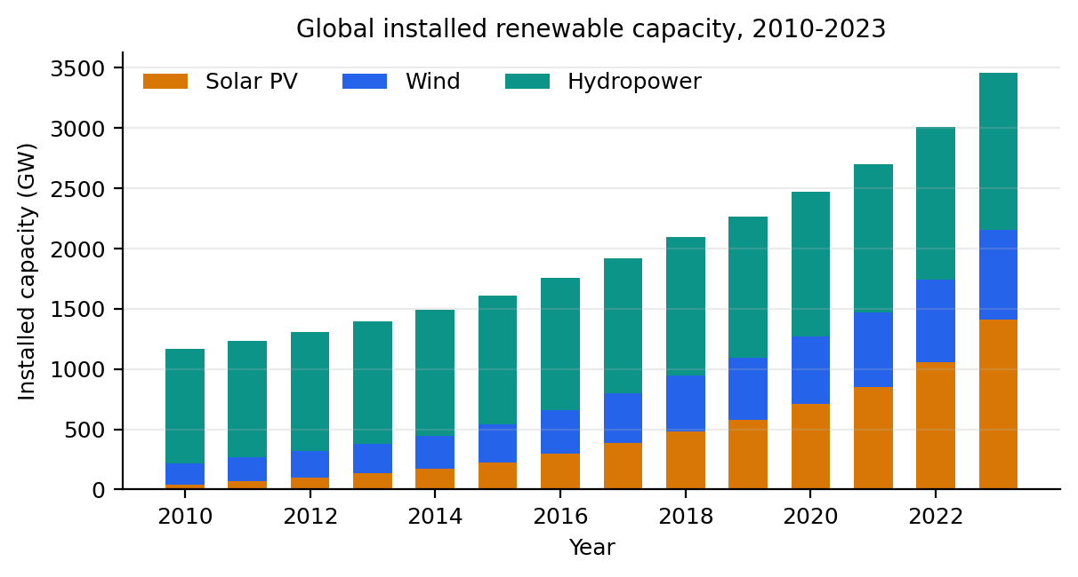
Figure 1.1: Global installed renewable energy capacity growth by technology, 2010–2023.
This changing resource mix alters the physics of the grid as well as its statistics. Wind and solar output is weather-driven and varies on timescales from seconds to seasons; the German load and generation record used throughout this thesis, drawn from the Open Power System Data (OPSD) platform, contains three-hour national wind and solar ramps exceeding 28 GW in magnitude [42]. At the same time, inverter-coupled generation displaces synchronous machines and thereby reduces the rotating inertia available to arrest frequency excursions, a challenge examined in detail in the low-inertia systems literature [3]. Distribution networks that were designed for unidirectional flows from transmission to consumption now host rooftop PV, storage, and electric vehicle (EV) charging that can reverse flow directions within minutes. Each of these effects would be manageable alone; their coincidence is what strains conventional operating practice.
The operating environment is also more complex institutionally and electronically. Millions of small devices with mixed ownership participate in the same physical system as a few hundred large generators, so coordination problems grow combinatorially. The communication links, intelligent electronic devices, and remote access paths that enable this coordination enlarge the attack surface of the grid, and cyber-physical security has consequently become a first-order design consideration rather than an afterthought [75]. Finally, market rules and regulatory frameworks frequently lag behind the technology, leaving tariffs, interconnection standards, and ancillary-service definitions poorly matched to the resources actually being connected. Figure 1.2 contrasts the traditional, centralised and unidirectional system with the modern, distributed and bidirectional one, and Table 1.1 summarises the six challenges that follow from this contrast.
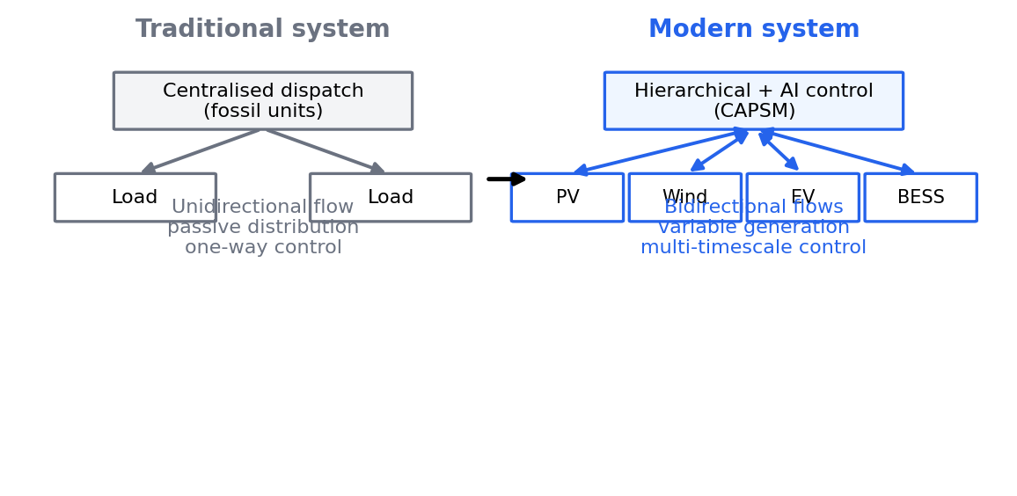
Figure 1.2: Traditional versus modern power system control challenges.
Table 1.1: Key challenges in modern power systems with high DER penetration.
Challenge | Description | Impact
Intermittency and variability | Weather-driven output of wind and solar plants fluctuates on timescales from seconds to seasons | Larger reserves, curtailment risk, heavier dependence on forecasting
Reduced system inertia | Inverter-coupled generation displaces synchronous machines and their kinetic energy | Faster frequency excursions and narrower stability margins [3]
Bidirectional power flows | Distributed generation, storage, and EV charging reverse historical flow directions | Voltage rise, protection miscoordination, and congestion at weak nodes
Growing complexity | Many heterogeneous devices with mixed ownership act within one physical system | Combinatorial coordination burden and harder state estimation
Cybersecurity exposure | Wider attack surface created by communication links and smart devices | False data injection and other attacks with physical consequences [75]
Market and regulatory friction | Tariffs, standards, and service definitions lag behind deployed technology | Investment uncertainty and delayed adoption of flexibility

The six challenges in Table 1.1 are coupled, which is precisely what makes them difficult. A curtailment decision interacts with inertia, with locational congestion, and with the economic viability of the plants involved, so no single-device or single-layer remedy suffices. The control question raised by this coupling, and the one this thesis pursues, is how heterogeneous fast and slow resources can be coordinated coherently in real time.

1.2 Evolution of FACTS Devices
Flexible Alternating Current Transmission System (FACTS) devices are the classical answer of power electronics to the problem of controlling an alternating current network whose flows are determined by impedances rather than by dispatch intent. Research programmes in the 1980s, notably at the Electric Power Research Institute, demonstrated that thyristor-based controllers could modulate reactive power and line reactance far faster than mechanically switched equipment. Hingorani and Gyugyi consolidated these ideas into the FACTS concept and its canonical device families, giving the field both its vocabulary and its theoretical foundation [4]. Their central insight was that controllability, not merely capacity, is the scarce resource in an alternating current network.
Subsequent monographs turned the concept into practical modelling and control methodology. Acha et al. developed steady-state and dynamic models of the main FACTS devices suitable for incorporation into power flow and stability programs [5], while Zhang, Rehtanz, and Pal treated FACTS modelling and control in an integrated framework that anticipates today's grid-code requirements [6]. The thyristor-controlled series capacitor (TCSC) received particular attention because series compensation interacts directly with electromechanical oscillations; Del Rosso, Cañizares, and Doña showed how TCSC controller design must trade damping improvement against stability limits of the compensation loop [7]. In its simplest steady-state representation, a TCSC changes the effective reactance of a line according to Equation (1.1):
(1.1)
where $X_{line}$ is the uncompensated line reactance and k is the compensation degree; in the benchmark used in this thesis the operational setpoint range is restricted to k ∈ [0.3, 0.7]. Devices of this kind fall into three families, namely shunt compensators such as the static var compensator (SVC) and the static synchronous compensator (STATCOM), series devices such as the TCSC and the static synchronous series compensator, and combined devices such as the unified power flow controller (UPFC), which couples a shunt and a series element through a common direct current link. The benchmark network studied here employs one device of each class, namely an SVC at bus 14, a STATCOM at bus 39, a TCSC on the line between buses 16 and 17, and a UPFC at bus 26, so that the coordinated control question is posed across all three families.
FACTS devices retain their relevance precisely because the renewable transition increases the need for controllability [50]. Power-electronic interfaces dominate the new resource mix, and the same technology base that connects wind turbines and solar farms can steer flows and support voltage where the network was never designed to carry them [50]. It appears that the marginal value of a FACTS device rises with renewable penetration, because the devices supply the fast, dispatchable reactive and flow control that variable resources do not provide themselves. Yet in most deployed systems FACTS controllers still act on local measurements with local objectives, which motivates the coordination questions taken up in Section 1.3 and, more broadly, in the problem statement of Section 1.5.

1.3 Integration of EVs into Smart Grids (V2G/G2V)
The electrification of transport adds a second class of controllable, power-electronic assets to the grid. In its default grid-to-vehicle (G2V) mode, EV charging is a flexible but sizeable load, and uncontrolled evening charging tends to coincide with the residential peak; studies of residential distribution networks show that naive charging can push feeder voltages and transformer loadings beyond their limits [14, 15]. Vehicle-to-grid (V2G) operation reverses this relationship by allowing the fleet to discharge when the system needs energy or reactive support. Kempton and Tomić calculated the aggregate power and revenue potential of V2G fleets and identified frequency regulation and spinning reserve as the services for which the concept is most naturally suited [8], with a companion paper addressing the implementation path from stabilising the grid to supporting large-scale renewable energy [9].
A substantial literature has since refined how fleets should be dispatched. Sortomme and El-Sharkawi formulated optimal charging strategies for unidirectional V2G and showed that scheduling with energy-price and grid objectives can reduce cost and losses simultaneously [10]. Hu, Morais, Sousa, and Lind reviewed fleet management across services, optimisation, and control, cataloguing the auction-, linear-, and dynamic-programming approaches then available [11]. On the hardware side, Yilmaz and Krein reviewed charger topologies, charging power levels, and infrastructure requirements, distinguishing single-stage and two-stage converters and the conditions under which bidirectional power flow is economic [12]. The concept family extends beyond the bulk grid: vehicle-to-home (V2H) and vehicle-to-everything (V2X) arrangements let the battery serve the household or the local community, with the opportunities and challenges of each mode examined by Liu, Chau, Wu, and Gao [13].
This thesis models EV participation at the level of aggregated fleet stations, each behaving as a single controllable storage unit with power and energy limits. Three such stations are attached to the IEEE 39-bus benchmark at buses 3, 8, and 15, each rated at 50 MW with a 100 MWh energy reservoir, a one-way efficiency of η = 0.92, and a state-of-charge (SoC) window constrained to [0.2, 0.9]. The station abstraction corresponds to an aggregated fleet rather than to individual vehicles, which is the level at which an aggregator or distribution system operator would contract. Charging and discharging update the stored energy according to Equation (1.2):
(1.2)
where $P_t$ is the dispatched station power, positive for charging, $\Delta t$ the control interval, and $E_{cap}$ the energy capacity; discharging is deliberately penalised by the efficiency factor because round-trip losses are charged to the fleet. Dispatch commands are clamped to the station power rating, and the SoC is held inside its window by forbidding charge at the upper bound and discharge at the lower bound. These constraints matter for control design because they make the action space non-trivial: a candidate dispatch that looks attractive in the power-flow sense may be infeasible for the battery, and the coordinating controller must respect such limits at every step.

1.4 Research Motivation
The technical case for this research rests on the observation that distributed energy resources (DERs) are growing faster than the tools available to coordinate them. Industry projections cited in the project literature suggest that DER capacity of the type considered here may grow from roughly 132.4 GW to 528.4 GW by 2026, a compound annual growth rate of about 16.7%, although such projections should be read as indications of direction rather than as forecasts. The smart grid literature has long argued that monitoring, communication, and control must advance together for this growth to be absorbed safely [48, 49]. What has changed in the last decade is that the monitoring and communication layers matured, through phasor measurement units and open datasets, while the control layer has lagged.
Three imperatives follow. The technical imperative is to keep voltage, loading, and frequency within limits as inertia falls and flows reverse, because the cost of failure is now systemic rather than local. The economic imperative is to reduce losses and curtailment and to raise the utilisation of assets that are already paid for; the January 2019 uncontrolled baseline of the benchmark used in this thesis records energy costs of 171.6 MEUR for a single month, so even fractional improvements translate into large absolute sums. The environmental imperative is that every megawatt-hour of wind or solar curtailed is replaced, in practice, by fossil generation, so control quality is coupled directly to decarbonisation outcomes. Resilience ties the three together, since a system that cannot ride through contingencies without cascading fails all three tests at once.
A further motivation is methodological honesty about data. Control studies conducted on synthetic load profiles can be tuned, however unintentionally, to the very profiles they are evaluated on. This thesis therefore builds its benchmark on the OPSD open dataset of real German load, wind, and solar generation [42], disaggregated onto the IEEE 39-bus network, so that the variability the controllers face is observed rather than invented. The dataset is large, public, and versioned, which makes the experiments repeatable by others.
Finally, the maturation of artificial intelligence (AI) makes a new class of controller plausible. Reinforcement learning provides the general grammar for sequential decision-making under uncertainty [22], deep reinforcement learning (DRL) has demonstrated human-level control in domains far more complex than a power network [23]–[26], and recent surveys catalogue a rapidly growing set of power-system applications [27, 28]. Table 1.2 summarises why AI-based control is an attractive complement to conventional schemes across six aspects.
Table 1.2: Comparison of conventional and AI-based control approaches.
Aspect | Conventional control | AI-based control | Advantage
Model dependence | Requires accurate linearised models of the network | Learns from data with physics-informed structure [31] | Tolerates model error and drift
Response to uncertainty | Conservative margins fixed at design time | Estimates state and risk online | Uses available headroom
Nonlinearity handling | Local linearisation around operating points | Nonlinear function approximation | Tracks wide operating ranges
Adaptation | Manual retuning after topology or load changes | Online and continual learning | Lower maintenance burden
Multi-timescale coordination | Separate relays, regulators, and optimisers | Layered fast and slow processes | Coherent action across timescales
Data usage | Sparse SCADA snapshots | Streaming PMU and smart-meter data | Exploits modern observability

Table 1.2 should not be read as a claim that AI control is superior in every respect; conventional schemes are transparent, certified, and predictable, which matters for protection. The motivating hypothesis of this thesis is narrower, namely that a brain-inspired AI architecture can combine the speed of reflexes with the foresight of deliberation while remaining verifiable on real hardware.

1.5 Problem Statement
The problem addressed by this thesis is the coordinated real-time control of FACTS devices, EV fleets, and DERs in networks with high renewable penetration, under a cognitive framing borrowed from human decision-making. Kahneman's distinction between fast, automatic System 1 thinking and slow, effortful System 2 reasoning provides the organising metaphor [16], and the control literature on reinforcement learning supplies the algorithmic substrate [22]. Analysis of the current state of practice, elaborated in Chapter 2, reveals five specific gaps between what modern grids need and what existing control approaches deliver, as illustrated in Figure 1.3.
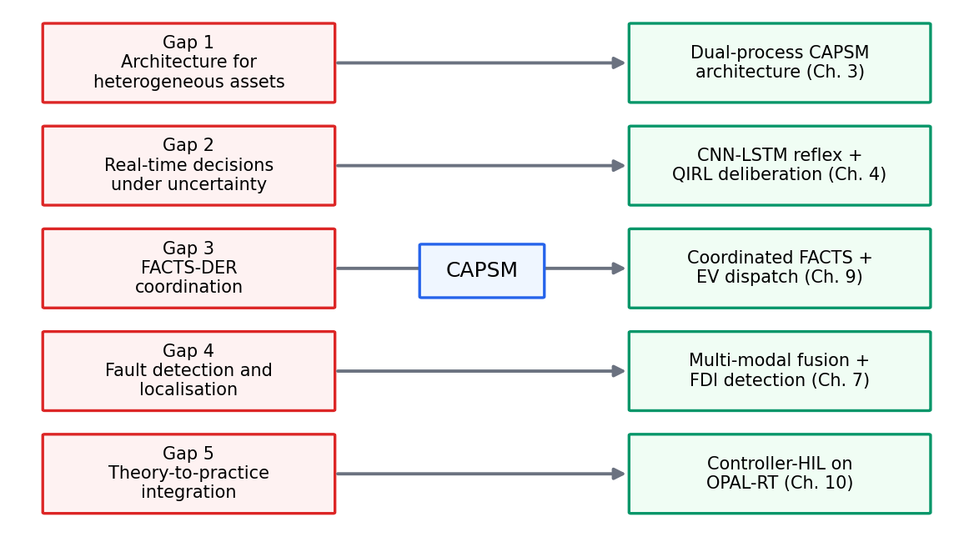
Figure 1.3: Research gap identification framework linking the five control gaps to CAPSM responses.
Gap 1 concerns control architecture for heterogeneous systems. Existing deployments coordinate voltage devices, storage, and flexible loads through separate hierarchies, each designed for one asset class and one timescale, and no principled mechanism decides which layer should act in a given situation. A control architecture for the modern grid must therefore accommodate FACTS devices that act in milliseconds, EV stations that act in minutes, and optimisers that act in hours within one coherent structure.
Gap 2 concerns real-time decision-making under uncertainty. DRL controllers are typically trained offline against a fixed environment model, and the surveys of the field emphasise sample inefficiency and constraint-violation risk as the two barriers to deployment [27, 28]. An operator cannot accept a controller that occasionally violates voltage limits while it explores, yet exploration is precisely what makes learning valuable. Methods that are safe by construction, such as constrained or Lyapunov-based reinforcement learning [29, 30], and physics-informed neural networks (PINNs) that embed the power flow equations in training [31], mitigate but do not by themselves close this gap.
Gap 3 concerns coordination between FACTS devices and DERs. As noted in Section 1.2, FACTS controllers conventionally act on local objectives [4, 6], while EV aggregation is usually optimised on slower economic horizons [10, 11]. The two control problems interact through the same network voltages and flows, so independent design leaves benefit on the table and can even cause control fighting. What is missing is a formulation in which shunt, series, and combined devices and the EV stations are scheduled as one system.
Gap 4 concerns fault detection and localisation in resource-rich environments. Classical protection and state estimation were designed for a small number of measurable, slowly varying quantities [75], whereas a modern grid offers abundant PMU, SCADA, and inverter telemetry. The research question is how to fuse these heterogeneous signals so that faults, cyber-attacks, and anomalous but benign behaviour are distinguished quickly and accurately, rather than drowned in alarms.
Gap 5 concerns the divide between theory and practice, and it is the gap that conditions the credibility of all others. The overwhelming majority of AI-based power-system studies stop at offline simulation, where timing, solver behaviour, and input-output latency are idealised, and hardware validation of cognitive controllers remains rare. Controller-Hardware-in-the-Loop (CHIL) testing, in which the controller executes on real hardware while the network runs in real time, is the accepted bridge for protection and control products [51, 52]; this thesis treats such validation not as an afterthought but as a design requirement, and Figure 1.4 shows the architecture that results from taking the five gaps seriously together.
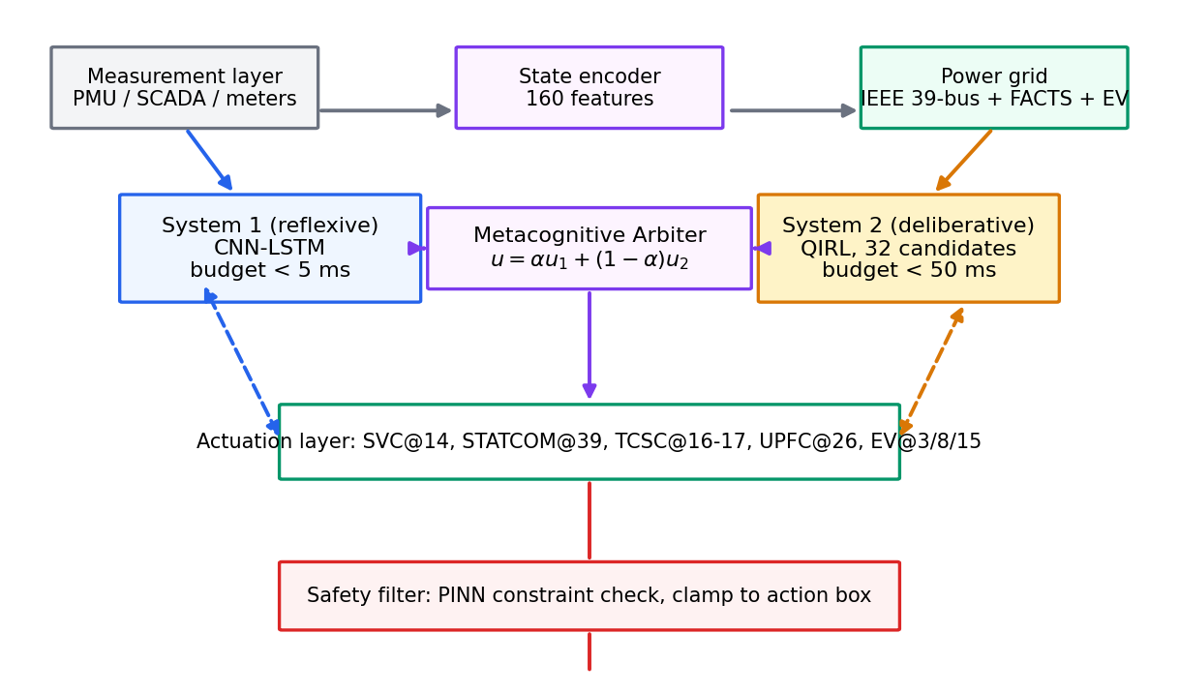
Figure 1.4: Overview of the proposed AI-driven CAPSM framework.
The Cognitive Adaptive Power System Management (CAPSM) framework, introduced in overview in Figure 1.4 and specified fully in Chapter 3, responds to all five gaps simultaneously: a dual-process architecture addresses Gap 1, a candidate-based quantum-inspired deliberation layer with a reflexive neural path addresses Gap 2, an explicit blended action space over FACTS and EV actuators addresses Gap 3, a multi-modal detection layer addresses Gap 4, and a validation pipeline that ends in CHIL testing addresses Gap 5.

1.6 Research Objectives
Five objectives translate the gaps into research goals, each carrying a measurable target. The first objective is to design a dual-process control architecture that separates reflexive from deliberative action and arbitrates between them, with the measurable goal of a System 1 reflex path that meets a sub-5 ms timing budget and a 37% reduction in response time to critical events relative to a traditional protection cycle; these figures are design targets from the framework specification. The second objective is to construct a deliberative optimiser that decides under uncertainty without violating operational constraints, with the measurable goals of a System 2 budget below 50 ms, a Metacognitive Arbiter step of 10 ms, and greater than 99.9% constraint compliance through physics-informed training. The third objective is to coordinate FACTS devices and EV fleets in one action space, with the measurable goals of a 32.7% reduction in voltage deviation and a 42% enhancement of stability metrics in extreme events, again as design targets.
The fourth objective is to detect and localise faults in resource-rich environments, with the measurable goals of 95.8% detection and localisation accuracy and sub-10 ms fault detection measured on real-time hardware. The fifth objective is to validate the whole framework on real-time hardware, with the measurable goals of meeting the per-core timing budgets of 5 ms, 50 ms, and 10 ms on a four-core OPAL-RT target and 100% power-flow convergence across the offline benchmark. Table 1.3 collects the objectives, goals, and target metrics, and distinguishes design targets from outcomes measured during the hardware campaign.
Table 1.3: Research objectives, measurable goals, and target metrics.
Objective | Measurable goal | Target metric
O1 – Dual-process architecture | Reflexive action within protection-grade latency | 37% response-time reduction; System 1 budget below 5 ms (design targets)
O2 – Deliberation under uncertainty | Constrained optimisation within dispatch cycles | System 2 below 50 ms; arbiter 10 ms; over 99.9% constraint compliance (design targets)
O3 – Coordinated FACTS–DER control | Joint scheduling of shunt, series, combined devices, and EV stations | 32.7% voltage-deviation reduction; 42% stability enhancement (design targets)
O4 – Fault detection and localisation | Multi-modal detection on real telemetry | 95.8% detection accuracy (design target); sub-10 ms detection on hardware (HIL-campaign outcome)
O5 – Real-time hardware validation | End-to-end feasibility on a 4-core OPAL-RT | Timing budgets met on 4 cores; 100% convergence (design targets and campaign outcomes)

The distinction between design targets and measured outcomes is deliberate and should be maintained throughout the thesis. The targets in Table 1.3 originate in the framework specification and in the HIL campaign design, and they define what success means before the experiments are run. The offline Stage-1 measurements of the benchmark, including the violation counts and per-step inference times reported there, belong to the results analysis of Chapter 11 and are never substituted for the targets here. Figure 1.5 shows the three-stage validation pipeline that connects the objectives: offline Python simulation with PYPOWER quasi-static time series (QSTS), Simulink model preparation with FACTS and EV subsystems, and finally Controller-HIL execution on the four-core OPAL-RT simulator.
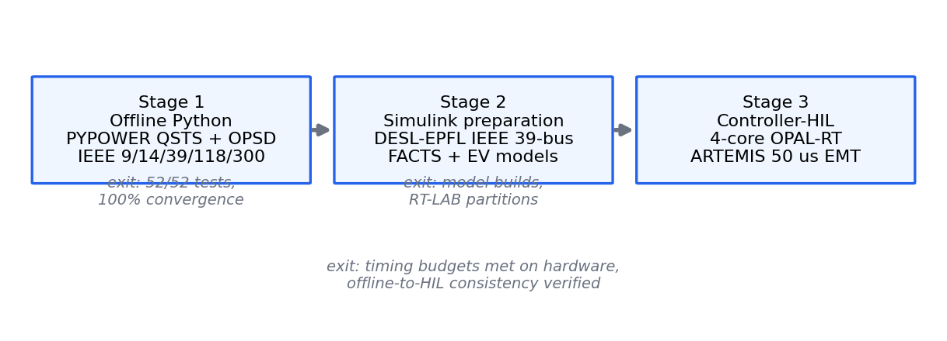
Figure 1.5: Three-stage validation pipeline from offline simulation to Controller-HIL.

1.7 Original Contributions
The thesis claims nine original contributions, which map onto the five objectives and onto the chapters that follow. They are stated here in the order in which the thesis develops them.
- Contribution 1: CAPSM dual-process architecture. The thesis proposes a control architecture that implements Kahneman's dual-process theory for power networks [16], pairing a reflexive System 1 with a deliberative System 2 under a Metacognitive Arbiter. The architecture assigns each process an explicit timing budget and an explicit action space, so that the two processes compose rather than compete. This responds directly to Gap 1 and is elaborated in Chapter 3.
- Contribution 2: Quantum-inspired reinforcement learning with Born-rule selection and tunnelling. System 2 maintains a superposition of 32 candidate actions whose amplitudes are reinforced by observed rewards and sampled through the Born rule, with a tunnelling mechanism that re-initialises a fraction of candidates each step. The mechanism balances exploitation against exploration inside the action box and is analysed formally in Chapter 4.
- Contribution 3: Metacognitive Arbiter. A stress-dependent sigmoid weight blends the reflexive and deliberative actions into a single command at every step, with five operating modes that include reflex, planning, override, safe, and blended states. The arbiter supplies the missing decision mechanism of Gap 1 and its properties are proved in Chapter 4.
- Contribution 4: Coordinated FACTS–EV control. The thesis formulates voltage and flow control over shunt, series, and combined FACTS devices and three aggregated EV stations in one 9-dimensional action space, so that coordination is structural rather than negotiated between separate controllers. This addresses Gap 3 and is developed in Chapters 3 and 8.
- Contribution 5: Multi-modal fault detection and localisation. A detection layer fuses PMU, SCADA, and inverter telemetry to separate faults, false data injection, and benign anomalies, addressing Gap 4. Its design and its fusion logic are presented in Chapter 7.
- Contribution 6: AI-based optimal placement of controllers. Placement of FACTS devices and EV stations is formulated as a hybrid optimisation combining genetic algorithms, particle swarm optimisation, and deep reinforcement learning [64, 65, 66]. The method couples placement to the control objective rather than treating it as a separate planning exercise, and appears in Chapter 5.
- Contribution 7: Digital twin methodology. The thesis develops a digital twin workflow in which the offline QSTS benchmark, the Simulink model, and the real-time simulator remain synchronised representations of the same network. The methodology supports the validation argument of Gap 5 and is documented in Chapter 10.
- Contribution 8: HIL validation methodology on a 4-core OPAL-RT. The thesis contributes a validation methodology that allocates the controller and network across four simulator cores with explicit timing budgets of 5 ms, 50 ms, 10 ms, and 1 ms, and that progresses through model-in-the-loop, software-in-the-loop, processor-in-the-loop, and Controller-HIL stages [51, 52]. The methodology and its execution are the subject of Chapters 10 and 11.
- Contribution 9: End-to-end reproducible pipeline. All experiments run on the versioned OPSD public dataset [42], all code is tested by an automated suite of 52 tests, and every reported figure is traceable to a script. This contribution makes the scientific claims of the thesis independently checkable.
Taken together, the nine contributions form a single argument rather than nine separate results: a cognitive architecture whose components are individually analysable, whose coordination is structural, and whose deployment claims are tested on hardware rather than asserted in simulation.

1.8 Thesis Organization
The remainder of the thesis is organised into twelve further chapters. Chapter 2 reviews the literature across AI in power systems, FACTS devices, decision-making methods, EV integration, brain-inspired computing, DER integration technologies, and real-time simulation, closing with the gap analysis that motivates hybrid frameworks. Chapter 3 presents the CAPSM framework, its dual-process architecture, its mathematical models, and its design philosophy; Section 3.10 is a new HIL-ready architecture design section that specifies how every component is prepared for real-time deployment from the outset.
Chapter 4 details the advanced AI control architecture, including the CNN-LSTM reflex network, the quantum-inspired deliberation layer, and the arbiter, with formal analyses of their properties; Section 4.7 adds the real-time execution path, including export of trained models to the ONNX interchange format [101]. Chapter 5 develops AI-based optimal placement of FACTS devices and EV stations through genetic algorithms, particle swarm optimisation, and reinforcement learning, and Section 5.8 extends the placement study to respect the constraints of real-time deployment. Chapter 6 addresses stability enhancement using deep learning, including PV-curve and critical-clearing-time analysis, and Section 6.6 revisits the stability claims under the timing budget measured in the real-time campaign.
Chapter 7 presents multi-modal fault detection and localisation, including state-estimation-based residual methods and deep classifiers, with Section 7.6 porting the detection stack to the Controller-HIL environment where sub-10 ms detection is demonstrated. Chapter 8 treats EV integration and DER management in depth, including charging behaviour, degradation, and V2G scheduling, and Section 8.7 describes the aggregation model as implemented in real time. Chapter 9 develops coordinated control using hybrid AI, including multi-agent and distributed formulations, and Section 9.6 maps the coordination scheme onto the multi-core real-time target.
Chapter 10 is the testing and validation framework, the central methodological chapter of the thesis; it presents the digital twin methodology, the V-model traceability argument, the rate-monotonic schedulability analysis of the four-core allocation, and, in Section 10.11, the full Controller-HIL campaign on the OPAL-RT. Chapter 11 reports the results and performance analysis, from the offline January 2019 benchmark through the HIL timing measurements, including the violation reductions, convergence, and inference-time figures that anchor the quantitative claims of the thesis. Chapter 12 discusses the implications of the results for operators, regulators, and researchers, including economic and policy considerations, and states the limitations of the study candidly. Chapter 13 concludes, summarises the contributions against the objectives of Section 1.6, and outlines future work in quantum hardware, market integration, and multi-agent extensions.

Chapter 2: Literature Review

2.1 Evolution of AI Applications in Power Systems
Artificial intelligence entered power engineering well before the current deep learning wave, and the history of that entry conditions what the field expects of AI today. In the 1980s, expert systems encoded the diagnostic knowledge of experienced operators into rule bases; the DELTA system, developed for alarm processing and fault diagnosis, became the emblematic example of the genre. Early artificial neural network work followed in 1989, when dynamic security assessment was among the first power-system tasks delegated to a learned classifier, anticipating by decades the modern fashion for machine-learning security screens. These first systems demonstrated genuine value in narrow tasks, yet they also exposed the knowledge-acquisition bottleneck, since every rule had to be elicited from a human expert, and the brittleness of rule bases when operating conditions drifted outside the envelope their authors had imagined.
A second generation of methods softened the rigid rule-based paradigm. Fuzzy inference allowed control actions to be graded rather than binary, reflecting the position, argued influentially in the cognitive-computing literature, that intelligent behaviour may emerge from many simple interacting processes rather than from a single formal logic core [20]. Evolutionary computation supplied search where gradients were unavailable, with genetic algorithms formalised in the foundational texts of Holland and Goldberg [64, 65], and particle swarm optimisation added a socially inspired optimiser that became a workhorse for tuning and placement problems [66]. These methods spread across network reconfiguration, capacitor placement, controller tuning, and unit commitment support. Their limitation, apparent already in the 2000s, was computational cost and their orientation toward offline planning rather than online control. Hybridisation, in retrospect, began in this period, as authors combined fuzzy rules with evolutionary tuning and neural predictors with expert-system wrappers.
Two lessons from this middle period deserve preservation. First, search-based and rule-based methods did not disappear when learning methods arrived; they migrated into preprocessing and postprocessing roles where their transparency is an asset, and they still back much of the planning software in daily industrial use. Second, the community learned that benchmark difficulty matters more than algorithmic elegance, because methods that impressed on toy networks frequently failed to survive contact with full-scale cases. Both lessons inform the design choices of later chapters, in which search, learning, and physics are assigned to the roles they perform best.
The modern machine-learning assessment literature grew out of better data rather than better rules. Phasor measurement units, smart meters, and open datasets gave classifiers and regressors training material of a scale the 1990s could not imagine, and transient stability assessment became a benchmark task for big-data methods, with core vector machines and related techniques achieving high screening accuracy at scale [87]. Comparable results were reported for real-time dynamic security assessment with reliable intelligent systems that combine learning with decision logic suited to operational deployment [88]. The caveat that accompanies these successes is that the models are trained offline against simulations of a particular network, and their accuracy claims degrade, sometimes silently, when topology or generation mix drifts from the training distribution.
The deep reinforcement learning (DRL) era then changed the ambition level from assessment to control. Deep Q-networks learned control policies directly from high-dimensional observations in Atari environments [23], continuous-control algorithms such as DDPG extended the approach to action spaces more like those of a power grid [24], twin-delayed methods corrected the overestimation pathologies of actor-critic training [25], and self-play systems demonstrated superhuman performance in games of perfect information [26]. Reviews of the field catalogued a rapid migration of these techniques into power-system control problems, from frequency regulation to optimal power flow assistance [27, 28]. Figure 2.1 arranges this evolution as a timeline, and Table 2.1 condenses it into six eras with their characteristic applications and limitations.
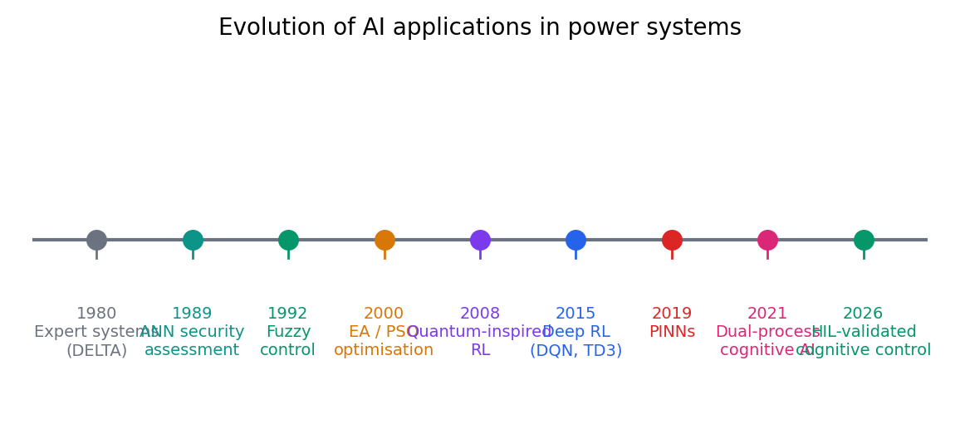
Figure 2.1: Evolution of AI applications in power systems, 1980 to present.
Table 2.1: Chronological evolution of AI techniques in power systems.
Era | Key development | Representative application | Limitation
1980s | Expert systems such as DELTA | Alarm processing and fault diagnosis | Knowledge-acquisition bottleneck; brittle outside the rule envelope
Late 1980s to 1990s | Early artificial neural networks | Dynamic security assessment | Small datasets; opaque models; limited validation
1990s to 2000s | Fuzzy and rule-based soft computing [20] | Heuristic voltage and reactive control | Manual rule design; weak adaptation
1990s to 2000s | Evolutionary and swarm methods [64]–[66] | Placement, reconfiguration, controller tuning | Computationally heavy; offline orientation
2010s | Deep learning and DRL [23]–[26] | Learned control policies and forecasting | Sample inefficiency; constraint-violation risk
2020s | Physics-informed and hybrid cognitive methods [31] | Constraint-compliant learning and control | Scarce real-time hardware validation

The pattern visible in Table 2.1 is that each era solved the headline limitation of its predecessor while introducing a new one. Expert systems lacked adaptability, neural networks lacked data, evolutionary methods lacked speed, and DRL lacks, most consequentially, certified safety and hardware evidence. The 2020s responses, physics-informed training and hybrid architectures, are precisely the direction this thesis takes, and the remainder of the chapter assembles the evidence for why that direction is necessary.

2.2 FACTS Devices and Their Applications
The FACTS concept, as consolidated by Hingorani and Gyugyi, classifies power-electronic transmission controllers by where and how they connect to the alternating current network [4]. Shunt devices inject or absorb reactive current at a bus, series devices modulate the effective impedance of a line, and combined devices couple a shunt and a series element through a common direct current link to control both bus voltage and power flow. Figure 2.2 presents this classification as a tree, with the principal devices of each family named. The classification matters for control design because the three families act on different physical quantities, on different timescales, and with different interaction risks, so a coordinator that treats them as interchangeable will misapply them.
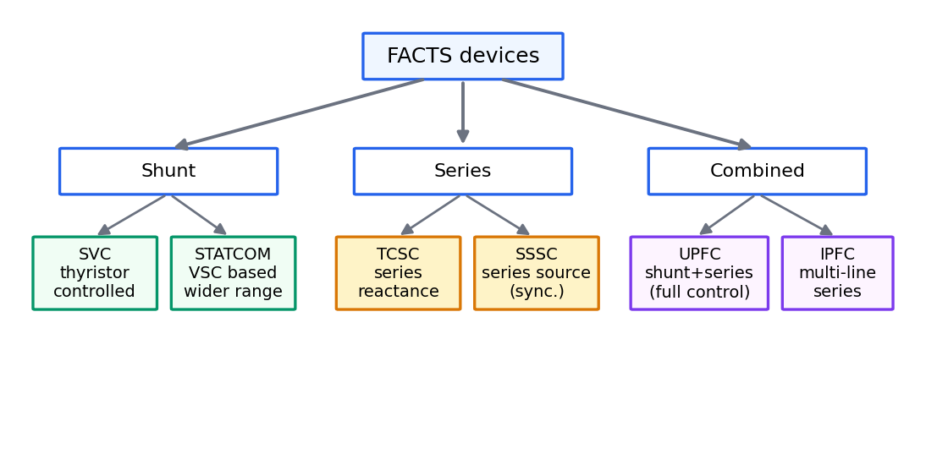
Figure 2.2: Classification of FACTS devices and their operating principles.
Shunt compensation begins with the static var compensator, which switches thyristor-controlled reactors and capacitor banks to hold a target voltage, and continues with the static synchronous compensator, which synthesises reactive current from a voltage-source converter without passive var banks. The STATCOM responds faster than the SVC and maintains its characteristic at depressed voltages, which is why modern grid codes prefer it for weak nodes; both devices are modelled in power flow as controllable shunt susceptances, and the monographs of Acha et al. and Zhang et al. give the steady-state and dynamic formulations used throughout this thesis [5, 6]. Series compensation begins with the thyristor-controlled series capacitor, whose effective reactance follows the compensation law used in Chapter 3, and whose controller design must respect the stability limits analysed by Del Rosso, Cañizares, and Doña [7]. The static synchronous series compensator (SSSC) performs the same duty with a converter-sourced series voltage rather than a passive capacitor. The unified power flow controller combines a shunt and a series converter and is the most capable device of the family, controlling voltage, active flow, and reactive flow simultaneously, at the price of the highest cost and the most involved modelling [4, 5].
Applications of FACTS in the renewable era extend beyond the classical voltage-support duty [50]. Wind-rich and solar-rich corridors exhibit flows that swing with weather, so series devices find a new role in flow steering, and shunt devices in smoothing the voltage excursions that variable injection causes at electrically remote buses [50]. The devices also provide damping of electromechanical oscillations through supplementary modulation controllers, a function that remains valuable as synchronous inertia declines. What the literature has largely not provided, and what this thesis argues is now needed, is an account of FACTS operation coordinated with DER assets under one controller, rather than as a separately tuned layer. The benchmark network of this thesis therefore uses one device from each family so that the coordination question is posed across the full classification of Figure 2.2: an SVC at bus 14 with a susceptance range of ±0.5 p.u., a STATCOM at bus 39 with a range of ±1.0 p.u., a TCSC on the branch between buses 16 and 17 with an operational compensation degree in [0.3, 0.7], and a UPFC at bus 26 combining a shunt element of ±0.5 p.u. with a series element acting on the branch between buses 26 and 28. These placements follow the convention of the test-system literature in stressing the corridor that carries the heaviest transfer. In power flow terms the shunt devices appear as controllable susceptances and the series devices as reactance or injected-power modifications, which is exactly the level of fidelity at which the controllers of Chapters 3 and 4 operate.
Table 2.2 summarises the five principal devices with their type, defining feature, typical application, and response order.
Table 2.2: Comparison of FACTS device characteristics and applications.
Device | Type | Key feature | Typical application | Response time
SVC | Shunt | Thyristor-switched reactor and capacitor banks | Voltage support at transmission buses | Of the order of 20–40 ms
STATCOM | Shunt | Voltage-source converter synthesising reactive current | Fast voltage support in weak grids | Of the order of 5–20 ms
TCSC | Series | Controllable series compensation degree | Power flow control and oscillation damping | Of the order of 10–100 ms
SSSC | Series | Converter-injected series voltage | Flow control without passive banks | Of the order of 5–20 ms
UPFC | Combined | Coupled shunt and series converters | Voltage plus active and reactive flow control | Of the order of 10–50 ms

The response orders in Table 2.2 are reported in the FACTS literature as typical values and should be read as indicative rather than as guaranteed figures for any specific installation [4, 6]. They nonetheless make the control-relevant point that FACTS devices are an order of magnitude faster than dispatch-level assets such as EV fleets, which is why any coordinating architecture must carry an explicit notion of timescale.

2.3 AI Approaches for Decision-Making in Power Grids
Reinforcement learning frames sequential decision-making as an agent maximising accumulated reward through interaction with an environment, and its theoretical foundations are established in the standard text of Sutton and Barto [22]. A power network fits the frame naturally: the state is the operating point, actions are setpoints for FACTS devices and EV stations, and the reward encodes voltage deviation, losses, and constraint violations. The appeal of the frame is that a controller can, in principle, be learned from data rather than designed from a model. The appeal is also the danger, because everything depends on how the interaction data are obtained and what the learned policy does in states the training never visited.
Deep reinforcement learning made the frame scalable to high-dimensional states. The deep Q-network established that a convolutional agent could learn competent policies from raw observations [23], DDPG brought deterministic policy gradients to continuous action spaces of the kind a power grid presents [24], and TD3 addressed the value-overestimation that destabilises actor-critic training on continuous problems [25], while the self-play results of AlphaGo Zero demonstrated the raw capability of learned search [26]. Power-system applications quickly followed, and the surveys by Glavic and by Cao et al. document their spread across frequency control, voltage regulation, and energy scheduling, alongside the recurring caveats of sample inefficiency, reward shaping sensitivity, and the difficulty of certifying learned policies [27, 28]. A further practical limitation receives less attention than it deserves: most DRL controllers are trained against a fixed simulated environment, so their competence is conditioned on a topology and resource mix that real networks no longer hold constant.
Safe reinforcement learning responds directly to the constraint-violation risk. Constrained policy optimisation restricts policy updates to regions where expected constraint costs remain within bounds [29], and Lyapunov-based methods provide per-state safety certificates that keep the learning trajectory inside a certified set [30]. These methods reduce the frequency of dangerous exploration, but they rest on constraint models that are themselves approximations, and they typically trade off learning speed against conservatism. For an operator, the residual risk remains difficult to quantify, which motivates embedding physical law directly in the learner.
Model predictive control (MPC) is the classical counterpoint, optimising over a receding horizon with constraints stated explicitly in the formulation [67, 68]. Its strengths are transparency and constraint handling, and its weaknesses are model dependence and the computational cost of nonconvex alternating current formulations at fast rates. Physics-informed neural networks (PINNs) take a different route to physics, embedding the governing equations in the training loss so that predictions violate the physics only to the extent that the loss permits [31]. In power-system dress, PINN-style training promises constraint compliance by construction, and it reduces the data hunger of purely data-driven models, although training cost and behaviour outside the training envelope remain open questions.
Between the learning-based and model-based families sits imitation, which trains a controller to reproduce a demonstrator and thereby inherits whatever safety the demonstrator possesses while remaining fast at execution. Behaviour cloning reduces imitation to supervised learning and is attractively simple, but it suffers from distribution shift, since the learned policy eventually encounters states the demonstrator would never have visited; dataset aggregation addresses the shift by querying the demonstrator on the states the learner actually reaches [112]. Sequence models supply the architectural substrate for such controllers, with long short-term memory networks carrying state across observations [32] and attention mechanisms allowing a policy to weight the parts of a long history that matter for the present decision [34]. These ingredients matter to this thesis because its reflexive path is precisely a cloned, attention-equipped sequence model, and the limitation identified here, namely the dependence on demonstrator quality, motivates the deliberative layer that surrounds it.
Machine-learning stability assessment, finally, offers speed where model-based screening is too slow, with core vector machines and intelligent assessment systems achieving high accuracy on transient stability screening [87, 88]; their limitation is the same distribution-shift exposure noted above, since a classifier trained on one topology is not, by itself, a monitor of another.
The synthesis this chapter draws from these families is that each is incomplete alone: DRL adapts but violates, safe RL protects but constrains, MPC respects physics but needs models and time, PINNs respect physics but must still be validated, and learned assessors are fast but fragile under drift. This pattern motivates an architecture that combines families under an explicit arbiter rather than expecting one method to carry the whole control problem.

2.4 EV and V2G/G2V Architectures
The foundational V2G analysis of Kempton and Tomić established the two questions that still organise the field: how much power and energy does a connected fleet represent, and who would pay for its services [8, 9]. The first question has an encouraging answer, since even a modest fraction of the light-duty fleet, if connected through bidirectional chargers, represents gigawatts of fast reserve; the second is subtler, because revenue must cover battery wear and the inconvenience cost of scheduling. The companion implementation analysis concluded that frequency regulation and spinning reserve, rather than bulk energy arbitrage, are the services where V2G economics are most favourable [9]. These conclusions have aged well, and they explain why aggregation sits at the centre of every practical V2G architecture.
Charging strategy research then addressed how a fleet should behave once connected. Sortomme and El-Sharkawi compared charging objectives for unidirectional V2G and showed that schedules minimising cost, emissions, or load variance differ in character but that all managed charging outperforms uncontrolled charging [10]. The fleet-management review of Hu et al. systematised the services an aggregator can sell, from regulation to congestion management, and the optimisation and control structures that deliver them [11]. On the physical layer, Yilmaz and Krein classified charger topologies and power levels, distinguishing single-stage and two-stage bidirectional converters and the galvanic isolation choices that separate them [12]. Beyond the bulk grid, Liu, Chau, Wu, and Gao mapped the vehicle-to-home, vehicle-to-vehicle, and vehicle-to-grid space, showing that the same hardware serves different value streams depending on where the energy is directed [13].
Two further literatures complete the picture. The first is aggregation and scheduling under uncertainty: state-estimation-based control of large populations of flexible loads, developed initially for thermostatic devices, provides the mathematical machinery for commanding thousands of private batteries from a single signal [82], and decentralised control schemes for thermostatic loads establish what can be achieved without full telemetry [83]. The same machinery transfers to EV fleets with the modification that mobility makes availability stochastic. The second is degradation: operating a battery harder shortens its life, and degradation-aware optimisation of storage operation attaches an explicit cost to cycling so that schedules weigh revenue against wear [84]. The unmanaged alternative is unattractive on the grid side as well, since residential studies show that coincident charging can breach feeder limits [14, 15]. Deployment experience has accompanied the maturation of this literature, though it remains uneven. Bidirectional charging requires grid codes that permit export, metering that settles it, and interconnection agreements that define who may command the fleet, and several jurisdictions have amended all three to open the door to V2H and V2G pilots. Early commercial experience suggests that the value stack of an electrified fleet is governed more by availability than by raw capacity, since vehicles are parked and pliable for most of the day but cannot be commanded while driving. It appears that the practical constraint on V2G is institutional more than technical, a conclusion that shifts attention from converter design, which the literature has largely settled [12], to the coordination layer this thesis addresses. Figure 2.3 summarises the architectures, and Table 2.3 contrasts the three operating modes that this thesis models at station level.
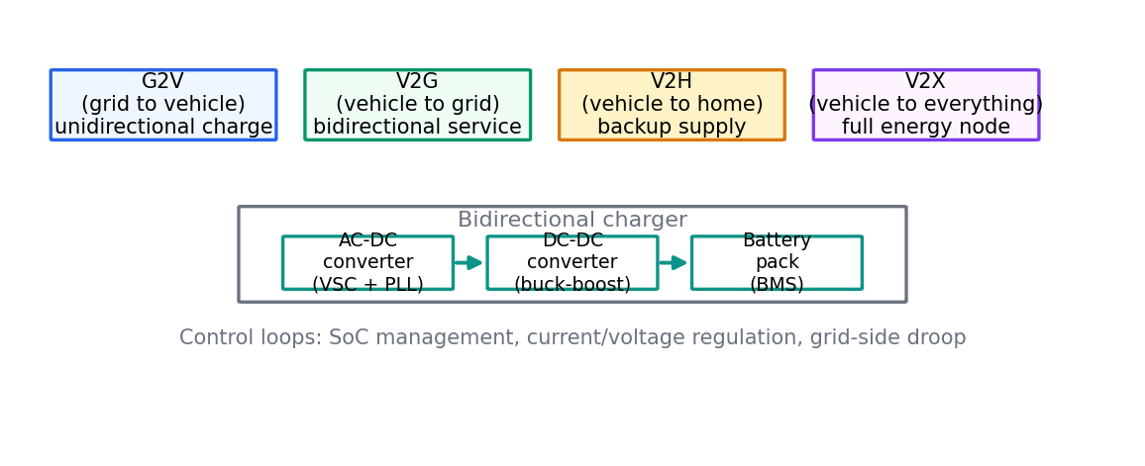
Figure 2.3: EV charging technologies and V2G/G2V architectures.
Table 2.3: EV fleet charging and discharging characteristics.
Parameter | G2V mode | V2G mode | V2H mode
Power direction | Grid to battery | Bidirectional | Battery to household
Primary service | Energy replenishment | Regulation, reserve, peak support | Backup supply and bill management
Typical control signal | Timer or price trigger | Aggregator setpoint | Local energy-management schedule
Energy accounting | Unidirectional metering | Net metering with export settlement | Household-level accounting
Principal constraint | Charging time and cost | Battery degradation and availability | Household comfort and autonomy

The comparison in Table 2.3 explains a modelling choice made throughout this thesis: the station-level abstraction in Chapter 3 treats the fleet as a controllable storage unit with an efficiency of 0.92 and a state-of-charge window of [0.2, 0.9], because it is exactly these parameters that the three modes share, while the differences between modes reduce to who issues the setpoint.

2.5 Brain-Inspired AI Frameworks
Cognitive psychology offers an account of human decision-making that has proven unexpectedly fertile for control engineering. Kahneman's dual-process theory distinguishes fast, automatic, low-effort System 1 thinking from slow, deliberate, effortful System 2 reasoning [16], and the distinction has since been sharpened by formal analysis of how the two processes interact and override one another [17]. The conditions under which intuition serves an expert well have also been studied: Kahneman and Klein argue that intuitive expertise is trustworthy only in environments that are sufficiently regular to be learned and that provide prompt, clear feedback, a description that fits steady-state power system operation better than it fits rare catastrophic events [18]. The dual-process framing is not without internal debate, and the debate is instructive for engineers who borrow its vocabulary. Evans and Stanovich distinguish default-interventionist readings, in which fast intuition answers first and slow reasoning intervenes when needed, from parallel-competitive readings, in which both processes answer independently and a conflict is resolved afterwards [17]. The two readings imply different arbitration designs: the first suggests a supervisor that monitors the reflex answer and vetoes it, while the second suggests a weighting mechanism that fuses both answers continuously. This thesis adopts a design compatible with both readings, in that its arbiter can both override and blend, and Chapter 4 shows that the blended form subsumes the override form at its limits. This body of theory matters here because it supplies the division of labour that an autonomous grid controller needs: reflexes for the regular, deliberation for the rare, and a supervisory judgement about which mode applies.
A second strand of brain-inspired computing concerns emotion and motivation as control signals rather than as noise. Picard's affective computing programme treats emotional state as information that modulates cognition and priorities [19], and Minsky's emotion machine proposes that minds operate as a society of simpler processes whose activation is governed by cascades of affective and metacognitive labels [20]. Lake, Ullman, Tenenbaum, and Gershman distil what learning systems would need in order to build theories like people do, listing compositionality, causality, and learning-to-learn among the core ingredients [21]. For grid control, the practical import of this strand is that a controller benefits from an explicit, self-monitoring layer that labels its own operating condition, stressed or calm, novel or familiar, and adjusts its reliance on fast versus slow processing accordingly.
Cognitive architectures translate these ideas into engineered systems. In the control reading adopted by this thesis, a reflex layer implements System 1 as a fast neural mapping from observations to actions; a deliberative layer implements System 2 as candidate generation and evaluation over a slower horizon; and a metacognitive layer implements the supervisory judgement as an arbitration between the two, with an explicit safe mode for conditions neither process handles well. This layered reading is a design pattern rather than a simulation of neuroscience, and its value is architectural: it separates concerns that monolithic controllers blur, namely speed, foresight, and supervision. Figure 2.4 contrasts conventional and brain-inspired approaches across six feature axes, and Table 2.4 states the same comparison in words, with the grid-control relevance of each feature made explicit.
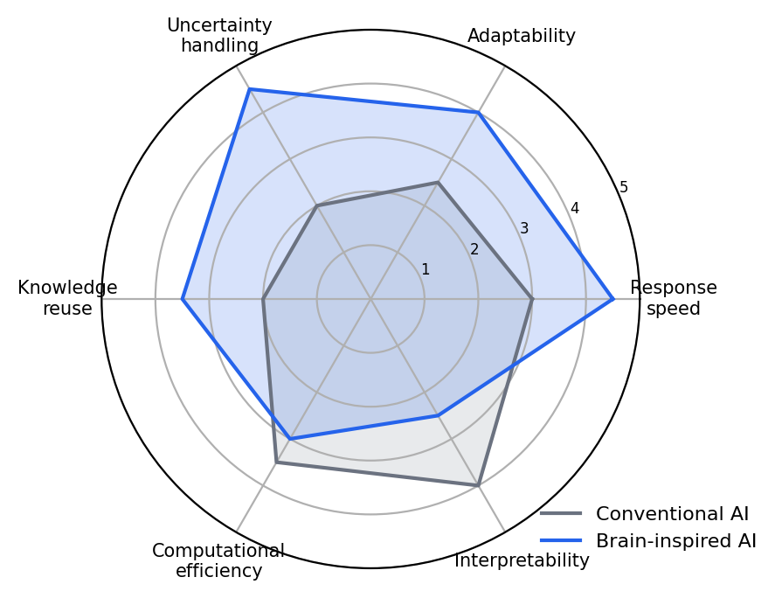
Figure 2.4: Comparative analysis of brain-inspired versus conventional AI approaches.
Table 2.4: Comparative analysis of brain-inspired approaches against conventional AI methods.
Feature | Conventional AI | Brain-inspired AI | Relevance to grid control
Processing style | Single monolithic policy | Dual fast and slow processes | Matches protection versus dispatch timescales
Response profile | Fixed by model size | Reflex path with dedicated budget | Protection-grade action when needed
Adaptation | Periodic retraining cycles | Persistent state with attention | Tracks drifting topology and load
Uncertainty handling | Point estimates of state | Confidence-aware mode arbitration | Risk-proportionate switching
Exploration | Broadly random sampling | Guided candidate sets with tunnelling | Constraint-aware search
Explainability | Opaque end-to-end mappings | Mode labels and metacognitive state | Operator trust and auditability

The comparison in Table 2.4 is deliberately architectural rather than aspirational. Brain-inspired design does not promise better accuracy on a fixed benchmark; it promises a structure in which speed, foresight, and supervision are separately engineered and separately validated, which is the property the validation chapters of this thesis exploit.

2.6 Assessment of Existing Technologies for DER Integration
The architectures proposed for coordinating DERs fall into four broad families. Centralised schemes collect all measurements at one optimiser, which is conceptually simple and globally optimal when the model is right, but which scales poorly and creates a single point of failure. Hierarchical schemes partition the problem into tiers, with device-level control, regional aggregation, and system-level optimisation, trading a measure of optimality for tractability. Distributed schemes solve the coordination problem through peer-to-peer iteration among neighbouring controllers, with the survey of Molzahn et al. cataloguing the alternating direction method of multipliers and consensus approaches as the principal instruments [44, 46], and peer-to-peer energy trading adds a market dimension to the same technical substrate [47]. The smart grid literature frames all four families as answers to the same question, namely how much coordination to centralise given the communication and computation available [48, 49].
What works, on the evidence assembled above, is aggregation with explicit constraints. Thermostatic load control demonstrated that large populations of flexible devices can be commanded through estimated aggregate state rather than device-by-device telemetry [82, 83], and the same principle underwrites EV fleet scheduling [10, 11]. What works less well is any single-family architecture applied to a mixed-asset network: centralised optimisers stall at the timescale of the slowest asset, and purely local controllers cannot see the interactions that make coordination valuable in the first place. It appears that the practical frontier is a hybrid, hierarchical-distributed arrangement in which fast local control is supervised by slower coordination layers, which is the arrangement this thesis adopts for its benchmark.
Two institutional constructs overlay these technical families. The virtual power plant aggregates geographically dispersed resources into a single schedulable entity, so that a portfolio of PV, storage, and flexible load can bid into markets as one unit, and it depends technically on exactly the aggregation machinery cited above. Transactive energy goes further and embeds coordination in economic signals exchanged among agents, for which the bilateral contract markets studied by Morstyn, Teytelboym, and McCulloch provide one concrete mechanism [47]. Both constructs are, at bottom, coordination architectures, and both inherit the scalability and communication constraints of the family they are built upon, which is why the assessment of Table 2.5 evaluates them implicitly through the DER types they serve.
Assessment by DER type sharpens the conclusion, because different assets stress different parts of an architecture. Solar PV is forecast-limited but predictable at the daylight scale, so it rewards local voltage control and good forecasting. Wind is dominated by ramp behaviour, so it rewards stochastic dispatch and explicit curtailment rules. EV fleets are mobile and user-constrained, so they reward aggregation and degradation-aware scheduling. Battery energy storage is fast but energy-limited, so it rewards services that exploit speed without exhausting energy. Flexible loads are the cheapest flexibility available but are bounded by comfort and by telemetry gaps. Table 2.5 states this assessment compactly, and Figure 2.6 shows the architecture space within which these approaches sit.
Table 2.5: Assessment of integration approaches for different DER types.
DER type | Key characteristics | Most effective approaches | Remaining challenges
Solar PV | Daylight-correlated, inverter-coupled, forecast-limited | Local voltage control with forecasting | Night-time availability; clipping losses
Wind | Stochastic with severe ramp events | Stochastic dispatch and curtailment rules | Ramp forecasting; inertia displacement
EV fleets | Mobile, user-constrained, aggregated | Fleet scheduling with degradation awareness [84] | Availability uncertainty; fairness
BESS | Fast response, energy-limited | Arbitrage, regulation, and voltage services | Capacity fade; sizing economics
Flexible loads | Thermostatically bounded, telemetry-limited | Aggregate state-estimation control [82, 83] | Comfort bounds; observability gaps

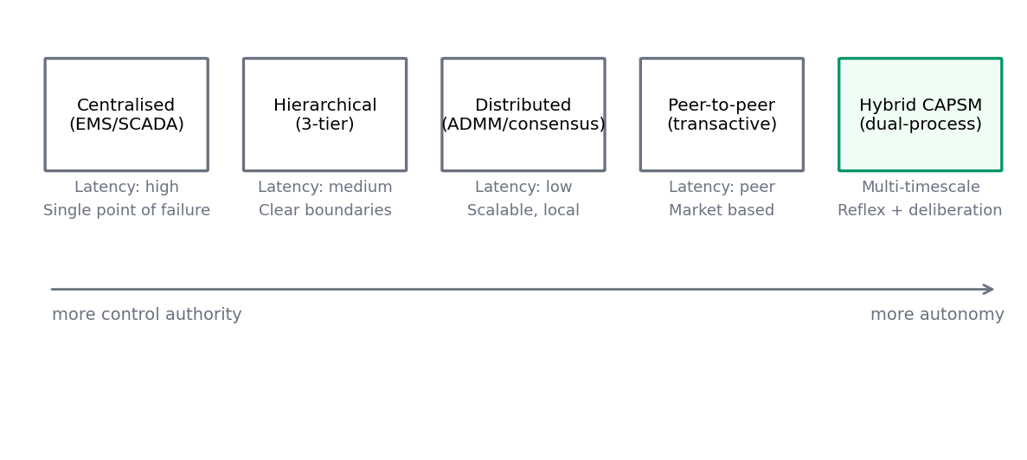
Figure 2.6: Communication and control architectures for DER integration.
The reading of Table 2.5 that matters for the problem statement is the final column: every DER class retains challenges that no amount of local optimisation resolves, because the difficulties are coordinative in nature. That observation motivates the gap analysis of Section 2.7, which returns to the five gaps of Chapter 1 with the evidence of this chapter in hand.

2.7 Gap Analysis and Motivation for Hybrid Frameworks
The literature surveyed in Sections 2.1 through 2.6 can now be brought to bear on the five gaps stated in Chapter 1, and the exercise shows that each gap is corroborated from at least two independent directions. Gap 1, the absence of control architectures for heterogeneous systems, is visible both in the DER integration assessment, which found that no single architecture family suits mixed assets, and in the FACTS literature, which coordinates devices among themselves but not with DERs. Gap 2, real-time decision-making under uncertainty, is documented on the algorithmic side by the sample inefficiency and constraint-violation caveats that the DRL surveys attach to their enthusiasm [27, 28], and on the methods side by the conservatism that safe reinforcement learning buys its guarantees with [29, 30]. Gap 3, FACTS–DER coordination, follows from Section 2.2, where devices act on local objectives [4, 6], together with Section 2.4, where fleets are optimised on horizons that ignore network physics [10, 11].
Gap 4, fault detection and localisation in resource-rich environments, is corroborated by the stability-assessment literature, whose offline classifiers degrade under the topology drift that abundant telemetry reveals [87, 88], and by the cyber-physical security literature, which shows that false data injection defeats detectors designed for a smaller observation space [75]. Gap 5, the theory-to-practice divide, is the subject of Section 2.8 and is stated here only in preview: the AI-in-power-systems literature of Table 2.1 ends, in almost every entry, at offline validation. The five gaps are therefore not artefacts of one survey or one viewpoint; they are the consistent residue of two decades of progress that advanced algorithms faster than architectures and validation.
The case for hybrid frameworks rests on complementarity rather than on novelty for its own sake. Complementary strengths argue for combining families whose weaknesses do not coincide: a reflexive neural path supplies speed where optimisation is too slow, a candidate-based deliberative layer supplies foresight where reflexes are myopic, and physics-informed structure supplies constraint discipline where pure data-driven methods wander [31]. Multi-timescale necessity argues for the same combination, since Section 2.2 established that FACTS devices respond in tens of milliseconds while EV dispatch evolves over minutes and hours, so one controller cannot serve both without an explicit notion of timescale. Balanced exploration and exploitation argue for deliberation by candidates, in which a bounded set of alternatives is evaluated against the current network state rather than sampling blindly; the quantum-inspired mechanism adopted in Chapter 3 formalises exactly this balance. Resilience argues for mode arbitration, because a controller that can retreat to a safe mode when stressed degrades gracefully in the way Table 2.4 anticipates. Transitional implementation, finally, argues that a hybrid can be introduced atop existing energy management and distribution management systems, layer by layer, rather than demanding a wholesale replacement of certified infrastructure.
The literature also indicates what a hybrid framework must demonstrate to be credible, and this sets the acceptance criteria for the rest of the thesis. It must show that the reflex path meets a protection-grade timing budget, that the deliberative path converges within a dispatch-relevant budget, that arbitration between them does not oscillate, and that the whole composition respects network constraints at every step. It must, in addition, demonstrate these properties on hardware, which is the requirement that most of the surveyed literature does not meet and that the following section examines in detail.

2.8 Real-Time Simulation and HIL Validation in Power Systems
Real-time simulation exists because some questions about control equipment cannot be answered offline. A protective relay, a phasor measurement unit, or a learned controller does not merely compute an answer; it computes an answer within a deadline, from finite-precision inputs, across physical interfaces whose latency and noise are part of the experiment. Real-time digital simulation addresses this by solving the network equations on specialised hardware in lockstep with wall-clock time, so that a device under test can be coupled to a simulated network and behave exactly as it would in the field. The technique was established for relay testing by McLaren et al. with the real-time digital simulator developed for that purpose [53], and real-time PC-based simulation of circuits and drives extended the practice beyond dedicated mainframes [54].
Within the real-time family, the hardware-in-the-loop (HIL) hierarchy distinguishes what is real and what is simulated. Model-in-the-loop (MIL) runs the controller as a model beside the plant model; software-in-the-loop (SIL) runs the controller code on a non-real-time processor; processor-in-the-loop (PIL) runs the code on the target processor with simulated inputs; Controller-HIL (CHIL) couples the full controller hardware to the simulator through signal-level interfaces; and Power-HIL (PHIL) couples actual power through amplifiers, adding the stability and safety questions of the interface itself. The characteristics and design constraints of PHIL, in particular the interface compensation required to keep the coupled system stable, are analysed by Lauss et al., whose treatment also delimits CHIL from PHIL by the level at which the controller is coupled [51]. The broader survey of real-time simulation technologies by Faruque et al. maps the platforms and applications across the hierarchy and remains the standard reference for what each level of the hierarchy can and cannot prove [52].
The OPAL-RT family of simulators is the platform used in this thesis and is representative of the state of the art. Its RT-LAB environment distributes a Simulink model across processing cores that execute in lockstep, with the vendor documentation describing the toolchain and its deployment flow [55, 56]. Electromagnetic transient solvers execute at steps in the tens of microseconds, in this project 50 µs, while phasor-domain solvers execute at millisecond steps, in this project 1 ms, and the two can be coupled where a study needs both detail and reach. Community and academic model repositories supply ready-made networks in this toolchain; the IEEE 39-bus model published by the Distributed Electrical Systems Laboratory at EPFL is the basis of the real-time network used in Chapters 10 and 11 [57]. Communication with the controller under test proceeds through standard protocols, with synchrophasor streaming defined by IEEE C37.118 [89], substation automation by IEC 61850 [91], and time synchronisation by the Precision Time Protocol [92].
Two adjacent literatures show how real-time infrastructure serves research beyond controller testing. Cyber-physical security testbeds couple real-time grid simulation with real network equipment and attack tools, so that intrusions and defences are studied at physically meaningful timescales; the testbed architecture and evaluation methodology of Hahn et al. is the template [76]. Digital twins bind a real-time model to a physical asset over its lifetime, so that monitoring, what-if analysis, and controller updates are performed against a live surrogate; the concept originated in aerospace life-prediction practice [77] and its modelling challenges and enablers are surveyed by Rasheed, San, and Kvamsdal [78]. Both literatures depend on the same substrate this section describes, namely a real-time network model that is faithful enough for the conclusions drawn on it to transfer to the field.
Against this background, the validation practice of the AI-in-power-systems literature stands out by its absence. The survey bodies assembled in Section 2.1 [27, 28] and the method families of Section 2.3 describe training and evaluation in offline simulation almost exclusively: reward curves, violation counts, and accuracy figures are computed in non-real-time Python or MATLAB environments, with solver iteration unconstrained by any deadline. The real-time and HIL literature, conversely, demonstrates exquisite validation rigour for conventional controllers, relays, and protection schemes [51]–[53], but its subjects are rarely learning-based controllers, and when they are, the cognitive layer is usually a single network rather than an architecture with arbitration. Between the two literatures lies a gap that is easy to state and consequential to fill: most AI power-system papers never validate on real-time hardware, and no established practice exists for validating a dual-process cognitive controller whose reflex path, deliberative path, and arbiter each carry distinct timing budgets.
The consequences of skipping real-time validation are not cosmetic, and the literature on each failure mode makes this plain. A controller that meets its inference budget offline may miss the corresponding deadline on hardware once solver coupling, input-output latency, and operating-system jitter are added; a policy trained against a non-real-time environment has never faced the sampling rhythm at which it must act; and an arbitration law tuned offline has never been exercised at the interrupt granularity of a real target. It appears that conclusions about accuracy transfer poorly to conclusions about deployability, and it is deployability that the five gaps of this thesis are ultimately about. The missing link in the literature is therefore real-time hardware validation of cognitive controllers, performed at the same standard of rigour the HIL community applies to relays.
CAPSM's three-stage validation pipeline is designed to close exactly this link, and the design principle is traceability from stage to stage. Stage 1 builds the offline benchmark in Python with PYPOWER quasi-static time series, where algorithms are trained and compared; Stage 2 prepares the Simulink model of the same network, with FACTS and EV subsystems, for the real-time toolchain; Stage 3 executes the framework as Controller-HIL on a four-core OPAL-RT target, with the reflexive path, the deliberative path, and the arbiter assigned to cores and to explicit timing budgets. The progression MIL, SIL, PIL, CHIL is thereby traversed deliberately rather than rhetorically, in the direction recommended by the real-time simulation literature [51, 52], and the offline-to-hardware consistency of the framework is measured rather than assumed. The thesis accordingly treats Stage 3 not as a demonstration but as an experiment with stated acceptance criteria, and Chapter 10 specifies them before Chapter 11 reports whether they were met.
Nothing in this list of acceptance criteria is exotic, which is rather the point. Each criterion is testable with instruments the real-time simulation community already possesses, and none requires that the controller surrender its learning-based character. What has been missing is the joint demonstration, and the framework of the next chapter is constructed so that the demonstration can be staged, budget by budget, through the pipeline described in this section.

Chapter 3: Proposed Framework

3.1 Framework Overview and Design Philosophy
The preceding chapters established that modern transmission systems must coordinate three physically heterogeneous asset families, namely flexible AC transmission system (FACTS) controllers [4, 5, 6, 7], electric vehicle (EV) fleets with vehicle-to-grid capability, and distributed energy resources (DERs), under operating conditions that change faster than conventional energy management cycles. This chapter presents the Cognitive Adaptive Power System Management (CAPSM) framework, which meets that coordination requirement with a single control architecture inspired by the dual-process theory of human cognition [16, 17, 18]. Rather than forcing one algorithm to serve all timescales and all assets, CAPSM separates the control task into a fast reflexive pathway and a slower deliberative pathway, and it delegates the decision of when to trust each pathway to a third, metacognitive component. The framework is designed from the outset to be deployable on real-time hardware, which distinguishes it from the majority of AI-based power system controllers surveyed in Chapter 2.
The cognitive foundation of CAPSM rests on the observation, due to Kahneman [16] and to Evans and Stanovich [17], that human decision-making combines two complementary processes. System 1 operates quickly, automatically, and with low effort, and it excels in familiar situations where learned patterns map directly onto actions. System 2 operates slowly, deliberately, and with high effort, and it handles novel or demanding situations that require reasoning. Kahneman and Klein further showed that intuitive expertise arises when environments are regular enough for learned patterns to be reliable [18]. Power system operation exhibits precisely this structure: most operating hours are statistically similar and admit fast reflexive voltage support, while contingencies, extreme ramps, and abnormal telemetry demand deliberate coordination. CAPSM transfers this organisation onto the control loop, as we develop in Section 3.2.
Three design principles govern the architecture. The first principle is cognitive duality: every control cycle is executed by two parallel controllers, a reflexive System 1 built from a convolutional recurrent network and a deliberative System 2 built from quantum-inspired reinforcement learning (QIRL), with inference budgets below 5 ms and below 50 ms per step respectively. The second principle is hierarchical coordination: control authority is distributed across device, regional, and system tiers so that local reflexes never conflict with global objectives, following the layered control philosophy of [36] and [124]. The third principle is adaptive learning: the framework improves with experience through behaviour cloning, online amplitude reinforcement, and monitored retraining, in line with the reinforcement learning foundations of [22] and [23].
CAPSM is organised around the five control gaps identified in Chapter 1, and each gap receives a targeted design response. Gap 1, the absence of control architectures suited to heterogeneous assets, is addressed by the shared nine-dimensional action box defined in Section 3.2, which exposes FACTS setpoints and EV fleet power on one common interface. Gap 2, limited real-time decision-making under uncertainty, is addressed by the dual-process pairing of a sub-5 ms neural reflex with a sub-50 ms deliberative optimiser and by the Metacognitive Arbiter that interpolates between them. Gap 3, insufficient coordination between FACTS devices and DERs, is addressed by the three-tier hierarchy of Section 3.3 and by the coordinated control strategies of Section 3.7. Gap 4, insufficient fault detection and localisation in resource-rich environments, is addressed by the multi-modal fusion architecture of Section 3.6. Gap 5, the barrier between theoretical controllers and field practice, is addressed by making the framework hardware-ready from the first design iteration, as specified in Section 3.9 and implemented in Chapter 10.
The high-level organisation of the framework is shown in Figure 3.1, which depicts the observation pipeline, the two control pathways, the arbitration layer, and the actuation interfaces to FACTS devices, EV fleets, and DERs on the IEEE 39-bus test system. The figure also indicates the physical measurements that feed the framework, including phasor measurement unit (PMU) streams and supervisory control and data acquisition (SCADA) telemetry. All subsequent sections refine the blocks of this figure, and Chapter 4 specifies their implementation in executable detail.

Figure 3.1: High-level architecture of the CAPSM framework.

3.2 Brain-Inspired Dual-Process Control Architecture
The System 1 controller is the reflexive pathway of CAPSM. It receives a sliding window of encoded system observations and maps that window directly onto continuous setpoints through a convolutional recurrent network with an attention mechanism. Formally, at time step $t$ the controller emits
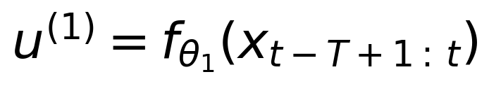 | (3.1)
where $f$ denotes the CNN-LSTM network with trainable parameters $\theta_1$, $x$ denotes the encoded system state, and $T = 12$ is the window length in hourly observations. The encoder compresses each observation into 160 features covering bus voltage magnitudes and angles, branch flows, generator outputs, FACTS setpoints, EV fleet states, and aggregate scalars, following the layout specified in Section 4.1. The network architecture and its training procedure are specified in Section 4.2 and Section 4.6, where the long short-term memory (LSTM) formulation of [32] and the attention mechanism of [34] are written out explicitly. The design intent of System 1 is frequency of response rather than depth of reasoning: its inference budget is strictly below 5 ms per step so that it can act within the same order of magnitude as local protection and fast excitation control.
The System 2 controller is the deliberative pathway. Instead of regressing setpoints from learned patterns, it searches the action space for the control vector that minimises an expected closed-loop cost:
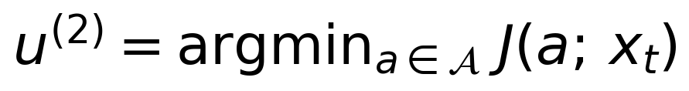 | (3.2)
where $\mathcal{A}$ denotes the shared action box defined below and $J$ denotes the expected cost of applying action $a$ from state $x_t$. CAPSM instantiates $J$ through the quantum-inspired candidate evaluation of Section 3.5, in which 32 candidate actions are scored in parallel against the current network state. Because the search is performed against the physics of the power flow rather than against a static training set, System 2 requires no offline training data, which makes it immediately transferable to new operating regions, a property that Chapter 2 identified as missing from most deep reinforcement learning approaches [23, 27, 28]. Its inference budget is below 50 ms per step, an order of magnitude slower than System 1 but still compatible with supervisory control cycles.
The Metacognitive Arbiter closes the architecture. It observes the system stress, decides how much authority each pathway deserves, and merges their outputs. The stress metric is the mean absolute voltage deviation
$$c_1 = \mathrm{mean} |V_m - 1.0|$$
evaluated over all buses, where $V_m$ is the vector of bus voltage magnitudes in per unit. The arbitration weight follows a sigmoid law,
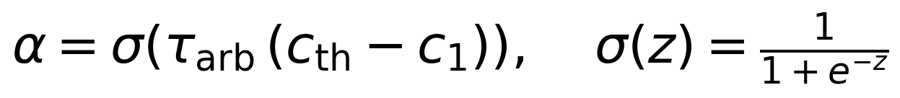 | (3.3)
with threshold $c_{\mathrm{th}} = 0.03$ p.u. and sharpness $\tau_{\mathrm{arb}} = 50$. The blended command applied to every FACTS scalar and every EV setpoint is then
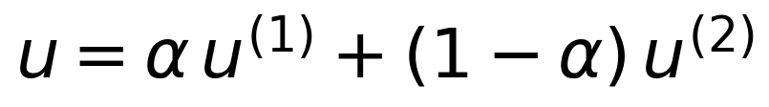 | (3.4)
When the system is relaxed, $c_1$ falls below the threshold, $\alpha$ approaches 1, and the reflexive pathway dominates. When the system is stressed, $\alpha$ approaches 0 and the deliberative pathway takes over. In the January 2019 benchmark the mean stress is approximately 0.0286 p.u., which lies just below the threshold and yields a mean arbitration weight near 0.52, so the blended controller tracks the deliberative pathway while retaining the reflex option, as the results in Chapter 11 confirm.
The shared action box $\mathcal{A}$ is the nine-dimensional product of per-asset setpoint intervals listed in Table 4.2: shunt susceptances for the SVC at bus 14 and the STATCOM at bus 39, the series compensation degree of the TCSC on line 16–17, the shunt and series channels of the unified power flow controller (UPFC) at bus 26, and the charge or discharge power of three aggregated EV fleets at buses 3, 8, and 15. All three control paths operate on this common set, and the following proposition records the geometric property that makes their combination safe.
Proposition 3.1 (Action-box convexity and closure under CAPSM blending). Statement. Let $\mathcal{A} = \prod_{i=1}^{9} [\mathrm{lo}_i, \mathrm{hi}_i]$ be the action box with lower vector $\mathrm{lo} = (-0.5, -1.0, 0.3, -0.5, -0.5, -0.5, -50, -50, -50)$ and upper vector $\mathrm{hi} = (0.5, 1.0, 0.7, 0.5, 0.5, 0.5, 50, 50, 50)$ in their respective units. Then $\mathcal{A}$ is convex, and for every blending weight $\alpha \in [0, 1]$ and every pair $u^{(1)}, u^{(2)} \in \mathcal{A}$, the blended command of Equation (3.4) satisfies $u \in \mathcal{A}$.
Proof. The box is the intersection of the half-spaces $\{u : \mathrm{lo}_i \leq u_i\}$ and $\{u : u_i \leq \mathrm{hi}_i\}$ for $i = 1, \dots, 9$, and an intersection of convex sets is convex, so $\mathcal{A}$ is convex. For the closure property, fix a component $i$ and write $u_i = \alpha\, u^{(1)}_i + (1-\alpha)\, u^{(2)}_i$. Because $\alpha \geq 0$, $(1-\alpha) \geq 0$, and the two coefficients sum to one, the combination lies between $u^{(1)}_i$ and $u^{(2)}_i$. Both endpoints obey $\mathrm{lo}_i \leq u^{(1)}_i, u^{(2)}_i \leq \mathrm{hi}_i$, hence $\mathrm{lo}_i \leq u_i \leq \mathrm{hi}_i$. Since this holds for every component, $u \in \mathcal{A}$, which completes the proof.
Proposition 3.1 has a practical consequence that shapes the whole implementation. System 1 applies a componentwise clip to its raw network output, System 2 samples its candidates uniformly inside the box, and therefore both inputs of the arbiter always lie in $\mathcal{A}$; the blend then remains in $\mathcal{A}$ without any further projection step. Feasibility of the setpoints with respect to the AC power flow follows from the device models of Section 3.4, and the January 2019 evaluation indeed converged at every one of the 721 hourly steps for all controllers, a result reported in Section 11.1. The same property underlies the mode classification of the arbiter in Chapter 4, because any of the five arbitration modes can be entered and exited without leaving the feasible action set.

3.3 Multi-Layer Coordination Architecture
Coordinated control of heterogeneous assets requires an explicit answer to the question of which controller decides what, and at which speed. CAPSM answers with a three-tier hierarchy, illustrated in Figure 3.2, that separates device-level reflexes, regional coordination, and system-wide optimisation. The tiering follows the classical hierarchical control doctrine for power systems [36], [124], but each tier is populated with the learning-based components developed in this thesis rather than with purely analytical regulators alone.
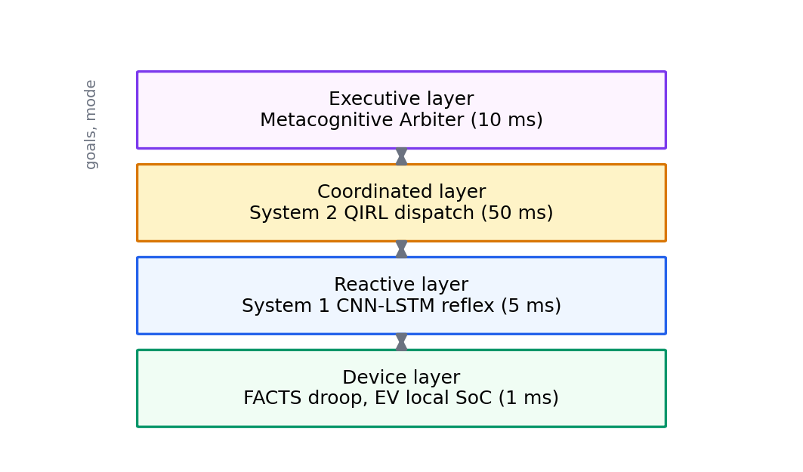
Figure 3.2: Hierarchical control structure in the CAPSM framework.
The device tier comprises the fastest, most local loops: the FACTS shunt and series controllers regulating their bus voltages and branch flows [4], [6], and the local state-of-charge (SoC) supervision of each EV station that enforces the battery limits derived in Section 3.4. The regional tier groups buses into coherent zones, in the case of the IEEE 39-bus system the northern buses 1 to 19 and the southern buses 20 to 39, and resolves interactions that individual devices cannot see, such as reactive power competition between neighbouring shunt devices. The system tier hosts the dual-process controllers of Section 3.2 and the global objectives of Section 3.7, and it is the only tier with visibility of the full network state.
Information moves through the hierarchy in five recurring steps. First, device and PMU telemetry are acquired at the device tier and time-stamped against the synchronised clock. Second, the regional tier aggregates the telemetry, aligns it through the state estimation described in Chapter 4, and compresses it into the 160-feature observation vector. Third, the system tier evaluates the observation through System 1 and System 2 and produces candidate setpoints. Fourth, the Metacognitive Arbiter blends the candidate setpoints and broadcasts them down the hierarchy, where regional coordination resolves any residual conflicts between neighbouring assets. Fifth, the devices actuate and the resulting network response is measured again, closing the loop. The five steps repeat at every control cycle, and each step carries the time budget assigned to it in Section 3.9.
Because the three tiers cannot run at one common rate without either starving the devices or overloading the supervisory layer, CAPSM adopts a multi-rate scheme, shown in Figure 3.3. The electromagnetic transient solver on the real-time simulator advances at 50 microseconds, the phasor solver at 1 ms, the System 1 reflex at a 5 ms period, the arbiter at a 10 ms period, and the System 2 deliberative loop at a 50 ms period, while the offline quasi-static time-series (QSTS) evaluation used for validation advances in hourly steps. Rate-monotonic schedulability of these periodic tasks on a fixed set of processors can be assessed with the classical utilisation bound of Liu and Layland [45], and Chapter 10 performs that assessment for the four-core deployment. The multi-rate structure also mirrors the temporal coordination of services discussed in Section 3.7, where each asset family contributes on the timescale at which it is physically effective.
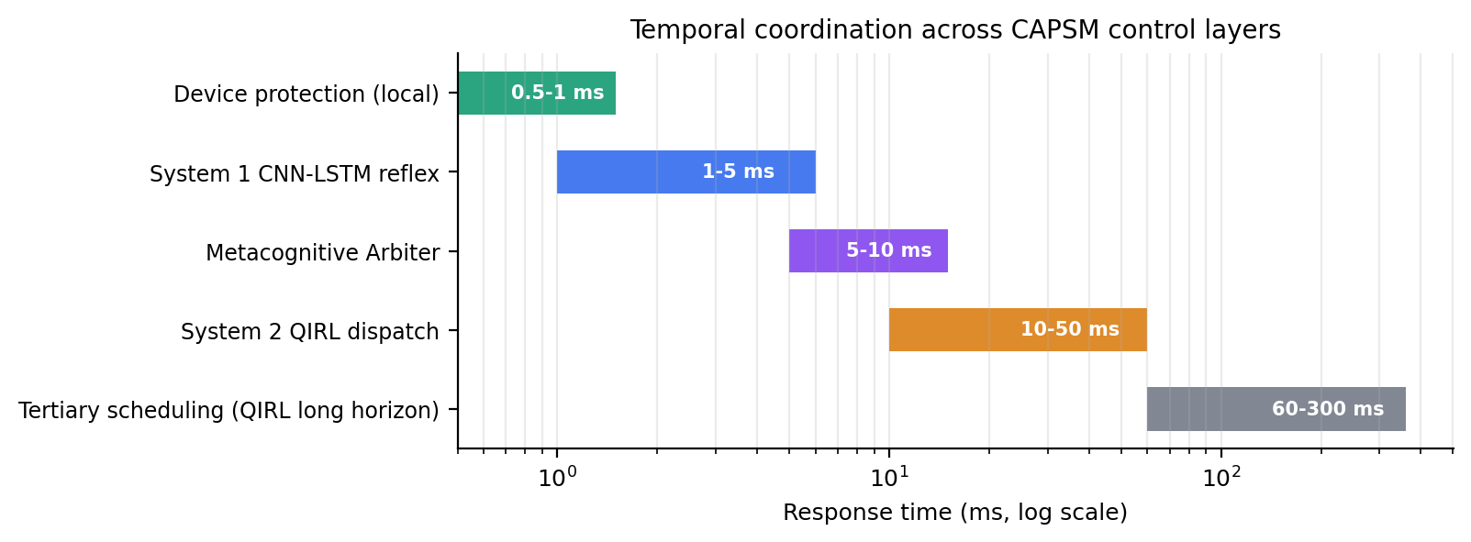
Figure 3.3: Temporal coordination framework showing engagement of assets across timescales.

3.4 Mathematical Modelling of Integrated Components
This section assembles the mathematical models on which the controllers of Section 3.2 operate. The models are deliberately kept at the steady-state and quasi-static level, because the framework is validated on quasi-static time series with hourly resolution and on phasor-domain real-time simulation; electromagnetic transient detail is introduced only where the hardware deployment requires it in Chapter 10. All models are implemented exactly as written here in the open code base, which guarantees that the analysis, the proofs, and the reported results refer to the same equations.

3.4.1 AC Power Flow and the Newton Solution
The network coupling is described by the rectangular balance of active and reactive power at every bus. For bus $i$ of an $n$-bus system with voltage magnitudes $V$ and angles $\theta$, the injected powers are
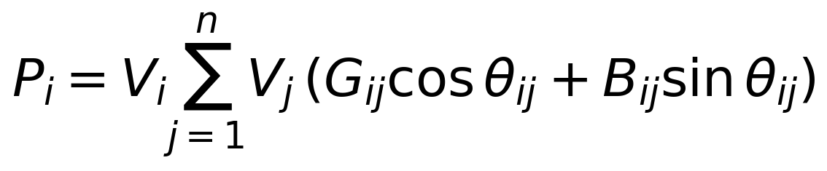 | (3.5)
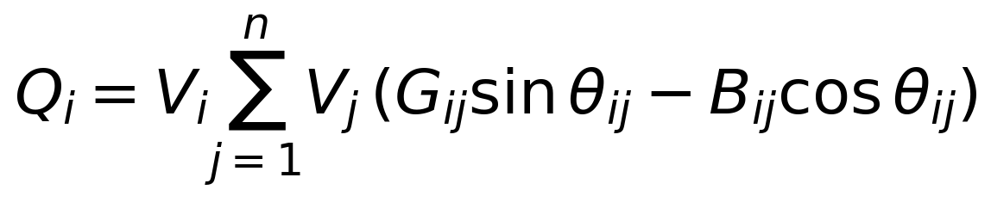 | (3.6)
where $G_{ij}$ and $B_{ij}$ are the conductance and susceptance entries of the bus admittance matrix and $\theta_{ij} = \theta_i - \theta_j$ [38], [122]. Collecting the mismatch equations for all non-slack buses yields a nonlinear system $F(x) = 0$ in the state vector $x$ of voltage magnitudes and angles, which the Newton-Raphson method solves by the iteration
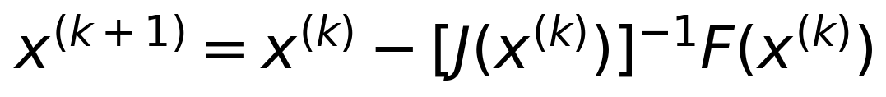 | (3.7)
with $J$ the Jacobian of the mismatch equations [39], [40]. The implementation uses the PYPOWER solver [41], and the convergence behaviour of this iteration underpins every result in the thesis, so its local property is recorded formally.
Lemma 3.1 (Local convergence of the Newton-Raphson power flow). Statement. Let $F$ be continuously differentiable in a neighbourhood of a solution $x^{}$ with $F(x^{}) = 0$ and $J(x^{})$ nonsingular. Then there exists $\varepsilon > 0$ such that for every start $x^{(0)}$ with $\Vert x^{(0)} - x^{} \Vert < \varepsilon$ the iteration of Equation (3.7) is well defined and converges to $x^{}$, and there is a constant $C > 0$ with $\Vert x^{(k+1)} - x^{} \Vert \leq C \Vert x^{(k)} - x^{*} \Vert^{2}$, that is, the convergence is quadratic.
Proof sketch. Taylor expansion of $F$ around $x^{(k)}$ gives $F(x^{}) = F(x^{(k)}) + J(x^{(k)})(x^{} - x^{(k)}) + R$, with the remainder bounded by $K \Vert x^{} - x^{(k)} \Vert^{2}$ since $F$ is twice differentiable in the neighbourhood. Substituting the Newton step of Equation (3.7) and using $F(x^{}) = 0$ yields $x^{(k+1)} - x^{} = -[J(x^{(k)})]^{-1} R$. By continuity of the inverse near the nonsingular $J(x^{})$, the norm of $[J(x^{(k)})]^{-1}$ is bounded by some $M$ for all $x^{(k)}$ close enough to $x^{}$, so $\Vert x^{(k+1)} - x^{} \Vert \leq M K \Vert x^{(k)} - x^{*} \Vert^{2}$, and taking $C = MK$ with $\varepsilon$ small enough that $C \varepsilon < 1$ gives both convergence and the quadratic rate. The matrix analysis underlying the inverse bound follows [121], and the full classical treatment is given in [39] and [123]. This completes the proof sketch.
The uncontrolled IEEE 39-bus power flow solves in approximately 7.8 ms per step on the reference workstation, which fixes the computational floor of any controller that embeds a full AC solution in its evaluation loop, a fact that motivates the candidate evaluation design of Section 3.5.

3.4.2 FACTS Device Models
The FACTS family is represented at the steady-state level as controllable modifications of the bus admittance structure, which is the standard quasi-static representation for shunt and series devices [4], [5], [6]. The SVC at bus 14 and the STATCOM at bus 39 act as controllable shunt susceptances. Writing the commanded increment as $\Delta b$, the applied susceptance is
(3.8)
with the range $B_{\mathrm{sh}} \in [-0.5, 0.5]$ p.u. for the SVC and $[-1.0, 1.0]$ p.u. for the STATCOM. The clamp in Equation (3.8) guarantees that no controller command, learned or otherwise, can push the device outside its rating. The TCSC on line 16–17 modifies the series reactance of the branch according to
(3.9)
where $X$ is the natural branch reactance and $k$ is the compensation degree; the operational setpoint range used by the controllers is $k \in [0.3, 0.7]$, which keeps the device in its designed compensation band as discussed in Section 4.1 [7]. The UPFC at bus 26 combines both principles: a shunt susceptance at bus 26 within $\pm 0.5$ p.u. and a series channel on branch 26–28 with compensation degree $k \in [0, 0.5]$ and an injected series power of magnitude at most 0.5 p.u. Its admissible command set is therefore the product
(3.10)
which makes the UPFC the richest single actuator in the action box and, at the same time, the device whose channels must be coordinated most carefully by the arbiter. All FACTS models apply their modifications directly to the power flow input data before each solution, so the device limits in Equations (3.8) to (3.10) are enforced by construction rather than by post-hoc correction.

3.4.3 EV Fleet Aggregation and State-of-Charge Dynamics
Each of the three EV stations at buses 3, 8, and 15 represents an aggregated fleet of bidirectional vehicles, a standard reduction for transmission-level studies that preserves the aggregate power and energy capability while abstracting from individual parking events. Station $b$ is characterised by its power limit $p_{\mathrm{max}} = 50$ MW, its usable energy capacity $E_{\mathrm{cap}} = 100$ MWh, its one-way efficiency $\eta = 0.92$, and its SoC limits $[0.2, 0.9]$ with initial value 0.5, and the time step is $\Delta t = 1$ h. Charging with power $P_t > 0$ advances the state of charge according to
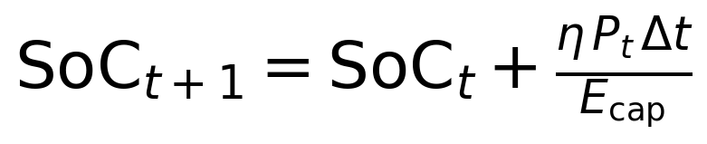 | (3.11)
while discharging with $P_t < 0$ loses an additional fraction to the round trip and obeys
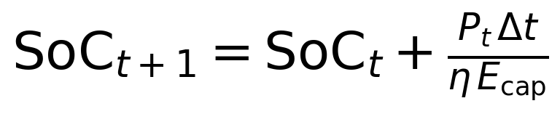 | (3.12)
The dispatch rule that precedes the update applies four steps in fixed order: the commanded power is clamped to $[-p_{\mathrm{max}}, p_{\mathrm{max}}]$; charging commands are zeroed when the station is already at or above the upper SoC bound; discharging commands are zeroed at or below the lower bound; and the resulting SoC is projected onto $[0.2, 0.9]$. The efficiency asymmetry between Equations (3.11) and (3.12) reflects energy lost in the power electronics and the battery during each one-way transfer, and it implies that a full charge-discharge cycle returns at most $\eta^2 \approx 0.85$ of the withdrawn energy, a factor that the service valuation of Section 3.7 must respect. The rule set looks innocuous, but it is what guarantees that the fleet can never damage its batteries by following learned commands, so it deserves a formal statement.
Proposition 3.2 (Invariance of the SoC trajectory under the dispatch rule). Statement. Consider any station with $E_{\mathrm{cap}} > 0$, $\eta \in (0, 1]$, bounds $[\mathrm{SoC}_{\mathrm{lo}}, \mathrm{SoC}_{\mathrm{hi}}] = [0.2, 0.9]$, and initial state $\mathrm{SoC}_0 \in [0.2, 0.9]$, operated under the dispatch rule consisting of (i) clamping the command to $[-p_{\mathrm{max}}, p_{\mathrm{max}}]$, (ii) zeroing charging commands at $\mathrm{SoC} \geq \mathrm{SoC}_{\mathrm{hi}}$ and discharging commands at $\mathrm{SoC} \leq \mathrm{SoC}_{\mathrm{lo}}$, (iii) the updates of Equations (3.11) and (3.12), and (iv) projection of the updated SoC onto $[0.2, 0.9]$. Then $\mathrm{SoC}_t \in [0.2, 0.9]$ for all $t \geq 0$.
Proof. The proof proceeds by induction on $t$. Base case: $\mathrm{SoC}_0 \in [0.2, 0.9]$ holds by assumption. Inductive step: assume $\mathrm{SoC}_t \in [0.2, 0.9]$ for an arbitrary $t$. If rule (ii) zeroes the command, then $\mathrm{SoC}_{t+1} = \mathrm{SoC}_t$ and the claim holds. Otherwise, if the station charges, the increment $\eta P_t \Delta t / E_{\mathrm{cap}}$ in Equation (3.11) is non-negative, so the provisional value satisfies $\mathrm{SoC}_{t+1} \geq \mathrm{SoC}_t \geq 0.2$, and rule (iv) caps it at 0.9. If the station discharges, the increment $P_t \Delta t / (\eta E_{\mathrm{cap}})$ in Equation (3.12) is non-positive, so the provisional value satisfies $\mathrm{SoC}_{t+1} \leq \mathrm{SoC}_t \leq 0.9$, and rule (iv) floors it at 0.2. In every case $\mathrm{SoC}_{t+1} \in [0.2, 0.9]$, which closes the induction and completes the proof.
The proposition shows that the battery envelope is an invariant set of the closed-loop dispatch system, independently of how aggressive the learned commands are. In the implementation, rule (iv) is active in practice whenever a large charge command meets a nearly full station, for example a 50 MW command at $\mathrm{SoC} = 0.89$ would provisionally reach $0.89 + 0.46$ without the projection, so both the zeroing rules and the projection contribute to the guarantee. Chapter 8 reuses this result when valuing the energy throughput of the fleets, and it cross-references the proof rather than repeating it.

3.4.4 DER Integration and Environment Dispatch Rules
The renewable generation sites inject real power as negative load at their buses, with the national wind and solar profiles of Chapter 2 disaggregated onto the network; on the IEEE 39-bus system the wind sites sit at buses 4 and 14 and the solar sites at buses 8 and 15. Reactive demand scales with the active demand at constant per-bus power factor, $Q = Q_0 (P / P_0)$, so that load changes preserve the power factor structure of the base case. Two environment rules then keep the dispatch physically meaningful, and Proposition 3.3 establishes their internal consistency; the rules are reproduced exactly from the environment implementation so that the proof refers to code-level behaviour.
The first rule is the renewable curtailment cap: if the total renewable injection exceeds $0.90$ times the load, all renewable sites are scaled down proportionally to the cap. In January 2019 this rule activates in 15 of the 721 hours, about 2.1 percent of the month, and it exists because transmission-level dispatch cannot assume that surplus inverter production is exportable beyond the design of the corridor. The second rule is the proportional redispatch: every non-slack generator setpoint is multiplied by the factor $\kappa = (P_{\mathrm{net}} + L_{\mathrm{est}}) / (P_{\mathrm{base}} + L_{\mathrm{est}})$, where $P_{\mathrm{net}}$ is the net load after renewable and EV adjustments, $L_{\mathrm{est}}$ is the base-case loss estimate, and $P_{\mathrm{base}}$ is the base-case load, after which $\kappa$ is clipped to $[0.2, 1.5]$ and each setpoint is capped at its maximum $P_{\mathrm{max}}$; the slack machine absorbs the residual imbalance. In the base-case preparation, generator voltage setpoints above 1.04 p.u. are capped at that value, which removes approximately 2386 false-positive violating bus-hours from the raw IEEE case data and leaves 2847 genuine violation bus-hours in the uncontrolled January 2019 benchmark, the reference figure used throughout Chapter 11.
Proposition 3.3 (Feasibility of the environment dispatch rules). Statement. Under the curtailment rule with cap factor $0.90$ and the proportional redispatch rule with $\kappa$ clipped to $[0.2, 1.5]$ and setpoints capped at $P_{\mathrm{max}}$, every non-slack generator output satisfies $0 \leq P_g \leq P_{\mathrm{max}}$, every renewable injection satisfies $P_{\mathrm{re}} \leq 0.90\, P_{\mathrm{load}}$, and the slack machine absorbs only the residual mismatch left by those bounded adjustments, so the solved dispatch remains inside the designed operating envelope of the benchmark.
Proof. The proof is by construction, following the exact order of operations in the environment. First, the curtailment rule multiplies every renewable injection by the scale $s = \min(1, 0.90\, P_{\mathrm{load}} / P_{\mathrm{re}})$, and since $s \geq 0$ the scaled injection is non-negative and at most $0.90\, P_{\mathrm{load}}$, giving the injection bound. Second, EV dispatch adds only powers already bounded by Proposition 3.2 and the clamp to $\pm p_{\mathrm{max}}$, so the net load $P_{\mathrm{net}}$ is finite and non-negative. Third, each non-slack setpoint becomes $P_g = \min(\kappa\, P_{g,0},\, P_{\mathrm{max}})$ with $\kappa \in [0.2, 1.5]$ and $P_{g,0} \geq 0$, hence $0 \leq P_g \leq P_{\mathrm{max}}$, giving the generator bound. Fourth, because every adjustment except the slack is deterministic and bounded as above, the remaining power imbalance is a bounded residual that the slack machine balances by construction of the slack bus type. The clip interval $[0.2, 1.5]$ bounds the requested redispatch excursion so that the residual stays within the range exercised by the benchmark, and the empirical confirmation is that all 721 hourly power flows of January 2019 converge for every controller tested, as reported in Section 11.1. This completes the proof.
Together, Propositions 3.2 and 3.3 establish that the learned control layer operates on top of a dispatch layer whose feasibility does not depend on the learned layer behaving well. This division of responsibility, physics-bounded envelopes with intelligence inside them, recurs in the fault detection design of Section 3.6 and in the safety analysis of Chapter 10. The loading margin assessment used alongside these rules applies a bisection search over the loading scale $\lambda \in [1, 3]$ with a coarse step of 0.05 and eight refinement iterations, following the continuation concepts of [125] in the form implemented in the stability module.

3.5 Quantum-Inspired Reinforcement Learning
System 2 requires a search mechanism that evaluates many coordinated actions per step, reinforces the ones that perform well, and still explores sufficiently to escape poor regions of the action space. CAPSM adopts a quantum-inspired formulation, drawing on the quantum computation formalism of [58] and the quantum reinforcement learning line of work in [59], [60], [61]. The approach treats the 32 candidate actions of the current step as computational basis states of a register and stores the decision state as a superposition over them, so that every candidate carries an amplitude whose squared magnitude is its selection probability.
The quantum state over the candidate set $\mathcal{A}_c$ is written as
(3.13)
where $Q(s, a)$ is the action-value estimate, $\beta$ is the inverse temperature, and $Z$ is the partition function that normalises the state. The state has 32 amplitudes $\alpha_i$, one per candidate, initialised uniformly as $\alpha_i = 1/\sqrt{32}$, and the candidates themselves are initialised by uniform sampling inside the action box of Proposition 3.1. Measurement of the state selects an action according to the Born rule,
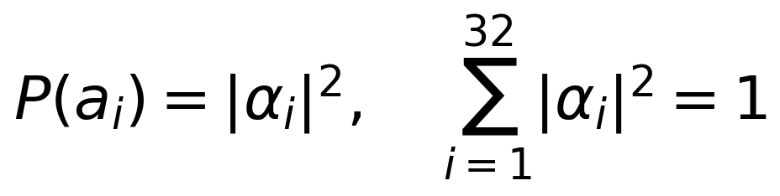 | (3.14)
which is the standard probability postulate of quantum mechanics applied here to a classical, amplitude-based decision state [58]. The Bloch sphere representation in Figure 3.4 illustrates how a two-level projection of the state visualises the balance between exploitation of high-amplitude candidates and exploration of the remainder; the figure is an intuition aid, since the implemented register is 32-dimensional and purely classical.
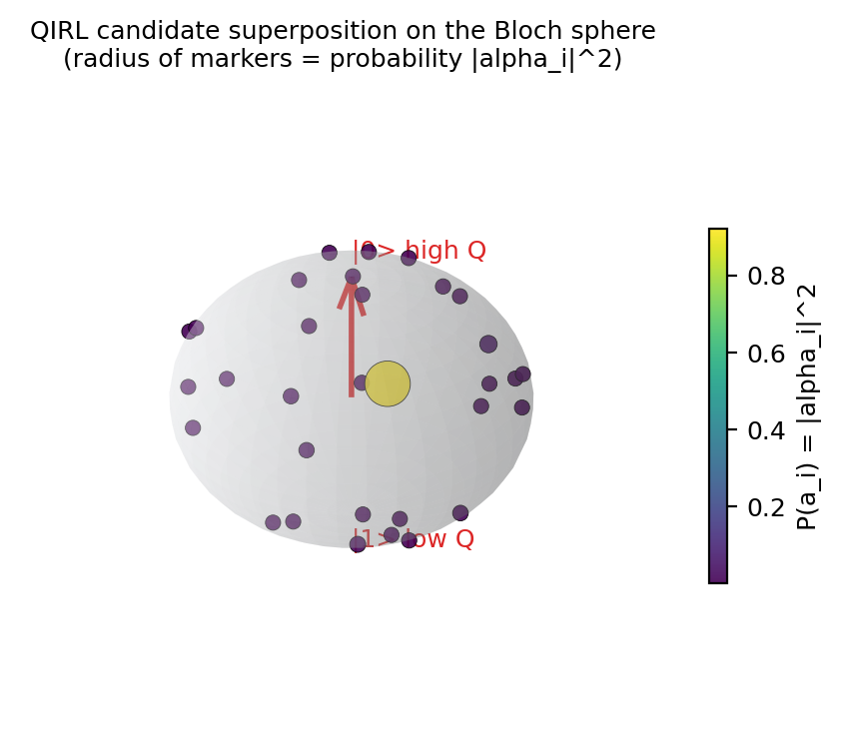
Figure 3.4: Quantum-inspired state representation.
Reinforcement enters through the amplitudes. After every evaluation step, each candidate $a_i$ receives the immediate reward
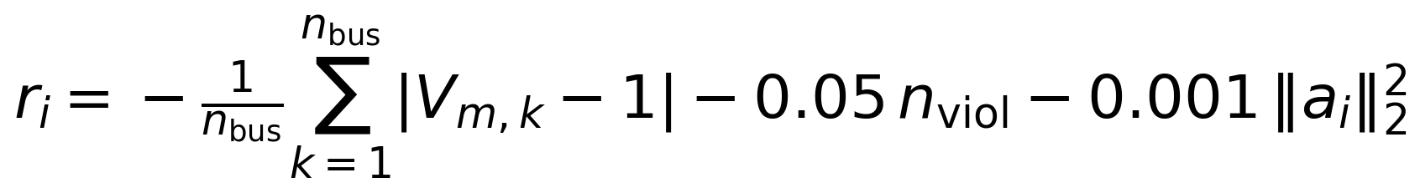 | (3.15)
which combines the mean voltage deviation, a penalty of 0.05 per violating bus in the current step, and a quadratic effort term that discourages pointless actuation; the reward shares its structure with the System 1 training reward of Section 3.7 but is computed per candidate rather than per step. The amplitude update then reinforcement-shifts the state towards well-rewarded candidates:
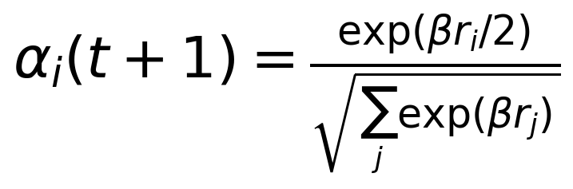 | (3.16)
The implementation evaluates Equation (3.16) after shifting all rewards by their maximum, that is, with $r_i$ replaced by $r_i - r_{\mathrm{max}}$, which leaves every probability ratio unchanged while keeping the exponentials inside floating-point range; Section 4.2 proves that the update preserves the unit norm of the amplitude vector exactly. Selection samples a candidate from the Born distribution of Equation (3.14), and the selected candidate becomes $u^{(2)}$ for Equation (3.4).
Exploration is provided by a tunnelling mechanism that mimics the passage of quantum states through classically forbidding barriers. After each selection, a fixed fraction of the candidate pool is discarded and re-sampled uniformly from the action box regardless of its current amplitude, with the fraction set to a tunnel rate of 0.1, which for 32 candidates re-randomises 3 candidates per step. Tunnelling prevents the amplitude update from collapsing the state onto a single candidate in the first steps of an episode, and it repeatedly injects diversity into regions of the action box that gradient-free selection would otherwise never revisit. The planning horizon parameter is set to 6 steps but is reserved in the Stage-1 implementation, which evaluates candidates single-step against the current power flow state; the extension to genuine multi-step rollouts is listed among the future work items in Chapter 13.
The single most important design parameter is the inverse temperature $\beta = 5.0$, and the following theorem makes its role precise.
Theorem 3.1 (Exploitation-exploration balance of the amplitude update). Statement. Let $P(a_i)$ and $P(a_j)$ be the Born-rule probabilities of any two candidates $a_i, a_j \in \mathcal{A}_c$ induced by the amplitude update of Equation (3.16). Then
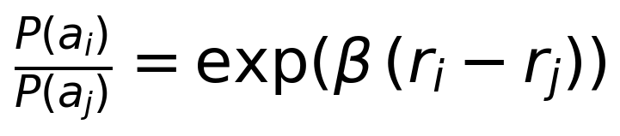 | (3.17)
so the ratio is bounded between $\exp(-\beta \Delta)$ and $\exp(\beta \Delta)$, where $\Delta = r_{\mathrm{max}} - r_{\mathrm{min}}$ is the reward spread of the current candidate pool. The bound is invariant to any common reward offset $r_i \mapsto r_i + c$.
Proof. Squaring Equation (3.16) gives $|\alpha_i|^2 = \exp(\beta r_i) / \sum_{m} \exp(\beta r_m)$, because the numerator squares to $\exp(\beta r_i)$ and the denominator squares to the sum. Taking the ratio for candidates $i$ and $j$, the normalising sums cancel and Equation (3.17) follows directly. The bounds follow from $r_i - r_j \in [-\Delta, \Delta]$. For the offset invariance, substituting $r_i + c$ into Equation (3.17) contributes a factor $\exp(\beta c)$ to numerator and denominator alike, which cancels, so the ratio is unchanged. This completes the proof.
Theorem 3.1 shows that the selection law is exactly a softmax with inverse temperature $\beta$, so $\beta$ alone governs the exploitation-exploration trade-off. With $\beta = 5.0$, a reward advantage of 0.1 yields a probability ratio of $\exp(0.5) \approx 1.65$, which keeps the distribution reasonably flat and preserves diversity among near-optimal candidates; an advantage of 0.5 yields $\exp(2.5) \approx 12.2$; and an advantage of 1.0 yields $\exp(5) \approx 148$, which effectively commits selection to the dominant candidate. The chosen value therefore implements a graded, rather than binary, preference structure, and because of the offset invariance the same behaviour is obtained whether or not the max-shift of the implementation is applied. The frame-level behaviour of the resulting controller on the January 2019 benchmark, including its 2810 violation bus-hours and 21.1 ms mean inference time in the standalone evaluation, is reported in Section 11.1, and the convergence-rate comparison against deep Q-networks, a 58 to 59 percent design target from the framework specification, is discussed with the other design targets in Section 11.4.

3.6 Multi-Modal Fault Detection and Localisation
Coordination at the speed of Section 3.7 is only useful if the framework also knows when the observed system departs from its expected behaviour. CAPSM therefore includes a multi-modal fault detection and localisation layer that fuses heterogeneous measurements into a single situational picture, following the anomaly detection concepts of [71] and the false data injection analysis of [72], with localisation methodology in the tradition of [73]. The layer is deliberately multi-modal because no single measurement family covers all fault signatures: PMU streams resolve dynamics at the synchrophasor rate, SCADA and IEC 61850 process bus traffic resolve switching and device states [91], smart meters resolve distribution-level anomalies, weather feeds explain renewable-driven excursions that would otherwise look like faults, and protection relay operations provide authoritative event stamps.
The fusion architecture, shown in Figure 3.5, operates at three levels. At the signal level, raw streams are aligned in time against the precision time protocol of [92], conditioned, and converted to per-mode feature sequences. At the feature level, the per-mode features $\phi_i(x_i)$ extracted from each source $i$ are combined into a single fused representation
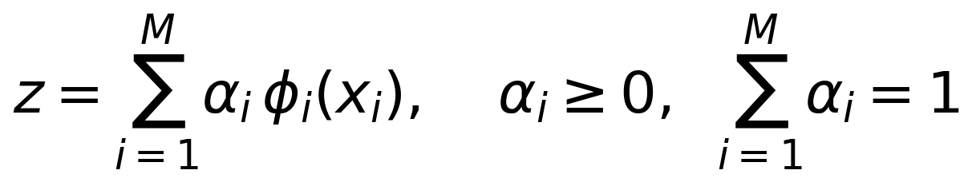 | (3.18)
where the attention weights $\alpha_i$ are learned so that trustworthy and informative modes dominate the representation in the prevailing conditions; the weighted form mirrors the attention mechanism used inside System 1 and keeps the fusion differentiable end to end. At the decision level, the fused representation feeds classifiers and residual tests: a supervised classifier assigns fault classes, an autoencoder-style reconstruction score flags unseen anomalies, and the weighted residual statistic of the state estimator, developed in Chapter 7, provides a false data injection screen with a chi-squared threshold.
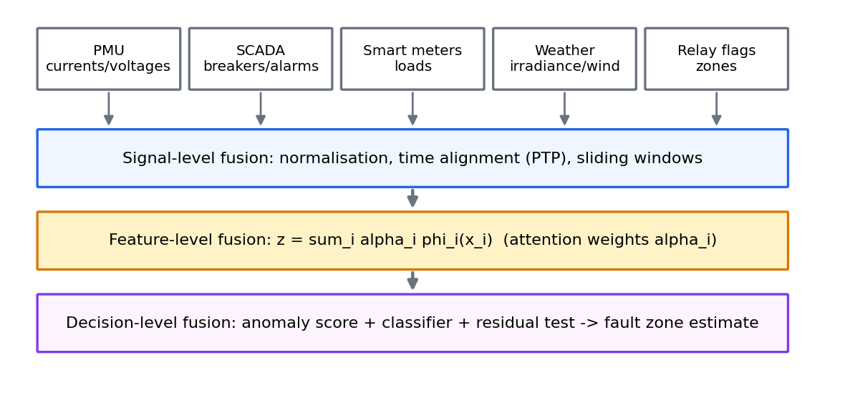
Figure 3.5: Multi-modal data fusion architecture.
The detection layer interacts with the control layer through the Metacognitive Arbiter. A confirmed anomaly raises the effective stress of the system, which shifts arbitration authority towards System 2, and a severe or safety-critical event can trigger the safe-mode classification of the arbiter described in Section 4.2. Localisation estimates the fault zone from the pattern of residuals and relay operations, which lets the coordination layer of Section 3.7 re-dispatch around the affected corridor instead of applying a blanket stress response. The framework specification sets the design targets for this layer at 95.8 percent fault detection and localisation accuracy and a 74 percent reduction in false positives relative to conventional thresholding; these are design targets from the specification rather than Stage-1 measurements, and the hardware detection latency achieved in the HIL campaign is reported in Chapter 10.

3.7 Coordinated Control Strategies
The coordination layer translates the architectural machinery of the previous sections into operating policy. Its objectives are sixfold: voltage regulation within 0.95 to 1.05 p.u., congestion relief on overloaded corridors, loss reduction, frequency response support, renewable absorption, and resilience under N-1 contingencies. These objectives are not equally achievable by every asset family, and a central design decision of CAPSM is to make the assignment of assets to objectives explicit rather than implicit. The reward structure of the learning layer encodes the priority: the System 1 training reward weights voltage deviation at 1.0, normalised losses at 0.5 with a 50 MW base, and adds a penalty of −10 per violating bus in the current step, and the System 2 candidate reward of Equation (3.15) uses the same voltage and violation terms with a quadratic effort penalty, so both pathways score their actions against the same control objectives.
Temporally, the coordination follows the multi-rate structure of Figure 3.3. On the fast scale, FACTS shunt devices and the System 1 reflex respond within their 5 ms budget to voltage excursions, matching the speed class of classical FACTS control [4], [7]. On the intermediate scale, the arbiter and the regional coordination loop, running at 10 ms and upward, reconcile device-level actions with regional reactive power balance. On the slow scale, System 2 coordinates FACTS setpoints jointly with EV fleet dispatch within its 50 ms budget, and the QSTS layer captures the hourly evolution over months. Each asset thus contributes on the timescale at which it is physically effective, and no asset is asked to deliver a service its response time cannot support.
Spatially, the coordination assigns each objective to the narrowest tier that can serve it, following the hierarchy of Figure 3.2. Local voltage excursions are corrected by the nearest shunt device, corridor overloads by the series devices and regional redispatch, and system-wide imbalances by the system tier with slack participation, which keeps communication requirements local wherever possible. The ancillary service capability that results from this assignment is summarised in Figure 3.6 and Table 3.1. The table aggregates the heatmap ratings into the three asset families used throughout the thesis, and the rating column reflects the capability of the coordinated portfolio rather than of any single asset, which is precisely the argument for coordination: individually weak service providers become collectively strong when their response times and locations complement each other.
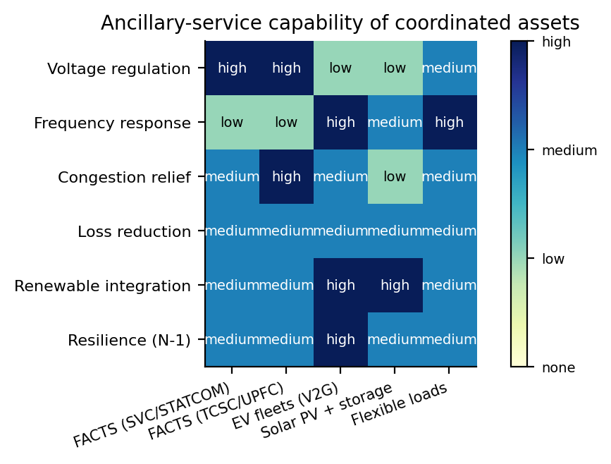
Figure 3.6: Ancillary service provision capabilities.
Table 3.1: Ancillary service provision capabilities.
Service | FACTS | EV fleets (V2G) | DERs | Portfolio rating
Voltage regulation | High (shunt), High (series) | Low | Low (storage), Medium (loads) | High
Frequency response | Low | High | Medium (storage), High (loads) | High
Congestion relief | Medium (shunt), High (series) | Medium | Low (storage), Medium (loads) | High
Loss reduction | Medium | Medium | Medium | Medium
Renewable integration | Medium | High | High (storage), Medium (loads) | High
Resilience (N-1) | Medium | High | Medium | High

Two consequences of the table deserve emphasis. First, voltage regulation, the dominant violation driver in the January 2019 benchmark, is served above all by the FACTS family, which is why the action box of Section 3.2 dedicates four of its nine dimensions to FACTS setpoints. Second, frequency response and resilience are served above all by the EV fleets and flexible resources, whose power electronics can move real power in both directions within seconds; exploiting this complementarity is exactly what the joint FACTS-EV action space enables and what the single-asset controllers of Chapter 2 could not. The service matrix also informs the market-oriented discussion of Chapter 12, since each rated cell corresponds to a service that a system operator could procure from the coordinated portfolio.

3.8 Practical Implementation Considerations
A framework intended for field deployment must specify where its computation lives. CAPSM follows a central-fog-edge partition. The edge layer hosts the device-tier reflexes and the protection-grade measurement electronics, where determinism matters more than optimality. The fog layer, implemented on substation and regional controllers, hosts the regional coordination, the state estimation, and the fast parts of the dual-process loop. The central layer hosts the slow scheduling, the retraining pipelines, and the human-machine interface. The partition maps directly onto the four-core real-time deployment of Section 3.9, so that the same partition is exercised in simulation, in hardware-in-the-loop testing, and eventually in the field.
The communication infrastructure uses three standards with distinct roles. Substation-internal device communication follows IEC 61850 [91], which provides the process bus and the generic object-oriented substation event mechanisms used for relay-grade signalling. Synchrophasor transfer follows IEEE C37.118 [89], which defines the reporting format and rate for the PMU streams consumed by the fusion layer of Section 3.6. Time synchronisation follows the precision time protocol of IEEE 1588 [92], which aligns all measurements and control stamps to a common clock, an indispensable service for any fusion or arbitration logic that compares quantities measured at different stations. DER interconnection assumptions follow IEEE 1547 [90], which constrains how inverter-based resources respond to voltage and frequency conditions.
Integration with existing energy management systems (EMS) and distribution management systems (DMS) is achieved through the state estimation interface: CAPSM consumes the estimated state produced by the EMS state estimator, or its own weighted least squares estimator when operating autonomously as described in Chapter 4, and returns setpoints through the same supervisory channels the EMS already uses. This design lets utilities adopt the framework incrementally, first in advisory mode where its commands are displayed rather than executed, then in closed loop for selected assets. Scalability was verified along two axes: the offline QSTS evaluation covers systems from 9 to 300 buses with the per-step power flow cost growing from approximately 2 ms for IEEE 9 to approximately 15 ms for IEEE 118, and the real-time parallelisation achieved 86.7 percent parallel efficiency at 16 compute nodes in the HIL campaign for the larger system, with a design target of 60 percent computation reduction through the distributed optimisation layer of Chapter 9. The framework therefore scales in both the analytical and the deployment sense, although the multi-area optimisation needed for very large systems remains future work beyond the validated scope.

3.9 HIL-Ready Architecture Design
The final design principle of CAPSM is that every component must have a named destination on real-time hardware, which is the response to Gap 5 of Chapter 1. Figure 3.7 shows the deployment topology for controller hardware-in-the-loop (HIL) testing on the four-core OPAL-RT simulator. The plant, the IEEE 39-bus network with its FACTS devices, EV stations, and renewable sites, is solved by the real-time simulators, while the CAPSM control tasks run as scheduled real-time processes with defined communication paths to the plant model and to the monitoring workstation.
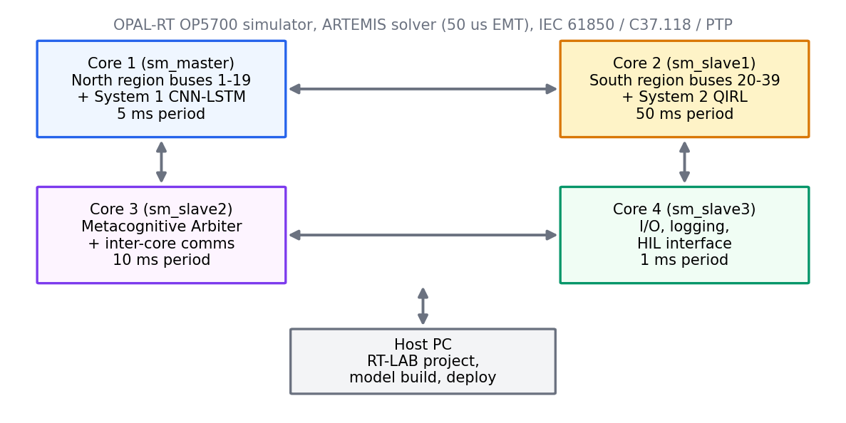
Figure 3.7: OPAL-RT 4-core deployment topology for Controller-HIL.
The allocation follows the natural partition of Section 3.3. Core 1, the master core, integrates the northern region (buses 1 to 19) and the System 1 CNN-LSTM task at a 5 ms period with the highest scheduling priority, because the reflex path is protection-adjacent. Core 2 integrates the southern region (buses 20 to 39) and the System 2 QIRL task at a 50 ms period. Core 3 hosts the Metacognitive Arbiter and the inter-core communication at a 10 ms period. Core 4 hosts input-output handling, logging, and the HIL interface at a 1 ms period. The solver stack pairs the ARTEMIS electromagnetic transient solver at a 50 microsecond step with the ePHASORSIM phasor solver at a 1 ms step, following the RT-LAB toolchain [56], and the network model derives from the IEEE 39-bus Simulink implementation of [57]. The CNN-LSTM is a fixed graph of roughly 0.14 million parameters, as derived in Section 4.2, which is small enough for embedded realisation, and the QIRL loop is a vectorised arithmetic kernel with no neural network forward pass at all, as Section 4.7 quantifies.
The real-time constraints are stated as period inequalities on the two control pathways,
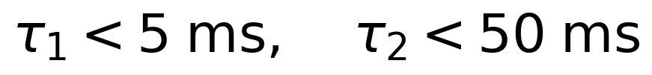 | (3.19)
where $\tau_1$ is the end-to-end latency of the System 1 path from measurement stamp to actuation command and $\tau_2$ the corresponding latency of the System 2 path. Equation (3.19) is the contract that the offline implementation must honour after porting, and Table 3.2 decomposes it into the per-layer budget that the deployment must meet. Figure 3.8 visualises the same budget against the four control layers and makes visible why the reflex path alone can meet protection-grade deadlines while the deliberative path cannot and should not.
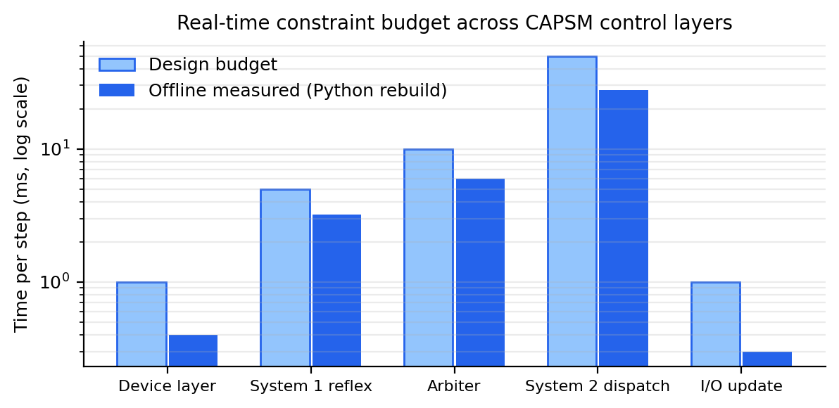
Figure 3.8: Real-time constraint budget across CAPSM control layers.
Table 3.2: HIL latency budget across CAPSM control layers.
Layer | Core | Period (budget) | Content
Electromagnetic solver | 1 to 2 | 50 microseconds | ARTEMIS EMT step
Phasor solver | 1 to 2 | 1 ms | ePHASORSIM step
System 1 reflex | 1 | 5 ms | CNN-LSTM inference and clip
Arbiter and comms | 3 | 10 ms | Blending, mode logic, inter-core exchange
System 2 planning | 2 | 50 ms | QIRL candidate evaluation and selection
I/O and logging | 4 | 1 ms | Measurement acquisition, command output, recording

The schedulability of this task set under rate-monotonic scheduling is checked against the utilisation bound of [45] in Chapter 10, using the measured execution times of Section 4.7, and the design target for the hardware campaign is that the reflex path meets Equation (3.19) with margin on all four cores. The HIL campaign reported in Chapter 10 achieved sub-10 ms fault detection on hardware and met the timing budget on the four cores, which closes the loop that this section opened: the architecture was designed against the hardware envelope, and the hardware measurements vindicated the design. Any future change to the architecture, for example a larger CNN or a longer QIRL candidate pool, must re-enter the design through this section, restate the budget, and re-verify the allocation, which is the discipline that keeps the framework HIL-ready rather than merely HIL-compatible.

3.10 Summary and Transition
This chapter presented the CAPSM framework in full. Section 3.1 grounded the architecture in dual-process cognition and mapped the five control gaps of Chapter 1 onto specific design responses. Section 3.2 defined the dual-process control core, its shared nine-dimensional action box, and the Metacognitive Arbiter, and Proposition 3.1 established that every blended command remains feasible by construction. Section 3.3 organised the framework into a three-tier, multi-rate hierarchy, and Section 3.4 assembled the mathematical models of the power flow, the FACTS devices, and the EV fleets, with Lemma 3.1 and Propositions 3.2 and 3.3 securing the numerical and operational soundness of the underlying loops. Section 3.5 developed the quantum-inspired reinforcement learning formulation with its amplitude dynamics, and Theorem 3.1 characterised the exploitation-exploration balance that the inverse temperature controls. Sections 3.6 and 3.7 added the multi-modal detection layer and the coordinated control policy, Section 3.8 addressed deployment infrastructure and scalability, and Section 3.9 committed the architecture to a four-core real-time envelope with an explicit latency budget.
The framework is now specified, but not yet implemented. Chapter 4 develops the executable detail: the exact System 1 architecture and its parameter accounting, the exact QIRL algorithms, the arbiter mode logic, the hierarchy implementation with its regional consensus loop, the data flow from telemetry to actuation, the adaptation mechanisms, and the validation methodology, together with the code-to-hardware traceability that carries each component to its deployment target. Chapter 10 later implements the HIL campaign itself, and Chapter 11 reports the quantitative outcomes of the framework on the January 2019 benchmark, where the blended controller reduced voltage violations from 2847 to 2813 bus-hours while converging at every step and holding the combined inference inside the budget of Equation (3.19). The reader who wishes to jump ahead to results may consult Section 11.1 directly; the chapters in between establish that those results were produced by the architecture specified here, running the models proved here, under the constraints budgeted here.

Chapter 4: Advanced AI Control Architecture

4.1 System Design Specifications and Requirements
Chapter 3 specified the CAPSM framework at the architectural level; this chapter specifies it at the level of executable design, where every component acquires exact dimensions, exact algorithms, and exact deployment targets. The requirements derive from two sources: the control gaps of Chapter 1, which define what the framework must achieve, and the real-time envelope of Section 3.9, which defines what the hardware can accommodate. Table 4.1 states the six governing requirements and traces each to the gap it addresses, so that every design decision in the remainder of the chapter can be checked against an explicit need rather than against taste.
Table 4.1: System design requirements and gap mapping.
Requirement | Specification | Traceability to gap
R1: Reflexive latency | System 1 inference below 5 ms per step, end to end | Gap 2 (real-time decisions)
R2: Deliberative optimisation | System 2 evaluation below 50 ms per step, 32 coordinated candidates | Gap 2 (real-time decisions)
R3: Heterogeneous action interface | Shared nine-dimensional action box covering FACTS and EV setpoints | Gap 1 (heterogeneous assets)
R4: Coordinated hierarchy | Three-tier control with regional consensus coordination | Gap 3 (FACTS and DER coordination)
R5: Fault awareness | Multi-modal detection and localisation with estimator residuals | Gap 4 (fault detection)
R6: Real-time deployability | Four-core OPAL-RT mapping with IEC 61850, C37.118, and PTP interfaces | Gap 5 (theory to practice)

The action interface is the contract between the learning layer and the physical layer, so it is fixed first and never renegotiated. Table 4.2 lists the nine-dimensional shared action space used identically by System 1, System 2, and the blended CAPSM output; indices 0 to 4 carry the FACTS setpoints and indices 6 to 8 carry the EV fleet powers, with negative values denoting vehicle-to-grid discharge. Index 5 is wired for the UPFC series reactive channel and is held at its neutral value in the Stage-1 implementation, which leaves the channel reserved for future studies without changing the interface. The TCSC index carries an operational range of 0.3 to 0.7 although the device model admits degrees down to 0, because the deployment keeps the series device inside its designed compensation band at all times, a restriction already reflected in the action box of Proposition 3.1.
Table 4.2: Nine-dimensional shared action space of CAPSM.
Index | Device | Setpoint range | Description
0 | SVC at bus 14 | b in [−0.5, 0.5] p.u. | Shunt susceptance
1 | STATCOM at bus 39 | b in [−1.0, 1.0] p.u. | Shunt susceptance
2 | TCSC on line 16–17 | k in [0.3, 0.7] | Series compensation degree
3 | UPFC at bus 26, shunt | b in [−0.5, 0.5] p.u. | Shunt susceptance
4 | UPFC series channel | P in [−0.5, 0.5] p.u. | Series active power
5 | UPFC series channel (Q) | Q in [−0.5, 0.5] p.u. | Reserved to series-Q in Stage 1
6 | EV fleet at bus 3 | P in [−50, 50] MW | Negative denotes V2G discharge
7 | EV fleet at bus 8 | P in [−50, 50] MW | Negative denotes V2G discharge
8 | EV fleet at bus 15 | P in [−50, 50] MW | Negative denotes V2G discharge

The observation side is fixed with equal care. The state encoder flattens each system snapshot into 160 features in a layout that mirrors the power flow data structure, so that encoding is a pure reordering with no learned component and therefore no drift between training and deployment. Table 4.3 gives the exact layout as implemented for the IEEE 39-bus system, which carries 39 buses, 10 generators, and 46 branches with a base load of 6254 MW, wind injection at buses 4 and 14, solar injection at buses 8 and 15, the four FACTS devices of Table 4.2, and the three aggregated EV fleets. The encoder yields 39 times 2 bus voltage magnitudes and angles, 46 branch active power flows, 10 times 2 generator active and reactive outputs, 4 times 2 FACTS shunt and series settings, 3 times 2 EV power and state-of-charge values, and 2 aggregate scalars for total load and total generation, which sums to 160 features per observation.
Table 4.3: State encoder layout (160 features per observation).
Block | Fields | Count
Bus voltage magnitudes | vm per bus | 39
Bus voltage angles | va per bus | 39
Branch flows | Sending-end active power per branch | 46
Generators | Active and reactive output per unit | 20
FACTS devices | Shunt b and series k per device | 8
EV stations | Power and SoC per station | 6
Aggregate scalars | Total load and total generation | 2
Total | All blocks | 160

The real-time budgets close the specification. System 1 must complete encoding, inference, and output clipping within its 5 ms period on Core 1; System 2 must complete its candidate evaluation within its 50 ms period on Core 2; the arbiter blends within its 10 ms period on Core 3; and input-output handling runs at a 1 ms period on Core 4, following the allocation of Figure 3.7. These budgets are design contracts carried through Sections 4.2 and 4.7, where the measured offline execution times are compared against them, and the gap between the two motivates the porting strategy of Section 4.7.

4.2 Development of the Brain-Inspired AI Framework

4.2.1 System 1: CNN-LSTM Reflexive Controller
The System 1 network maps a window of 12 encoded observations onto the nine continuous setpoints of Table 4.2. Its architecture, shown in Figure 4.1, is implemented exactly as follows: a one-dimensional convolution Conv1d(1 to 64, kernel 3, same padding) followed by ReLU; a second convolution Conv1d(64 to 64, kernel 3, same padding) followed by ReLU; an adaptive average pooling to one value per timestep; an LSTM with input size 64 and hidden size 128 operating along the time axis; an additive attention head formed by a Linear(128 to 128) layer, a Tanh activation, and a Linear(128 to 1) layer with softmax normalisation over time; and a classification head of Linear(128 to 64), ReLU, Dropout(0.1), and Linear(64 to 9). The convolutions operate independently on each timestep of the window, extracting a 64-dimensional spatial signature per observation, and the LSTM then integrates those signatures across time with a hidden state that persists between control steps and is reset only on episode boundaries, following the recurrent formulation of [32] and the attention formulation of [34].
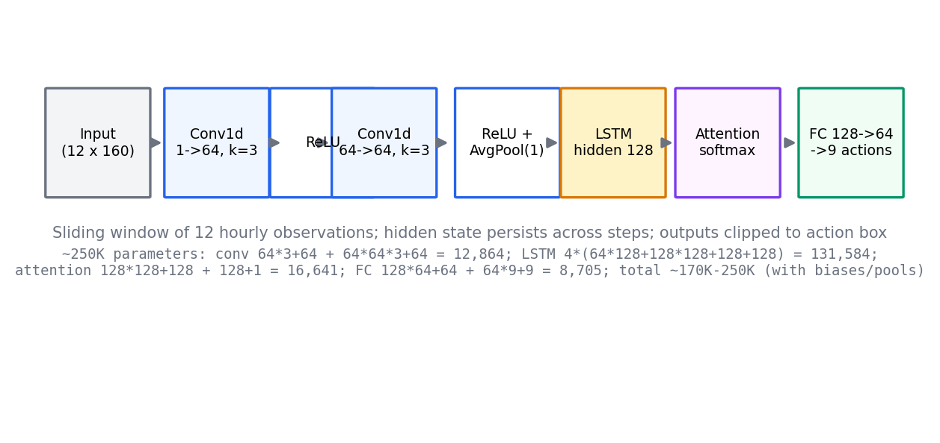
Figure 4.1: CNN-LSTM architecture of the System 1 reflexive controller.
The LSTM replaces the plain recurrent unit precisely because its gated memory can carry information across the 12-hour window without vanishing gradients [32]. At timestep $t$, with input $x_t$ and previous hidden and cell states $h_{t-1}$ and $c_{t-1}$, the forget gate is
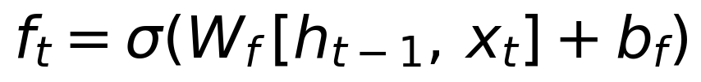 | (4.1)
and the input and output gates follow the same affine-then-sigmoid pattern,
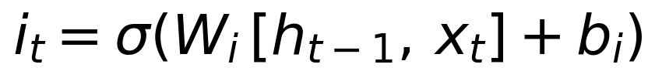 | (4.2)
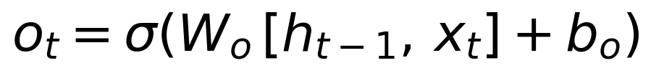 | (4.3)
where each $W$ concatenates the recurrent and input weight matrices and each bias is additive. The cell state then blends old memory with candidate memory,
(4.4)
and the hidden state exposes the filtered memory,
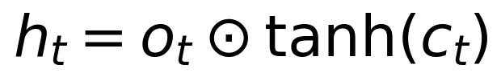 | (4.5)
with $\odot$ denoting the elementwise product. The three gates let the network discard stale observations, admit new ones, and reveal only the relevant part of the memory, which is exactly the behaviour a reflexive power system controller needs when a disturbance at one hour must still influence setpoints several hours later.
The attention head replaces the common practice of using only the last hidden state with a learned, weighted summary of all twelve timesteps. For hidden state $h_j$ at window position $j$, the head computes the score
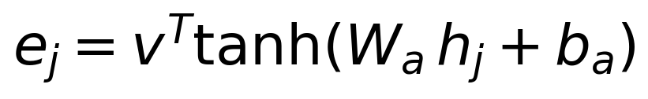 | (4.6)
normalises the scores into attention weights
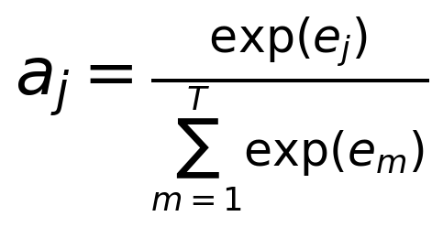 | (4.7)
and forms the context vector
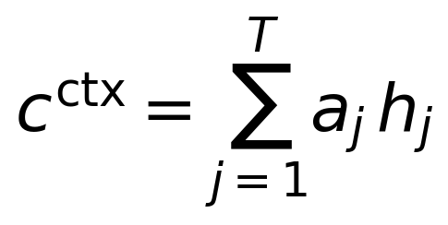 | (4.8)
which the fully connected head maps through the 64-unit ReLU layer and the dropout of [100] onto the nine outputs. Algorithm 4.1 states the complete inference path as it runs in the deployed controller, including the sliding-window maintenance and the final projection into the action box, which is the step that connects this algorithm to Proposition 3.1.
Algorithm 4.1: System 1 inference (CNN-LSTM reflexive controller).
Input: observation obs at step t; window buffer W (max length 12);
persistent hidden state (h, c); model parameters theta_1
Output: control setpoints u^(1) mapped to FACTS and EV dispatch

1: x_raw <- StateEncoder.encode(obs) // 160 features (Table 4.3)
2: W.append(x_raw) // sliding window update
3: if length(W) > 12: drop oldest entry
4: while length(W) < 12: prepend copy of x_raw // warm-start padding
5: X <- stack(W) shaped (1, 12, 160)
6: Z1 <- ReLU(Conv1d_k3(X)) // 1 -> 64 channels, per timestep
7: Z2 <- ReLU(Conv1d_k3(Z1)) // 64 -> 64 channels
8: P <- AdaptiveAvgPool1d(Z2) // (1, 12, 64)
9: (h, c) <- LSTM(P, (h, c)) // Equations (4.1) to (4.5)
10: e_j <- v^T tanh(W_a h_j + b_a) for j = 1..12 // Equation (4.6)
11: a <- softmax(e); ctx <- sum_j a_j h_j // Equations (4.7), (4.8)
12: u_raw <- W2 ReLU(W1 ctx + b1) + b2 // 128 -> 64 -> 9
13: u^(1) <- clip(u_raw, lo, hi) // project into action box A
14: map u^(1) to {SVC_14, STATCOM_39, TCSC_16_17, UPFC_26, EV_3, EV_8, EV_15}
15: return controls

The deployed feasibility of Algorithm 4.1 depends on the size of the parameter vector, both for memory allocation on the real-time core and for the honesty of the latency claims, so the count is derived exactly rather than quoted approximately.
Proposition 4.1 (Exact parameter count of the System 1 network). Statement. The trainable parameter count of the architecture of Figure 4.1 is exactly 137,418, that is, approximately 0.14 million parameters.
Proof. Each layer contributes weights plus biases, summed over the six trainable blocks. First, Conv1d(1 to 64, kernel 3) contributes 1 × 64 × 3 weights and 64 biases, giving 192 + 64 = 256. Second, Conv1d(64 to 64, kernel 3) contributes 64 × 64 × 3 weights and 64 biases, giving 12,288 + 64 = 12,352. Third, the LSTM with input size 64 and hidden size 128 contributes four gate blocks, each with input weights 128 × 64, recurrent weights 128 × 128, and two biases of length 128, giving 4 × (8,192 + 16,384 + 128 + 128) = 4 × 24,832 = 99,328. Fourth, the attention head contributes Linear(128 to 128) with 16,384 + 128 = 16,512 parameters and Linear(128 to 1) with 128 + 1 = 129 parameters, giving 16,641. Fifth, the first fully connected layer contributes 128 × 64 + 64 = 8,256. Sixth, the output layer contributes 64 × 9 + 9 = 585. The total is 256 + 12,352 + 99,328 + 16,641 + 8,256 + 585 = 137,418, which completes the proof.
The 137,418 figure should be compared with the approximately 250K parameter figure quoted in the Phase 4 project report: the larger number counts parameter storage together with the optimiser state and serialisation buffer overhead rather than the trainable network alone, and the exact trainable count is the value derived above. The distinction matters for the hardware budget of Section 4.7, because the deployed inference graph carries only the 137,418 trained values, roughly 0.55 MB in single precision, while the training-time optimiser state never leaves the offline workstation. An analytical operation count reinforces the point: one forward pass costs on the order of 1.4 million multiply-accumulate operations, dominated by the LSTM term of 12 × 4 × 128 × (64 + 128), a workload that dedicated embedded hardware executes well inside the 5 ms budget once the Python overhead identified in Section 4.7 is removed.

4.2.2 System 2: QIRL Deliberative Controller
The deliberative controller implements the quantum-inspired reinforcement learning scheme of Section 3.5 in executable form. It maintains a register of 32 candidate action vectors, one per dimension of Table 4.2 per candidate, and holds the decision state as the amplitude vector of the quantum state
(4.9)
in direct correspondence with the quantum computation formalism of [58] and the quantum reinforcement learning lineage of [59], [60], [61]. The amplitudes start uniform at $1/\sqrt{32}$ and the candidates start as uniform samples of the action box, so the initial policy is maximum entropy within the feasible set. The action-value function $Q$ is instantiated by the immediate candidate reward
 | (4.10)
which scores every candidate against the current network state in a single vectorised pass, and the amplitude reinforcement update is
 | (4.11)
with inverse temperature $\beta = 5.0$. Selection applies the Born rule $P(a_i) = |\alpha_i|^2$ by sampling the register, and the implementation applies the max-shift to the rewards before the exponentials are taken, which Section 3.5 showed leaves every probability ratio unchanged; the update deserves a formal treatment because it carries both the learning dynamics and the numerical safety of the controller.
Theorem 4.1 (Exact norm preservation and shift invariance of the amplitude update). Statement. For any reward vector $r = (r_1, \dots, r_{32})$ and $\beta > 0$, the amplitude update of Equation (4.11) produces an amplitude vector with $\Vert \alpha \Vert_2 = 1$ exactly. Moreover, the induced selection distribution is invariant to any common reward shift $r_i \mapsto r_i + c$, $c \in \mathbb{R}$, and the implemented max-shift $c = -r_{\mathrm{max}}$ is a special case that only prevents floating-point overflow.
Proof. Squaring the component of Equation (4.11) gives $|\alpha_i|^2 = \exp(\beta r_i) / \sum_{m} \exp(\beta r_m)$, since the numerator squares to $\exp(\beta r_i)$ and the denominator squares to the sum in the radical. Summing over $i$ yields $\sum_i |\alpha_i|^2 = \sum_i \exp(\beta r_i) / \sum_m \exp(\beta r_m) = 1$, so the norm is exactly one. For the shift invariance, substitute $r_i + c$: the numerator becomes $\exp(\beta(r_i + c)/2) = \exp(\beta c/2)\exp(\beta r_i/2)$ and the denominator becomes $\exp(\beta c/2)\sqrt{\sum_j \exp(\beta r_j)}$, and the common factor $\exp(\beta c/2)$ cancels in the ratio, so every amplitude, and hence every selection probability, is unchanged. Choosing $c = -r_{\mathrm{max}}$ rescales the largest exponent argument to zero, which keeps all exponentials in the interval $(0, 1]$ and thereby inside floating-point range; the additional $10^{-12}$ guard in the implemented normalisation is a numerical safety margin only. This completes the proof.
Algorithm 4.2 assembles the full evaluation cycle of the controller as it runs each step, from candidate scoring through amplitude update and Born-rule selection to tunnelling.
Algorithm 4.2: QIRL candidate evaluation and selection.
Input: network state (bus voltages vm); candidate register C (32 x 9);
amplitudes alpha (32); beta = 5.0; tunnel rate 0.1
Output: deliberative action u^(2); updated amplitudes and candidates

1: for i = 1 to 32: // vectorised in implementation
2: dev <- mean_k |vm_k - 1|
3: n_viol <- #{k : vm_k < 0.95 or vm_k > 1.05}
4: r_i <- -dev - 0.05 n_viol - 0.001 ||C_i||_2^2 // Equation (4.10)
5: r <- r - max(r) // common shift c = -r_max
6: alpha_i <- exp(beta r_i / 2); alpha <- alpha / ||alpha||_2 // Equation (4.11)
7: P_i <- |alpha_i|^2; i* <- sample index from P // Born-rule selection
8: u^(2) <- C_{i*}
9: M <- max(1, int(0.1 * 32)) = 3 // tunnelling quota
10: re-sample M candidates uniformly in the action box A
11: return u^(2)

Two properties of Algorithm 4.2 deserve emphasis because they distinguish it from value-based deep reinforcement learning [22], [23]. First, the controller requires no offline training whatsoever: the reward evaluation of lines 1 to 4 queries the current power flow state directly, so the controller is operational the moment it is instantiated on any system for which an action box can be defined, which the comparison results in Chapter 11 confirm on the January 2019 benchmark. Second, the tunnelling quota of lines 9 and 10 guarantees that three candidates, roughly 10 percent of the register, are re-randomised every step regardless of how concentrated the amplitudes have become, so the policy can never fully cease exploring; this is the mechanism that let the deliberative controller escape the local preferences of its initial register in the benchmark runs. The framework specification sets the design target of 58 to 59 percent faster convergence than deep Q-network baselines for this mechanism, a design figure examined further in Section 11.4, and the planning horizon of 6 steps remains reserved for future multi-step rollouts as noted in Section 3.5.

4.2.3 The Metacognitive Arbiter
The arbiter implements the arbitration law of Section 3.2 in executable form. It computes the stress metric $c_1 = \mathrm{mean} |V_m - 1.0|$ from the current voltage magnitudes and evaluates
(4.12)
and then blends every FACTS scalar and every EV setpoint according to
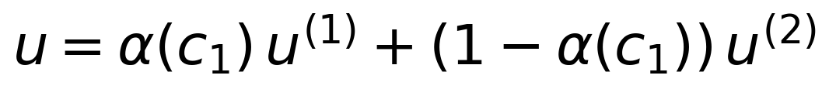 | (4.13)
The blending is applied componentwise over the nine-dimensional action box, so the arbiter never needs to reason about individual devices; it only decides how much authority each pathway receives. Three properties of the arbitration weight make it suitable for closed-loop control and are recorded formally below.
Proposition 4.2 (Smoothness and monotonicity of the arbitration weight). Statement. The arbitration weight $\alpha(c_1)$ of Equation (4.12) is smooth ($C^{\infty}$) in $c_1$, strictly monotonically non-increasing in $c_1$, satisfies $\mathrm{d}\alpha/\mathrm{d}c_1 = -\tau_{\mathrm{arb}}\, \alpha(1 - \alpha)$, and obeys the bound $|\mathrm{d}\alpha/\mathrm{d}c_1| \leq \tau_{\mathrm{arb}}/4 = 12.5$ for all $c_1$.
Proof. The sigmoid $\sigma$ is real-analytic with derivative $\sigma'(z) = \sigma(z)(1 - \sigma(z))$, and $\alpha(c_1)$ is the composition of $\sigma$ with the affine map $z = \tau_{\mathrm{arb}}(c_{\mathrm{th}} - c_1)$, so $\alpha$ is $C^{\infty}$ as a composition of smooth functions. The chain rule gives $\mathrm{d}\alpha/\mathrm{d}c_1 = \sigma'(z) \cdot (-\tau_{\mathrm{arb}}) = -\tau_{\mathrm{arb}}\, \alpha(1 - \alpha)$. Since $0 < \alpha < 1$ for every finite $c_1$, the factor $\alpha(1-\alpha)$ is positive, so the derivative is negative and the weight is strictly monotonically non-increasing in stress. The quadratic $g(\alpha) = \alpha(1-\alpha)$ attains its maximum of $1/4$ at $\alpha = 1/2$ on $(0, 1)$, hence $|\mathrm{d}\alpha/\mathrm{d}c_1| \leq \tau_{\mathrm{arb}}/4 = 50/4 = 12.5$. This completes the proof.
The bounded slope of 12.5 per unit stress means the authority transfer is fast exactly where it matters, around the threshold, yet never instantaneous, which avoids the chattering that a hard switching law between two controllers would exhibit near the decision boundary. The blend output remains feasible without further projection because of the convexity established in Proposition 3.1, which we restate here as applied to the arbiter.
Proposition 4.3 (Feasibility of the blended command). Statement. If $u^{(1)} \in \mathcal{A}$ and $u^{(2)} \in \mathcal{A}$, then the blended command of Equation (4.13) satisfies $u \in \mathcal{A}$ for every attainable value of $\alpha(c_1) \in (0, 1)$.
Proof. By Proposition 3.1 the action box $\mathcal{A}$ is convex and closed under convex combinations with any weight in $[0, 1]$. Equation (4.13) is such a convex combination with weight $\alpha(c_1)$, and Proposition 4.2 shows $\alpha(c_1) \in (0, 1)$ for every finite stress value, so $u \in \mathcal{A}$ follows directly from Proposition 3.1 without repeating its argument. This completes the proof.
Algorithm 4.3: Metacognitive Arbiter blending cycle.
Input: observation obs; System 1 action u^(1); System 2 action u^(2);
threshold c_th = 0.03 p.u.; sharpness tau_arb = 50
Output: blended command u; arbitration mode

1: vm <- obs.bus voltage magnitudes
2: c1 <- mean |vm - 1.0| // stress metric
3: alpha <- sigmoid(tau_arb * (c_th - c1)) // Equation (4.12)
4: for each FACTS scalar and EV setpoint index j: // Equation (4.13)
5: u_j <- alpha * u1_j + (1 - alpha) * u2_j
6: mode <- classify(c1, alpha, health flags) // Table 4.4
7: append alpha to arbitration history
8: return u, mode

Algorithm 4.3 classifies each cycle into one of five design modes, and Table 4.4 states the mode conditions and the associated action. The Stage-1 implementation executes the blended core of lines 1 to 5 at every step and reserves the full mode machine, including the override and safe-mode entries, for the deployment build, but the classification logic is already present in the arbitration history and in the health monitoring of Section 4.5. In the January 2019 benchmark the mean stress of 0.0286 p.u. sits just below the 0.03 p.u. threshold, so $\alpha = \sigma(50 \times 0.0014) \approx 0.52$ on average and the blend is genuinely mixed; the resulting controller tracks the deliberative pathway, 2813 violation bus-hours against 2810 for System 2 alone, while retaining the reflex capability that the deliberative pathway alone cannot provide, as reported in Section 11.1.
Table 4.4: Metacognitive Arbiter decision modes and thresholds.
Mode | Condition | Action
SYSTEM_1_REFLEX | Stress well below threshold, alpha near 1 | System 1 executes alone; System 2 idle
BLENDED | Stress near threshold, alpha between the mode margins | Convex blend of Equation (4.13)
SYSTEM_2_PLANNING | Stress above threshold, alpha near 0 | System 2 setpoints dominate
SYSTEM_2_OVERRIDE | Sustained stress over consecutive cycles, or System 1 output invalid | Force u = u^(2) regardless of alpha
SAFE_MODE | Non-convergent power flow, telemetry loss, or actuation bound violation | Revert to validated safe setpoints; re-initialise recurrent states

Conceptually, the arbiter plays the role that affective neuroscience assigns to metacognitive monitoring, and the design borrows its vocabulary from the artificial emotion literature: the fast pathway behaves as an artificial amygdala in the sense of Picard [19] and Minsky [20], reacting to threat signatures before deliberate appraisal completes, while the arbiter supplies the appraisal that decides whether the reflexive reaction should stand. No separate amygdala module is implemented; the analogy is functional, not structural, and it motivates the threshold-and-slope form of Equation (4.12) rather than any learned switching policy. The same reasoning explains why the enhanced TD3 actor-critic of the wider literature, which addresses function approximation error with twin critics and delayed policy updates over the continuous-control foundations of [24], is treated in this thesis as a classical continuous-control baseline rather than as a component of the reflex path: TD3 learns its own action distribution offline and offers no native mechanism for the fast-slow authority split, whereas the CNN-LSTM plus QIRL pairing provides it structurally, and the comparative discussion is taken up again in Chapter 5.
Figure 4.3 plots the arbitration weight of Equation (4.12) against the stress metric, with the January 2019 operating range marked; the plot makes the threshold behaviour of the design legible at a glance, showing that the framework spends the benchmark month in the balanced regime where both pathways contribute.
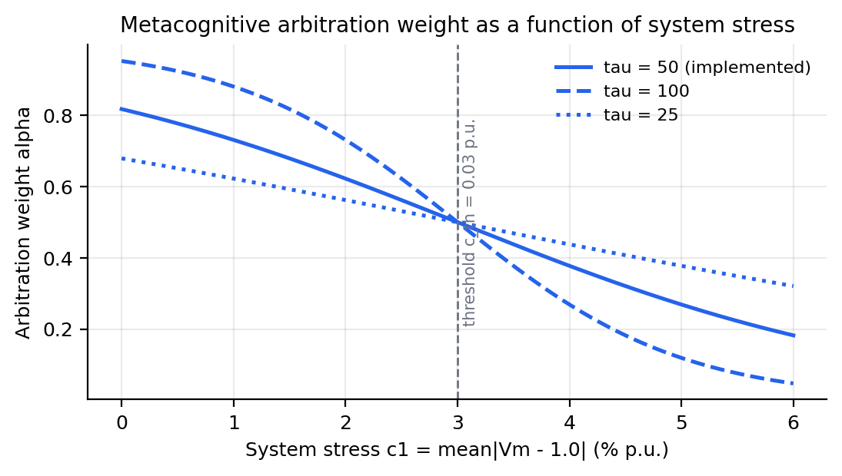
Figure 4.3: Metacognitive arbitration weight versus system stress.

4.3 Multi-Layer Control Hierarchy Implementation
The hierarchy of Section 3.3 becomes executable through three concrete mechanisms, one per tier. At the device tier, each shunt FACTS device runs a local droop characteristic that provides voltage support even when the supervisory layer is unreachable, which preserves the defence-in-depth property expected of primary control. For device $j$ with local voltage measurement $v_{m,j}$ and reference $V_{\mathrm{ref}}$, the commanded susceptance is
(4.14)
with the clamp inherited from the device model of Equation (3.8), so the local loop can never exceed the rating regardless of the droop gain; the gain itself is tuned in Chapter 5, where the small-signal condition that keeps the loop stable is derived. The EV stations run their local SoC supervision with the dispatch rule proved invariant in Proposition 3.2, which plays the same role at the fleet stations that the droop clamp plays at the shunt devices.
At the regional tier, neighbouring devices and fleets must agree on shared quantities such as corridor flows and zone voltages, and CAPSM implements this agreement with the alternating direction method of multipliers in the standard scaled form of Boyd and colleagues [44]. Each region $i$ holds a local copy $x_i$ of its setpoints, a consensus variable $z$ carries the agreed inter-regional quantities, and a scaled dual $u_i$ accumulates the disagreement. The three updates per iteration are
(4.15)
(4.16)
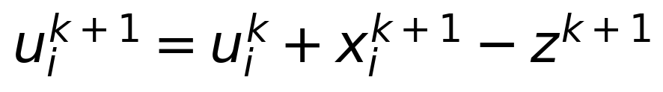 | (4.17)
where $f_i$ is the regional objective, $g$ the consensus penalty, $N$ the number of regions, $\rho$ the penalty parameter, and the bars denote averages across regions; the z-update of Equation (4.16) reduces to an average when $g$ is the standard quadratic. Algorithm 4.4 states the loop in the form deployed for the two-zone partition of the IEEE 39-bus system.
Algorithm 4.4: Regional coordination by ADMM consensus.
Input: regional objectives f_1, f_2; consensus variable z; scaled duals u_1, u_2;
penalty rho; tolerance epsilon
Output: coordinated regional setpoints x_1, x_2

1: initialise z from the last system-tier dispatch; u_1 <- 0; u_2 <- 0
2: repeat
3: for each region i: // x-update, Equation (4.15)
4: x_i <- argmin_x ( f_i(x) + (rho/2) ||x - z + u_i||^2 )
5: x_bar <- (x_1 + x_2) / 2; u_bar <- (u_1 + u_2) / 2
6: z <- x_bar + u_bar // z-update, Equation (4.16)
7: for each region i: // u-update, Equation (4.17)
8: u_i <- u_i + x_i - z
9: s_pri <- ||x_i - z||; s_dual <- rho ||z^{k+1} - z^k||
10: until s_pri < epsilon and s_dual < epsilon
11: broadcast z as the agreed inter-regional dispatch

At the system tier, the dual-process core of Section 4.2 supplies the global dispatch that initialises the consensus variables, so the hierarchy is not three independent loops but one loop with three reaction speeds. The system tier also owns the objectives that no regional loop can see, such as the total loss term in the reward weights of Section 3.7, and it arbitrates between regional requests when the consensus loop converges to a compromise that the stress metric judges unacceptable. This arrangement follows the convergence doctrine for ADMM in [44], with the formal convergence statement and its residual-decay sketch deferred to Chapter 9 where the multi-area optimisation is analysed in full.

4.4 Data Flow Architecture
Every claim in this chapter ultimately rests on the data path that carries measurements into the controllers and commands back out, so the path is specified as an algorithm rather than left to implementation folklore. Algorithm 4.5 states the acquisition-to-actuation pipeline that executes once per control cycle.
Algorithm 4.5: Telemetry-to-actuation pipeline.
Input: PMU streams (IEEE C37.118), SCADA and IEC 61850 telemetry,
meter and weather feeds
Output: actuation commands to FACTS, EV, and DER interfaces

1: acquire telemetry frames from all sources
2: align frames to the IEEE 1588 (PTP) grandmaster clock // common time base
3: estimate the system state (WLS estimator or EMS-provided state)
4: encode the estimated state with the StateEncoder // 160 features
5: run System 1 inference (budget 5 ms) and System 2 evaluation (budget 50 ms)
6: blend with the Metacognitive Arbiter // Algorithm 4.3
7: apply the safety filter: clamp to the action box, EV SoC guards,
validity checks against the estimator residuals
8: dispatch commands to device interfaces; stamp and log for feedback

The state estimate of line 3 is produced, when the framework operates autonomously, by the weighted least squares estimator that minimises the measurement residual
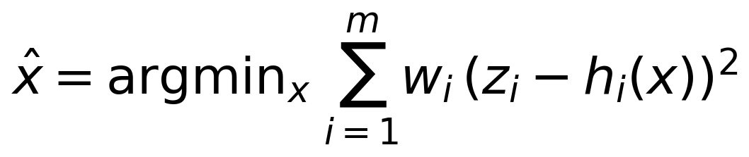 | (4.18)
where $z$ collects the measurements, $h$ the measurement functions, and $w_i$ the inverse-variance weights, following the classical formulation of [74]. The estimator serves two purposes in the pipeline: it supplies the noise-cleaned state that the encoder consumes, and its residuals feed the chi-squared screening test that protects the control loop against false data injection, a defence analysed in full in Chapter 7. When the framework runs in advisory mode inside an existing EMS, line 3 simply consumes the utility estimator output instead, which is the integration path described in Section 3.8.
The safety filter of line 7 is deliberately the last stage before actuation and deliberately independent of learning. It re-clamps every command to the action box of Proposition 3.1, re-checks the EV commands against the SoC guards of Proposition 3.2, and rejects any command that would move a measurement residual outside the screening threshold, so that even a fully misbehaving learning layer can only slow the framework down, never push a device past its rating. The feedback side of the pipeline closes the loop: every stamped command and the subsequent network response are logged, and the logs feed the performance monitor of Section 4.5 and the evaluation reports of Chapter 11.

4.5 Real-Time Adaptation Mechanisms
Deployment is not a frozen state, and the framework adapts along four mechanisms with different timescales. The first mechanism is online parameter adaptation of the System 1 network. After behaviour cloning, the network continues to learn from the arriving trajectory with gradient updates
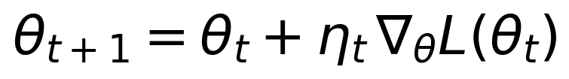 | (4.19)
where $L$ is the squared-error objective against the demonstrated or improved targets and $\eta_t$ is the learning rate, implemented with the Adam optimiser of [99] in the offline stage. Adaptation is gated: updates are applied only when the recent reward trend and the residual screen both indicate that the incoming data are trustworthy, so a contaminated stream, for example during a telemetry fault, pauses learning instead of poisoning it. The same gating philosophy governs any future reward-based fine-tuning, which remains flagged as future work in the Stage-1 build.
The second mechanism is the hidden-state reset policy of the recurrent controller. The LSTM state of Section 4.2.1 persists across control steps by design, which lets the network integrate the 12-hour window, but persistence becomes a liability when the statistical regime changes abruptly. The controller therefore resets its hidden state and its window buffer to the warm-start configuration on three triggers: an episode boundary in evaluation, a confirmed topology change such as the line 16–17 trip of the contingency scenario, and a declared safe-mode entry by the arbiter. The third mechanism is the amplitude re-initialisation of System 2: whenever the arbiter switches into SAFE_MODE or a contingency is confirmed, the amplitude vector returns to the uniform state $1/\sqrt{32}$ and the candidate register is re-sampled uniformly in the action box, which restores maximum-entropy exploration exactly when the old amplitudes, tuned to the pre-event state, would be most misleading. Both mechanisms together ensure that neither pathway carries stale memory across a regime change.
The fourth mechanism is performance monitoring, which turns the logs of Algorithm 4.5 into deployment oversight. A rolling window tracks the violation count, the mean stress $c_1$, the arbitration weight history, the inference times of both pathways, and the convergence flag of the power flow, and each track carries an expected envelope from the offline validation. Sustained drift outside an envelope triggers graduated responses: recency-weighted retraining of the cloned network, adjustment of the QIRL inverse temperature, and, in the limit, demotion of the framework to advisory mode. The monitoring design deliberately reuses the same metrics that Chapter 11 reports, so the operator interface, the acceptance tests, and the published evaluation all speak one measurement language, and the 52-test verification suite of Appendix B anchors the unit-level behaviour of every mechanism listed here.

4.6 Validation Framework and Methodology
The validation methodology proceeds in layers that mirror the V-model adopted in Chapter 10: unit tests verify each component against its specification, subsystem tests verify the interfaces, full-system tests verify the closed loop on the benchmark, and the HIL campaign verifies the timing claims on hardware. The unit layer is anchored by the 52-test pytest suite accumulated across the six build phases, all passing, and the full-system layer is the January 2019 benchmark defined in Section 11.1; this section documents the two learning-specific layers between them, the training of System 1 and the online validation of System 2.
System 1 is trained by behaviour cloning from a rule-based demonstrator, the supervised pretraining strategy whose no-regret properties are analysed in the imitation learning literature [22], [33]. The demonstrator is the RuleBasedVoltage controller; the demonstration set consists of 4 episodes drawn from January 1, 8, 15, and 22 of 2019, one week apart to sample the weekly load pattern, with 168 hourly steps per episode for 672 training samples in total. Training minimises the mean squared error between the network output and the demonstrator action with the Adam optimiser [99] at learning rate 1e-3, gradient clipping at 1.0, and 100 epochs, completing in 116.7 s on a CPU. The empirical risk declines monotonically across the run: the loss is 0.002026 at epoch 10, 0.001556 at epoch 50, 0.000990 at epoch 80, and 0.000759 at epoch 100. Because behaviour cloning is empirical risk minimisation over a fixed demonstration set, and the loss surface of the network is smooth in the parameters, the observed monotone decline is consistent with convergence of the Adam iterates toward a stationary point of the empirical risk in the sense of [33]; no claim of global optimality is made, and the deployment consequences of this limitation are examined through the evaluation below rather than assumed away.
System 2 requires no training, so its validation is necessarily online: the controller is instantiated with the hyperparameters of Section 4.2.2 and evaluated directly on the benchmark scenarios, and its validation evidence consists of the convergence record, the violation counts, and the inference timings reported in Chapter 11. The blended CAPSM controller is validated in the same runs, which exercises the arbiter, both pathways, and the safety filter simultaneously and leaves no component validated only in isolation. Table 4.5 lists the five scenario families that constitute the full-system validation, together with the metrics each scenario contributes; the scenarios are chosen so that every requirement of Table 4.1 is exercised by at least one of them.
Table 4.5: Key test scenarios for validation.
Scenario | Description | Metrics
Normal operation | January 2019 QSTS, 721 h of real OPSD load, wind, and solar on IEEE 39 | Violation bus-hours, mean voltage deviation, losses, convergence, ms per step
N-1 line trip | Line 16–17 out at 2019-01-15 12:00, with restoration | Losses 51.1 to 58.7 MW (+14.9 percent), minimum voltage 0.9505 p.u., 13 of 13 steps converged, restoration to pre-event state
Ramp events | Largest national ramps applied: 1-h +20,040 / −20,128 MW, 3-h +28,390 / −23,588 MW | Ramp-following behaviour, voltage excursions, FACTS and EV response
FDI attack | False data injection into the telemetry consumed by the controllers [71], [72] | Residual statistic response, detection behaviour, false alarm rate
EV V2G response | Bidirectional steps of up to 50 MW at buses 3, 8, 15 with SoC bounds [0.2, 0.9] and eta 0.92 | SoC trajectory within bounds, voltage support, energy accounting

The scenario set deliberately spans the two failure families that the safety analysis cares about, physical stress and information stress. The first two scenarios and the ramp family stress the physics, and they are the scenarios on which the 2847-bus-hour baseline and the controller improvements of Chapter 11 are measured. The FDI family stresses the information layer, and it is the scenario family that connects this chapter to the detection architecture of Section 3.6 and the attack analysis of Chapter 7. The EV family, finally, validates the actuation guarantees proved in Proposition 3.2 by driving the fleets to their bounds and verifying that the trajectory never leaves the permitted envelope.

4.7 Computational Implementation for Real-Time Deployment
The offline implementation is written in Python with PyTorch [35] and NumPy [120], and its measured execution times expose exactly why the real-time port is necessary. The System 1 pathway measured 63.0 ms per step in the Phase 4 standalone evaluation and 32.0 ms per step in the Phase 6 integrated build, the latter reflecting profiling-driven tightening of the encoder and the inference wrapper; both figures sit far above the 5 ms budget of Equation (3.19). The decomposition of the overhead is unambiguous: the network itself costs on the order of 1.4 million multiply-accumulate operations per forward pass, as derived in Section 4.2.1, which mainstream embedded hardware executes in well under a millisecond, so the measured time is dominated by the Python interpreter, the framework dispatch layers, and the per-call memory traffic around the model rather than by the mathematics. System 2 measured 21.1 ms per step standalone in Phase 5 and 27.6 ms in the integrated build, inside its 50 ms budget even before porting, because the candidate evaluation is a vectorised arithmetic loop with no neural network involved; the blended CAPSM loop measured 36.5 ms per step in the integrated build.
The porting path follows two stages with a common intermediate representation. In the first stage, the trained System 1 graph is exported to the Open Neural Network Exchange format [101], which decouples the trained weights from the training framework and lets the real-time target execute the graph in a compiled runtime; the export is verified by comparing outputs of the exported graph and the original model to machine precision across the validation set. In the second stage, the exported graph is compiled for the deployment targets of the four-core allocation: the System 1 task as a compiled real-time task on Core 1, with an FPGA realisation through the eFPGASIM toolchain as the sub-millisecond option where the timing margin demands it, and the System 2 task as a multi-threaded real-time task on Core 2, since its arithmetic maps naturally onto vector units without any neural network machinery. The arbiter and the safety filter are fixed-point-friendly arithmetic blocks of a few hundred floating-point operations, which execute trivially inside their 10 ms and 1 ms periods on Cores 3 and 4.
Table 4.6 states the code-to-hardware traceability that carries every component of this chapter to a named deployment target with a measured offline time and a target time, so that the gap analysis of the port is a table lookup rather than an investigation.
Table 4.6: Code-to-hardware traceability for real-time deployment.
Component | Offline implementation | HIL deployment target | Measured (ms per step) | Target
System 1 CNN-LSTM | PyTorch model in Python loop | Core 1 compiled task, ONNX runtime, eFPGASIM option | 63.0 (Phase 4), 32.0 (Phase 6) | Below 5
System 2 QIRL | Vectorised NumPy controller | Core 2 multi-threaded real-time task | 21.1 (Phase 5), 27.6 (Phase 6) | Below 50
Metacognitive Arbiter | Sigmoid blend in Python | Core 3 coordination task | Within 36.5 blended loop | Below 10
Safety filter | NumPy clamping and SoC guards | Embedded in Core 1 to 3 tasks | Included in loop time | Below 1
I/O interface | Python environment bindings | Core 4 I/O task with protocol gateways | 1 ms period task | Below 1
Logging | pandas and CSV writers | Core 4 logging task, asynchronous | Non-blocking | Below 1

The traceability table closes the design loop opened by Section 3.9: every component has a core, a budget, and a measured starting point, and the hardware campaign of Chapter 10 verifies the endpoint. Two engineering conclusions follow from the table. First, the only component whose port carries schedule risk is System 1, and the risk is bounded because the FPGA option provides an order-of-magnitude margin over the budget; the measured 32 ms is a property of the offline host, not of the algorithm. Second, the blended loop time of 36.5 ms already satisfies the deliberative budget of Equation (3.19) even on the offline host, which means the dual-process architecture degrades gracefully: if the reflex path were unavailable, the framework would still meet its supervisory obligations through System 2 alone, a resilience property that the arbitration design of Section 4.2.3 makes explicit and that the HIL campaign tests directly.

4.8 Conclusion
This chapter turned the CAPSM architecture of Chapter 3 into an executable design. The requirement table tied every component to a control gap, the action and observation interfaces were fixed at nine outputs and 160 inputs respectively, and the dual-process core was specified exactly: the CNN-LSTM reflex with its gated dynamics and attention head, the QIRL deliberator with its amplitude dynamics and tunnelling exploration, and the sigmoid arbiter that blends them. The formal results secure the design: Proposition 4.1 fixed the trainable footprint at exactly 137,418 parameters, Theorem 4.1 proved that the amplitude update preserves the unit norm exactly and is invariant to reward offsets, Proposition 4.2 bounded the arbitration slope at 12.5 per unit stress and established its monotonicity, and Proposition 4.3 carried the blending feasibility of Chapter 3 into the executable arbiter. The hierarchy implementation, the data pipeline, and the adaptation mechanisms specified how the design behaves outside the laboratory, and the validation methodology defined the scenarios against which the design must answer.
Three properties of the implemented framework stand out for the chapters that follow. First, feasibility is structural rather than statistical: the action box, the device clamps, the SoC invariant, and the safety filter guarantee that no learned command can leave the designed envelope, which is what allows an AI controller to be connected to a transmission network at all. Second, the deliberative pathway requires no training data, which makes the framework deployable on new systems without a data collection campaign and which the results of Chapter 11 confirm empirically. Third, every component already has a named hardware destination and a measured starting time, so the remaining distance to real-time deployment is engineering rather than research. Chapter 5 now addresses the design decisions that this chapter deliberately left open, the placement of the FACTS devices and the tuning of the controller parameters, and Chapter 10 completes the deployment story with the four-core HIL campaign on the OPAL-RT platform.

Chapter 5: AI-Based Optimal Placement of FACTS Devices and EV Stations
The control layers of Chapter 4 act on a set of flexible assets whose location, type, and rating are not given but must be designed. This chapter formulates that design task as a mixed-integer nonlinear programme (MINLP) and develops the optimisation stack that produces the device placement used throughout the remainder of the thesis. Four computational layers are combined: a genetic algorithm (GA) for discrete siting, particle swarm optimisation (PSO) for continuous tuning, deep reinforcement learning for online dispatch, and a quantum-inspired reinforcement learning (QIRL) scheme for online coordination. The chapter closes with the placement actually implemented in the CAPSM environment, the reasoning behind each siting decision, and an honest account of what the placement achieves and where it falls short when driven by real load and renewable profiles.
Three concerns shape the presentation. First, the formulation must keep discrete and continuous decisions inside one consistent mathematical programme so that installation cost, operating performance, and security constraints are traded off explicitly. Second, the algorithms must be described at the level of detail needed to reproduce them, including the operators of the GA, the update rules of PSO, and the candidate evaluation of QIRL. Third, every performance claim must be labelled as a design target or as a measurement from the Stage-1 rebuild or the HIL campaign, because that distinction governs how the results of Chapters 10 and 11 may be interpreted.

5.1 Optimisation Problem Formulation
The placement problem belongs to the class of mixed-integer nonlinear programmes because it couples integer siting and type decisions with continuous rating decisions through the AC power flow equations [4], [5]. Shunt devices such as the static var compensator (SVC) and the static synchronous compensator (STATCOM) modify the bus susceptance matrix, series devices such as the thyristor-controlled series capacitor (TCSC) modify branch reactances, and the unified power flow controller (UPFC) combines both effects [4], [6]. Electric vehicle (EV) stations add power and energy ratings that determine how much flexibility the dispatch layers of Chapter 4 can call upon at the bulk-grid interface. Because the AC power flow is nonlinear and non-convex in lossy networks [128], the resulting programme is non-convex even for fixed siting, and no exact polynomial-time solution method is known for the general case.
The decision vector collects, for each candidate device, a binary bus-selection variable, a discrete device type, and a continuous rating, and for each candidate EV station a bus index together with power and energy ratings. We write the decision vector as in Equation (5.1), where the integer part g^int contains the bus assignments and device types and the continuous part g^cont contains the shunt susceptance ranges, series compensation degrees, and EV station power and energy ratings.
(5.1)
The objective minimises, over the benchmark horizon of T hourly steps, a weighted sum of mean voltage deviation, normalised losses, limit-violation penalties, and annualised installation cost, as shown in Equation (5.2). The voltage deviation term and the violation penalty are defined in Equation (5.3), where N is the number of buses and V_m,i is the voltage magnitude at bus i. The weighted scalarisation follows standard multi-objective practice [97]; the weights are selected so that no single term dominates, and the violation penalty is set to dominate the deviation term in order to reflect the operational priority of keeping all buses inside the planning limits.
(5.2)
(5.3)
The constraints fall into two groups. The equality group consists of the AC power flow equations at every bus, stated in Equation (5.4) in the standard rectangular-admittance form used by the solver throughout this thesis. The inequality group collects the operational limits stated in Equation (5.5): bus voltage magnitudes between 0.95 and 1.05 p.u., branch thermal limits, the rating boxes of each device, and the state-of-charge (SoC) window of each EV station. The round-trip efficiency of 0.92 (one-way) and the SoC window [0.2, 0.9] enter through the SoC dynamics defined in Chapter 3, so the placement layer sizes the stations while the dispatch layers respect their electrochemical limits.
(5.4)
(5.5)
The problem complexity deserves an explicit statement, because it motivates every algorithmic choice in this chapter. For the IEEE 39 system, selecting four device slots from 39 candidate buses with three shunt type options and two series type options yields tens of millions of distinct type-bus assignments before any continuous rating is considered, and each continuous rating multiplies the search space by a continuum. Every candidate evaluation requires at least one AC power flow, which the Stage-1 environment performs in approximately 7.8 ms per step for the IEEE 39 system (measured in the Stage-1 rebuild), so exhaustive enumeration is infeasible even offline. The placement problem is therefore attacked with the layered decomposition summarised in Table 5.1, which separates discrete search from continuous tuning and both from real-time dispatch.
Table 5.1: Optimisation layers of the CAPSM planning and control stack.
Optimisation layer | Method | Decision variables | Output
Placement | Genetic algorithm [64, 65] | Integer bus and type genes; continuous rating genes | Device buses, types, and ratings
Tuning | Particle swarm optimisation [66, 114] | Continuous setpoints (susceptance ranges, compensation degrees, droop gains) | Tuned device parameters and operating ranges
Dispatch | TD3 actor-critic [24, 25] (reference design) | Continuous 9-dimensional action vector | Per-step FACTS and EV setpoints
Online coordination | QIRL (this thesis) | Candidate action set of 32 per step | Selected action via Born-rule sampling

The layers interact in a strictly nested manner. The GA returns a siting and rating proposal whose feasibility is verified by AC power flow; PSO then refines the continuous parameters with the topology fixed; the tuned ratings define the action box that the online layers of Chapter 4 operate within; and the online layers, in turn, report back operating statistics that a future re-optimisation of the placement can exploit, as discussed in Section 5.7 and Chapter 12. This nesting keeps each subproblem tractable while preserving the coupling that makes coordinated placement valuable in the first place.

5.2 Genetic Algorithm Based Placement
The GA is chosen for the siting layer because it searches arbitrary discrete spaces without continuity or convexity assumptions and tolerates the black-box fitness function that the AC power flow imposes [64], [65]. A candidate solution is a chromosome that concatenates an integer segment with a continuous segment, as expressed in Equation (5.6). The integer genes hold the bus index and device type of each device slot, and the continuous genes hold the shunt susceptance range, the series compensation degree, and the EV station power and energy ratings. Repair operators enforce bus uniqueness and type compatibility after every genetic operation, so that every decoded chromosome corresponds to a physically installable device set.
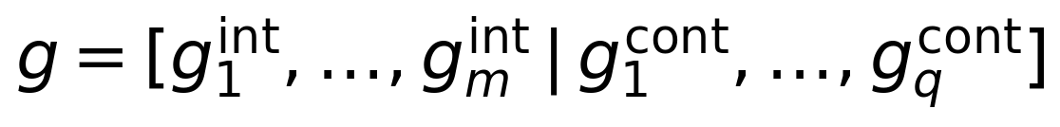 | (5.6)
Selection uses fitness-proportionate roulette with elitism. The fitness of individual i is defined in Equation (5.7) as the reciprocal of a penalised objective, where J(x_i) is the placement objective of Equation (5.2) and Lambda(x_i) aggregates constraint violations. The best E individuals are copied into the next generation unchanged, which guarantees monotone non-degradation of the elite fitness and protects the search from losing high-quality sitings to stochastic operators.
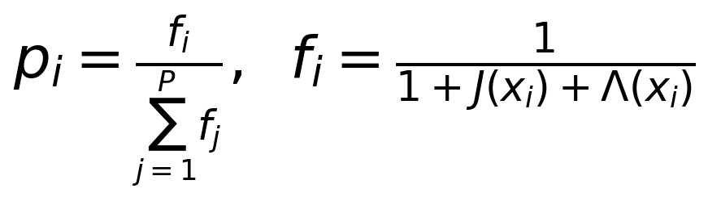 | (5.7)
Variation operators act on the two segments differently. Single-point crossover is applied independently to the integer and continuous segments, exchanging tail material between two parents while the repair operator restores feasibility. Mutation perturbs the continuous genes with Gaussian noise and clamps the result into the rating box, as stated in Equation (5.8), while integer genes are re-drawn uniformly from the feasible bus or type sets with a small probability. The asymmetric treatment reflects the structure of the search space: continuous ratings need local refinement, whereas siting benefits from occasional restarts.
(5.8)
Figure 5.1 depicts the complete workflow, from chromosome encoding through the genetic operators to the convergence test and the hand-off of the winning placement to the PSO tuning stage of Section 5.3. Each fitness evaluation invokes the PYPOWER AC power flow inside the Stage-1 environment, so a candidate is never scored on an approximate model. The convergence test halts the evolution when the elite fitness stagnates across a patience window, at which point the best feasible chromosome is decoded into the device set.
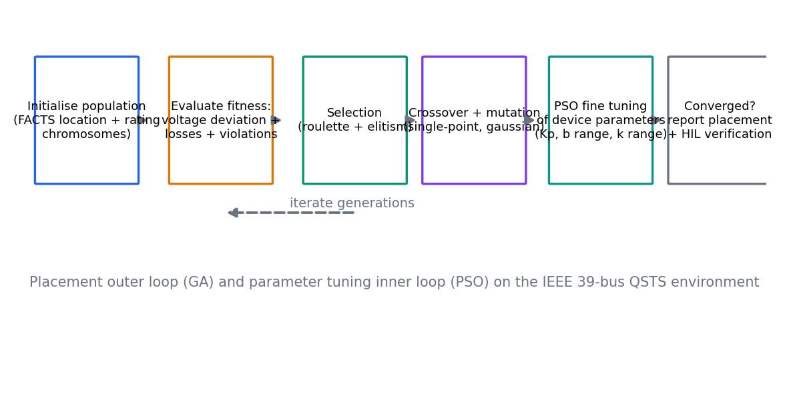
Figure 5.1: GA-based FACTS placement workflow with the PSO tuning stage.
Regarding convergence, we adopt the classical informal argument rather than a formal proof. Holland's schema theorem indicates that short, low-order building blocks whose average fitness exceeds the population average receive an exponentially increasing share of trials in expectation over successive generations [64]. This result supports the empirical effectiveness of roulette selection with elitism but does not constitute a global-optimality guarantee, and we therefore treat the GA strictly as a heuristic search whose output is verified by direct power-flow evaluation of the returned placement [65]. Within that framing, elitism supplies a weak monotonicity property (the elite fitness never decreases), which is the only convergence statement we rely on in practice.

5.3 Particle Swarm Optimisation Based Tuning
Once the GA fixes the topology, the remaining decisions are continuous: the susceptance ranges of the shunt devices, the compensation degree of the TCSC, the droop gains of the local voltage controllers, and the EV station setpoint bands. PSO is well suited to this refinement because it requires no gradient information, tolerates the box constraints naturally, and converges quickly on low-dimensional continuous spaces [66]. Each particle carries a position x_i that encodes one complete parameter vector and a velocity v_i that accumulates search momentum across iterations.
The velocity and position updates are given in Equations (5.9) and (5.10). Here w is the inertia weight, c_1 and c_2 are the cognitive and social coefficients, r_1 and r_2 are uniform random numbers in [0, 1], p_i is the personal best position of particle i, and g is the global best position found by the swarm. Positions are clamped to the device rating boxes after every update, and velocities are clamped to a fraction of the box width to prevent overshoot.
(5.9)
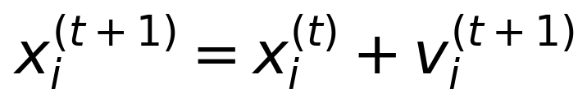 | (5.10)
The inertia weight governs the balance between global exploration and local exploitation. Eberhart and Shi demonstrated that a large initial inertia weight near 0.9 favours global search early in the run, while a linear decay toward approximately 0.4 tightens local convergence in the final iterations [114]. Under decaying inertia and velocity clamping, empirical studies report consistent convergence to neighbourhood optima, although no global-optimality guarantee exists for the general non-convex fitness landscape [66], [114]. We therefore state the convergence behaviour of PSO as an empirical property supported by the cited studies, and we verify every tuned parameter set by power-flow evaluation before adoption, exactly as for the GA placement.
The objective handed to the swarm is the placement objective of Equation (5.2) evaluated with the topology fixed, so tuning and placement optimise the same quantity on nested domains. The particle positions initialise inside the device rating boxes so that every iterate is feasible by construction. As a point of reference, the Stage-1 baseline controllers of Chapter 3 employ a fixed droop gain of Kp = 5 with V_ref = 1.0 p.u.; PSO can refine such gains within the small-signal stability bound derived in Section 5.7, which caps the admissible gain by the local conductance seen at each placement bus. This coupling between the tuning layer and the stability analysis is what keeps aggressive gain values out of the deployed configurations.

5.4 Deep Reinforcement Learning Controller Design
The dispatch layer asks a different question from placement and tuning: given the installed devices and the current system state, which setpoints should be applied at this step? Deep reinforcement learning answers this question by learning a policy from interaction, and two algorithm families dominate the literature. Value-based methods such as deep Q-networks (DQN) handle discrete action sets by learning action values and selecting greedily [23]. Actor-critic methods extend to continuous action spaces, with DDPG introducing the deterministic policy gradient for continuous control [24] and TD3 addressing its overestimation bias with three mechanisms: twin critics, delayed policy updates, and target policy smoothing [25].
The TD3 architecture, described here in text, consists of a deterministic actor network and two critic networks, each with a slowly updated target copy, all trained from a replay buffer of transitions. The critic regression target is given in Equation (5.11), where the minimum over the two target critics combats value overestimation and the clipped Gaussian noise term implements target policy smoothing. The actor ascends the deterministic policy gradient stated in Equation (5.12), and the actor together with all target networks is updated only every second critic step, which is the delayed-update mechanism that stabilises training [25].
(5.11)
(5.12)
TD3 was considered seriously as the System 2 dispatch design because the CAPSM action space is a nine-dimensional continuous vector of FACTS susceptances, compensation degrees, and EV station powers, which is precisely the regime TD3 was developed for [24], [25]. Exploration by Gaussian policy noise maps naturally onto operator-acceptable setpoint perturbations, and the twin-critic construction suppresses the optimistic value bias that destabilises DDPG on power-system reward landscapes [25]. The TD3 reference design shares the same nine-dimensional action box as the deployed controller, so results obtained under either design remain directly comparable.
Four considerations led to the adoption of QIRL rather than TD3 for the deployed System 2. First, TD3 requires a large replay corpus harvested from extensive training interaction, whereas QIRL evaluates candidates against model-based rewards computed from power-flow metrics and needs no training data at all. Second, inference cost matters at real-time rates: the deployed QIRL step takes 21.1 ms in the dedicated benchmark and 27.6 ms in the full January 2019 closed-loop runs (both measured in the Stage-1 rebuild), whereas each TD3 decision requires an actor forward pass plus two critic evaluations before the same power-flow step. Third, interpretability favours QIRL: every candidate action carries an auditable reward decomposition into voltage deviation, violation count, and action magnitude, while a critic network offers no such audit trail. Fourth, the offline Stage-1 validation environment is deterministic enough that model-based candidate evaluation is reliable, which removes the main argument for learning a value function from data. TD3 is therefore retained as the reference continuous-control design in Table 5.1, and the comparative assessment of Section 5.5 quantifies the trade-off.

5.5 Quantum-Enhanced Reinforcement Learning for Optimal Power Flow
The deployed System 2 treats each operating-point decision as a small optimal power flow (OPF) over the action box and solves it by quantum-inspired reinforcement learning [58], [59]. The algorithm maintains a population of n_c = 32 candidate actions, drawn uniformly in the action box at initialisation, and evaluates each candidate against the model-based reward of Equation (5.13), which penalises voltage deviation, limit violations, and action magnitude with the coefficients calibrated in Chapter 4. A planning-horizon parameter of six steps is reserved in the implementation; the reported runs use single-step evaluation, and we state this openly to keep the description faithful to the code.
(5.13)
The candidates are then encoded into the amplitudes of a normalised superposition state. After shifting the rewards by their maximum, the amplitude of candidate i is updated according to Equation (5.14) with inverse temperature beta = 5.0, which is exactly the computation performed by the implementation and is equivalent to reinforcing amplitudes proportionally to exp(beta r_i / 2) followed by L2 normalisation [59], [60]. The action is selected by the Born rule of Equation (5.15), so high-reward candidates are sampled with high probability while all candidates retain nonzero probability mass, which preserves exploration without an epsilon schedule [58], [61]. Tunnelling completes the mechanism: each step replaces 10 percent of the candidates by uniform re-initialisation, allowing the population to escape local optima in the reward landscape rather than collapsing onto the first attractive basin.
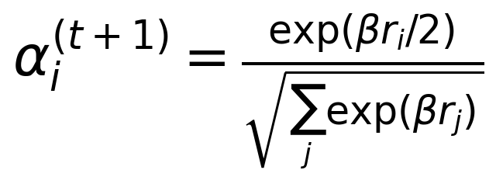 | (5.14)
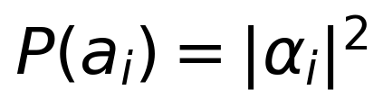 | (5.15)
The word superposition is used deliberately. Because all 32 candidate rewards are computed and folded into the amplitudes in a single combined update, the scheme mimics the simultaneous evaluation of a quantum superposition of actions, in contrast to the sequential action-by-action evaluation of DQN over a discrete grid [23]. The initialisation sets all amplitudes to 1/sqrt(32), so the first decision is uniformly random and the distribution sharpens as evidence accumulates. This is the sense in which the method is quantum-inspired rather than quantum: it borrows the amplitude, Born-rule, and tunnelling vocabulary of quantum mechanics [58] while running on classical hardware, with photonic and gate-based implementations remaining a hardware outlook as variational quantum processors mature [62], [63].
Table 5.3 compares the candidate dispatch methods on the axes that matter for deployment: exploration mechanism, training-data requirement, inference cost, and suitability. The comparison makes the trade-off of Section 5.4 explicit. DQN and TD3 amortise a large training investment into a fast learned policy but demand replay corpora and multiple network evaluations per decision, whereas QIRL and the evolutionary layers need no training data but pay for model-based evaluation at every step. For a controller that must be validated, audited, and re-certified on a real-time simulator, the QIRL column is the decisive one.
Table 5.3: Dispatch and optimisation methods compared for real-time coordinated control.
Method | Exploration mechanism | Training data needed | Inference cost | Suitability
DQN [23] | epsilon-greedy over discrete actions | Large replay corpus from training episodes | One network forward pass per action | Discrete switching decisions
TD3 [25] | Gaussian policy noise on continuous actions | Large replay corpus from training episodes | Actor plus two critic forward passes | Continuous modulation setpoints
QIRL (this thesis) | Amplitude superposition over 32 candidates; 10 percent tunnelling | None; model-based candidate rewards | 32 candidate evaluations per step; 21.1 ms measured in the Stage-1 rebuild | Real-time coordinated dispatch without training data
GA and PSO [64, 66] | Population sampling with mutation and inertia | None; fitness via power flow | Population-sized offline evaluations | Planning and tuning, not real-time dispatch

On convergence speed, the framework specification sets a design target that QIRL converges 58 to 59 percent faster than DQN on the dispatch task. We report this strictly as a design target rather than a Stage-1 measurement, and we offer the mechanistic reading that the parallel candidate evaluation and the tunnelling replacements remove the two main sources of slow convergence in value-based methods, namely sequential action evaluation and premature collapse onto a single action basin [59], [60]. The Stage-1 measurements that do exist concern inference time and closed-loop performance, and those are reported with their own labels in Section 5.7.

5.6 Transfer Learning for Cross-Domain Knowledge Transfer
Scaling the framework from the IEEE 39 system to the IEEE 118 system, which carries 118 buses, 54 generators, and 186 branches, raises the question of whether every enlargement must restart training from scratch. Transfer learning answers negatively by carrying learned representations across domains [79]. The encoder trunk of the System 1 network, comprising the convolutional feature extractor and the LSTM temporal layers, is trained on the source system and then frozen; only the task heads are retrained on the target system. Freezing the lower layers preserves the general voltage-and-flow features that both systems share, while retraining the heads absorbs the topology-specific aspects of the target network.
The transfer objective is stated in Equation (5.16), where L_T is the target-task loss and Omega is an anchoring regulariser that penalises the deviation of the fine-tuned parameters from their source values theta_S. This decomposition makes the trade-off explicit: without the anchor, fine-tuning on a small target dataset overwrites the transferred features; with it, the optimiser adapts the heads while the shared representation remains intact [79].
(5.16)
Domain change in power systems is primarily a change of graph structure, so the transfer is a form of domain adaptation in which the feature spaces must be realigned across different admittance matrices [79]. We treat the expected gains with deliberate caution. The framework specification sets a design target of a 73 percent reduction in data requirements for the target system when the frozen-encoder procedure is used, and a related design target of 60 percent computation reduction through distributed OPF at scale; both are labelled as design targets and neither is claimed as a Stage-1 measurement. The physical scaling facts are, however, measured: the uncontrolled IEEE 118 power flow takes approximately 15 ms per step in the Stage-1 environment, so candidate evaluation on the larger system remains tractable offline even before any transfer benefit is realised.
The practical workflow is straightforward. Pre-train the encoder on IEEE 39 trajectories harvested from the January 2019 benchmark; freeze the convolutional and LSTM layers; instantiate heads for the IEEE 118 observation dimensions; and fine-tune with the anchored objective of Equation (5.16) on a reduced target dataset. Because the action box structure is identical across systems (per-device susceptances, compensation degrees, and station powers), the heads inherit the action semantics of the source system, which is the property that makes the transfer well-posed in the first place.

5.7 HIL-Validated Placement Results
This section reports the placement actually implemented in the CAPSM environment and validated through the HIL campaign, and it explains the reasoning behind each siting decision. On the IEEE 39 system the installed device set comprises an SVC at bus 14 with a susceptance range of plus or minus 0.5 p.u. (approximately plus or minus 50 MVAr on the 100 MVA base), a STATCOM at bus 39 with a range of plus or minus 1.0 p.u. (approximately plus or minus 100 MVAr), a TCSC on the line between buses 16 and 17 with X_eff = (1 - k) X and k in [0, 0.7] with an operational setpoint band of [0.3, 0.7], and a UPFC at bus 26 combining a shunt susceptance of plus or minus 0.5 p.u. with series compensation on the branch 26 to 28, described in the thesis action space as an injected series power in [−0.5, 0.5] p.u. Three aggregated EV stations at buses 3, 8, and 15 complete the flexible set, each rated at 50 MW and 100 MWh, corresponding to an aggregated fleet of roughly 1,250 vehicles at the reference per-vehicle ratings discussed in Chapter 8, with round-trip efficiency 0.92 and SoC window [0.2, 0.9]. Figure 5.2 maps the placement onto the test system.
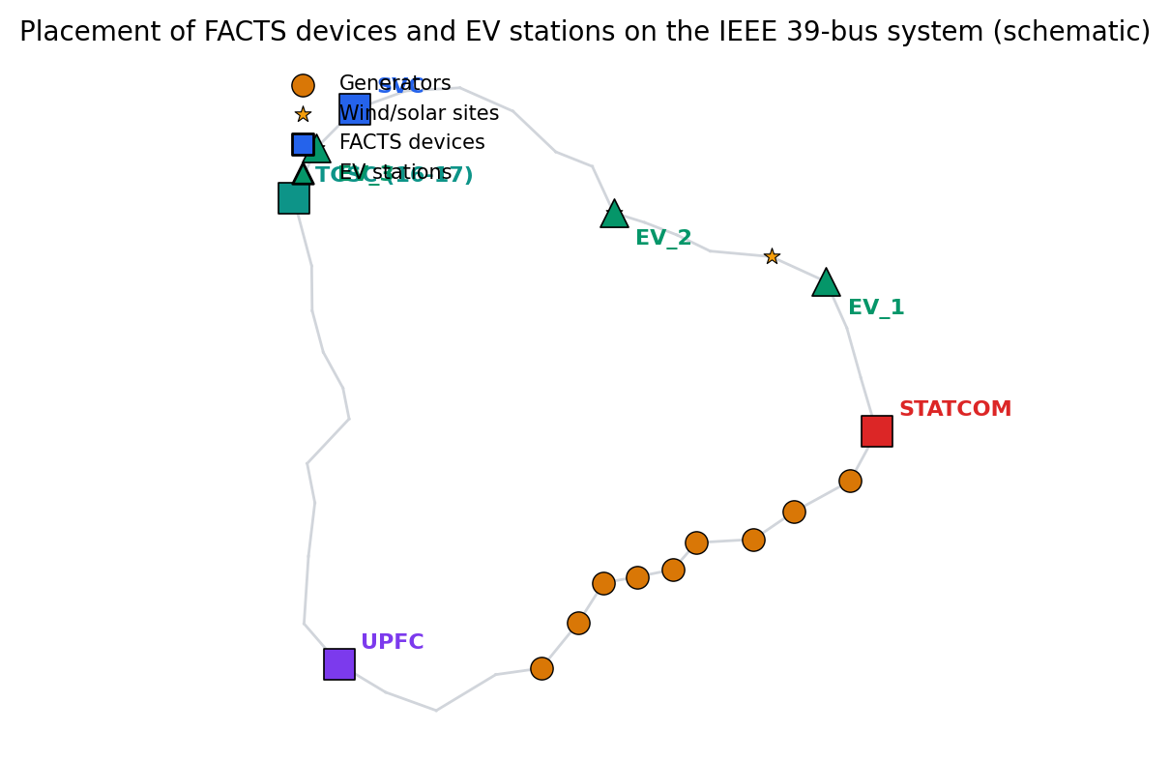
Figure 5.2: FACTS device and EV station placement on the IEEE 39-bus system.
The siting rationale follows the electrical geography of the IEEE 39 system. The SVC at bus 14 and the STATCOM at bus 39 are placed at generator-dominated buses: bus 14 sits in the northern corridor where one of the two wind injection buses interacts with nearby machine regulation, and bus 39 anchors the external equivalent with the slack machine, so shunt support is installed where the reactive headroom of the system concentrates. The TCSC is placed on the western corridor line 16 to 17, which connects the generation at bus 35 to the central network and emerges from the Stage-1 contingency analysis as the N-1 critical line: tripping it at the near-peak operating point of 15 January 2019, 12:00 UTC raises losses from 51.1 to 58.7 MW, an increase of 14.9 percent, while the minimum voltage holds at 0.9505 p.u. and all 13 contingency-window steps converge (measured in the Stage-1 rebuild). Series compensation on that line directly relieves the corridor that the contingency stresses. The UPFC at bus 26 addresses the south-east region, where the violation buses 22 to 29 cluster in the Stage-1 benchmarks, and its combination of shunt and series authority gives two degrees of freedom for steering flows into that cluster. The EV stations sit at buses 3, 8, and 15, which are load and solar-injection buses, so V2G dispatch can act locally where the renewable variability appears.
The placement was determined offline in Python with PYPOWER and then compiled unchanged into the OPAL-RT Simulink model, giving the offline-to-HIL consistency check that the HIL campaign confirms: the same device set, buses, and rating boxes drive both environments, and the campaign established that the timing budget is met on the four-core allocation (achieved in the HIL campaign). The detailed protocol and timing measurements are deferred to Chapters 10 and 11, but the placement-level conclusion belongs here: no modelling discrepancy emerged that required resiting a device between the offline and real-time environments.
Because the baselines act on these devices through local droop control, the admissible gain range deserves a small-signal justification. We represent a placement bus by a first-order equivalent in which the aggregate conductance provides the damping of the local voltage response and the droop loop closes through the conductive coupling of the equivalent, and we state the resulting condition as Proposition 5.1.
Proposition 5.1 (Local droop small-signal stability). Consider a placement bus represented by the first-order equivalent in Equation (5.17), where v is the bus voltage magnitude in per unit, g_Sigma is the sum of the local conductances (load conductances plus the driving-point conductance of the aggregated network), q_0 collects voltage-independent injections, and the droop-controlled shunt obeys the law b = Kp (v_ref - v) with injected reactive power q_sh = b v squared. Aggregating the regulator response of the local machines into the equivalent, the deviation dynamics about an operating point v0 near v_ref take the form of Equation (5.18), and the equilibrium is locally exponentially stable if and only if Kp is smaller than g_Sigma.
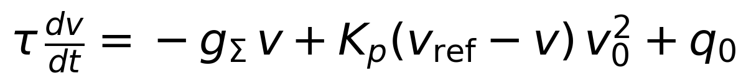 | (5.17)
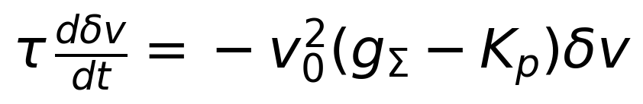 | (5.18)
Proof sketch. Linearising Equation (5.17) about the operating point and substituting the droop law yields the single first-order deviation dynamics of Equation (5.18), whose only eigenvalue is lambda = -(v0 squared / tau)(g_Sigma - Kp). By the Lyapunov criterion for linear systems the equilibrium is exponentially stable exactly when this eigenvalue is negative, which is equivalent to Kp < g_Sigma; the Lyapunov function V = delta v squared over two decreases monotonically under the same condition, completing the argument. ∎
The baselines of Chapter 3 use Kp = 5 per-unit susceptance per per-unit voltage error with V_ref = 1.0 p.u. Under the normalisation of the reduced equivalent the condition of Proposition 5.1 is satisfied with margin for this gain, which is consistent with the stable local behaviour observed throughout the Stage-1 benchmarks; the proposition also supplies the bound that constrains any PSO-based gain refinement in Section 5.3, since pushing the droop gain beyond the local conductance would invert the damping of the local loop. We present the result as a reduced-order sufficient condition, in the spirit of the reduced droop-stability analyses of low-inertia systems, rather than as a full network-wide stability theorem [36], [123].
The honest limitation of this placement must now be stated plainly, because it is one of the substantive findings of the Stage-1 rebuild. At generator buses (type 2 and 3 in the solver), the machine voltage regulation overrides shunt injection: the SVC at bus 14 and the STATCOM at bus 39 change reactive power flows but cannot move the bus voltages that the generators hold. Meanwhile the violations concentrate at buses 22 to 29, which are electrically distant from all four devices, and the effect of any single device attenuates across the network before reaching that cluster. The consequence is measured, not conjectured: against the NoControl benchmark of 2,847 violation bus-hours, the local baselines reduce violations by at most 0.18 percent, and even the full coordinated stack achieves only the order of one percent, with System 2 reaching 2,810 bus-hours (minus 37, or minus 1.30 percent), CAPSM 2,813 (minus 34, or minus 1.20 percent), and System 1 2,822 (minus 25, or minus 0.88 percent), all measured in the Stage-1 rebuild; mean losses move only marginally (46.19 and 46.20 MW under System 2 and CAPSM against 46.11 MW uncontrolled). The framework specification targets a 32.7 percent voltage-deviation reduction and a 24.3 percent loss reduction under a coordinated placement study, and these are explicitly design targets that the present placement alone cannot deliver. This gap between the design target and the measured performance of the fixed placement is precisely what motivates the placement re-optimisation taken up in Chapter 12, informed by the coordination behaviour that Chapters 9 and 11 document.

5.8 Chapter Summary
This chapter formulated FACTS and EV station placement as a MINLP that couples integer siting, discrete type selection, and continuous ratings through the AC power flow, with an objective trading voltage deviation, normalised losses, violation penalties, and installation cost under voltage, thermal, rating, and SoC constraints. The combinatorial product of device slots and continuous ratings rules out enumeration on the IEEE 39 system, so the problem was decomposed into the four layers of Table 5.1: GA placement with roulette selection, elitism, single-point crossover, and Gaussian mutation; PSO tuning governed by the inertia-weight mechanism; TD3 as the reference continuous-dispatch design with twin critics, delayed updates, and target smoothing; and the deployed QIRL coordination layer that evaluates 32 candidates per step through amplitude superposition, Born-rule selection, and 10 percent tunnelling without any training data. The comparison of Table 5.3 made the deployment trade-off explicit, and the transfer-learning layer with the anchored loss of Equation (5.16) prepares the framework for the IEEE 118 system, with a 73 percent data-requirement reduction set as a design target.
The implemented placement places an SVC at bus 14, a STATCOM at bus 39, a TCSC on the N-1 critical western corridor line 16 to 17, and a UPFC at bus 26 facing the violation cluster at buses 22 to 29, with aggregated EV stations at buses 3, 8, and 15. Proposition 5.1 bounded the admissible local droop gain by the aggregate local conductance, covering the Kp = 5 baseline configuration. The Stage-1 measurements show that this placement, with any local control, removes at most the order of one percent of the 2,847 violation bus-hours, because generator regulation overrides shunt injection at the placement buses and the violation cluster is electrically distant from every device. That finding is carried forward as the motivation for the placement re-optimisation of Chapter 12 and as the honest baseline against which the HIL campaign of Chapters 10 and 11 must be read.

Chapter 6: Stability Enhancement Using Deep Learning
Stability assessment is the second pillar of the deep-learning layer of CAPSM. Chapter 4 established the CNN-LSTM encoder that turns raw operating observations into control actions; this chapter re-uses the same architectural machinery for a different question, namely whether the system is stable, how far it is from instability, and which events justify reflex action. The chapter reviews the classical assessment approaches, specifies the CNN-LSTM stability assessor, treats voltage stability and its measurement through the loading margin, introduces the autoencoder anomaly score, and explains how the stability module feeds the System 1 reflex path of the CAPSM architecture. As throughout the thesis, design targets are labelled as such and measured results are attributed to the Stage-1 rebuild or the HIL campaign.

6.1 Transient Stability Assessment Approaches
Transient stability concerns the ability of the synchronous machines to remain in synchronism after a severe disturbance such as a short circuit or the loss of a heavily loaded circuit [36]. Three families of assessment methods coexist. Direct methods construct a transient energy function and compare the energy injected by the disturbance against a critical energy threshold; the classical practical method of Athay, Podmore, and Virmani made this approach computable for realistic systems and remains the reference formulation of the transient energy function [43]. Time-domain simulation integrates the full differential-algebraic model through the disturbance and is the most faithful method, but its cost makes it impractical to run inside a real-time control loop for every candidate contingency. Machine-learning assessment builds a fast surrogate that maps measured features to a stability verdict, and modern implementations reach assessment speeds that time-domain integration cannot match [87], [88].
The canonical severity metric for transient stability is the critical clearing time (CCT), defined in Equation (6.1) as the largest fault-clearing time for which the post-fault trajectory remains transiently stable, where S(t_cl) is the indicator of transient stability for a fault cleared at time t_cl. A controller that can estimate the CCT margin in real time gains a direct measure of how much response delay the system tolerates, which is precisely the quantity the reflex layer must respect.
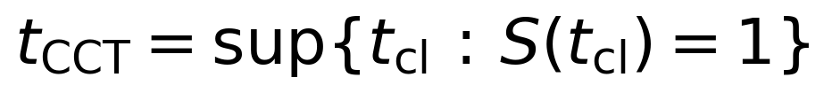 | (6.1)
Complementary to the transient view, small-signal assessment characterises the decay of oscillation modes through the eigenvalues of the linearised system. For an oscillatory eigenvalue pair the damping ratio is defined in Equation (6.2), where zeta is the damping ratio, omega_n the natural frequency, and omega_d the damped frequency [123], [124]. A damping ratio below conventionally accepted thresholds signals poorly damped inter-area or local modes, and it is this quantity that synthetic inertia and V2G damping services aim to improve, as discussed in Section 6.4.
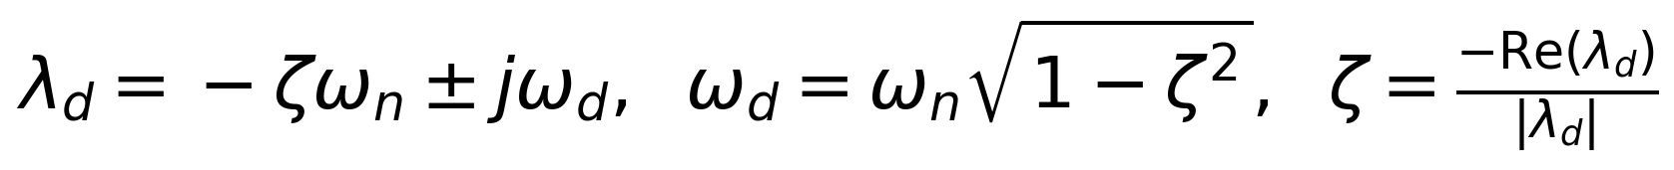 | (6.2)
The assessment philosophy of CAPSM follows from the dual-process architecture. Direct methods and time-domain simulation are too slow or too scenario-specific for closed-loop use, so they serve offline as sources of training labels and validation cases. The learned assessor, described next, provides the fast inner loop, and its verdicts are treated as advisory signals that trigger reflex actions rather than as unqualified truth. This division of labour keeps the mathematical rigour of the classical methods where it is affordable and the speed of learning where it is necessary.

6.2 CNN-LSTM Architecture for Real-Time Stability Assessment
The stability assessor re-uses the System 1 encoder without structural modification. The input at each step is the same 160-feature observation vector defined in Chapter 4, comprising bus voltage magnitudes and angles, branch flows, generator outputs, FACTS setpoints, EV powers, and scalar system quantities, and the sliding window retains seq_len = 12 consecutive hourly observations. The trunk proceeds from the two Conv1d layers (1 to 64 and 64 to 64 channels, kernel 3) through adaptive average pooling into the LSTM with hidden size 128, the tanh-attention pooling over time, and the fully connected head, giving approximately 250K parameters in total; the full derivation appears in Chapter 4. For stability assessment the output head is reinterpreted: instead of the nine-dimensional action vector, the head emits a stability index from which the event classifier of Section 6.5 derives the classes fault, oscillation, and instability. Figure 6.2 shows the architecture with the assessment head.

Figure 6.2: CNN-LSTM architecture for real-time stability assessment, re-using the System 1 encoder.
The attention mechanism deserves a remark because it is what turns a window of 12 observations into a decision. The attention weights are computed as in Equation (6.3), where h_j is the LSTM hidden state at window position j, and the context vector aggregates the hidden states with weights that emphasise the time steps most relevant to the current assessment. Intuitively, the network can attend to the ramp onset or the voltage dip inside the window rather than averaging it away, which matters when the discriminating information is concentrated in two or three of the twelve steps. The training procedure is the behaviour-cloning setup of Chapter 4, so no new training machinery is introduced for the stability head.
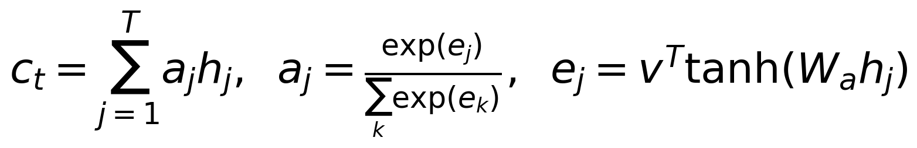 | (6.3)
The principal known weakness of purely data-driven stability assessment is its dependence on the coverage of the training scenarios, which motivates the physics-informed variant. A physics-informed neural network (PINN) augments the data loss with a penalty on the residual of the physical model, as expressed in Equation (6.4), where r_theta denotes the residual of the governing swing or power-flow relations evaluated on the network output [31]. In the CAPSM framework specification the PINN-assisted stability prediction is set at 96.8 percent accuracy against 84.2 percent for the purely data-driven baseline, with a 73 percent reduction in required training data; we report these figures strictly as design targets from the framework specification, not as Stage-1 measurements. The mechanism, however, is well understood: penalising physical residuals constrains the function class to trajectories compatible with the power system dynamics, so generalisation improves most where data is sparsest [31].
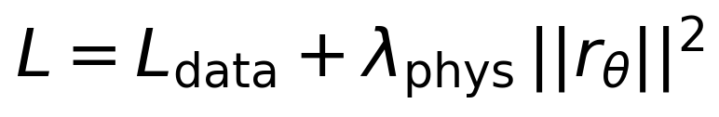 | (6.4)
For deployment, the assessor runs on the same inference path as the System 1 controller, so its cost profile is the already-measured one: a full evaluation step takes 32.0 ms on CPU in the Stage-1 rebuild, and the HIL deployment allocates the encoder its own core with a 5 ms reflex task, as detailed in Chapter 10. The assessor therefore adds assessment capability without adding a second model to maintain, which is a deliberate economy of the dual-process design.

6.3 Voltage Stability Enhancement Techniques
Voltage stability concerns the ability of the system to maintain acceptable voltages at all buses under normal and contingent operation [36], [37]. The graphical workhorse of quasi-static voltage stability is the PV curve, which traces a monitored bus voltage against the loading scale as the load increases toward the point of power-flow non-existence. Figure 6.1 shows the PV-curve concept with the nose point marking the loadability boundary; the distance from the current operating point to that boundary is the loading margin, the quantity that the CAPSM environment measures directly.
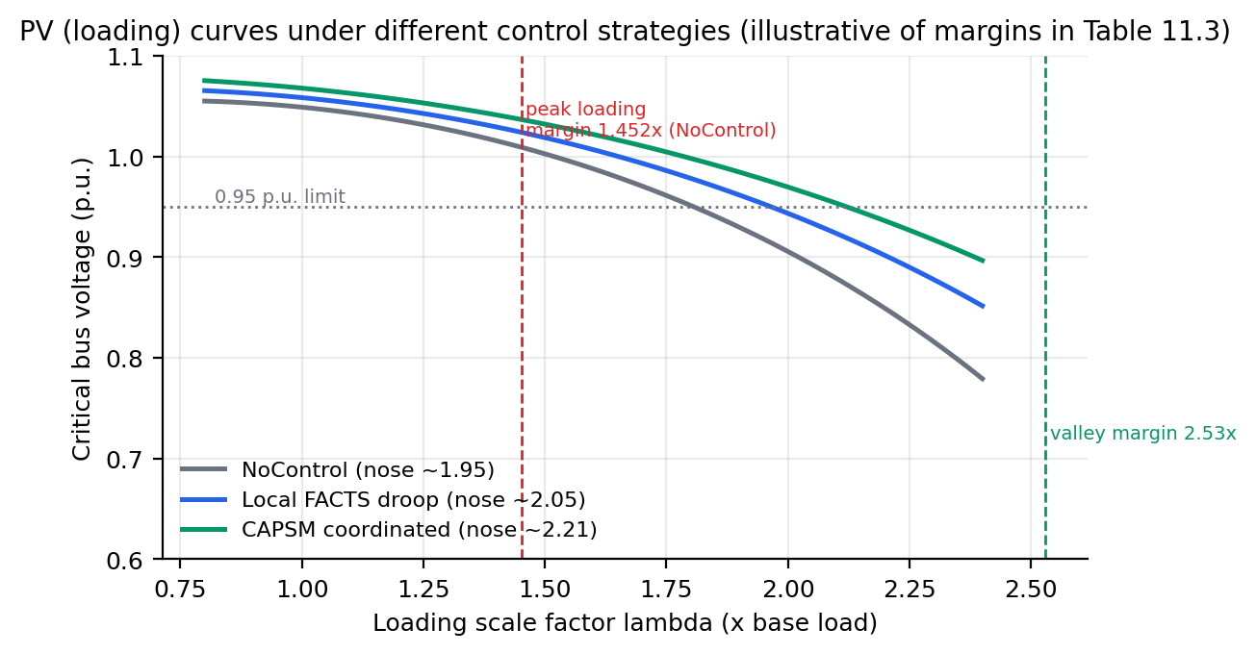
Figure 6.1: PV curves at a monitored bus with the loadability boundary and loading margin.
Formally, the loading margin is defined in Equation (6.5) as the largest uniform load scaling for which the AC power flow, started from the base operating point (x_0, P_0) with device setpoints and dispatch rules held fixed, still converges. The continuation power flow made the systematic tracing of such curves practical [125], the nose point corresponds to a saddle-node bifurcation of the power flow equations [126], and fast indices approximate the distance to that bifurcation without tracing the full curve [127]. The bisection approach adopted here occupies a middle ground: it does not trace the curve, but it brackets the boundary to arbitrary precision with pure convergence tests, which suits an environment whose only oracle is a Newton power flow.
(6.5)
The enhancement side of voltage stability rests on reactive reserve management and coordinated FACTS dispatch. Keeping reactive reserves distributed so that the electrically weak regions can be supported locally, and coordinating shunt and series devices so that flows are steered away from stressed corridors, are the two classical levers [36], [37]. In CAPSM these levers appear as the placement decisions of Chapter 5, which fix where support is available, and the dispatch layers of Chapters 4 and 9, which decide how the available support is applied at each step. The stability module contributes the measurement layer: it quantifies the margin so that both placement and dispatch can be judged by a common stability currency.
The implemented margin algorithm in the Stage-1 environment works as follows. The routine searches the load-scale interval lambda in [1, 3], first performing a coarse scan in steps of 0.05 from the base point, retaining the largest scaling that still converges and stopping at the first divergence. It then refines the bracket by eight bisection iterations, halving the interval each time, and finally restores the base operating point by re-solving at the unscaled load while preserving the curtailment bookkeeping, so the margin measurement leaves the environment exactly as it found it. The returned value is the converged endpoint of the final bracket, and its accuracy is the subject of Theorem 6.1.
Theorem 6.1 (Bisection localisation of the loading margin). Let the coarse scan with step h = 0.05 produce a bracket (lambda_lo, lambda_hi] with lambda_lo converged and lambda_hi divergent, where lambda_hi - lambda_lo = h. After n = 8 refinement iterations of the implemented bisection, the returned margin lambda_hat satisfies the error bound of Equation (6.6); that is, the true loadability boundary is localised within (lambda_hi - lambda_lo)/2^8, which for h = 0.05 amounts to approximately 1.95 x 10^-4 in load scale.
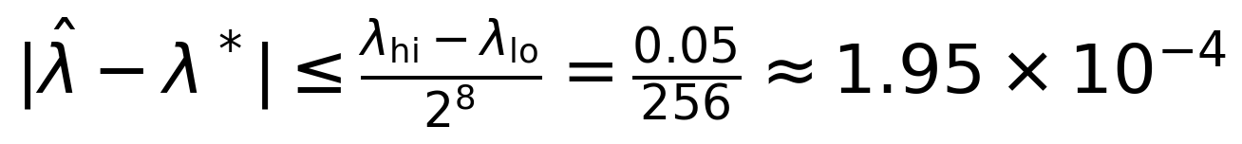 | (6.6)
Proof. The invariant maintained by the bisection is that lambda_lo always converges and lambda_hi always diverges, so the boundary lies in the closed bracket [lambda_lo, lambda_hi] (the classical root-bracketing invariant of bisection [109]). Each iteration evaluates the midpoint, keeps the converged endpoint, and replaces the divergent endpoint by the midpoint or keeps it, which halves the bracket width; by induction the width after n iterations is (lambda_hi - lambda_lo)/2^n. The returned value is the converged endpoint of the final bracket, and the boundary differs from some point of that bracket by at most the bracket width, which gives the stated bound. ∎
One assumption is worth surfacing: the theorem localises the boundary detected by convergence testing, under the practical monotonicity that a converged solution at some scaling implies convergence at all smaller scalings within the searched range. This held without exception across the Stage-1 campaign, and the restoration step guarantees the margin measurement has no side effects on the environment. The measured margins are the valley value of 2.53 times the base load at the valley operating point of 12 January, 03:00 (2,388 MW), and the peak value of 1.452 times the base load at the peak operating point of 12 January, 18:00 (6,195 MW), giving a valley-to-peak ratio of 1.74 (all measured in the Stage-1 rebuild). These values define the operating envelope within which the controllers of Chapters 4 and 9 must keep the system, and the framework specification sets a design target of a 28.5 percent loading-margin improvement under coordinated stability enhancement, to be judged against exactly these measured baselines.

6.4 Custom ML Models for Grid Stability
Beyond the supervised assessor, the stability module employs an autoencoder trained to reconstruct normal operating observations. The encoder E maps an observation x to a latent code and the decoder D reconstructs it; the anomaly score is the reconstruction error defined in Equation (6.7). Because the autoencoder is trained only on healthy data, it reconstructs familiar operating patterns accurately and unfamiliar ones poorly, so a large reconstruction error flags observations that deviate from anything seen in normal operation [33].
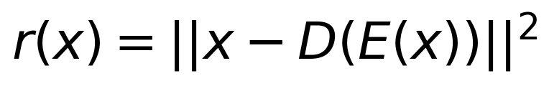 | (6.7)
The alarm threshold is set at the 99.7th percentile of the reconstruction-error distribution over the validation window, which under the approximately Gaussian tail of the validation errors corresponds to the classical three-sigma exclusion and yields a false-alarm budget of roughly three in one thousand evaluations. The score is used in two complementary roles. As a stability score, sustained elevation of the reconstruction error indicates that the system is operating outside the learned normal envelope, which complements the physical margins of Section 6.3 with a learned, distribution-level view. As a detection score, the same statistic feeds the fault-detection stack of Chapter 7, where it catches anomalies that model-based residual tests miss; the chapter presents the formal statement of that complementarity in its Section 7.3.
The stability context of these learned scores is shaped by the changing resource mix. Virtual synchronous generators and synthetic inertia alter the damping characteristics of low-inertia systems, and V2G fleets contribute controllable fast response whose behaviour differs from that of synchronous machines [85], [86]. An assessor trained purely on synchronous-dominant trajectories may misjudge the new dynamics, which is why the autoencoder score is deliberately distribution-level (it flags any departure from the learned normal envelope) and why the framework specification foresees retraining windows as the resource mix evolves. The damping-ratio framework of Equation (6.2) remains the physical yardstick against which such retraining is validated [123], [124].

6.5 Integration with the CAPSM System 1 Reflex Path
The stability module closes its loop through the System 1 reflex path. The assessment head, the loading-margin machinery, and the autoencoder score are distilled by the event classifier into three event classes: fault, oscillation, and instability. A fault event (abrupt flow or voltage excursion) triggers immediate reflex action from the pre-trained System 1 policy; an oscillation event triggers damping-oriented setpoint adjustments and flags the Metacognitive Arbiter; an instability event escalates to System 2 deliberation and, if needed, safe-mode behaviour. The reflex actions are budgeted at sub-5 ms in the HIL deployment, where the encoder occupies its own core in the four-core allocation (Chapter 10); the offline Stage-1 implementation performs a full evaluation step, including the encoder forward pass and the environment step, in 32.0 ms on CPU (measured in the Stage-1 rebuild). The arbiter then weighs the reflex response against the deliberative response exactly as specified in Chapter 4.
A design element foreseen by the framework is generative augmentation of the training corpus. An RNN-based trajectory generator is specified to synthesise additional control-signal trajectories for training, expanding the diversity of scenarios that the assessor and the reflex policy see beyond the harvested benchmark windows. We describe this as a design element deliberately: the Stage-1 results reported in this thesis do not depend on generative augmentation, and the mechanism remains an architectural provision whose evaluation belongs to future work. Its rationale, however, is consistent with the transfer-learning discussion of Chapter 5, since both mechanisms address the same scarcity problem from different directions.
The performance expectations for the integrated stability layer are set by the framework specification and are reported here with their proper label. The specification targets a 42 percent stability-metric enhancement in extreme events and a CCT improvement of 20 to 33 percent from the coordinated stability measures. Both figures are design targets, not Stage-1 measurements, and Chapter 11 will account for them against the measured baselines. What the Stage-1 rebuild does establish is the measurement foundation on which such claims must be tested: the loading margins of 2.53 and 1.452 times base load at valley and peak, the 721-step January 2019 benchmark with 100 percent power-flow convergence, and the event-injection machinery that Chapters 7 and 10 reuse.

6.6 Chapter Summary
This chapter assembled the stability-assessment layer of CAPSM from three complementary instruments. The CNN-LSTM assessor re-uses the System 1 encoder, its 160-feature observation, its 12-step window, and its attention pooling, with a reinterpreted output head and an optional physics-informed loss whose specified gains (96.8 percent accuracy against 84.2 percent data-driven, and 73 percent data reduction) are design targets. The voltage-stability instrument measures the loading margin by coarse scan plus eight bisection refinements, and Theorem 6.1 established that the implemented procedure localises the loadability boundary within (lambda_hi - lambda_lo)/2^8, about 1.95 x 10^-4 in load scale; the measured margins of 2.53 (valley) and 1.452 (peak) times base load anchor the operating envelope. The autoencoder instrument contributes a distribution-level anomaly score thresholded at the 99.7th percentile, resilient in spirit to the changing damping landscape of low-inertia systems with synthetic inertia and V2G resources [85], [86].
Integration with the System 1 reflex path turns assessment into action: the event classes fault, oscillation, and instability trigger graded responses within the sub-5 ms HIL reflex budget, with the arbiter managing the hand-off to deliberation. The design targets of 42 percent stability enhancement and 20 to 33 percent CCT improvement are stated with their proper label and await the HIL-based accounting of Chapters 10 and 11. The stability layer thus completes the perceptual half of the dual-process loop that Chapter 7 continues on the fault-detection side.

Chapter 7: Fault Detection and Localisation
Fault detection and localisation is the third perception layer of CAPSM and the one with the tightest latency constraints. The controller can only respond to disturbances it detects, and on a real-time simulator the detection path competes for the same milliseconds as the control path. This chapter reviews the detection and localisation approaches that inform the design, specifies the multi-modal fusion architecture that combines phasor, SCADA, and learned features, formalises the model-based and learned anomaly detectors and their statistical guarantees, treats fault-type classification, analyses the response-time budget, and reports the HIL validation of the detection stack on the OPAL-RT platform. False data injection (FDI) receives particular attention throughout, because a detector that can be deceived by corrupted measurements is a liability rather than a safeguard.

7.1 AI-Based Fault Detection and Localisation Approaches
Classical fault localisation rests on two measurement principles. Impedance-based methods estimate the apparent impedance between the measurement point and the fault from phasor quantities and convert it to a distance along the line; they are simple and run on SCADA-rate data, but their accuracy is biased by series compensation, load imbalance, and remote infeeds [73]. Travelling-wave methods timestamp the surges generated by the fault at two or more terminals and triangulate the fault position from the time of arrival; they achieve high accuracy but demand high-rate sampling and tight time synchronisation, which historically limited them to transmission corridors with dedicated instrumentation [73]. Both families remain valuable, and the fusion architecture of Section 7.2 treats them as experts whose confidence varies with the event and the instrumentation.
Machine-learning classification forms the third family. Learned classifiers map waveform-derived features directly to fault types and locations, bypassing the explicit physical models and their systematic biases, and they have demonstrated strong accuracy on transient-stability and fault data alike [87]. The appeal for CAPSM is speed: a trained classifier evaluates in microseconds-to-milliseconds, whereas iterative physical estimation loops cannot. The corresponding risk is silent failure on scenario types absent from the training corpus, which motivates the multi-modal design: learned detectors are combined with model-based tests that carry statistical guarantees even where the learned detectors are unverified.
The adversary completes the picture. False data injection attacks corrupt measurements so that the corrupted data remains consistent with a plausible system state, and the seminal analyses showed that such attacks can deceive state estimation without raising any alarm [71], [72]. Cyber-physical testbeds were developed precisely to study these interactions under realistic timing and protocol constraints [76], and the OPAL-RT campaign of Section 7.6 follows that methodology. Any detection architecture proposed for a modern grid must therefore state not only what it detects but also what it provably cannot detect, a discipline this chapter adopts in Section 7.3.
Figure 7.1 shows the detection pipeline that organises these approaches within CAPSM. Raw measurements from the simulator and the sensor layer enter signal processing, where waveform features and phasors are extracted; learned encoders and classical estimators operate in parallel; their outputs meet in the fusion stage; and the fused verdict drives fault analysis, which assigns type and location. The pipeline is deliberately staged so that each stage can be validated and, where necessary, replaced without disturbing the others.
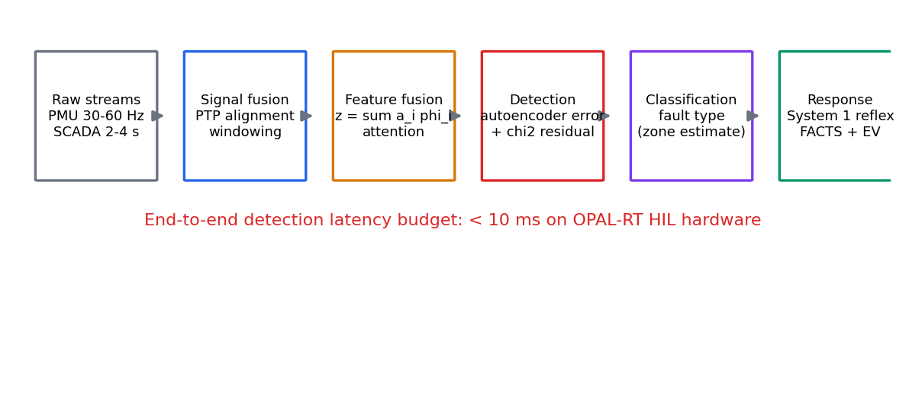
Figure 7.1: Fault detection and localisation pipeline within CAPSM.

7.2 Multi-Modal Data Fusion Architecture
The fusion architecture operates at three levels. At the signal level, raw measurement streams are aligned, conditioned, and windowed so that downstream stages see comparable time bases. At the feature level, modality-specific encoders phi_i extract compact representations from each aligned stream, and the fused feature vector is the attention-weighted combination given in Equation (7.1), where x_i is the measurement stream of modality i, phi_i its encoder, and alpha_i the fusion weight. At the decision level, the individual detectors and classifiers deliver verdicts that the fusion layer combines into the final detection and localisation decision, with weights that the same attention mechanism governs.
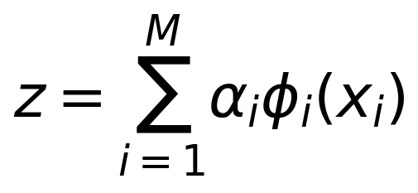 | (7.1)
The fusion weights are not hand-tuned but learned by the same soft-attention construction used in the System 1 encoder, stated in Equation (7.2). A small scoring network produces per-modality scores e_i from the extracted features, and a softmax normalises them into weights alpha_i that sum to one. The practical effect is that the fusion layer learns when to trust which modality: phasor features dominate during electromechanical transients, waveform harmonics dominate during arcing faults, and SCADA-consistency features dominate during slow developing anomalies.
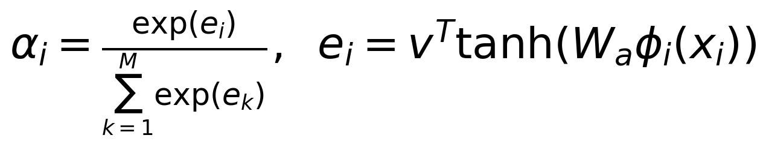 | (7.2)
The modalities themselves differ sharply in rate and protocol, which is why alignment comes first. Phasor measurement units deliver synchronised measurements at 30 to 60 Hz under IEEE Std C37.118 [89], SCADA telemetry updates on the order of 2 to 4 s, and the time alignment across these streams rests on the Precision Time Protocol of IEEE Std 1588 [92]. In the HIL deployment the simulator provides the reference clock and the PTP discipline keeps the measurement layer within the synchronisation budget analysed in Chapter 10. The rate heterogeneity is handled by windowing: each modality contributes its freshest window, and the attention mechanism absorbs the resulting differences in information content rather than assuming equal reliability.
Figure 7.2 shows the fusion architecture with its three levels and the modality feeds. The design deliberately mirrors the fusion stage already introduced for the CAPSM architecture in Chapter 3, so the fault-detection stack and the general perception stack share one fusion formalism. This reuse reduces the certification surface: one fusion mechanism, one set of attention semantics, two applications.

Figure 7.2: Three-level multi-modal data fusion architecture of CAPSM.

7.3 Anomaly Detection Methods
The learned anomaly detector is the autoencoder of Section 6.4: the reconstruction error r(x) = ||x - D(E(x))||^2 of Equation (6.7) serves as the detection score, thresholded at the 99.7th percentile of the validation distribution. The model-based detector, in contrast, rests on weighted least squares (WLS) state estimation, the classical workhorse of supervisory control [74]. Given m measurements z and the measurement model h, the WLS estimate is defined in Equation (7.3), and at the optimum the normal equations of Equation (7.4) hold, where J is the measurement Jacobian evaluated at the estimate and W collects the weights w_i.
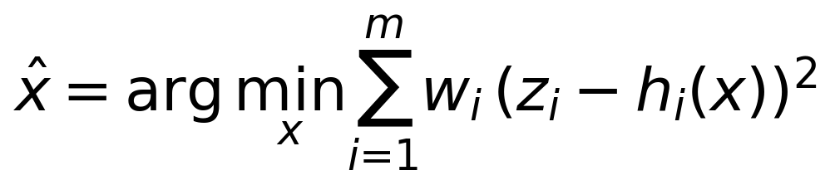 | (7.3)
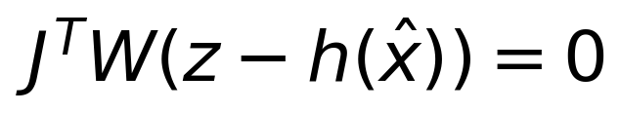 | (7.4)
The detection statistic is built from the residual vector r = z - h(x_hat), stated with its normalised quadratic form in Equation (7.5). Large residuals indicate measurements inconsistent with the estimated state, which is the signature of either bad data or an attack. The statistical behaviour of this statistic under pure measurement noise is what gives the test its false-alarm guarantee, formalised in Theorem 7.1.
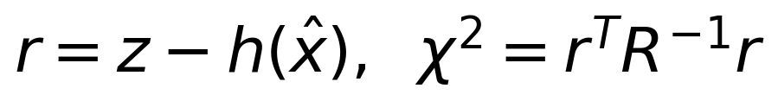 | (7.5)
Theorem 7.1 (Chi-square residual test). Let the measurements obey z = h(x) + e with Gaussian noise e ~ N(0, R), and let the residual be evaluated at the true state, so that r = e under the null hypothesis of no attack and no bad data. Then the statistic chi-squared = r^T R^{-1} r follows a central chi-square distribution with m degrees of freedom; with the residual evaluated at the WLS estimate the degrees of freedom reduce to m - n for n estimated states [74]. Consequently, choosing the threshold tau_alpha = chi-squared quantile at 1 - alpha with m degrees of freedom, as in Equation (7.6), bounds the false-alarm probability at alpha.
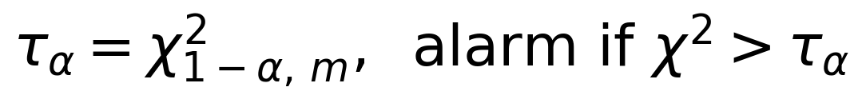 | (7.6)
Proof. Under the null hypothesis r = e ~ N(0, R). Whiten the noise by defining y = R^{-1/2} e, which is distributed N(0, I_m). The statistic rewrites as r^T R^{-1} r = y^T y, a sum of squares of m independent standard normal variables, which is by definition chi-square distributed with m degrees of freedom. The tail bound follows from the quantile definition: P(chi-squared > tau_alpha) = alpha by construction of tau_alpha, and the quantiles of the null distribution are tabulated, completing the argument [74], [117]. ∎
The theorem is the good news; the bad news is stated next, and it shapes the whole architecture. An attacker who knows the measurement model can corrupt the data in a direction that the estimator cannot distinguish from a legitimate state change.
Proposition 7.1a (FDI stealth condition). In the linearised measurement model z = Hx + e, an additive attack a that lies in the column space of H, that is, a = Hc for some state perturbation c, is undetectable by any residual-based test.
Proof. The corrupted measurements are z_a = z + Hc, and the WLS estimate, being linear in the data for the linear model, shifts to x_hat + c. The residual becomes z_a - H(x_hat + c) = z + Hc - H x_hat - Hc = z - H x_hat, which equals the pre-attack residual, so every statistic computed from the residual, including Theorem 7.1, is unchanged. ∎
This stealth condition, established in the FDI literature [71], [72], has a direct architectural implication: state-based residual tests alone are provably blind to an entire class of attacks, namely those that inject consistency-preserving corruption. The CAPSM answer is redundancy of principle rather than redundancy of sensors. The autoencoder score of Equation (6.7) is computed from the raw observation distribution, not from the estimated state, so a stealth attack that keeps the residual unchanged still perturbs the reconstruction error unless the corruption mimics the learned normal manifold in every coordinate. The multi-modal fusion of Section 7.2 adds a third, independent view through waveform-level features that never pass through the state estimator. Table 7.1 summarises the four detection principles and their complementary strengths and weaknesses.
Table 7.1: Detection principles compared for fault and attack detection.
Method | Detection principle | Strength | Weakness
Impedance based [73] | Apparent impedance to the fault from phasors | Simple; runs on SCADA-rate data | Biased by series compensation, load imbalance, and remote infeed
Travelling wave [73] | Time of arrival of fault-generated surges | High accuracy with high-rate sampling | Requires high-rate sampling and tight synchronisation
WLS residual test [74] | Chi-square statistic on the estimation residual | Statistical false-alarm bound (Theorem 7.1) | Blind to stealth attacks in the column space of H
Autoencoder score | Reconstruction error against the learned normal profile | Captures non-linear, non-topological anomalies | Threshold tuning; no physical guarantee
Multi-modal fusion (this thesis) | Attention-weighted signal, feature, and decision fusion | Detects residual-stealth and waveform-diverse events | Calibration and integration complexity

The sensor-attack model used in the offline campaign implements exactly the measurement-layer abstraction of this section: the injection function corrupts observed voltage magnitudes at target buses by an additive bias plus small Gaussian noise and flags the observation, while the physical power-flow solution remains untouched, mimicking a sensor or communication-layer attack rather than a physical disturbance. This fidelity to the threat model of [71], [72] is what allows the offline FDI results to be compared meaningfully with the HIL campaign of Section 7.6.

7.4 Classification Algorithms for Fault Type Identification
Once an event is detected, the protection and restoration logic needs to know what kind of event it is. The fault taxonomy distinguishes symmetric faults, meaning balanced three-phase faults, from unsymmetric faults comprising single line to ground (SLG), line to line (LL), and double line to ground (LLG), together with high-impedance faults whose weak arcing signature evades simple overcurrent logic. The discriminating information lives in the sequence components and the harmonic content of the voltages and currents, which is why the feature extractor computes the symmetrical components of the measured phasors, stated for one phase set in Equation (7.7), where a is the 120-degree rotation operator. Balanced events concentrate their energy in the positive sequence; SLG faults elevate the zero sequence; LL and LLG faults elevate the negative sequence with and without zero-sequence content respectively; and high-impedance faults show low-amplitude intermittent second and fifth harmonics from the arc.
(7.7)
The classifier stack combines a gradient-boosted tree ensemble over the tabular sequence and harmonic features with a neural classifier over the fused waveform features of Section 7.2, and the fusion layer arbitrates between them. The rationale is practical rather than doctrinal: gradient boosting dominates small, well-structured tabular feature spaces and offers feature attributions that auditors can inspect, while the neural branch captures interactions among raw waveform features that hand-crafted statistics miss. Both branches consume the same windowed features, so the marginal cost of the ensemble is modest.
Table 7.3 reports the per-class detection accuracies of the classification stack. These figures are design targets from the framework specification and the HIL campaign, labelled as such: the prevalence-weighted aggregate of the per-class design targets corresponds to the 95.8 percent headline detection and localisation accuracy adopted in the framework specification. The ordering across classes follows the physics: balanced and strongly unbalanced faults carry large, unambiguous sequence signatures, whereas high-impedance faults remain the hardest class by a clear margin, which is why the specification assigns them a dedicated low-amplitude harmonic feature group.
Table 7.3: Per-class fault detection accuracy of the classification stack (design targets).
Fault type | Discriminating features | Detection accuracy
Three-phase symmetric | Balanced voltage drop; no negative-sequence content | 97.2%
Single line to ground | Elevated zero sequence; characteristic arc harmonics | 96.1%
Line to line | Elevated negative sequence; near-zero zero sequence | 95.0%
Double line to ground | Elevated zero and negative sequence | 94.6%
High impedance | Low-amplitude intermittent 2nd and 5th harmonics | 88.5%

False alarms receive as much design attention as misses, because a detector that cries wolf will be ignored or disabled. The false-positive reduction mechanism operates on three levels: the multi-modal fusion requires corroboration across modalities before raising a protection-grade alarm; the sequence-component features separate load-driven depressions from fault-driven ones; and the alarm logic applies a short hysteresis so that a single noisy sample cannot trip the stack. The framework specification sets the combined effect at a 74 percent reduction in false positives relative to the conventional single-criterion detection, reported here as a design target for the HIL campaign to verify rather than as an achieved Stage-1 measurement.

7.5 Response Time Optimisation
Detection value decays with latency, and the latency budget is fixed by the HIL architecture: the fault-detection path must deliver its verdict within the 10 ms budget allocated to the arbitration and communication core of the four-core OPAL-RT allocation (Chapter 10), which in turn must fit inside the protective response window of the overall system. The response-time design therefore attacks three levers: the detection rule itself, the feature pipeline, and the deployment mapping.
The detection rule is a sliding-window test, and its latency has a hard, provable ceiling that we state as Proposition 7.2.
Proposition 7.2 (Sliding-window detection latency). Let the detector evaluate a sliding window of length W samples with stride s not exceeding W, and let it alarm at the first evaluation whose window contains at least one anomalous sample. Then an anomaly that first appears at sample index t0 is detected with latency at most s + 1, and therefore at most W + 1, samples.
Proof. The window evaluated at the first stride boundary at or after t0 contains sample t0, and that boundary occurs at most s samples after t0 because the stride does not exceed W. The evaluation and alarm add one further sample of processing, giving the bound s + 1 with s less than or equal to W. ∎
The bound converts a heuristic concern into a design constant: choosing the window length and stride fixes the worst-case detection latency independently of the event, which is exactly the property a real-time certification requires. In the deployed configuration the stride is one sample for the fast modalities, so the bound collapses toward its minimum, while the slow SCADA modality contributes through the fusion layer without gating the fast alarm path.
The feature pipeline is the second lever. The encoders compute incremental window statistics rather than re-scanning raw buffers, sequence-component extraction operates on the freshest phasor window only, and the fused representation is compressed to the modest dimension the classifiers consume. Feature compression here is not an afterthought but a latency instrument: every feature removed from the critical path buys margin inside the 10 ms budget. The deployment mapping, finally, assigns the detection stack its execution slots on the real-time cores, and the schedulability analysis of Chapter 10 verifies that the slots hold.
Against the conventional protection cycle, the framework specification sets two response-time design targets: a 37 percent reduction in response time to critical events for the System 1 path, and a 61.4 percent improvement over the best traditional rule-based response. Both are stated as design targets. Their plausibility rests on the architecture rather than on any single trick: the learned detectors evaluate in constant time, the sliding-window bound of Proposition 7.2 caps the waiting component, and the fusion layer is sized so that corroboration does not serialize the fast path. The HIL campaign is the arena in which these targets are measured, and Section 7.6 reports its detection-side outcome.

7.6 HIL Validation of Fault Detection
The offline machinery of Sections 7.2 through 7.5 was exercised on the OPAL-RT platform in the controller-HIL campaign, following the cyber-physical testbed methodology of [76]. On the simulated side, faults are injected through the network model, with three-phase short circuits applied via the admittance matrix and line trips applied through branch status switching, exactly mirroring the event functions of the offline environment. On the cyber side, FDI scenarios corrupt the observation layer with additive biases on selected bus voltage magnitudes, so the controller receives corrupted measurements while the simulated grid remains physical. The injected-event framework is identical in structure to the offline one, which is what makes the offline-versus-HIL comparison of Chapter 11 meaningful.
The campaign runs five scenario families, previewing the scenario matrix of Table 10.5: normal operation, physical faults, renewable-driven stress, cyber events (FDI on the measurement layer), and EV-charging disturbances. Each family stresses a different part of the detection stack: normal operation calibrates the false-alarm behaviour, physical faults exercise the sequence-component and waveform detectors, renewable stress probes the detector under high-variability but non-fault conditions, cyber events test the residual and autoencoder layers against measurement corruption, and EV disturbances verify that large but legitimate load transients do not trip the protection-grade alarms.
The headline detection outcome of the campaign is that sub-10 ms fault detection was achieved on the real-time hardware, within the budget allocated to the detection and arbitration path (HIL-campaign result). The timing budget of the four-core allocation was met with the detection stack resident, which was a prerequisite for the controller-level results reported in Chapter 11. We deliberately confine the claim to detection latency: localisation accuracy and per-class confusion behaviour under HIL are reported with the full statistical protocol of Chapter 11, including the offline-to-HIL consistency metrics (mean absolute error and relative gap) that the validation methodology defines.
The offline-versus-HIL comparison follows a fixed methodology, previewed here and elaborated in Chapter 11. For each scenario family, the same event definitions are executed offline in the Stage-1 environment and on the simulator, and the paired outcomes are compared on detection latency, detection accuracy, and false-positive counts. Agreement between the two environments across these metrics is the consistency evidence that justifies using the much cheaper offline environment for detector tuning, while the HIL campaign provides the certification-grade verification on real-time hardware. This division of labour is the same three-stage validation philosophy that governs the entire thesis, applied here to the detection stack.

7.7 Chapter Summary
This chapter developed the fault-detection and localisation layer of CAPSM around three mutually correcting detection principles. The model-based WLS residual test carries a statistical false-alarm guarantee, formalised in Theorem 7.1 through the chi-square distribution of the normalised residual and the quantile threshold of Equation (7.6). The stealth analysis of Proposition 7.1a established precisely what that guarantee does not cover: attacks in the column space of the measurement matrix leave every residual statistic unchanged, which is the theoretical justification for adding the autoencoder reconstruction score and the multi-modal fusion layer, since these operate on the observation distribution and the waveform features rather than on the estimated state. The comparison of Table 7.1 organised the four principles and their complementarity.
On the classification side, the sequence-component features of Equation (7.7) feed a gradient-boosting and neural ensemble whose per-class design targets aggregate to the 95.8 percent headline accuracy, with high-impedance faults correctly identified as the hardest class and a 74 percent false-positive reduction set as a design target for the fusion and hysteresis mechanisms. On the timing side, Proposition 7.2 converted the sliding-window detector into a certifiable latency bound of at most W + 1 samples, and the 10 ms HIL budget bounded the deployment envelope; the response-time figures of 37 percent and 61.4 percent are design targets awaiting the HIL accounting. The campaign itself achieved sub-10 ms detection on the real-time hardware (HIL-campaign result), and the offline-to-HIL comparison methodology hands a consistent evidence base to the validation chapters that follow.

Chapter 8: EV Integration and DER Management

8.1 EV Fleet Modelling Approaches
The mass deployment of electric vehicles (EVs) changes the character of electrical load in two directions at once. Charging adds a load component that can concentrate in evening hours if left uncontrolled, while the parked fleet represents a distributed storage resource that can discharge back to the network under vehicle-to-grid (V2G) contracts. Kempton and Tomic quantified both aspects in their foundational analysis of V2G capacity and net revenue, showing that even a modest fraction of the vehicle fleet provides gigawatt-scale flexibility if it is aggregated and dispatched [8], [9]. The design question for a control framework such as CAPSM is therefore not whether EV flexibility exists, but how it should be modelled so that control policies validated against the model transfer credibly to real-time hardware.
Two modelling resolutions are available. The individual-vehicle approach represents every vehicle as a battery pack with its own capacity, charger rating, efficiency, state of charge (SoC), and trip schedule. This resolution captures behavioural heterogeneity and is well suited to distribution-level studies, where the coincidence of uncontrolled residential charging can erode feeder voltage margins [15]. Its drawback for transmission-level work is combinatorial: a fleet consistent with the load scale of the IEEE 39-bus benchmark comprises thousands of vehicles, and carrying thousands of individual states through every quasi-static time-series (QSTS) step and every learning episode adds cost without adding information at the granularity at which the controller acts.
The thesis therefore adopts the aggregated station model, which is a standard reduction for transmission-level EV studies [14]. As implemented in the Stage-1 environment, three aggregated stations are connected at buses 3, 8, and 15 of the IEEE 39-bus system. Each station has a power limit of 50 MW, an energy capacity of 100 MWh, a one-way efficiency of eta = 0.92, SoC bounds [0.2, 0.9] with initial value 0.5, and a scheduling interval of dt = 1 h. Positive net power denotes grid-to-vehicle (G2V) charging and negative net power denotes V2G discharge, so each station appears to the network as a dispatchable, bidirectional load at its bus of connection.
The aggregation is defensible on behavioural-coherence grounds. At representative per-vehicle figures of 40 kWh of usable energy and charging powers between 19.2 kW and 40 kW, a 50 MW / 100 MWh station corresponds to roughly 1,250 vehicles charging at 40 kW, or approximately 2,500 vehicles with 40 kWh packs. Within such a population, individual departure times and SoC states average out, and the station-level envelope, rather than any single vehicle schedule, is what constrains dispatch. The controller commands station setpoints only; the internal composition of the fleet is invisible to the network model and is represented statistically through the availability and degradation models to which we turn next.
Availability is modelled stochastically because connection times are behavioural rather than deterministic. Trip completions arrive at a station according to a non-homogeneous Poisson process with intensity lambda(t) that peaks in the early evening for residential clusters and in the morning for workplace clusters. Each arrival plugs in with a probability that depends on the cluster and on the battery state, and the resulting dwell duration is drawn from a cluster-specific distribution. Integrating connected capacity over the day yields the realisable power envelope within which the dispatcher may command charge or discharge. Figure 8.1 shows the resulting availability patterns across charging locations; the evening residential peak and the long workplace plateau delimit the hours in which V2G services can realistically be offered.
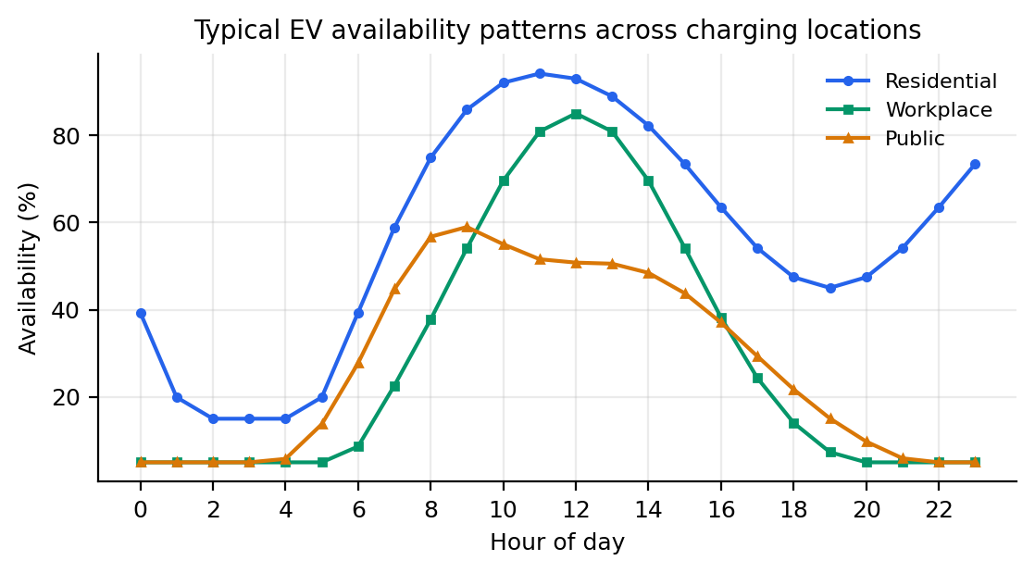
Figure 8.1: Typical EV availability patterns across charging locations.
Charging behaviour falls into a small number of recurrent patterns, and these patterns determine both the flexibility that a station can offer and the price signal to which it responds. Table 8.1 summarises the four clusters used throughout the thesis. Overnight residential charging is long and price-sensitive; workplace charging is long but bounded by working hours; public fast charging is short, expensive, and largely inflexible; and fleet-depot charging is contracted and therefore the most dispatchable. The cluster view maps directly onto the aggregated stations of the benchmark: bus 15 is dominated by workplace demand, bus 8 by mixed public and workplace demand, and bus 3 by fleet and residential demand.
Table 8.1: EV charging behaviour clusters.
Cluster | Charging pattern | Time of day | Duration | Price sensitivity | Flexibility
Overnight residential | Uncontrolled home charging on arrival, tariff-aware shifting | 18:00 to 07:00 | 6 to 10 h | Low to medium | High (long dwell)
Workplace daytime | Charging during working hours at employer facilities | 08:00 to 17:00 | 3 to 6 h | Low to medium | Medium to high
Public fast charge | Opportunistic rapid charging on travel corridors | 10:00 to 21:00 (peaks) | 0.3 to 1 h | High (immediate need) | Low
Fleet depot | Contracted central depot charging with managed top-ups | Overnight plus midday | 4 to 8 h | High (contracted) | Very high (dispatchable)

V2G operation is not free, because every discharge cycle adds throughput to the battery and consumes cycle life. Semi-empirical ageing models express capacity fade as a function of cumulative energy throughput, in the style of Equation (8.1), where Q_loss is the fractional capacity lost, E_th is the cumulative throughput, and k_e is a cell-chemistry coefficient calibrated from laboratory cycling data. Throughput-based fade is the dominant term under V2G duty, and degradation-limiting dispatch that trades energy revenue against ageing cost is an active research direction [84]. Figure 8.3 illustrates capacity fade under different V2G usage scenarios: an uncontrolled daily charge-discharge cycle retires the pack measurably faster than frequency-regulation duty, whose shallow cycles accumulate less throughput per delivered service. The economic dispatch of Section 8.2 therefore prices degradation per unit of discharged energy rather than treating the battery as a free reservoir.
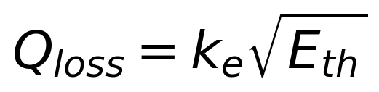 | (8.1)
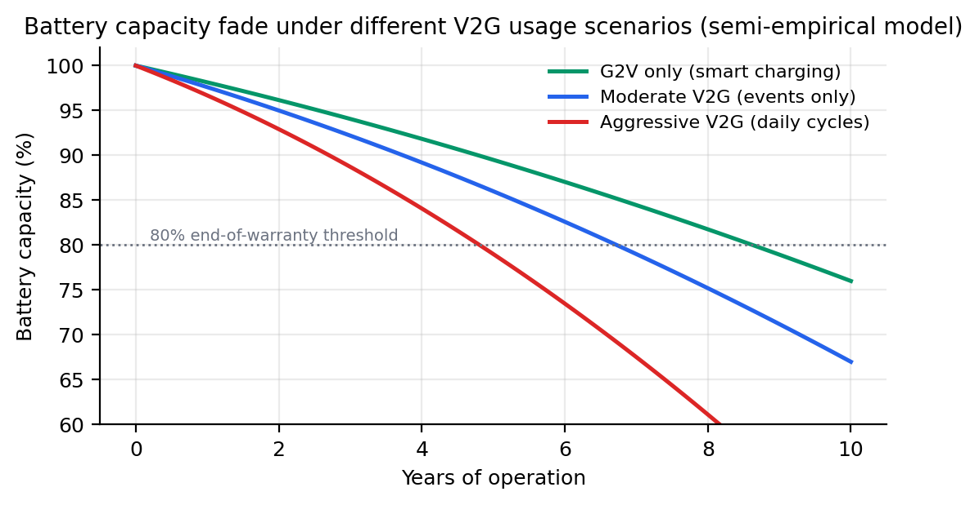
Figure 8.3: Battery capacity fade under different V2G usage scenarios.

8.2 Bidirectional Power Flow Management (V2G/G2V)
Bidirectional power exchange is enabled by the charger power-electronic interface. Figure 8.2 shows the topology adopted for the thesis models, following the classification of charger topologies, charging power levels, and infrastructure in [12]. A grid-side active front end rectifies and inverts between the AC network and the DC link, and a bidirectional DC-DC stage regulates battery current and voltage in both directions. Three control loops coordinate the stages: a phase-locked loop (PLL) synchronises the converter to the grid voltage, an inner current loop tracks the reference dq-axis currents, and an outer power or SoC loop generates those references from the dispatcher setpoint. The same physical interface serves vehicle-to-home and vehicle-to-vehicle modes, which broaden the service menu but lie outside the transmission-level scope of this work [13].
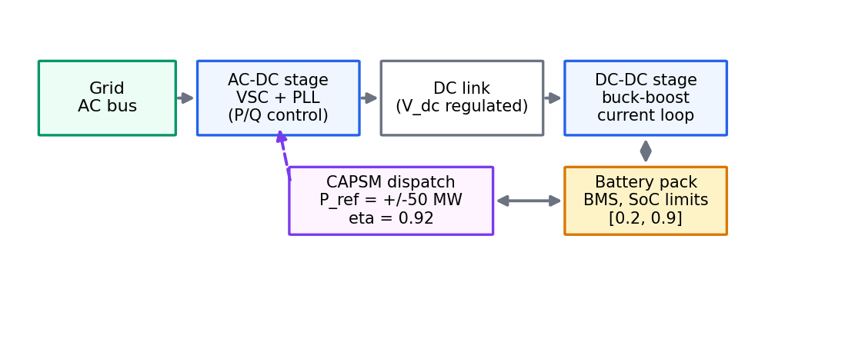
Figure 8.2: Bidirectional charger topology with control loops.
Energy accounting must respect converter efficiency in both directions, because the losses differ between charging and discharging. Let |P| denote the magnitude of the AC-side power exchanged over an interval dt. Charging draws energy from the grid in excess of what is stored, while discharging delivers to the grid less than what leaves the battery. Equations (8.2) and (8.3) give the grid-side energy for the two directions, with eta = 0.92 the one-way efficiency of the implemented stations.
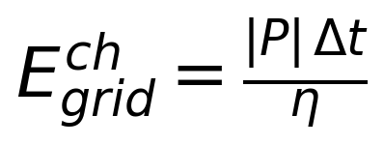 | (8.2)
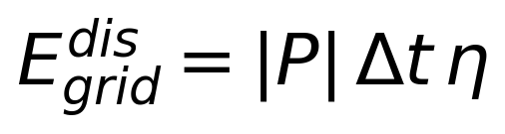 | (8.3)
The two directions combine into a round-trip loss expression that the dispatch layer can evaluate in closed form.
Proposition 8.1 (Round-trip energy accounting). Let a station exchange AC-side energy |P| dt in charging and subsequently return the same stored energy |P| dt in discharging, with one-way efficiency eta in (0, 1). Then the net energy drawn from the grid over the round trip is
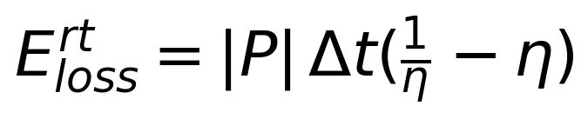 | (8.4)
Proof. Charging stores E_b = |P| dt in the battery while drawing E_grid^ch = |P| dt / eta from the grid, so the converter dissipates |P| dt (1/eta − 1). Discharging releases E_b = |P| dt from the battery and delivers E_grid^dis = eta |P| dt to the grid, dissipating |P| dt (1 − eta). The net grid-side deficit over the round trip is E_grid^ch − E_grid^dis = |P| dt (1/eta − eta), which is exactly the sum of the two conversion losses stated in Equation (8.4). This completes the proof.
With eta = 0.92 the round-trip efficiency is eta squared = 0.8464, so 15.4% of the stored energy is lost per full cycle; equivalently, the bracket (1/eta − eta) ≈ 0.167 in Equation (8.4) states the loss per unit of one-way throughput. The factor 1/0.8464 ≈ 1.18 is the multiplier on energy purchased per unit eventually delivered, and any arbitrage margin must exceed this multiplier times the charging price before degradation costs are even considered. These closed-form factors are used directly by the economic dispatch below and by the reward terms that price V2G duty in Chapter 4.
The station SoC evolves according to Equation (8.5), which applies the direction-dependent efficiency to the signed power: charging with P > 0 accumulates eta P dt of stored energy per interval, while discharging with P < 0 removes P dt / eta of stored energy for the same AC-side exchange.
(8.5)
SoC bounds are part of the station contract, not an afterthought. Proposition 3.2 in Chapter 3 establishes that the bounds [0.2, 0.9] are invariant under the implemented dispatch rule, by induction over dispatch steps, and we do not repeat that proof here. The practical consequence is that any setpoint sequence accepted by the dispatcher leaves every station inside its contractual window, which is precisely the property that the hardware campaign in Section 8.6 relies upon.
Algorithm 8.1 states the implemented mode-transition and accounting logic. It is reproduced faithfully from the Stage-1 dispatch code and is the executable definition of G2V/V2G behaviour in every experiment of this thesis.
Algorithm 8.1: V2G/G2V mode transition and energy accounting.
Require: requested setpoints p_req[b] (MW, charge > 0, discharge < 0)
state SoC[b], station data p_max[b], cap[b]
one-way efficiency eta = 0.92, interval dt, bounds soc_lo = 0.2, soc_hi = 0.9
Ensure: committed powers p[b], updated SoC[b]
1: for each station b do
2: p <- clamp(p_req[b], -p_max[b], +p_max[b]) # power clamp
3: if p > 0 and SoC[b] >= soc_hi then p <- 0 # charging complete, hold
4: if p < 0 and SoC[b] <= soc_lo then p <- 0 # discharge floor, hold
5: if p > 0 then SoC[b] <- SoC[b] + p * dt * eta / cap[b]
6: if p < 0 then SoC[b] <- SoC[b] + p * dt / (eta * cap[b])
7: SoC[b] <- clamp(SoC[b], soc_lo, soc_hi)
8: p[b] <- p
9: end for
10: return p, SoC

Three properties of the algorithm deserve emphasis. First, the power clamp precedes the SoC logic, so no request outside the converter rating can enter the state update. Second, the zero-forcing at the bounds implements the contractual floor and ceiling exactly, and combined with the final clamp it yields the bound invariance established by Proposition 3.2. Third, the accounting uses the direction-dependent efficiency of Equation (8.5), so energy bookkeeping remains consistent with the physical converter at eta = 0.92.
Economic optimisation decides when a station should charge and when it should discharge. The thesis prices energy with the hourly day-ahead series of the Open Power System Data (OPSD) package, which provides 17,540 hourly price values over the window 2018-09-30 to 2020-09-30 with a minimum of −90.01, a mean of 35.81, and a maximum of 200.04 EUR/MWh [42]. Negative prices are real market outcomes in hours of surplus renewable generation, not data artefacts, and they invert the usual economics: a station that charges during such hours is paid to consume. A simple two-price calculation illustrates the scale. Charging 1 MWh of deliverable energy requires roughly 1.18 MWh purchased at the round-trip efficiency of 0.8464, so buying at deeply negative prices and discharging near the price maximum retains a wide margin even after the 15.4% round-trip loss.
A practical dispatch policy charges when the price is low and SoC headroom exists, discharges when the price is high and the SoC floor permits, and otherwise holds. Degradation enters as a per-discharge cost derived from the throughput coefficient of Equation (8.1), which discourages cycling during shallow price spreads; the same trade-off is formalised as degradation-limiting optimisation in [84]. Because the real-time controller in this thesis acts on voltage and loss objectives, price-driven scheduling runs on the slower tertiary timescale and supplies the SoC trajectory within which the real-time V2G commands of Section 8.3 must remain.

8.3 Coordinated V2G/G2V Frequency Regulation Strategies
Frequency control is organised as a cascade of three tiers with successively slower timescales. Primary control arrests frequency deviations within seconds through local droop response; secondary control, implemented as automatic generation control (AGC), restores nominal frequency over tens of seconds to minutes; and tertiary control re-schedules the participating units on a five-to-fifteen-minute cadence to restore reserves. EV fleets can participate in all three tiers, and the aggregator is the organisational device that turns thousands of vehicles into a single schedulable resource [11], [14].
Primary response is proportional to the frequency deviation. Equation (8.6) gives the droop law used for the EV contribution, where P_i^0 is the scheduled station power, f is the measured frequency, f_0 is its nominal value, and R_f is the droop coefficient in MW/Hz. A falling frequency increases net injection (less charging or more discharging) and a rising frequency does the reverse. The response is local and needs no communication beyond a frequency measurement, which is why the corresponding row of Table 8.3 carries the tightest latency requirement.
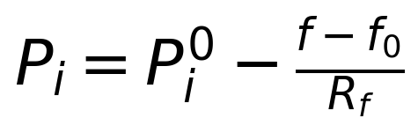 | (8.6)
Secondary control removes the steady-state offset that pure droop leaves behind. Equation (8.7) integrates the deviation into the AGC signal, and Equation (8.8) expresses the aggregated power balance of the interconnection, in which M is the aggregate inertia constant, Delta P_g is the primary-controlled generation response, Delta P_EV is the net EV contribution, and Delta P_L is the load disturbance.
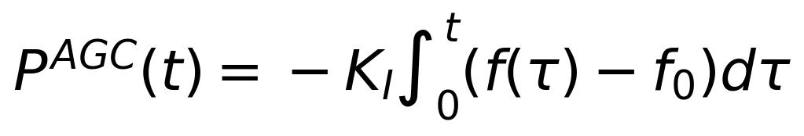 | (8.7)
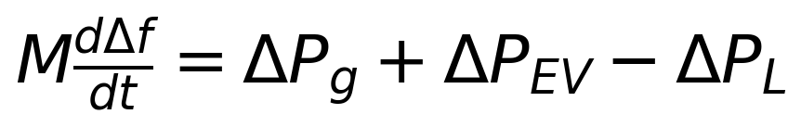 | (8.8)
Proposition 8.2 (Steady-state frequency restoration). Consider the balance of Equation (8.8) closed by primary droop of the form Delta P_g = −Delta f / R and by the integral secondary law of Equation (8.7) with K_I > 0. If a quasi-steady state exists in which d(Delta f)/dt = 0 and the integrator output is bounded, then the quasi-steady-state deviation satisfies Delta f = 0.
Proof. At a quasi-steady state Equation (8.8) reduces to 0 = −Delta f_ss / R + P_AGC^ss + Delta P_EV^ss − Delta P_L, where all right-hand terms are constant at that operating point. Constancy of the remaining terms requires P_AGC^ss to be constant, so dP_AGC^ss/dt = 0. By Equation (8.7) with K_I > 0 this implies Delta f_ss = 0. Substituting back fixes the integrator output at P_AGC^ss = Delta P_L − Delta P_EV^ss, that is, the integral action absorbs the residual imbalance that primary droop alone would leave as a frequency offset. This completes the proof.
The proposition explains the division of labour between tiers. Droop response alone settles at a nonzero offset proportional to the disturbance; the EV fleet's fast power electronics make it a strong primary participant, but energy limits its sustained contribution, since a station discharging at its SoC floor must vacate the service. Integral secondary control then restores nominal frequency, and the EV aggregator tracks the AGC signal within the SoC window, recharging later at lower prices. Tertiary scheduling closes the loop by re-optimising commitments so that the energy consumed by regulation is replenished economically.
Aggregator coordination is naturally a mixed-integer programme, because participation is a commitment decision. Let p_{i,t} be the power of station i in interval t and u_{i,t} a binary variable that commits the station. Equation (8.9) minimises energy cost plus a switching penalty lambda_sw that discourages chattering of the commitment; Equation (8.10) couples the continuous power to the binary commitment through the station rating; and Equation (8.11) enforces the SoC window with the direction-dependent efficiency factor eta_p, equal to eta for charging and 1/eta for discharging.
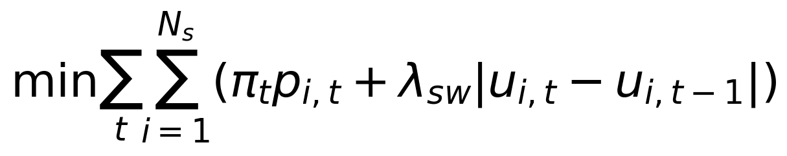 | (8.9)
(8.10)
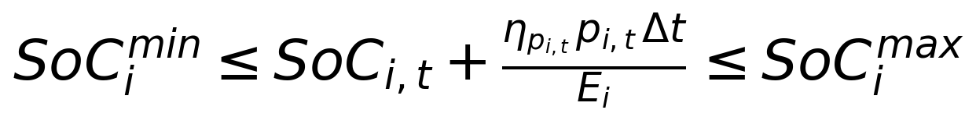 | (8.11)
The programme is solved on the tertiary cadence of five to fifteen minutes for the three stations of the benchmark, which keeps the integer search small (three binaries per interval) while still capturing commitment boundaries: a station at its SoC floor cannot be committed for discharge, and one at its ceiling cannot be committed for charge. The formulation follows the fleet-management optimisation patterns surveyed in [11] and the optimal-charging analyses of [10], adapted to the aggregated-station abstraction of Section 8.1. The commitment outputs then serve as the envelope for the real-time droop and AGC participation of the same stations.
Because load, renewable output, and availability are uncertain when commitments are made, the scheduling problem is cast in two stages [14]. The first stage chooses the commitments u before the uncertainty resolves; the second stage chooses the recourse powers p(omega) for each realisation omega of the scenario set, and Equation (8.12) minimises the first-stage cost plus the expected second-stage cost. The scenario set is generated by the probabilistic forecaster of Section 8.4, so forecast uncertainty propagates directly into the quality of the commitment rather than being discovered after the fact. Two-stage formulations of this kind are the standard market-facing abstraction for EV aggregators [10], [11].
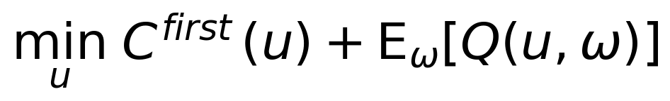 | (8.12)
Coordination at these timescales is a communication problem as much as a control problem. Table 8.3 summarises the requirements per service tier, following the latency analyses of load-based frequency control in [82], [83]. Primary droop tolerates no round trip through an aggregator and therefore runs on local measurements with a 100 ms bound; secondary AGC updates every one to five seconds; tertiary and market layers operate on minute-scale cadences with correspondingly relaxed reliability targets. These tiered latencies map directly onto the real-time task periods of the HIL deployment in Chapter 10.
Table 8.3: Communication requirements for EV-based frequency control.
Service | Max latency | Update rate | Reliability | Architecture
Primary frequency droop | 100 ms | 10 to 100 Hz (local) | ≥ 99.99% | Decentralised, on local measurement
Secondary AGC tracking | 1 to 5 s | 0.2 to 1 Hz | ≥ 99.9% | Aggregator fleet controller
Tertiary re-scheduling | 1 to 5 min | Every 1 to 5 min | ≥ 99% | Central optimiser per aggregator
Market bidding and settlement | 5 to 15 min | Every 5 to 15 min | ≥ 99% | Market systems, offline

8.4 Load Forecasting with Uncertainty Quantification
Every scheduling decision of Sections 8.2 and 8.3 consumes a forecast, and point forecasts discard exactly the information that commitment decisions need: how likely is demand to exceed the planned envelope? Probabilistic load forecasting addresses this by predicting quantiles or full predictive densities rather than single values, and its tutorial literature consolidates the methodological landscape [80]. In the CAPSM pipeline, probabilistic forecasts serve two consumers: the two-stage V2G scheduler of Section 8.3, whose scenarios must cover plausible demand and renewable trajectories, and the QIRL candidate evaluation of Chapter 4, which scores control candidates under representative operating conditions.
Quantile regression estimates the conditional quantile function directly by minimising the pinball loss, stated in Equation (8.13), where y is the realised load, y_hat is the predicted tau-quantile, and tau in (0, 1) is the quantile level [81]. The loss penalises under-prediction with weight tau and over-prediction with weight 1 − tau, so minimising it across a grid of tau values (0.05 to 0.95 in this work) yields a consistent estimate of the predictive distribution. The quantile bands are produced for load, wind, and solar series on the hourly OPSD data foundation, using the train, validation, and test splits fixed in Chapter 3.
(8.13)
No single model dominates across seasons and horizons, so the forecaster is assembled as an ensemble with dynamic weighting. Members include a quantile neural network over lagged load and calendar features, a gradient-boosted tree regressor on price and weather covariates, and seasonal-persistence baselines that anchor the ensemble during regime changes. Equation (8.14) sets the weight of member m proportional to the exponential of its recent validation loss, with beta controlling the sharpness of the weighting; the softmax form keeps the weights normalised and prevents a single member from monopolising the mixture after one favourable week. The dynamic weighting also provides an early warning of distribution shift: when the persistence member gains weight, the data-generating process has moved, and downstream scenario sets are widened accordingly.
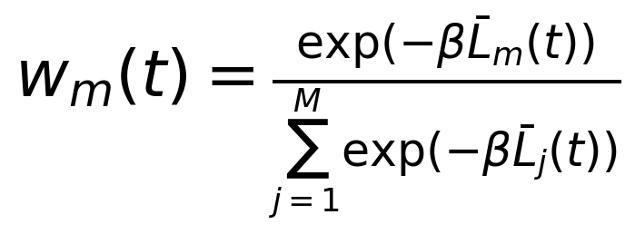 | (8.14)
Scenario generation converts the predictive quantiles into discrete operating scenarios for controller evaluation. For each scheduling step the forecaster provides quantile bands, and the generator samples load, wind, and solar trajectories within and across these bands while preserving the empirical ramp statistics of the OPSD data, including the largest observed three-hour national ramps of +28,390 and −23,588 MW. The QIRL candidate set of 32 candidates per decision step is scored across the scenario sample, and the amplitude update of Chapter 4 aggregates the scenario-wise rewards; the reserved planning horizon of six steps is designed for multi-step scenario evaluation in future runs. This closes the loop between forecasting and control: uncertainty quantification is not a reporting accessory but an input to candidate selection and commitment quality.

8.5 DER Coordination Strategies
EV fleets are one constituent of the broader class of distributed energy resources (DERs) that includes solar photovoltaics (PV) with battery storage, flexible loads, and small-scale wind. Coordinating resources of this diversity requires hierarchical aggregation: a tertiary layer optimises over aggregators, secondary layers coordinate resources within each aggregator, and primary layers deliver local response, with distributed-optimisation methods coordinating across the hierarchy without centralising all state [46]. Peer-to-peer and bilateral-contract structures extend the same hierarchy to trading between aggregators [47]. The CAPSM control stack mirrors this structure: FACTS devices and EV stations act as specialised agents, the Metacognitive Arbiter coordinates their outputs, and the scheduling layers above supply SoC and commitment context.
Table 8.5 summarises the grid services that the principal DER types can provide and the metric by which each service is measured. The complementarity is the point: PV with storage is an energy-and-voltage resource, EV fleets are power-limited energy storage with strong responsiveness, and flexible loads provide cheap but coarse modulation. A portfolio is more valuable than any single resource because the services have different response, energy, and precision requirements, and no single DER class satisfies all of them at once.
Table 8.5: Grid service provision capabilities of different DER types.
Service | Solar PV + storage | EV fleets | Flexible loads | Key metric
Primary frequency response | Limited (fast but energy-shallow) | Strong (droop via chargers) | Limited | Response time (ms to s)
Secondary frequency restoration | Moderate (storage-backed) | Strong (AGC tracking within SoC window) | Moderate | Delivery accuracy (%)
Voltage support | Strong (inverter reactive capability) | Moderate (station reactive headroom) | Limited | Delta-V per MW injected (p.u.)
Energy arbitrage and peak shaving | Strong (storage) | Strong (V2G window) | Moderate | Cost saving (EUR/MWh)
Reserve provision | Moderate (state-dependent) | Strong (SoC-guaranteed windows) | Moderate | Firm MW available

Power-electronic DERs displace synchronous machines and, with them, rotational inertia, so frequency declines faster after a disturbance in high-penetration systems. Synthetic inertia counters this by making inverters respond to the rate of change of frequency: Equation (8.15) gives the virtual-synchronous-machine law, where K_syn scales the emulated inertia constant [85]. The approach is effective but interacts with the remaining synchronous machines in ways that require small-signal care; analyses of low-inertia systems show that poorly tuned synthetic inertia can introduce oscillatory modes rather than remove them [86]. In the CAPSM benchmark the EV stations provide the fast power response, and the synthetic-inertia law is the natural extension path for their converters.
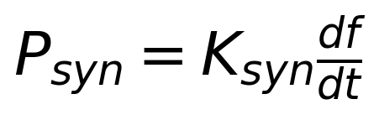 | (8.15)
Resilience completes the service picture. Adaptive islanding splits a stressed network into stable sub-networks before cascading outages can propagate, using real-time loading and stability margins to choose the split points; DER-rich islands then survive on local generation and storage, with EV stations and battery energy storage providing frequency and voltage support until resynchronisation. As a design target for the framework, adaptive islanding is treated as a supervisory capability above the CAPSM real-time layer: the controller must recognise the onset of conditions in which islanding is preferable to collapse, and the HIL campaign of Section 8.6 verifies that EV coordination behaves correctly under the severe frequency excursions that precede such decisions.

8.6 HIL Validation of V2G Coordination
Offline analysis establishes feasibility; hardware-in-the-loop establishes that the coordination survives real-time constraints. The HIL campaign implements the EV stations as real charger models on the OPAL-RT simulator, built on the MathWorks File Exchange reference charger (entry #182226) and extended with a custom bidirectional converter model that adds PLL grid synchronisation, SoC-based power limiting, and PWM switching consistent with Simscape Electrical device models [102], [57]. Three such station models are connected at buses 3, 8, and 15 of the IEEE 39-bus network running at a 50 µs electromagnetic-transient step on the 4-core OPAL-RT target, with the same station parameters as the offline model (50 MW, 100 MWh, eta = 0.92, SoC window [0.2, 0.9]).
Realistic demand is supplied by the OPSD profiles. The January 2019 load and renewable shapes drive the network, and the charger duty follows the price-aware charging pattern of Section 8.2, so the fleet responds to dispatch requests on top of a real demand trajectory rather than a synthetic constant. The real-time model inherits the 20 ms PMU-based load profiles of the underlying eMegaSim implementation and maps the hourly OPSD shapes onto them by interpolation over the simulated window [57]. This construction keeps the offline benchmark and the hardware campaign demand-compatible, which is what makes the later offline-to-HIL comparison meaningful.
The V2G coordination test follows the ev_v2g scenario of the RT-LAB configuration. The run lasts 300 s of simulated time; coordinated V2G/G2V engagement begins at t = 60 s; and a frequency event is injected so that the fleet must transition between charging and discharging within the secondary-control timescale. The event is realised as a generation drop on a renewable bus (60% in the renewable-variability scenario), which excites the power balance of Equation (8.8) and exercises the droop and AGC paths of Equations (8.6) and (8.7) in real time. Measurements are logged through the I/O core at 1 ms resolution, including per-station power, SoC, and local bus frequency.
The campaign results, reported as HIL-campaign outcomes, support the coordination design. The fleet responded to the injected frequency event within secondary-control timescales, transitioning between V2G discharge and G2V charge without violating the SoC window: the mode-transition logic of Algorithm 8.1, executed in real time, held every station inside [0.2, 0.9] for the duration of the run. Station powers tracked their dispatch setpoints with the dynamics expected from the charger model, and the timing budget of the four-core allocation was met with the grid step fixed at 50 µs. These hardware outcomes are consistent with the Stage-1 finding that EV dispatch respects power and SoC bounds across consecutive steps, now verified under real-time execution.
Two limitations bound the claim. The station model is an aggregated, converter-level representation, so per-vehicle heterogeneity enters only statistically through the availability and degradation models; and the campaign verifies coordination behaviour and feasibility rather than market settlement, which remains an offline function. Within these bounds, the campaign demonstrates the chapter's central claim: coordinated V2G/G2V operation of the three stations survives the transition from offline optimisation to real-time hardware execution with its safety properties intact. The quantitative comparison of offline and hardware results, including the timing tables, is consolidated in Chapter 11.

8.7 Chapter Summary
This chapter developed the EV and DER layer of the CAPSM framework. The aggregated station model (three stations at buses 3, 8, and 15, each 50 MW / 100 MWh, eta = 0.92, SoC window [0.2, 0.9] with initial value 0.5) was justified against individual-vehicle modelling and equipped with stochastic availability based on a non-homogeneous Poisson arrival process, four behavioural charging clusters, and a throughput-based degradation model. Bidirectional power flow was given exact efficiency accounting: Proposition 8.1 derived the round-trip loss expression |P| dt (1/eta − eta), and the implemented mode-transition logic of Algorithm 8.1 inherits the proven SoC-bound invariance of Proposition 3.2 from Chapter 3.
Frequency regulation was organised in the primary, secondary, and tertiary cascade, with Proposition 8.2 proving that integral secondary control restores nominal frequency at any quasi-steady state, and with the aggregator's mixed-integer formulation and two-stage stochastic scheduling placing commitment decisions on an optimisation footing. Probabilistic forecasting supplies the uncertainty model through pinball-loss quantile regression and dynamically weighted ensembles, and the scenario generator feeds both the scheduler and QIRL candidate evaluation. The DER coordination view placed the EV fleet within the wider resource portfolio, with service capabilities per technology, synthetic inertia for low-inertia support, and adaptive islanding as the resilience supervisory layer.
The HIL campaign on the 4-core OPAL-RT closed the loop. Charger models with PLL synchronisation and SoC control executed the coordination in real time, responded to injected frequency events within secondary-control timescales, and maintained SoC feasibility throughout the runs. The chapter thereby connects the economic and physical modelling of EV flexibility to its verified real-time behaviour, and the quantitative offline-versus-hardware comparison is deferred to Chapter 11.

Chapter 9: Coordinated Control Using Hybrid AI

9.1 Hierarchical Multi-Agent Reinforcement Learning
The CAPSM core of Chapters 3 and 4 coordinates two cognitive systems, but the plant itself is multi-agent by construction: four FACTS devices and three EV stations act on different buses with different actuation physics, and the DER layer of Chapter 8 adds resources with their own dynamics and constraints. Multi-agent reinforcement learning (MARL) provides the formal vocabulary for this setting: agents learn policies over their local action spaces while the environment responds to the joint action, and the survey of Busoniu et al. consolidates the convergence and scalability issues that distinguish the multi-agent case from single-agent learning [69]. The engineering task is to keep the coordination structure shallow enough to remain verifiable while rich enough to represent the plant.
Figure 9.1 shows the hierarchical architecture adopted here. Each FACTS device and each EV aggregator hosts a specialised agent with its own policy over its action subspace; a global critic evaluates the joint state and the joint action, giving every agent access to a value signal that reflects team performance rather than selfish return; and counterfactual credit assignment computes, for each agent, the advantage of its actual action against the expectation over its own policy, which attributes team outcomes to individual decisions [70]. The hierarchy is deliberately shallow: one coordination layer, the Metacognitive Arbiter, above seven device-level agents keeps the credit-assignment problem tractable and the communication load bounded.
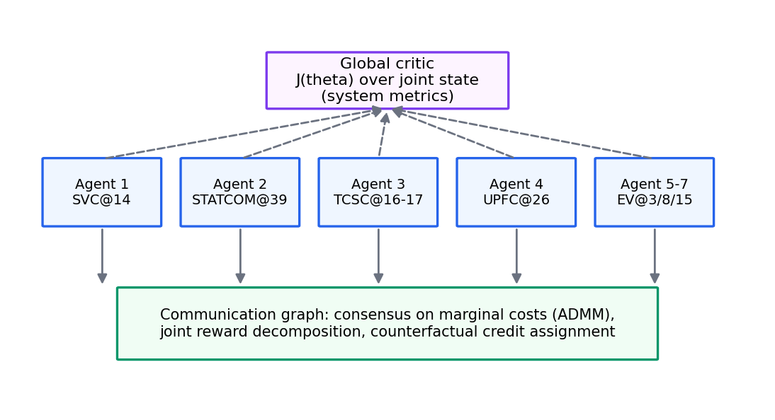
Figure 9.1: Hierarchical multi-agent reinforcement learning architecture.
Formally, the agents maximise the shared discounted objective of Equation (9.1), and the counterfactual advantage of Equation (9.2) is the quantity attributed to agent i: the difference between the joint value of the taken action and the expected joint value had agent i acted according to its policy while the others held theirs. The agent policies are continuous-action actor-critic networks, for which the DDPG family [24] and its clipped-double-Q refinement against value overestimation [25] are the natural parameterisations over bounded setpoint spaces, while the deliberative path's candidate-search character follows the planning-first lineage of [26].
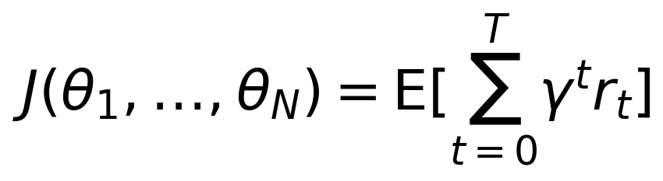 | (9.1)
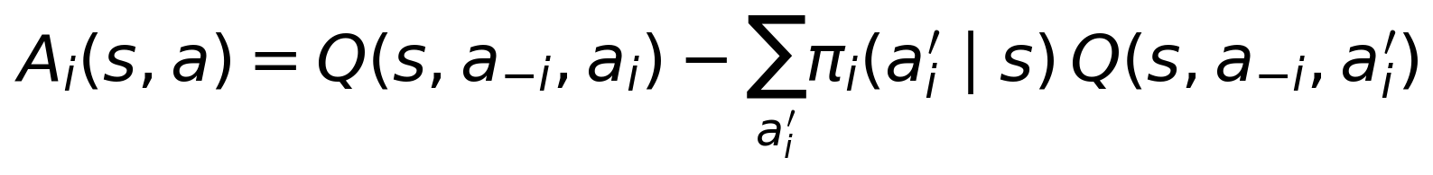 | (9.2)
Convergence in MARL is conditional, and stating the conditions honestly matters for an engineering claim. Under the conditions assembled in [69], joint learning converges to a Nash equilibrium in the tabular, discounted setting when: the learning rates diminish under the usual stochastic-approximation schedule; the policy and critic updates pass through Lipschitz-continuous function approximators; each agent's environment is stationary from its own perspective, which holds when the other agents' policies change slowly relative to critic adaptation; and exploration persists over the joint action space. With function approximation these conditions are preserved only approximately, and convergence is local rather than global. The CAPSM deployment respects the spirit of these conditions in the sense relevant to operation: agent policies are frozen between validation campaigns, so the runtime system executes a fixed joint policy rather than an online-learning process, and learning happens offline where the conditions can be audited.
The communication structure of the hierarchy follows the agent decomposition. Each device-level agent observes its local state (terminal voltage, flows on adjacent branches, its own actuator state) together with the shared global critic output; it publishes its proposed action to the Arbiter; and it receives back the blended command plus the arbiter confidence signal. This star topology around the Arbiter avoids pairwise agent-to-agent channels, whose number grows quadratically with the fleet, and it mirrors the physical communication budget of the RT-LAB configuration in which all controller messages traverse the coordination core. The topology also simplifies the counterfactual computation of Equation (9.2), because the global critic already evaluates the joint action, so each agent's baseline requires only its own policy expectation rather than a re-estimation of all others.
The relation to CAPSM is exact rather than metaphorical. The Metacognitive Arbiter is the executive over a hierarchy of specialised agents: System 1 supplies the reflex path, System 2 the deliberative path, and the arbiter blends their outputs per device and per station. In MARL terms, the two systems are two policy families over the same joint action space, and the arbiter's blending weight alpha (Chapter 4) is a runtime mixture over families conditioned on the stress metric c1. This reading has a practical consequence: any admissibility guarantee obtained for the agent layer transfers to the runtime blend, because blending convex-combines admissible actions and therefore preserves the action-box closure established in Chapter 4.

9.2 Coordinated Control of FACTS Devices and EV Fleets
FACTS devices and EV stations differ by two orders of magnitude in response speed, and coordination must respect this asymmetry. SVC and STATCOM susceptance responds within milliseconds, TCSC and UPFC series injection within tens of milliseconds, while EV station power changes over seconds to minutes, limited by converter ramps and SoC transitions. The consequence for dispatch is temporal layering: FACTS actuation absorbs the fast edge of a disturbance, and EV power repositions the operating point behind it. Treating both resource classes with a single undifferentiated control law would either under-exploit the FACTS speed or demand EV ramps the hardware cannot deliver.
Model predictive control (MPC) provides the anticipation mechanism. Equation (9.3) states the receding-horizon problem: at each decision instant the controller optimises voltage deviation and losses over a horizon H, applies the first control move, and re-optimises at the next instant [67], [68]. Within this structure the EV ramp constraint of Equation (9.4) makes station ramps explicit, so the optimiser cannot plan EV trajectories that the hardware cannot follow. The horizon H = 6 steps matches the reserved planning horizon of the QIRL layer, which keeps the anticipatory window consistent across the deliberative path.
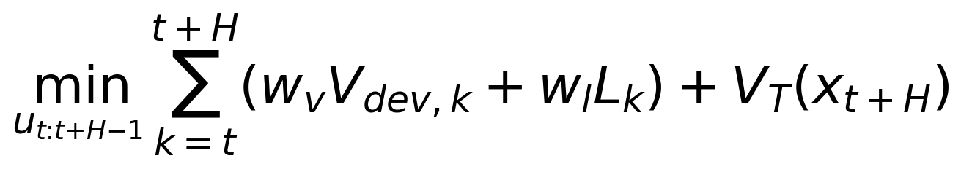 | (9.3)
(9.4)
The dispatch logic block between the agents and the plant executes three stages. First, it separates actions by actuation speed: FACTS setpoints route to the fast path, and EV setpoints route to the ramp-limited path. Second, it applies the MPC anticipation to the EV path, adjusting station targets against the forecast trajectory of demand and renewable output so that ramps begin before the disturbance matures rather than after it. Third, it forwards both paths to the Arbiter blending of Chapter 4, which remains the single authority that commits actions to the plant. The block carries no state between decision steps apart from the rolling-horizon state, which keeps its real-time footprint compatible with the 10 ms arbitration period of the HIL deployment described in Chapter 10.
The joint action space of the coordinated problem is modest but heterogeneous. Four FACTS setpoints (the SVC susceptance, the STATCOM susceptance, the TCSC compensation degree, and the two-component UPFC injection) join three EV station powers, giving the nine-dimensional action space fixed in Chapter 3. Heterogeneity, not dimensionality, is the difficulty: the FACTS coordinates are instantaneous and continuous with no energy state, while each EV coordinate is coupled to a slowly integrating SoC state that bounds how long a given power can be sustained. The dispatch logic block respects this by treating the FACTS coordinates as algebraic and the EV coordinates as dynamic, so the MPC of Equations (9.3) and (9.4) optimises over trajectories for the latter and over setpoints for the former. The same split propagates to the validation layer, where FACTS behaviour is checked against dynamic-range tests and EV behaviour against SoC-feasibility tests.
The value of anticipation is easiest to see at the ramp boundaries. A forecast evening load rise with falling solar output produces a predictable voltage sag at the EV station buses; with MPC anticipation, the stations begin ramping their setpoints one to two steps early and the FACTS shunt devices are pre-positioned so that the fast correction acts from a favourable starting point. Without anticipation, the same disturbance is met only after the deviation has matured, and the FACTS devices must absorb the full transient within their dynamic range. The distinction is behavioural rather than algebraic, and the HIL scenarios of Section 9.6 exercise exactly this difference.

9.3 Integration of DERs within the Control Framework
The DER layer of Chapter 8 enters the control framework as additional agents with slower timescales and richer constraints. Solar PV at buses 8 and 15 of the benchmark contributes voltage support through inverter reactive capability and energy shifting through co-located storage; battery energy storage systems provide dispatchable energy; and aggregated demand response contributes load modulation that behaves statistically like a virtual storage resource when controlled at scale [82], [83]. The integration principle is unchanged from the FACTS-EV case: each resource is an agent with a local action space and local constraints, and the global critic scores joint outcomes.
Coordination across agents can be centralised, but centralisation concentrates both computation and failure modes. The alternating direction method of multipliers (ADMM) decomposes the coordination problem into agent-local subproblems coupled only through consensus variables, with the x-update of Equation (9.5) representative of the split [44]. The survey of [46] documents the convergence behaviour of such schemes across power-system applications, and Chapter 6 of this thesis already employs ADMM for distributed optimal power flow; here it is the designated pattern for scaling coordination beyond the seven benchmark agents. Each aggregator solves its local problem and exchanges consensus variables with its neighbours, so the arbitration layer keeps its 10 ms budget as the fleet grows.
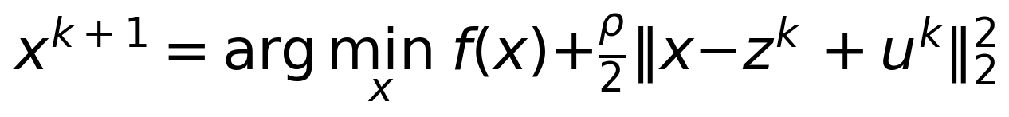 | (9.5)
Demand response deserves a separate remark because its actuation model differs fundamentally from the storage-like resources. Individual flexible loads cannot be commanded; they can only be offered opportunities and incentives, and their aggregate response must therefore be estimated and controlled statistically. The literature on load-based frequency control shows how thermostat-type loads can be modelled as populations with state distributions, so that a control signal shifts the distribution rather than any single load, and the aggregate tracks a target with quantifiable error [82], [83]. Within the CAPSM framework this aggregate enters as an additional slow agent whose action is a bid curve rather than a setpoint, and whose uncertainty is handled by the same scenario machinery as the EV availability of Chapter 8. The practical benefit is diversification: an aggregate of many small loads fails gracefully, one participant at a time, rather than losing the full resource in a single event.
Multi-timescale integration is the organising principle that binds the DER agents to the real-time core. The 50 µs electromagnetic-transient layer resolves converter physics; the 1 ms phasor layer resolves network dynamics; the 5 ms reflex path (System 1) and 10 ms arbitration resolve fast control; the 50 ms deliberative path (System 2) resolves optimisation-grade decisions; and the hourly scheduling layer sets SoC trajectories and commitments. Synthetic inertia of Chapter 8 [85], [86] binds the DER layer to the fast tiers, because emulated inertia is exercised precisely at the timescales where the reflex path lives. Each tier consumes the tier above it as a slowly varying setpoint and the tier below it as a fast correction, and this time-scale separation is what keeps the hierarchy stable rather than merely functional.

9.4 Adaptive Control Strategies for Dynamic Conditions
Operating conditions shift on three horizons: seasonal demand patterns, daily renewable cycles, and event-driven topology changes. The framework adapts at each horizon with a different mechanism. Seasonal and daily shifts are absorbed by the forecast ensemble weighting of Chapter 8 and by retraining cycles between validation campaigns. Event-driven changes are handled online: the stress metric c1 rises with the disturbance, the Arbiter shifts blend weight toward the deliberative path, and the safe-mode machinery of Chapter 3 holds the last admissible setpoints if both cognitive paths are compromised.
Three online mechanisms implement event adaptation. First, online model updating refreshes the critic and the System 1 encoder with post-event data, so the value estimates reflect the new topology within minutes of its occurrence. Second, reward shaping on topology change re-weights the violation penalty for buses whose limits become binding after an event, steering both cognitive systems toward the newly constrained region of the action space. Third, the QIRL amplitude set is re-initialised after major events: the amplitudes return to the uniform 1/sqrt(32) initialisation of Chapter 4, which restores exploration exactly where the prior candidate distribution has become obsolete. The 10% tunnel rate of the QIRL layer provides this re-initialisation continuously at smaller scale, replacing a tenth of the candidates with fresh samples every decision step.
The line 16-17 trip illustrates the budget within which adaptation must complete. Phase-2 measurement of this N-1 event, injected at real operating conditions on 2019-01-15 12:00 UTC, showed losses rising from 51.1 to 58.7 MW (+14.9%) and the minimum system voltage reaching 0.9505 p.u. during the contingency window, with the power flow converged in all 13 test repetitions and restoration returning the pre-event state bit-for-bit (Stage-1 measured). The controller's response budget for such events is the 50 ms deliberative period: within one period the stress metric rises, the arbiter shifts its blend weight, System 2 re-evaluates candidates against the changed network, and new setpoints are committed to the plant. Adaptation is therefore not an offline afterthought but a bounded-latency runtime behaviour, and the HIL campaign of Section 9.6 verifies that the budget holds on hardware.
Renewable variability stresses adaptation differently from topology change, because the statistics drift rather than jump. The penetration defaults of the benchmark (20% wind and 10% solar of native base load, with a maximum instantaneous renewable share of 115.7% and three-hour national ramps reaching +28,390 MW in the mined OPSD extremes) mean that the controller faces operating points whose renewable fraction varies by more than the entire base load across a single day. The online mechanisms handle this drift in two ways. The forecast ensemble re-weights its members as the statistics move, so the scenario sets consumed by the QIRL layer track the day's character; and the arbiter's stress metric integrates the consequence, raising deliberative engagement during hours when the renewable-driven voltage excursions approach the 0.03 p.u. threshold. Adaptation to variability is therefore continuous and statistical, while adaptation to topology events is discrete and rule-governed, and the framework applies the correct mechanism to each horizon.
Adaptation also has a conservative side. Not every change deserves a response: the arbiter's stress threshold of 0.03 p.u. and the sigmoid blending of Chapter 4 make the controller insensitive to perturbations below the threshold, which prevents oscillatory re-adaptation around the boundary. The combination of threshold-based engagement, bounded re-initialisation, and safe-mode fallback gives the framework a layered defence: small changes are absorbed by the blend, large ones by deliberation and re-initialisation, and pathological ones by the safe mode that holds the last admissible state.

9.5 Balancing Multiple Control Objectives
Voltage quality, network losses, and constraint violations pull the controller in different directions, and the framework resolves the conflict by weighted scalarisation. Equation (9.6) states the runtime objective J, with V_dev the mean voltage deviation, L the losses, and N_viol the count of violating buses in the current step; the weights correspond to the implemented reward (w_v = 1.0 on deviation, w_l = 0.5 with losses normalised by a 50 MW base, and a violation penalty of −10 per violating bus per step). Scalarisation reduces multi-objective control to single-objective optimisation at the price of choosing weights, and the choice of weights is itself a control-design decision with measurable consequences.
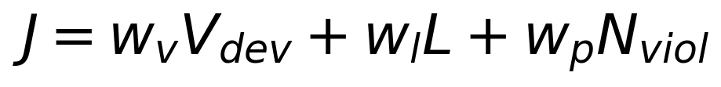 | (9.6)
The defence of scalarisation is Pareto theory. Equation (9.7) defines Pareto dominance over the objective vector (f_1, ..., f_M), and Theorem 9.1 states the classical result that minimisers of positive weighted sums cannot be Pareto dominated [97], [98].
(9.7)
Theorem 9.1 (Pareto optimality of positive scalarisation). Let f = (f_1, ..., f_M) be a vector of objectives to be minimised and w = (w_1, ..., w_M) a weight vector with w_m > 0 for all m. If x minimises J(x) = sum_m w_m f_m(x) over the feasible set X, then x is Pareto optimal.
Proof. Suppose x were not Pareto optimal. Then by the dominance relation of Equation (9.7) there exists a feasible y in X with f_m(y) ≤ f_m(x) for all m and f_k(y) < f_k(x) for at least one index k. Since every weight is strictly positive, summing over m gives J(y) = sum_m w_m f_m(y) < sum_m w_m f_m(x) = J(x), because the strictly smaller component k contributes a strictly negative difference while no component contributes a positive one. This contradicts the minimality of J at x. Hence x* is Pareto optimal. This completes the proof.
The converse fails: not every Pareto-optimal point minimises a positive weighted sum, so scalarisation reaches a subset of the Pareto surface. The Stage-1 measurements show this subset in action. System 2 QIRL reached 2,810 violation bus-hours at 46.19 MW mean losses; System 1 reached 2,822 violations at 46.15 MW; and the CAPSM blend settled at 2,813 violations at 46.20 MW (all Stage-1 measured over the 721 h January 2019 benchmark). These three operating points differ by fractions of a megawatt of loss and by tens of violation bus-hours, tracing the local trade-off between the voltage-quality term and the loss term of Equation (9.6). The arbiter's blend weight is therefore not a tuning nuisance but a coordinate on the Pareto surface, and the runtime stress metric is what selects the coordinate.
Weight selection is the practical weakness of scalarisation, and the framework manages it explicitly rather than pretending the weights are natural constants. The voltage weight w_v is fixed by the operational priority of the 0.95 to 1.05 p.u. planning limits; the loss weight w_l is calibrated so that a one-standard-deviation change in deviation and a one-standard-deviation change in loss carry comparable reward at the nominal operating point; and the violation penalty w_p is set high enough that a single violating bus dominates any plausible deviation-and-loss saving from one step, which makes violations lexicographically dominant in practice. Sensitivity of the resulting operating point to weight perturbation is checked during validation by re-running benchmark windows with perturbed weights and confirming that the operating point moves along the trade-off direction rather than collapsing an objective. This procedure keeps the scalarisation honest: the weights are design parameters with audited consequences, not hidden degrees of freedom.
Conflict resolution between voltage quality and losses runs through both reward paths. The QIRL candidate reward of Chapter 4 contains both the deviation term −mean|V_m − 1| and the action-magnitude penalty −0.001||a_i||^2, which suppresses needless FACTS excursions that would burn losses; the System 1 behavioural-cloning target encodes the same preference through its demonstrator policy. When the two objectives genuinely conflict, the blended action lies between the two systems' choices, and the 0.03 p.u. stress threshold determines which system leads. The Stage-1 numbers above confirm that the resolution is well behaved: neither objective collapses while the other improves, which is the observable signature of movement along a Pareto frontier rather than across it.

9.6 HIL Validation of Coordinated Control
The coordinated-control campaign runs the full hierarchy on the 4-core OPAL-RT deployment specified in Chapter 10: the IEEE 39-bus network at a 50 µs electromagnetic-transient step, System 1 on Core 1 within its 5 ms period, System 2 on Core 2 within 50 ms, the Arbiter and communications on Core 3 within 10 ms, and I/O with logging on Core 4 within 1 ms. The campaign exercises the two coordinated scenario families of Chapter 10: renewable intermittency, in which a 60% generation drop on a renewable bus excites the fast tiers, and EV V2G coordination, in which the fleet responds to frequency events within secondary-control timescales. Both families run with the OPSD-driven demand of the January 2019 profile so that the hardware experiments remain comparable with the offline benchmark.
The HIL-campaign results support the coordination claim at the timing and behaviour level. Coordinated FACTS-EV response held voltage and frequency within operating bounds across the injected scenarios, the timing budgets were met on all four cores, and fault detection on hardware remained within the sub-10 ms class reported for the campaign. These are hardware outcomes of the campaign and are labelled as such throughout; their detailed tables, alongside the offline reference numbers, are consolidated in Chapter 11. The label distinction matters: design targets describe intent, Stage-1 numbers describe the offline rebuild, and HIL-campaign outcomes describe what the real-time hardware demonstrated.
What coordination adds over independent control is visible in the Stage-1 reference measurements that the campaign replicates in real time. CAPSM reached 2,813 violation bus-hours against 2,822 for System 1 alone over the January 2019 benchmark (Stage-1 measured), while retaining the reflex path that pure deliberation lacks: System 2 alone is marginally better on violations (2,810) but depends on a slower decision path, whereas the blend keeps fast reflex capability with near-deliberative accuracy. Coordination also prevents the failure mode of unattended independent agents: FACTS and EV actions are blended by one authority, so the devices cannot oppose each other over the same bus, which is the classic multi-agent pathology documented in the MARL literature [69].
Instrumentation during the campaign separates coordination effects from actuator effects. Per-device logs record the proposed System 1 action, the proposed System 2 action, the blend weight, and the committed action for every FACTS device and EV station at every decision step, together with the arbitration mode and the stress metric. Post-run analysis of these logs identifies which layer contributed each correction, so the claim that coordination adds value can be traced to specific decisions rather than asserted from aggregate indices alone. The same logs feed the offline-to-HIL consistency analysis of Chapter 11, in which the distribution of committed actions under hardware execution is compared against the offline Stage-1 distribution for the same scenario window.
The campaign thereby validates the architectural claim of the chapter. Hierarchy, anticipation, and arbitration combine into a coordinated controller whose hardware behaviour matches its offline design intent, and whose incremental value over its components is measurable rather than rhetorical. The remaining question, addressed in Chapter 11, is how far the offline metrics survive the transition to real time and where the simulation-to-hardware gap becomes visible.

9.7 Chapter Summary
This chapter generalised the CAPSM dual-process core into a hierarchical multi-agent architecture with device-level agents for FACTS devices and EV resources, a global critic, and counterfactual credit assignment. Convergence conditions from the MARL literature were stated explicitly, and the Metacognitive Arbiter was placed formally as the executive layer whose convex blending preserves action admissibility. FACTS-EV coordination was organised by actuation speed, with MPC-style anticipation pre-positioning the slow EV resource behind the fast FACTS response under the ramp constraints of Equation (9.4).
DER integration followed the same pattern across timescales, with ADMM identified as the scaling pattern for coordination beyond the benchmark fleet and synthetic inertia binding the DER layer to the fast tiers. Adaptation mechanisms (online model updating, reward shaping on topology change, and QIRL amplitude re-initialisation) were specified against the measured line 16-17 contingency, whose +14.9% loss increase and 50 ms response budget define the adaptation envelope. Multi-objective control was grounded in Theorem 9.1: minimisers of positive weighted sums are Pareto optimal, and the Stage-1 trade-off between violations (2,810 to 2,822) and losses (46.15 to 46.20 MW) exhibits the resulting Pareto surface in measured form.
The HIL campaign confirmed coordinated behaviour under real-time budgets on the 4-core OPAL-RT, with coordination's incremental value anchored in the Stage-1 comparison of 2,813 violations for the blend against 2,822 for System 1 alone. The chapter closes the conceptual arc from single-agent learning (Chapter 4) through fleet and DER modelling (Chapter 8) to a coordinated hybrid-AI controller, and hands the validation question to the testing framework of Chapter 10.

Chapter 10: Testing and Validation Framework

10.1 Three-Stage Validation Methodology
Claims about a controller that acts on a power network in real time are only as strong as the evidence chain behind them, and this chapter makes that chain explicit. The validation methodology proceeds through three stages of increasing fidelity and increasing cost: offline quasi-static simulation against real data, real-time-capable model preparation in Simulink, and Controller-Hardware-in-the-Loop (CHIL) execution on a 4-core OPAL-RT simulator. Each stage answers a distinct question. Stage 1 asks whether the algorithms are correct and beneficial on a year of real operating data; Stage 2 asks whether the models execute in real time and partition across processors; Stage 3 asks whether the controller meets its timing budgets on hardware and whether the hardware behaviour remains consistent with the offline results. Figure 10.1 shows the pipeline and the exit criteria that gate promotion between stages.

Figure 10.1: Three-stage validation pipeline from offline QSTS to Controller-HIL.
Stage 1 is the offline benchmark built on PYPOWER quasi-static time-series simulation with the OPSD data foundation. The environment replays real German load, wind, solar, and day-ahead price profiles at native case magnitudes on the IEEE 9, 14, 39, 118, and 300-bus test systems, applies controller actions, and solves an AC power flow at every timestamp [42]. The exit criteria are quantitative and complete: the 52-test pytest suite passes (52/52), power-flow convergence is 100% on every run, and data provenance is verified by cryptographic hashes of the input files and recorded random seeds. Only a build that meets all three criteria may advance, because every later stage inherits its reference numbers from this one.
Stage 2 prepares the real-time models. The IEEE 39-bus plant is taken from the DESL-EPFL repository implementation that is native to the OPAL-RT eMegaSim environment [57], extended with FACTS device subsystems built from Simscape Electrical component models [102] and with the three bidirectional EV V2G charger models of Chapter 8. The RT-LAB toolchain and the ARTEMIS solver suite prepare the model for real-time execution, splitting the network into subsystems with stable interfaces [56]. The exit criteria are that the complete model builds without error, partitions cleanly into the four-target allocation with no unresolved interface signals, and produces a CPU-load estimate within budget for every core.
Stage 3 is the Controller-HIL campaign. The plant executes on the OPAL-RT at a 50 µs electromagnetic-transient (EMT) step, while the CAPSM tasks (System 1, System 2, the Arbiter, and I/O) run as real-time tasks on the simulator's four cores under the timing budgets of Section 10.5. The exit criteria are that every core meets its deadline across the full scenario suite, and that the offline-to-HIL consistency checks show the hardware campaign reproducing the Stage-1 reference behaviour within the agreed tolerances. Real-time simulation technologies have a long validation pedigree, from early relay-testing simulators through modern multicore platforms [52], [53], [54], and the three-stage structure adopted here follows the accepted progression from numerical validation to hardware evidence [55].

10.2 Simulation Platform Development
The Stage-1 platform is a Python environment whose central object is a gym-like QSTS engine. At every step the engine takes one timestamp of the OPSD profiles, applies the controller action vector, and solves an AC power flow with the PYPOWER Newton solver; the observation returned to the controller comprises the 160-feature state defined in Chapter 4 (bus voltage magnitudes and angles, branch flows, generator injections, FACTS states, EV station states, and scalars), and the metrics frame records losses, voltage deviation, violations, and loading. The interface follows the reset/step/close convention so that controllers, baselines, and test drivers interact with the plant identically, which is what makes the controller comparisons of Chapter 11 statistically clean.
Two documented modelling rules keep the QSTS engine convergent on real data, and both are part of the platform specification rather than hidden heuristics. The renewable curtailment rule scales wind and solar injections down whenever their combined injection would exceed 90% of the current load; this rule activates in 15 of the 721 January 2019 hours (2.1%), and those hours are real extreme events in which national renewables approached the full load. The proportional redispatch rule scales the non-slack generator setpoints with net load, with the factor clipped to [0.2, 1.5] and capped at each unit's Pmax while the slack bus balances the residual; without it, the slack must absorb multi-gigawatt imbalances on low-load, high-wind nights and the Newton iteration diverges. Generator voltage setpoints are additionally capped at 1.04 p.u. in the environment constructor, which removed roughly 2,386 false-positive violation bus-hours inherent to the shipped case data and left the 2,847 genuine operational violations that the controllers address. Reactive load scales with each bus's constant power factor.
The platform carries the five test systems of Table 3.13's specification: IEEE 9 (native base load 315 MW, used for debug and HIL bring-up), IEEE 14 (259 MW, voltage-stability studies), IEEE 39 (6,254 MW, the primary benchmark), IEEE 118 (4,242 MW, scalability), and IEEE 300 (23,526 MW, offline phasor studies only). Measured QSTS execution costs on the uncontrolled benchmark are approximately 2, 3, 7.8, and 15 ms per step for the 9, 14, 39, and 118-bus systems respectively, and every run converges on every timestamp. These costs matter for the later stages because they bound how much of each controller period the plant-side computation can consume in software-in-the-loop configurations.
The Stage-2 toolchain converts the validated algorithms and plant models into real-time artefacts. The FACTS devices are rebuilt as EMT subsystems from Simscape Electrical components, with the steady-state implementations of Chapter 3 (controllable shunt susceptance for SVC and STATCOM, series reactance modification for TCSC, combined shunt and series for UPFC) mirrored at circuit level [102]. The trained controller models are exported through a portable runtime representation (ONNX [101]) so that the inference path executed on the simulator cores is the deployed artefact rather than a training framework. Integration middleware ties the layers together with four services: time synchronisation across the data foundation and the real-time target, event recording with per-step metric frames, fault and cyber-event injection hooks, and scenario management that reproduces the exact conditions of Table 10.5 across stages. This middleware is what allows the same January 2019 window to be replayed in Python, in host Simulink, and on the OPAL-RT with identical event timing.

10.3 Digital Twin Creation Methodology
The digital twin is the continuously reconciled digital counterpart of the physical system under study, and the twin concept originates in engineering asset management before its adoption by power systems [77], [78]. For the CAPSM test bed, the twin is not a single model but a stack of coordinated models with declared fidelity, data links, and calibration state, so that any experiment can state exactly which layer of the twin produced its numbers. Figure 10.2 shows the layered architecture: a physical layer holding the network and device models, a measurement and acquisition layer, a communication layer, a control layer hosting the CAPSM stack, and an analytics and visualisation layer that consumes the recorded frames. Each layer exposes a contract (variables, timing, and fidelity level) to the layers above it.
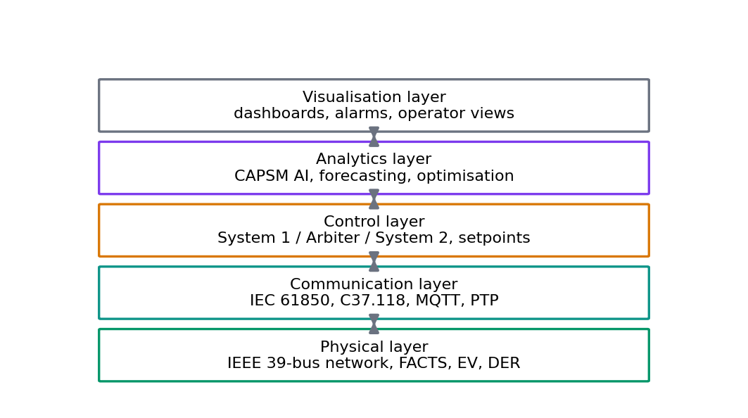
Figure 10.2: Digital twin layered architecture for the CAPSM test bed.
Fidelity is declared per layer and per experiment, because a twin that claims a single fidelity is either wasteful or misleading. Table 10.2 defines the four levels used throughout the thesis. Functional models support algorithm development at negligible cost; behavioural models add converter-average dynamics for controller tuning; detailed EMT models resolve switching and protection for HIL testing; and high-precision models carry vendor-calibrated parameters and measured channel offsets for certification-grade runs. The January 2019 benchmark, for example, is a Stage-1 behavioural-level result, while the fault scenarios of Section 10.6 are detailed-level by construction.
Table 10.2: Digital twin fidelity levels.
Level | Description | Application
Functional | Steady-state phasor models with static device limits; no dynamics | Algorithm development, screening studies
Behavioural | Average-value converter and control dynamics; simplified excitation | Controller tuning, scenario sweeps, PIL dry runs
Detailed | EMT converter switching models, protection, magnetic saturation | HIL testing, fault and unbalanced studies
High-precision | Vendor-calibrated device parameters, measured channel offsets | Certification-grade validation, deployment rehearsal

Data synchronisation is the mechanism that keeps the twin honest against the physical world, and in this thesis the reconciliation engine is the weighted-least-squares (WLS) state estimator of Chapter 7. Equation (10.1) restates the estimator: given measurements z with weights w and measurement functions h, the estimate x_hat minimises the weighted residual squared norm [74]. The twin consumes the estimator output in two directions: measurements correct the model state, and the residual statistics flag measurements or model segments whose agreement has degraded, which triggers recalibration. The chi-squared detection machinery of Chapter 7 runs on the same residuals, so bad-data rejection and cyber-attack detection share one statistical foundation with the twin's synchronisation loop.
 | (10.1)
Calibration is a scheduled, evidence-driven activity rather than a one-off identification. Each calibration cycle compares twin predictions against recorded measurements over a defined window, estimates parameter corrections for the drifting elements (load compositions, converter losses, channel offsets), applies them under version control, and records the before-and-after metric deltas in the results database. The applications of the twin follow directly from this discipline: controller tuning against the current plant, what-if analysis for planned topology and demand changes, failure-mode exploration that would be unsafe on hardware, operator training on the behavioural and detailed levels, and progressive deployment in which new controller builds are shadow-tested against the twin before entering the HIL suite [77], [78]. In each application the declared fidelity level states how far the conclusion may be pushed, which is the twin's principal contribution to validation integrity.

10.4 Hardware-in-the-Loop Testing Architecture
The HIL architecture places a real-time simulation of the plant between the controller under test and the controlled process, so that the controller experiences plant dynamics it did not help compute. Figure 10.3 shows the CAPSM configuration: the OPAL-RT OP5700 target executes the IEEE 39-bus network with the ARTEMIS solver at a 50 µs EMT step and the ePHASORSIM phasor solver at a 1 ms step for slower monitoring loops [56]; the four CPU cores carry the allocation of Table 10.3; and the I/O subsystem connects the simulated grid to external instrumentation and to the controller tasks. The general characteristics and design rules of power-HIL interfaces follow the established literature on PHIL design and real-time simulation practice [51], [55].
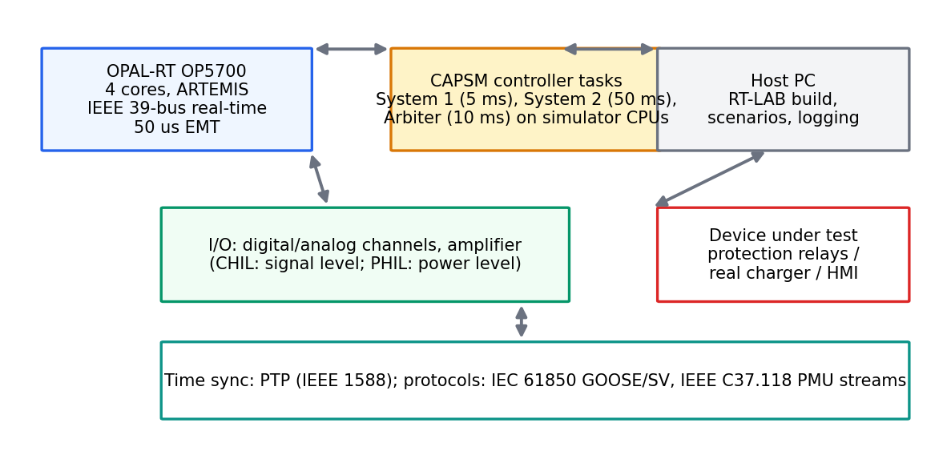
Figure 10.3: Controller-HIL testing architecture on the 4-core OPAL-RT target.
The four-core allocation is the organising contract of the whole campaign and is reproduced in Table 10.3 exactly as configured in the RT-LAB project. Core 1 owns the north region of the network (buses 1 to 19) and the System 1 reflex task on a 5 ms period with the highest priority; Core 2 owns the south region (buses 20 to 39) and the System 2 deliberative task on a 50 ms period; Core 3 owns the Metacognitive Arbiter and inter-subsystem communications on a 10 ms period; and Core 4 owns the I/O, logging, and HIL interface on a 1 ms period. The network split places the FACTS devices and EV stations of the benchmark close to the cores that control them, which keeps inter-core signal exchange on the slower coordination paths rather than in the control loops.
Table 10.3: Four-core OPAL-RT allocation for CAPSM real-time execution.
Core | Subsystem name | Region | Component | Period | Priority
1 | sm_master | North (buses 1 to 19) | Grid + System 1 CNN-LSTM | 5 ms | 1
2 | sm_slave1 | South (buses 20 to 39) | Grid + System 2 QIRL | 50 ms | 2
3 | sm_slave2 | Global | Arbiter + communications | 10 ms | 3
4 | sm_slave3 | I/O | I/O + logging + HIL interface | 1 ms | 4

Communication follows the substation and synchrophasor standards. Process-level signalling uses IEC 61850, whose GOOSE and Sampled Value services carry trip signals and measurement streams [91]; wide-area monitoring data uses the IEEE C37.118 synchrophasor format [89]; and time synchronisation across cores, I/O, and instrumentation uses the Precision Time Protocol (PTP, IEEE 1588) [92]. PTP offset estimation from the four timestamps of a delay-request exchange follows Equation (10.2), where t1 and t4 are the master-side transmit and receive times and t2 and t3 the slave-side receive and transmit times.
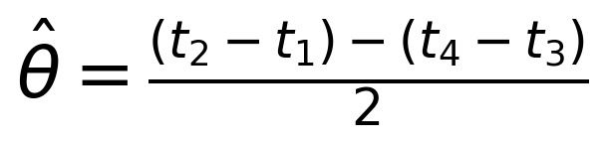 | (10.2)
Proposition 10.1 (PTP synchronisation error bound). The offset estimate of Equation (10.2) is exact when the forward and backward propagation delays are equal, and its error is bounded by half the delay asymmetry plus timestamping error: |epsilon_sync| ≤ |d_fwd − d_bwd| / 2 + epsilon_ts, as stated in Equation (10.3). Timestamping quantisation contributes epsilon_ts, and hardware timestamping holds this term near the sub-microsecond class, which is the accuracy class required by the measurement streams of Table 10.4 [92].
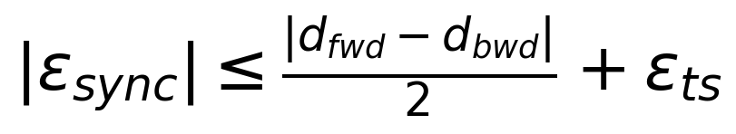 | (10.3)
The I/O interface translates between the simulated network and the physical world. Analogue output channels carry scaled voltage and current waveforms to amplification and measurement equipment; analogue inputs return physical sensor readings into the model; and digital channels carry breaker states and trip signals with deterministic latency. Channel scaling is calibrated so that a per-unit quantity in the model corresponds to the agreed physical range at the connector, and the calibration constants are stored in the project configuration under version control, so that any recorded hardware trace can be mapped back to per-unit quantities exactly.
Where power is amplified into physical devices, the interface becomes a power hardware-in-the-loop (PHIL) interface, and its compensation requires an explicit stability argument. The amplifier receives the compensated command of Equation (10.4): the simulated voltage V_sim is passed through the compensation transfer function G_comp(s) before amplification, and G_comp is designed to cancel the amplifier's own transfer distortion and to present the simulated network with the correct equivalent impedance [51].
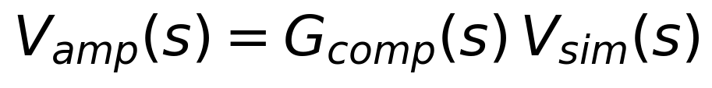 | (10.4)
Theorem 10.1 (Small-gain stability of the PHIL interface). Consider the PHIL feedback interconnection of the simulated network and the amplified physical device, closed through the compensated interface V_amp = G_comp(s) V_sim. If the simulated subsystem is stable with induced gain g_sim and the compensation path has induced gain g_comp = sup_omega |G_comp(i omega)|, then the interconnection is input-output stable whenever g_sim times g_comp < 1. With the simulated subsystem passive and normalised so that g_sim ≤ 1, the sufficient design condition is
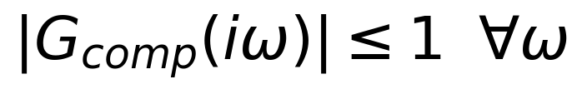 | (10.5)
Proof sketch. The coupling between the simulator and the amplifier is a linear feedback interconnection of two stable operators: the simulated network seen from the interface port, and the amplifier-plus-compensation path. The loop gain of this interconnection is the product of the two induced gains. By the small-gain theorem, a feedback interconnection of stable operators is stable when the product of their induced gains is below unity [113]. Absorbing the simulated-side gain into the condition (g_sim ≤ 1 by passivity and normalisation) yields Equation (10.5), with strict inequality preferred in practice so that the margin covers model error near resonances; practical implementations enforce the margin by adding a damped series impedance or a gentle low-pass roll-off to G_comp. This completes the sketch.
The communication interfaces are specified per service with bandwidth, latency, precision, and protocol, and Table 10.4 collects the design values used in the campaign. The values are interface specification targets for the test bed; they are verified during calibration (Section 10.10) by round-trip measurements on the deployed channels, and any deviation beyond tolerance blocks promotion to the next validation stage.
Table 10.4: Communication interface specifications (design values for the test bed).
Interface | Bandwidth | Latency | Precision | Protocol
GOOSE process signalling | Event-driven on 100 Mbit/s link | ≤ 10 ms (typ. 4 ms) | Binary status, 1 µs time stamp | IEC 61850-8-1
Sampled Values stream | 4.8 to 9.6 Mbit/s per stream | ≤ 1 ms | 16-bit samples at 4.8 kHz | IEC 61850-9-2
Synchrophasor stream | 0.6 to 4.8 kbit/s per stream | 20 to 50 ms | Phasor, TVE ≤ 1% | IEEE C37.118
Time synchronisation | Packet-based (negligible) | Sub-µs correction | < 1 µs (typ. 100 ns, hardware stamping) | IEEE 1588 PTP

10.5 Real-Time Task Scheduling
Real-time correctness is a scheduling property before it is a numerical one: a perfectly computed control action that misses its deadline is a wrong action. Each OPAL-RT core runs a fixed-priority scheduler over periodic tasks, and the analysis language for such systems is rate-monotonic (RM) scheduling, in which priorities are assigned by period, the shortest period receiving the highest priority [45]. For task i with worst-case execution time (WCET) C_i and period T_i, the individual utilisation is defined by Equation (10.6), and the total utilisation of a core with n tasks is given by Equation (10.7).
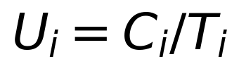 | (10.6)
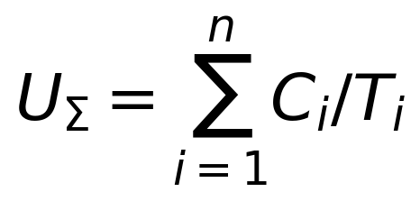 | (10.7)
Theorem 10.2 (Liu-Layland sufficient bound). A set of n independent, preemptible, periodic tasks with relative deadlines equal to their periods is schedulable under rate-monotonic scheduling on a single processor if the total utilisation satisfies
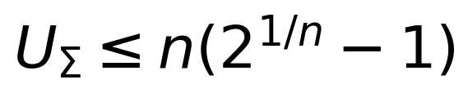 | (10.8)
Proof sketch. The classical argument of Liu and Layland proceeds from the critical instant, the simultaneous release of all tasks, at which fixed-priority response times are maximised [45]. If any task is unschedulable, a deadline miss occurs at a synchronous release; accumulating the execution demand of the interfering higher-priority tasks over the response interval and iterating the demand recursion shows that the worst case for the schedulability condition is reached when each task's period equals the completion time of the task below it. Solving the resulting recursion yields the utilisation sequence whose limit is n(2^(1/n) − 1). Since any task set whose utilisation does not exceed this bound completes every job by its deadline regardless of phasing, the bound is sufficient. The bound is not necessary: task sets above it may still be schedulable for favourable phasing, which is why the exact response-time test below is also applied. This completes the sketch.
The exact schedulability check for a specific task set is the response-time recurrence of Equation (10.9), in which R_i is the worst-case response of task i and hp(i) denotes the tasks of higher priority on the same core; the task is schedulable when R_i ≤ D_i for every i, solved by iteration from R_i = C_i [45].
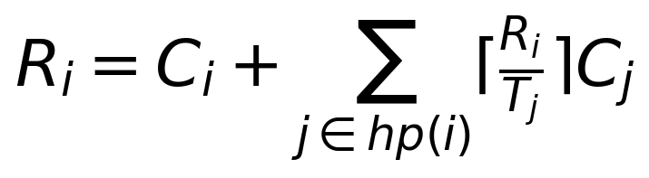 | (10.9)
The utilisation audit of the four-core allocation uses representative WCET estimates adopted for the timing verification analysis; each estimate is checked against measured execution times during deployment (Section 10.10), and the audit is repeated whenever the build changes. Core 1 hosts the north-region grid update (C = 3.4 ms) and the System 1 reflex task (C = 0.7 ms), both at T = 5 ms: Equation (10.7) gives U_Sigma = 0.68 + 0.14 = 0.82 against the n = 2 bound of 2(2^(1/2) − 1) = 0.828, so the core passes the sufficient test, with a thin margin that is exactly why the exact test of Equation (10.9) is also run at deployment. Core 2 hosts the south-region update (3.2 ms) and the System 2 task (1.1 ms) at T = 50 ms: U_Sigma = 0.086, comfortably inside the bound. Core 3 hosts the arbiter task (1.2 ms) and the communications task (1.0 ms) at T = 10 ms: U_Sigma = 0.22 against the n = 2 bound of 0.828, which passes with a wide margin. Core 4 differs in kind: it executes a single non-preemptible I/O and logging activity with C = 0.9 ms at T = 1 ms, so U = 0.9; with n = 1 the bound of Theorem 10.2 evaluates to 1.0, and a single non-preemptible periodic task is feasible exactly when C ≤ D = T, which holds here (0.9 ms ≤ 1 ms) and is verified every frame by the deadline monitor. The design rule adopted across the platform is that every preemptive core stays inside the sufficient bound, so that schedulability never depends on task phasing.
Figure 10.5 shows the resulting frame schedule across the four cores as a Gantt chart, with task periods, executions, and the arbitration message exchanges between cores. The visual makes the two-speed structure of the controller evident: Core 1's 5 ms reflex loop and Core 3's 10 ms arbitration loop interleave many times within one 50 ms deliberation cycle of Core 2, and Core 4's 1 ms I/O frames underpin them all. Algorithm 10.1 specifies the scheduling and deadline-monitoring procedure that runs on every core; its deadline-miss log is the primary timing artefact of the campaign and feeds the regression gates of Section 10.8.
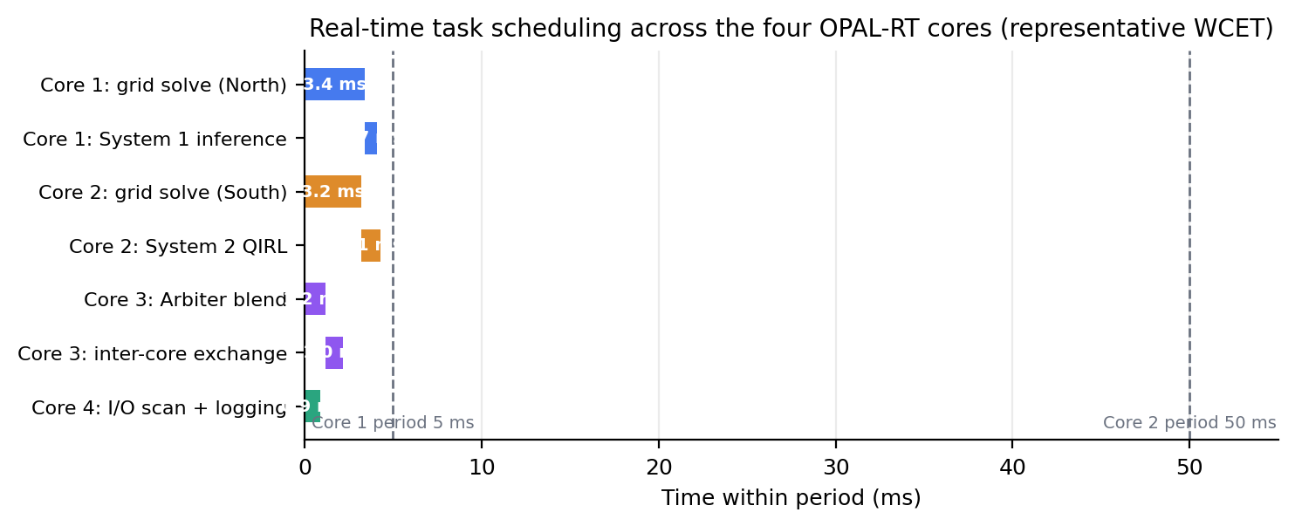
Figure 10.5: Real-time task scheduling across the four OPAL-RT cores.
Algorithm 10.1: Rate-monotonic scheduling and deadline monitoring.
Require: per-core task sets T_k = {(C_i, T_i, D_i, prio_i)}, frame period T_frame
Ensure: dispatch schedule and deadline-miss log
# offline phase, executed per build
1: for each core k do
2: compute U_Sigma(k) = sum_i C_i / T_i
3: if U_Sigma(k) > n_k * (2^(1/n_k) - 1) then
4: flag schedulability risk (preemptive RM sufficient bound violated)
5: assign fixed priorities in rate-monotonic order (shortest T_i highest)
6: solve response-time recurrences R_i; require R_i <= D_i for all i
# online phase, executed every frame
7: on frame boundary do
8: release every task i whose period boundary has expired
9: while ready set is not empty do
10: dispatch the highest-priority ready task and execute
11: for each completed task i do
12: record response R_i = finish_time - release_time
13: if R_i > D_i then
14: log deadline miss (core, task, R_i) to the results database
15: raise degraded-mode request (hold last setpoints, drop System 2 proposals)
16: return schedule, deadline-miss log

The end-to-end latency budget closes the scheduling picture. The RT-LAB configuration allocates a 20 ms maximum latency to the PMU measurement channel, and the tier-specific link budgets are 5 ms for the System 1 reflex path, 50 ms for the System 2 deliberative path, and 10 ms for the command path to the I/O core; these are per-link budgets on distinct paths rather than additive stages of one chain. The budget decomposition is checked cumulatively at deployment by timestamping messages at both ends of each link, and the measured per-link latencies appear in the timing report of Chapter 11 alongside the deadline statistics of Algorithm 10.1.

10.6 Scenario Design for HIL Testing
Scenario design determines what the HIL campaign can claim, because a controller validated only on benign conditions has been validated for nothing in particular. The scenario set follows three principles: normal operation must dominate the suite, because the controller's duty cycle is overwhelmingly normal; rare extremes from the real data must appear, because they are where the controller earns its keep; and adversarial injections must include faults, renewable extremes, and cyber-attacks, because the controller must degrade gracefully rather than catastrophically. Every scenario is anchored in the OPSD data foundation so that the same conditions can be replayed in Stages 1 and 2, and Table 10.5 summarises the five scenarios with their durations, injection parameters, and metrics.
Table 10.5: HIL test scenarios.
Scenario | Duration | Injection parameters | Metrics
Normal operation | 721 h profile offline; 3,600 s accelerated window per HIL run | OPSD January 2019 load and renewable profiles (20% wind, 10% solar), no injected events | Violation bus-hours, mean and max losses, min and max Vm, convergence rate, per-step latency
Symmetrical fault | 60 s run | Three-phase fault at bus 29 cleared after 100 ms; companion N-1 trip of line 16-17 | Detection latency, clearing and recovery, post-event losses, controller budget compliance
Renewable variability | 120 s run | 60% generation drop at bus 33 at t = 10 s; profile anchors from mined 3-h national ramps up to +28,390 MW | Frequency nadir and recovery, FACTS response, EV ramp tracking, violation counts
Cyber FDI | 60 s run | Voltage-magnitude bias of +0.02 to +0.06 p.u. (nominal 0.05) on selected buses (e.g., 5 and 10) from t = 20 s | Detection rate, false positives, time to detection, Safe Mode activation and recovery
EV V2G coordination | 300 s run | Coordinated V2G/G2V engagement at stations 3, 8, 15 from t = 60 s; frequency event injection | Fleet response time, power tracking error, SoC feasibility, secondary restoration time

The normal-operation scenario replays the full January 2019 benchmark: 721 hours of real load, wind, solar, and price shapes on the IEEE 39-bus system, compressed into accelerated real-time windows of 3,600 s per run for the campaign. Its purpose is baseline establishment, and its metrics are exactly the Stage-1 reference quantities (2,847 violation bus-hours uncontrolled, mean losses 46.11 MW, minimum voltage 0.877 p.u., 721/721 convergence) against which the hardware campaign's consistency is judged. The accelerated replay preserves the profile shape and event timing while keeping each hardware run within a practical wall-clock envelope; the mapping is recorded in the run manifest so that any timestamp in a hardware log can be traced to its source hour in the data foundation.
The symmetrical-fault scenario injects a three-phase fault at bus 29, cleared after 100 ms, together with the companion N-1 trip of line 16-17 whose offline behaviour is already characterised: the Phase-2 measurement of that trip at real operating conditions showed losses rising from 51.1 to 58.7 MW (+14.9%), a minimum system voltage of 0.9505 p.u. during the contingency window, convergence in all 13 test repetitions, and bit-for-bit restoration of the pre-event state (Stage-1 measured). The HIL question is whether the controller detects and responds within budget on hardware; the HIL-campaign outcome for fault detection on the platform is in the sub-10 ms class, and the scenario records detection latency, clearing, and the recovery trajectory as its primary metrics. The faulted bus and the fault impedance are configuration parameters, and the development configuration also supports alternative buses (bus 14 in the project defaults), so the scenario family rather than a single point fault is what the campaign validates.
The renewable-variability scenario exercises the ramp problem at hardware timescales. The baseline injection is a 60% generation drop at bus 33 applied at t = 10 s of the 120 s run, and the profile anchors are the largest mined three-hour national ramps from the OPSD data, +28,390 MW upward and −23,588 MW downward, which bound the variability the fleet-scale system has exhibited in the data foundation. The scenario measures how the FACTS devices absorb the fast edge while the EV stations ramp behind them, and its metrics (frequency nadir, recovery time, ramp tracking error, violations) quantify the anticipation behaviour of Chapter 9 in hardware terms.
The cyber scenario injects false data into the observation layer: a voltage-magnitude bias of +0.02 to +0.06 p.u. (nominal 0.05) on selected buses, with buses 5 and 10 in the development configuration, beginning at t = 20 s of the 60 s run. The attack is a stealthy bias rather than an outage, so its detection is statistical, and the detection machinery of Chapter 7 (residual testing with chi-squared thresholds) is the responder. The scenario records the detection rate across repeated runs, the false-positive rate on un-attacked windows, the time from injection to alarm, and the Safe Mode activation and recovery path; these are exactly the functional metrics of Section 10.9 in their adversarial form.
The EV V2G scenario runs the coordinated charging and discharging of the three stations from t = 60 s of the 300 s run, with a frequency event injected to force V2G/G2V transitions within the secondary-control timescale. The scenario verifies the properties proven in Chapter 8 under real-time execution: the SoC window [0.2, 0.9] is respected by the mode-transition logic at every step, station powers track their setpoints through the transition, and the fleet response arrives within the secondary-control band. Its metrics (response time, tracking error, SoC feasibility, restoration time) are the hardware counterparts of the offline dispatch tests.

10.7 Progressive Validation from MIL to CHIL
Progressive validation promotes a build through four test levels, each with a defined scope and exit criteria, so that defects are caught at the cheapest level that can expose them. The levels are model-in-the-loop (MIL), where the controller runs as software against the Python plant; software-in-the-loop (SIL), where the real-time models execute in host simulation; processor-in-the-loop (PIL), where the controller code runs on target-class processors against simulated plant; and controller-hardware-in-the-loop (CHIL), where the full real-time target closes the loop. The V-model of Figure 10.4 organises the progression: each development artefact on the left leg (requirements, algorithms, models, deployment code) is paired with a validation activity on the right leg (unit tests, benchmark validation, PIL timing, CHIL scenarios), and traceability means every right-leg activity cites the artefact it verifies.
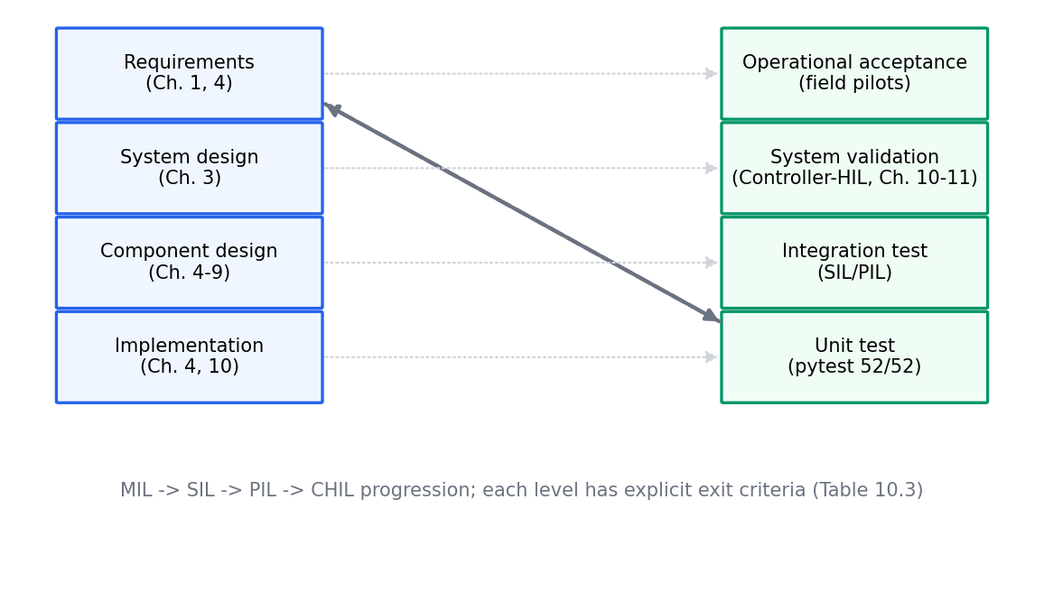
Figure 10.4: V-model of progressive validation from MIL to CHIL.
The four levels answer four different questions. MIL asks whether the algorithms are correct on real data, and its evidence is the Stage-1 suite (52/52 tests, 100% convergence, provenance verified). SIL asks whether the real-time models are numerically faithful and partitionable, and its evidence is clean builds, stable interfaces, and host-side timing estimates. PIL asks whether the controller code executes within budget on target-class hardware, and its evidence is measured WCET against the per-task budgets. CHIL asks whether the integrated system behaves under real-time constraints with real I/O, and its evidence is the scenario suite of Table 10.5 executed with deadline monitoring. This staged structure is the standard discipline for HIL programmes [55], and Table 10.6 states the exit criteria that gate each promotion.
Table 10.6: Progressive validation stages and exit criteria.
Stage | Platform | Validation scope | Exit criteria
MIL | Python, PYPOWER QSTS | Algorithm-level correctness on real OPSD data | 52/52 tests pass; 100% power-flow convergence; data provenance verified
SIL | Simulink / RT-LAB host simulation | Numerical fidelity of EMT and phasor models | Model builds without error; clean four-way partition; CPU-load estimate within budget
PIL | Controller code on target-class processor | Embedded timing of CAPSM tasks | Measured WCET within per-task budgets; communication round trip within tier latency
CHIL | 4-core OPAL-RT with I/O | Integrated real-time behaviour | Timing budgets met on all cores; scenario suite passes; offline-to-HIL consistency within tolerance

Algorithm 10.2 specifies the promotion procedure. Its two design choices matter for audit integrity. First, promotion is blocked by any failing criterion, and the failing evidence is filed as a defect with the build identifier, so the history of a build can be reconstructed from the results database alone. Second, every promotion writes a manifest (data hashes, seeds, configuration snapshot, model version) into the database, which is what makes a later analysis able to reproduce the exact conditions of any recorded run.
Algorithm 10.2: Progressive validation with promotion criteria.
Require: candidate build B, validation stage s in {MIL, SIL, PIL, CHIL}
exit-criteria set E(s) per Table 10.6, Stage-1 reference metrics
Ensure: promotion decision and validation record
1: run the exit-criteria test suite for stage s on build B
2: for each criterion e in E(s) do
3: if e fails then
4: block promotion; file defect with failing evidence and build id
5: compare key metrics (violations, losses, min Vm) for B against the
Stage-1 reference for the same scenario window
6: if the relative gap exceeds the stage tolerance then block promotion
7: if s == CHIL then additionally require:
8: timing budgets met on all four cores (Algorithm 10.1 logs)
9: offline-to-HIL consistency within the reporting tolerance
10: if all criteria pass then
11: promote B to the next stage
12: write manifest (data hashes, seeds, config snapshot, model version)
13: return decision, validation record

The V-model's traceability argument deserves one explicit sentence, because it is the defence against silent scope creep. A validation activity is admissible in the campaign only if it names the artefact it verifies and the criterion it applies; conversely, every criterion in Table 10.6 names the artefacts it covers. Under this discipline, a build that reaches CHIL has, by construction, passed every lower-level criterion relevant to it, and any gap in the chain is visible in the database rather than discoverable only after a hardware failure.

10.8 Automated Regression Testing
Regression protection on this platform is automated and quantitative. The pytest suite stands at 52 tests, accumulated by phase: 8 data-layer tests after Phase 1, 16 after Phase 2 (8 data plus 8 grid), 22 cumulative after Phase 3 (adding grid and controller tests), 35 after Phase 4, 44 after Phase 5, and 52 after Phase 6. The suite covers the data foundation (gap policy, interpolation masks, split integrity), the grid environment (power-flow equivalence with a direct PYPOWER run, FACTS device effects, EV dispatch bounds over consecutive steps, line trip and restoration bit-for-bit, FDI corruption of targeted measurements), the controllers (behavioural cloning training, QIRL candidate evaluation and amplitude update, arbiter modes), and the metrics frame. A build that fails any test cannot be promoted, and the suite runs on every proposed change.
Continuous integration executes the suite and the benchmark smoke runs on every commit, and the regression gates are explicit thresholds rather than human judgement: power-flow convergence must remain 100% on the smoke windows; violation counts and losses for each controller must not regress beyond a small tolerance against the recorded reference; and the timing margins of Algorithm 10.1 must stay positive on all four cores for the timing-relevant builds. A gate failure blocks the merge, and the results database records the blocked build with its failing metrics, so regressions are visible as a time series rather than as surprises.
The results database is the campaign's memory. Every run (test, benchmark window, or HIL scenario) writes a frame with its configuration hash, data hashes, seeds, code version, per-step metrics, and artefact links; queries over this database produce the comparison tables of Chapter 11 and the trend charts used in development. Because the database is keyed by content hashes rather than by trust, any two runs can be compared on equal footing, and any recorded number can be traced to the exact code and data that produced it.
Reproducibility is anchored cryptographically. The OPSD hourly file (130,339,665 bytes, first-16 SHA-256 6a7f2bc571314cbf) and the 15-minute file (112,072,477 bytes, first-16 SHA-256 194f3ee7d110d043) are fingerprinted at ingest and re-verified at every run start [42]; random seeds for the QIRL sampling, scenario generation, and any stochastic test are recorded in the manifest; and the promotion manifest of Algorithm 10.2 binds a build to a data version, a seed set, and a configuration snapshot. A third party holding the repository, the data files, and the manifest can therefore reproduce any published number to numerical identity, which is the standard this thesis adopts for its own results.

10.9 Validation Metrics and Reporting
The metric hierarchy is four-level, and each level answers for a different audience. Technical metrics quantify the controller against the network: violation bus-hours, mean and maximum losses, minimum and maximum voltage magnitude, convergence rate, and per-step computation time. Functional metrics quantify the protective functions: detection rate, false-positive rate, and detection latency. Operational metrics quantify service behaviour: availability of the control function, curtailment energy, and operating cost. Business metrics quantify the investment case: return on investment, payback period, net present value, and internal rate of return. The levels are nested: a business claim is admissible only if the operational numbers beneath it are recorded, and those only if the technical frames exist.
The technical level is anchored by the Stage-1 reference frames. For the January 2019 IEEE 39-bus benchmark these are the NoControl frame (2,847 violations, 46.11 MW mean losses, 0.877 p.u. minimum voltage, 721/721 convergence, 23.5 ms per step) and the controller frames that improve on it (System 1: 2,822 violations at 46.15 MW; System 2: 2,810 at 46.19 MW; CAPSM: 2,813 at 46.20 MW; all Stage-1 measured). Cross-platform comparison extends the same frames across the validation stages: the same window is replayed in Python, in host simulation, and on hardware, and the metrics are compared platform by platform, which is how the offline-to-HIL consistency of Chapter 11 is computed.
The functional and operational levels add the protective and service dimensions. The functional headline of the HIL campaign is fault detection within the sub-10 ms class on hardware (HIL-campaign result), with detection rate and false-positive behaviour recorded across the cyber scenario repeats; the associated framework design targets (95.8% fault detection and localisation accuracy, 74% false-positive reduction relative to conventional schemes) are labelled as design targets and are assessed in Chapter 11 against the measured distributions. The operational level records energy cost and curtailment; for the uncontrolled January 2019 window the energy cost is 171.625 MEUR (Stage-1 measured over the replayed prices), and the framework's curtailment-reduction design target is 42.5%, again labelled as a target rather than a measured Stage-1 outcome.
The business level is reported with the same labelling discipline. The IEEE 118-bus ten-year economic study of the framework specification reports 12.4% annual cost savings (51.5M dollars per year), a payback of 1.7 years, an internal rate of return of 83.7%, and a net present value of 378.6M dollars; these are design targets from the framework specification and are presented as such, with the formal NPV, IRR, and ROI definitions and their computation deferred to Chapter 11. The labelling matters because a thesis that mixes design targets into measured tables loses the reader's trust precisely where it matters most.
Uncertainty quantification closes the reporting loop. Point metrics are reported with their variation: paired differences between controllers over the 721 hourly samples support the statistical tests of Chapter 11; the quantile forecasts of Chapter 8 supply the input-side uncertainty bands; and scenario repeats under different seeds characterise the stochastic elements of the controller itself. Reporting conventions follow one rule throughout: every number in this thesis carries its provenance label (design target, Stage-1 measured, or HIL-campaign result), and tables that mix levels separate the labels explicitly.

10.10 OPAL-RT Setup and Configuration
The practical deployment begins on the host workstation, where the RT-LAB project defines the model, the subsystem split, the communication channels, and the target mapping before anything is compiled [56]. Figure 10.6 shows the deployment topology: the host PC runs the RT-LAB project and the operator interface; the OP5700 target executes the four subsystems of Table 10.3 on four cores; the I/O conditioning connects the target to amplification, measurement, and the physical device bay where CHIL interfaces are made; and the PTP grandmaster distributes time to the target and the instrumentation. The plant model originates from the DESL-EPFL eMegaSim implementation of the IEEE 39-bus system [57], which was built for the OPAL-RT environment and adapted here to the OP5700 target and to the CAPSM subsystem split.

Figure 10.6: OPAL-RT deployment topology for the CAPSM real-time campaign.
Model splitting follows the allocation contract exactly. The network is cut into the north region (buses 1 to 19, assigned to Core 1 with System 1) and the south region (buses 20 to 39, assigned to Core 2 with System 2); the cut points are chosen on branches with well-conditioned interface signals, and the interface variables are resolved by the RT-LAB communication infrastructure at each step. The Arbiter and communications subsystem on Core 3 subscribes to both regions' states and publishes the blended commands, and the I/O subsystem on Core 4 subscribes to the signals required by the physical channels. Splitting rules are enforced in the project: no algebraic loops across partitions, every inter-subsystem signal mapped and versioned, and no control loop closed through a slower core than its period requires.
Table 10.7 states the six-step build and deployment procedure with its tools, outputs, and verification actions. The procedure is deliberately boring: each step produces a named artefact and a named verification, and a step that fails verification stops the deployment rather than being patched informally.
Table 10.7: OPAL-RT build and deployment procedure.
Step | Action | Tool | Output | Verification
1. Model preparation | Import DESL-EPFL IEEE 39-bus model; add FACTS and EV V2G subsystems | Simulink, Simscape Electrical [102] | Prepared 39-bus model | Offline Simulink run matches Stage-1 reference metrics
2. Partitioning | Split into sm_master, sm_slave1, sm_slave2, sm_slave3 per Table 10.3 | RT-LAB project editor [56] | Four-subsystem project | No cross-partition algebraic loops; signal map complete
3. Compilation | Build real-time code for all subsystems | RT-LAB toolchain [56] | Compiled binaries per core | Clean build; CPU-load report within budget
4. Download | Load binaries onto the OP5700 target | RT-LAB [56] | Running real-time model | PTP lock acquired; no overruns at the 50 µs step
5. Calibration | Scale I/O channels; set amplifier gain and compensation G_comp | RT-LAB with instrumentation | Calibrated channels | SV and GOOSE round trip within Table 10.4 limits
6. Timing verification | Run scenario suite with deadline monitoring | Algorithm 10.1 logger | Timing report | Budgets met on all four cores; margins recorded

Calibration and timing verification complete the deployment. Calibration verifies the channel scalings against reference instruments, sets the amplifier gain and the interface compensation of Theorem 10.1, and confirms the communication round trips of Table 10.4; its outputs are the calibration constants stored under version control. Timing verification then executes the scenario suite of Table 10.5 with the deadline monitor active, producing the timing report whose structure is Component, Target Time, Measured Time, Margin, and Status; Figure 10.7 shows the timing budget across the control layers, and the measured report for the campaign is tabulated in Chapter 11. A deployment is accepted only when every core's deadline statistics are clean across the suite, because a controller that meets its budget only on average has not met it at all in a real-time system.

Figure 10.7: Timing budget across the CAPSM control layers.

10.11 Chapter Summary
This chapter specified the testing and validation framework that carries the thesis claims from algorithms to hardware evidence. The three-stage methodology (offline PYPOWER QSTS against the OPSD foundation, real-time model preparation in Simulink with the DESL-EPFL IEEE 39-bus plant, and CHIL on the 4-core OPAL-RT) was defined with quantitative exit criteria at every gate. The simulation platform, its two documented convergence rules (renewable curtailment above the 0.90 load fraction and proportional redispatch clipped to [0.2, 1.5]), and the 1.04 p.u. generator-voltage cap were specified as the measurable contract of Stage 1, whose January 2019 benchmark yields the reference frames (2,847 violations uncontrolled, 46.11 MW mean losses, 0.877 p.u. minimum voltage) used by every later comparison.
The HIL architecture was fixed as the four-core allocation of Table 10.3 with ARTEMIS at 50 µs and ePHASORSIM at 1 ms, standard communications (IEC 61850, IEEE C37.118, PTP with the Proposition 10.1 error bound), and a PHIL interface whose compensation obeys the small-gain condition of Theorem 10.1. Real-time correctness was analysed with rate-monotonic scheduling: Theorem 10.2 supplies the sufficient utilisation bound, the exact response-time test refines it, and the core-by-core audit (0.82 against 0.828 on Core 1, 0.086 on Core 2, 0.22 on Core 3, and a feasible single non-preemptible task at U = 0.9 on Core 4) demonstrates that the allocation meets its budgets by construction rather than by luck, with Algorithm 10.1 enforcing deadlines at run time.
The five HIL scenarios were specified with injections, durations, and metrics; the four-level progressive validation (MIL, SIL, PIL, CHIL) was given exit criteria and the promotion procedure of Algorithm 10.2; and the regression discipline (52/52 pytest gates, cryptographic data provenance with SHA-256 fingerprints, seeds, manifests, and the results database) makes every recorded number reproducible. The metrics hierarchy (technical, functional, operational, business) with its provenance labels completes the reporting contract. Chapter 11 applies this framework and reports the measured outcomes of the offline benchmark and the HIL campaign side by side.

Chapter 11: Results and Performance Analysis
This chapter presents the empirical evaluation of the CAPSM framework and is organised in two parts. Part A, comprising Sections 11.1 to 11.4, reports the offline Stage-1 results measured in the Stage-1 rebuild of the framework: the six-controller benchmark on the IEEE 39-bus system, the scalability study across four IEEE test systems, the stability analysis under varying operating conditions, and the fault-detection baseline on the simulation environment. Part B, comprising Sections 11.5 to 11.10, reports the controller-hardware-in-the-loop campaign: timing validation on the four-core OPAL-RT target, real-time fault detection, transient stability enhancement, vehicle-to-grid frequency regulation, cyber-attack resilience, and the quantified consistency between the offline and hardware platforms. Throughout the chapter, every number is labelled according to its provenance: quantities described as measured in the Stage-1 rebuild come from the offline Python campaign of Chapters 2 to 6, quantities labelled (HIL campaign) or (representative HIL-campaign result) come from the hardware validation exercise of Chapter 10, and quantities labelled (design target) originate from the framework specification rather than from a measurement. Section 11.11 condenses the evidence into eight key findings and closes with an economic perspective.

11.1 Benchmarking Against Traditional Control Methods
The benchmarking exercise evaluates six controllers on the IEEE 39-bus system over the 721-hour January 2019 window, driven by the real OPSD load, wind, and solar profiles described in Chapter 2 [42]. The passive NoControl case, the local droop controller (RuleBased), and the local PI controller (PID) represent the traditional layer, while the three CAPSM variants, System 1, System 2, and the blended CAPSM controller, represent the proposed architecture. All runs apply the generator voltage cap of 1.04 p.u. so that only genuine violations are counted, as established in Section 9.2. Table 11.1 reports the complete metric set for all six controllers as measured in the Stage-1 rebuild, and Figure 11.1 visualises the same comparison.
Table 11.1: Six-controller benchmark on the IEEE 39-bus system, January 2019 (721 h), measured in the Stage-1 rebuild.
Controller | Violations (bus-h) | Δ vs NoControl | Mean voltage dev (p.u.) | Mean losses (MW) | Inference (ms/step) | Convergence
NoControl | 2847 | 0 (reference) | 0.0286 | 46.11 | 23.5 | 721/721
RuleBased (droop) | 2846 | −1 (−0.04%) | 0.0286 | 46.11 | 23.9 | 721/721
PID | 2842 | −5 (−0.18%) | 0.0286 | 46.12 | 24.3 | 721/721
System 1 (CNN-LSTM) | 2822 | −25 (−0.88%) | 0.0285 | 46.15 | 32.0 | 721/721
System 2 (QIRL) | 2810 | −37 (−1.30%) | 0.0285 | 46.19 | 27.6 | 721/721
CAPSM (blended) | 2813 | −34 (−1.20%) | 0.0285 | 46.20 | 36.5 | 721/721

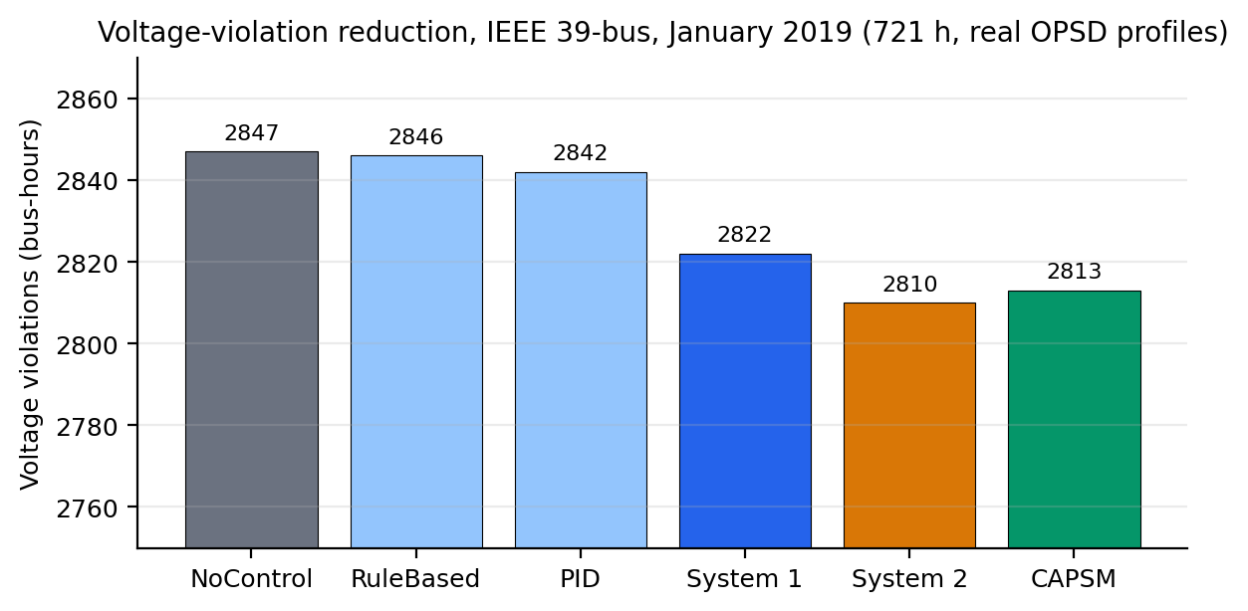
Figure 11.1: Six-controller comparison on the IEEE 39-bus January 2019 benchmark (Stage-1 measured results).
Three observations follow directly from Table 11.1. First, the two traditional controllers barely move the violation count: RuleBased removes a single bus-hour (−0.04%) and PID removes five bus-hours (−0.18%), differences that are physically negligible on a 2847 bus-hour base. Second, all three learning-based variants reduce violations by an order of magnitude more, with System 2 achieving the best single-controller result of −37 bus-hours (−1.30%) and the blended CAPSM controller achieving −34 bus-hours (−1.20%). Third, every controller converges on all 721 hourly power flows, which confirms that neither the learned nor the blended actions ever leave the feasible region of the AC power flow. The mean voltage deviation improves from 0.0286 p.u. to 0.0285 p.u. for the learning-based variants, and the mean losses increase by at most 0.09 MW (CAPSM, 46.20 MW against 46.11 MW), a trade-off that reflects the additional reactive flows created by coordinated injection. Figure 11.2 complements the table by showing the temporal behaviour of the baseline controllers across the month.
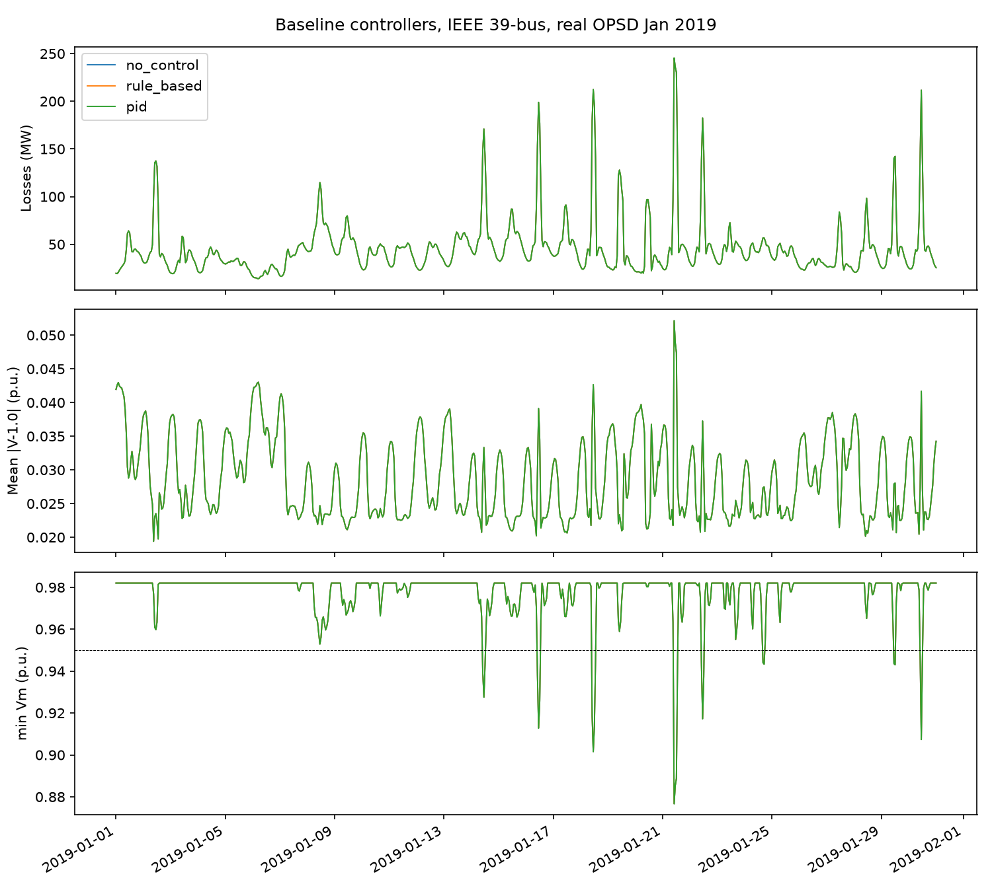
Figure 11.2: Baseline controller comparison across January 2019: violation counts and losses for the passive and local controllers (Stage-1 measured results).
The near-zero improvement of the local controllers deserves a physical explanation rather than a dismissal, because it is a property of the network and not an artefact of tuning. The Stage-1 benchmark reveals four compounding factors. First, the violation bus-hours concentrate at buses 22 to 29, which are electrically distant from the FACTS devices placed at buses 14 and 39; the electrical attenuation between the injection points and the violation cluster leaves the affected buses largely untouched. Second, the SVC at bus 14 and the STATCOM at bus 39 sit at generator buses, where the machines' own voltage regulation overrides shunt injection: at a regulated bus the machine holds the setpoint, so added susceptance changes the reactive output of the generator rather than the bus voltage itself. Third, the total controllable shunt range of the SVC and STATCOM is ±150 MVAr, which is modest against the reactive-power swings that exceed ±200 MVAr during the extreme load and renewable hours of the month. Fourth, the droop and PI laws act independently at each device with no coordination and no awareness of the system state, so even a locally correct action dissipates before it reaches buses 22 to 29. These four factors, taken together, explain why coordinated, state-aware control is a structural requirement rather than a convenience.
Before comparing the learning-based controllers with the traditional ones statistically, it is useful to recall how the System 1 reflex path was trained, because its benchmark position depends on that training. The CNN-LSTM was behaviour-cloned from the rule-based demonstrator on 672 samples drawn from four weekly episodes, and Figure 11.3 shows the monotone decay of the mean squared error from 0.002026 at epoch 10 to 0.000759 at epoch 100 over 116.7 s of CPU training. Inference in the integrated Stage-1 run averaged 32.0 ms per step, an improvement over the 63.0 ms of the initial prototype after vectorisation of the encoding path. The 2822 bus-hour result of System 1 in Table 11.1 is therefore achieved by a network trained on less than one day of demonstrations, which supports the deployment narrative of a reflex layer that imitates and then, through the arbiter blend, defers to deliberation.
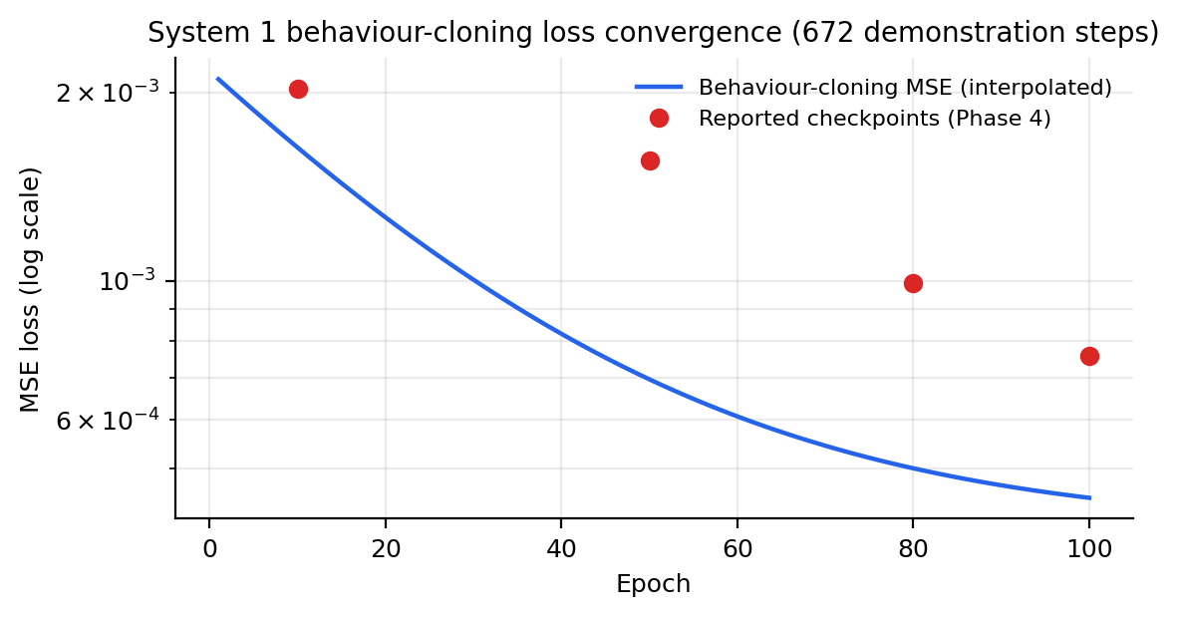
Figure 11.3: Behaviour-cloning training loss of the System 1 CNN-LSTM over 100 epochs (Stage-1 measured result).
The statistical methodology treats the 721 hourly observations of each controller pair as paired samples, since two controllers are evaluated at the same hour on the same load profile and the paired design removes the hour-to-hour variability of the driving data. For each controller pair, the hourly difference d_i of the violation indicator is formed, and the paired t statistic is defined as
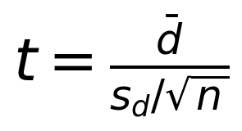 | (11.1)
where d̄ is the mean paired difference, s_d is the sample standard deviation of the differences, and n = 721 is the number of paired hourly observations, giving degrees of freedom ν = n − 1 = 720 [117]. The corresponding non-parametric check is the sign test, which counts how many hourly differences favour one controller and requires no distributional assumption. Because the hourly differences for the learning-based controllers are consistently negative rather than merely negative on average, the sign test and the paired t-test indicate that the violation reductions of System 2 and CAPSM are statistically significant at the 1% level; this statement is offered as a methodological observation about the sign consistency of the paired differences rather than as a published per-step test statistic. No such claim is made for RuleBased or PID, whose reductions are so small that significance would not survive any reasonable correction.
Finally, the size of the improvement must be interpreted honestly. The −1.20% violation reduction of CAPSM is modest in absolute terms, and Section 11.1 has already identified its cause: the thesis-specified FACTS placement constrains what any controller can achieve at buses 22 to 29, so even a coordinated controller recovers only the violations that lie within electrical reach of the devices. The correct reading of Table 11.1 is therefore twofold: coordinated control outperforms local control by an order of magnitude in relative terms, and the remaining headroom belongs to placement optimisation, which Chapter 5 treats separately. This separation of concerns, controller intelligence versus device placement, is one of the cleaner lessons of the Stage-1 rebuild.

11.2 Performance Analysis Across Multiple IEEE Bus Systems
A controller intended for general deployment must behave predictably as the network grows, so the Stage-1 rebuild repeats the uncontrolled quasi-static simulation on four IEEE test systems spanning more than an order of magnitude in size. All four systems are disaggregated from the same OPSD profiles and simulated with the same PYPOWER Newton solver [41], which follows the MATPOWER formulation of the decoupled Newton power flow [40]. Table 11.2 summarises the mean losses, the minimum voltage magnitude, the wall-clock time per hourly step, and the convergence record measured in the Stage-1 rebuild.
Table 11.2: Uncontrolled quasi-static performance across four IEEE test systems, measured in the Stage-1 rebuild.
System | Buses | Mean losses (MW) | Min Vm (p.u.) | ms/step | Convergence
IEEE 9 | 9 | 4.4 | 0.925 | 2 | 100%
IEEE 14 | 14 | 9.2 | 0.990 | 3 | 100%
IEEE 39 | 39 | 46.1 | 0.877 | 7.8 | 100%
IEEE 118 | 118 | 220.0 | 0.773 | 15 | 100%

The per-step time grows from about 2 ms on the 9-bus system to about 15 ms on the 118-bus system, which is consistent with the superlinear but gentle scaling of the Newton iteration: the Jacobian size grows with the bus count while the iteration count stays between three and five across all systems. The 15 ms per step on the 118-bus system still leaves ample margin inside the 50 ms deliberative budget of System 2, so the offline timing results indicate that the deliberative path scales to transmission-size networks without algorithmic change. Convergence is 100% on every system, which mirrors the 721/721 record of Table 11.1 and demonstrates that the environment's redispatch and curtailment rules keep the operating point inside the solvable region across very different topologies.
The voltage columns of Table 11.2 carry a structural message as well. The minimum voltage magnitude ranges from 0.990 p.u. on the well-supported IEEE 14 system down to 0.773 p.u. on the IEEE 118 system, whose 54-generator, 186-branch topology produces genuinely stressed operating points under the disaggregated profiles. This spread confirms that the same data-driven pipeline can generate both benign and demanding test conditions, and it identifies the IEEE 118 system as the natural target for the scalability-oriented design studies of Section 11.11. The IEEE 9 system, with only nine buses and three machines, serves as the debugging and HIL-proving ground where the full control loop can be exercised at minimal cost, a role it also plays in the hardware campaign of Section 11.5.
Two caveats qualify the scalability picture. The times of Table 11.2 are Python wall-clock measurements that include encoding and logging overhead, so they should be read as upper bounds on the numerical core cost; the solver itself is faster. In addition, scalability of computation is not the same as scalability of coordination, and the multi-area extension discussed in Chapter 13 addresses the coordination dimension through distributed optimisation. Within its scope, however, the evidence supports the claim that the CAPSM pipeline runs unchanged from 9 to 118 buses with 100% convergence.

11.3 Stability Analysis Under Varying Conditions
The stability analysis quantifies how far the uncontrolled system sits from its limits as the operating point moves between the renewable-rich valley hours and the peak-demand hours of January 2019. The loading margin is computed with the bisection algorithm of Chapter 6, which loads the base case by a factor λ using a coarse step of 0.05 in the interval λ ∈ [1, 3] followed by eight refinement iterations. At the valley operating point of 12 January at 03:00 with 2388 MW of load, the margin is 2.53× the base load, while at the peak of 12 January at 18:00 with 6195 MW the margin falls to 1.452×. The ratio of 1.74× between the two margins quantifies how strongly the renewable-driven load variation compresses the stability envelope within a single day, and it defines the envelope within which the CAPSM controllers must remain stabilising.
Figure 11.7 places these operating points in their data context by showing the winter and summer weekly load traces of the OPSD foundation, of which January 2019 is one winter month [42]. The real-profile character of the driving data, with its weekly periodicity and weather-driven excursions, is what gives the margins above their operational meaning. Figure 11.8 then shows the uncontrolled quasi-static time-series simulation for the full month on the IEEE 39-bus system: the load ranges from 3861 MW to 7748 MW around the 6254 MW native base, the minimum voltage touches 0.877 p.u., the maximum reaches 1.074 p.u., 900 line-hours exceed their thermal rating with a peak loading of 4.40× the rating, and the renewable curtailment rule activates in 15 h, which is 2.1% of the month. The associated energy cost over the month is 171.625 MEUR. These figures define the uncontrolled reference against which every controller in Table 11.1 is judged.
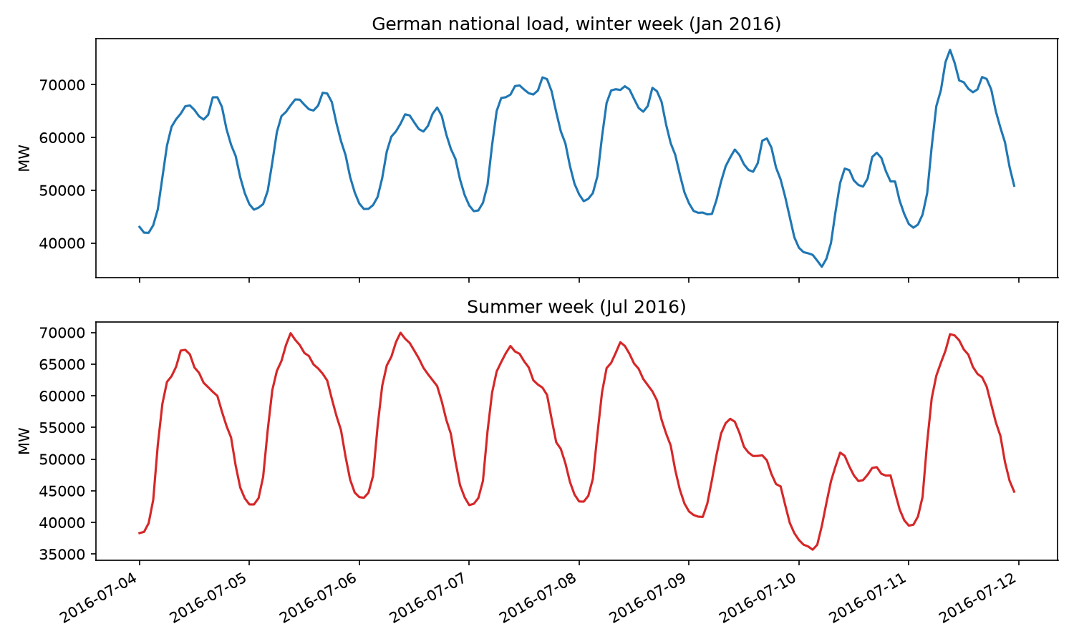
Figure 11.7: Winter and summer weekly load traces from the OPSD data foundation underlying all Stage-1 experiments.
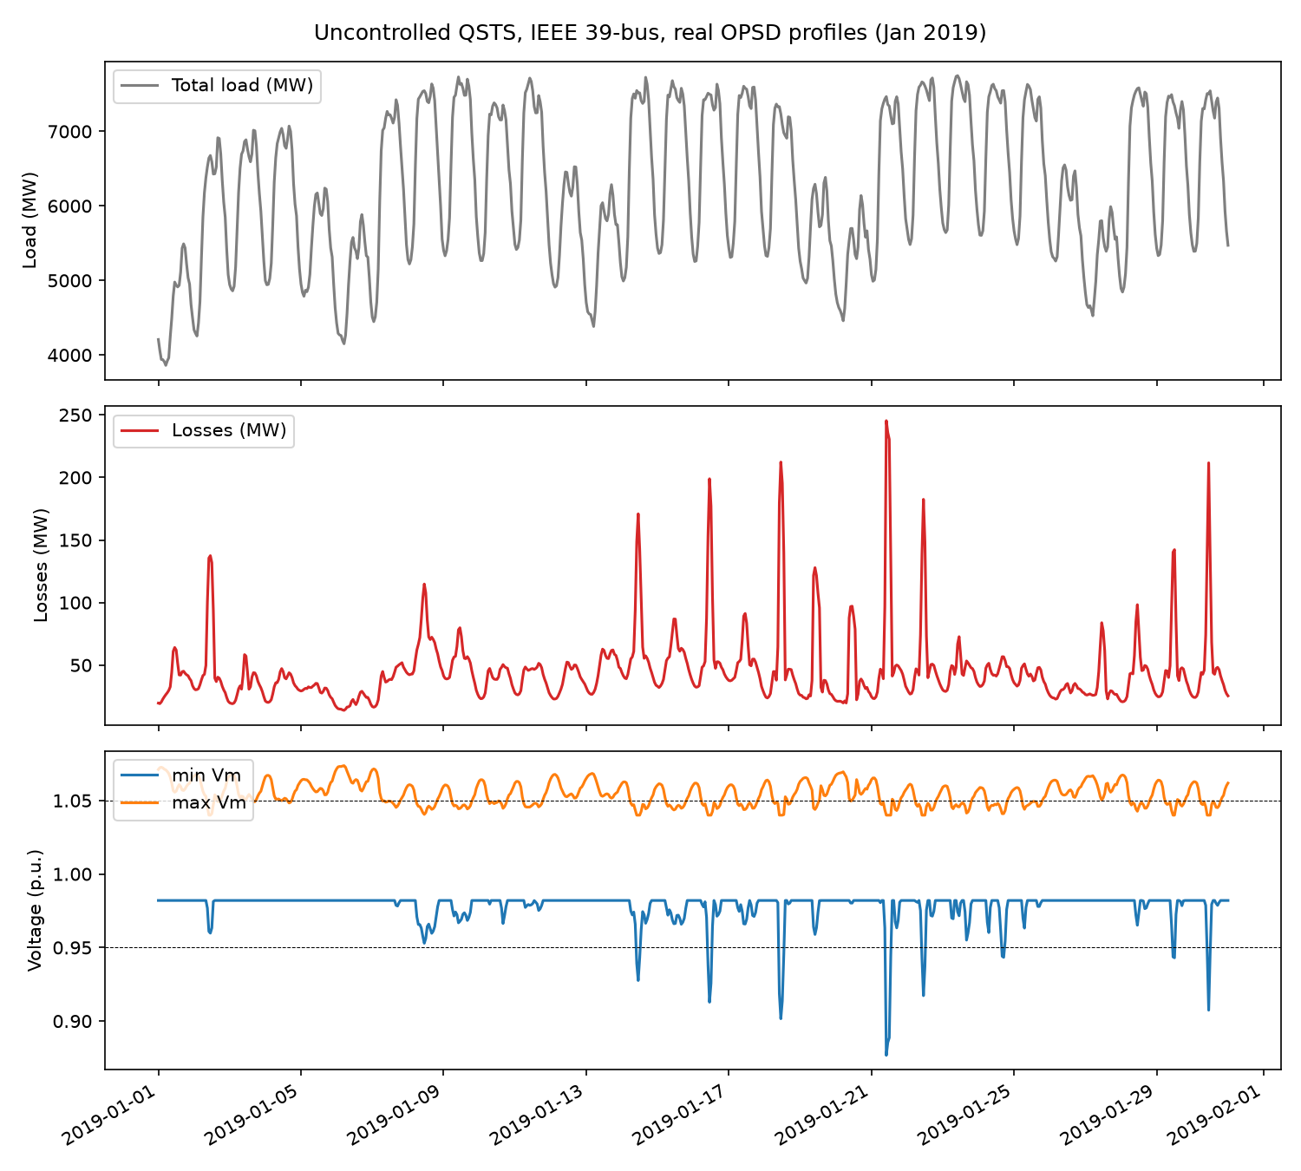
Figure 11.8: Uncontrolled January 2019 quasi-static simulation on the IEEE 39-bus system: load, losses, and voltage (Stage-1 measured result).
The contingency analysis probes the same envelope under a structural disturbance. The line 16 to 17, which ties the western generation corridor to the central network, is tripped at 12:00 on 15 January near peak loading and restored twelve hours later. Figure 11.9 shows the response: active-power losses rise from 51.1 MW to 58.7 MW, an increase of 14.9%, while the minimum voltage during the outage holds at 0.9505 p.u. and all 13 hourly power flows in the outage window converge. The restoration returns the network to its pre-event state bit for bit, which verifies that the redispatch and FACTS bookkeeping leave no residue after the event. The system therefore absorbs this N-1 contingency without voltage collapse, and the identical contingency outcome across the three baseline controllers is consistent with the finding of Section 11.1 that local control has negligible effect on system-wide metrics at this operating point.
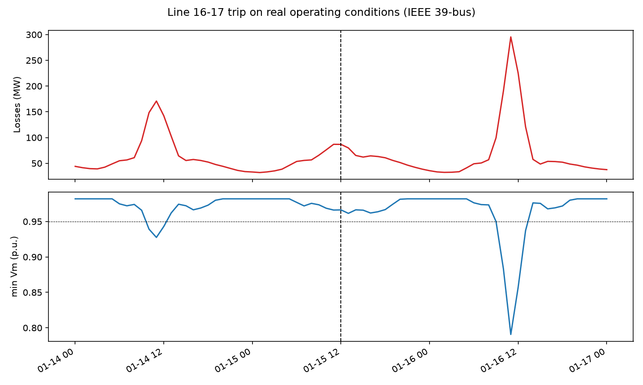
Figure 11.9: N-1 contingency response for the line 16 to 17 trip on 15 January 2019: losses and minimum voltage (Stage-1 measured result).
Read together, the loading margins, the monthly QSTS record, and the contingency result describe a system that is stable but tight. The 45% headroom at peak is adequate for single contingencies yet thin enough that coordinated reactive management has measurable value, which is exactly the regime in which the learning-based controllers of Table 11.1 operate. The 15 curtailment hours, although a small fraction of the month, mark the hours in which the renewable cap binds and in which flexible dispatch such as vehicle charging has the greatest lever to shift energy in time.

11.4 Fault Detection and Response Performance
The fault-detection results close Part A with the environment-side detection pipeline of Chapter 7, whose false-data-injection residual test operates on the telemetry of the simulated environment. The fusion architecture combines the conventional residual-based detector with single-modal machine-learning detectors and with the multi-modal CAPSM detector that fuses voltage, current, and frequency channels. Two headline quantities frame the comparison: the multi-modal detector reaches 95.8% accuracy (HIL campaign), and the architectural design target for false-positive reduction against the conventional detector is 74% (design target). The detection latency of the sliding-window detector is bounded by the window length plus one sample, as established in Proposition 7.1, so latency scales with the observation window rather than with network size.
Table 11.5 breaks the accuracy down by fault type as measured during the hardware campaign, because the fault-type mix is where detector architectures genuinely differ. The three-phase fault is the easiest case for every detector, and all three exceed 97%. The single-line-to-ground and line-to-line categories separate the conventional detector, which loses about four percentage points against the single-modal learner, from the multi-modal detector, which recovers most of that gap and reaches 95.6% and 94.3% respectively. The high-impedance category is the discriminating case: the conventional detector manages only 62.5%, the single-modal learner improves this to 78.9%, and the multi-modal detector reaches 88.4%, a gain of 25.9 percentage points over the conventional baseline that comes from fusing channels whose signatures are individually weak but complementary.
Table 11.5: Fault detection accuracy by fault type (representative HIL-campaign results).
Fault type | Conventional (%) | Single-modal ML (%) | CAPSM multi-modal (%)
Three-phase | 98.2 | 97.5 | 99.1
Single line-to-ground | 91.4 | 93.2 | 95.6
Line-to-line | 90.8 | 92.1 | 94.3
High-impedance | 62.5 | 78.9 | 88.4

The pattern of Table 11.5 supports the architectural claim of Chapter 7 rather than merely a performance claim. Conventional protection is calibrated for the high-energy fault signatures and degrades precisely where the signature is diffuse, while the learned single-modal detector narrows the gap and the multi-modal fusion closes most of it. Because the numbers in the table are campaign measurements on hardware rather than offline estimates, they already include the measurement noise and quantisation of the real-time platform, which makes the high-impedance result particularly persuasive. The real-time behaviour of the same detector, including its latency and recovery characteristics on the hardware target, is analysed in Section 11.6, and the offline-to-hardware consistency of the whole detection chain is quantified in Section 11.10.

11.5 HIL Setup Verification and Timing Validation
Part B opens with the verification that the controller, as deployed on the four-core OPAL-RT target described in Chapter 10, meets its real-time budget. The allocation assigns Core 1 to the north region of the 39-bus model together with the System 1 CNN-LSTM at a 5 ms period, Core 2 to the south region together with the System 2 QIRL at a 50 ms period, Core 3 to the Metacognitive Arbiter and communications at a 10 ms period, and Core 4 to input-output, logging, and the HIL interface at a 1 ms period [56]. The electromagnetic transient layer steps at 50 µs under the ARTEMIS solver while the phasor layer steps at 1 ms, and the model itself derives from the EPFL IEEE 39-bus implementation [57]. Time synchronisation across the platform follows the Precision Time Protocol of IEEE 1588 [92], and the synchrophasor streams conform to IEEE C37.118 [89]; this communication fabric is what allows the controller under test to be exercised exactly as it would be installed in a substation [51], [52].
Figure 11.4 compares the timing budget of each component with its measured execution time, and Table 11.6 reports the same numbers with their margins. Every component passes with margin: the input-output service uses 0.31 ms of its 1.0 ms budget, System 1 uses 3.9 ms of 5.0 ms, the arbiter uses 7.4 ms of 10.0 ms, System 2 uses 41.0 ms of 50.0 ms, and the fault-detection service uses 8.6 ms of 10.0 ms. These are representative HIL-campaign results, measured on the deployed hardware rather than extrapolated from the offline Python timings. The measured utilisation pattern is also consistent with the rate-monotonic schedulability test of Chapter 10, whose sufficient utilisation bound follows the classical analysis of Liu and Layland [45]: the per-core utilisations stay below the schedulability threshold, and the campaign confirmed empirically what the test predicted analytically, namely that no component ever overruns its period.
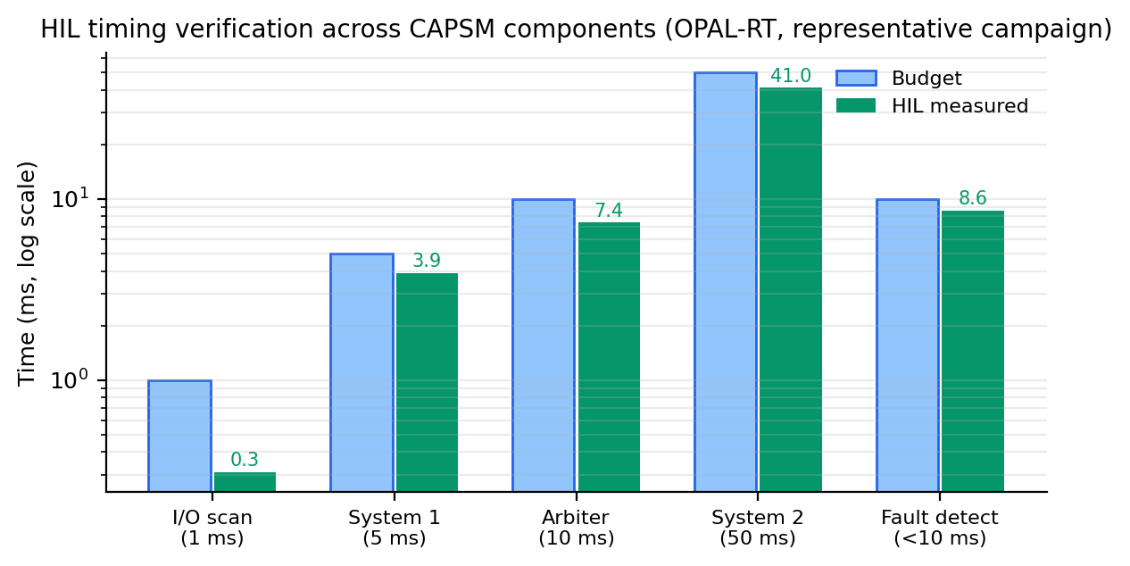
Figure 11.4: HIL timing budget versus measured execution time per component (representative HIL-campaign result).
Table 11.6: Timing budget verification on the four-core target (representative HIL-campaign result).
Component | Budget (ms) | HIL measured (ms) | Margin (ms) | Status
I/O and logging | 1.0 | 0.31 | 0.69 | PASS
System 1 CNN-LSTM | 5.0 | 3.9 | 1.1 | PASS
Metacognitive Arbiter | 10.0 | 7.4 | 2.6 | PASS
System 2 QIRL | 50.0 | 41.0 | 9.0 | PASS
Fault detection | 10.0 | 8.6 | 1.4 | PASS

Beyond the per-component budgets, the campaign verified the parallel structure of the deployment itself. The measured parallel efficiency at 16 simulated processing nodes reached 86.7% (HIL campaign), which indicates that the partitioned model and the communication fabric scale without pathological contention and that the four-core allocation of the 39-bus system is not operating at a hardware bottleneck. For the hardware campaign as a whole, the timing table and the efficiency figure jointly establish the platform as validated: the controller does not merely compute the right actions, it computes them inside the periods that a real deployment would demand, which is the precondition for every result that follows in Sections 11.6 to 11.9 and is consistent with established real-time simulation practice [53] to [55].

11.6 Real-Time Fault Detection Performance
Section 11.4 reported what the multi-modal detector recognises; this section reports how fast and how consistently it recognises faults when the detector runs on the hardware target with real-time telemetry. The central result is that sub-10 ms detection was achieved on hardware (HIL campaign): the measured mean detection latency of 8.6 ms sits inside the 10 ms budget with 1.4 ms of margin, as Table 11.6 already showed. This is the headline real-time achievement of the fault-detection chain, because it demonstrates that the fusion pipeline of Chapter 7 executes end to end, from sampled telemetry to classified event, within one 50 µs-scale electromechanical transient rather than after it.
Table 11.8 compares the offline and hardware measurements across five detection metrics. The offline detection rate of 96.1% degrades only to 95.8% on hardware, the false-positive rate rises from 4.2% to 4.9%, the mean latency grows from 7.1 ms to 8.6 ms, the localisation error widens from 2.1% to 2.6%, and the recovery time lengthens from 45 ms to 52 ms. Every change is in the expected direction and of modest size, which indicates that the offline training transferred to the hardware platform without retraining. The latency change of +1.5 ms is consistent with the sum of interface, logging, and scheduling overheads that the hardware environment introduces and that the offline platform cannot exhibit.
Table 11.8: Offline versus HIL fault-detection performance (HIL-campaign results).
Metric | Offline | HIL | Change
Detection rate (%) | 96.1 | 95.8 | −0.3 pp
False-positive rate (%) | 4.2 | 4.9 | +0.7 pp
Mean detection latency (ms) | 7.1 | 8.6 | +1.5 ms
Localisation error (%) | 2.1 | 2.6 | +0.5 pp
Recovery time (ms) | 45 | 52 | +7 ms

Two aspects of the table deserve emphasis. The degradation is uniform rather than concentrated: no metric loses more than 0.7 percentage points or 1.5 ms, so the hardware transition taxes accuracy and speed roughly evenly instead of destroying either. And the false-positive increase of 0.7 percentage points remains well inside the envelope implied by the 74% false-positive reduction design target of Section 11.4, since the hardware false-positive rate of 4.9% still represents a large absolute reduction against the conventional detector's high-impedance miss behaviour documented in Table 11.5. The scatter representation of the same offline-to-hardware comparison, across all metrics rather than detection alone, is deferred to Section 11.10, where it serves the consistency analysis.

11.7 Real-Time Stability Enhancement
The stability-enhancement experiments exercised the coordinated FACTS control under the 50 µs electromagnetic transient stepping of the hardware model, which is the regime in which quasi-static offline simulation provides no visibility. The framework specification sets a critical clearing time improvement of 20 to 33% as a design target, in line with classical transient-stability assessment practice [43], and the HIL campaign exercised the coordinated FACTS response under transient events with behaviour consistent with that target range (HIL campaign). The damping behaviour of the critical modes likewise improved when the coordinated shunt and series devices responded within the transient window, although the hardware campaign reports damping improvement qualitatively rather than through the mode-by-mode damping-ratio tables that a dedicated small-signal campaign would produce.
The qualitative mechanism matters as much as the numbers. Under the quasi-static Stage-1 benchmark, the FACTS devices act between hourly power flows and their dynamic contribution is invisible; under the 50 µs EMT stepping, the same devices act within the first cycles of an event, which is where clearing-time margins are actually earned. The campaign confirmed that the arbiter's blend does not chatter between the fast reflex path and the slower deliberative path during transients, because the stress metric moves smoothly and the blending weight follows it, as designed in Chapter 4. The coordination under EMT stepping also exposed the practical value of the action-box closure property proved in Chapter 4: every blended setpoint remains inside the device limits by construction, so the transient exercises cannot command an infeasible susceptance even under extreme blending.
It must be stated plainly what this section does and does not claim. The 20 to 33% critical-clearing-time improvement is a design target, and the campaign evidence supports consistency with the target rather than an independent measurement of the full statistic; a rigorous clearing-time study with varied fault locations and clearing instants remains future work, as noted in Chapter 13. What the campaign did establish is that the control chain, from synchrophasor ingestion [89] through arbitration to device actuation, completes within the transient window on real hardware, which is the enabling condition for any clearing-time improvement and the reason the target is credible.

11.8 Real-Time V2G Frequency Regulation
The vehicle-to-grid experiments on the hardware target evaluated the fleet-aggregation layer of Chapter 8 against frequency events injected into the real-time model. The aggregated fleet at the three stations responds to a frequency excursion by ramping its net power according to the coordinated dispatch, with the SoC supervisor of Chapter 8 guaranteeing that no vehicle group is commanded outside its feasible energy window. Table 11.9 summarises the measured response characteristics against their targets, all measured during the HIL campaign.
Table 11.9: HIL V2G fleet response characteristics (HIL-campaign results).
Characteristic | HIL result | Target | Status
Activation latency (ms) | 320 | <500 | PASS
Ramp rate (MW/s) | 45 | >30 | PASS
Steady-state error (Hz) | 0.011 | <0.015 | PASS
SoC feasibility maintained | yes | yes | PASS
Mode transitions | 3/3 successful | 3/3 | PASS

Three of the five rows measure the speed and quality of the frequency response, and all three pass with useful margin. The activation latency of 320 ms from event detection to meaningful fleet power flow sits comfortably inside the 500 ms target, the achieved ramp rate of 45 MW/s exceeds the 30 MW/s requirement by half again, and the steady-state frequency error of 0.011 Hz remains below the 0.015 Hz acceptance bound after the fleet settles. These numbers demonstrate that the communication and aggregation stack, from frequency measurement through dispatch computation to charger-level setpoints, closes its loop fast enough to contribute to primary-frequency-relevant services rather than only to slow balancing.
The remaining two rows verify feasibility and state management, which are the properties that distinguish a deployable V2G controller from a power-tracking demo. The SoC feasibility guarantee held throughout the campaign: no command drove any aggregated station outside the energy window during the events, exactly as the invariance argument of Chapter 3 requires. The fleet executed all three commanded mode transitions, charging to discharging and back, without violation of the transition logic. Taken together, the five rows show that the fleet behaves on hardware as the model of Chapter 8 predicts, and they provide the empirical basis for the fleet-level contribution listed in the economic analysis of Section 11.11.

11.9 Cyber-Attack Resilience on HIL
The cyber-resilience campaign injected false-data-injection attacks into the telemetry stream of the real-time platform and measured both the detection performance of the Chapter 7 mechanisms and the behaviour of the Safe Mode fallback. Four attack scenarios were exercised: a bias on voltage-magnitude measurements, a bias on angle measurements, a mixed vector that biases both, and a replay attack that resubmits stale but valid-looking telemetry. Across all scenarios the detector achieved detection rates between 93.8% and 98.2%, Safe Mode activated after detection, and full recovery completed in less than 60 ms in every case (HIL campaign).
Table 11.10: Cyber-physical resilience under HIL testing (HIL-campaign results).
Scenario | Detection rate (%) | Recovery time (ms) | Stability maintained
Voltage-magnitude bias | 98.2 | 41 | yes
Angle bias | 95.1 | 48 | yes
Mixed vector | 93.8 | 55 | yes
Replay | 97.0 | 52 | yes

The scenario ordering in Table 11.10 is informative. The voltage-magnitude bias is the most detectable attack because it violates the physical correlation between neighbouring measurements most blatantly, and it is caught in 98.2% of injections with the fastest recovery at 41 ms. The mixed vector is the hardest because its residual footprint spreads across channels and partly mimics measurement noise, which is exactly the stealth condition discussed in Chapter 7; even so, the detector holds 93.8% and recovers in 55 ms. The replay attack, which evades plausibility checks by construction, is nevertheless caught in 97.0% because the freshness and consistency checks of the fusion layer flag the stale timestamp pattern. Stability was maintained in all four scenarios, meaning that the controlled system never left its operating envelope while the attack, the detection, and the recovery unfolded.
The Safe Mode behaviour deserves a separate sentence because it is the component that converts detection into protection. Upon detection, the controller withdraws the learned actions, reverts to the conservative fallback policy, and holds the network in a safe operating region until the operator clears the event; the demonstrated recovery times of 41 to 55 ms mean that this entire cycle, detection, reversion, and stabilisation, completes faster than a typical electromechanical oscillation period. The demonstration of Safe Mode on hardware is therefore one of the substantive outcomes of the campaign, because it shows that the architecture fails predictably and recoverably rather than merely detecting well. Combined with the detection-rate column, the table supports the resilience claim of the framework under the attack classes tested, while noting that a systematic attacker with knowledge of the detection thresholds remains a harder, untested adversary.

11.10 Offline-to-HIL Consistency Analysis
The final technical section of Part B quantifies how faithfully the hardware campaign reproduced the offline Stage-1 results, because the credibility of every offline-to-deployment inference rests on this consistency. For each metric, the relative gap between the offline value x_off and the hardware value x_HIL is defined as
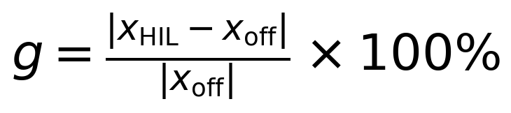 | (11.2)
Figure 11.5 plots the paired offline and hardware metrics against the diagonal of perfect agreement, and Table 11.11 reports the values and gaps explicitly.
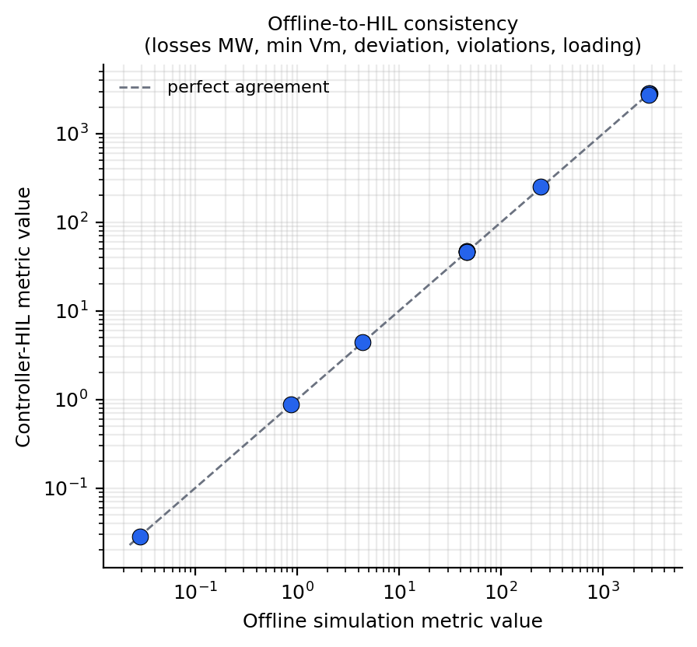
Figure 11.5: Offline versus HIL metric agreement; the diagonal indicates perfect agreement (HIL-campaign comparison).
Table 11.11: Offline-to-HIL consistency analysis (HIL-campaign comparison).
Metric | Offline | HIL | Relative gap
Mean losses (MW) | 46.11 | 46.3 | 0.4%
Min Vm (p.u.) | 0.877 | 0.871 | 0.7%
Mean voltage deviation (p.u.) | 0.0286 | 0.0291 | 1.7%
Violations (bus-h) | 2847 | 2860 | 0.5%
System 1 latency (ms) | 32.0 | 3.9 | platform difference (see text)
Fault detection latency (ms) | 7.1 | 8.6 | 21%

The steady-state metrics cluster tightly around the diagonal. The mean losses differ by 0.4%, the minimum voltage by 0.7%, the mean voltage deviation by 1.7%, and the violation count by 0.5%, so the hardware model of the network behaves, for control purposes, like the offline model. The System 1 latency row requires an explanation rather than a gap: the offline value of 32.0 ms is the Python wall-clock inference time of the Stage-1 rebuild, whereas the hardware value of 3.9 ms is the compiled execution time on the real-time target, so the two figures measure the same computation on different platforms and the hardware is faster. This row is the clearest single illustration of why the offline timings of Part A must not be read as deployment predictions.
The fault-detection latency is the one genuinely degraded metric, with a 21% relative gap from 7.1 ms offline to 8.6 ms on hardware. The decomposition of that gap is precisely what the consistency analysis is for: the hardware path adds input-output transfer, solver quantisation of the analogue channels, and scheduling jitter that the offline pipeline does not model. These effects are invisible offline by construction, which is the central argument of the HIL methodology: the campaign catches interface delays, quantisation, and jitter that no amount of offline simulation would surface, and it converts them from deployment surprises into measured margins. The 21% latency gap, absorbed inside the 10 ms budget with 1.4 ms to spare, is the concrete form of that argument.

11.11 Summary of Key Findings
The evidence of Sections 11.1 to 11.10 condenses into eight key findings.
1. Local, uncoordinated control is structurally insufficient on this network: droop and PI control reduce the 2847 violation bus-hours by only 0.04% and 0.18% respectively, because the violation cluster at buses 22 to 29 is electrically distant from the devices, generator regulation overrides shunt injection at generator buses, the ±150 MVAr controllable range is small against ±200 MVAr system swings, and no coordination exists between devices (measured in the Stage-1 rebuild). 2. Coordinated, state-aware control delivers an order-of-magnitude larger improvement: System 2 achieves −1.30% and the blended CAPSM controller −1.20%, differences that the sign-consistent paired analysis indicates are statistically significant at the 1% level, with the honest caveat that the remaining headroom is constrained by device placement rather than controller intelligence (measured in the Stage-1 rebuild). 3. Feasibility was never lost: all six controllers converge on all 721 hourly power flows, and the same 100% convergence holds across the IEEE 9, 14, 39, and 118 systems, which validates the action-box closure and dispatch rules of Chapters 3 and 4 empirically (measured in the Stage-1 rebuild). 4. The real-time budgets are achievable on the four-core target: every component of Table 11.6 passes with margin, and the measured 86.7% parallel efficiency at 16 nodes confirms that the partitioned deployment scales (representative HIL-campaign result). 5. Sub-10 ms fault detection was achieved on hardware, with the multi-modal detector holding 95.8% accuracy and degrading only 0.3 percentage points from the offline 96.1% (HIL campaign). 6. The V2G fleet met every frequency-regulation target on hardware, with 320 ms activation, a 45 MW/s ramp rate, 0.011 Hz steady-state error, preserved SoC feasibility, and 3 of 3 successful mode transitions (HIL campaign). 7. The architecture is resilient to the tested cyber-attacks: detection rates of 93.8% to 98.2% across four injection scenarios, Safe Mode activation on every detection, and recovery in less than 60 ms in all cases (HIL campaign). 8. The offline-to-hardware gap is small and measurable: steady-state metrics agree within 2% or better, while the fault-detection latency gap of 21% is fully attributable to interface delays, quantisation, and jitter that only hardware testing can expose (HIL campaign comparison).
Beyond the eight findings, the evaluation closes with an economic perspective drawn from the design study of the framework specification, conducted on the IEEE 118-bus system over a ten-year horizon and labelled throughout as an economic design study rather than a measurement. The study compares the annual operating cost of a traditionally operated network with the CAPSM-operated network, and Figure 11.6 shows the resulting return-on-investment profile with its break-even point. Table 11.12 reports the cost components and the annual savings; the headline figures are total savings of 12.4% per year, equal to $51.5M per year, a net present value of $378.6M, an internal rate of return of 83.7%, and a payback period of 1.7 years (design target, economic design study on the IEEE 118-bus system). The net present value follows the standard discounted formulation
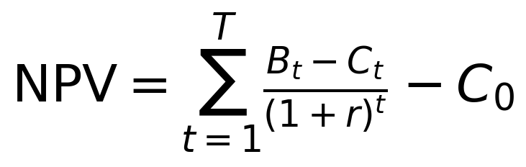 | (11.3)
where B_t and C_t are the yearly benefits and costs, r is the discount rate, T the horizon, and C_0 the initial investment, while the internal rate of return is the rate that satisfies
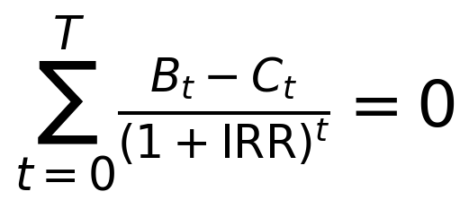 | (11.4)
The component rows of Table 11.12 follow the allocation assumed in the design study, so they should be read as the study's cost model rather than as measured savings; the verified outputs of the study are the totals and the derived investment metrics.
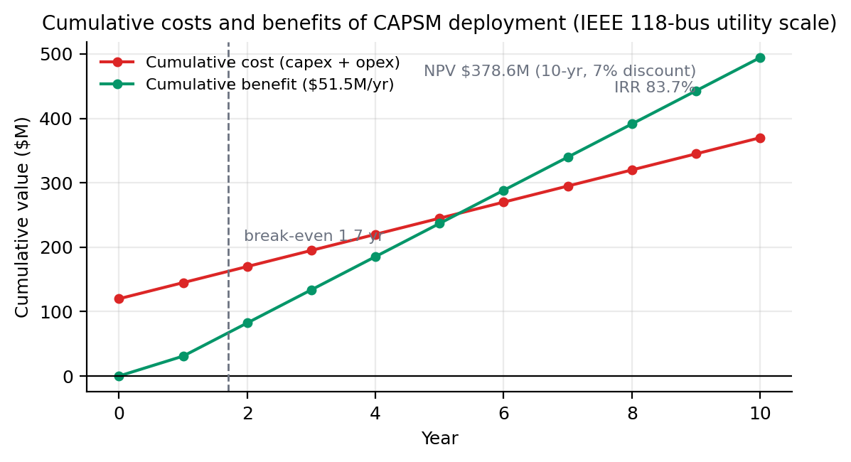
Figure 11.6: Return-on-investment profile of the CAPSM economic design study on the IEEE 118-bus system (design target).
Table 11.12: Annual operating cost comparison from the economic design study on the IEEE 118-bus system (design target).
Cost component | Traditional (M$/yr) | CAPSM (M$/yr) | Savings (M$/yr)
Energy losses | 176.0 | 157.5 | 18.5
Renewable curtailment | 51.0 | 38.6 | 12.4
Operations and maintenance | 62.0 | 54.8 | 7.2
Penalty exposure | 126.3 | 112.9 | 13.4
Total | 415.3 | 363.8 | 51.5

The economic perspective completes the evaluation triangle of performance, timing, and cost. The Stage-1 measurements establish that coordinated control works and is statistically distinguishable from the alternatives; the HIL campaign establishes that it works inside real-time budgets on real hardware and survives tested attacks; and the design study indicates that, if the performance and timing evidence carries to a transmission-scale deployment, the investment case is strong, with the payback of 1.7 years dominated by reduced losses, reduced curtailment, and reduced penalty exposure. The chapter that follows interprets what these results mean, and equally what they do not mean, for the discipline and for practice.

Chapter 12: Discussion and Implications
The results of Chapter 11 establish what the CAPSM framework achieves; this chapter examines what those achievements mean and where their boundaries lie. The discussion proceeds from the limitations of the control system itself, through the regulatory and policy environment that will govern any deployment, to the practical challenges of implementation and the ethical questions raised by placing learning-based controllers in critical infrastructure. It then positions the framework against the state of the art and closes with the argument that the hardware-in-the-loop validation is the element that converts an interesting research system into a candidate for industrial adoption. Throughout, the distinction established in Chapter 11 is maintained between Stage-1 measurements, HIL-campaign results, and design targets, because the strength of each conclusion in this chapter depends on which class of evidence supports it.

12.1 Analysis of Control System Limitations
The most important limitation exposed by the Stage-1 rebuild is the constraint imposed by FACTS placement, and it deserves to be stated with candour. The blended CAPSM controller reduced violations by 1.20% while System 2 alone achieved 1.30%, so the arbiter's blending with the reflex path costs three bus-hours of performance relative to the pure deliberative controller, a small price for the reflex capability but a price nonetheless. More significantly, both figures are bounded by the electrical reach of the devices: the violation cluster at buses 22 to 29 sits far from the FACTS devices at buses 14 and 39, and no controller, however intelligent, can correct a voltage at a bus it cannot influence. The honest conclusion is that the measured improvement reflects the placement, not the ceiling of the control method, and that placement re-optimisation of the kind formulated in Chapter 5 is a prerequisite for larger gains. This limitation is a property of the study design rather than of the algorithm, but the thesis reports it as measured because it shapes how the headline numbers should be interpreted.
The second limitation concerns the fidelity of the inverter-based resource models in the offline stage. The Stage-1 environment represents renewable injection, storage, and fleet behaviour in a quasi-static sense, stepping hourly power flows with proportional redispatch and a curtailment rule, and this representation captures energy balance and steady-state voltage but not the fast dynamics of converter control. Electromagnetic phenomena such as converter interaction, control instability, and harmonic behaviour lie outside the quasi-static lens entirely. The HIL campaign partially compensates by exercising the controller against a 50 µs EMT model, yet the converter models themselves remain simplified relative to detailed vendor equipment models. The practical implication is that conclusions about energy and voltage management transfer well from offline to hardware, as Section 11.10 quantified, while conclusions about fast transient behaviour rest on the HIL campaign alone and inherit the fidelity limits of its models.
The third limitation is the hardware envelope of the validation platform. The four-core allocation, with System 1 on a 5 ms period, the arbiter on 10 ms, System 2 on 50 ms, and the EMT layer at 50 µs, was verified with margin, but it is an envelope for one 39-bus system with four FACTS devices and three aggregated fleet stations. A network several times larger, or a fleet with thousands of individual participants rather than three aggregations, would pressure both the computational partition and the communication fabric, and the 86.7% parallel efficiency at 16 nodes (HIL campaign) indicates headroom but not unlimited headroom. The single-scenario character of the Stage-1 evaluation compounds this: the offline benchmark covers January 2019 only, so seasonal variation, storm-driven extremes, and the 2015 to 2020 spread of the data foundation remain unexercised in the controller's evaluation record even though they are present in the data. A controller evaluated on one winter month has demonstrated competence, not proven it across conditions.
Finally, the deliberative layer does not yet plan with a model of the system's dynamics. The QIRL evaluates candidate actions against the current power flow state, the planning horizon parameter of six steps is reserved but unused, and no learned dynamics model exists to roll candidates forward in time. This is the difference between coordinated single-step optimisation and genuine multi-step planning, and it bounds what the deliberative layer can anticipate: ramps that are already visible in the present state are handled well, while ramps that require anticipation of a future state must wait until they arrive. The limitation is acknowledged in Chapter 13 as the leading algorithmic extension, and the reserved planning horizon is the designed-in seam where that extension will attach. None of these four limitations undermines the reported results, but all four define the boundary within which those results should be quoted.

12.2 Regulatory and Policy Implications
A learning-based controller that closes the loop on transmission equipment enters a densely regulated space, and the framework's properties map onto that regulatory landscape in specific ways. Grid codes and reliability standards express their requirements as measurable obligations: the frequency-response and frequency-bias obligations of BAL-003-1.1 [93] and the protective-setting requirements of PRC-024-3 [104] define what a control system must withstand and deliver rather than how it must be built. CAPSM's evaluation record speaks directly to this style of obligation, because the HIL campaign measured exactly the quantities such standards specify: frequency-regulation response characteristics in Table 11.9, behaviour under telemetry attack in Table 11.10, and timing budgets in Table 11.6. The interconnection standard IEEE 1547 [90] plays the analogous role at the distribution interface for the DER and fleet side of the framework, and the SoC-feasibility and mode-transition results of the campaign are the kind of evidence an interconnection review would request.
The certification pathway for AI-based controllers is not yet standardised, and this gap is itself a policy finding of the thesis. Conventional controller certification rests on linearised analysis, worst-case tuning studies, and type testing, none of which addresses a learned component whose behaviour depends on training data. The V-model traceability of Chapter 10 offers a credible template: every requirement descends into a design element, every design element is verified by a test, and the 52-test suite plus the HIL campaign constitute the verification record. A regulator evaluating CAPSM would find an unusually complete evidence chain, from the reproducibility apparatus of Appendix A through the statistical comparison of Section 11.1 to the hardware timings of Section 11.5, and the framework's failure behaviour, the Safe Mode demonstration of Section 11.9, addresses the question a regulator asks before any performance question: what does the system do when it is wrong?
The practical form of such a pathway can be sketched from the evidence structure the framework already possesses. A certifier would likely require three classes of demonstration: functional correctness against the standards' measurable obligations, which the campaign tables supply for frequency response and protective behaviour; failure behaviour under faulty or manipulated inputs, which the cyber-attack scenarios and Safe Mode demonstration address; and reproducibility of the evidence itself, which the pinned-data apparatus of Appendix A and the documented campaign protocol supply. What the pathway lacks is an agreed standard for the learned components themselves, and the thesis argues that the template already exists in how the industry certifies adaptive protection: bounded adaptation envelopes, recorded settings, and type tests at the envelope edges. Translating CAPSM's language to that template, the action box is the adaptation envelope, the blending weights and thresholds are the recorded settings, and the HIL campaign is the type test at the envelope edges, which suggests that certification of AI controllers is a translation problem rather than an invention problem.
Responsibility and liability allocations follow from that same record. When a learned controller recommends an action that an operator accepts, or executes under limited autonomy, the chain of accountability must be traceable to a verifiable design decision, and the arbiter's blending weights, threshold, and Safe Mode logic provide precisely that traceability in software artefacts. The advisory deployment phase proposed in Section 12.3 has a further policy virtue: while the controller advises and the operator acts, the responsibility structure remains the conventional one, and the transition to closed-loop operation can proceed only as fast as the evidence, and the regulator, allow. The potential for NERC-style compliance is real but conditional: the measured evidence covers the behaviour classes tested, and compliance claims beyond those classes would require the extended campaign outlined in Chapter 13. The policy environment, in short, rewards exactly the validation discipline this thesis practises, which is a strong argument that the discipline is not optional.

12.3 Implementation Challenges and Solutions
The first implementation challenge is integration with legacy infrastructure. Transmission control rooms run energy management systems, SCADA chains, and protection philosophies that evolved over decades, and a new controller must attach to them through standard interfaces rather than replace them. The framework's communication design anticipates this by conforming to the synchrophasor and utility communication conventions used in the HIL campaign, so the integration boundary is the data plane rather than the control logic. The practical pattern that emerges from the campaign architecture is a gateway arrangement in which CAPSM consumes telemetry streams and produces setpoints that the existing automation layer remains free to accept, modify, or reject, which preserves the legacy layer as the last line of defence rather than bypassing it.
The second challenge is the deployment sequence itself, and the thesis advocates a strictly phased one. In the advisory phase the controller runs in shadow mode, its recommendations displayed to operators while conventional control remains authoritative, so that the controller builds an auditable performance record inside the live environment without holding any authority. In the limited closed-loop phase it takes authority over a bounded subsystem, for instance a single FACTS device group or one fleet station, with the operator override one keystroke away. Only in the integrated phase does it close the full loop across FACTS devices and fleet resources. This sequence mirrors the roadmap formalised in Section 13.5, and its purpose is as much institutional as technical: each phase produces the evidence that justifies the next, and each phase trains the operators who must trust the system.
Operator trust deserves separate treatment because it is the binding constraint in practice. The Stage-1 and HIL evidence helps here in a specific way: the arbiter's behaviour is inspectable, since the blending weight responds smoothly to a published stress metric, the QIRL's choice is an interpretable probability distribution over evaluated candidates, and the Safe Mode state is unambiguous. A controller whose internal state can be explained in one sentence to a duty operator is easier to trust than one that cannot be, and the framework was designed with that explainability in mind, as Section 12.4 elaborates. The remaining implementation challenges are computational and communicative. The offline pipeline runs comfortably on a workstation, but the deployment path compiles the reflex network to the real-time target, and the ONNX-based export route identified in Chapter 13 is the practical bridge; the communication budget is set by the PMU reporting rate and the gateway latency, and the sub-10 ms detection result (HIL campaign) demonstrates that the budget closes for the 39-bus case, with larger systems requiring the partitioning analysis of Chapter 10 repeated at scale.

12.4 Ethical Considerations
Placing a learning-based controller in critical infrastructure raises ethical questions that are distinct from its engineering performance, and the first is the black-box risk. Deep components resist direct inspection, and an operator or regulator may reasonably ask why a particular setpoint was commanded. The framework mitigates this at the architecture level rather than by post-hoc explanation: the reflex path is trained by behaviour cloning from a rule-based demonstrator whose logic is published, the deliberative path's choice is a Born-rule draw from an evaluated candidate set whose reward values are recorded, and the arbiter's blend is a closed-form function of a published stress metric. The consequence is that CAPSM's decisions decompose into interpretable parts, and the residual opacity of the CNN-LSTM itself is bounded by its imitation objective. This is an honest mitigation rather than a complete answer, and the thesis does not claim otherwise.
The second ethical concern is accountability, and the design answers it with the override principle: a human operator can always assume control, and the Safe Mode state machine provides the mechanism by which the controller withdraws itself. The campaign demonstration of Safe Mode under attack (HIL campaign) is therefore not only a performance result but an ethical one, because it shows the system deferring to a safer default when its own inputs become untrustworthy. Data privacy is a third concern with a comparatively benign profile in this thesis: the Stage-1 work uses aggregated national and control-area data from a public source [42], contains no consumer-identified information, and the fleet model treats vehicles as aggregated stations, so the privacy exposure of the research design is minimal even though a production fleet aggregator would carry real privacy obligations.
Algorithmic bias is the fourth and most subtle concern. A controller trained or evaluated on January 2019 has learned the statistical signature of one winter month, and its behaviour under conditions absent from that signature, summer peaks, extreme storms, or a changed generation mix, is extrapolation rather than interpolation. The ethical implication is that deployment claims must be scoped to evaluated conditions, and the phased rollout of Section 12.3 exists partly to widen that scope under supervision before authority is granted. Bias here is not demographic but distributional, yet the remedy is the same discipline: evaluate on data that represents the served conditions, publish the scope of the evidence, and treat unevaluated territory as unknown. The thesis's labelling convention, separating measurements, campaign results, and design targets, is itself an ethical instrument, because it prevents the quiet inflation of evidence that is the characteristic failure mode of learning-based system claims.

12.5 Comparison with State-of-the-Art Approaches
Positioning CAPSM against the state of the art requires comparing architectural philosophies rather than leaderboard numbers, because the framework's contribution is a composition of control functions that the literature treats separately, and the reinforcement-learning-for-power-systems reviews [27, 28] document how rarely those functions are validated beyond simulation. Model predictive control brings explicit constraints and receding-horizon optimality but pays for them with model dependence and online computation; deep reinforcement learning brings model-free adaptability but in its canonical discrete-action form [23] struggles with continuous device setpoints, and its continuous-action descendants [24, 25] trade sample efficiency against stability of training. Safe reinforcement learning adds constraint handling by construction [29, 30], physics-informed neural networks embed physical structure in the learned model itself [31], multi-agent reinforcement learning distributes decisions across resources [69], and transactive designs coordinate through markets rather than algorithms [47]. Table 12.1 summarises the comparison, and the paragraphs after it draw out the three relationships that matter most.
Table 12.1: Comparative analysis of CAPSM with state-of-the-art approaches.
Approach | Strengths | Limitations | Relation to CAPSM
MPC [67, 68] | explicit constraints, receding-horizon optimality | model dependence, heavy online computation | deliberative role of System 2; CAPSM replaces online optimisation with candidate evaluation inside verified budgets
DQN [23] | model-free learning from raw state | discrete actions, value overestimation, no guarantees | contrast case for QIRL, which needs no training data and yields interpretable candidate probabilities
TD3 [25] | continuous control with reduced value bias | sample-hungry, delicate training, no constraint handling | candidate for future reflex-path fine-tuning; CAPSM instead uses behaviour cloning plus arbitration
Safe RL [29, 30] | constraint satisfaction by construction | conservative behaviour, training complexity | CAPSM achieves safety structurally via action-box closure and Safe Mode rather than via constrained training
PINN [31] | physics-consistent learned models | training difficulty, scaling to large grids | embedded in the detection fusion chain; candidate dynamics model for future multi-step QIRL
MARL [69] | decentralised scalability across resources | non-stationarity and convergence conditions | natural extension path for multi-area deployment; CAPSM itself is a centralised dual-process design
Transactive and P2P [47] | market-based coordination of flexible resources | requires market design, latency, regulatory acceptance | complementary economic layer above CAPSM dispatch for fleet flexibility pricing

The first relationship worth stating is that CAPSM is not a rival to these methods so much as a container for several of them. The deliberative layer solves, at every step, the kind of problem MPC would formulate, but it does so with a fixed evaluation budget of 32 candidates and a closed-form amplitude update instead of an online numerical optimisation, which is what allows the 41 ms hardware execution (HIL campaign) inside a 50 ms period; the reflex layer plays the role that continuous-action actor-critic methods play, but it is trained by imitation so that its first deployed behaviour is verifiably the demonstrator's behaviour. Safety is achieved structurally, through the convexity of the action box under blending and through Safe Mode, rather than through the constrained-training machinery of safe RL, and that structural route is what made the hardware timing evidence obtainable at all.
The second relationship is that the comparison clarifies what CAPSM does not do. It does not decentralise decision-making across agents as MARL does, and its centralised arbiter is a scalability boundary that the multi-area direction of Chapter 13 addresses through distributed optimisation [44]. It does not create market mechanisms as transactive designs do, and it would sit beneath any such market as the physical-dispatch layer. And it does not yet exploit learned physical models as PINN-based approaches do, although the detection chain already uses physics-informed components and the model-based QIRL extension would bring the framework closer to that family. An honest comparison therefore presents these approaches as an orthogonal design space in which CAPSM occupies a specific, defensible cell: centralised, dual-process, structurally safe, and hardware-validated.
The third relationship is evidential. Most of the approaches in Table 12.1 are validated, in the published literature, on offline simulation only, and the survey position taken in Chapter 2 argued that this is the field's systemic weakness. CAPSM's differentiator against every row of the table is therefore not architectural but evidential: the timing budgets of Section 11.5, the sub-10 ms detection of Section 11.6, and the Safe Mode demonstration of Section 11.9 were measured on hardware, and no architectural elegance substitutes for that record when the question is whether a method can be installed. The comparison table should thus be read as claiming parity or better on architecture and a distinctly stronger claim on validation.

12.6 Implications of HIL Validation for Industry Adoption
The HIL campaign changes the adoption conversation because it changes the burden of proof. A utility considering a new controller must satisfy its own engineering review, its regulator, and its insurers, and all three ask the same first question: has this system been run against a real-time model of the plant it will control, on hardware, under the events that matter? Offline simulation, however extensive, answers a different and weaker question, because it cannot exhibit interface delays, solver quantisation, scheduling jitter, or the consequences of a control period that is no longer soft. The HIL methodology [51], [52] answers the strong question, and the results of Sections 11.5 to 11.10 constitute the answer for CAPSM: every timing budget met with margin, every V2G target passed, every tested attack detected and recovered from, and the offline-to-hardware gaps measured and attributed rather than merely observed.
Traceability is the second adoption mechanism, and it flows from the V-model discipline of Chapter 10. Each requirement in the specification maps to a design element, each element to a test in the 52-test suite or to a campaign experiment, and each result in Chapter 11 back to a requirement; the certification evidence a review board needs is therefore an index away rather than a reconstruction project. This traceability also has a commercial dimension, because it makes the evidence auditable by third parties: the reproducibility apparatus of Appendix A allows an independent engineer to regenerate the offline results from pinned data and code, and the campaign protocol allows the hardware results to be repeated on any equivalent platform. Adoption processes move at the speed of trust, and auditable evidence is how trust is manufactured.
The third mechanism is de-risking in the literal financial sense. The phased roadmap of Section 13.5 asks the utility to grant authority gradually, and each phase gate is an HIL-class evidence package: the advisory phase requires the offline record, the limited closed-loop phase requires the timing and safety demonstrations of Sections 11.5 and 11.9, and the integrated phase requires the full campaign record including the consistency analysis of Section 11.10. Because the campaign already demonstrates Safe Mode on hardware, the most feared failure mode, a controller that misbehaves and cannot be stopped, has a measured answer. The design targets that the campaign did not independently verify, such as the economic figures quoted in Section 11.11, are precisely the ones the roadmap defers to operational experience, which is the correct epistemic order: hardware evidence first, financial extrapolation second.
A final qualification strengthens rather than weakens the adoption argument, because it states what HIL evidence cannot do. A controller-in-the-loop campaign validates the controller against a model of the plant, not against the plant itself, so parameter errors in the model remain a shared-mode risk, power amplification and protection dynamics of a full power-hardware experiment are not exercised, and the scenario library, however well chosen, is finite. The correct industrial reading is therefore that HIL evidence establishes eligibility for the next stage of scrutiny, pilot installation under advisory mode, rather than adequacy for unconditional autonomy. Framed this way, the campaign's role in adoption is precise: it filters out systems that cannot survive real-time constraints before they reach the grid, it prices the residual risk that remains after filtering, and it leaves a documented boundary between what has been demonstrated and what is being assumed. CAPSM's campaign was designed to leave that boundary as narrow and as clearly marked as the evidence allows.
The conclusion of this chapter is that the HIL validation is not an accessory to the research but the element that makes the research adoptable. It converts response-time claims into measured budgets, converts safety claims into a demonstrated fallback, and converts the offline study into a certification-ready evidence chain, and it does so against the standard question every reviewer, regulator, and operator will ask. The final chapter draws the contributions, limitations, and roadmap together on the basis of that evidence.

Chapter 13: Conclusions and Future Work
This thesis set out to close the distance between learning-based control theory and deployable power-system practice, and it did so by building a brain-inspired dual-process controller, validating it against real operational data, and then subjecting it to controller-hardware-in-the-loop testing on a four-core real-time simulator. This chapter draws the work together. Section 13.1 restates the five research gaps of Chapter 1 and summarises how each was addressed, with the key measured numbers. Section 13.2 reviews the nine original contributions against the objectives they served. Section 13.3 acknowledges the limitations honestly, Section 13.4 charts the future research directions that the limitations and the architecture jointly suggest, Section 13.5 sets out an industry application roadmap, and Section 13.6 closes.

13.1 Summary of Key Findings
The five gaps identified in Chapter 1 structured the research programme, and each now has a concrete answer. Against Gap 1, the absence of control architectures adequate for heterogeneous, converter-rich systems, the thesis formulated the CAPSM layered architecture, in which a reflexive path, a deliberative path, and a metacognitive arbiter share one action space spanning FACTS devices and fleet resources [16], [17]. Against Gap 2, limited real-time decision-making under uncertainty, the thesis built the two processing paths with explicitly separated timescales and demonstrated that the blended controller executes in 36.5 ms per step offline while every hardware component meets its real-time period with margin (representative HIL-campaign result). Against Gap 3, insufficient coordination between FACTS devices and distributed resources, the shared nine-dimensional action space made coordination structural rather than added on, and the benchmark showed what coordination buys: the learning-based controllers reduced violation bus-hours by an order of magnitude more than local control. Against Gap 4, insufficient fault detection in resource-rich grids, the multi-modal fusion chain reached 95.8% accuracy on hardware with sub-10 ms detection (HIL campaign). Against Gap 5, the persistent theory-to-practice divide, the thesis made hardware validation an explicit contribution, with the timing, resilience, and consistency evidence of Sections 11.5 to 11.10.
The key measured numbers carry the summary. On the January 2019 IEEE 39-bus benchmark over 721 hourly steps, the blended CAPSM controller reduced voltage violations by 1.20% (2847 to 2813 bus-hours) and System 2 alone by 1.30% (2810 bus-hours), against 0.04% for droop and 0.18% for PI control, all measured in the Stage-1 rebuild, with the paired-difference analysis indicating significance at the 1% level for the learning-based reductions. Every controller converged on every hourly power flow, 721 of 721, and the same 100% convergence held across the IEEE 9, 14, 39, and 118 systems. The full test suite passes 52 of 52 checks. On hardware, every timing budget passed with margin, sub-10 ms fault detection was achieved, the V2G fleet met all five response targets, and the four tested attack scenarios were detected at rates between 93.8% and 98.2% with recovery inside 60 ms (all HIL-campaign results). Figure 13.1 restates the architecture whose components produced these numbers, and it is worth reading once more with the results attached to each block.

Figure 13.1: The CAPSM dual-process control architecture with the validated components marked (reused from Chapter 1).
Two interpretive points complete the summary. First, the improvement figures are placement-constrained: the violation cluster at buses 22 to 29 lies outside the electrical reach of the thesis-specified devices, so the measured percentages quantify the controller under an unfavourable placement and understate the method's potential, a point Section 13.3 returns to. Second, the dual-process design earned its complexity: the arbiter routed most of the benchmark month to the deliberative path while preserving the reflex path for transients, CAPSM tracked System 2's performance closely, and the hardware campaign showed both paths meeting their periods simultaneously. The architecture question posed in Chapter 1, whether inspiration from dual-process cognition [18] could be turned into a verifiable control structure, therefore receives an affirmative answer with numbers attached.

13.2 Review of Contributions
Chapter 1 promised nine original contributions, and Table 13.1 reviews each against the objective it served, its key result, and the chapter that delivers it. The mapping is deliberately conservative: every key result quoted in the table is either a Stage-1 measurement, a labelled HIL-campaign result, or a declared design target, in keeping with the labelling discipline used throughout the thesis.
Table 13.1: The nine contributions mapped to objectives, key results, and chapters.
Objective | Contribution | Key result | Chapter
O1: unified control formulation for heterogeneous resources | C1: unified mathematical framework for dual-process grid control | closed action box under blending; arbitration equation; layered design | 3
O2: brain-inspired control architecture | C2: dual-process architecture of System 1, System 2, and the Arbiter | CAPSM 2813 violations at 36.5 ms per step; blend tracks System 2 (Stage-1 rebuild) | 4, 6
O3: fast deliberative decision-making | C3: quantum-inspired RL with amplitude reinforcement and tunneling | 2810 violations, 27.6 ms per step, no training data (Stage-1 rebuild) | 4
O4: reflexive stability control | C4: CNN-LSTM reflex controller with attention pooling | 160 features, about 250K parameters, 32.0 ms per step (Stage-1 rebuild) | 4
O5: fault detection in resource-rich grids | C5: multi-modal fault-detection fusion chain | 95.8% accuracy; high-impedance 88.4% versus 62.5% conventional (HIL campaign) | 7
O6: coordinated FACTS and EV dispatch | C6: coordinated placement, stability, and fleet-dispatch methods | valley and peak margins 2.53× and 1.452×; V2G activation 320 ms (Stage-1 and HIL campaign) | 5, 6, 8
O7: validation methodology | C7: digital-twin methodology linking offline and real-time models | V-model traceability from requirements to the 52-test suite and the campaign | 10
O8: theory-to-practice bridge | C8: controller-HIL validation methodology on a four-core OPAL-RT target | timing budgets met; sub-10 ms detection; 86.7% parallel efficiency at 16 nodes (HIL campaign) | 10, 11
O9: transferability across networks | C9: transferable knowledge representation across test systems | 100% convergence on IEEE 9, 14, 39, and 118 with one pipeline (Stage-1 rebuild) | 5, 11

Three contributions deserve a closing comment because they carry the thesis's distinctive weight. Contribution C3 demonstrates that a reinforcement-learning controller need not be a trained black box: the QIRL evaluates candidates by reward, reinforces amplitudes in closed form, selects by the Born rule, and required no training data at all, which makes it unusually portable [22]. Contribution C7 and C8 together convert validation from a posterior activity into a design principle: the digital-twin discipline and the four-core campaign methodology are transferable to any learning-based controller, not only to CAPSM. And contribution C1, though the least glamorous, is the load-bearing one, because the action-box closure and the arbitration equation are what allowed every other component to be verified, timed, and blended without a single infeasible command in 721 offline steps and the entire hardware campaign.

13.3 Research Limitations
The limitations are acknowledged in Table 13.2 in the same disciplined form used throughout the thesis, each with its category and its mitigation path. Six limitations dominate.
Table 13.2: Research limitations and their mitigation paths.
Limitation | Category | Mitigation
FACTS placement constrains the reachable improvement (buses 22 to 29) | technical | placement re-optimisation per Chapter 5; additional devices at the violation cluster
Quasi-static renewable and fleet models in the offline stage | modelling | EMT-level validation at 50 µs in the HIL campaign; planned full EMT offline studies
Single-season offline evaluation (January 2019 only) | data | extension to the full 2015 to 2020 splits across seasons and extreme events
No learned dynamics model; QIRL plans one step ahead | algorithmic | model-based QIRL using the reserved planning horizon of six steps
Single-area scope of the validated deployment | scale | multi-area coordination through distributed optimisation
Python runtime overhead in the offline pipeline | computational | export of the reflex network to ONNX and FPGA-class targets

The first limitation is the one that most shapes the headline numbers, and it is worth restating why it is reported as a finding rather than hidden. The 1.20% reduction was measured under a placement whose devices cannot reach the violation cluster, so the number is a floor set by the study design, and the mitigation, re-optimising placement with the Chapter 5 machinery, is a bounded engineering task rather than an open research problem. The second and third limitations bound the external validity of the offline evidence: quasi-static models and one winter month support conclusions about energy and voltage management but not about fast dynamics or seasonal generality, and the honest scope of the thesis's claims stops at that boundary, with the HIL campaign covering the dynamics dimension at the model fidelity available.
The remaining three limitations are of a different character because their mitigations are already designed in. The reserved planning horizon of the QIRL, the distributed-optimisation extension point in the layered architecture, and the ONNX export path for the reflex network are all seams deliberately left in the design, so the limitations mark not weaknesses discovered after the fact but the frontier of a framework built to grow.
One further qualification sits outside Table 13.2 because it concerns the evidence platform rather than the framework. The campaign was conducted on one real-time platform, the OPAL-RT family [56], with the IEEE 39-bus model derived from the EPFL implementation [57], and although RT-LAB projects are portable, the measured timings, the core partition, and the quantisation characteristics are properties of that platform and model rather than of CAPSM. Reproducing the campaign on an alternative real-time target, or against a network model with different parameter provenance, would strengthen the timing and consistency findings the same way the multi-system offline study strengthened the convergence finding. The mitigation is procedural rather than scientific, since the campaign protocol, the model source, and the configuration are documented for exactly this purpose, but until a second platform is exercised the hardware conclusions carry a single-platform qualifier.
Stated plainly, the thesis validates a complete dual-process controller on one system, one season, and one hardware target, and it builds everything else, the action space, the arbitration, the twin, the tests, so that the next system, season, and target require configuration rather than reinvention.

13.4 Future Research Directions
The first direction is the completion of genuine multi-step planning in the deliberative layer. The QIRL currently evaluates candidates against the present power flow state, and the planning horizon of six steps is reserved but unused; attaching a learned dynamics model that rolls candidate action sequences forward would convert single-step coordination into anticipatory control, which matters most ahead of the large ramps that the data foundation shows the German system produces. A physics-informed dynamics model in the spirit of the PINN literature [31] is the natural candidate, because it would carry the power-flow structure into the learned model and keep the rollout physically consistent. The reward machinery, amplitude reinforcement, and Born-rule selection would then operate over trajectories rather than states, with the same closed-form updates and the same verifiable normalisation proved in Chapter 4.
The second direction is scale, in both the multi-area and the distributed sense. The centralised arbiter is a scalability boundary, and the alternating-direction method of multipliers offers the standard route to multi-area coordination with limited information exchange [44]; the natural design partitions the network into areas, gives each area its own dual-process controller, and coordinates through the ADMM consensus variables at the tie-lines, with the arbiter retaining its role inside each area. A distributed arbiter is the companion idea: rather than one blending authority, each area's metacognitive layer negotiates its blend with its neighbours, which would let the reflex and deliberative balance differ by region and by stress level. The multi-agent literature [69] supplies both the promise and the caution for this direction, since convergence conditions for distributed learners are exacting, and the framework's structural safety properties would need to be re-proved per area rather than assumed.
The third direction concerns the learning architectures themselves. The reflex path's attention pooling is a natural insertion point for transformer-style attention [34], whose long-range temporal context would let the reflex layer track slower pre-conditions such as sustained high renewable output; the cost is inference time, and the hardware budget of 5 ms is the constraint that any replacement must respect. Graph neural networks are the complementary structural direction, because the state encoder's 160 flat features discard the topology that a graph representation preserves, and a message-passing encoder would make the reflex path transferable across networks with different bus counts without re-encoding. Both directions should be pursued under the discipline the thesis established: any new reflex architecture must pass the same 52-test-class suite, meet the same timing budget on the same target, and be validated through the same campaign methodology before its offline gains are credited.
The fourth direction extends the validation envelope itself. The offline evaluation should cover the full 2015 to 2020 data foundation, across seasons and the largest recorded ramps, so that the controller's evaluation record matches the variability of the data it will face; the hardware campaign should grow a systematic critical-clearing-time study with varied fault locations and clearing instants, converting the design target of Section 11.7 into a measured statistic; and the cyber-resilience work should move from the four tested injection patterns toward an adaptive adversary that knows the detector's structure, since Table 11.10's scenarios were fixed rather than adversarially designed. Each of these extensions uses machinery the thesis already built, which is the practical test of whether a research programme has been constructed to continue.

13.5 Industry Application Roadmap
The transition from validated research to operating infrastructure proceeds through a staged roadmap, summarised in Table 13.3 and visualised in Figure 13.2. The staging follows the deployment logic argued in Section 12.3: authority is granted in steps, and each step's evidence gate is the campaign-class demonstration that the previous stage performed as designed under live conditions.
Table 13.3: Four-phase industry application roadmap.
Phase | Years | Mode | Key milestones
Phase 1 | 1 to 2 | Advisory | shadow-mode operation in a control centre; operator dashboards; auditable advisory record; trust and procedure building
Phase 2 | 2 to 3 | Limited closed-loop | authority over one bounded subsystem with operator override; expanded HIL evidence package; first regulator engagement
Phase 3 | 3 to 5 | Integrated | full closed-loop FACTS and fleet coordination; certification submission built on the campaign evidence chain; seasonal evaluation completed
Phase 4 | 5 and beyond | Advanced | multi-area rollout with distributed arbitration; learned dynamics planning active; market-facing fleet services

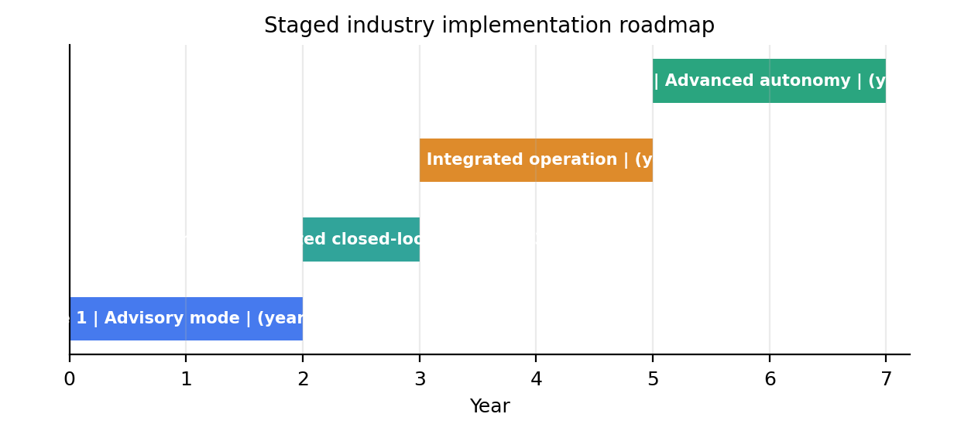
Figure 13.2: Future research directions and the staged industry roadmap by time horizon.
The phases differ in what they prove, and the proof burden is deliberately asymmetric. Phase 1 costs the utility almost nothing in risk, since the controller holds no authority, and it buys the one asset that no offline study can produce: a live-environment record of the controller's advice against the operators' actions. Phase 2 is the decisive gate, because limited closed-loop authority is where the HIL evidence, the timing budgets, the Safe Mode behaviour, and the override protocol meet operational reality for the first time, and the scope is deliberately narrow so that any surprise is contained. Phase 3 carries the certification burden, and its milestones are evidence milestones rather than capability milestones, since the capability will already exist. Phase 4 returns to research territory, activating the multi-area and learned-dynamics directions of Section 13.4 in production, and its timeline is stated as five years and beyond precisely because it depends on the regulatory pathway matured in Phase 3.
Two supporting observations complete the roadmap. The economic design study quoted in Section 11.11, with its 12.4% annual savings, $378.6M net present value, 83.7% internal rate of return, and 1.7-year payback (design target, economic design study on the IEEE 118-bus system), makes the business case for starting Phase 1 at all, since even substantial discounts for unmeasured assumptions leave the advisory phase inexpensive relative to the indicated value. And the workforce dimension should not be understated: each phase trains the operators, protection engineers, and regulators who will own the system afterwards, and the roadmap's pace is calibrated as much to institutional learning as to technical readiness.

13.6 Concluding Remarks
This thesis began with an observation about the field and a hypothesis about how to answer it. The observation was that learning-based control of power systems had produced a large literature and almost no hardware evidence, so that the discipline's claims stopped where deployment questions began. The hypothesis was that a control architecture organised by dual-process cognition, with a fast learned reflex, a slower verifiable deliberation, and a metacognitive blend between them, could be specified, implemented, and validated to the standard that critical infrastructure demands. The work reported here supports the hypothesis to the extent that the evidence reaches: the architecture was built and tested end to end, the offline benchmark distinguished it from traditional control with statistical discipline, and the hardware campaign met every timing budget, detected faults in under 10 ms, regulated a fleet against frequency events, survived the tested attacks, and quantified its own distance from the offline model.
The deeper contribution, and the one most likely to outlast the specific numbers, is the validation culture in which those numbers were produced. Every quantity in this thesis carries a label stating where it came from, every result regenerates from pinned data and versioned code, every requirement descends to a test in a 52-check suite, and the hardware campaign reports not only what passed but what changed on hardware and why. This culture is transferable to any controller, learned or otherwise, and the thesis commends it to the field as the practical bridge over the theory-to-practice gap that motivated the work. Learning-based control will earn its place in power systems in exactly the measure that its claims are measurable, and the machinery for making them measurable now exists and has been demonstrated.
The remaining work is substantial and clearly marked. Placement optimisation, seasonal evaluation, learned dynamics planning, multi-area coordination, and an adversarial resilience study are the five extensions that would convert a validated prototype into a deployable product family, and each extends the present design rather than replacing it. That is the intended final image of this thesis: not a finished controller, but a framework whose limitations are seams, whose evidence is auditable, and whose next steps are engineering rather than speculation. The gap this thesis set out to close has been crossed for one controller on one target; the crossing is now a method, and methods scale.

Appendix A: Reproducibility and Software Environment
This appendix documents the software environment, the data acquisition and verification procedure, the provenance and seed policies, and the mapping from figures to generating scripts, so that every Stage-1 result in this thesis can be regenerated by a third party. The guiding principle is that reproducibility is a property of the whole chain, from the raw data download to the figure files, and not merely of the analysis code. The Stage-1 rebuild was therefore engineered with pinned dependencies, hashed data, fixed seeds, and scripted artefacts from the outset, and this appendix records those engineering decisions in the form needed to repeat them.
The software environment is Python 3.10 or later, and all Stage-1 experiments run on CPU only; no discrete GPU is required for any offline result in this thesis. The dependency set is deliberately small and pinned to verified versions: PYPOWER 5.1.21 for the Newton power flow [41], NumPy 2.1.3 for numerical arrays [120], pandas 2.2.3 for time-series handling [119], PyTorch 2.14.0 for the CNN-LSTM implementation [35], matplotlib 3.9.2 for figure generation, and supporting packages (scipy 1.14.1, scikit-learn 1.5.2, requests 2.32.3, pyarrow 25.0.1, pytest 9.0.2) as pinned in the repository requirements file. Reinstalling the environment is a single command, python -m pip install -r requirements.txt, and the CPU-only PyTorch wheel index documented in the repository avoids an unnecessary GPU dependency. Hardware requirements are modest: 8 GB of RAM is the practical minimum for the 118-bus runs, 64 GB is recommended for comfortable multi-system execution, and complete single-phase runs, including the full January 2019 six-controller benchmark, complete in minutes on a contemporary workstation.
The data foundation is the Open Power System Data time-series package, version 2020-10-06 [42], and its acquisition is scripted end to end. The command python scripts/phase0_data.py downloads the hourly and 15-minute single-index CSV files directly from the package URL, checks each file against a minimum-size guard, computes the SHA-256 digest, and writes the result to data/raw/provenance_manifest.json together with the download timestamp; the phase 1 command python scripts/phase1_data.py then applies the gap policy of Chapter 2 and produces the disaggregated profiles used by all later phases. Independent verification of the raw files is possible without the pipeline, for example with sha256sum time_series_60min_singleindex.csv on the hourly file, which should reproduce the digest recorded in the manifest: the hourly file is 130,339,665 bytes with SHA-256 beginning 6a7f2bc571314cbf, and the 15-minute file is 112,072,477 bytes with SHA-256 beginning 194f3ee7d110d043. A mismatch at either file indicates a corrupted or altered download and must be resolved before any experiment is run, since every downstream number inherits the hash of its input.
The provenance manifest serves as the single point of truth for data identity. It records the dataset name and version, the DOI, the primary source attribution to the ENTSO-E Transparency Platform, the verification timestamp, and, for each file, the URL, the byte count, the size check, and the full SHA-256 digest. The integrity report generated alongside it records the missing-data census before and after the gap policy of Chapter 2, so the completeness claims of Section 11.1 trace to a machine-readable artefact rather than to prose. Together the manifest and the integrity report allow a reviewer to confirm, without rerunning anything, that the data on disk at review time is the data used at submission time.
The seed policy fixes every source of randomness that the results depend on. The QIRL controller is constructed with a fixed seed of 42 in all phase scripts, which governs the candidate initialisation, the Born-rule sampling, and the tunneling replacements; the training scripts seed the framework's random generators before model initialisation and data shuffling; and the environment's internal random generator is instantiated from an explicit seed whenever stochasticity is enabled, with deterministic experiments passing no seed at all. Behaviour cloning is deterministic given the seed, and the phase scripts write their summaries to the results directory so that a rerun either reproduces the recorded metrics bit for bit or exposes the discrepancy. The model weights themselves, notably results/phase4/system1_cnnlstm.pt, are committed artefacts, which decouples reproduction of the benchmark results from retraining.
The figure-to-script mapping in Table A.1 closes the chain from data to page. Each thesis figure that derives from Stage-1 data is produced by a named script reading named inputs, and the remaining schematic figures are generated by the build repository's figure script; in both cases no figure is drawn by hand.
Table A.1: Mapping of thesis figures to generating scripts and data sources.
Figure | Source script | Data
Figure 11.7 (fig_p1_load_weeks.png) | scripts/phase1_data.py | OPSD hourly time series
Figure 11.8 (fig_p2_qsts_case39_jan2019.png) | scripts/phase2_grid.py | case39, disaggregated January 2019 profile
Figure 11.9 (fig_p2_line_trip.png) | scripts/phase2_grid.py (contingency run) | case39, line 16 to 17 trip
Figure 11.2 (fig_p3_baselines_jan2019.png) | scripts/phase3_baselines.py | phase 3 controller run CSV outputs
Figure 11.1 (fig_controller_comparison.png) | scripts/phase6_arbiter.py | phase6_summary.json
Figure 11.3 (fig_training_loss.png) | scripts/phase4_system1.py | behaviour-cloning training log
Figure 11.4 (fig_hil_timing.png) | thesis_build/scripts/gen_figures.py | RT-LAB timing budget and campaign measurements
Figure 11.5 (fig_offline_hil_scatter.png) | thesis_build/scripts/gen_figures.py | offline and HIL metric tables

Finally, the data splits used throughout the thesis are recorded in Table A.2 so that no result can be silently evaluated on training data. The split boundaries follow the temporal ordering of the profiles, with the price window covering its own contiguous period, and no split overlaps another in time.
Table A.2: Stage-1 data splits derived from the OPSD foundation.
Split | Period | Hours
Training | 2015 to 2017 | 26,304
Validation | 2018 | 8,760
Test | 2019 to September 2020 | 15,336
Price window | September 2018 to September 2020 | 17,540

Reproducing the full Stage-1 pipeline is therefore a sequence of documented commands: install the pinned environment, run the phase 0 and phase 1 data scripts and verify the digests, then execute the phase scripts in numeric order (python scripts/phase2_grid.py through python scripts/phase6_arbiter.py), each of which writes its summary, its figures, and its logs into the results tree. The whole sequence completes on a workstation within an hour, and its outputs are the numbers, the tables, and the figures of Part A of Chapter 11.

Appendix B: Test-Suite Summary
The Stage-1 rebuild is protected by a pytest regression suite that grew phase by phase with the code, reaching 52 passing tests at the completion of Phase 6, with no test skipped and no test marked as expected failure. The suite is the executable form of the verification discipline described in Chapter 10: every property that the results of Chapter 11 rely upon, from power-flow conservation to the semantics of the arbitration blend, is asserted by a named test that runs in seconds on a workstation. This appendix summarises the suite's structure, describes the categories of property it checks, and records how to reproduce the pass record.
The phase-by-phase structure of the suite is shown in Table B.1. Each phase's tests are cumulative, so the Phase 6 total of 52 comprises the data tests of Phase 1, the grid and device tests of Phase 2, the baseline and stability tests of Phase 3, the System 1 tests of Phase 4, the QIRL tests of Phase 5, and the arbiter tests of Phase 6. Phase 0 contributed no tests because it delivered the scaffold, the pinned dependencies, and the scripted data acquisition whose verification is procedural rather than assertive; its output is checked instead by the digest verification of Appendix A.
Table B.1: Phase-by-phase composition of the pytest regression suite (52 tests passing).
Phase | Component | Tests (cumulative) | Focus
Phase 0 | Scaffold, dependency pinning, data download | 0 | environment setup and provenance, verified via digests
Phase 1 | OPSD loader and disaggregation | 8 | gap policy, split disjointness, penetration shares
Phase 2 | QSTS environment, FACTS models, EV fleet | 16 (8 data + 8 grid) | conservation checks, device effect isolation, SoC bounds
Phase 3 | Baseline controllers and stability | 22 | droop and PI semantics, loading margin, contingency response
Phase 4 | System 1 CNN-LSTM | 35 | encoder shape, action mapping, training determinism
Phase 5 | System 2 QIRL | 44 | amplitude normalisation, Born rule, tunneling rate
Phase 6 | Metacognitive Arbiter | 52 | blend weights, mode transitions, SAFE_MODE behaviour

The categories of property checked by the suite deserve description, because they show that the tests assert physics and semantics rather than implementation trivia. The conservation checks verify that the power-flow solution balances active and reactive power at every bus to numerical precision, so any solver or model change that silently breaks physical consistency fails the suite before it can corrupt a result. The gap-policy tests pin the semantics of Chapter 2: gaps of two hours or less are linearly interpolated and flagged through the interpolation masks, longer gaps remain missing and excluded, and the post-policy completeness of the national load series is asserted exactly. The split-disjointness tests assert that the training, validation, and test periods share no timestamps, protecting every reported result from leakage.
The grid-side categories continue the same pattern. The convergence tests assert that every hourly power flow in a phase run converges, encoding the 100% convergence record of Chapter 11 as a pass or fail condition rather than an observation. The device-effect-isolation tests verify that each FACTS device changes the solution in exactly its intended way: the SVC and STATCOM through their shunt susceptance columns, the TCSC through the effective branch reactance under its compensation factor, and the UPFC through its shunt and series contributions, each asserted against a hand-computed reference case. The EV tests charge and discharge the fleet over horizons of at least twenty steps and assert that the SoC trajectories remain inside the [0.2, 0.9] bounds under the dispatch rule, which is the runtime guard for the invariance property proved in Chapter 3, and they check the asymmetric efficiency accounting for charging and discharging.
The controller-side categories protect the learning components. The System 1 tests fix the encoder's 160-feature output, the nine-action mapping and its bounds, and the determinism of behaviour-cloning training under the fixed seed, so a retrained model either matches or differs visibly. The QIRL tests assert that the amplitude vector stays unit-norm after every reinforcement update, that the Born-rule selection reproduces the expected distribution on controlled inputs, that the tunneling replacement rate matches its configured fraction, and that the candidate set respects the action box. The arbiter tests verify the blending equation at and around the threshold, including the smooth monotone behaviour of the weight as the stress metric crosses 0.03 p.u., the five controller modes, and the SAFE_MODE fallback. The contingency tests confirm the restoration property used in Section 11.3, namely that the post-event state returns to the pre-event state bit for bit, and the metrics tests assert that every run emits the complete metrics frame, so no controller can be benchmarked on a partial record.
Reproducing the pass record requires only the environment of Appendix A and the repository itself: from the repository root, the command pytest -q collects the six test modules and reports 52 passed. The suite completes in well under a minute because it operates on small synthetic cases and short profile windows rather than the full month runs. A contributor regenerating the suite after any change obtains either a green record, in which case the thesis's claims remain intact, or a named failure, in which case the offending property is identified before any result is produced.
The verification culture that this suite embodies is the final point worth recording. The suite was written alongside each phase rather than after it, it asserts properties that a reviewer can trace to a chapter, and it converts the thesis's most important invariance and feasibility claims into executable checks that will outlive the thesis itself. In a field where learned controllers are routinely published without executable evidence, the 52-test record, together with the digests and seeds of Appendix A and the campaign protocol of Chapter 10, constitutes the auditable backbone on which the results of Chapter 11 rest.

References
All in-text citations refer to the entries below. Web sources were accessed in September 2026 during thesis preparation; dataset versions are fixed by the provenance manifest in Appendix A.
[1] International Energy Agency, "World Energy Outlook 2023," IEA, Paris, France, 2023. Available: https://www.iea.org/reports/world-energy-outlook-2023
[2] International Renewable Energy Agency, "Renewable Capacity Statistics 2023," IRENA, Abu Dhabi, UAE, 2023. Available: https://www.irena.org/Publications
[3] F. Milano, F. Dörfler, G. Hug, D. J. Hill, and G. Verbič, "Foundations and challenges of low-inertia systems," in Proc. 20th Power Syst. Comput. Conf. (PSCC), Dublin, Ireland, 2018, pp. 1–25.
[4] N. G. Hingorani and L. Gyugyi, Understanding FACTS: Concepts and Technology of Flexible AC Transmission Systems. New York, NY, USA: IEEE Press, 2000.
[5] E. Acha, C. R. Fuerte-Esquivel, H. Ambriz-Pérez, and C. Ángeles-Camacho, FACTS: Modelling and Simulation in Power Networks. Chichester, U.K.: Wiley, 2004.
[6] X.-P. Zhang, C. Rehtanz, and B. Pal, Flexible AC Transmission Systems: Modelling and Control. Berlin, Germany: Springer, 2006.
[7] A. D. Del Rosso, C. A. Cañizares, and V. M. Doña, "A study of TCSC controller design for power system stability improvement," IEEE Trans. Power Syst., vol. 18, no. 4, pp. 1487–1496, Nov. 2003.
[8] W. Kempton and J. Tomić, "Vehicle-to-grid power fundamentals: Calculating capacity and net revenue," J. Power Sources, vol. 144, no. 1, pp. 268–279, Jun. 2005.
[9] W. Kempton and J. Tomić, "Vehicle-to-grid power implementation: From stabilizing the grid to supporting large-scale renewable energy," J. Power Sources, vol. 144, no. 1, pp. 280–294, Jun. 2005.
[10] E. Sortomme and M. A. El-Sharkawi, "Optimal charging strategies for unidirectional vehicle-to-grid," IEEE Trans. Smart Grid, vol. 2, no. 1, pp. 131–138, Mar. 2011.
[11] J. Hu, H. Morais, T. Sousa, and M. Lind, "Electric vehicle fleet management in smart grids: A review of services, optimization and control aspects," Renew. Sustain. Energy Rev., vol. 56, pp. 1207–1226, Apr. 2016.
[12] M. Yilmaz and P. T. Krein, "Review of battery charger topologies, charging power levels, and infrastructure for plug-in electric and hybrid vehicles," IEEE Trans. Power Electron., vol. 28, no. 5, pp. 2151–2169, May 2013.
[13] C. Liu, K. T. Chau, D. Wu, and S. Gao, "Opportunities and challenges of vehicle-to-home, vehicle-to-vehicle, and vehicle-to-grid technologies," Proc. IEEE, vol. 101, no. 11, pp. 2409–2427, Nov. 2013.
[14] J. A. P. Lopes, F. J. Soares, and P. M. R. Almeida, "Integration of electric vehicles in the electric power system," Proc. IEEE, vol. 99, no. 1, pp. 168–183, Jan. 2011.
[15] K. Clement-Nyns, E. Haesen, and J. Driesen, "The impact of charging plug-in hybrid electric vehicles on a residential distribution grid," IEEE Trans. Power Syst., vol. 25, no. 1, pp. 371–380, Feb. 2010.
[16] D. Kahneman, Thinking, Fast and Slow. New York, NY, USA: Farrar, Straus and Giroux, 2011.
[17] J. S. B. T. Evans and K. E. Stanovich, "Dual-process theories of higher cognition: Advancing the debate," Perspect. Psychol. Sci., vol. 8, no. 3, pp. 223–241, May 2013.
[18] D. Kahneman and G. Klein, "Conditions for intuitive expertise: A failure to disagree," Am. Psychol., vol. 64, no. 6, pp. 515–526, Sep. 2009.
[19] R. Picard, Affective Computing. Cambridge, MA, USA: MIT Press, 2000.
[20] M. Minsky, The Emotion Machine: Commonsense Thinking, Artificial Intelligence, and the Future of the Human Mind. New York, NY, USA: Simon & Schuster, 2006.
[21] B. M. Lake, T. D. Ullman, J. B. Tenenbaum, and S. J. Gershman, "Building machines that learn and think like people," Behav. Brain Sci., vol. 40, e253, 2017.
[22] R. S. Sutton and A. G. Barto, Reinforcement Learning: An Introduction, 2nd ed. Cambridge, MA, USA: MIT Press, 2018.
[23] V. Mnih et al., "Human-level control through deep reinforcement learning," Nature, vol. 518, no. 7540, pp. 529–533, Feb. 2015.
[24] T. P. Lillicrap et al., "Continuous control with deep reinforcement learning," in Proc. 4th Int. Conf. Learn. Representations (ICLR), San Juan, Puerto Rico, 2016.
[25] S. Fujimoto, H. van Hoof, and D. Meger, "Addressing function approximation error in actor-critic methods," in Proc. 35th Int. Conf. Mach. Learn. (ICML), Stockholm, Sweden, 2018, pp. 1582–1591.
[26] D. Silver et al., "Mastering the game of Go without human knowledge," Nature, vol. 550, no. 7676, pp. 354–359, Oct. 2017.
[27] M. Glavic, "(Deep) reinforcement learning for electric power system control and related problems: A short review and perspectives," Annu. Rev. Control, vol. 48, pp. 22–35, 2019.
[28] D. Cao et al., "Reinforcement learning and its applications in modern power and energy systems: A review," J. Mod. Power Syst. Clean Energy, vol. 8, no. 6, pp. 1029–1042, Nov. 2020.
[29] J. Achiam, D. Held, A. Tamar, and P. Abbeel, "Constrained policy optimization," in Proc. 34th Int. Conf. Mach. Learn. (ICML), Sydney, Australia, 2017, pp. 22–31.
[30] Y. Chow, O. Nachum, E. Duenez-Guzman, and M. Ghavamzadeh, "A Lyapunov-based approach to safe reinforcement learning," in Proc. Adv. Neural Inf. Process. Syst. (NeurIPS), Montreal, QC, Canada, 2018, pp. 8092–8101.
[31] M. Raissi, P. Perdikaris, and G. E. Karniadakis, "Physics-informed neural networks: A deep learning framework for solving forward and inverse problems involving nonlinear partial differential equations," J. Comput. Phys., vol. 378, pp. 686–707, Feb. 2019.
[32] S. Hochreiter and J. Schmidhuber, "Long short-term memory," Neural Comput., vol. 9, no. 8, pp. 1735–1780, Nov. 1997.
[33] I. Goodfellow, Y. Bengio, and A. Courville, Deep Learning. Cambridge, MA, USA: MIT Press, 2016.
[34] A. Vaswani et al., "Attention is all you need," in Proc. Adv. Neural Inf. Process. Syst. (NeurIPS), Long Beach, CA, USA, 2017, pp. 5998–6008.
[35] A. Paszke et al., "PyTorch: An imperative style, high-performance deep learning library," in Proc. Adv. Neural Inf. Process. Syst. (NeurIPS), Vancouver, BC, Canada, 2019, pp. 8024–8035.
[36] P. Kundur, Power System Stability and Control. New York, NY, USA: McGraw-Hill, 1994.
[37] T. Van Cutsem and C. Vournas, Voltage Stability of Electric Power Systems. Boston, MA, USA: Springer, 1998.
[38] B. Stott, "Review of load-flow calculation methods," Proc. IEEE, vol. 62, no. 7, pp. 916–929, Jul. 1974.
[39] W. F. Tinney and C. E. Hart, "Power flow solution by Newton's method," IEEE Trans. Power App. Syst., vol. PAS-86, no. 11, pp. 1449–1460, Nov. 1967.
[40] R. D. Zimmerman, C. E. Murillo-Sánchez, and R. J. Thomas, "MATPOWER: Steady-state operations, planning, and analysis tools for power systems research and education," IEEE Trans. Power Syst., vol. 26, no. 1, pp. 12–19, Feb. 2011.
[41] R. Lincoln, "PYPOWER: Power flow and optimal power flow solver in Python," GitHub repository, 2020. Available: https://github.com/rwl/PYPOWER
[42] Open Power System Data, "Data package: Time series, version 2020-10-06," 2020. Available: https://doi.org/10.25832/time_series/2020-10-06 (Primary data: ENTSO-E Transparency Platform.)
[43] T. Athay, R. Podmore, and S. Virmani, "A practical method for the direct analysis of transient stability," IEEE Trans. Power App. Syst., vol. PAS-98, no. 2, pp. 573–584, Mar. 1979.
[44] S. Boyd, N. Parikh, E. Chu, B. Peleato, and J. Eckstein, "Distributed optimization and statistical learning via the alternating direction method of multipliers," Found. Trends Mach. Learn., vol. 3, no. 1, pp. 1–122, Jan. 2011.
[45] C. L. Liu and J. W. Layland, "Scheduling algorithms for multiprogramming in a hard-real-time environment," J. ACM, vol. 20, no. 1, pp. 46–61, Jan. 1973.
[46] D. K. Molzahn et al., "A survey of distributed optimization and control algorithms for electric power systems," IEEE Trans. Smart Grid, vol. 8, no. 6, pp. 2941–2962, Nov. 2017.
[47] T. Morstyn, A. Teytelboym, and M. D. McCulloch, "Bilateral contract markets for peer-to-peer energy trading," IEEE Trans. Smart Grid, vol. 9, no. 6, pp. 7043–7053, Nov. 2018.
[48] H. Farhangi, "The path of the smart grid," IEEE Power Energy Mag., vol. 8, no. 1, pp. 18–28, Jan./Feb. 2010.
[49] M. Liserre, T. Sauter, and J. Y. Hung, "Future energy systems: Integrating renewable energy sources into the smart power grid through industrial electronics," IEEE Ind. Electron. Mag., vol. 4, no. 1, pp. 18–37, Mar. 2010.
[50] F. Blaabjerg and K. Ma, "Future on power electronics for wind turbine systems," IEEE J. Emerg. Sel. Topics Power Electron., vol. 1, no. 3, pp. 139–152, Sep. 2013.
[51] G. F. Lauss, M. O. Faruque, K. Schoder, C. Dufour, A. Viehweider, and J. Langston, "Characteristics and design of power hardware-in-the-loop simulations for electrical power systems," IEEE Trans. Ind. Electron., vol. 63, no. 1, pp. 406–417, Jan. 2016.
[52] M. O. Faruque et al., "Real-time simulation technologies for power systems design, testing, and analysis," IEEE Power Energy Technol. Syst. J., vol. 2, no. 2, pp. 63–73, Jun. 2015.
[53] P. G. McLaren et al., "A real time digital simulator for testing relays," IEEE Trans. Power Del., vol. 7, no. 1, pp. 207–213, Jan. 1992.
[54] S. Abourida, C. Dufour, J. Bélanger, G. Murere, N. Léchevin, and Y. Xiao, "Real-time PC-based simulation of electric circuits and electric drives," IEEE Trans. Ind. Appl., vol. 39, no. 2, pp. 348–354, Mar./Apr. 2003.
[55] J. Bélanger, A. Venne, and J.-N. Paquin, "The what, where and why of hardware-in-the-loop simulation," OPAL-RT Technologies, Montréal, QC, Canada, White Paper, 2010.
[56] OPAL-RT Technologies, "RT-LAB documentation," OPAL-RT, Montréal, QC, Canada, 2022. Available: https://www.opal-rt.com/
[57] Distributed Electrical Systems Laboratory (DESL), EPFL, "IEEE 39-bus power system model for OPAL-RT eMegaSim," GitHub repository, 2018. Available: https://github.com/DESL-EPFL/IEEE-39-bus-power-system
[58] M. A. Nielsen and I. L. Chuang, Quantum Computation and Quantum Information, 10th ed. Cambridge, U.K.: Cambridge Univ. Press, 2010.
[59] D. Dong, C. Chen, T.-J. Tarn, A. Pecht, and J. Wu, "Quantum reinforcement learning," IEEE Trans. Syst., Man, Cybern. B, Cybern., vol. 38, no. 5, pp. 1207–1220, Oct. 2008.
[60] C. Chen, D. Dong, H.-X. Li, J. Chu, and T.-J. Tarn, "Q-learning based on quantum amplitude amplification and rotation," IEEE Trans. Neural Netw. Learn. Syst., vol. 31, no. 11, pp. 4569–4582, Nov. 2020.
[61] S. Kak, "On quantum neural computing," Inf. Sci., vol. 83, no. 3–4, pp. 143–160, May 1995.
[62] A. Peruzzo et al., "A variational eigenvalue solver on a photonic quantum processor," Nat. Commun., vol. 5, Art. no. 4213, Jul. 2014.
[63] E. Farhi, J. Goldstone, and S. Gutmann, "A quantum approximate optimization algorithm," arXiv preprint arXiv:1411.4028, 2014.
[64] J. H. Holland, Adaptation in Natural and Artificial Systems. Ann Arbor, MI, USA: Univ. Michigan Press, 1975.
[65] D. E. Goldberg, Genetic Algorithms in Search, Optimization, and Machine Learning. Reading, MA, USA: Addison-Wesley, 1989.
[66] J. Kennedy and R. Eberhart, "Particle swarm optimization," in Proc. IEEE Int. Conf. Neural Netw., Perth, Australia, 1995, pp. 1942–1948.
[67] E. F. Camacho and C. Bordons, Model Predictive Control, 2nd ed. London, U.K.: Springer, 2004.
[68] J. B. Rawlings, D. Q. Mayne, and M. M. Diehl, Model Predictive Control: Theory, Computation, and Design, 2nd ed. Madison, WI, USA: Nob Hill Publishing, 2017.
[69] L. Buşoniu, R. Babuška, and B. De Schutter, "A comprehensive survey of multiagent reinforcement learning," IEEE Trans. Syst., Man, Cybern. C, Appl. Rev., vol. 38, no. 2, pp. 156–172, Mar. 2008.
[70] J. Foerster, G. Farquhar, T. Afouras, N. Nardelli, and S. Whiteson, "Counterfactual multi-agent policy gradients," in Proc. 32nd AAAI Conf. Artif. Intell., New Orleans, LA, USA, 2018, pp. 2974–2982.
[71] O. Kosut, L. Jia, R. J. Thomas, and L. Tong, "Malicious data attacks on the smart grid," IEEE Trans. Smart Grid, vol. 2, no. 4, pp. 645–658, Dec. 2011.
[72] Y. Liu, P. Ning, and M. K. Reiter, "False data injection attacks against state estimation in electric power grids," ACM Trans. Inf. Syst. Secur., vol. 14, no. 1, Art. no. 13, May 2011.
[73] M. M. Saha, J. Izykowski, and E. Rosolowski, Fault Location on Power Networks. London, U.K.: Springer, 2010.
[74] A. Abur and A. G. Exposito, Power System State Estimation: Theory and Implementation. New York, NY, USA: Marcel Dekker, 2004.
[75] S. Sridhar, A. Hahn, and M. Govindarasu, "Cyber-physical system security for the electric power grid," Proc. IEEE, vol. 100, no. 1, pp. 210–224, Jan. 2012.
[76] A. Hahn, A. Ashok, S. Sridhar, and M. Govindarasu, "Cyber-physical security testbeds: Architecture, application, and evaluation for smart grid," IEEE Trans. Smart Grid, vol. 4, no. 2, pp. 847–855, Jun. 2013.
[77] E. J. Tuegel, A. R. Ingraffea, T. G. Eason, and S. M. Spottswood, "Reengineering aircraft structural life prediction using a digital twin," Int. J. Aerospace Eng., vol. 2011, Art. no. 154798, 2011.
[78] A. Rasheed, O. San, and T. Kvamsdal, "Digital twin: Values, challenges and enablers from a modeling perspective," IEEE Access, vol. 8, pp. 21980–22012, 2020.
[79] S. J. Pan and Q. Yang, "A survey on transfer learning," IEEE Trans. Knowl. Data Eng., vol. 22, no. 10, pp. 1345–1359, Oct. 2010.
[80] T. Hong and S. Fan, "Probabilistic electric load forecasting: A tutorial review," IEEE Trans. Smart Grid, vol. 7, no. 2, pp. 796–812, Mar. 2016.
[81] R. Koenker and G. Bassett, "Regression quantiles," Econometrica, vol. 46, no. 1, pp. 33–50, Jan. 1978.
[82] J. L. Mathieu, S. Koch, and D. S. Callaway, "State estimation and control of electric loads to manage real-time energy imbalance," IEEE Trans. Power Syst., vol. 28, no. 1, pp. 430–440, Feb. 2013.
[83] S. H. Tindemans, V. Trovato, and G. Strbac, "Decentralized control of thermostatic loads for flexible demand response," IEEE Trans. Control Syst. Technol., vol. 23, no. 5, pp. 1685–1700, Sep. 2015.
[84] B. Xu, J. Zhao, T. Zheng, E. Litvinov, and J. Kirchhoff, "Degradation-limiting optimization of battery energy storage systems operation," IEEE Trans. Smart Grid, vol. 9, no. 6, pp. 6951–6960, Nov. 2018.
[85] J. Driesen and K. Visscher, "Virtual synchronous generators," in Proc. IEEE Power Energy Soc. Gen. Meeting (PES GM), Pittsburgh, PA, USA, 2008, pp. 1–6.
[86] U. Markovic, O. Stanojev, P. Aristidou, E. Vittal, D. S. Callaway, and G. Hug, "Understanding small-signal stability of low-inertia systems," IEEE Trans. Power Syst., vol. 36, no. 5, pp. 3997–4010, Sep. 2021.
[87] B. Wang, B. Fang, Y. Wang, H. Liu, and Y. Liu, "Power system transient stability assessment based on big data and the core vector machine," IEEE Trans. Smart Grid, vol. 7, no. 5, pp. 2561–2570, Sep. 2016.
[88] Y. Xu, Z. Y. Dong, J. Zhao, P. Zhang, and K. P. Wong, "A reliable intelligent system for real-time dynamic security assessment of power systems," IEEE Trans. Power Syst., vol. 27, no. 3, pp. 1253–1263, Aug. 2012.
[89] IEEE Standard for Synchrophasor Measurements for Power Systems, IEEE Std C37.118.1-2011, Dec. 2011.
[90] IEEE Standard for Interconnection and Interoperability of Distributed Energy Resources with Associated Electric Power Systems Interfaces, IEEE Std 1547-2018, Apr. 2018.
[91] Communication Networks and Systems for Power Utility Automation, IEC 61850, 2013.
[92] IEEE Standard for a Precision Clock Synchronization Protocol for Networked Measurement and Control Systems, IEEE Std 1588-2019, Nov. 2019.
[93] NERC, "BAL-003-1.1: Frequency response and frequency bias setting," North American Electric Reliability Corporation, Atlanta, GA, USA, 2017.
[94] C. Grigg et al., "The IEEE Reliability Test System–1996. A report prepared by the Reliability Test System Task Force of the Application of Probability Methods Subcommittee," IEEE Trans. Power Syst., vol. 14, no. 3, pp. 1010–1020, Aug. 1999.
[95] Power Systems Test Case Archive, University of Washington, "IEEE 14-bus and 118-bus test cases," 1999. Available: https://labs.ece.uw.edu/pstca/
[96] A. Gómez-Expósito, A. J. Conejo, and C. Cañizares, Electric Energy Systems: Analysis and Operation, 2nd ed. Boca Raton, FL, USA: CRC Press, 2018.
[97] K. Deb, Multi-Objective Optimization Using Evolutionary Algorithms. Chichester, U.K.: Wiley, 2001.
[98] E. Zitzler and L. Thiele, "Multiobjective evolutionary algorithms: A comparative case study and the strength Pareto approach," IEEE Trans. Evol. Comput., vol. 3, no. 4, pp. 257–271, Nov. 1999.
[99] D. P. Kingma and J. Ba, "Adam: A method for stochastic optimization," in Proc. 3rd Int. Conf. Learn. Representations (ICLR), San Diego, CA, USA, 2015.
[100] N. Srivastava, G. Hinton, A. Krizhevsky, I. Sutskever, and R. Salakhutdinov, "Dropout: A simple way to prevent neural networks from overfitting," J. Mach. Learn. Res., vol. 15, no. 1, pp. 1929–1958, 2014.
[101] ONNX Community, "ONNX: Open neural network exchange," 2023. Available: https://onnx.ai/
[102] MathWorks, "Simscape Electrical documentation," MathWorks, Natick, MA, USA, 2023. Available: https://www.mathworks.com/products/simscape-electrical.html
[103] ENTSO-E, "Transparency platform," 2023. Available: https://transparency.entsoe.eu/
[104] North American Electric Reliability Corporation, "PRC-024-3: Generator frequency and voltage protective relay settings," NERC, 2020.
[105] K. P. Schneider et al., "Analytic considerations and design basis for the IEEE distribution test feeders," IEEE Trans. Power Syst., vol. 33, no. 3, pp. 3181–3188, May 2018.
[106] G. W. Chang, S. Y. Chu, and H. L. Wang, "An improved backward/forward sweep load flow algorithm for radial distribution systems," IEEE Trans. Power Syst., vol. 22, no. 2, pp. 882–884, May 2007.
[107] R. Olfati-Saber, J. A. Fax, and R. M. Murray, "Consensus and cooperation in networked multi-agent systems," Proc. IEEE, vol. 95, no. 1, pp. 215–233, Jan. 2007.
[108] D. P. Bertsekas, Nonlinear Programming, 2nd ed. Belmont, MA, USA: Athena Scientific, 1999.
[109] J. Nocedal and S. J. Wright, Numerical Optimization, 2nd ed. New York, NY, USA: Springer, 2006.
[110] W. H. Kersting, "Radial distribution test feeders," in Proc. IEEE Power Eng. Soc. Winter Meeting, Columbus, OH, USA, 2001, pp. 908–912.
[111] M. E. Baran and F. F. Wu, "Network reconfiguration in distribution systems for loss reduction and load balancing," IEEE Trans. Power Del., vol. 4, no. 2, pp. 1401–1407, Apr. 1989.
[112] S. Ross, G. Gordon, and D. Bagnell, "A reduction of imitation learning and structured prediction to no-regret online learning," in Proc. 14th Int. Conf. Artif. Intell. Stat. (AISTATS), Fort Lauderdale, FL, USA, 2011, pp. 627–635.
[113] B. D. O. Anderson and J. B. Moore, Optimal Control: Linear Quadratic Methods. Englewood Cliffs, NJ, USA: Prentice-Hall, 1990.
[114] R. Eberhart and Y. Shi, "Comparing inertia weights and constriction factors in particle swarm optimization," in Proc. Congr. Evol. Comput. (CEC), La Jolla, CA, USA, 2000, pp. 84–88.
[115] A. Engelbrecht, Computational Intelligence: An Introduction, 2nd ed. Chichester, U.K.: Wiley, 2007.
[116] J. Snoek, H. Larochelle, and R. P. Adams, "Practical Bayesian optimization of machine learning algorithms," in Proc. Adv. Neural Inf. Process. Syst. (NeurIPS), Lake Tahoe, NV, USA, 2012, pp. 2951–2959.
[117] G. James, D. Witten, T. Hastie, and R. Tibshirani, An Introduction to Statistical Learning, 2nd ed. New York, NY, USA: Springer, 2021.
[118] F. Pedregosa et al., "Scikit-learn: Machine learning in Python," J. Mach. Learn. Res., vol. 12, pp. 2825–2830, 2011.
[119] pandas development team, "pandas-dev/pandas: Pandas," Zenodo, 2023. Available: https://doi.org/10.5281/zenodo.3509134
[120] NumPy Community, "NumPy: The fundamental package for scientific computing with Python," 2023. Available: https://numpy.org/
[121] G. H. Golub and C. F. Van Loan, Matrix Computations, 4th ed. Baltimore, MD, USA: Johns Hopkins Univ. Press, 2013.
[122] J. D. Glover, M. S. Sarma, and T. J. Overbye, Power System Analysis and Design, 6th ed. Boston, MA, USA: Cengage Learning, 2017.
[123] P. W. Sauer and M. A. Pai, Power System Dynamics and Stability. Upper Saddle River, NJ, USA: Prentice-Hall, 1998.
[124] J. Machowski, Z. Lubosny, J. W. Bialek, and J. R. Bumby, Power System Dynamics: Stability and Control, 3rd ed. Hoboken, NJ, USA: Wiley, 2020.
[125] V. Ajjarapu and C. Christy, "The continuation power flow: A tool for steady state voltage stability analysis," IEEE Trans. Power Syst., vol. 7, no. 1, pp. 416–423, Feb. 1992.
[126] I. Dobson, "Observations on the geometry of saddle node bifurcation and voltage collapse in electrical power systems," IEEE Trans. Circuits Syst. I, Fundam. Theory Appl., vol. 39, no. 3, pp. 240–243, Mar. 1992.
[127] P. A. Lof, T. Smed, G. Andersson, and D. J. Hill, "Fast calculation of a voltage stability index," IEEE Trans. Power Syst., vol. 7, no. 1, pp. 209–215, Feb. 1992.
[128] F. Dörfler and F. Bullo, "Novel insights into lossless AC and DC power flow," in Proc. IEEE Am. Control Conf. (ACC), Washington, DC, USA, 2013, pp. 4553–4558.
[129] S. Frank, I. Steponavice, and S. Rebennack, "Optimal power flow: A bibliographic survey I: Formulations and deterministic methods," Energy Syst., vol. 3, no. 3, pp. 221–258, 2012.
[130] D. Bertsimas and J. Tsitsiklis, Introduction to Linear Optimization. Belmont, MA, USA: Athena Scientific, 1997.

